Exploring SQL Server Database with R

This project is created for Boston Code Camp 23. It demonstrates how to connect and query the SQL Server database with RODBC, and how to explore and visualize the data with ggplot2. The focus is on the technology rather than the interpretation of the content. I use AdventureWorks as the sample database because it is free and widely available. Please be aware that the schema is slightly different in each version. You may need to modify the query statement if you find this issue with your installed AdventureWorks database.

For data exploring with ggplot2, I build plots from a simple one, add features incrementally, and achieve relatively sophisticated plots in the end. I also create several identical plots with both qplot and ggplot, respectively. This will be helpful for beginners to better understand the concepts and techniques of ggplot2.

### System Requirements

* Microsoft SQL Server 2005 or higher
* AdventureWorks Databases <http://msftdbprodsamples.codeplex.com/releases/view/125550>. For older versions, <http://msftdbprodsamples.codeplex.com/releases/view/93587>
* Microsoft ODBC Driver for SQL Server <http://www.microsoft.com/en-US/download/details.aspx?id=36434>
* R <http://cran.r-project.org/>

### Demo: Conneting to SQL Server database

Connecting to AdventureWorks database with RODBC.

library(RODBC)  
conn <- odbcDriverConnect("Driver=ODBC Driver 11 for SQL Server;Server=HP2;Database=AdventureWorks;Trusted_Connection=yes")

### Demo: Querying with the stored procedure

The returned result is in a data frame.

# AdventureWorks query  
#managers<-sqlQuery(conn,"exec dbo.uspGetEmployeeManagers @EmployeeID = 1")  
# AdventureWorks2014 query  
managers<-sqlQuery(conn,"exec dbo.uspGetEmployeeManagers @BusinessEntityID = 5")  
head(managers)

## RecursionLevel BusinessEntityID FirstName LastName OrganizationNode  
## 1 0 5 Gail Erickson /1/1/2/  
## 2 1 3 Roberto Tamburello /1/1/  
## ManagerFirstName ManagerLastName  
## 1 Roberto Tamburello  
## 2 Terri Duffy

### Demo: Generating a simple table with knitr

Displaying the data with kable, a simple table generator.

library(knitr)  
kable(managers)

|  |  |  |  |  |  |  |
| --- | --- | --- | --- | --- | --- | --- |
| RecursionLevel | BusinessEntityID | FirstName | LastName | OrganizationNode | ManagerFirstName | ManagerLastName |
| 0 | 5 | Gail | Erickson | /1/1/2/ | Roberto | Tamburello |
| 1 | 3 | Roberto | Tamburello | /1/1/ | Terri | Duffy |

### Demo: Querying with the SQL statement

Querying the sales data. The returned result is in a data frame.

sales <- sqlQuery(conn, "SELECT soh.OrderDate,   
 cr.Name as CountryRegion,  
 p.Name AS ProductName,   
 soh.TotalDue,  
 ps.Name AS Category,  
 pc.Name AS Subcategory,  
 CASE WHEN soh.OnlineOrderFlag >0 THEN 'TRUE' ELSE 'FALSE' END AS OnlineOrder  
 FROM [AdventureWorks].[Sales].[SalesOrderHeader] soh  
 INNER JOIN [AdventureWorks].[Sales].[SalesTerritory] AS t   
 ON t.territoryid=soh.territoryid  
 INNER JOIN [AdventureWorks].[Person].[CountryRegion] AS cr   
 ON cr.countryregioncode=t.countryregioncode  
 INNER JOIN [AdventureWorks].[Sales].[SalesOrderDetail] AS sod  
 ON soh.SalesOrderID = sod.SalesOrderID  
 INNER JOIN [AdventureWorks].[Production].[Product] AS p  
 ON sod.ProductID = p.ProductID  
 INNER JOIN [AdventureWorks].[Production].[ProductSubcategory] AS ps  
 ON p.ProductSubcategoryID = ps.ProductSubcategoryID  
 INNER JOIN [AdventureWorks].[Production].[ProductCategory] AS pc  
 ON ps.ProductCategoryID = pc.ProductCategoryID  
 ORDER BY cr.Name")  
close(conn)  
head(sales, 3)

## OrderDate CountryRegion ProductName TotalDue Category  
## 1 2013-06-06 Australia LL Mountain Tire 654.4584 Tires and Tubes  
## 2 2013-06-22 Australia LL Mountain Tire 632.3473 Tires and Tubes  
## 3 2013-07-02 Australia LL Mountain Tire 30.1444 Tires and Tubes  
## Subcategory OnlineOrder  
## 1 Accessories TRUE  
## 2 Accessories TRUE  
## 3 Accessories TRUE

str(sales)

## 'data.frame': 121317 obs. of 7 variables:  
## $ OrderDate : POSIXct, format: "2013-06-06" "2013-06-22" ...  
## $ CountryRegion: Factor w/ 6 levels "Australia","Canada",..: 1 1 1 1 1 1 1 1 1 1 ...  
## $ ProductName : Factor w/ 266 levels "All-Purpose Bike Stand",..: 78 78 78 78 78 78 78 78 78 78 ...  
## $ TotalDue : num 654.5 632.3 30.1 35.7 38.9 ...  
## $ Category : Factor w/ 35 levels "Bib-Shorts","Bike Racks",..: 31 31 31 31 31 31 31 31 31 31 ...  
## $ Subcategory : Factor w/ 4 levels "Accessories",..: 1 1 1 1 1 1 1 1 1 1 ...  
## $ OnlineOrder : logi TRUE TRUE TRUE TRUE TRUE TRUE ...

summary(sales)

## OrderDate CountryRegion   
## Min. :2011-05-31 00:00:00 Australia :15058   
## 1st Qu.:2013-02-28 00:00:00 Canada :19064   
## Median :2013-09-30 00:00:00 France : 9088   
## Mean :2013-07-15 20:03:09 Germany : 7528   
## 3rd Qu.:2014-01-31 00:00:00 United Kingdom:10426   
## Max. :2014-06-30 00:00:00 United States :60153   
##   
## ProductName TotalDue   
## Water Bottle - 30 oz. : 4688 Min. : 1.52   
## AWC Logo Cap : 3382 1st Qu.: 623.75   
## Patch Kit/8 Patches : 3354 Median : 2785.52   
## Mountain Tire Tube : 3095 Mean : 24126.63   
## Sport-100 Helmet, Blue: 3090 3rd Qu.: 41890.97   
## Sport-100 Helmet, Red : 3083 Max. :187487.83   
## (Other) :100625   
## Category Subcategory OnlineOrder   
## Road Bikes :20944 Accessories:41194 Mode :logical   
## Tires and Tubes :17495 Bikes :40031 FALSE:60919   
## Mountain Bikes :12457 Clothing :21394 TRUE :60398   
## Helmets : 9180 Components :18698 NA's :0   
## Bottles and Cages: 8425   
## Jerseys : 7191   
## (Other) :45625

### Demo: Exploring the sales history

This section shows how to generate the same plots with both qplot and ggplot step by step. Let's start with qplot and add features incrementally.

library(ggplot2)  
qplot(data=sales, y=TotalDue, x=OrderDate, main='Simple Plot (qplot)')

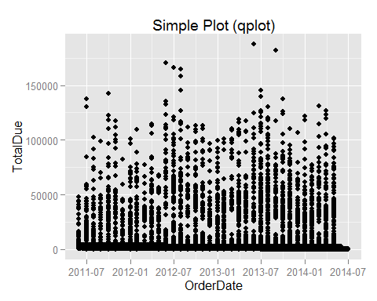

qplot(data=sales, y=TotalDue, x=OrderDate, color=OnlineOrder, size=TotalDue, main='Plot with aesthetic mappings (qplot)')

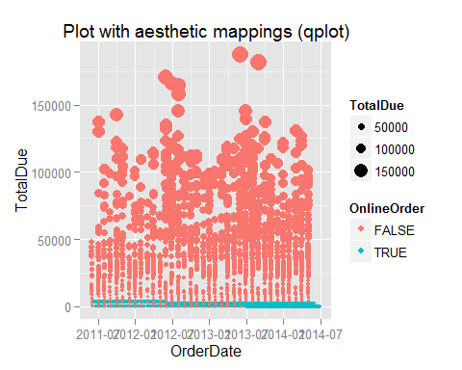

qplot(data=sales, y=TotalDue, x=OrderDate, color=OnlineOrder, size=TotalDue, main='Plot with log and aesthetic mappings (qplot)') + scale_y_log10()

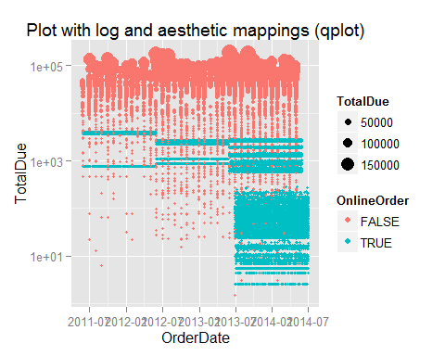

Now let's generate the same plot set with ggplot step by step.

ggplot(sales, aes(OrderDate, TotalDue)) + geom_point() + ggtitle('Simple Plot (ggplot)')

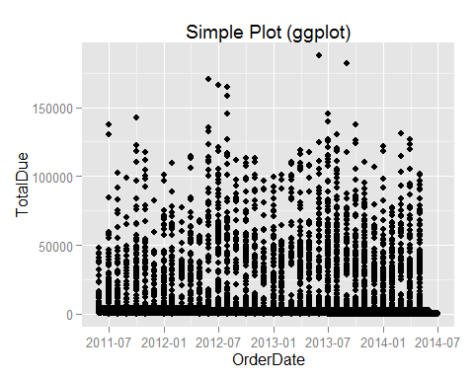

ggplot(sales, aes(OrderDate, TotalDue)) + geom_point(aes(colour = OnlineOrder, size=TotalDue)) + ggtitle('Plot with aesthetic mappings (ggplot)')

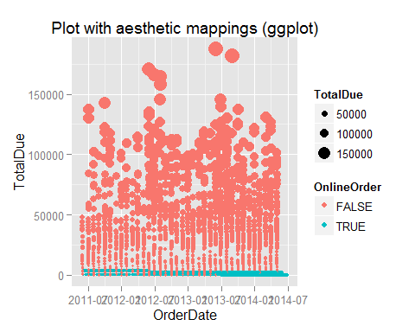

ggplot(sales, aes(OrderDate, TotalDue)) + geom_point(aes(colour = OnlineOrder, size=TotalDue)) + ggtitle('Plot with log and aesthetic mappings (ggplot)') + scale_y_log10()

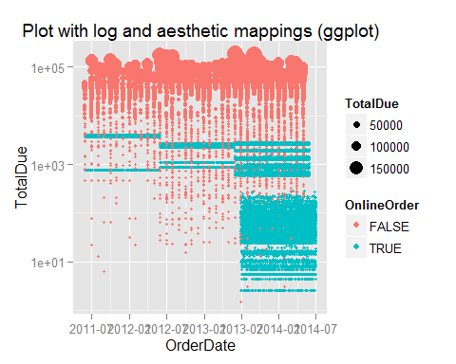

### Demo: Bar plot with qplot and ggplot

This section shows how to create bar plots with qplot and ggplot. Please also pay attention to how to use lubridate to extract the month value from OrderDate.

library(lubridate)  
qplot(month(OrderDate), TotalDue/1000000, fill=CountryRegion, data=sales, geom="bar", stat="identity", xlab="Month", ylab="Value ($m)", main='Bar Plot (qplot)') +  
 scale_x_discrete(limits=c(1:12))

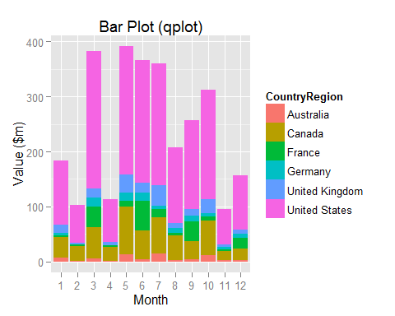

ggplot(data=sales,aes(x=month(OrderDate), y=TotalDue/1000000, fill=CountryRegion)) +   
 geom_bar(stat="identity") +   
 labs(x="Month", y="Value ($m)") +  
 scale_fill_brewer(type="qual") +  
 scale_x_discrete("Month", limits=c(1:12)) +  
 ggtitle("Bar Plot (ggplot)")

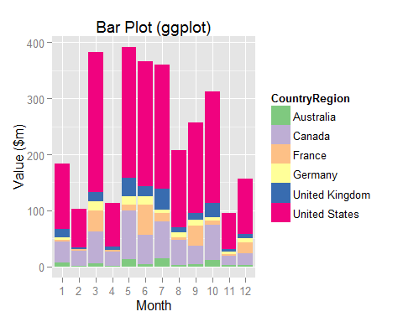

The above two bar plots should be the same, except the built-in pallet.

### Demo: Bar plot with flipped cartesian coordinates

Following two examples show how to use coord_flip to flip the cartesian coordinates. Please also pay attention to how to convert OrderDate to year with lubridate.

qplot(year(OrderDate), TotalDue/1000000, fill=CountryRegion, data=sales, geom="bar", stat="identity", xlab="Year", ylab="Value ($m)", main="Bar Plot with Coordinate Flip (qplot)") + coord_flip()

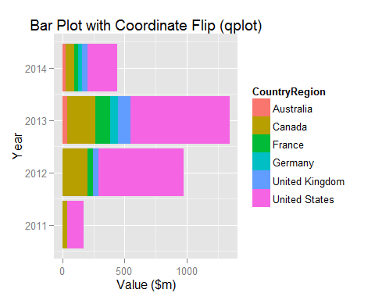

ggplot(data=sales,aes(x=year(OrderDate), y=TotalDue/1000000, fill=CountryRegion)) +   
 geom_bar(stat="identity") +   
 labs(x="Year",y="Value ($m)") +  
 scale_fill_brewer(type="qual") +  
 ggtitle("Bar Plot with Coordinate Flip (ggplot)") +  
 coord_flip()

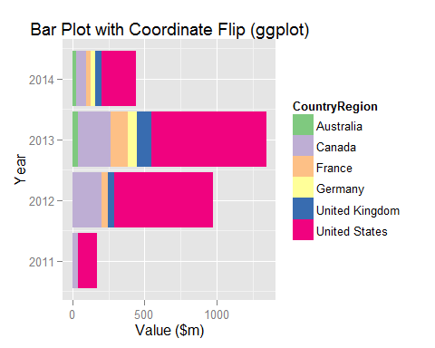

The above two bar plots should be identical, except the built-in pallet.

### Demo: Tabular display

The tabular plot is excellent in representing multivariate data. Let's start with displaying sales per year per country.

ggplot(sales, aes(OrderDate, TotalDue)) +   
 geom_point(aes(color=factor(CountryRegion), fill = factor(CountryRegion))) +   
 facet_grid(.~CountryRegion) +   
 theme(legend.position="none", axis.text.x=element_text(angle=90))

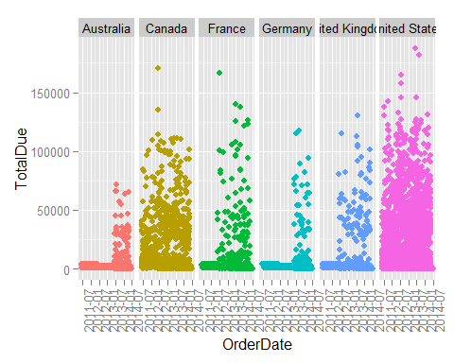

It appears there are a lot of overlapped data points; and we can't see how many data points are overlapped. We definitely need to improve the plot. Let's try to use the violin plot to show the density of data.

ggplot(sales, aes(OrderDate, TotalDue)) +   
 geom_violin(aes(fill = factor(CountryRegion))) +   
 facet_grid(.~CountryRegion) +   
 theme(legend.position="none", axis.text.x=element_text(angle=90))

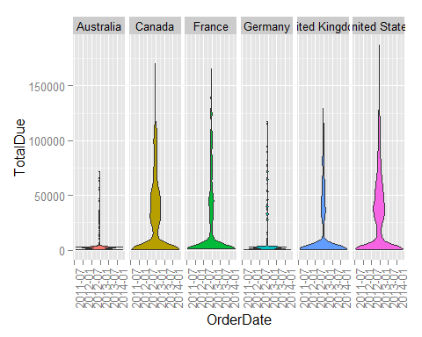

Looks good! Let's overlap the points with violin in the same plot. The order matters!

ggplot(sales, aes(OrderDate, TotalDue)) +   
 facet_grid(.~CountryRegion) +   
 theme(legend.position="none", axis.text.x=element_text(angle=90)) +   
 geom_point(aes(color=factor(CountryRegion), fill = factor(CountryRegion))) +  
 geom_violin(aes(fill = factor(CountryRegion)))

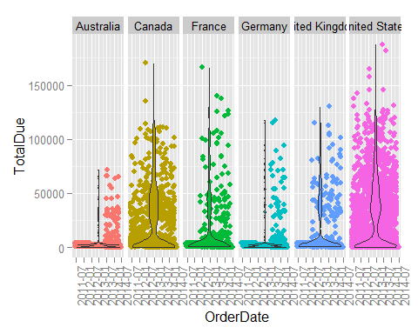

Looks pretty cool! We have learned how to overlap two plots together for richer representation.

Depending on characteristics of data, sometimes you may need to try different plots to better represent the density. As an exercise, you can replace the geom_violin with either geom_boxplot or geom_density to see the different plots. You don't know which one is the best for your data until you try.

### Demo: Lay out panels in a grid

Let's generate an arrry of bar plots in the panel. Each plot is associated to a country. Note how to set the palette with the index.

ggplot(data=sales,aes(x=year(OrderDate),y=TotalDue/1000000, fill=CountryRegion)) +  
 geom_bar(stat="identity") +   
 facet_grid(.~CountryRegion) +  
 theme(legend.position="none",axis.text.x=element_text(angle=90)) +  
 labs(x="Year",y="Value ($m)") +  
 scale_fill_brewer(type="qual", palette=3)

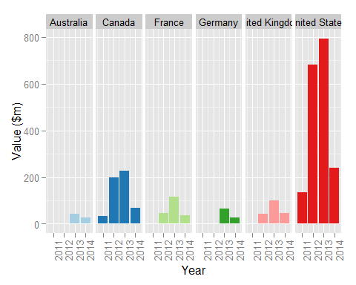

Finally, let's format the above plot with the Subcategory. Note how to set the palette with the name.

#library(lubridate)  
ggplot(data=sales,aes(x=year(OrderDate), y=TotalDue/1000000, fill=CountryRegion)) +  
 geom_bar(stat="identity") +  
 facet_grid(Subcategory~CountryRegion) +  
 theme(legend.position="none", axis.text.x=element_text(angle=90)) +   
 labs(x="Year",y="Value ($m)") +  
 scale_fill_brewer(type="qual", palette='Paired')

