L0

1. iload 1
2. iload 2
3. iload 3
4. iadd
5. if_cmpge L6
6. iload 2
7. iload 1
8. iload 3
9. iadd
10. if_cmpge L6
11. iload 3
12. iload 1
13. iload 2
14. iadd
15. if_cmpge L6

L1

1. iload 1
2. iload 2
3. if_cmpne L3
4. iload 2
5. iload 3
6. if_cmpne L3

L2

1. iconst_1
2. ireturn

L3

1. iload 1
2. iload 2
3. if_cmpeq L5
4. iload 1
5. iload 3
6. if_cmpeq L5
7. iload 2
8. iload 3
9. if_cmpeq L5

L4

1. iconst_2
2. ireturn

L5

1. iconst_3
2. ireturn

L6

1. iconst_4
2. ireturn

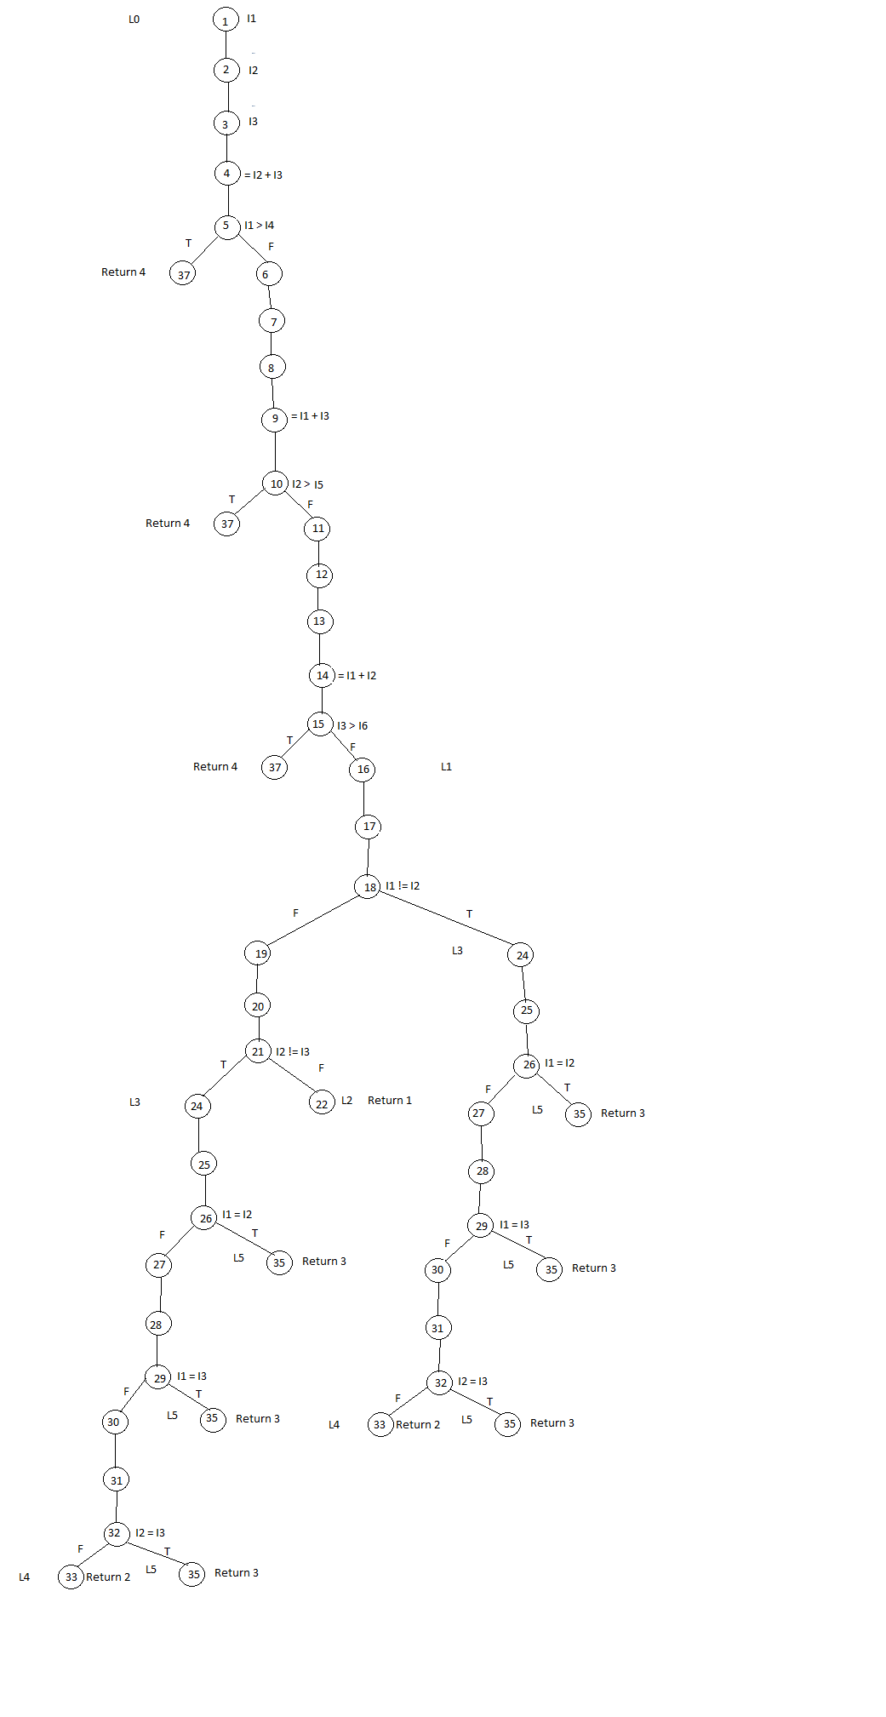

**Paths:**

|  |  |  |
| --- | --- | --- |
| **Triangle** | **Path ID** | **Path** |
| **Equilateral** | **1** |  |
| **Isosceles** | **2** |  |
|  | **3** |  |
|  | **4** |  |
|  | **5** |  |
|  | **6** |  |
|  | **7** |  |
| **Scalene** | **8** |  |
|  | **9** |  |
| **Not a Triangle** | **10** |  |
|  | **11** |  |
|  | **12** |  |

|  |  |  |
| --- | --- | --- |
| Path ID | Instructions | Dependencies |
| 1 | L0   1. iload 1 2. iload 2 3. iload 3 4. iadd 5. if_cmpge L6 6. iload 2 7. iload 1 8. iload 3 9. iadd 10. if_cmpge L6 11. iload 3 12. iload 1 13. iload 2 14. iadd 15. if_cmpge L6   L1   1. iload 1 2. iload 2 3. if_cmpne L3 4. iload 2 5. iload 3 6. if_cmpne L3   L2   1. iconst_1 2. ireturn |  |
| 2 | L0   1. iload 1 2. iload 2 3. iload 3 4. iadd 5. if_cmpge L6 6. iload 2 7. iload 1 8. iload 3 9. iadd 10. if_cmpge L6 11. iload 3 12. iload 1 13. iload 2 14. iadd 15. if_cmpge L6   L1   1. iload 1 2. iload 2 3. if_cmpne L3   L3   1. iload 1 2. iload 2 3. if_cmpeq L5   L5   1. iconst_3 2. ireturn |  |
| 3 | L0   1. iload 1 2. iload 2 3. iload 3 4. iadd 5. if_cmpge L6 6. iload 2 7. iload 1 8. iload 3 9. iadd 10. if_cmpge L6 11. iload 3 12. iload 1 13. iload 2 14. iadd 15. if_cmpge L6   L1   1. iload 1 2. iload 2 3. if_cmpne L3   L3   1. iload 1 2. iload 2 3. if_cmpeq L5 4. iload 1 5. iload 3 6. if_cmpeq L5   L5   1. iconst_3 2. ireturn |  |
| 4 | L0   1. iload 1 2. iload 2 3. iload 3 4. iadd 5. if_cmpge L6 6. iload 2 7. iload 1 8. iload 3 9. iadd 10. if_cmpge L6 11. iload 3 12. iload 1 13. iload 2 14. iadd 15. if_cmpge L6   L1   1. iload 1 2. iload 2 3. if_cmpne L3   L3   1. iload 1 2. iload 2 3. if_cmpeq L5 4. iload 1 5. iload 3 6. if_cmpeq L5 7. iload 2 8. iload 3 9. if_cmpeq L5   L5   1. iconst_3 2. ireturn |  |
| 5 | L0   1. iload 1 2. iload 2 3. iload 3 4. iadd 5. if_cmpge L6 6. iload 2 7. iload 1 8. iload 3 9. iadd 10. if_cmpge L6 11. iload 3 12. iload 1 13. iload 2 14. iadd 15. if_cmpge L6   L1   1. iload 1 2. iload 2 3. if_cmpne L3 4. iload 2 5. iload 3 6. if_cmpne L3   L3   1. iload 1 2. iload 2 3. if_cmpeq L5   L5   1. iconst_3 2. ireturn |  |
| 6 | L0   1. iload 1 2. iload 2 3. iload 3 4. iadd 5. if_cmpge L6 6. iload 2 7. iload 1 8. iload 3 9. iadd 10. if_cmpge L6 11. iload 3 12. iload 1 13. iload 2 14. iadd 15. if_cmpge L6   L1   1. iload 1 2. iload 2 3. if_cmpne L3 4. iload 2 5. iload 3 6. if_cmpne L3   L3   1. iload 1 2. iload 2 3. if_cmpeq L5 4. iload 1 5. iload 3 6. if_cmpeq L5   L5   1. iconst_3 2. ireturn |  |
| 7 | L0   1. iload 1 2. iload 2 3. iload 3 4. iadd 5. if_cmpge L6 6. iload 2 7. iload 1 8. iload 3 9. iadd 10. if_cmpge L6 11. iload 3 12. iload 1 13. iload 2 14. iadd 15. if_cmpge L6   L1   1. iload 1 2. iload 2 3. if_cmpne L3 4. iload 2 5. iload 3 6. if_cmpne L3   L3   1. iload 1 2. iload 2 3. if_cmpeq L5 4. iload 1 5. iload 3 6. if_cmpeq L5 7. iload 2 8. iload 3 9. if_cmpeq L5   L5   1. iconst_3 2. ireturn |  |
| 8 | L0   1. iload 1 2. iload 2 3. iload 3 4. iadd 5. if_cmpge L6 6. iload 2 7. iload 1 8. iload 3 9. iadd 10. if_cmpge L6 11. iload 3 12. iload 1 13. iload 2 14. iadd 15. if_cmpge L6   L1   1. iload 1 2. iload 2 3. if_cmpne L3   L3   1. iload 1 2. iload 2 3. if_cmpeq L5 4. iload 1 5. iload 3 6. if_cmpeq L5 7. iload 2 8. iload 3 9. if_cmpeq L5   L4   1. iconst_2 2. ireturn |  |
| 9 | L0   1. iload 1 2. iload 2 3. iload 3 4. iadd 5. if_cmpge L6 6. iload 2 7. iload 1 8. iload 3 9. iadd 10. if_cmpge L6 11. iload 3 12. iload 1 13. iload 2 14. iadd 15. if_cmpge L6   L1   1. iload 1 2. iload 2 3. if_cmpne L3 4. iload 2 5. iload 3 6. if_cmpne L3   L2   1. iconst_1 2. ireturn   L3   1. iload 1 2. iload 2 3. if_cmpeq L5 4. iload 1 5. iload 3 6. if_cmpeq L5 7. iload 2 8. iload 3 9. if_cmpeq L5   L4   1. iconst_2 2. ireturn |  |
| 10 | L0   1. iload 1 2. iload 2 3. iload 3 4. iadd 5. if_cmpge L6   L6   1. iconst_4 2. ireturn |  |
| 11 | L0   1. iload 1 2. iload 2 3. iload 3 4. iadd 5. if_cmpge L6 6. iload 2 7. iload 1 8. iload 3 9. iadd 10. if_cmpge L6   L6   1. iconst_4 2. ireturn |  |
| 12 | L0   1. iload 1 2. iload 2 3. iload 3 4. iadd 5. if_cmpge L6 6. iload 2 7. iload 1 8. iload 3 9. iadd 10. if_cmpge L6 11. iload 3 12. iload 1 13. iload 2 14. iadd 15. if_cmpge L6   L6   1. iconst_4 2. ireturn |  |

Code Implementation:

Com.gannon.executor.opcodes: all java file will implement Analyzable Interface and force implement dependencyAnalysing Method.

Create an DependencyDataHolder object. It should have ArrayListOfTree, tempVariableStack, tempVariableCounter, nodeCounter.

In the implementation of dependencyAnalysing method, make a use of tempVariableStack to hold the tempVariable Data same as JVM Stack does to hold the variables value. Whenever JVM Stack pops out the values during execution, we have to pops out the tempVariables from the stack and create a new tempVariable, which will be the root of the tree.

Pseudocode

Init two array lists a_r and a_v

Init two stack s_r and s_v

//a_r: store relations

//a_v: store temp computing values

For (each instruction)

if push (load) value in a_r to s_r

push corresponding variable name in a_v to s_r

end if

…

If pop (store) value in s_v to a_v

If(!exist)

Pop corresponding variable name r in s_r to a_r

Else

Move the r to correct position

End if

End for