PARTNER ARCHITECTURE · JULY 2026

Alba Gut Intelligence System
  - From microbiome insight to safe, sustained family action
A governed parent journey, skill system and agent layer for Alba Health
CURRENT STRENGTH  Test + coach + 12-month Advisor | MISSING SYSTEM  Governed longitudinal family memory | PILOT OUTCOME  Safer action, higher adherence, stronger retest loop
Prepared for Nora Cavani and Alba Health
Starlight Intelligence Systems · FrankX

1. Decision
THE MOVE Build the Gut Intelligence System as an Alba-owned vertical runtime on the Starlight control plane. It should augment Alba Advisor, not replace it; remain invisible to parents as infrastructure; and turn the existing test-to-report experience into a governed 90-day behavior and outcomes loop.
Alba already owns the hard wedge: child-specific microbiome science, a certified-lab workflow, a trusted brand, nutrition coaches, an app, a 12-month AI Advisor, and meaningful family distribution. Rebuilding those surfaces would add technical debt without creating strategic advantage.
The missing economic system is longitudinal: convert recommendations into family-compatible meals, capture what was actually tried, route uncertainty to a human, measure adherence and outcomes, and make the retest decision obvious. That is the Gut Intelligence vertical.

Venture thesis
Element | Decision
Change | Every family receives an evidence-bounded, context-aware operating layer after the microbiome report.
Buyer | Alba Health; the end user is a caregiver acting for a child or family member.
Job | Turn a complex result into safe, practical meals and routines that survive real family life.
Promise | Within 10 minutes of report release, create an approved first-week plan; sustain weekly learning for 90 days.
Mechanism | Structured family memory + deterministic constraints + Alba-approved evidence + bounded AI explanation.
Payment event | A funded design-partner pilot begins on signed SOW/DPA; production becomes a recurring platform licence after proof gates.
PORTFOLIO PLACEMENT No new consumer brand or public domain. “Gut Intelligence System” is a Starlight vertical pack; “Alba Advisor” remains the customer-facing product. A private Alba deployment is justified because it has an independent security, release and regulatory boundary.

2. Nora Cavani and the Alba business
Nora Cavani is Alba Health’s founder and CEO, with training in biotechnology and pharmaceutical engineering, prior digital-health work at Boston Consulting Group, and a founder story rooted in her experience with severe eczema and allergies. She co-founded Alba with microbiome scientist Professor Willem M. de Vos. The business is positioned as preventive family wellness, not diagnosis or treatment.[1][2][3]

What Alba already sells
Layer | Current product evidence | Strategic implication
Acquisition | 40,000+ mini-series sign-ups; webinars, podcast/radio, Instagram education.[4][5] | Education already converts attention into high-intent parent demand.
Core product | At-home stool test, app report, action plan, 30-minute nutrition consultation, retest path.[6] | The test is the paid activation event and proprietary data source.
Advisor | 12 months of meal plans, shopping lists, food/menu/meal/care-product scanning and chat support.[6][7] | Do not pitch generic AI features that Alba already claims.
Research | PREVENT follows 300+ Swedish families; Alba cites 1,600+ team publications.[2][8] | Alba’s moat is the evidence/data loop, not a chatbot.
Traction | Nora reports 8x growth, a 20,000-person community and two million monthly Instagram reach.[5] | Distribution risk is unusually low for a design partnership.

The constraint hiding inside the success
The Advisor’s public feature surface is broad. That increases the need for a hidden operating layer that can explain exactly which data, rule, evidence release, safety gate and human escalation produced each response. Recent public reviews are predominantly positive, but the negative cases concentrate around unmet expectations, response delays, test limitations and advice safety—the precise failure modes a governed journey must absorb.[9]
PARTNER POSITIONING Nora is unlikely to respond to “we can build an AI meal planner.” She is already building one. The credible proposition is: make Alba Advisor auditable, safer, longitudinal, coach-amplifying and ready to learn from outcomes without mixing family data.

3. The parent journey
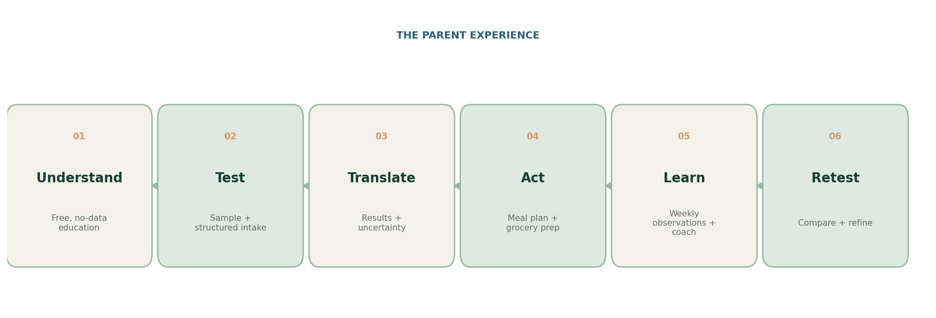
Figure 1. One continuous loop replaces a result PDF plus disconnected chat interactions.
The critical moment of value is not “the report arrived.” It is “this family knows what to prepare this week, why it is compatible with their constraints, what uncertainty remains, and when a human should take over.”
Stage | Parent experience | System receipt
Understand | No-data education; clarify what Alba can and cannot tell them. | Consent intent, no health profile.
Test | Sample workflow plus structured diet, allergy, age, routine and household intake. | Versioned intake + guardian authority.
Translate | Plain-language result with confidence and limits separated from action. | Result snapshot + evidence/policy versions.
Act | 7-day plan, grocery list, preparation sequence, substitutions and school/travel variants. | Constraint-checked plan receipt.
Learn | Weekly check-in, meal observations, barriers and coach escalation. | Event log + reviewed plan changes.
Retest | Compare snapshots without overclaiming causality; decide next experiment. | Longitudinal comparison + human-reviewed next step.
DESIGN RULE The parent should see one calm guide. Internally, every output is decomposed into approved knowledge, household constraints, a bounded skill, a policy decision, provenance and a confidence label.

4. System architecture
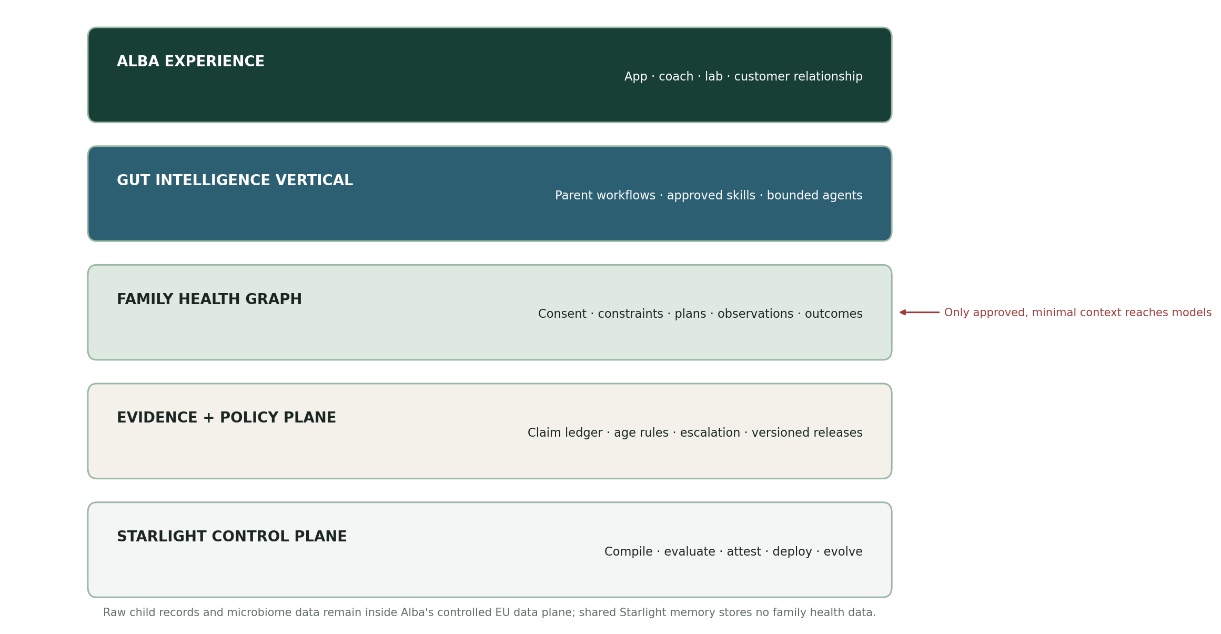
Figure 2. Starlight compiles and proves the capability; Alba owns the experience, health data, scientific interpretation and human support.

Hybrid intelligence, not an unconstrained health chatbot
- Alba’s validated microbiome-to-recommendation mapper produces approved intervention candidates; the language model never infers clinical meaning from raw taxa.
- A deterministic constraint engine blocks age-inappropriate items, declared allergens, diet conflicts, unavailable foods and coach-authored exclusions before generation.
- The meal composer selects from approved foods, recipes and substitutions; the model may explain, sequence and personalize presentation inside those bounds.
- The evidence and claims guardian attaches source, population, age range, evidence grade, limitations, review date and permitted wording to every material claim.
- The safety router uses approved static escalation language. It does not diagnose, reassure or decide urgency.
- The Starlight Proving Ground runs privacy, boundary, factual, taste, latency, cost and drift evaluations before a capability release.

Ownership boundary
Owner | Owns | Never receives by default
Alba | Brand, app, lab pipeline, result model, customer relationship, coach network, child/family data. | No restriction—subject to its own consent, security and regulatory controls.
Starlight | Vertical compiler, skill/agent contracts, policy schemas, eval harness, evidence receipts, adapter SDK. | Raw stool data, raw sequences, identifiable family records, coach notes.
Joint release | Alba-specific workflows, claims ledger, golden cases, integration adapter and pilot scorecard. | Cross-family memory or unreviewed clinical claims.

5. Family Health Graph and privacy model
CORE DATA DECISION Use an isolated EU data plane inside Alba’s environment. SIS carries package definitions and non-personal evidence receipts; it is not a shared health record. No family’s memory is available to another family, the public research graph or a general Starlight vault.

Canonical objects
Object | What it contains | Control
Authority | Caregiver identity, child relationship, consent scope, country, expiry, revocation. | Explicit guardian authority; auditable changes.
Context | Age/stage, allergens, sensitivities, medical exclusions, preferences, culture, budget, kitchen, school routine. | Field-level minimisation; parent/coach editable.
Assessment | Test/report identifier, result snapshot, approved interpretation and uncertainty. | No raw sequence in model context.
Plan | Goals, food candidates, recipes, substitutions, preparation tasks, responsible caregiver. | Constraint engine + policy/evidence release.
Observation | What was served/accepted, stool or symptom notes, barriers, parent confidence and adherence. | Structured capture; no causal claim.
Handoff | Coach brief, open questions, exceptions, plan history and parent-approved export. | Human review before sharing.
Receipt | Skill version, model route, sources, policies, tool calls, confidence, reviewer and outcome. | Append-only audit and release traceability.

Four data zones
Zone | Examples | AI and learning rule
Public | Education, generic recipes, source summaries. | May enter public models; no family data.
Family-private | Identities, intake, results, plans, observations. | Minimal context through approved gateway; tenant-isolated.
Coach-private | Consultation notes, escalations, overrides. | Role-bound; never used for generic training by default.
Research | Separately consented, de-identified outcomes. | Separate pipeline; purpose limitation and disclosure controls.
PUBLIC-POLICY DILIGENCE Alba’s current storefront privacy policy says it does not request or process sensitive information, while the product necessarily handles questionnaires and health-related data and names AI providers among processors. Align the data map, lawful bases, app notices, processor list, retention, research consent and public policy through counsel before the pilot.[10]

6. Skill and agent packs
A skill is callable competence. An agent exists only where a persistent policy, memory and escalation boundary is required. Most parent features should therefore be skills behind one calm guide—not a theatrical swarm.

Parent-facing Alba Gut Journey Pack
Skill | Output | Hard gate
guided-intake | Structured family context and missing-information list. | Guardian authority + minimisation.
report-translator | Plain-language result and uncertainty summary. | Uses Alba-approved interpretation only.
first-week-plan | 7-day meals, substitutions, grocery and prep sequence. | Age, allergen, exclusion and evidence checks.
picky-eater-adapter | Low-friction exposure ladder and familiar-food bridge. | No coercion; coach review for flagged cases.
school-travel-adapter | Lunchbox, restaurant and travel variants. | Uncertain menu data remains explicit.
food-and-meal-scan | Compatibility explanation, not a pass/fail medical claim. | Image/text prompt-injection and allergen tests.
weekly-review | Adherence, barriers, observations and next small experiment. | No causal inference from self-report.
coach-handoff | One-page brief with exceptions and questions. | Parent-approved export only.
retest-comparison | Snapshot comparison and next questions. | No diagnosis, prognosis or attribution.
data-rights | Export, correction, consent change and deletion workflow. | Identity verification + complete audit.

Persistent agents
Agent | Responsibility | Escalates to
Family Journey Guide | Owns the parent’s current stage, next action, memory scope and output contract. | Coach or support.
Evidence & Claims Guardian | Allows only approved claims and wording from the current evidence release. | Alba science lead.
Safety & Consent Guardian | Enforces scope, authority, tenant isolation, refusal and static care routing. | Privacy/clinical owner.
Coach Copilot | Builds briefs, surfaces exceptions and records human overrides. | Assigned coach.
Outcomes Steward | Computes aggregate product metrics from separately governed data. | Product/research governance.
DISTRIBUTION RULE Personalised packs launch inside the Alba app. A public ChatGPT/website companion may teach generic gut habits but must collect no child health data. Portability comes later, after the Alba adapter, consent model and eval suite are proven.

7. What to reuse—and what not to
Asset | Observed maturity | Decision
Health Intelligence System v0.2.1 | Strong public protocol: versioned agent pack, local/private vault patterns, clinician handoff, privacy tiers, safety boundary and release verification.[11] | Reuse safety, privacy, workflow and package contracts. Add gut-specific policies and evals.
Starlight Intelligence System | Strong substrate: SIP memory/governance contract, skills/agents, MCP, orchestration, eval and attestation direction.[12] | Reuse as compiler/control plane. Keep it out of raw child data.
Starlight Foundry v0.1 | Clear canonical vertical-pack contract, TaskEnvelope, capability graph, Proving Ground and evidence receipts.[13] | Use as the packaging and evaluation standard.
Agentic Health OS runtime | Thin TypeScript science-gateway stub with placeholder results and no parent journey, database, policy engine or production integration.[14] | Do not extend for Alba. Quarantine placeholder clinical outputs; build a new private vertical runtime.
Family Intelligence OS | Useful deny-by-default policy, controlled MCP gateway, audit and family-role patterns.[15] | Reuse role/consent/audit patterns, not genealogy product scope.
Starlight Knowledge Tree | Useful public ontology and evidence graph; explicitly excludes private health data.[16] | Use for public evidence metadata only; never as family memory.

Repository and deployment decision
- Create one private, vendor-neutral `gut-intelligence-vertical` package because health data, regulated claims, customer isolation and independent release gates justify the boundary.
- Integrate it into Alba’s existing backend/app through narrow typed APIs; do not create a second parent app.
- Contribute only generic, non-customer safety patterns upstream to the public Health Intelligence System.
- Keep Alba-specific claims, recipes, test mappings, golden cases and outcome logic private and versioned.
NON-NEGOTIABLE REPAIR The existing Agentic Health OS placeholder can return a hard-coded pathogenic BRCA1 interpretation. That class of mock must be deleted or made structurally impossible before any health runtime is presented as active.

8. Evidence, safety and regulatory posture
Alba’s current terms intentionally position the test and app as general health and wellness, not medical advice. Preserve that intended purpose unless Alba deliberately enters a medical-device pathway. The boundary must live in system behavior and evaluation—not only disclaimers.[7]

Claim architecture
Tier | Allowed system behavior | Example wording
A — established | Approved general nutrition and food-safety guidance for the defined age/population. | “This plan includes approved fibre sources for this age group.”
B — supported association | Explain association plus limits; no causal claim. | “This pattern has been associated with…; it does not establish cause.”
C — emerging | Education or coach/science review only. | “Research is emerging; Alba does not use this as a treatment decision.”
D — blocked | Diagnosis, prognosis, treatment, medication/supplement dosing, emergency triage, unsupported product claims. | No generated recommendation.

Why the guardrail depth is proportionate
- GDPR treats health data as a special category and gives children specific protection; high-risk processing may require a DPIA.[17]
- The EU AI Act’s chatbot transparency rules apply from 2 August 2026; every conversational surface should clearly identify itself as AI.[18]
- Medical software qualification follows intended purpose and actual functionality. Clinical or treatment claims can move the product into MDR/IVDR and AI Act high-risk territory.[19]
- A 2025 international consensus found insufficient evidence to widely recommend routine microbiome testing in clinical practice; a 2026 NIST-led evaluation found major discrepancies across commercial services.[20][21]
POSITIONING CONSEQUENCE The system should maximize practical wellness support while making analytical uncertainty legible. Alba’s scientific advantage becomes more credible when the product can show where evidence ends.

9. Product and economic system
Offer layer | Buyer promise | Economic role
Free Gut Habits Companion | Understand the category without sharing child health data. | Qualifies webinar/Instagram demand into test intent.
Test + 12-month Journey Pack | Result, coach and a practical 90-day action loop. | Raises activation, perceived value and referral quality.
Year-two Family Membership | Retain family memory, planning, seasonal refreshes and coach escalation. | Creates recurring revenue after included Advisor access.
Coach Operations Pack | Less preparation time; consistent, auditable follow-up. | Improves gross margin and support quality.
Research/Partner Pack — later | Consent-governed outcome and cohort workflows. | New B2B/research revenue only after consumer proof.

Starlight–Alba engagement
This should not be sold as an open-ended custom AI project. The commercial unit is a versioned vertical pack plus an Alba deployment licence.
- Phase 1: funded architecture and data/claims audit with executable golden cases.
- Phase 2: fixed-scope 90-day design-partner pilot inside Alba’s controlled environment.
- Phase 3: recurring platform licence plus usage or active-family economics after acceptance gates.
- Alba retains customer/data/scientific ownership; Starlight retains the generic vertical compiler, contracts and evaluation substrate.
PAYMENT EVENT The pilot starts only when Alba funds the SOW and both parties approve the data-processing, intended-purpose, IP and acceptance-test boundaries. Production pricing begins only after the pilot clears demand, activation, quality and economics gates.

10. 90-day design-partner pilot
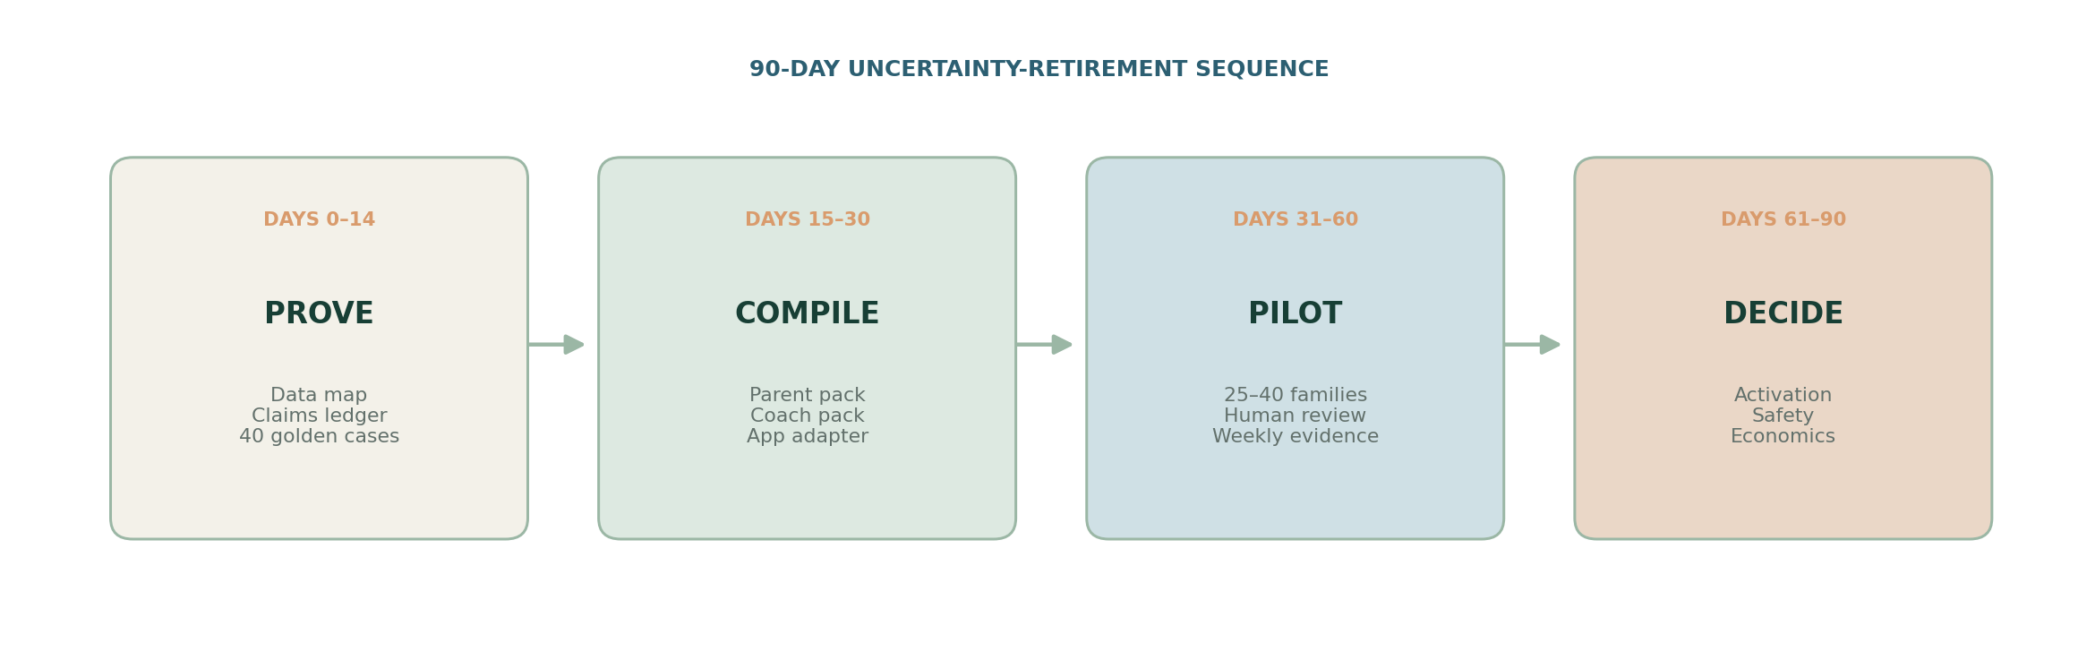
Figure 3. Build in the order that retires risk, not the order that maximizes feature count.

Pilot scope
Window | Deliverable | Exit evidence
Days 0–14 | Data map, intended-purpose statement, claims ledger, consent model, 40 golden cases, architecture ADR. | Nora/science/privacy owners approve or stop.
Days 15–30 | Family Journey Guide, first-week plan, weekly review, coach handoff, receipts, Alba app adapter. | Fictional-data evals and privacy tests pass.
Days 31–60 | 25–40 consented families across age cohorts; mandatory coach review for escalations. | Weekly activation, friction and boundary report.
Days 61–90 | Retest/continuity offer, outcome readout, production decision and release evidence receipt. | Proceed only when all proof thresholds pass.

Scoreboard and stop conditions
Gate | Pilot threshold | Stop or narrow when
Activation | ≥70% generate and approve a first-week plan. | Parents do not exchange time/data after viewing results.
Retention | ≥50% complete four weekly reviews. | Use collapses after novelty or plans do not fit family life.
Quality | ≥4.5/5 usefulness; coach prep time reduced ≥30%. | Human workload increases or outputs require broad rewriting.
Safety/privacy | 0 critical boundary or cross-family leaks; 100% allergen/authority critical-case pass. | Any unresolved critical incident or consent ambiguity.
Economics | Credible path to recurring margin or materially higher retest/referral value. | No measurable value beyond features Alba already ships.
IMMEDIATE MOVE Run a 90-minute architecture session with Nora, Alba’s product lead, science lead and privacy owner. The only decision required is whether the dominant bottleneck is parent adherence, coach capacity or evidence/governance. Freeze one bottleneck before any implementation.

11. The proposition to Nora
ONE-SENTENCE POSITION Alba has already built the right surface; Starlight can help turn it into a governed family intelligence layer that remembers safely, compounds coaching, proves every recommendation and learns from outcomes without mixing family data.

What the first session must resolve
- Which current Advisor workflow creates the greatest parent friction or coach workload?
- Which recommendation logic is deterministic, proprietary and already approved—and which is still generated or manually interpreted?
- Where do family context, chat history, coach notes, result versions and consent records live today?
- Which claims and interventions have age-specific source and approval records?
- Which outcome would justify a production licence: adherence, coach capacity, retest conversion, retention or research quality?

What not to promise
Do not promise disease prevention, diagnostic insight, treatment selection, a universal “healthy microbiome,” or autonomous personalization. Promise a safer operating system for translating Alba-approved science into repeatable family action.

The first sellable artifact
A clickable, fictional-data walkthrough of one child’s journey from report release to first-week meal plan, grocery prep, weekly review and coach handoff—accompanied by the exact evidence receipt and ten adversarial test results. This creates more information than another strategy deck.
DECISION Proceed as a design-partner proposal. Do not launch a separate Starlight gut-health consumer product, marketplace pack or parent community until Alba—or an equivalent partner—proves repeated paid demand and the safety/evaluation model.

Source ledger
Current-state claims were checked on 29 July 2026. Company traction and product claims are identified as Alba/Nora-reported where applicable. Regulatory classification requires qualified counsel and depends on intended purpose and actual implementation.
[1] Alba Health — About. https://albahealth.com/pages/about — Founder story, co-founder and scientific team
[2] European Investment Fund — Alba Health case study. https://www.eif.org/case-study/all/alba-health — Product workflow, AI and demand
[3] LinkedIn — Nora Cavani. https://uk.linkedin.com/in/eleonoracavani — Background and role
[4] Alba Health — Gut Mini-Series. https://albahealth.com/pages/gut-health-mini-series — 40,000+ sign-ups and content offer
[5] Nora Cavani — 2026 founder award post. https://www.linkedin.com/posts/eleonoracavani_entrepreneur-healthtech-startup-activity-7425490422707343360-782- — Self-reported growth and distribution
[6] Alba Health — Buy gut health tests. https://albahealth.com/pages/buy-gut-health-tests — Product catalogue and journey
[7] Alba Health — Terms of service. https://albahealth.com/policies/terms-of-service — Wellness purpose and 12-month AI chat
[8] Business Insider — Alba Health seed round. https://www.businessinsider.com/alba-health-gut-testing-pitch-deck-funding-seed-2025 — Funding, study and offer
[9] Trustpilot — Alba Health. https://www.trustpilot.com/review/albahealth.co — Current review themes; anecdotal customer evidence
[10] Alba Health — Privacy policy. https://albahealth.com/policies/privacy-policy — Controller, processors, security and public-policy gap
[11] GitHub — Health Intelligence System. https://github.com/frankxai/health-intelligence-system — Public protocol and v0.2.1 agent pack
[12] GitHub — Starlight Intelligence System. https://github.com/frankxai/Starlight-Intelligence-System — SIP/SIS substrate
[13] Starlight Intelligence Foundry Architecture v0.1. Library artifact, 28 July 2026 — Vertical pack and evaluation contract
[14] GitHub — Agentic Life OS / health package. https://github.com/frankxai/agentic-life-os/tree/main/packages/health — Current private runtime
[15] GitHub — Family Intelligence OS. https://github.com/frankxai/family-intelligence-os — Policy, roles and audit patterns
[16] GitHub — Starlight Knowledge Tree. https://github.com/frankxai/starlight-knowledge-tree — Public evidence graph boundary
[17] EUR-Lex — General Data Protection Regulation. https://eur-lex.europa.eu/eli/reg/2016/679/oj/eng — Health data, children and DPIA
[18] European Commission — AI Act. https://digital-strategy.ec.europa.eu/en/policies/regulatory-framework-ai — Transparency and high-risk obligations
[19] European Commission — MDCG guidance. https://health.ec.europa.eu/medical-devices-sector/new-regulations/guidance-mdcg-endorsed-documents-and-other-guidance_en — Medical-device software qualification
[20] Porcari et al. — International consensus on microbiome testing. https://pubmed.ncbi.nlm.nih.gov/39647502/ — Clinical-use evidence boundary
[21] Servetas et al. — DTC microbiome test analytical performance. https://www.nature.com/articles/s42003-025-09301-3 — Cross-provider variability and validity concerns

