BTP500 – Final Exam Review

- Below is a linked list
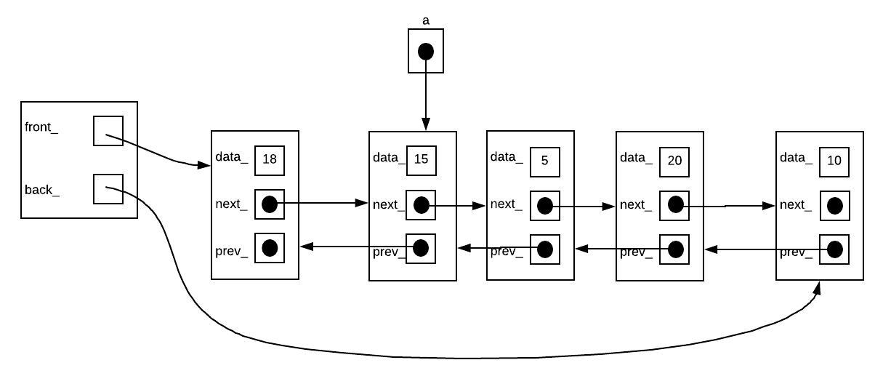
What code would you have to write to move node (15) one place to the right – between (5) and (20). Use one intermediary node if necessary:

Answer:
Node *b = a->next_;
a->prev_->next_ = a->next_;
a->next_->prev_ = a->prev_;
a->next_ = b->next_;
a->prev_ = b;
b->next_->prev_ = a;
b->next_ = a;
- For the following tree:
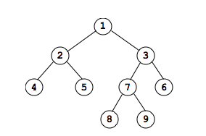
- Show the root node
- Show the leaf nodes
- Show the sibling of node 5
- Show the uncle of node 8
- Show the grandparent of node 9
- Show the ancestors of node 4
- Show the descendants or successors of node 3
- What is the depth of node 7?
- What is the height of node 7?
- What is the height of the tree?
- Show the preorder traversal of this tree
- Show the inorder traversal of this tree
- Show the postorder traversal of this tree
- Show the breadth-first traversal of this tree
- Is the tree complete?
- Is the tree full?
- Is the tree perfectly balanced?
- Is the tree height balanced?

Answers: See notes…

- AVL Trees, to practice inserts see:
https://www.cs.usfca.edu/~galles/visualization/AVLtree.html

- Red-Black Trees, to practice inserts see:
https://www.cs.usfca.edu/~galles/visualization/RedBlack.html

- 2-3 Trees, to practice inserts see:
https://www.cs.usfca.edu/~galles/visualization/BTree.html

- The Heap, to practice inserts and removal see:
https://www.cs.usfca.edu/~galles/visualization/Heap.html

- What is P vs NP? See your Lab6, your notes or see:
https://www.youtube.com/watch?v=YX40hbAHx3s&t=551s

- Draw the adjacency matrix and adjacency list for (see notes for answer):
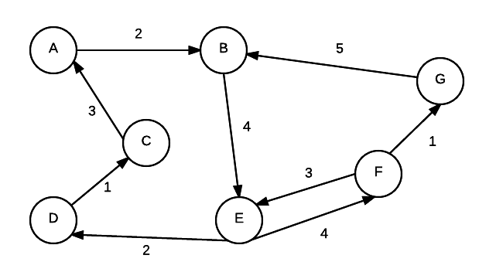
- What do the following terms in relation to graphs mean (see notes for answer)?
  - Adjacent nodes
  - Edge weight/cost
  - Path
  - Simplepath
  - Pathlength
  - Cycle
  - Strongly connected
  - Weakly connected

- For a Binary tree as shown:

class BST{
struct Node{
int data_;
Node* left_;
Node* right_;
Node(int dat){
data_=dat;
left_=right_=nullptr;
}
};
Node* root_;
...
};

Write the following functions:
- Print Preorder Traversal
- Print Inorder Traversal
- Print PostOrder Traversal
- Find the Maximum node.
- Find the Minimum node.
- Insert a node.
- Find a node.
- Find the height of a tree (useful in determining whether the tree is balanced).
- Print Breadth-First Traversal (by default left to right, could also be right to left).

Answers: See BinaryTree.cpp of Week9 and see the next few pages
void PrintPreorder(Node *node)
{
if (node == NULL)
{
return;
}
cout << " data:" << node->data_ << endl;
PrintPreorder(node->left_);
PrintPreorder(node->right_);
}

void PrintInorder(Node *node)
{
if (node == NULL)
{
return;
}
PrintInorder(node->left_);
cout << " data:" << node->data_ << endl;
PrintInorder(node->right_);
}

void PrintPostorder(Node *node)
{
if (node == NULL)
{
return;
}
PrintPostorder(node->left_);
PrintPostorder(node->right_);
cout << " data:" << node->data_ << endl;
}

Node* FindMax(Node *node)
{
if (node == NULL)
{
/* There is no element in the tree */
return NULL;
}
if (node->right_) /* Go to the right sub tree to find the max element */
return FindMax(node->right_);
else
return node;
}

Node* FindMin(Node *node)
{
if (node == NULL)
{
/* There is no element in the tree */
return NULL;
}
if (node->left_) /* Go to the left sub tree to find the min element */
return FindMin(node->left_);
else
return node;
}
Node * Insert(Node *node, int data)
{
if (node == NULL)
{
Node *temp;
temp = (Node *)malloc(sizeof(Node));//Should use new
temp->data_ = data;
temp->left_ = temp->right_ = NULL;
return temp;
}

if (data > (node->data_))
{
node->right_ = Insert(node->right_, data);
}
else if (data < (node->data_))
{
node->left_ = Insert(node->left_, data);
}
/* Else there is nothing to do as the data is already in the tree. */
return node;

}

Node * Find(Node *node, int data)
{
if (node == NULL)
{
/* Element is not found */
return NULL;
}
if (data > node->data_)
{
/* Search in the right sub tree. */
return Find(node->right_, data);
}
else if (data < node->data_)
{
/* Search in the left sub tree. */
return Find(node->left_, data);
}
else
{
/* Element Found */
return node;
}
}

int height(Node *node)//See AVLTree.cpp of week 10
{
if (node == NULL)
/* Element is not found */
return NULL; /* tree is empty */
return 1 + max(height(node->left), height(node->right));
}
int max(int a, int b) { return (a >= b)? a: b;}
void Tree::breadthFirst()//See notes of week 11
{
/* Temporary queue. */
Queue queue;
Tree *traverse;

/*
* Gotta put something in the queue initially,
* so that we enter the body of the loop.
*/

queue.insert(root);

while (!queue.isEmpty()) {
traverse = queue.remove();

Visit the node pointed to by traverse.

/*
* If there is a left child, add it
* for later processing.
*/
if (traverse->getLeftSubTree() != NULL)
queue.insert(traverse->getLeftSubTree());

/*
* If there is a right child, add it
* for later processing.
*/
if (traverse->getRightSubTree() != NULL)
queue.insert(traverse->getRightSubTree());
}

}

