HACK3D Damaged G-code Identification
Geometry and Filament Evidence for Pawn, Bishop, and Queen
Research question: Which reference piece best explains the preserved geometry and the missing extrusion in the damaged G-code?
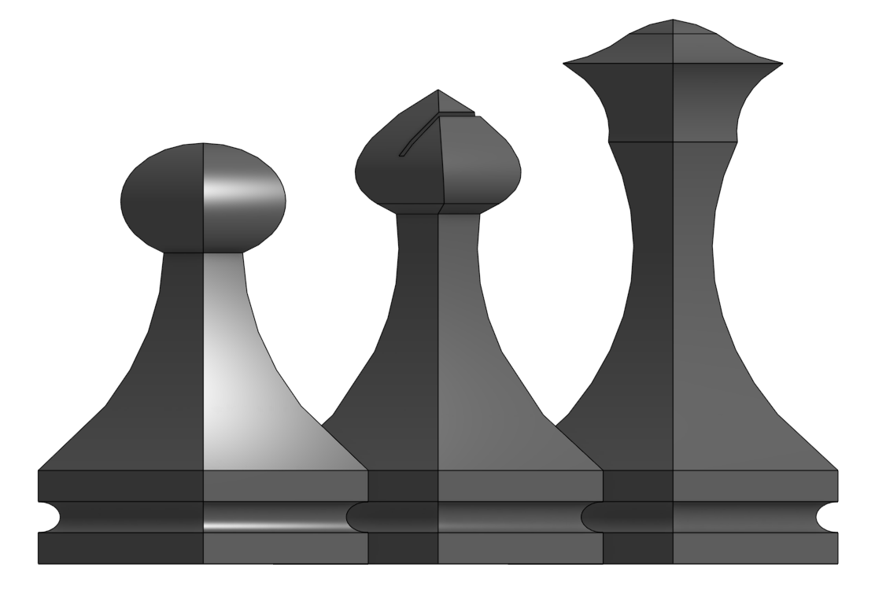
Figure 1. Reference candidates used in the analysis: Pawn, Bishop, and Queen.
Evidence Pipeline
Stage | Input | Output
1 | damaged_chess.gcode | Clean deposition segments
2 | Deposition segments | Layer profile: Z -> half-width
3 | Reference image | Pawn / Bishop / Queen profiles
4 | Profile comparison | RMSE / MAE / max error
5 | Extrusion metadata + learned E/path | Predicted missing filament
Decision rule: Use geometry as one evidence source and filament consumption as a second, independent cross-check.
1. G-code Cleaning and Measured Damaged Geometry
- Parsed motion state from G0/G1, G90/G91, M82/M83, and G92.
- Kept only XY moves with positive extrusion (deposition).
- Grouped deposition by Z layer and measured the outer X/Y extent.
- Converted the toolpath centerline to a surface half-width using the extrusion-width offset.
Measured item | Result
Clean deposition segments | 27,666
Printing layers | 237
Printing Z range | 0.35 to 23.95 mm
Parsed deposition filament | 3198.14 mm
2. Reference Profile Extraction
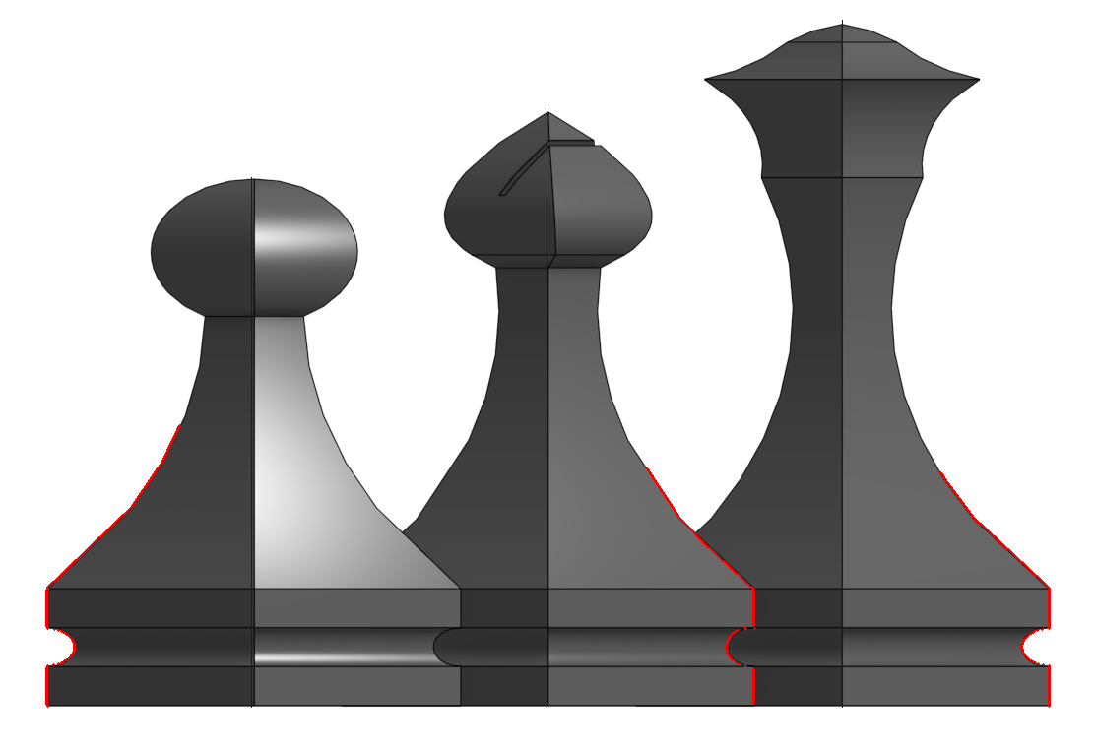
Figure 2. Contour check. Blue lines mark piece centerlines; red traces show the extracted reference boundary.
- Reference heights: Pawn 45 mm, Bishop 60 mm, Queen 70 mm.
- Image coordinates were scaled to millimeters.
- Each candidate was represented as Z -> half-width.
- Geometry comparison used only the preserved range up to Z = 23.95 mm.

3. Geometry Match
Metric: RMSE between the damaged half-width profile and each reference profile at matched Z positions.
Candidate | RMSE (mm) | MAE (mm) | Max error (mm)
Bishop | 0.1040 | 0.0570 | 0.6510
Queen | 0.1882 | 0.1212 | 0.7088
Pawn | 1.4866 | 1.2178 | 2.2047
Geometry result
- Bishop is the best lower-profile match: RMSE = 0.1040 mm.
- Queen is also close: RMSE = 0.1882 mm.
- Pawn is clearly inconsistent: RMSE = 1.4866 mm.
Sensitivity Check
Parameter sweep | Bishop wins | Queen wins | Pawn wins
Full preserved profile | 78.3% | 21.7% | 0%
Body-only profile | 83.7% | 16.3% | 0%
Interpretation: The preserved lower geometry favors Bishop, but the Bishop-Queen separation is small enough that geometry alone is not decisive.

4. Missing-Filament Test
Observed missing extrusion budget: 4290.7 - 3198.14 = 1092.56 mm
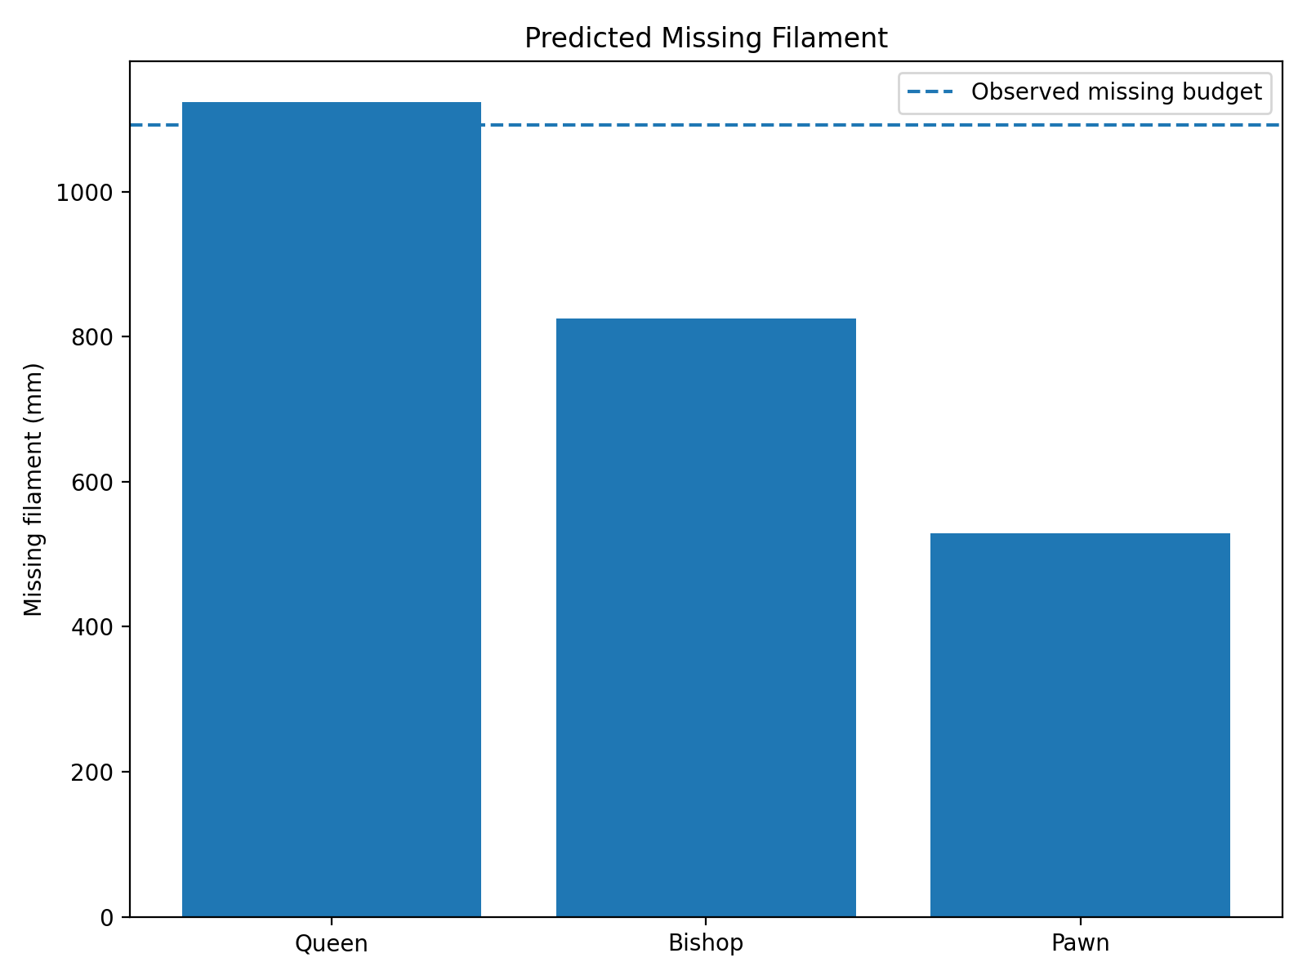
Figure 3. Predicted missing filament for the three candidates. The dashed line is the observed missing budget.
Candidate | Added layers | Predicted (mm) | Abs. error (mm) | Rel. error
Queen | 460 | 1124.07 | 31.50 | 2.88%
Bishop | 360 | 825.32 | 267.25 | 24.46%
Pawn | 210 | 528.45 | 564.11 | 51.63%
5. Conclusion
- Geometry evidence: Bishop is the closest match to the preserved lower shape.
- Filament evidence: Queen is much closer to the observed missing budget.
- Queen prediction: 1124.07 mm vs. 1092.56 mm observed (2.88% error).
- Bishop prediction error: 24.46%; Pawn prediction error: 51.63%.
- Combined evidence therefore favors the Queen as the most plausible target.
Limitations
- Reference geometry was measured from a raster image, so pixel calibration introduces uncertainty.
- Only the lower 23.95 mm of the damaged piece is directly preserved.
- Filament prediction is a model-based consistency check, not proof of byte-for-byte recovery.

