20161103



ERR has some good features.

1. *Diminishing Return:* whenever a relevant document is found, the value of another relevant document found later in the list is discounted.
2. The utility function for ERR is 1/r. It takes the position information into consideration. Penalty for lower result.

ERP developed from ERR:

1. Explicitly considering the ``killer’’ results: one result which could fulfill the information need. For a ``killer’’ result, the searcher would be satisfied with p=1.
2. Encode the position information in Utility Function.

**Inner Consistency**

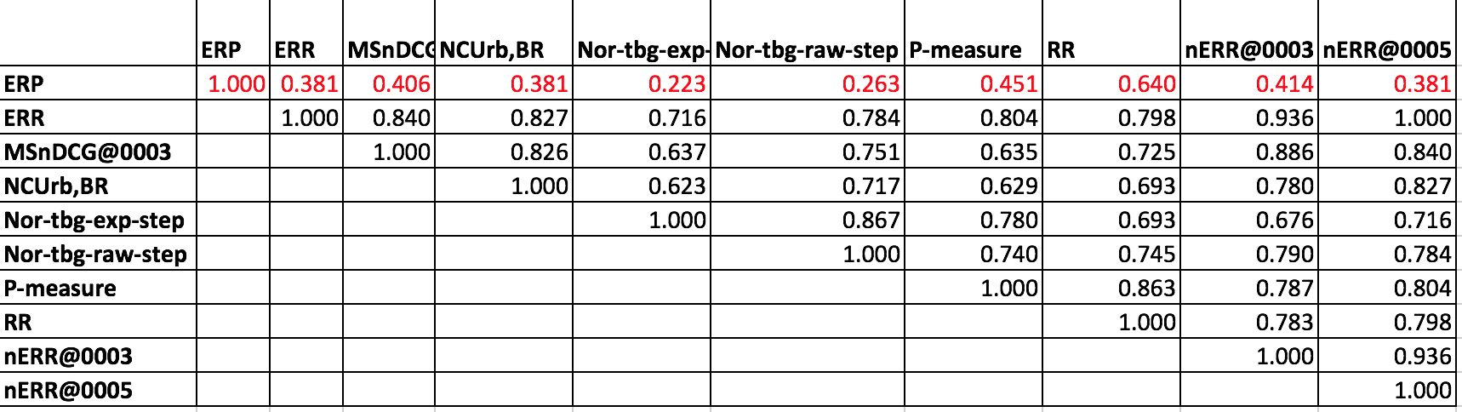

**SBS Agreement**

|  |  |  |  |
| --- | --- | --- | --- |
| **Metric** | **Agree** | **Disagree** | **RATE** |
| **ERR** | **132** | **18** | **88.00%** |
| **nERR@0005** | **132** | **18** | **88.00%** |
| **Nor-tbg-raw-step** | **126** | **24** | **84.00%** |
| **Nor-tbg-raw-binom** | **125** | **25** | **83.33%** |
| nERR@0003 | 124 | 26 | 82.67% |
| NCUrb,BR | 121 | 29 | 80.67% |
| Nor-lwofv-raw-step | 119 | 31 | 79.33% |
| Nor-lwofv-raw-binom | 119 | 31 | 79.33% |
| Q@0005 | 118 | 32 | 78.67% |
| Q-measure | 118 | 32 | 78.67% |
| Nor-nDCG-raw-step | 118 | 32 | 78.67% |
| Nor-nDCG-raw-binom | 117 | 33 | 78.00% |
| Q@0003 | 117 | 33 | 78.00% |
| Nor-tbg-exp-binom | 113 | 37 | 75.33% |
| Nor-lwfv-exp-step | 111 | 39 | 74.00% |
| Nor-lwofv-exp-step | 111 | 39 | 74.00% |
| Nor-lwfv-raw-step | 111 | 39 | 74.00% |
| MSnDCG@0005 | 111 | 39 | 74.00% |
| Nor-nDCG-exp-step | 111 | 39 | 74.00% |
| Nor-nDCG-exp-binom | 111 | 39 | 74.00% |
| *Nor-lwfv-exp-binom* | *111* | *39* | 74.00% |
| Nor-lwfv-raw-binom | 111 | 39 | 74.00% |
| Nor-lwofv-exp-binom | 111 | 39 | 74.00% |
| MSnDCG@0003 | 110 | 40 | 73.33% |
| Nor-tbg-exp-step | 110 | 40 | 73.33% |
| NCUgu,BR | 106 | 44 | 70.67% |
| RBP | 106 | 44 | 70.67% |
| nDCG@0005 | 104 | 46 | 69.33% |
| P-measure | 102 | 48 | 68.00% |
| P-plus | 102 | 48 | 68.00% |
| nDCG@0003 | 101 | 49 | 67.33% |
| O-measure | 96 | 54 | 64.00% |
| NCUgu,P | 96 | 54 | 64.00% |
| ERP | 81 | 69 | 54.00% |
| NCUrb,P | 72 | 78 | 48.00% |
| AP@0005 | 72 | 78 | 48.00% |
| AP | 72 | 78 | 48.00% |
| P@0005 | 70 | 80 | 46.67% |
| AP@0003 | 69 | 81 | 46.00% |
| P@0003 | 68 | 82 | 45.33% |
| RR | 57 | 93 | 38.00% |
| Hit@0003 | 46 | 104 | 30.67% |
| Hit@0005 | 45 | 105 | 30.00% |