Biostatistics Homework 1

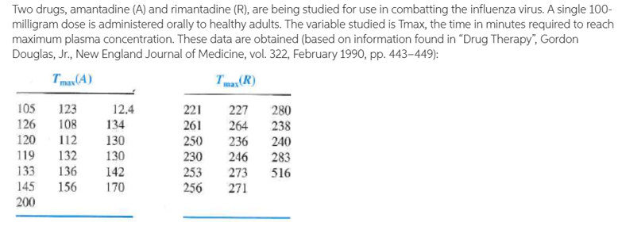

(a) Construct a side-by-side box plot and identify outliers. (10%)

(b) Calculate $\overline{x}$ and $s^{2}$ for the data of set A. (5%)

(c) Assume that the outlier of set A is the result of a misplaced decimal point. Correct the error by deleting the decimal and see what changes this makes in your box plot. Recompute $\overline{x}$ and $s^{2}$, using the correct data point, and compare your results to those of part b. (10%)

(d) Is there an outlier in set R? If so, is there an obvious legitimate reason to delete it from the data set. (5%)

(a) A的outlier12.4、170、200

R的outlier516

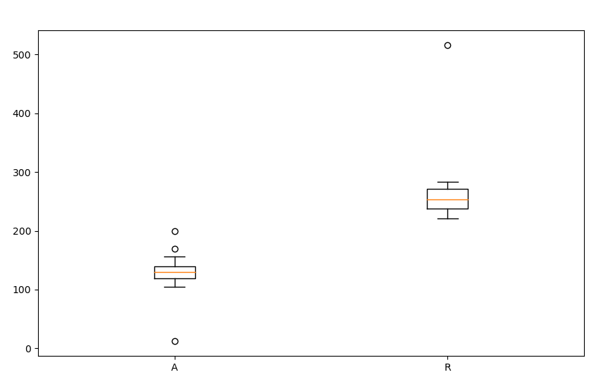

(b) $\overline{x}$ =(105+123+12.4+126+108+134+120+112+130+119+132+130+133+136+142+145+156+170+200)/19=128.07

$s^{2}$ = ${(\left(105-128.07\right)}^{2}+{\left(123-128.07\right)}^{2}+{\left(12.4-128.07\right)}^{2}+{\left(126-128.07\right)}^{2}+{\left(108-128.07\right)}^{2}+{\left(134-128.07\right)}^{2}+{\left(120-128.07\right)}^{2}+{\left(112-128.07\right)}^{2}+{\left(130-128.07\right)}^{2}+{\left(119-128.07\right)}^{2}+{\left(132-128.07\right)}^{2}+{\left(130-128.07\right)}^{2}+{\left(133-128.07\right)}^{2}+{\left(136-128.07\right)}^{2}+{\left(142-128.07\right)}^{2}+{{\left(145-128.07\right)}^{2}+\left(156-128.07\right)}^{2}+{\left(170-128.07\right)}^{2}+{\left(200-128.07\right)}^{2})/(19-1)=1282$.68

(c) A的outlier只剩170、200

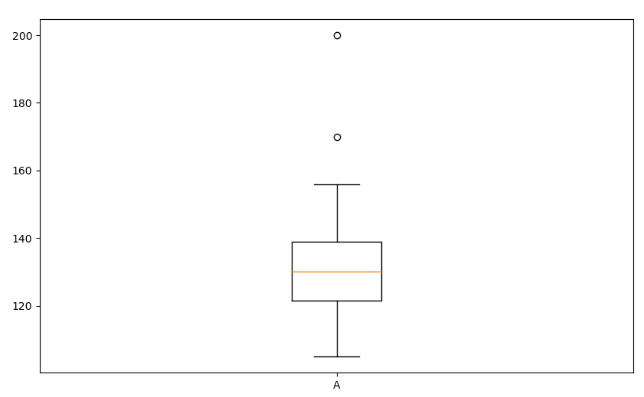

$$\overline{x}=(105+123+124+126+108+134+120+112+130+119+132+130+133+136+142+145+156+170+200)/19=133.95$$

$s^{2}$ = ${(\left(105-133.95\right)}^{2}+{\left(123-133.95\right)}^{2}+{\left(124-133.95\right)}^{2}+{\left(126-133.95\right)}^{2}+{\left(108-133.95\right)}^{2}+{\left(134-133.95\right)}^{2}+{\left(120-133.95\right)}^{2}+{\left(112-133.95\right)}^{2}+{\left(130-133.95\right)}^{2}+{\left(119-133.95\right)}^{2}+{\left(132-133.95\right)}^{2}+{\left(130-133.95\right)}^{2}+{\left(133-133.95\right)}^{2}+{\left(136-133.95\right)}^{2}{+{\left(145-133.95\right)}^{2}+\left(142-133.95\right)}^{2}+{\left(156-133.95\right)}^{2}+{\left(170-133.95\right)}^{2}+{\left(200-133.95\right)}^{2})/(19-1)=503.83$

(d) 516是outlier，因為Q3:271、Q1:238，IQR:271-238=33，上限= 271+1.5*33=320.5

2. The data sets below are temperature readings from two different sensors (a Celsius sensor and a Fahrenheit sensor). Which sensor is better by picking the one with the least variance.(15%)

Celsius: [0, 10, 20, 30, 40]

Fahrenheit: [32, 50, 68, 86, 104]

Sol:

$$\overline{c}=\frac{0+10+20+30+40}{5}=20$$

$${Vc=(\left(0-20\right)}^{2}+{\left(10-20\right)}^{2}+{\left(20-20\right)}^{2}+{\left(30-20\right)}^{2}+{\left(40-20\right)}^{2})/(5-1)=250$$

$$\overline{f}=\frac{32+50+68+86+104}{5}=68$$

$${Vf=(\left(32-68\right)}^{2}+{\left(50-68\right)}^{2}+{\left(68-68\right)}^{2}+{\left(86-68\right)}^{2}+{\left(104-68\right)}^{2})/(5-1)=810$$

Ans:Vc,因為Vc<Vf

3.**Coevolution.**  Different varieties of the tropical flower Heliconia are fertilized by different species of hummingbirds. Over time, the lengths of the flowers and the form of the hummingbirds’ beaks have evolved to match each other. Here are data on the lengths in millimeters of two variates of these flowers on the island of Dominica.

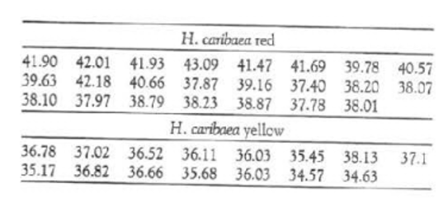

(a) Make a back-to-back stem-leaf plot to compare the two samples. That is, use one set of stems with two sets of leaves, one to the right and one to the left of the stems. (Draw a line on either side of the stems to separate stems and leaves.) Order both sets of leaves from smallest at the stem to largest away from the stem. (Please round the data to the first decimal place. Use non-fractional part as the stem, first decimal place as leaf. Ex: $41.93 → 41.9 →stem=41,leaf=9; 38.79 →38.8, stem =38, leaf =8$). (15%)

(b) What are the most important differences among the two varieties of flower? (5%)

(c) Find Q1, Median and Q3 for each group. (10%)

(a)

|  |  |  |  |  |  |  |  |  |  |  |  |  |  |  |  |
| --- | --- | --- | --- | --- | --- | --- | --- | --- | --- | --- | --- | --- | --- | --- | --- |
| yellow | | | | | | |  | red | | | | | | | |
|  |  |  |  |  |  |  | 43 | 1 |  |  |  |  |  |  |  |
|  |  |  |  |  |  |  | 42 | 0 | 2 |  |  |  |  |  |  |
|  |  |  |  |  |  |  | 41 | 5 | 7 | 9 | 9 |  |  |  |  |
|  |  |  |  |  |  |  | 40 | 6 | 7 |  |  |  |  |  |  |
|  |  |  |  |  |  |  | 39 | 2 | 6 | 8 |  |  |  |  |  |
|  |  |  |  |  |  |  | 38 | 0 | 0 | 1 | 1 | 2 | 2 | 8 | 9 |
|  |  |  |  | 1 | 1 | 0 | 37 | 4 | 8 | 9 |  |  |  |  |  |
| 8 | 8 | 7 | 5 | 1 | 0 | 0 | 36 |  |  |  |  |  |  |  |  |
|  |  |  |  | 7 | 5 | 2 | 35 |  |  |  |  |  |  |  |  |
|  |  |  |  |  | 6 | 6 | 34 |  |  |  |  |  |  |  |  |

(b)

Red品種長度Q1、中位數、Q3皆比yellow長

(c)

|  |  |  |  |
| --- | --- | --- | --- |
|  | Q1 | Median | Q3 |
| Red | 38.1 | 39.2 | 41.6 |
| yellow | 35.6 | 36.1 | 36.8 |