Homework 2

Computer Vision 2022 Spring

310554031 數據所 葉詠富

Github: https://github.com/frankye1000/NYCU-ComputerVision/tree/master/HW2

* **Preprocess**

1. Import package

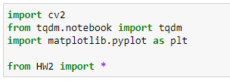

1. Use HW2.py function read_img to read 2 images(left, right).

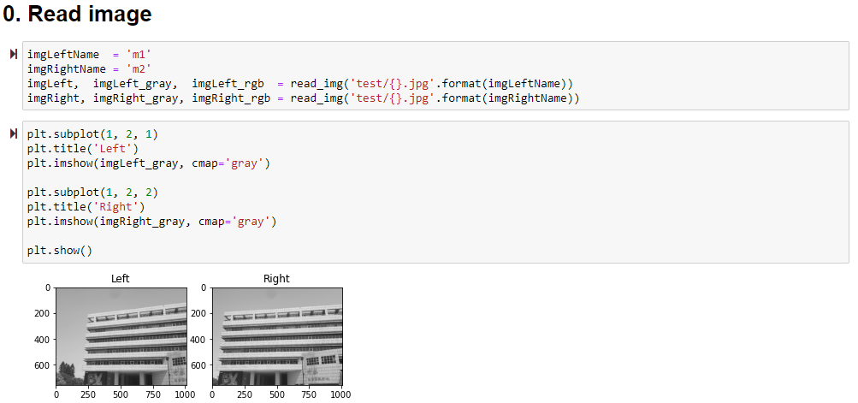

|  |
| --- |
|  |

* **Image stitching**

1. **Detecting key point(feature) on the images**

Use SIFT to detect key points(red points).

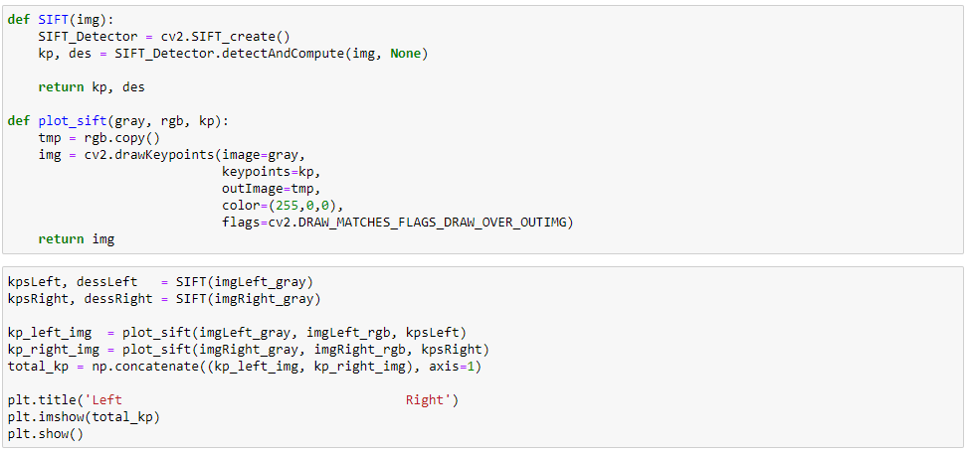

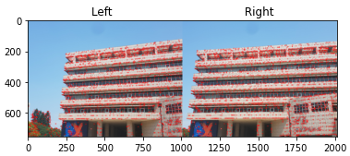

1. **Finding features correspondences (feature matching)**

Use KNN to calculate the Euclidean distance between each key point in the left image and each key point in the right image, and find the top two key points with the shortest distance.

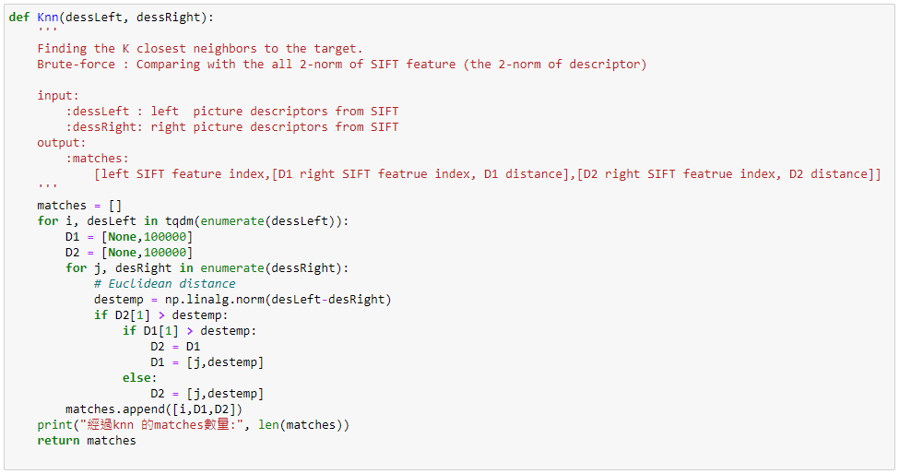

Then set threshold for each key point through Low’e ratio to get good match points.

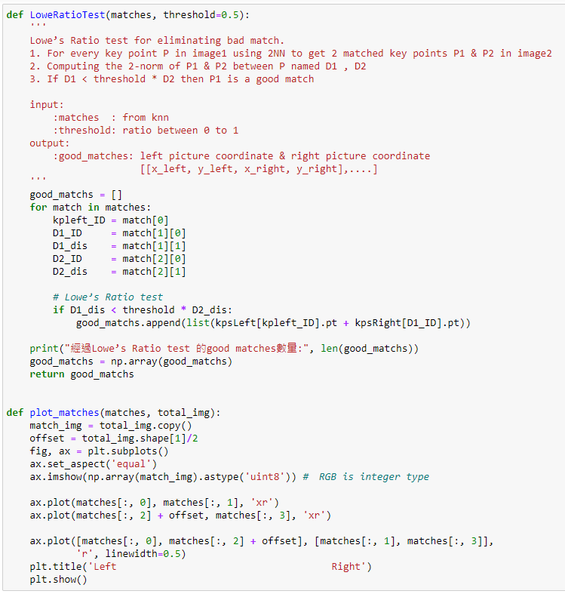

plot good matches points.



經過knn 的matches數量: 3196

經過Lowe’s Ratio test 的good matches數量: 227

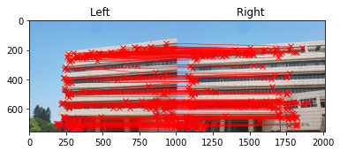

1. **Computing homography matrix.**

Follow the step(A~E) below to get the homography matrix.

1. Construct a linear system as: P2=HP1, P2 = (x2,y2,1) , P1 = (x1,y1,1) where P2 and P1 are correspondence points, H is homography matrix.
2. For perspective transformation , you can use 4 pairs of match result to slove 8 unknow variable in homography matrix
3. Using SVD decomposition to find Least Squares error solution
4. the solution = eigenvector of associated with the smallest eigenvalue (V stores the eigenvector of , stores the singular value (root of eigenvalue)) find the smallest number in and H = corresponding vector in VT
5. Remember to normalize h33 to 1

PS: SVD eigenvalue 由大到小排列，且h的解是「the eigenvector of ATA associated with the smallest eigenvalue」，所以選V最後一個eigenvector

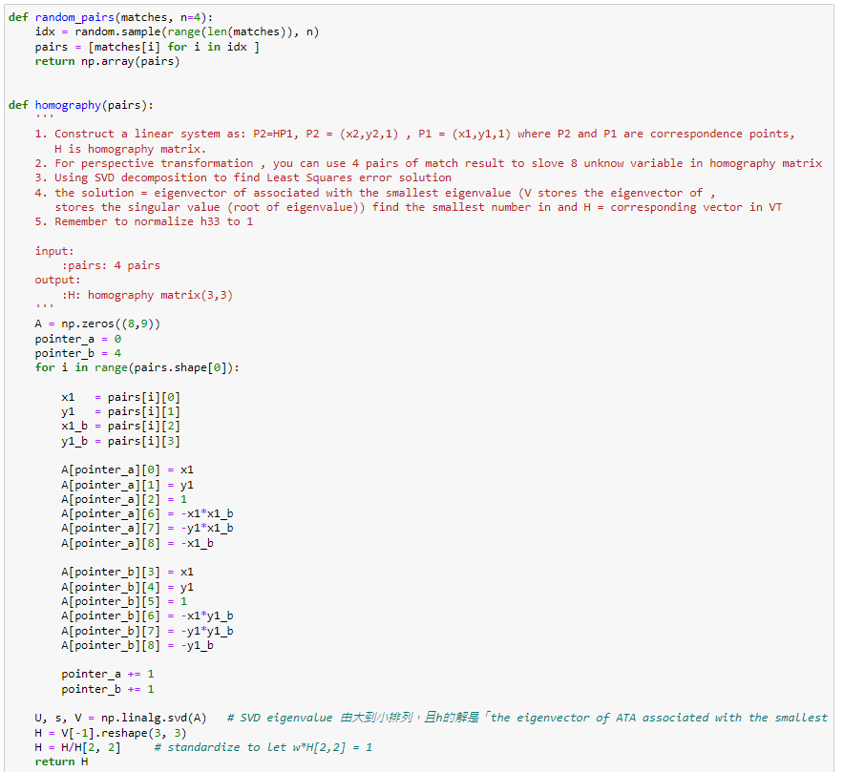

Then, we use the RANSAC (Random Sample Consensus) algorithm to find the best Homography matrix corresponding to the two images.

Follow the step(A~E) below to get the best homography matrix.

1. 隨機挑出要計算出 Homography H 所需的最少個的點
2. 求出 Homography H 的解
3. 將所有 Good matching 特徵配對去計算 P=HP'估，並統計有多少對在容許內的誤差範圍，並稱為 Inliers
4. 接著用這個 H 去算誤差 ∥P'估-P'真∥ ，如果誤差比規定的門檻還小，我們可以相信這次結果是可靠的。若為可靠，那麼統計這次 Inliers 數量有沒有比最佳次數還多，有的話我們就更新最佳 H 和最佳 Inliers 數量
5. 反覆進行步驟 1 到 4 反覆 N 次，並取得最佳 H

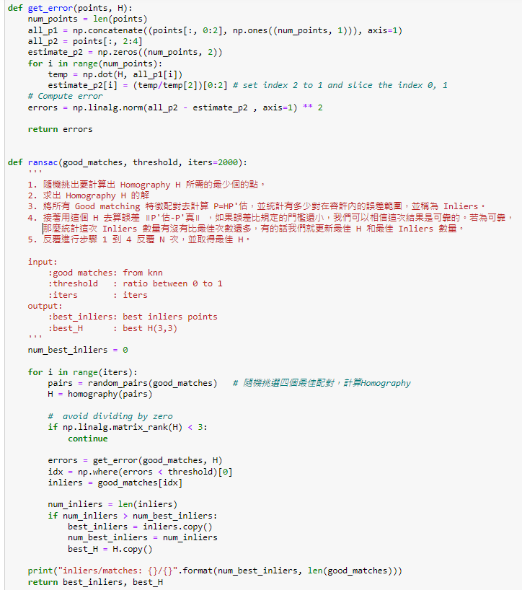

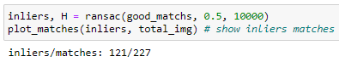

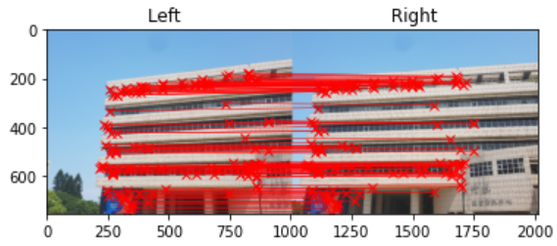

1. **Stitching image (warp images into same coordinate system)**

Use the Homography matrix to calculate the translation matrix **A**, the left image uses A*H for warp, and the right image uses **A** directly for warp. Finally, the right image is projected onto the left image.

The new projection logic is:

If the left pixel RGB total value is greater than the right, use the left pixel RGB, otherwise use the right.

Example:

|  |  |  |
| --- | --- | --- |
|  | left image | right image |
| RGB | [1,2,3] | [4,5,6] |
| Sum(RGB) | 6 | 15 |

We pick right image pixel.

PS: 這樣做pixel挑選投影後，比 (左圖+右圖)/2接合處較圓滑。

|  |  |
| --- | --- |
| (左圖+右圖)/2:接合處很明顯 | 我新創邏輯:沒有接合處 |
|  |  |

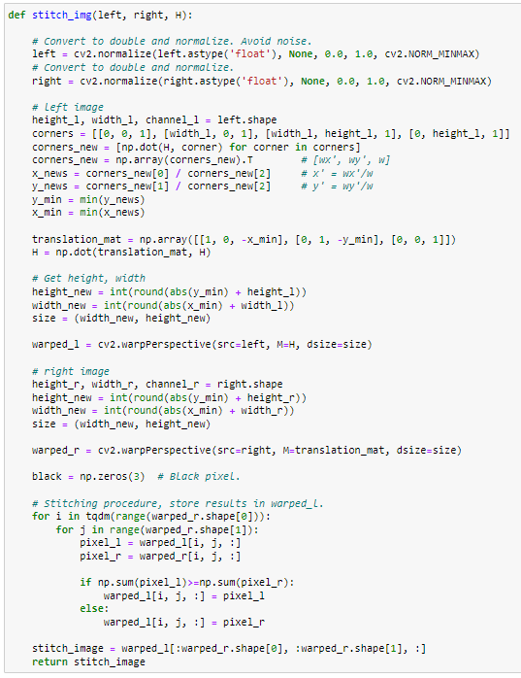

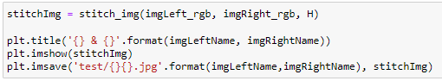

* **Image stitching Result**

|  |  |
| --- | --- |
| m1~m2 |  |
| m1~m3 |  |
| m1~m4 |  |
| m1~m5 |  |
| m1~m6 |  |
| m1~m7 |  |
| m1~m8 |  |

* **Discussion & Conclusion**

1. 使用Lowe’s Ratio test非常重要，可以找出good matches，減少配對錯誤，和降低計算成本。
2. 在 Lowe’s ratio test和Ransac error的threshold參數設定非常重要，會影響ratio test能不能找到good match 和 ransac的迭代次數。
3. 由上圖可以看到合併到m1~m8時，圖形已變形非常嚴重，可以使用Cylindrical projection改善情況。

* **Reference**
* <https://www.796t.com/content/1549421657.html>
* <https://tigercosmos.xyz/post/2020/05/cv/image-stitching/>
* <https://yungyung7654321.medium.com/python%E5%AF%A6%E4%BD%9C%E8%87%AA%E5%8B%95%E5%85%A8%E6%99%AF%E5%9C%96%E6%8B%BC%E6%8E%A5-automatic-panoramic-image-stitching-28629c912b5a>