**Introduction:**I like watching NBA games and playing basketball very much, so I choose the famous star in the NBA as the object of image effects. I have a dream about opening an NBA coffee shop with all the NBA series products, especially the characters latte. I hope it can easily present the image of the stars.

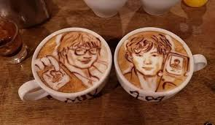

(make by japanese laflorist Geroge)

**Method:**

A total of five NBA images were used, and five image processing methods were used, namely:

1. Image Interpolation Methods
   1. Nearest Neighbor
2. Intensity Transformations
   1. Gamma correction
   2. Histogram Equalization
3. Contrast Enhancement for color images
   1. Do it separately for the RBG channels by HE
   2. Do it separately for the RGB channels by gamma
4. Smoothing Filters
   1. Box filter
   2. Min\max filter
   3. Median filter
   4. Gaussian filter
   5. Laplacian filter

**Preprocessing:**

1. Load images

Use python matplotlib api load images，and change images to 3-dimension array.

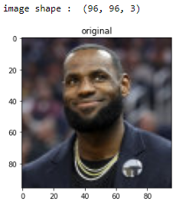 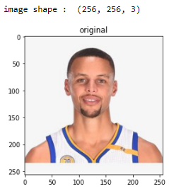 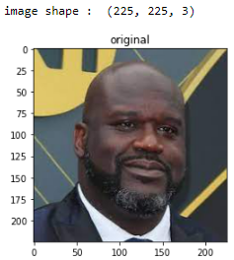

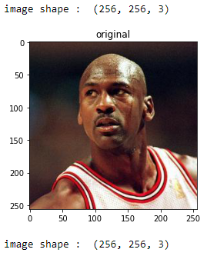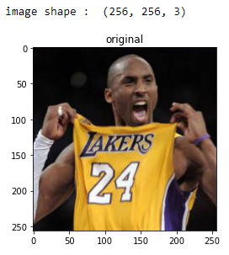

1. Image grayscale

Use **Y' = 0.299 R + 0.587 G + 0.114 B**，change images from 3-dimension to 1-dimension。

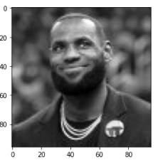 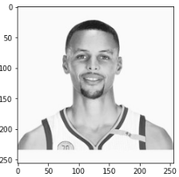 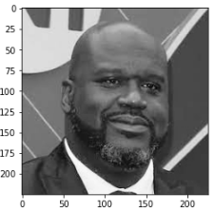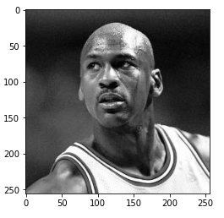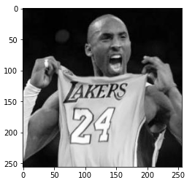

**Method detail**

1. Image Interpolation Methods

A. Nearest neighbor

I copy nearest neighbor matrix to enlarge images。The King LBJ can be the coffee shop sign canvas.

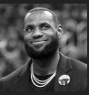 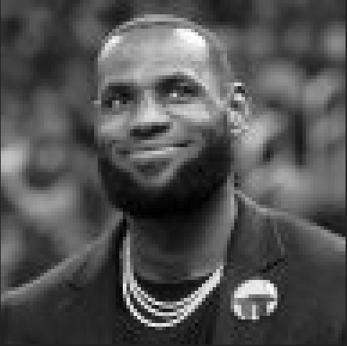

(origin) (n=5)

1. Intensity Transformations
   1. Gamma correction

Use s = c*r*gamma. In order to find evidence that curry is black, enhance contrast(just kidding). The gamma more higher, the people color more black.

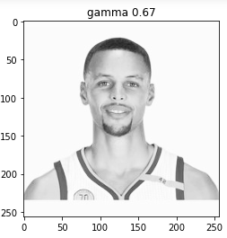 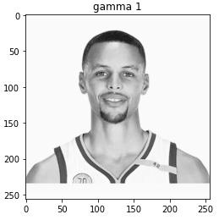 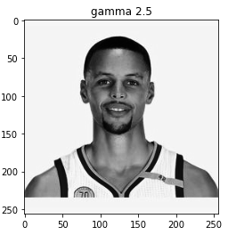 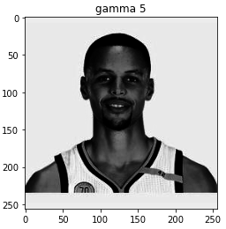

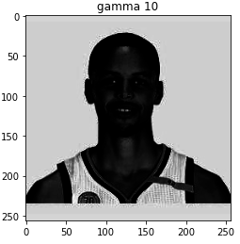

* 1. Histogram Equalization

Calculate probability density function(pdf). Then, accumulate probability of every grayscale to get cumulative distribution function(cdf). Finally, every grayscale cdf plus the total grayscale-1(256-1), then you can obtain the new grayscale.

ONeal is one of my favorite stars, rolling the NBA court with a tall and sturdy body.

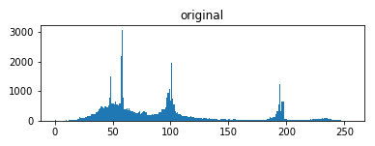 (origin grayscale histogram)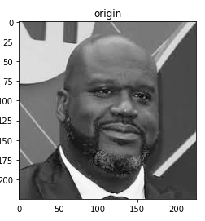 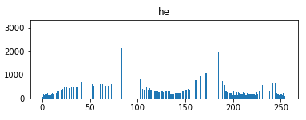(after he grayscale histogram)

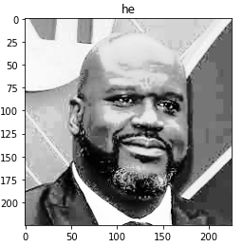

3. Contrast Enhancement for color images

A. Do it separately for the RBG channels by HE

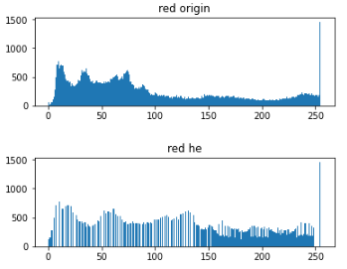(origin red v.s. after he red histogram))

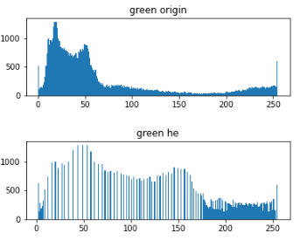(origin green v.s. after he green histogram))

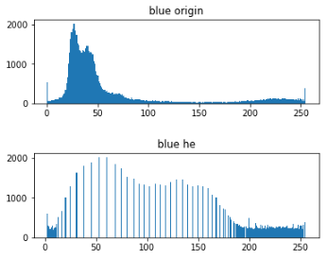(origin blue v.s. after he blue histogram))

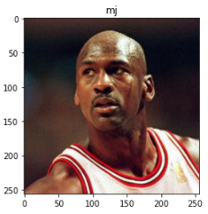 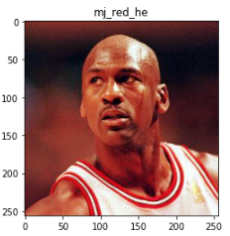

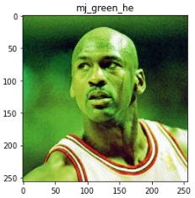 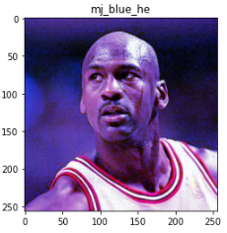

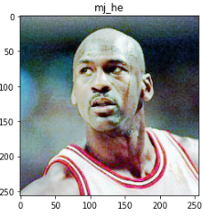

B. Do it separately for the RGB channels by gamma

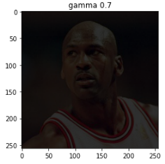 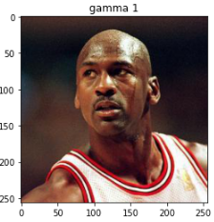

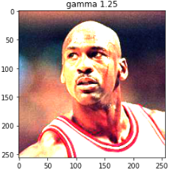 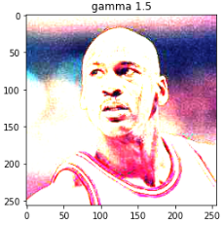

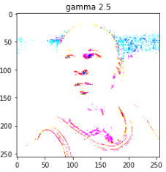

1. Smoothing Filters
   1. Box filter

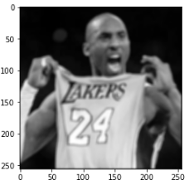(kernel=5)

* 1. Min\max filter

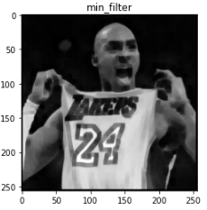(kernel=5) 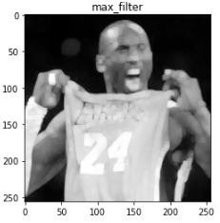(kernel=5)

* 1. Median filter

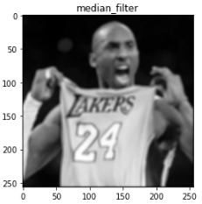(kernel=5)

* 1. Gaussian filter

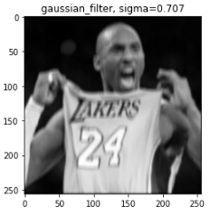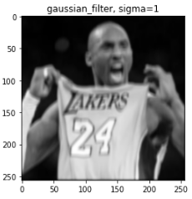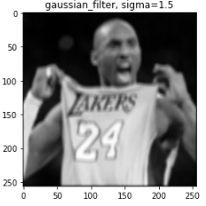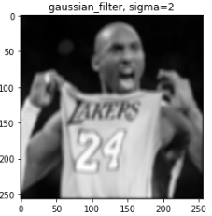

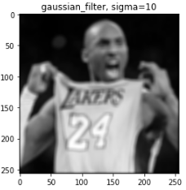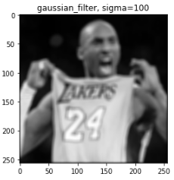

* 1. Laplacian filter

We can obtain contour obviously.

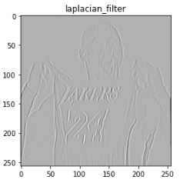

**Result**

First I use histogram equalization to enhance constrast.

Second I use min filter let image more roughly.

Then can get the coffee latte, like below images.

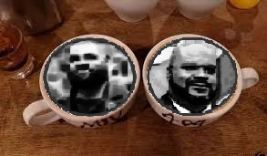

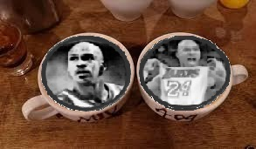

Code:

Image preprocessing

A. load images

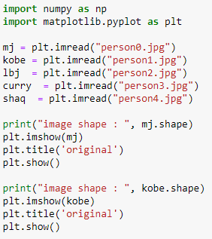

B. to gray

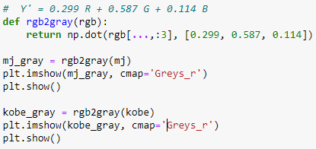

1. Image Interpolation Methods

A. Nearest Neighbor

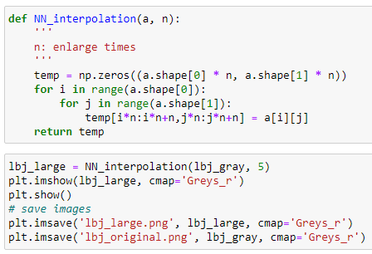

2. Intensity Transformations

A. Gamma correction

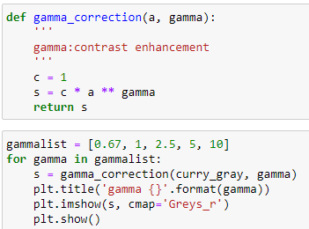

B. Histogram Equalization

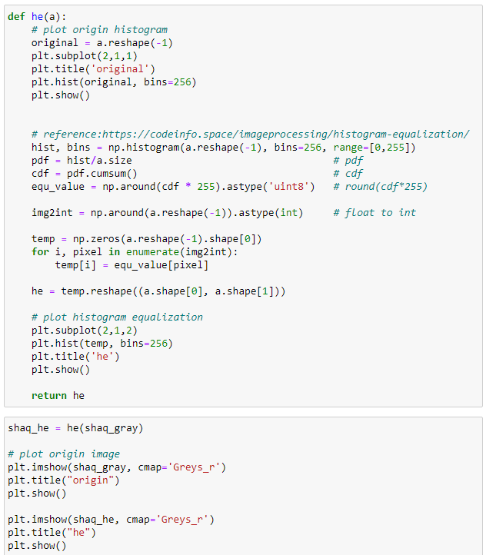

3. Contrast Enhancement for color images

A. Do it separately for the RBG channels by HE

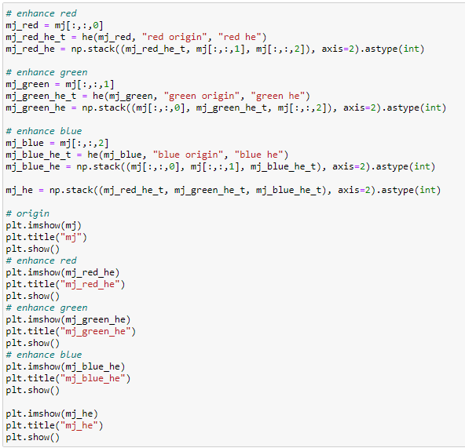

B. Do it separately for the RGB channels by gamma

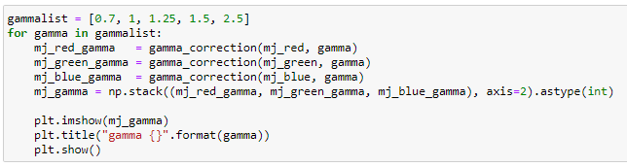

4. Smoothing Filters

A. Box filter

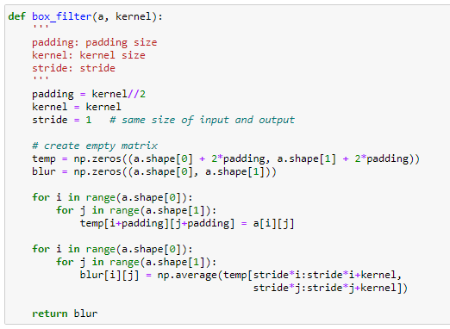

B. Min\max filter

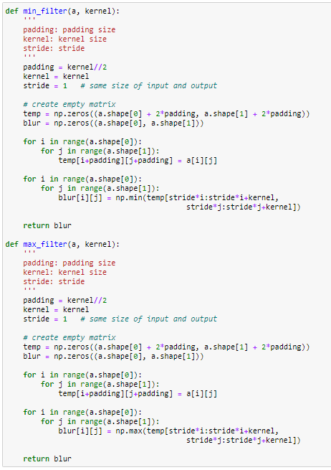

C. Median filter

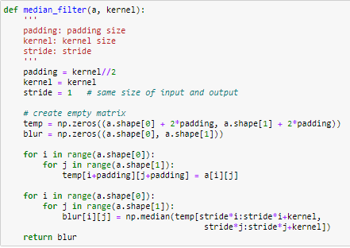

D. Gaussian filter

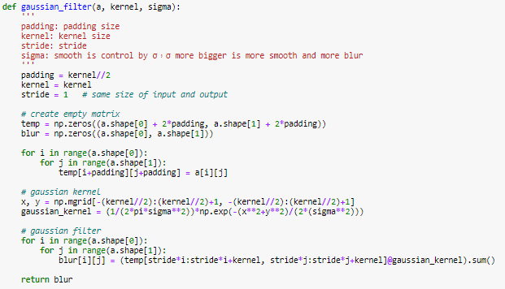

E. Laplacian filter

