**Introduction:**

I am a native of Hsinchu. Many people say that Hsinchu is a **desert of delicacy** and there are no tourist attractions in Hsinchu, but I strongly disagree, so I will use this assignment to share the food and beauty of Hsinchu that I know.

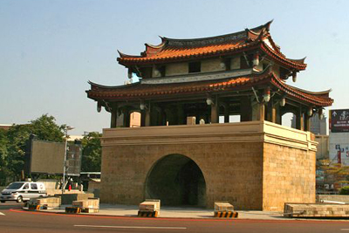

East door city(東門城)

**Task3: Use Hough transform to detect straight lines and cycles.**

A total of three tourist attractions images and three food image were used, and four image processing methods were used, namely:

1. Smoothing Filters
   1. Gaussian filter
2. Edge Detection
   1. Sobel Filters
   2. Threshold
3. Hough transform for lines
4. Hough transform for cycles

**Preprocessing:**

1. Load images

Use python matplotlib api load images，and change images to array.

|  |  |  |
| --- | --- | --- |
| Nanliao Fishing Port  Fish scale ladder(魚鱗天梯) | Hsinchu Xiangshan  Voice of the Sea(海之聲) | Hsinchu Zhubei  Tofu Rock(豆腐岩) |
| (阿富 魯肉飯) | (新美珍 布丁蛋糕) | C:\Users\user\AppData\Local\Microsoft\Windows\INetCache\Content.Word\meatball0.png  (石家魚丸) |

1. Image grayscale

Use **Y' = 0.299 R + 0.587 G + 0.114 B**，change images from 3-dimension to 1-dimension。

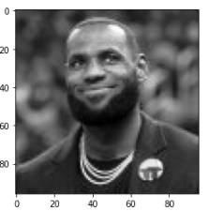 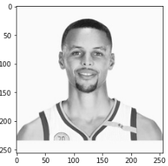 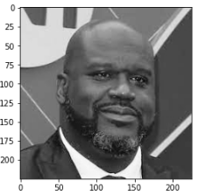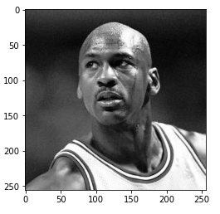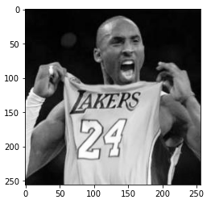

**Method detail**

1. Image Interpolation Methods

A. Nearest neighbor

I copy nearest neighbor matrix to enlarge images。The King LBJ can be the coffee shop sign canvas.

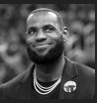 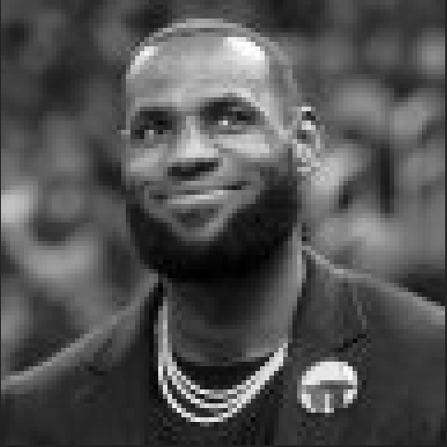

(origin) (n=5)

1. Intensity Transformations
   1. Gamma correction

Use s = c*r*gamma. In order to find evidence that curry is black, enhance contrast(just kidding). The gamma more higher, the people color more black.

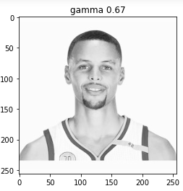 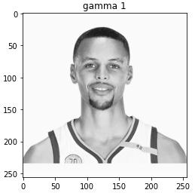 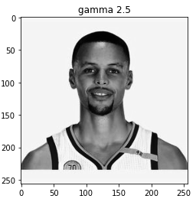 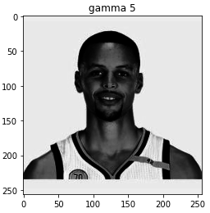

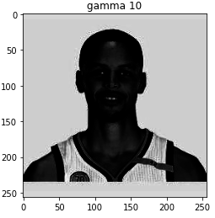

* 1. Histogram Equalization

Calculate probability density function(pdf). Then, accumulate probability of every grayscale to get cumulative distribution function(cdf). Finally, every grayscale cdf plus the total grayscale-1(256-1), then you can obtain the new grayscale.

ONeal is one of my favorite stars, rolling the NBA court with a tall and sturdy body.

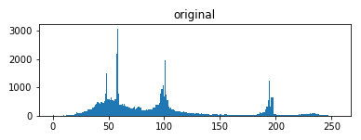 (origin grayscale histogram)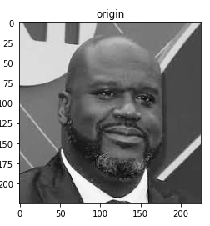 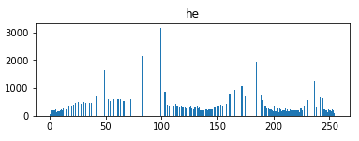(after he grayscale histogram)

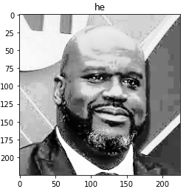

3. Contrast Enhancement for color images

A. Do it separately for the RBG channels by HE

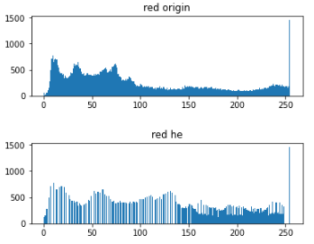(origin red v.s. after he red histogram))

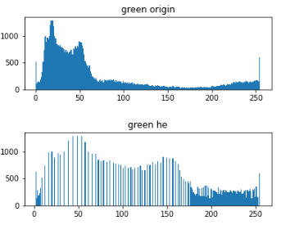(origin green v.s. after he green histogram))

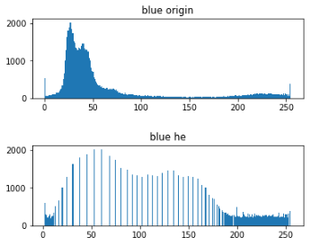(origin blue v.s. after he blue histogram))

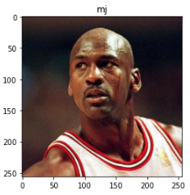 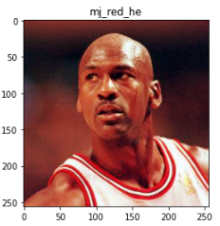

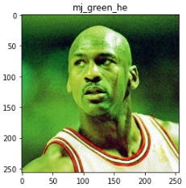 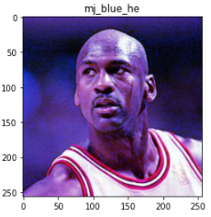

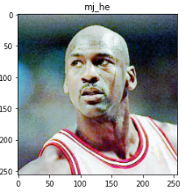

B. Do it separately for the RGB channels by gamma

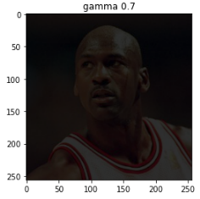 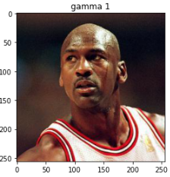

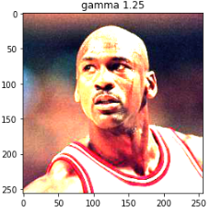 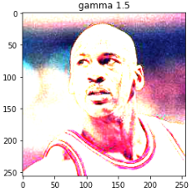

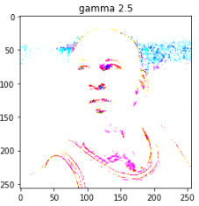

1. Smoothing Filters
   1. Box filter

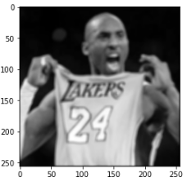(kernel=5)

* 1. Min\max filter

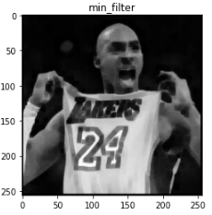(kernel=5) 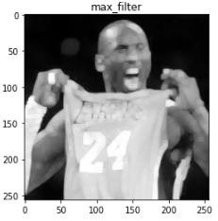(kernel=5)

* 1. Median filter

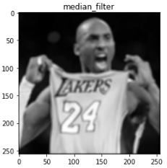(kernel=5)

* 1. Gaussian filter

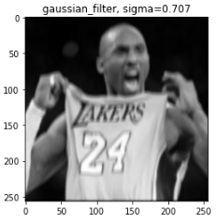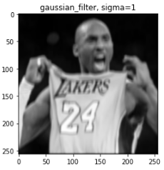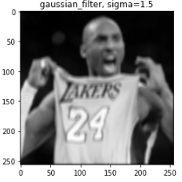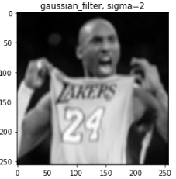

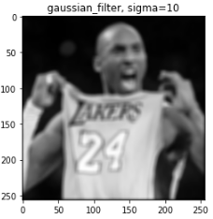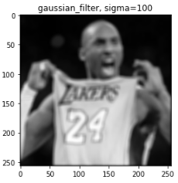

* 1. Laplacian filter

We can obtain contour obviously.

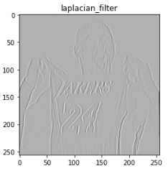

**Result**

First I use histogram equalization to enhance constrast.

Second I use min filter let image more roughly.

Then can get the coffee latte, like below images.

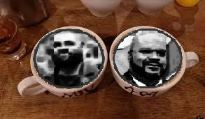

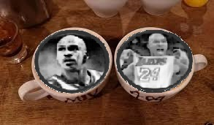

Code:

Image preprocessing

A. load images

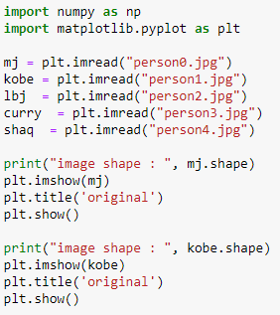

B. to gray

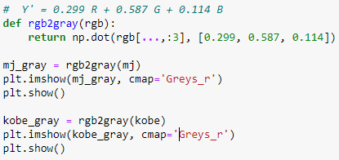

1. Image Interpolation Methods

A. Nearest Neighbor

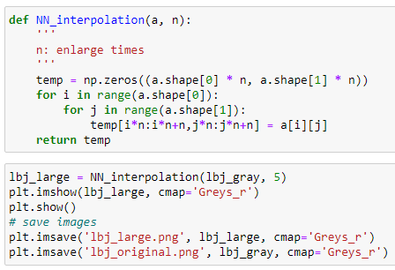

2. Intensity Transformations

A. Gamma correction

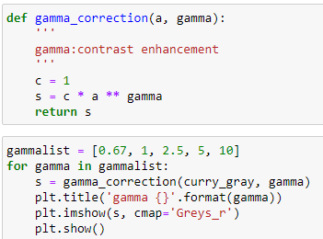

B. Histogram Equalization

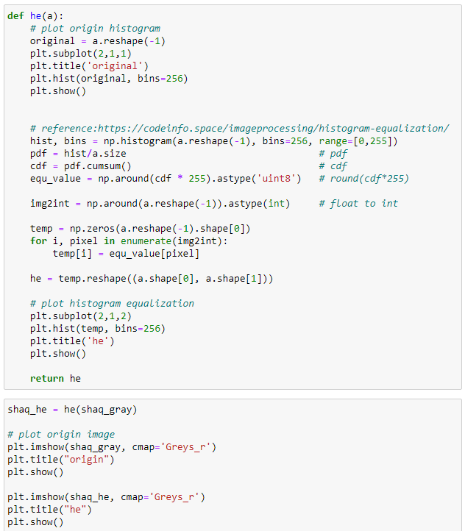

3. Contrast Enhancement for color images

A. Do it separately for the RBG channels by HE

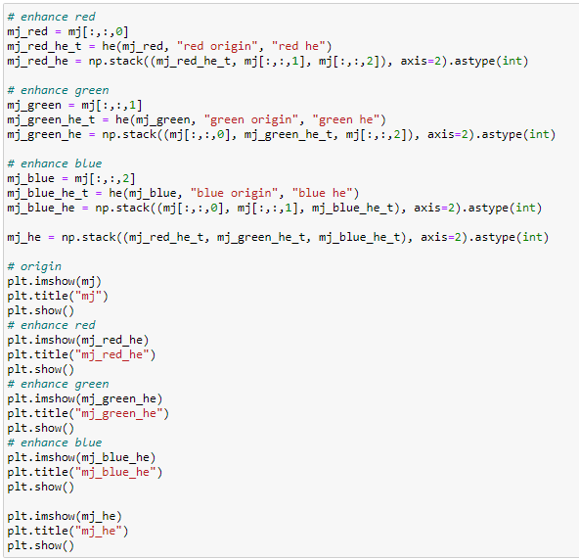

B. Do it separately for the RGB channels by gamma

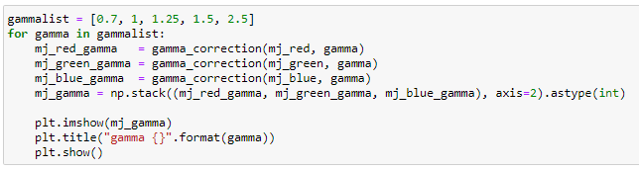

4. Smoothing Filters

A. Box filter

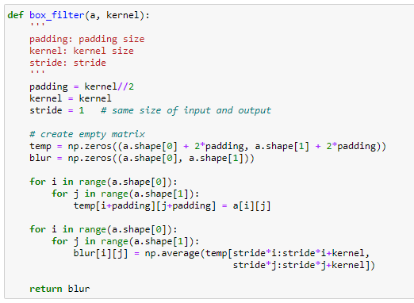

B. Min\max filter

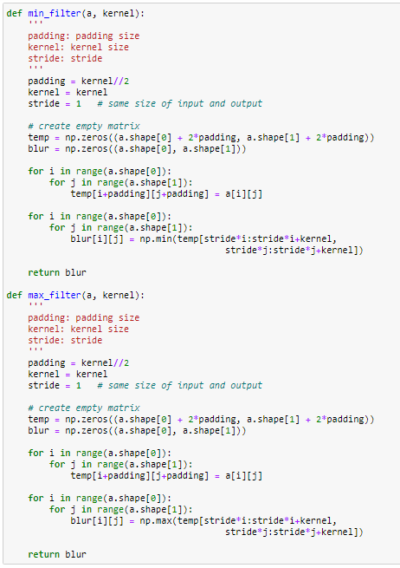

C. Median filter

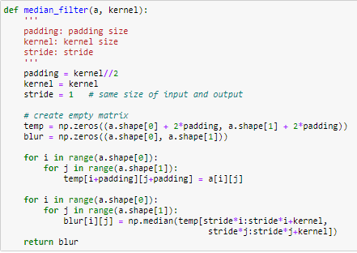

D. Gaussian filter

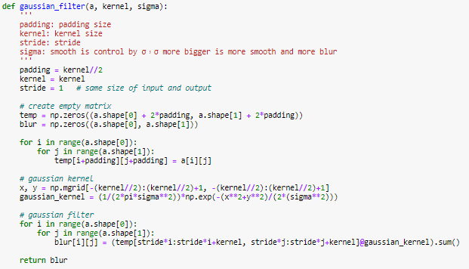

E. Laplacian filter

