**Introduction:**

I am currently planning to use a motorcycle to travel around Taiwan, and some seniors recommended the four-pole roundabout in Taiwan. During this round of the island, I hope to help raise funds for the Hsinchu Family Support Center([新竹家扶中心](https://www.facebook.com/ccf.shinchu/)), so that children can have a better quality of life and education.

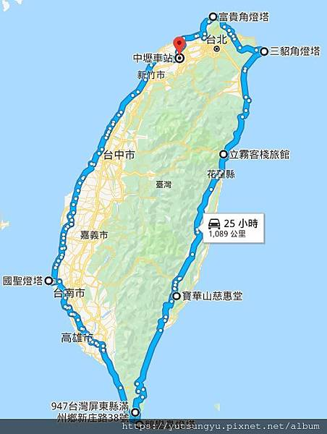

**Task: The objective of this assignment is for you to experiment with the various components of a JPEG codec. Your implementation should include both an encoder and a decoder.**

A total of four-pole roundabout in Taiwan images were used, and jpeg Encoder、Decoder and Mse methods were used, namely:

1. Encoder

A. Image read & resize & Block

B. Quantized

C. ZigZag

D. Run length encode

E. Huffman

F. Store

1. Decoder

A. Read encoded file & De-Huffman & Run length decode

B. ZigZag

C. Quantized

1. Mse

**Result:**

|  |  |  |  |
| --- | --- | --- | --- |
|  | **Original image** | **Decode image** | **Mse** |
| **North** | **C:\Users\user\AppData\Local\Microsoft\Windows\INetCache\Content.Word\north_original.jpg** | **C:\Users\user\AppData\Local\Microsoft\Windows\INetCache\Content.Word\north_decoder.jpg** | **381.27** |
| **East** |  |  | **362.14** |
| **South** |  |  | **225.25** |
| **West** |  |  | **549.42** |

**The main steps**:

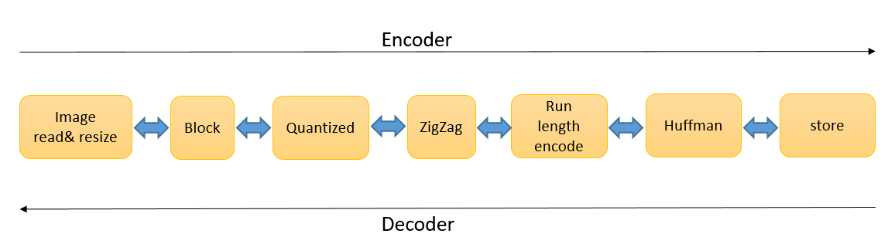

**Code:**

1. Encoder

A. Image read & resize & Block

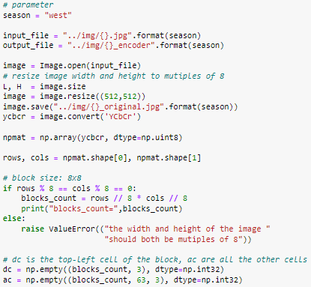

B. Quantized



C. ZigZag



D. Run length encode

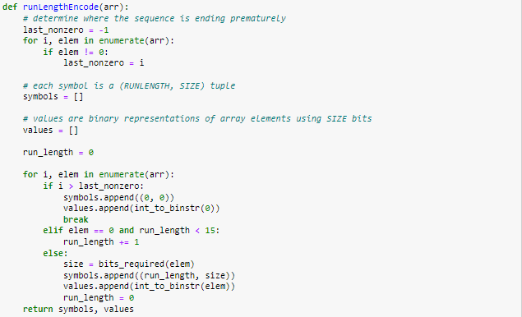

E. Huffman

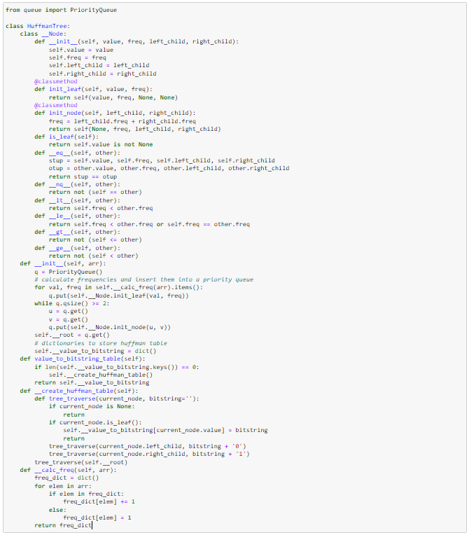

F. Store

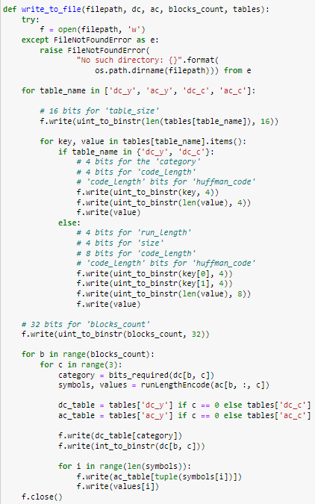

1. Decoder

A. Read encoded file & De-Huffman & Run length decode

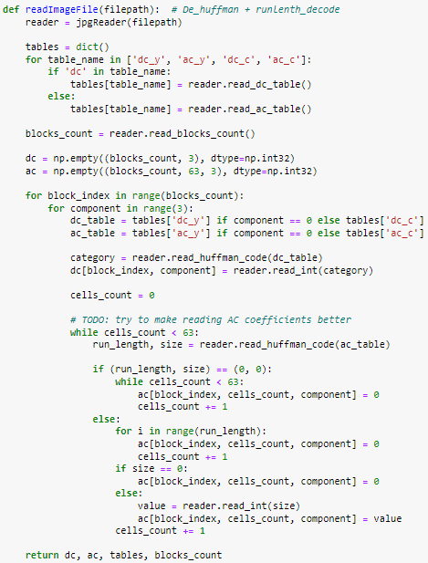

B. ZigZag

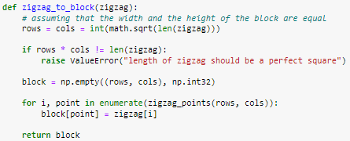

C. Quantized



1. Mse

