The Final Exam of Network Programming (2015-1)

January 7th, 2016

(Total: 110 points)

# (5%) Explain the key idea of effective *user IDs* in UNIX.

# 略

1. (4%) For the following program segment, indicate where the problem is and how to fix it.

int flag =0

mychld() ( flag = 1,

main() ( ..., signal(SIGCHLD, mychld), ...}

for(„) {

sigblock(sigmask(SIGINT));

while(f1ag==0)

sigpause(0);

//pause();

// when each child process finishes, process it here.

1. (18%) Write a simple and short program (named wrapper) for the following:
   1. create three *child* processes p1, p2 and error_hand1er,
   2. forward stdin(or 0) messages of wrapper to stdin(or 0) of pl,
   3. forward stdout (or 1) of p1 to stdin (or 0) of p2,
   4. forward stdout (or 1) of p2 back to wrapps er’stdout (or 1),t
   5. forsward stderr (or 2) of both pl and p2 to error_handler’s stdin (or 0), and
   6. forward stdout (or 1) of error_handler back to wrapper’s stdout (or 1).
   7. forward stderr (or 2) of error_handler back to wrapper’s stderr (or 2).

???

1. (18%) Write a simple and short program (named test) for the single process concurrent server doing this: All messages from clients are broadcast to all clients. (Assume that the connectTCP and passiveTCP functions are provided.)

???

5. (6%) In the expiration model of HTTP, describe the method of calculating the age of an object and the principle behind it.

略

6. (16%) In Apache, it can be configured to support pre-al1ocation and fastcgi. (a) Explain what pre-al1ocation is. (b) Explain what FastCGI is. (c) Describe how both work together in UNIX. Hint: for (a) and (b), also describe their advantages; for (c) need to illustrate.

(6%) Explain what is ine t d in UNIX. Describe how it works, why it is important iIl UNIX, and

how it is related to firewalls.

(a)略

(b)略

(c) FastCGI可以預先開好worker，這樣master分配工作時，worker可以直接開始工作。

1. (8%) For each of the following four firewall architecture s, indicate whether it is safe and explain the reason.

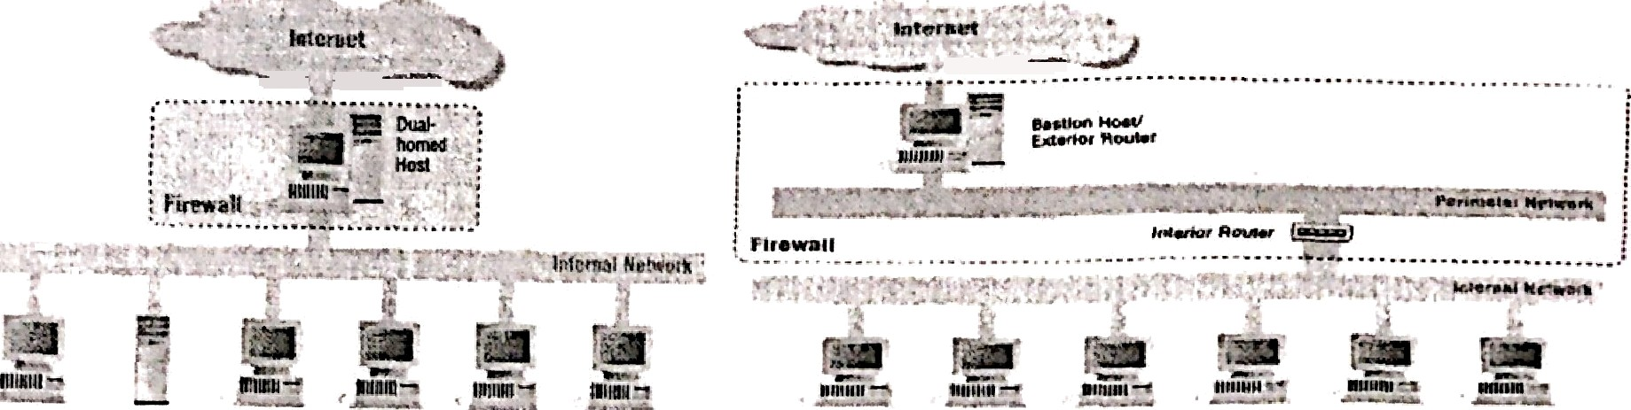

* 1. p)

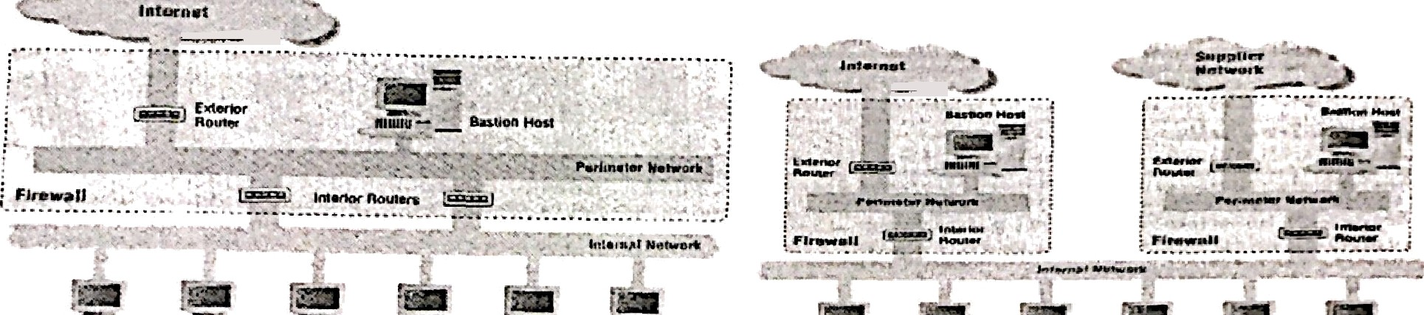

“""- •.".!''* ""” . p!,!!'! _ . , , „_, ;Bii' kfi, _ eeU»w c•U. *•Zii ,

(c) (d) ’*

.

9. (10%) In a *standard* firewall, if we want to allow outbound ftp connections only, how do you

design your proxy servers in DMZ and how do you change FTP clients to allow ftp services

# with passive mode? Also, design your policy setting table for the interior routers.

# ????

10. *(5%)* If a mail system supports “piping” in the fields of “To” and “From” without any protection,

design a simple way to attack the system and explain the reason.

可以在信件中加入惡意程式碼，當用戶開啟信件時就執行惡意程式碼，例如刪除用戶全部資料等等。

1. (6%) For an NAT, assume that it is Cone NAT as described in the class. Briefly describe now to do UDP hole punching on the NAT.

略

1. (8%) For SUN RPC, let the server netprog.csie.nctu.edu.tw have a RPC process including: registerrpc(MYSERVER=5, MYVER SION=2, PROCEDURE=1, funcA, ...); svc_run();

the client on student 1.csie.nctu.edu.tw have the following actions: callrpc(“netprog.csie.nctu.edu.tw”, MYSERVER=5, MYVERSION=2,PROCEDURE=l,…);

Please explain how the above functions works with Portmapper. Please use a flow chart to illustrate the work of each function.

1. 服務器調用函數“registerrpc”以使用給定的 MYSERVER 和 MYVERSION 參數註冊一個新的 RPC 進程。此函數向 Portmapper 發送請求以註冊 RPC 進程。
2. Portmapper 接收請求並將有關 RPC 進程的信息存儲在其數據庫中。
3. 客戶端調用函數“callrpc”向服務器發起RPC請求。此函數向 Portmapper 發送請求，以查找服務器上 RPC 進程的地址。
4. Portmapper 收到請求並在其數據庫中查找 RPC 進程的地址。
5. Portmapper 將 RPC 進程的地址返回給客戶端。
6. 客戶端使用從 Portmapper 獲得的地址向服務器發送 RPC 請求。
7. 服務器接收到 RPC 請求並使用“svc_run”函數對其進行處理。該函數處理請求並將結果返回給客戶端。
8. 客戶端收到 RPC 請求的結果並繼續處理。