Sample of the Final Exam of Network Programming

- (6%) For the following program, please indicate what are in (a) program text, (b) initialized read-only data, (c) initialized read-write data, (d) uninitialized data, (e) heap, (f) stack, in UNIX.
int limit = 5;
char **strs;
int main(int argc, char *argv[]) {
int i;
strs = malloc(sizeof(char*) * argc);
for (i=0; i<argc; i++) {
strs[i] = malloc(strlen(argv[i]) + 1);
strcpy(str[i], argv[i]);
if(i <= limit)
printf("%s\n",str[i]);
}
}
- (5%) For the following program segment, indicate where the problem is and how to fix it.
...
int flag =0;
...
mychld() { flag = 1; }
...
main() { ...; signal(SIGCHLD, mychld); ...}
...
for(;;) {
while(flag==0)
pause();
// when each child process finishes, process it here.
...
}
...
- (8%) Explain the key idea of effective user IDs in UNIX. Assume that you need to write a CGI program to update a system database with root privilege. How would you use effective user IDs to solve the problem?
- (4%) Explain how copy-on-write is used to implement fork. Describe the advantages and disadvantages of using copy-on-write.

- (10%) For the following code:
using namespace std;
using namespace boost::asio;
array<char, 2018> data;
io_service global_io_service;
ip::tcp::socket accept_socket(global_io_service);
ip::tcp::endpoint ep(ip::tcp::v4(), 8888);
ip::tcp::acceptor acceptor(global_io_service, ep);
void write_handler(boost::system::error_code ec, size_t length) {
cout << "write_handler end with size " << length << endl;
}
void read_handler(boost::system::error_code ec, size_t length) {
async_write(accept_socket, buffer(data, length), write_handler);
cout << "read_handler end with size " << length << endl;
}
void accept_handler(boost::system::error_code) {
accept_socket.async_read_some(buffer(data), read_handler);
cout << "accept_handler end" << endl;
}
int main() {
acceptor.async_accept(accept_socket, accept_handler);
global_io_service.run();
return 0;
}
Assume that after running the program, a user first connects to it and sends a message “Hello”.
- What is the output (stdout) of this program?
- Draw the call stack of this program when it is executing the cout in write_handler. (You only need to consider main, io_service.run, *_handler)
- Under what situation will global_io_service.run() terminate under normal conditions? (Do not consider the program being interrupted or killed.)
- (14%) Write a simple INETD program whose configuration file is as follows.
# sample for /etc/inetd.conf
telnet stream tcp nowait root /usr/sbin/tcpd in.telnetd
shell stream tcp nowait root /usr/sbin/tcpd in.rshd
login stream tcp nowait root /usr/sbin/tcpd in.rlogind
Hint: assume (a) line(i).field(j) indicate the j’th token in line i, e.g., line(3).field(0) is “login”, (b) for the last line, line(i).field(j) is null, e.g., line(4).field(0) is null, (c) you can ignore “stream”, “nowait”, “root”, directly use passivesock, with parameters service (column 1) and protocol (column 3) to create connection, and execute the code (column 6) with arguments (all after column 7).
- (7%) In the expiration model of HTTP, how can HTTP guarantee that a stored object does not exceed the expiration date in all proxies and clients?
- (4%) A file system named NFS (Network File System) is based on the pre-allocation model. Describe how pre-allocation works in UNIX. Explain why it works in this way, and how it helps file systems in local area networks.
- (4%) In Apache, it can be configured to support fastcgi. Explain and illustrate what FastCGI is, and how it works in UNIX.
- (8%) For each of the following four firewall architectures, indicate whether it is safe and explain the reason.
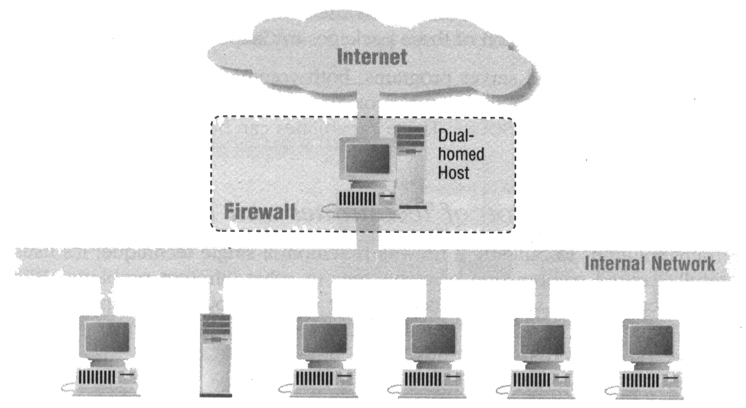 | 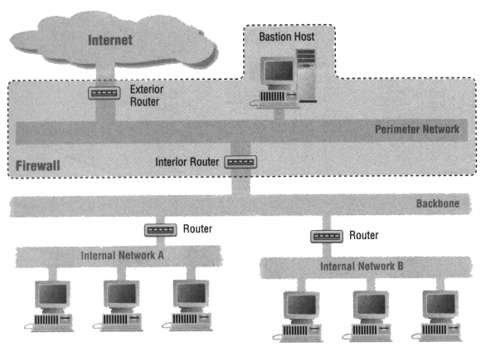
(a) | (b)
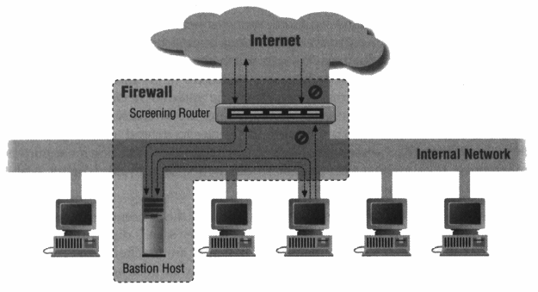 | 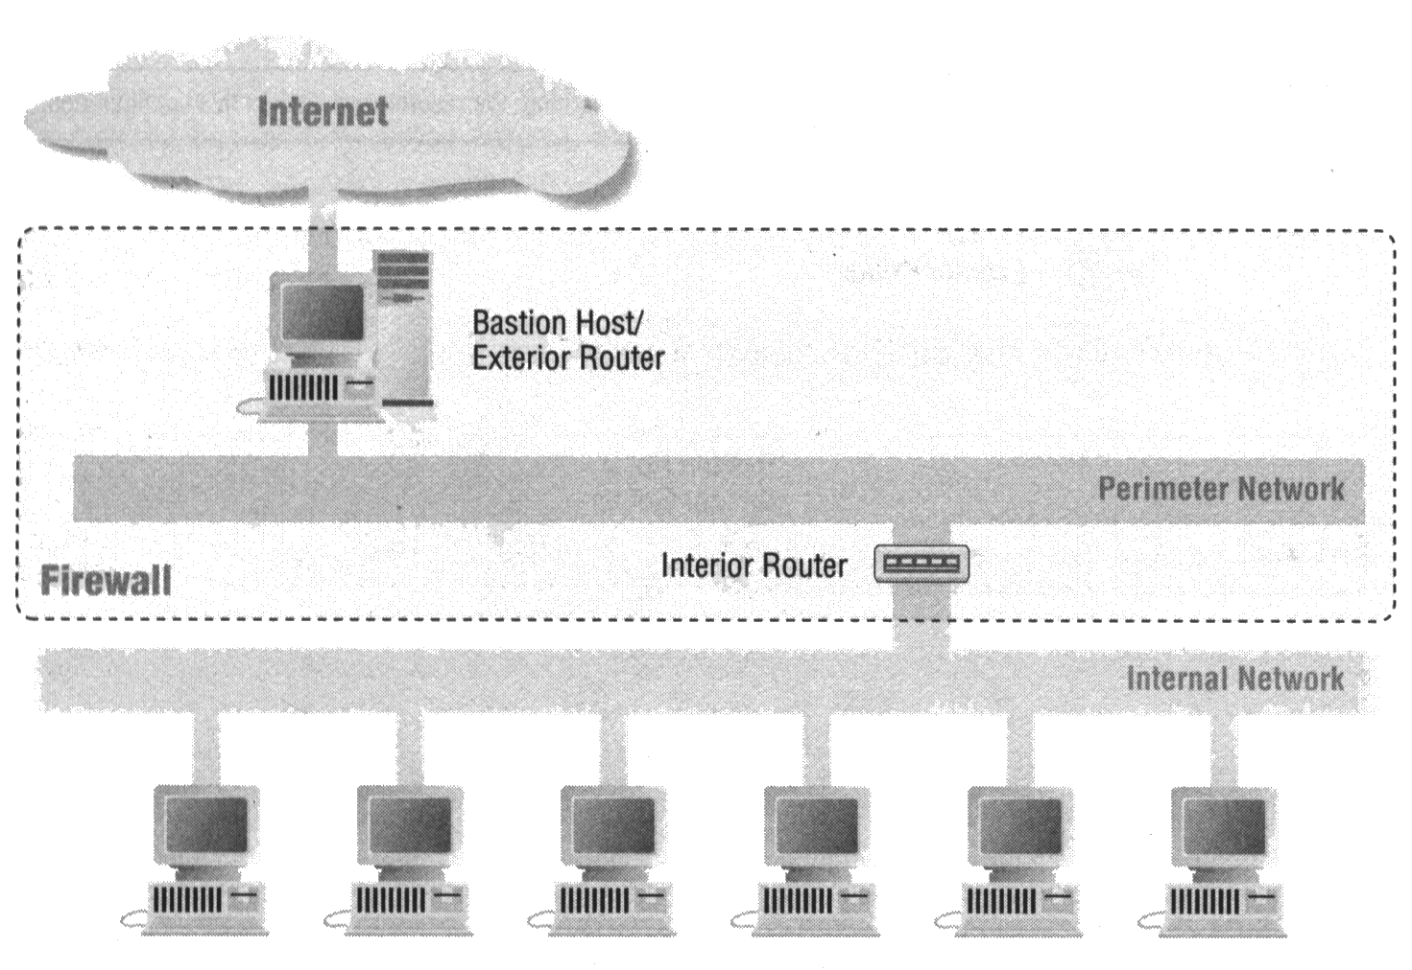
(c) | (d)
- (8%) Now, we want to design a firewall as the one with DMZ described in the class. If we want to allow outbound telnet connections and allow both inbound and outbound SMTP connections between bastion SMTP server S1 and internal SMTP server S2, design your policy setting table for the interior routers. (The port of SMTP service is 25.)
- (8%) For an NAT, assume that it is Cone NAT as described in the class. Briefly describe how to do UDP hole punching on the NAT.
- (6%) Describe how WebSocket can prevent hackers from scanning hosts inside intranets.

