Type your answers. Your solutions will be graded on correctness, elegance, clarity and originality. Please note that the work handed in must be your own.

**Short Answer Questions**

*Answer the following questions. Your answers should be concise; aim for two or three sentences.*

* What common programming language statement, in your opinion, is most detrimental to readability? Explain why.

**If there is one thing, I would consider detrimental to the readability of a language, it would be the if-else statements, or the conditional statements. Creating complex lines of code require things like loops, if statements, switch statements, etc., and if these are unreadable, then it is extremely difficult to make something useful out of the code. Having conditional statements be readable to the user is extremely important if you hope to make something major out of the language being used.**

* Java uses a right brace to mark the end of all compound statements. What are the arguments for and against this design?

**The strength of using this method of ending code is that it is simple to do. Almost all IDE’s will close the pair of braces on its own so that you do not need to worry about it when typing your code and since it is just a right brace, it is really simple to remember. The weakness, however, is that when you begin creating advanced code, nested conditional statements and extremely long lines of code start to appear and it is extremely difficult to keep track of one right brace when there are hundreds of them.**

* Write three fundamental features of C++ language.

**One feature that is what makes C++ so popular is that is an object-orientated language which allows the creation and destruction of objects and has concepts like polymorphism, inheritance and abstraction which allows it to be known as a high-level language. The second fundamental feature is that it is machine independent, which means that you can transfer code from one machine environment to another and the code will work in the same way. The third feature is that it is simple, which means that learning it, or creating code with this language is not difficult at all and if something is needed that the current library does not have, C++ offers a variety of libraries to use**.

* Write two language design criteria and explain why they are in direct conflict with each other.

**The two most common language design criteria that are always in conflict with each other are reliability and the cost of execution. The reason being is because when checking something in a certain language’s code, it increases the execution time but is reliable. The same can be said about the latter, if the language did not check for errors, the cost of the code will be low and the reliability of the code would be low as will.**

* Consider the following grammar G1 for simple English sentences:

< sentence > $→$ < subject > < predicate >

< subject > $→$ < noun_phrase >

< predicate > $→$ < verb > < noun_phrase >

< noun_phrase > $→$ < noun > | < article > < noun >

< noun > $→$ jack | jill | ball

< verb > $→$ threw | saw

< article > a | the

* 1. Write five syntactically correct sentences generated by G1.

1. **The jill threw a ball**
2. **jack saw ball**
3. **Jack saw a jill**
4. **a jack saw a ball**
5. **Jill threw ball**
   1. Is the sentence “jack threw a jill” syntactically correct by G1? If so, show a left most derivation or parse tree for it.

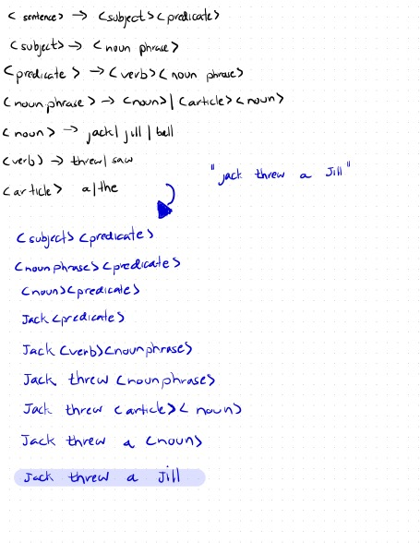 **Yes it is.**