- Introduction
In today’s competitive manufacturing environment, efficiency, accuracy, and timely decision-making are critical for maintaining a competitive edge. Enterprise Resource Planning (ERP) systems integrate various business processes into a unified platform, enabling organizations to streamline operations, optimize resources, and improve overall productivity.
This project focuses on the design and development of an ERP system tailored for manufacturing operations. The system aims to integrate key modules such as inventory management, production planning, procurement, sales, human resources, and financial management into a centralized platform. By consolidating these functions, the ERP system ensures real-time data flow between departments, reduces duplication of effort, and enhances coordination across the organization.
The implementation of an ERP system in manufacturing not only improves operational efficiency but also provides valuable insights through data analytics, enabling managers to make informed strategic decisions. This project emphasizes scalability, usability, and adaptability to suit different manufacturing processes, ensuring that the system remains relevant as business needs evolve.

- Objectives
- To integrate manufacturing operations by connecting production, inventory, procurement, sales, and finance in a centralized platform
- To enable real-time information flow for better coordination and reduced delays
- To optimize resource utilization through improved planning, scheduling, and inventory control
- To increase data accuracy by automating processes and standardizing data entry
- To support decision-making with analytical reports and interactive dashboards
- To enhance scalability so the system can adapt to business growth and changing requirements
- To reduce operational costs by streamlining workflows and minimizing waste

- Requirements Specifications
3.1 Functional Requirements
- FR-01 — Create budget
- Requirement: The system shall allow creating a budget with name, time period, and allocated amount.
- Priority: High
- Inputs: Budget name, period, allocated amount
- Output: Budget record
- Acceptance: Given valid inputs, when submitted, then budget is stored and visible in budget list.
- FR-02 — Compare budget vs actual
- Requirement: The system shall allow comparing budgeted vs actual values for a selected period.
- Priority: High
- Acceptance: Given budget and actual data exist, when comparison requested, then variance report is generated accurately.
- FR-03 — Financial forecast
- Requirement: The system shall generate financial forecasts based on historical sales, income, and expenses.
- Priority: High
- Acceptance: Given historical data exists, when forecast requested, then predicted values displayed with summary chart.

- FR-04 — Add invoice
- Requirement: The system shall allow creating an invoice with invoice number, customer, items, quantity, unit price, tax, discount, and total.
- Priority: High
- Input: Customer, items, quantity, price, tax, discount
- Outputs: Invoice record
- Acceptance: Given valid inputs, when saved, then invoice record exists and can be viewed or exported.
- FR-05 — Edit invoice
- Requirement: The system shall allow editing existing invoices.
- Priority: High
- Acceptance: Given invoice exists, when edits saved, then DB updated and invoice totals recalculated.
- FR-07 — Search invoice
- Requirement: The system shall allow searching invoices by ID, customer, or date.
- Priority: High
- Acceptance: Given invoices exist, when search is performed, then results match query and returned within 2 seconds.
- FR-08 — Add income
- Requirement: The system shall allow creating income entries with source, amount, date, and optional linked sale.
- Priority: Medium
- Inputs: Source, amount, date, optional saleID
- Outputs: Income record
- Acceptance: Given valid data, when saved, then income record exists, and totals reconcile.

- FR-09 — Edit income
- Requirement: The system shall allow editing existing income records.
- Priority: Medium
- Acceptance: Given income exists, when edits saved, then DB updated.
- FR-10 — Remove income
- Requirement: The system shall allow deleting an income record.
- Priority: Medium
- Acceptance: Given income exists, when deleted, then record removed or marked inactive.
- FR-11 — Search income
- Requirement: The system shall allow search income by source, date, or linked sale.
- Priority: Medium
- Acceptance: Given income records exist, when search performed, then results match query ≤2s.
- FR-12 — Manage income categories
- Requirement: The system shall allow creating and deleting income categories.
- Priority: Medium
- Acceptance: Given valid category, when added/deleted, then category list updated and reflected in income entry forms.

- FR-13 — Add expenses
- Requirement: The system shall allow creating expense entries with category, amount, date, payee, and optional receipt attachment.
- Priority: Medium
- Inputs: Category, amount, date, payee, optional receipt
- Outputs: Expense record
- Acceptance: Given valid data, when saved, then expense record exists and totals reconcile.
- FR-14 — Edit expense
- Requirement: The system shall allow editing existing expense records.
- Priority: Medium
- Acceptance: Given expenses exist, when saved, then DB updated.
- FR-15 — Remove expense
- Requirement: The system shall allow deleting an expense record.
- Priority: Medium
- Acceptance: Given expense exists, when deleted, then record removed or marked inactive.
- FR-16 — Search expense
- Requirement: The system shall allow search expenses by category, date, or payments.
- Priority: Medium
- Acceptance: Given expense records exist, when search is performed, then results match query ≤2s.
- FR-17 — Manage expense categories
- Requirement: The system shall allow creating and deleting expense categories.
- Priority: Medium
- Acceptance: Given valid category, when added/deleted, then category list updated and reflected in expense entry forms.
- FR-18 — Generate reports
- Requirement: The system shall generate reports (sales, purchase, product, customer, financial) with export to PDF/Excel.
- Priority: High
- Acceptance: Given report data exists, when report generated, then file downloads in ≤10s and matches DB totals.
- FR-19 — Add employee
- Requirement: The system shall allow creating employee records with employeeID, name, role, and contact info.
- Priority: Medium
- Acceptance: Given valid inputs, when saved, then employee record exists and role mapping created.
- FR-20 — Edit employee
- Requirement: The system shall allow editing employee records.
- Priority: Medium
- Acceptance: Given employee exists, when saved, then DB updated.
- FR-21 — Search employee
- Requirement: The system shall allow searching employees by name, ID, or role.
- Priority: Medium
- Acceptance: Given employee records exist when search performed, then results match query ≤2s.
- FR-22 — Add sales
- Requirement: The system shall allow creating sales transaction with customers, products, quantity, price, tax, discount, total, and payment status.
- Priority: High
- Acceptance: Given valid sale, when saved, then DB updated, inventory reduced, and invoice generated.
- FR-23 — Edit sale
- Requirement: The system shall allow editing sales transactions.
- Priority: High
- Acceptance: Given sale exists, when saved, then DB updated and totals recalculated.
- FR-24 — Search sales
- Requirement: The system shall allow searching sales by saleID, customer, or date.
- Priority: High
- Acceptance: Given sales exist, when search performed, then results match query ≤2s.
- FR-25 — Add customer (Sales staff)
- Requirement: The system shall allow creating customer records with unique ID, name, phone, email, address, and status.
- Priority: High
- Acceptance: Given valid inputs, when saved, then customer record exists and contact info validated.
- FR-26 — Edit customer (Sales staff)
- Requirement: The system shall allow editing customer records.
- Priority: High
- Acceptance: Given customer exists, when saved, then DB updated.
- FR-27 — Search customer (Sales staff)
- Requirement: The system shall allow searching customers by name/ID/status.
- Priority: High
- Acceptance: Given customers exist, when search performed, then results match query ≤2s.

- FR-28 — Add product
- Requirement: The system shall allow creating product records with productID, name, price, stock, and category.
- Priority: High
- Acceptance: Given valid inputs, when saved, then product record exists.
- FR-29 — Edit product
- Requirement: The system shall allow editing product records.
- Priority: High
- Acceptance: Given product exists, when saved, then DB updated.
- FR-30 — Search product
- Requirement: The system shall allow searching products by name, ID, or category.
- Priority: High
- Acceptance: Given products exist, when search performed, then results match query ≤2s.

  - Non-Functional Requirements
- NFR-01 — Performance
- Requirement: The system shall respond to all user actions (search, save, edit) within ≤ 2 seconds for 95% of requests.
- Priority: High
- Acceptance: Measured with load testing under 100 concurrent users, response times ≤ 2s.
- NFR-02 — Scalability
- Requirement: The system shall support scaling to at least 500 concurrent users without performance degradation.
- Priority: Medium
- Acceptance: Verified by stress/load test with 500 users maintaining ≤ 3s response.
- NFR-03 — Availability
- Requirement: The system shall provide 99.5% uptime during business hours.
- Priority: High
- Acceptance: Uptime monitored via server logs and monitoring tools.
- NFR-04 — Security
- Requirement: The system shall require authentications for all users and role-based access for sensitive functions (e.g., financial data).
- Priority: High
- Acceptance: Penetration test confirms access controls and no unauthorized data access.

- NFR-05 — Data Integrity
- Requirement: The system shall ensure no data loss or corruption occurs during CRUD operations or system failures.
- Priority: High
- Acceptance: Verified through transaction rollback tests and DB consistency checks.
- NFR-06 — Usability
- Requirement: The system shall provide an intuitive UI with ≤ 3 steps for major tasks (e.g., add invoice, generate report).
- Priority: Medium
- Acceptance: User testing confirms ≥ 80% success rate on first attempt without training.
- NFR-07 — Maintainability
- Requirement: The system should be modular, with well-documented code and API for easy maintenance and extension.
- Priority: Medium
- Acceptance: Code review ensures documentation and adherence to coding standards.
- NFR-08 — Reliability
- Requirement: The system shall handle unexpected crashes gracefully and recover without data loss.
- Priority: High
- Acceptance: Verified by simulated crash tests and recovery logs.

- Use Case Diagram
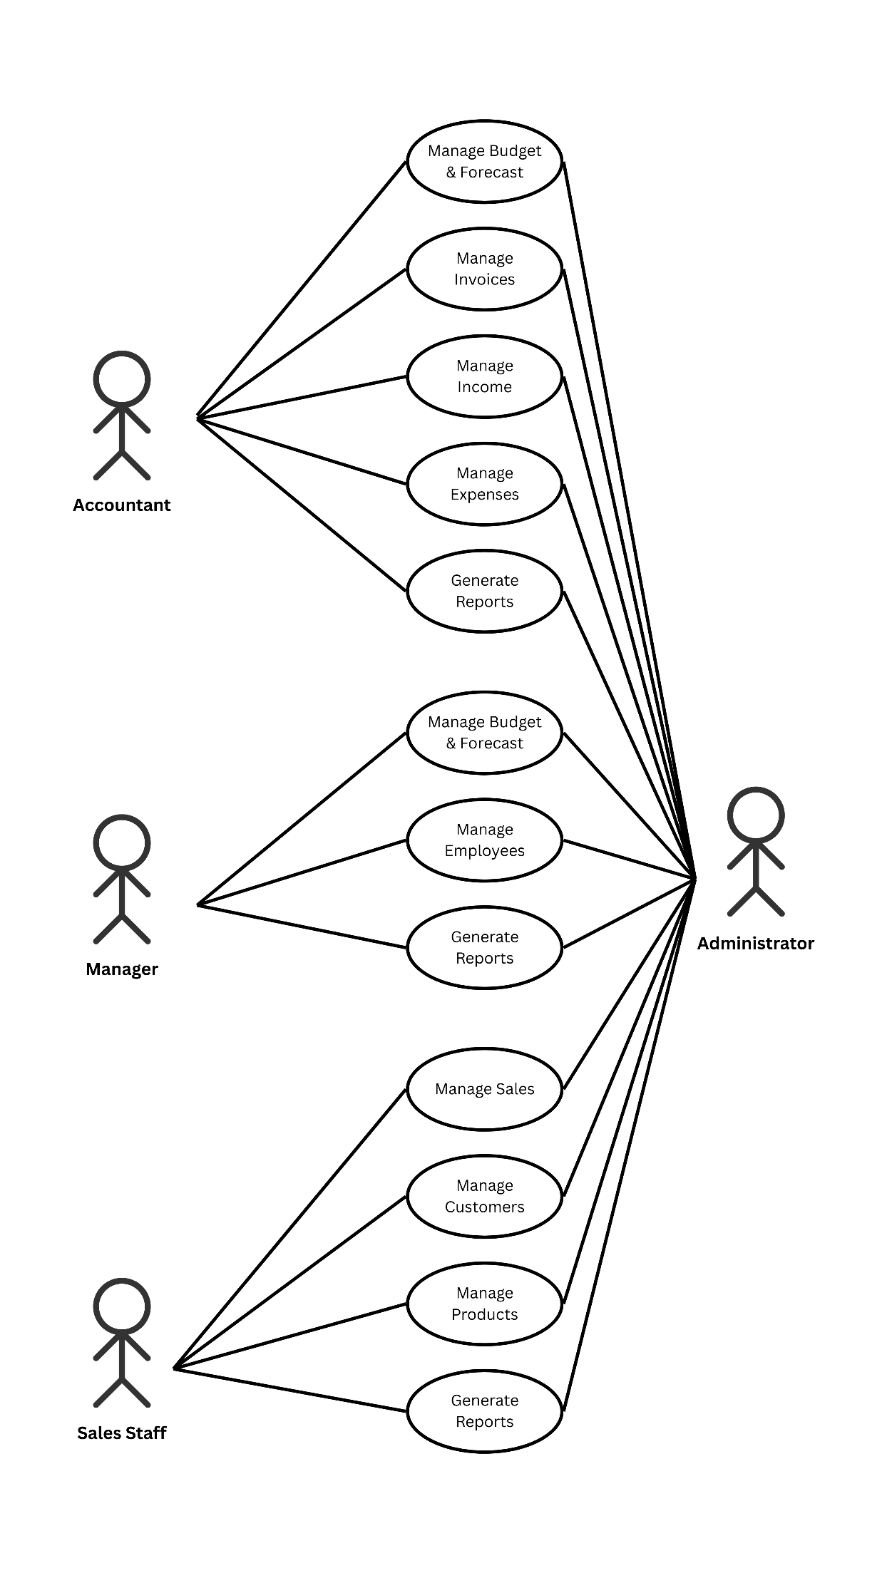

- Text Description for Use Case Diagram
Table (6.1) Use Case: Manage Budget & Forecast
Actions performed by the actor | Responses from the system
1. The user selects the option to manage budget & forecast | 2. The system prompts the user to enter budget details (period, categories, expected amounts)
3. The user creates or updates a financial forecast | 4. The system stores the forecast, compares it with past data, and generates summary insights
5. The user requests a comparison report | 6. The system displays forecast vs. actual financial results

Table (6.2) Use Case: Manage Invoices
Actions performed by the actor | Responses from the system
1. The user selects the invoice management option | 2. The system provides options to add, edit, remove, or search invoices
3. The user adds or edits invoice details (customer, amount, due date) | 4. The system validates and saves the invoice
5. The user searches or removes an invoice | 6. The system retrieves or deletes the invoice and confirms the action

Table (6.3) Use Case: Manage Income
Actions performed by the actor | Responses from the system
1. The user selects the income management option | 2. The system provides options to add, edit, remove, or search income records
3. The user enters income details (amount, category, source, date) | 4. The system validates, categorizes, and stores the data
5. The user searches, edits, or removes a record | 6. The system retrieves, updates, or deletes the income record

Table (6.4) Use Case: Manage Expenses
Actions performed by the actor | Responses from the system
1. The user selects the expense management option | 2. The system provides options to add, edit, remove, or search expenses
3. The user enters expense details (amount, category, vendor, date) | 4. The system validates, categorizes, and stores the data
5. The user searches, edits, or removes an expense | 6. The system retrieves, updates, or deletes the expense record

Table (6.5) Use Case: Generate Reports
Actions performed by the actor | Responses from the system
1. The user selects the report generation option | 2. The system provides options for different reports (sales, purchase, product, customer, financial)
3. The user requests a specific report | 4. The system fetches relevant data and generates the report
5. The user views or downloads the report | 6. The system presents the report in the requested format (screen, PDF, Excel)

Table (6.6) Use Case: Manage Employees
Actions performed by the actor | Responses from the system
1. The user selects the employee management option | 2. The system provides options to add, edit, or search employee records
3. The user enters employee details (name, position, salary, contact info) | 4. The system validates and stores the employee data
5. The user searches or edits employee information | 6. The system retrieves or updates the employee record

- Domain Modeling

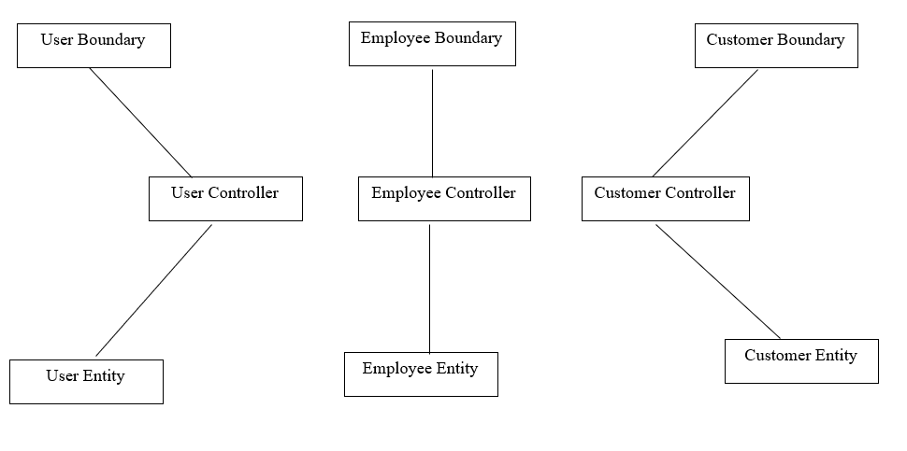
Figure (7.1)

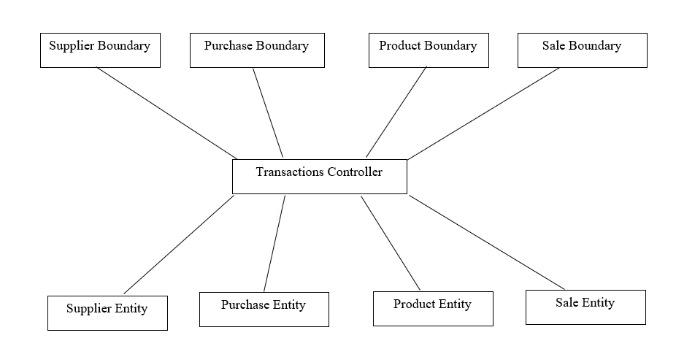

Figure (7.2)

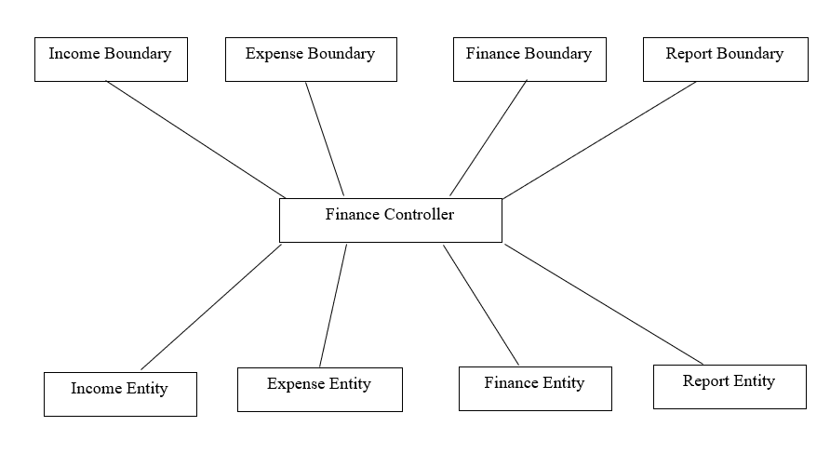
Figure (7.3)

8. Interaction Modeling

