**Exploratory Data Analysis with Chocolate Rating¶**

**Analysing the dataset of**[**Chocolate Bar Ratings**](https://www.kaggle.com/rtatman/chocolate-bar-ratings)**to unearth key insights hidden within the data¶**

**Context**

Chocolate is one of the most popular candies in the world. Each year, residents of the United States collectively eat more than 2.8 billions pounds. However, not all chocolate bars are created equal! This dataset contains expert ratings of over 1,700 individual chocolate bars, along with information on their regional origin, percentage of cocoa, the variety of chocolate bean used and where the beans were grown.

**Flavors of Cacao Rating System:**

* 5= Elite (Transcending beyond the ordinary limits)
* 4= Premium (Superior flavor development, character and style)
* 3= Satisfactory(3.0) to praiseworthy(3.75) (well made with special qualities)
* 2= Disappointing (Passable but contains at least one significant flaw)
* 1= Unpleasant (mostly unpalatable)

Each chocolate is evaluated from a combination of both objective qualities and subjective interpretation. A rating here only represents an experience with one bar from one batch. Batch numbers, vintages and review dates are included in the database when known.

The database is narrowly focused on plain dark chocolate with an aim of appreciating the flavors of the cacao when made into chocolate. The ratings do not reflect health benefits, social missions, or organic status. Flavor is the most important component of the Flavors of Cacao ratings. Diversity, balance, intensity and purity of flavors are all considered. It is possible for a straight forward single note chocolate to rate as high as a complex flavor profile that changes throughout. Genetics, terroir, post harvest techniques, processing and storage can all be discussed when considering the flavor component.

Texture has a great impact on the overall experience and it is also possible for texture related issues to impact flavor. It is a good way to evaluate the makers vision, attention to detail and level of proficiency. Aftermelt is the experience after the chocolate has melted. Higher quality chocolate will linger and be long lasting and enjoyable. Since the aftermelt is the last impression you get from the chocolate, it receives equal importance in the overall rating.

Overall Opinion is really where the ratings reflect a subjective opinion. Ideally it is my evaluation of whether or not the components above worked together and an opinion on the flavor development, character and style. It is also here where each chocolate can usually be summarized by the most prominent impressions that you would remember about each chocolate.

**Acknowledgements**

These ratings were compiled by Brady Brelinski, Founding Member of the Manhattan Chocolate Society. Kindly visit[Flavors of Cacao](http://flavorsofcacao.com/index.html) for updated dataset.

**Hypothesis**

Over time, there has been a correlation between cocoa ratings and the proportion of cocoa in a chocolate bar, as the quality of cocoa beans and chocolate bars has improved.

**Hypothetical Questions.**

* Which countries produces the best cocoa beans?
* Which countries have the highest-rated chocolate bars?
* Is there relationship between the proportion of cocoa in chocolate bar and the rating?
* What are the top ten companies with the highest rating?
* What is the pattern over the years with respect to rating?
* Is there a correlation between a bean's origin and the average rating of bars?
* Which chocolate beans have the highest ratings?

**1. Packages**

In [274]:

*# Import necessary libraries and packages*

**import** **pandas** **as** **pd** *# for data processing,*

**import** **numpy** **as** **np** *# for data processing*

**import** **matplotlib.pyplot** **as** **plt** *# for data-visualization*

%matplotlib inline

**import** **seaborn** **as** **sns** *# for data-visualization*

**2. Data preprocessing**

**2.1 Loading Data**

In [2]:

*# Importing the dataset*

data = pd.read_csv('flavors_of_cacao.csv')

data

Out[2]:

|  | **CompanyÂ \n(Maker-if known)** | **Specific Bean Origin\nor Bar Name** | **REF** | **Review\nDate** | **Cocoa\nPercent** | **Company\nLocation** | **Rating** | **Bean\nType** | **Broad Bean\nOrigin** |
| --- | --- | --- | --- | --- | --- | --- | --- | --- | --- |
| **0** | A. Morin | Agua Grande | 1876 | 2016 | 63% | France | 3.75 | Â | Sao Tome |
| **1** | A. Morin | Kpime | 1676 | 2015 | 70% | France | 2.75 | Â | Togo |
| **2** | A. Morin | Atsane | 1676 | 2015 | 70% | France | 3.00 | Â | Togo |
| **3** | A. Morin | Akata | 1680 | 2015 | 70% | France | 3.50 | Â | Togo |
| **4** | A. Morin | Quilla | 1704 | 2015 | 70% | France | 3.50 | Â | Peru |
| **...** | ... | ... | ... | ... | ... | ... | ... | ... | ... |
| **1790** | Zotter | Peru | 647 | 2011 | 70% | Austria | 3.75 | Â | Peru |
| **1791** | Zotter | Congo | 749 | 2011 | 65% | Austria | 3.00 | Forastero | Congo |
| **1792** | Zotter | Kerala State | 749 | 2011 | 65% | Austria | 3.50 | Forastero | India |
| **1793** | Zotter | Kerala State | 781 | 2011 | 62% | Austria | 3.25 | Â | India |
| **1794** | Zotter | Brazil, Mitzi Blue | 486 | 2010 | 65% | Austria | 3.00 | Â | Brazil |

1795 rows × 9 columns

***The Flavors of Cacao dataset consists of 1795 rows and 9 columns.***

***The Columns are:***

| **Column** | **Description** |
| --- | --- |
| Company (Maker-if known) | Name of the company manufacturing the bar. |
| Specific Bean Originor Bar Name | The specific geo-region of origin for the bar. |
| REF | A value linked to when the review was entered in the database. Higher = more recent. |
| ReviewDate | Date of publication of the review. |
| CocoaPercent | Cocoa percentage (darkness) of the chocolate bar being reviewed. |
| CompanyLocation | Manufacturer base country. |
| Rating | Expert rating for the bar. |
| BeanType | The variety (breed) of bean used, if provided. |
| Broad BeanOrigin | The broad geo-region of origin for the bean. |

**2.2 Understanding basic information of the data**

In [3]:

*# function to for data information*

**def** data_info(data):

print("Basic Information anout Data:**\n**")

print('---------------------------------------------')

*# Data Types of a DataFrame*

print("Data Types of all Columns",data.dtypes)

print('---------------------------------------------')

*# Shape of the DataFrame*

print("**\n**Number of Rows:",data.shape[0])

print("Number of Columns:",data.shape[1])

print('---------------------------------------------')

*# Summary Statistics*

print("**\n**Summary Statistics:")

print(data.describe())

print('---------------------------------------------')

*# Getting basic information*

data_info(data)

Basic Information anout Data:

---------------------------------------------

Data Types of all Columns CompanyÂ \n(Maker-if known) object

Specific Bean Origin\nor Bar Name object

REF int64

Review\nDate int64

Cocoa\nPercent object

Company\nLocation object

Rating float64

Bean\nType object

Broad Bean\nOrigin object

dtype: object

---------------------------------------------

Number of Rows: 1795

Number of Columns: 9

---------------------------------------------

Summary Statistics:

REF Review\nDate Rating

count 1795.000000 1795.000000 1795.000000

mean 1035.904735 2012.325348 3.185933

std 552.886365 2.927210 0.478062

min 5.000000 2006.000000 1.000000

25% 576.000000 2010.000000 2.875000

50% 1069.000000 2013.000000 3.250000

75% 1502.000000 2015.000000 3.500000

max 1952.000000 2017.000000 5.000000

---------------------------------------------

***The data type information reveals something about our data, and it's not a good one!***

The column names are a little messy because they contain the "\n" or "newline" character, which will result in unidentifiable errors we have to go through each column name and rename it explicitly!.

***Information about the summary statistics on the dataset:***

* The mean review date is 2012 which shows that the data is centered around 2012.
* The most current review date is 2017 and the oldest date is 2006.
* This shows the data was collected for the period 2006-2017(a 11-year period)
* The average rating of chacolate bar 3.18, which is satisfactory (represent a well made bar with special qualities.)
* The rating of the bars is within a range of 1 to 5

**2.3 Data Cleaning**

In [4]:

*# function to for identifying missing values and anomalies*

**def** data_cleaning(data):

*# Missing Value Inspection*

print("Basic Information to check data:**\n**")

print('---------------------------------------------')

print("**\n**Missing Values:")

print('---------------------------------------------')

print(data.isna().sum())

print("**\n**First 10 rows of the data frame.:")

print('---------------------------------------------')

print('head',data.head(10))

print("**\n**Last 10 rows of the data frame.:")

print('---------------------------------------------')

print(data.tail(10))

data_cleaning(data)

Basic Information to check data:

---------------------------------------------

Missing Values:

---------------------------------------------

CompanyÂ \n(Maker-if known) 0

Specific Bean Origin\nor Bar Name 0

REF 0

Review\nDate 0

Cocoa\nPercent 0

Company\nLocation 0

Rating 0

Bean\nType 1

Broad Bean\nOrigin 1

dtype: int64

First 10 rows of the data frame.:

---------------------------------------------

head CompanyÂ \n(Maker-if known) Specific Bean Origin\nor Bar Name REF \

0 A. Morin Agua Grande 1876

1 A. Morin Kpime 1676

2 A. Morin Atsane 1676

3 A. Morin Akata 1680

4 A. Morin Quilla 1704

5 A. Morin Carenero 1315

6 A. Morin Cuba 1315

7 A. Morin Sur del Lago 1315

8 A. Morin Puerto Cabello 1319

9 A. Morin Pablino 1319

Review\nDate Cocoa\nPercent Company\nLocation Rating Bean\nType \

0 2016 63% France 3.75 Â

1 2015 70% France 2.75 Â

2 2015 70% France 3.00 Â

3 2015 70% France 3.50 Â

4 2015 70% France 3.50 Â

5 2014 70% France 2.75 Criollo

6 2014 70% France 3.50 Â

7 2014 70% France 3.50 Criollo

8 2014 70% France 3.75 Criollo

9 2014 70% France 4.00 Â

Broad Bean\nOrigin

0 Sao Tome

1 Togo

2 Togo

3 Togo

4 Peru

5 Venezuela

6 Cuba

7 Venezuela

8 Venezuela

9 Peru

Last 10 rows of the data frame.:

---------------------------------------------

CompanyÂ \n(Maker-if known) Specific Bean Origin\nor Bar Name REF \

1785 Zotter Huiwani Coop 879

1786 Zotter El Ceibo Coop 879

1787 Zotter Santo Domingo 879

1788 Zotter Kongo, Highlands 883

1789 Zotter Indianer, Raw 883

1790 Zotter Peru 647

1791 Zotter Congo 749

1792 Zotter Kerala State 749

1793 Zotter Kerala State 781

1794 Zotter Brazil, Mitzi Blue 486

Review\nDate Cocoa\nPercent Company\nLocation Rating \

1785 2012 75% Austria 3.00

1786 2012 90% Austria 3.25

1787 2012 70% Austria 3.75

1788 2012 68% Austria 3.25

1789 2012 58% Austria 3.50

1790 2011 70% Austria 3.75

1791 2011 65% Austria 3.00

1792 2011 65% Austria 3.50

1793 2011 62% Austria 3.25

1794 2010 65% Austria 3.00

Bean\nType Broad Bean\nOrigin

1785 Criollo, Trinitario Papua New Guinea

1786 Â  Bolivia

1787 Â  Dominican Republic

1788 Forastero Congo

1789 Â  Â

1790 Â  Peru

1791 Forastero Congo

1792 Forastero India

1793 Â  India

1794 Â  Brazil

***The missing values information***

BeanType and Broad BeanOrigin both have 1 missing value.

***The first and last ten rows of the dataset shows a special character (Â) within the BeanType and Broad BeanOrigin columns.***

A further probe will give us more information on how to handle it.

In [5]:

*#cleaning column names*

cols_names = list(data.columns)

*# Function to replace newline characters and spaces in the feature names*

**def** replace_columnNames(column_names):

replace_names = []

**for** f **in** column_names:

replace_names.append(((f.casefold()).replace("**\n**","_")).replace(" ","_"))

**return** replace_names

print("Column Names before Cleaning:")

print(cols_names)

print("**\n**Column Names after Cleaning:")

print(replace_columnNames(cols_names))

Column Names before Cleaning:

['CompanyÂ\xa0\n(Maker-if known)', 'Specific Bean Origin\nor Bar Name', 'REF', 'Review\nDate', 'Cocoa\nPercent', 'Company\nLocation', 'Rating', 'Bean\nType', 'Broad Bean\nOrigin']

Column Names after Cleaning:

['companyâ\xa0_(maker-if_known)', 'specific_bean_origin_or_bar_name', 'ref', 'review_date', 'cocoa_percent', 'company_location', 'rating', 'bean_type', 'broad_bean_origin']

***The columns now look much better than before. However, the "companyâ\x..." column still looks very weird.***

***We will manually edit and rename the column.***

***Finally, we shall re-assign the new columns names to our dataframe.***

In [6]:

*# Manually renaming Company name*

new_ColumnNames = replace_columnNames(cols_names)

new_ColumnNames[0] = 'Company'

*# Re-assigning column names back to data*

data=data.rename(columns=dict(zip(data.columns,new_ColumnNames)))

data.dtypes

Out[6]:

Company object

specific_bean_origin_or_bar_name object

ref int64

review_date int64

cocoa_percent object

company_location object

rating float64

bean_type object

broad_bean_origin object

dtype: object

***The columns names looks better and easily readable.***

In [7]:

*# Probing the Â character further*

print('Checking special character in bean_type data')

print('----------------------------------------------')

print(data['bean_type'].value_counts().head())

print("Missing Spaces encoded as:")

list(data['bean_type'][0:10])

Checking special character in bean_type data

----------------------------------------------

Â  887

Trinitario 419

Criollo 153

Forastero 87

Forastero (Nacional) 52

Name: bean_type, dtype: int64

Missing Spaces encoded as:

Out[7]:

['Â\xa0',

'Â\xa0',

'Â\xa0',

'Â\xa0',

'Â\xa0',

'Criollo',

'Â\xa0',

'Criollo',

'Criollo',

'Â\xa0']

***The information shows that we actually have 887 instances in which "bean_type" is encoded as a special character Â and space or Â\xa0.***

In [8]:

*# Replace the Â character spaces with None (Symbolizes no data)*

*# Creating a dictionary for the replace character*

replace_character = {'Â**\xa0**':'None'}

*# Replacing Â character spaces with None*

data.replace(replace_character, regex=**True**, inplace=**True**)

*# Replacing missing value with None*

data['bean_type'] = data['bean_type'].fillna('None')

data['broad_bean_origin'] = data['broad_bean_origin'].fillna('None')

data.head(10)

*#*

Out[8]:

|  | **Company** | **specific_bean_origin_or_bar_name** | **ref** | **review_date** | **cocoa_percent** | **company_location** | **rating** | **bean_type** | **broad_bean_origin** |
| --- | --- | --- | --- | --- | --- | --- | --- | --- | --- |
| **0** | A. Morin | Agua Grande | 1876 | 2016 | 63% | France | 3.75 | None | Sao Tome |
| **1** | A. Morin | Kpime | 1676 | 2015 | 70% | France | 2.75 | None | Togo |
| **2** | A. Morin | Atsane | 1676 | 2015 | 70% | France | 3.00 | None | Togo |
| **3** | A. Morin | Akata | 1680 | 2015 | 70% | France | 3.50 | None | Togo |
| **4** | A. Morin | Quilla | 1704 | 2015 | 70% | France | 3.50 | None | Peru |
| **5** | A. Morin | Carenero | 1315 | 2014 | 70% | France | 2.75 | Criollo | Venezuela |
| **6** | A. Morin | Cuba | 1315 | 2014 | 70% | France | 3.50 | None | Cuba |
| **7** | A. Morin | Sur del Lago | 1315 | 2014 | 70% | France | 3.50 | Criollo | Venezuela |
| **8** | A. Morin | Puerto Cabello | 1319 | 2014 | 70% | France | 3.75 | Criollo | Venezuela |
| **9** | A. Morin | Pablino | 1319 | 2014 | 70% | France | 4.00 | None | Peru |

***Thus, we have filled those special characters and missing values with None.***

***NOTE : Imputing the missing values with None does not offer great advantage from the viewpoint of analysis. However, it helps us maintain a much cleaner dataset which I feel is as important as keeping the visualizations clean.***

In [9]:

data.info()

<class 'pandas.core.frame.DataFrame'>

RangeIndex: 1795 entries, 0 to 1794

Data columns (total 9 columns):

# Column Non-Null Count Dtype

--- ------ -------------- -----

0 Company 1795 non-null object

1 specific_bean_origin_or_bar_name 1795 non-null object

2 ref 1795 non-null int64

3 review_date 1795 non-null int64

4 cocoa_percent 1795 non-null object

5 company_location 1795 non-null object

6 rating 1795 non-null float64

7 bean_type 1795 non-null object

8 broad_bean_origin 1795 non-null object

dtypes: float64(1), int64(2), object(6)

memory usage: 126.3+ KB

***From the data information, data has no missing values.***

***Convert Cocoa_percent to numerical values***

**We change the % notation in 'cocoa_percent' to make it a numerical column for manipulation.**

In [10]:

*# Converting % sign to percentage value*

data['cocoa_percent']=data['cocoa_percent'].str.replace('%','').astype(float)/100

data.head()

Out[10]:

|  | **Company** | **specific_bean_origin_or_bar_name** | **ref** | **review_date** | **cocoa_percent** | **company_location** | **rating** | **bean_type** | **broad_bean_origin** |
| --- | --- | --- | --- | --- | --- | --- | --- | --- | --- |
| **0** | A. Morin | Agua Grande | 1876 | 2016 | 0.63 | France | 3.75 | None | Sao Tome |
| **1** | A. Morin | Kpime | 1676 | 2015 | 0.70 | France | 2.75 | None | Togo |
| **2** | A. Morin | Atsane | 1676 | 2015 | 0.70 | France | 3.00 | None | Togo |
| **3** | A. Morin | Akata | 1680 | 2015 | 0.70 | France | 3.50 | None | Togo |
| **4** | A. Morin | Quilla | 1704 | 2015 | 0.70 | France | 3.50 | None | Peru |

***The cocoa percent is now a numerical value.***

In [11]:

*# checking if null values have been filled*

null_bool = pd.isnull(data['bean_type'])

data[null_bool]

Out[11]:

|  | **Company** | **specific_bean_origin_or_bar_name** | **ref** | **review_date** | **cocoa_percent** | **company_location** | **rating** | **bean_type** | **broad_bean_origin** |
| --- | --- | --- | --- | --- | --- | --- | --- | --- | --- |

In [12]:

*# Droping the ref column*

data.drop(['ref'], axis = 1,inplace = **True**)

data.head(10)

Out[12]:

|  | **Company** | **specific_bean_origin_or_bar_name** | **review_date** | **cocoa_percent** | **company_location** | **rating** | **bean_type** | **broad_bean_origin** |
| --- | --- | --- | --- | --- | --- | --- | --- | --- |
| **0** | A. Morin | Agua Grande | 2016 | 0.63 | France | 3.75 | None | Sao Tome |
| **1** | A. Morin | Kpime | 2015 | 0.70 | France | 2.75 | None | Togo |
| **2** | A. Morin | Atsane | 2015 | 0.70 | France | 3.00 | None | Togo |
| **3** | A. Morin | Akata | 2015 | 0.70 | France | 3.50 | None | Togo |
| **4** | A. Morin | Quilla | 2015 | 0.70 | France | 3.50 | None | Peru |
| **5** | A. Morin | Carenero | 2014 | 0.70 | France | 2.75 | Criollo | Venezuela |
| **6** | A. Morin | Cuba | 2014 | 0.70 | France | 3.50 | None | Cuba |
| **7** | A. Morin | Sur del Lago | 2014 | 0.70 | France | 3.50 | Criollo | Venezuela |
| **8** | A. Morin | Puerto Cabello | 2014 | 0.70 | France | 3.75 | Criollo | Venezuela |
| **9** | A. Morin | Pablino | 2014 | 0.70 | France | 4.00 | None | Peru |

In [13]:

*## Checking for the relationship between the variables*

*# using the correlation matrix and heatmap*

*# calculate correlation matrix*

corr_matrix = data.corr()

*# plot the heatmap*

sns.heatmap(corr_matrix, xticklabels=corr_matrix.columns,yticklabels=corr_matrix.columns, annot=**True**, cmap="Spectral")

sns.set(rc={'figure.figsize':(8, 9)})

plt.title("A Heatmap showing the correlation between variables", fontdict = {'fontsize' : 16});

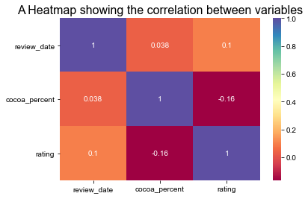

**Observations:**

It is clear from the heatmap and the seaborn(sns) correlation graphs that:

* There is a No correlation amongst the variables.

In [160]:

*# pair plot to further visualize the relationship between the variables*

sns.set(style='white')

sns.pairplot(data);

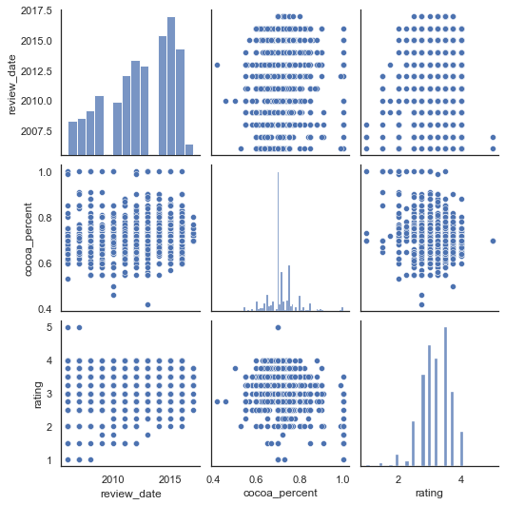

***The pair plot further indicate a NO correlation between rating, percentage of cocoa and review date.***

**3. Analyzing Hypothetical Questions**

**3.1. Which countries produces the best cocoa beans?**

In [94]:

*# countries with the most reviews*

countries=data['broad_bean_origin'].value_counts().index.tolist()[:5]

*# countries has the top 5 countries in terms of reviews*

satisfactory={} *# empty dictionary*

**for** i **in** countries:

count=0

best_country=data[data['broad_bean_origin']==i]

best_rating=best_country[best_country['rating']>=3] *# rating more than 4*

**for** j **in** best_rating['rating']:

count+=1

satisfactory[i]=count

satisfactory = pd.DataFrame(list(satisfactory.items()),columns = ['Country','Number of Chocolate Bars'])

satisfactory

Out[94]:

|  | **Country** | **Number of Chocolate Bars** |
| --- | --- | --- |
| **0** | Venezuela | 166 |
| **1** | Ecuador | 138 |
| **2** | Peru | 111 |
| **3** | Madagascar | 117 |
| **4** | Dominican Republic | 113 |

***Venezuela has the largest number of chocolate bars rated above 3.0***

In [159]:

*# Code to visualize the countries that give best cocoa beans*

satisfactory = pd.DataFrame(satisfactory).reset_index()

sns.set(style='white')

plt.figure(figsize=(16,9))

sns.barplot(x='Country', y='Number of Chocolate Bars', data=satisfactory)

plt.xlabel('**\n**Country')

plt.ylabel('Number of chocolate bars')

plt.title("Top 5 Broad origins of the Chocolate Beans with a Rating above 3.0**\n**")

plt.show()

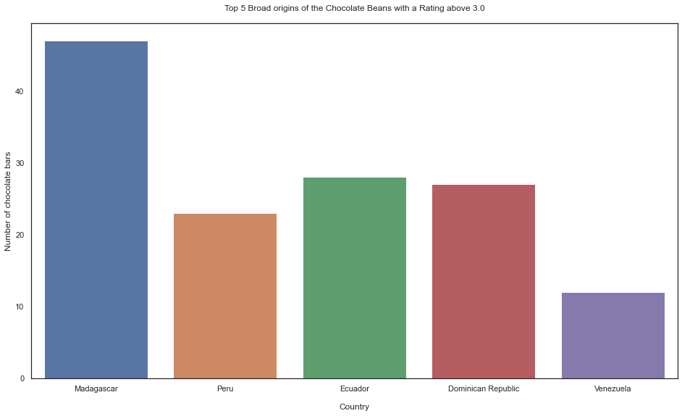

In [67]:

*#Top 10 countries in terms of cocoa beans by rating*

*# Create dataframe for bean producers and rating*

cols = ['broad_bean_origin','rating']

top_10_beans = data[cols]

*# Top 10 beans producers by their rating average*

top_10_beans = top_10_beans.groupby('broad_bean_origin').aggregate({'rating':'mean'}).sort_values(by=['rating'],ascending=**False**).head(10)

top_10_beans = pd.DataFrame(top_10_beans).reset_index()

top_10_beans

Out[67]:

|  | **broad_bean_origin** | **rating** |
| --- | --- | --- |
| **0** | Peru, Dom. Rep | 4.00 |
| **1** | Guat., D.R., Peru, Mad., PNG | 4.00 |
| **2** | Ven, Bolivia, D.R. | 4.00 |
| **3** | Venezuela, Java | 4.00 |
| **4** | Dom. Rep., Madagascar | 4.00 |
| **5** | Gre., PNG, Haw., Haiti, Mad | 4.00 |
| **6** | Ven.,Ecu.,Peru,Nic. | 3.75 |
| **7** | Venez,Africa,Brasil,Peru,Mex | 3.75 |
| **8** | Dominican Rep., Bali | 3.75 |
| **9** | PNG, Vanuatu, Mad | 3.75 |

***This table shows that on the average a combination of regions produce a top rating cocoa bean type. The highest average rating is 4.0***

In [158]:

*# visualizing the top to bean producers by rating*

sns.set(style='white')

plt.figure(figsize=(16,9))

sns.barplot(x='broad_bean_origin', y='rating', data=top_10_beans)

plt.xticks(rotation=45)

plt.xlabel("**\n**Beans Producing Geo-Region")

plt.ylabel("Average Rating")

plt.title("Top 10 Bean Producing Geo-Region by Average Rating**\n**")

plt.show()

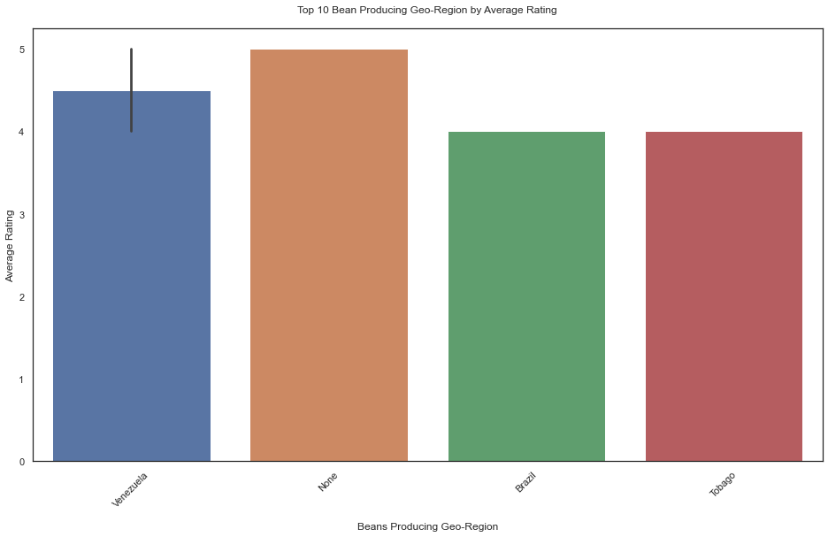

**3.2. Which countries have the highest-rated chocolate bars?**

In [151]:

*#create dataframe for specific_bean_origin_or_bar_name and rating*

cols = ['specific_bean_origin_or_bar_name','rating']

review_data = data[cols]

*# countries with the most reviews (satisfactory:rating >=3)*

most_reviews = review_data[review_data['rating']>=3]

*# Top 5 countries with most reviews*

most_reviews = pd.DataFrame(most_reviews['specific_bean_origin_or_bar_name'].value_counts()[:5])

*# Make index (specific_bean_origin_or_bar_name) a column*

most_reviews.reset_index(level=0, inplace=**True**)

*# rename columns*

most_reviews.columns=['Country','Number of Reviews']

most_reviews

Out[151]:

|  | **Country** | **Number of Reviews** |
| --- | --- | --- |
| **0** | Madagascar | 47 |
| **1** | Ecuador | 28 |
| **2** | Dominican Republic | 27 |
| **3** | Peru | 23 |
| **4** | Sambirano | 17 |

***The table shows that Madagascar was reviewed satisfactory(>=3) 47 times, at least 19 more than Ecuador the second highest reviewed.***

In [157]:

*# visualizing the top 5 most rated countries*

sns.set(style='white')

plt.figure(figsize=(16,9))

sns.catplot(x='Country', y='Number of Reviews',kind="bar", palette="ch:.25",data=most_reviews)

plt.xticks(rotation=45)

plt.title("Top 5 Countries with Highest Reviews **\n**")

plt.show()

<Figure size 1152x648 with 0 Axes>

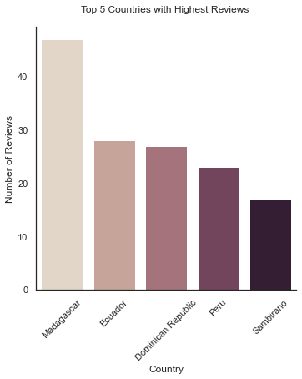

***The catplot confirms Madagascar as the highest-rated chocolate bars (rating >=3)***

**3.3. Is there relationship between the proportion of cocoa in chocolate bar and the rating?**

In [238]:

*# Cocoa Percentage patterns and rating over the years*

cols = ['review_date','cocoa_percent','rating']

relation_table = data[cols]

*# group table by review year and Aggregate by mean rating and percentage of cocoa in bar*

relation_table = relation_table.groupby('review_date').agg(

cocoaPercent=pd.NamedAgg(column='cocoa_percent', aggfunc='mean'),

cocoaRating=pd.NamedAgg(column='rating', aggfunc='mean'))

*# Reset Index*

relation_table = relation_table.reset_index()

*# rename columns*

relation_table.columns=['Review Year','Average Cocoa Percentage', 'Average Rating']

*# Print table*

print(relation_table)

*# visualizing of Cocoa Percentage and rating patterns over the years*

sns.set(style='white')

plt.figure(figsize=(15, 4))

g1 = sns.lineplot(x='Review Year', y='Average Cocoa Percentage', data=relation_table, color="red",marker='o',label = '% Cocoa')

*# Adding Twin Axes to plot using Average Rating*

ax2 = plt.twinx()

g2 = sns.lineplot(x='Review Year', y='Average Rating', data=relation_table, color="green",marker='o',ax=ax2,label = 'Rating')

*# Adding title*

plt.title('Relationship between the Percentage of Cocoa in Chocolate Bar and the Rating Over years', fontweight ="bold")

*# Adding grid*

g1.grid()

*# Show plot*

plt.show()

sns.lmplot(x='cocoa_percent',y='rating',fit_reg=**False**,scatter_kws={"color":"darkred","alpha":0.3,"s":100},data=data)

plt.xlabel('Percentage of Cocoa',size=12,color='darkred')

plt.ylabel('Expert Rating of the Bar',size=12,color='darkred')

plt.show()

Review Year Average Cocoa Percentage Average Rating

0 2006 0.710000 3.125000

1 2007 0.720390 3.162338

2 2008 0.726989 2.994624

3 2009 0.704431 3.073171

4 2010 0.707793 3.148649

5 2011 0.709697 3.256061

6 2012 0.715282 3.178205

7 2013 0.722663 3.197011

8 2014 0.722530 3.189271

9 2015 0.720140 3.246491

10 2016 0.717580 3.226027

11 2017 0.715417 3.312500

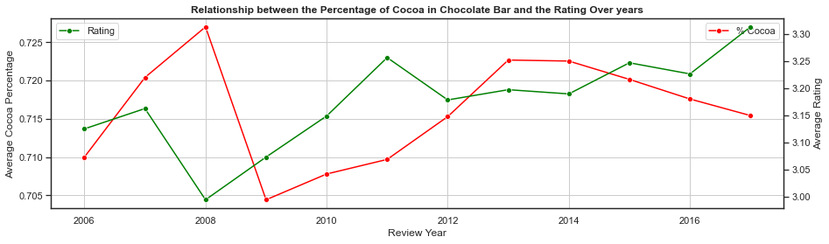

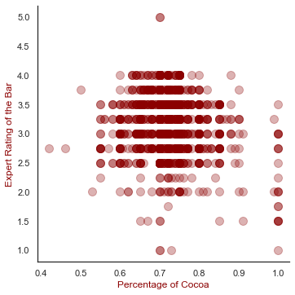

***Rating over the years (Taking the average amounts per year)***

* The lowest ever average rating was around 3 and it came in 2008.
* Since then to 2011, there was a steady increase in average ratings and in 2011 it was at 3.26.
* From 2011 to 2017, there have been several fluctuations in the ratings, and in 2017 the rating lies at its apex at around 3.31.
* The Year 2008 - Year of Coincidence or something more than that?
  + The highest average cocoa percent was in 2008
  + The lowest average ratings came in 2008
* The next year 2009 saw two major changes from the previous year :
  + There was a drastic reduce in cocoa content on an average
  + The average rating across the world had an increase from 3.00 to 3.08 in 2008

***Cocoa Percent versus Rating - Reading the Scatterplot above***

* No evident correlation. A numerical correlation gives a weak negative correlation coefficient of -0.16
* The density of the graph is highest between 65% and 80% of cocoa
* Chocolate bars with low cocoa percentage(less than 50%) and high cocoa percentage(above 90%) are less in number, but the most important fact is that most of these chocolate bars have a rating of less than 3,i.e they have been deemed 'Unsatisfactory'
* Seems like people do not prefer very low or very high cocoa percentages in their chocolate!

***From the scatter plot above, we can infer that it would not be a good idea to guess a chocolate's rating based on its Cocoa Percentage.***

**3.4. What are the top ten companies with the highest rating?**

In [234]:

*# Top 10 companies in terms of chocolate bars in this dataset*

top10companies = data[['Company','rating']]

top10companies = top10companies['Company'].value_counts().sort_values(ascending=**False**).head(10)

top10companies = pd.DataFrame(top10companies)

top10companies.reset_index(level=0, inplace=**True**)

top10companies.columns=['Company','Rating']

print(top10companies)

*# visualizing Top 10 companies*

sns.set(style='white')

plt.figure(figsize=(10,4))

sns.barplot(x='Company', y='Rating', data=top10companies,palette="Blues_d")

plt.xlabel("**\n**Chocolate Company")

plt.ylabel("Number of Bars")

plt.title("Top 5 Companies in terms of Chocolate Bars**\n**")

plt.xticks(rotation=45)

plt.show()

Company Rating

0 Soma 47

1 Bonnat 27

2 Fresco 26

3 Pralus 25

4 A. Morin 23

5 Arete 22

6 Guittard 22

7 Domori 22

8 Valrhona 21

9 Hotel Chocolat (Coppeneur) 19

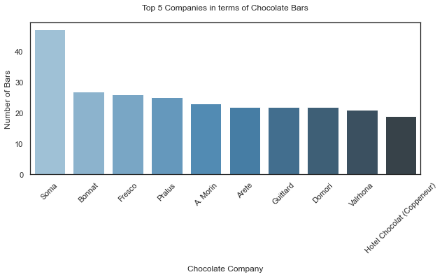

***Soma has the highest number of chocolate bars in this dataset with 47 number of ratings.***

**3.5. What is the pattern over the years with respect to rating?**

In [162]:

*# Cocoa Percentage patterns over the years*

cols = ['review_date','cocoa_percent']

cocoaPercent = data[cols]

cocoaPercent = data.groupby('review_date').aggregate({'cocoa_percent':'mean'})

cocoaPercent = cocoaPercent.reset_index()

print(cocoaPercent)

*#visualizing of Cocoa Percentage patterns over the years*

sns.set(style='white')

plt.figure(figsize=(15, 4))

ax = sns.lineplot(x='review_date', y='cocoa_percent', data=cocoaPercent, color="red",marker='o')

ax.set(xticks=cocoaPercent.review_date.values)

plt.xlabel("**\n**Date of Review")

plt.ylabel("Average Cocoa Percentage")

plt.title("Cocoa Percentage patterns over the years **\n**")

plt.show()

review_date cocoa_percent

0 2006 0.710000

1 2007 0.720390

2 2008 0.726989

3 2009 0.704431

4 2010 0.707793

5 2011 0.709697

6 2012 0.715282

7 2013 0.722663

8 2014 0.722530

9 2015 0.720140

10 2016 0.717580

11 2017 0.715417

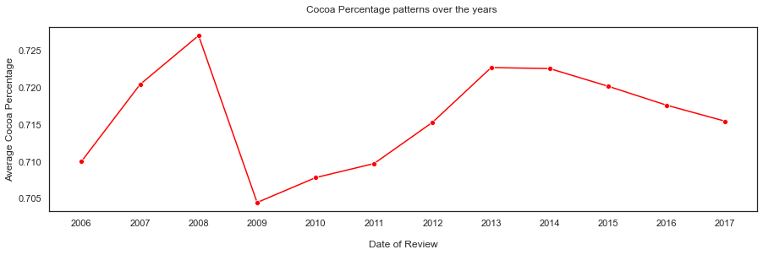

***Percentage of Cocoa over the years (Taking the average amounts per year)***

* The highest percentage of cocoa in a chocolate bar came in 2008 and was about 73%.
* The lowest percentage of cocoa followed in the very next year, 2009 and hit 69%.
* There was a steep rise in the amount of cocoa in chocolate from 2009 to 2013 where it rose to about 72.2% from 69%.
* From 2014, a steady decline in cocoa percentage in chocolate bars have been noticed and in 2017, it stands at just above 71.5%.

**3.6 Which Countries produces the best chocolate bars?**

In [243]:

*# Countries*

print ('Top Chocolate Producing Countries in the World**\n**')

country=list(data['company_location'].value_counts().head(10).index)

choco_bars=list(data['company_location'].value_counts().head(10))

prod_ctry=dict(zip(country,choco_bars))

print(data['company_location'].value_counts().head())

plt.figure(figsize=(10,5))

plt.hlines(y=country,xmin=0,xmax=choco_bars,color='skyblue')

plt.plot(choco_bars,country,"o")

plt.xlabel('Number of chocolate bars')

plt.ylabel('Country')

plt.title("Top Chocolate Producing Countries in the World")

plt.show()

Top Chocolate Producing Countries in the World

U.S.A. 764

France 156

Canada 125

U.K. 96

Italy 63

Name: company_location, dtype: int64

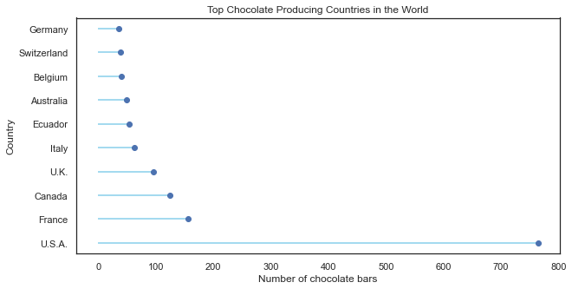

In [268]:

*#create dataframe for company_location and rating*

cols = ['company_location','rating']

best_choc_data = data[cols]

*# countries with the rating >=4*

best_choc = best_choc_data[best_choc_data['rating']>=4]

*# Top countries with most high ratings*

best_choc = pd.DataFrame(best_choc['company_location'].value_counts()).head(10)

*# Make index (specific_bean_origin_or_bar_name) a column*

best_choc.reset_index(level=0, inplace=**True**)

*# rename columns*

best_choc.columns=['Company Location','Number of Rating']

print(best_choc)

*# Code to visualize the countries that produce the best choclates*

sns.set(style='white')

plt.figure(figsize=(15, 4))

sns.barplot(x="Company Location", y="Number of Rating",data=best_choc)

plt.xlabel('Country')

plt.ylabel('Number of chocolate bars')

plt.title("Top Chocolate Producing Countries in the World (Ratings above 4.0)")

plt.xticks(rotation=45)

plt.show()

Company Location Number of Rating

0 U.S.A. 25

1 France 23

2 Canada 10

3 Italy 9

4 Belgium 6

5 Switzerland 6

6 U.K. 4

7 Australia 4

8 Ecuador 3

9 Spain 3

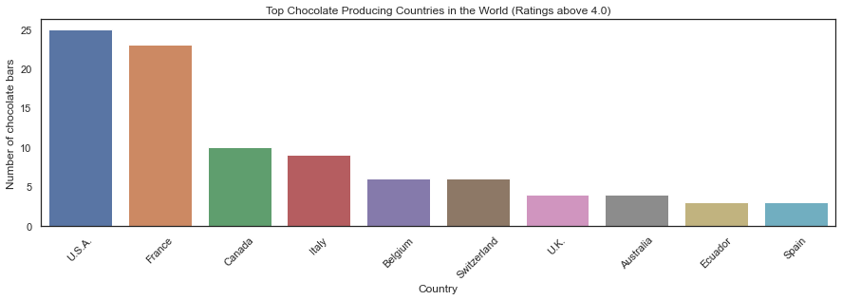

***U.S.A produces way more chocolate companies than any other country has according to this data***

**3.7 Which chocolate beans have the highest ratings?**

In [278]:

*# Repla all None with NaN*

data.replace(to_replace=['None'], value=np.nan, inplace=**True**)

*#create dataframe for bean_type and rating*

cols = ['bean_type','rating']

bean_data = data[cols]

*# countries with the rating >=4*

best_bean = bean_data[bean_data['rating']>=4]

*# Top countries with most high ratings*

best_bean = pd.DataFrame(best_bean['bean_type'].value_counts()).head(5)

*# Make index (specific_bean_origin_or_bar_name) a column*

best_bean.reset_index(level=0, inplace=**True**)

*# rename columns*

best_bean.columns=['Bean Type','Number of Rating']

print(best_bean)

*# Code to visualize the countries that produce the best choclates*

sizes = best_bean['Number of Rating'].to_list()

label_names = best_bean['Bean Type'].to_list()

*# Now let's make the donut plot*

explode = (0.05,0.05,0.05,0.05,0.05)

my_circle=plt.Circle((0,0),0.7,color='white')

plt.figure(figsize=(7,7))

plt.pie(sizes,labels=label_names,explode=explode,autopct='**%1.1f%%**',pctdistance=0.85,startangle=90,shadow=**True**)

fig=plt.gcf()

fig.gca().add_artist(my_circle)

plt.axis('equal')

plt.tight_layout()

plt.show()

Bean Type Number of Rating

0 Trinitario 26

1 Criollo 14

2 Blend 6

3 Criollo, Trinitario 4

4 Forastero 4

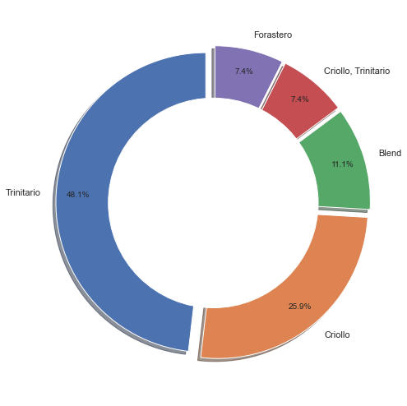

***This donut plot affirms that Trinitario is the best cocoa bean among the top rated beans.***