Database description

The database “world” is used to store information about different countries. There are three tables: “country”, “city” and “countrylanguage”. In this test, you will use “country” and “countrylanguage” only.

- country table: it stores information about a country.
  - Code: the primary key used to uniquely represent a country
  - Name: country name
  - Continent: the continent the country belongs to, e.g., “Asia”, “Europe”, etc.
  - Population: the total population in the country

  - countrylanguage table: it contains information about the language being spoken in a country
  - CountryCode: a foreign key, references country table
  - Language: the name of the language
  - isOfficial: a Boolean number, “T” if the language is an official language and “F” otherwise
  - Percentage: the percentage of the population in a country speaking that particular language

Example:

To determine the number of people speaking a particular language, we need to consider the percentage of the population inside a country speaking the language. For example, consider the Language “Greek”. It is spoken in the country “DEU”, but the percentage is only 0.4. As the population of “DEU” is 82164700 (82.16 million), hence the number of people speaking Greek in “DEU” is 0.4*82164700/100 = 328658.8 = 0.33M (million).

To determine the ranking about the popularity of a language (i.e., the number of people speaking a particular language), we should obtain data showing the total number of people speaking that language in all countries. By considering all countries and the percentage of population in a country speaking that language, we can find the following data,
Language | No of people speaking the language
Chinese | 1191.8 M
Hindi | 405.6 M
Spanish | 355.0M
English | 347.1M

Top of Form

Bottom of Form
Top of Form
Bottom of Form

From this, we can work out the language “Chinese” should rank No 1, “Hindi” is No 2, and so on.
Question 1 – “Debugging”

The files page1.html and page2.php are given. In page1.html, there is a form named “myForm” consisting of a text box and one set of radio buttons. User will input two things in the form: his/her username (i.e., student number) and the quiz paper. These data will be passed to page2.php.

Expected behavior of page1.html and page2.php:
In page1.html, the JavaScript function validate(f) is used to perform client-side checking. The field “username” is mandatory. If it is empty at the time when user clicks “submit”, the message “This field is required” (in italic style and purple color defined using the embedded style class “s1”) will appear next to the textbox as shown in Figure Q1(a).

If the field “username” is not empty, the data will be sent to page2.php. In page2.php, the function welcomeMessage() is used to display the username and the quiz paper as in Figure Q1(b).

However the given files “page1.html” and “page2.php” have some problems. Debug these two files so that the two pages function as what have been described above.

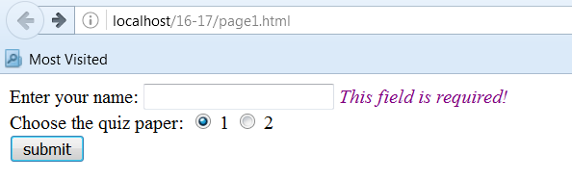
(a)
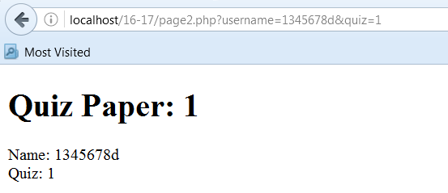
(b)
Figure Q1

Question 2

The file “page3.php” is given. There is a set of radio button for user to choose the language. Once user clicks the “submit” button, the choice is sent to page4.php using GET method.

In page4.php, requests will be sent to the database “world” to obtain some information about the language. In particular, two types of information are sought,

- A list of countries in which the chosen language is an official language
- The distribution of these countries among different continents

Figure Q2 shows some example displays. Suppose that the user has chosen “Chinese”. There are only two countries having “Chinese” as an official language. These two countries (i.e., China and Singapore) are listed as in Figure Q2(a). These two countries are located inside “Asia” (the field “continent” in country table stores this information). Hence, “Asia: 2” is shown.

Suppose that the user chooses “English”. There are a lot of countries having “English” as an official language as can be seen in Figure Q2(b). These countries are located at different continents. Their statistics are summarized as in Figure Q2(c).

Complete page4.php to display the information as described above.

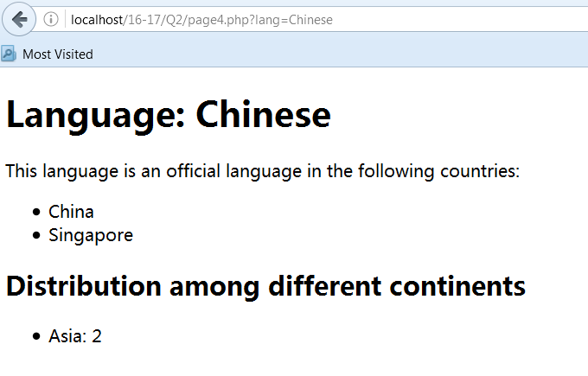
(a)
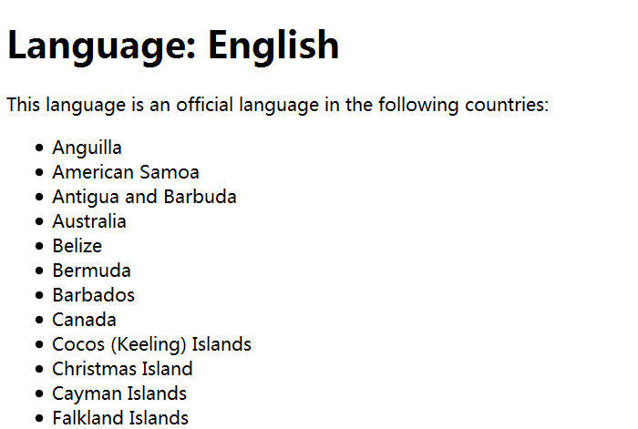
(b)
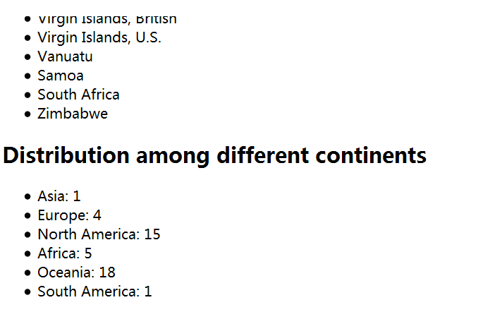
(c)
Figure Q2.

Question 3 (15 marks)

Consider the given file page3.php. There are only three languages for user to choose (i.e., Arabic, Chinese and English). These three languages are coded directly into the file (i.e., page3.php).

In fact, the table “countrylanguage” stores information about the languages spoken in different places. We would like to obtain the language information from the countrylanguage table so that users can have more choices. In particular, we would like to list out the languages in which the languages are spoken in more than 15 countries For example, the language “French” is spoken in 25 countries. Hence, “French” should be shown as in Figure Q3. Find out all languages that are spoken in more than 15 countries and put them as one of choices of the radio button.

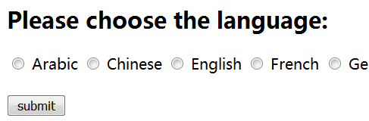
Figure Q3

Save the modified page3.php as page3new.php.

Question 4 (30 marks)

Consider the given files page5.php and page6.php. In page5.php, there are two sets of radio buttons for users to compare two languages as shown in Figure Q4(a). After user has selected two languages, the choices are sent to page6.php to show some comparison between these two languages.

In page6.php, it functions as follows:

- If users choose same language in both set of radio buttons in page5.php, page6.php will show “Please choose two different languages” as in Figure Q4(b). No comparison will be done in this case.

- If users choose two different languages, three sets of numbers are shown as in Figure Q4(c).

  - The first row shows the total number of countries that have chosen the language as an official language
  - The second row shows the total number of people speaking that language (in millions)
  - The last row shows the ranking in terms of the total number of people speaking that language

An example of calculation is given in the second page of the test paper. Figure Q4(c) shows the sample display of comparing English and Chinese. Complete page6.php to display the information as described above.

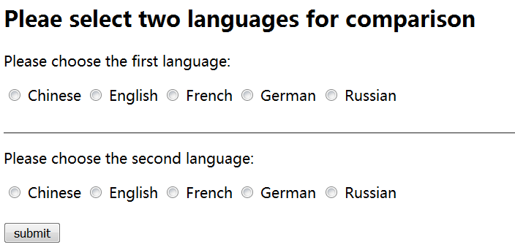
(a)
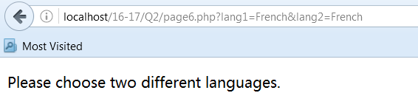
(b)
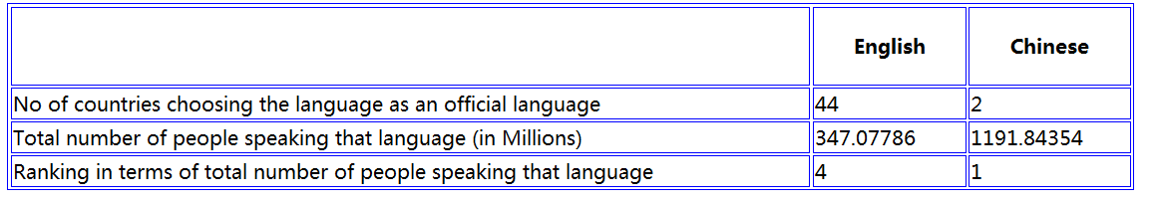
(c)

Figure Q4

Page1.html
1 | <!DOCTYPE html>
2 | <html>
3 | <head>
4 | <title> Page A </title>
5 | <style type="text/css">
6 | span.s1 {font-style: italic
7 | color: purple}
8 | </style>
9 | <script type="text/javascript">
10 | function validate(f) {
11 | var t1=0;
12 | if (f=="") {
13 | document.getElementById("infousername").className="s1";
14 | document.getElementById("infousername").innerHTML = "This field is required! ";
15 | t1=1;
16 | }
17 | if (t1==1) return false;
18 | else return true;
19 | }
20 | </script>
21 | </head>
22 | <body>
23 | <form name="myForm" action="page2.php" method="get" onsubmit="return validate(this)">
24 | <label> Enter your name: </label> <input type="text" name="username" id="username"/>
25 | <span id="infoUsername" name="infoUsername"> </span>
26 | <br />
27 | <label> Choose the quiz paper: </label>
28 | <input type="radio" name="quiz" value="1" checked /> 1
29 | <input type="radio" name="quiz" value="2" /> 2
30 | <br />
31 | <input type="submit" value="submit" />
32 | </form>
33 | </body>
34 | </html>

Page2.php
1 | <!DOCTYPE html>
2 | <html>
3 | <head>
4 | <title> Test your knowledge </title>
5 | <script type="text/javascript">
6 | function welcomeMessage() {
7 | <?php $s1 = echo $_POST["Quiz"];
8 | headInfo = $s1;
9 | $s2 = "Name: " . $_POST["Username"] . "<br /> Quiz: " . echo $_POST["Quiz"];
10 | pInfo = $s2;
11 | ?>
12 | }
13 | </script>
14 | </head>
15 | <body onload="welcomeMessage()">
16 | <h1 id="headInfo"> Quiz Paper: </h1>
17 | <p id="pInfo"> </p>
18 | </body>
19 | </html>

Page3.php
<!DOCTYPE html>
<html>
<head> <title> Page 3 </title> </head>
<body>
<form name="myForm" action="page4.php" method="get" >
<h2> Please choose the language: </h2>
<input type="radio" name="lang" value="Arabic" /> Arabic
<input type="radio" name="lang" value="Chinese" /> Chinese
<input type="radio" name="lang" value="English" /> Enlgish
<br /> <br />
<input type="submit" value="submit" />
</form>
</body>
</html>

Page5.php
<!DOCTYPE html>
<html>
<head> <title> Page 5 </title> </head>
<body>
<form name="myForm" action="page6.php" method="get" >
<h2> Pleae select two languages for comparison </h2>
<p> Please choose the first language: </p>
<input type="radio" name="lang1" value="Chinese" /> Chinese
<input type="radio" name="lang1" value="English" /> English
<input type="radio" name="lang1" value="French" /> French
<input type="radio" name="lang1" value="German" /> German
<input type="radio" name="lang1" value="Russian" /> Russian
<br /> <br />
<hr />
<p> Please choose the second language: </p>
<input type="radio" name="lang2" value="Chinese" /> Chinese
<input type="radio" name="lang2" value="English" /> English
<input type="radio" name="lang2" value="French" /> French
<input type="radio" name="lang2" value="German" /> German
<input type="radio" name="lang2" value="Russian" /> Russian
<br /> <br />
<input type="submit" value="submit" />
</form>
</body>
</html>

Page6.php
<!DOCTYPE html>
<html>
<head> <title> Page 6 </title>
<style type="text/css">
table, th, td {border:1px solid blue;}
th {padding: 20px;}
</style>
</head>
<body>

</body>
</html>

