Supplementary Materials and Methods
TCGA mutation collection
TCGA mutation annotation format (MAF) file data for 23 tumor types was downloaded from Xena data store (https://genome-cancer.soe.ucsc.edu/proj/site/xena/hub/) using their API. The following filtering steps were applied. For each tumor type, if multiple MAFs were available from TCGA, a MAF labeled as curated was chosen. If no curated MAF was present, a MAF containing aggregate calls from the three TCGA sequencing centers (Broad, Baylor, Washington University) was selected. If neither curated nor aggregated MAFs were available, the tumor type was not used in our analysis. Tumor types under TCGA embargo were not used. The final list of tumor types was: ACC=Adrenocortical carcinoma, BLCA=Bladder Urothelial Carcinoma, BRCA=Breast Invasive Carcinoma, CESC=Cervical squamous cell carcinoma and endocervical adenocarcinoma, ESCA=Esophageal Carcinoma, GBM=Glioblastoma Multiforme, HNSC=Head and Neck squamous cell carcinoma, KICH=Kidney chromophobe, KIRC=Kidney renal clear cell carcinoma, KIRP= Kidney Renal Papillary Cell Carcinoma, LGG=low-grade glioma, LIHC=Liver hepatocellular carcinoma, LUAD=Lung adenocarcinoma, LUSC=Lung squamous cell carcinoma, OV=Ovarian serous cystadenocarcinoma, PAAD=Pancreatic adenocarcinoma, PCPG= Pheochromocytoma and Paraganglioma, PRAD=Prostate adenocarcinoma, SKCM=Skin Cutaneous Melanoma, STAD=Stomach adenocarcinoma, THCA=Thyroid carcinoma, UCEC=Uterine Corpus Endometrial Carcinoma and UCS=Uterine Carcinosarcoma. Hyper-mutated samples for each tumor type, defined as samples with more mutations than the third quartile + 4.5* (inter-quartile range) were removed. All mutation calls were de-duplicated by removing redundant mutations, evidenced by the same tumor sample ID and genomic mutation, likely reflecting multiple sequencing runs on the same sample.

TCGA protein expression data collection
TCGA protein expression measurements (Level 3 normalized) for HIF1A (antibody HIF-1_alpha-M-E) from Reverse phase protein arrays (RPPA) were collected from the TCGA ftp website (https://tcga-data.nci.nih.gov/tcgafiles/ftp_auth/distro_ftpusers/anony-mous/tumor/). Specifically, for each tumor sample ID we used the latest version number protein expression data available.

3D protein structure and theoretical model collection and processing
PDB structures were obtained from the Worldwide Protein Data Bank (PDB) (10/17/2015). Only structures solved by x-ray crystallography and containing at least one human protein chain were used. To avoid computation on crystal-packing artifacts that are common in PDB multi-domain protein structures and proteins in complex with other proteins or DNA/RNA structures, we use PDB biological assemblies that model how proteins exist in vivo (ftp://ftp.wwpdb.org/pub/pdb/data/biounit). Additionally, single-domain, theoretical protein structure models constructed based on homology to non-human proteins were included to increase coverage over a greater proportion of genes. Theoretical models were obtained from the ModPipe human 2013 dataset (ftp://salilab.org/databases/modbase/projects/genomes/H_sapiens/2013/), built with Modeller 9.11 . In addition to criteria required by ModPipe (ModPipe Protein Quality Score > 1.1), we further filtered the theoretical models to increase the quality of structures used in our assessment, requiring that: 1) models had a minimum length of 75 residues. 2) The sequence of the target human protein and the sequence of the non-human homolog used for homology modeling were ≥ 10% identical. 3) The “loop” content of the protein model was ≤ 30%. 4) Compactness score C (Supplementary Materials and Methods Eq S1) was ≤ 1Å/residue. Our compactness score was based on the protein radius of gyration (R_{g}), and was employed to reject overly extended or unfolded structures. All thresholds were selected by visual inspection of structures meeting each of the four criteria.

Theoretical protein structure compactness score filter
(Eq S1)
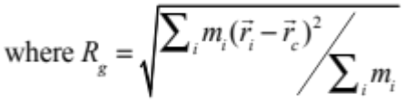

where N is total number of residues. m_{i} is the mass of the i^{th} atom, is the center of the i^{th} atom, and 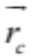 is the protein center of geometry.
Mapping genome coordinates to protein structures and models
Mapping of genome coordinates was done using a modified version of the TransMap algorithm (Fig S3), previously described in . In a minority of cases mutations did not have a one-to-one mapping within a protein structure (0.6% of mutations analyzed in this study were impacted). Any hotspot region residue positions with ambiguous mappings were dropped from the final analysis (Table S9). Protein sequences in the UniProt database (SwissProt curated only) were aligned to all transcripts in RefSeq, CCDS and Ensembl databases with tBLASTn . Transcripts were then aligned to human genome assembly GRCh37 (hg19) with BLAT . BLAT was also used to align the UniProt protein sequences with PDB SEQRES amino acid residue sequences (Fig S3). For theoretical models, ModPipe provided a RefSeq or Ensembl transcript identifier and translation of each transcript into protein sequence, eliminating the need for the tBLASTn step to align protein sequence to transcript.

HotMAPS algorithm mathematical details
Let K be the set of all 3D protein structures and theoretical models in the collection described above. Each protein structure or model was an element 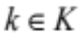. For each , the center of geometry in Euclidean space (i.e., centroid) was calculated for each residue (r), considering all backbone and side-chain atoms,
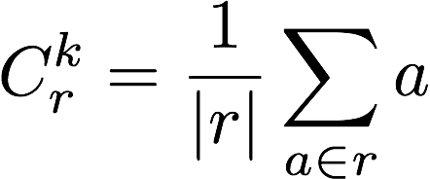 (Eq S2)
where  is the center of geometry for residue r in k, and a is a 3D position vector for each atom in residue r. The neighbors of residue r were identified using a 10 angstrom radius cutoff from the center of geometry,
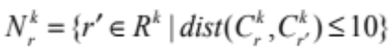 (Eq S3)
where 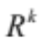is the set of residues for k, 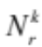 is the set of neighbor residues for residue r, and dist is the Euclidean distance function. The density D of mutations at residue r was calculated as the sum of mutations in the residue’s neighborhood,
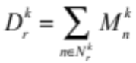 (Eq S4)
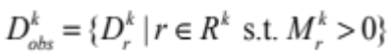 (Eq S5)
where 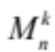 is the number of missense mutations for the n’th residue neighbor, 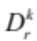 is the density of mutations for a specific residue and k, and 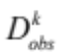is the set of observed mutation densities for all mutated residues in a given k.

Next, we simulated a null distribution expected if mutations on the protein structure were under no selective pressure in a cancer cell to occur in any particular region. The null distribution is reasonably modeled by a discrete uniform distribution. Mutations occurring under the null were simulated by sampling with replacement a number of residues equal to the total observed mutations,
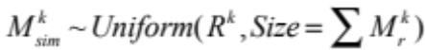 (Eq S6)
where 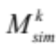 is the simulated missense counts for all residues in k. The procedure was modified slightly for protein complexes, containing multiple protein chains that originated from a single gene product (e.g., a homodimer). We accounted for this non-independence by running identical simulations simultaneously on multiple duplicated protein chains. Duplicate chains were identified based on either having same PDB chain letter and/or the same chain description. The mutation density for simulated mutations was calculated in the same manner as the observed mutations.
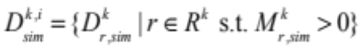 (Eq S7)

The simulation procedure was repeated for 10,000 iterations on each structure, where i represents the i^{th} iteration. For computational efficiency on non-significant structures or models, we stopped early if at least 200 simulated mutation densities exceeded the maximum observed mutation density in that structure. Based on the empirical null distribution established from simulations, we calculated the one-tailed p-value for each residue’s mutation density being equal or larger,
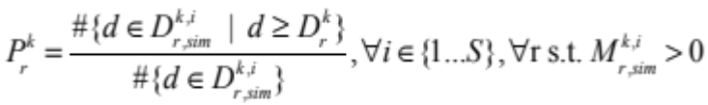 (Eq S8)
where S is the total number of simulations, 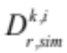is the mutation density for residue r in the i^{th} iteration, and 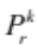 is the p-value for residue r in k. Since there may be many structures and/or models that cover the same corresponding portion of the genome, multiple p-values were collapsed by taking the minimum p-value among residues that mapped to the same genomic codon. These unique genomic-level p-values were then corrected for multiple hypotheses by the Benjamini-Hochberg method and deemed significant at a q-value of 0.01. We selected the very conservative q=0.01 empirically, to minimize the number of false discoveries in our study. Identifying the corresponding significant residues at the structure (or model) level was backtracked by using the supremum of significant p-values at the codon level as a cutoff,
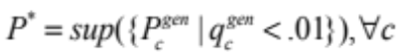 (Eq S9)
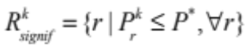 (Eq S10)
where 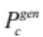 and 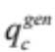 are the genomic p-value and q-value, respectively, for codon c, 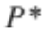 is the p-value cutoff adjusted for multiple hypotheses,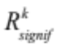is the set of significant residues for k.

3D mutation hotspot regions were identified as groupings of significant residues, according to the principle of maximum parsimony. Specifically, we found the minimum number of non-contiguous hotspot regions that explained all significant residues. We first constructed a neighbor graph amongst significant residue positions, where edges were created if two residues could be considered as neighbors, defined as within 10 angstroms (1nm), which is the order of magnitude for the length of an amino acid residue side chain. 3D mutation hotspot regions for each k were then found as the connected components of the neighbor graph using breadth-first search.

The neighbor graph and connected components are computed as shown in Fig S1. A single parameter defined the maximum distance between residue neighbors (10 A). Our results were not very sensitive to small perturbations of this parameter (8A, 9A, 11A, 12A). The 10A maximum distance identified 85% of the hotspot residues identified at the four other threshold values.

Fig S4 shows an overview flowchart of the HotMAPS algorithm.

Merging redundant hotspot regions
PDB structures and theoretical protein models most frequently do not represent the full length of human genes. Thus, a single gene was represented in our study by many structures and models that may overlap. To handle overlap, we created a single non-redundant gene-level set of 3D missense mutation hotspot regions for each tumor type, which were merged amongst the many possible structures and theoretical models for each gene. The union of residues found in overlapping hotspot regions identified in different structures and models was found, where overlap between two regions was defined as having at least one shared residue position. We also created a gene-level set of hotspot regions that was aggregated across tumor types (tumor-type-aggregated gene level regions), with the same merging strategy (Table S1). Discrepancies in residue position numbering across multiple structures and models were handled by mapping to corresponding codon positions on selected reference transcripts, which in this work were obtained through the CRAVAT pipeline (v3.2) .

Reference transcript selection
Reference transcripts were selected with the method implemented in CRAVAT 3.2 , by clustering available transcripts from RefSeq , CCDS and Ensembl into loci (sets of overlapping transcripts on the same DNA strand) using the clusterGenes tool from the Kent Source library . Each locus was divided into blocks. Blocks were defined only for the CDS (coding sequence). Bases that resided within the 5' UTR or 3' UTR were excluded. Within the CDS, a new block was initiated when an exon start or exon stop occurred in any transcript. Blocks captured instances of overlap across the locus. Each transcript was scored with a metric that prioritizes the coverage of coding bases and agreement between RefSeq, CCDS and Ensembl transcript definitions, and the reference transcript was selected with a greedy algorithm.
Identifying 1D missense mutation hotspot regions
1D mutation hotspot regions were calculated by applying an equivalent approach to HotMAPS. Mutations were considered with respect to their positions in 1D amino acid residue chains of the 19,368 PDB protein structures and 46,004 theoretical models used for the 3D analysis. All steps in the 1D algorithm were the same as in the 3D HotMAPS version, except that Eq S3 was replaced by Eq S11 for 1D,
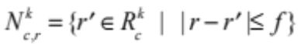 (Eq S11)
where c is each of the amino acid residue chains in the protein structure or model k, 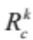 is the set of residues for chain c in k,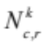 is the set of neighbor residues for the r^{th} residue on chain c, and f is the size of the flanking sequence on either side of the residue r along the primary sequence. Each r lies at the center of window, so that window size is 2f+1. Three window sizes were evaluated (w=7, 13 and 19).

We identified 3D hotspot regions that were not identified in 1D, regions that were identified in both 3D and 1D, and regions that were identified only in 1D (Tables 1, 2, Tables S6, S7). Regions identified only in 3D were strictly defined as containing no residues that occurred in a 1D region and vice versa for 1D only.

While counter-intuitive, the 1D version of HotMAPS can fail to identify single residue hotspot regions which are captured by the 3D version. Fig S5 illustrates a toy example of this behavior.

Identifying characteristic properties of 3D missense mutation hotspot regions
We compared features of residue positions and of missense mutations that occurred in the 3D hotspot regions with the features of the rest of the positions and missense mutations in our dataset. For each analysis, we considered only a unique set of positions or missense mutations and comparison was done by the Mann Whitney U test in the scipy stats package. The features considered were conservation, in silico missense mutation driver scores (CHASM scores) , in silico missense mutation pathogenicity scores (VEST scores) and occurrence at a protein-protein interface in a PDB structure.

Amino-acid residue position conservation in vertebrate evolution was estimated as Shannon entropy of amino acid composition in a column of a protein multiple sequence alignment, available in SNVBox and was accessed through the CRAVAT 3.2 web service . We used the multiple sequence alignments protein-translated versions of the UCSC Genome Browser's 46-Way Multiz vertebrate genome alignments . In silico missense mutation scores were obtained from the CRAVAT 3.2 web service. To control for bias due to correlation between conservation, in silico scores and biophysical differences between surface and buried protein residues, we repeated our analysis after stratifying all residue positions into buried, intermediate and exposed categories. Residues were assigned a category based on their relative solvent accessibility (RSA) values, computed with the DSSP program and dividing by the maximum possible solvent accessibility for each residue side-chain type (using the BioPython wrapper) (Fig S6). Buried residues: RSA<0.09; intermediate residues: 0.09≤RSA<0.36; exposed residues: RSA≥0.36.

Identifying features of 3D mutation hotspot regions in OGs and TSGs
Distinguishing features of missense mutations in the 3D hotspot regions found in OGs and TSGs were identified by the Mann-Whitney U test. For this analysis, regions were merged amongst the all structures and models available for each gene to form a single gene-based set of 3D missense mutation hotspot regions. Merging was performed by taking the union of residues found in overlapping hotspot regions identified in different protein structures and models. Vertebrate evolution conservation scores, residue solvent accessibility, occurrence at interface, CHASM and VEST scores, were computed as described above. Additionally, the number of residue positions in a hotspot region and the mutational diversity of the region were considered.

The mutational diversity score considered the Shannon entropy of the joint distribution of mutations occurring at a specific residue position and having a specific somatic mutant amino acid 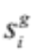 for the i^{th} hotspot region in gene g,
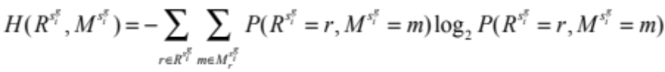 (Eq S12)
where 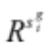are the set of residues in the hotspot region, and 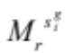is the set of alternative (mutated) amino acids for residue r. Because the maximum Shannon entropy grows with the number of residues in a region, the score is normalized so hotspot regions of different sizes can be compared,
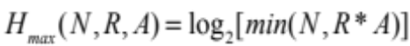 (Eq S13)
where N is the number of mutations in the hotspot region, R is the number of residues, and A is the number of possible alternate amino acids per residue. Since a single base substitution could at most change a reference amino acid to 3 alternatives per position within a codon, not all 19 alternative amino acids are possible. We chose A=6 alternative amino acids per residue, because often the third wobble position results in no change to the amino acid. The mutational diversity score was then:
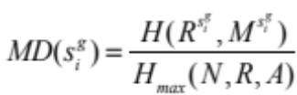 (Eq S14)
which ranged from 0 (all mutations in the hotspot region were the same) to 1 (every mutation was equally likely).

The mean vertebrate evolution conservation score, residue solvent accessibility, mutation net change in hydrophobicity, mutation net change in volume, occurrence at interface, CHASM and VEST score were computed for each gene-level hotspot region. For the interface feature, we computed the proportion of mutations occurring at an interface out of the total mutations at the interface.

Impact of large hotspot regions
To rule out the possibility that separation between OG and TSG hotspots was an artifact of a few very large hotspots in TSGs, we repeated our analysis, dropping any regions larger than 20 residues. This eliminated 10 hotspot regions, all of which were in TP53. The six features all remained statistically significant (region size p=0.009, mutational diversity p=0.001, vertebrate conservation p=0.003, residue solvent accessibility p=8.5E-05, mutation net hydrophobicity change p=3.3E-05, mutation net residue volume change p=3.1E-06; Mann-Whitney U test). Naive Bayes classifier performance decreased from ROC AUC of 0.84 (with the >20 residue hotspots) to 0.78 (with >20 residue hotspots removed). These results suggested that the 10 very large TP53 hotspot regions were most different from OG regions, but that the characteristic differences persisted, regardless if they were included or not.

Enrichment analysis of hotspot regions in TSGs
To assess the added value of 3D hotspot region detection beyond what was found with 1D approaches, the list of hotspot regions that were only identified in 3D was compared to a list of regions identified both in 3D and in 1D. An outcome of identified by both was defined as a case where the 1D algorithm found any region in the same gene that overlapped the 3D region by ≥1 residue position. A region was considered identified in 1D, if it was identified using any of the three 1D window sizes. To avoid over-counting of regions that occurred repeatedly in many tumor types, tumor-type-aggregated gene level regions were used in this analysis (Materials and Methods: Merging redundant hotspot regions), so that each region was represented once for each gene. A one-sided Fisher's Exact Test was used to assess enrichment of OG hotspot regions in the 3D-and-1D lists as compared to the 3D-only list.

Naive Bayes classification of 3D mutation hotspot regions
A Gaussian Naive Bayes classifier (scikit-learn Python package ) was trained to predict whether each 3D mutation hotspot region occurred in an OG or a TSG. The training set consisted of 114 tumor-specific, gene-level hotspot regions, labeled by their annotation in Cancer Genome Landscapes . Seventy-seven of the regions occurred in 54 annotated OGs, and 37 of the regions occurred in 71 annotated TSGs. Each 3D mutation hotspot region was represented by six features: region size, mutational diversity, vertebrate conservation, residue solvent accessibility, mutation net hydrophobicity change and residue volume change. A rigorous gene-holdout cross-validation protocol was applied to avoid overfitting. Sequentially each gene and its corresponding hotspot regions were held out from training, and then predicted as the test set.

References

1. Kandoth C, McLellan MD, Vandin F, Ye K, Niu B, Lu C, et al. Mutational landscape and significance across 12 major cancer types. Nature 2013;502(7471):333-9.
2. Pieper U, Eswar N, Webb BM, Eramian D, Kelly L, Barkan DT, et al. MODBASE, a database of annotated comparative protein structure models and associated resources. Nucleic acids research 2009;37(Database issue):D347-54.
3. Niknafs N, Kim D, Kim R, Diekhans M, Ryan M, Stenson PD, et al. MuPIT interactive: webserver for mapping variant positions to annotated, interactive 3D structures. Human genetics 2013;132(11):1235-43.
4. Wu CH, Apweiler R, Bairoch A, Natale DA, Barker WC, Boeckmann B, et al. The Universal Protein Resource (UniProt): an expanding universe of protein information. 2006.
5. Altschul SF, Madden TL, Schaeffer AA, Zhang J, Zhang Z, Miller W, et al. Gapped BLAST and PSI-BLAST: a new generation of protein database search programs. Nucleic acids research 1997;25(17):3389-402.
6. Kent WJ. BLAT--the BLAST-like alignment tool. Genome Res 2002;12(4):656--64.
7. Benjamini Y, Hochberg Y. Controlling the false discovery rate: a practical and powerful approach to multiple testing. Journal of the Royal Statistical Society Series B (Methodological) 1995:289-300.
8. Douville C, Carter H, Kim R, Niknafs N, Diekhans M, Stenson PD, et al. CRAVAT: cancer-related analysis of variants toolkit. Bioinformatics 2013;29(5):647-48.
9. Pruitt KD, Brown GR, Hiatt SM, Thibaud-Nissen F, Astashyn A, Ermolaeva O, et al. RefSeq: an update on mammalian reference sequences. Nucleic acids research 2014;42(Database issue):D756-63.
10. Farrell CM, O'Leary NA, Harte RA, Loveland JE, Wilming LG, Wallin C, et al. Current status and new features of the Consensus Coding Sequence database. Nucleic acids research 2014;42(Database issue):D865-72.
11. Cunningham F, Amode MR, Barrell D, Beal K, Billis K, Brent S, et al. Ensembl 2015. Nucleic acids research 2015;43(Database issue):D662-9.
12. Dreszer TR, Karolchik D, Zweig AS, Hinrichs AS, Raney BJ, Kuhn RM, et al. The UCSC Genome Browser database: extensions and updates 2011. Nucleic acids research 2012;40(Database issue):D918-23.
13. Carter H, Chen S, Isik L, Tyekucheva S, Velculescu VE, Kinzler KW, et al. Cancer-specific high-throughput annotation of somatic mutations: computational prediction of driver missense mutations. Cancer Research 2009;69(16):6660-67.
14. Carter H, Douville C, Stenson PD, Cooper DN, Karchin R. Identifying Mendelian disease genes with the variant effect scoring tool. BMC Genomics 2013;14(Suppl 3):S3.
15. Wong WC, Kim D, Carter H, Diekhans M, Ryan MC, Karchin R. CHASM and SNVBox: toolkit for detecting biologically important single nucleotide mutations in cancer. Bioinformatics 2011;27(15):2147-48.
16. Blanchette M, Kent WJ, Riemer C, Elnitski L, Smit AF, Roskin KM, et al. Aligning multiple genomic sequences with the threaded blockset aligner. Genome Research 2004;14(4):708-15.
17. Kabsch W, Sander C. Dictionary of protein secondary structure: pattern recognition of hydrogen-bonded and geometrical features. Biopolymers 1983;22(12):2577-637.
18. Pedregosa F, Varoquaux G, Gramfort A, Michel V, Thirion B, Grisel O, et al. Scikit-learn: Machine learning in Python. The Journal of Machine Learning Research 2011;12:2825-30.
19. Vogelstein B, Papadopoulos N, Velculescu VE, Zhou S, Diaz LA, Jr., Kinzler KW. Cancer genome landscapes. Science 2013;339(6127):1546-58.

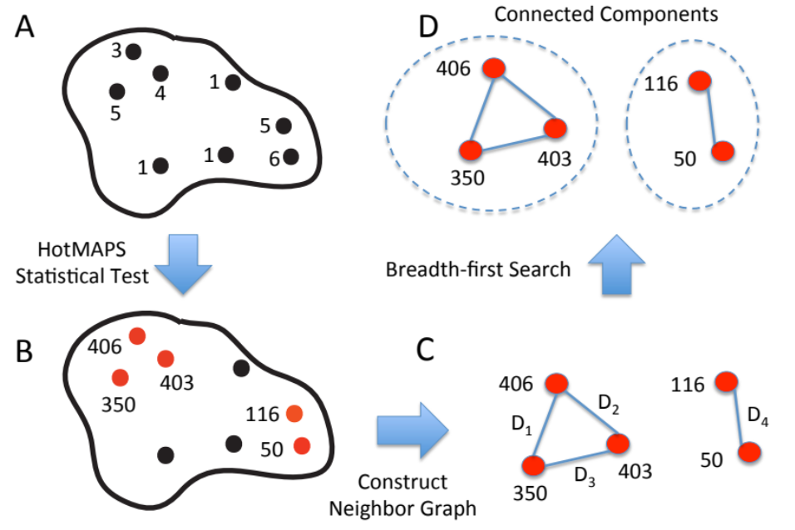

Fig S1: HotMAPS neighbor graph and connected components. In this toy example, a protein structure contains 8 mutated residue positions. A. Numbers indicate how many mutations occurred at each residue position. B. HotMAPS Statistical Test (Eq S8, S9 and S10) identifies five residue positions (with sequence numbering 50, 116, 350, 403, 406) having significantly increased mutation density (red). C. Neighbor graph is constructed with significant residues from B as nodes. Edges between the nodes (blue lines) are created if there is a pairwise distance Di between residue centroids <= 10 angstroms. In this case, D1 through D4 met the 10 angstrom threshold. D. Breadth-first search is used to identify connected components in the Neighbor Graph (outlined in dashes). Each connected component is an individual hotspot region in the protein structure.

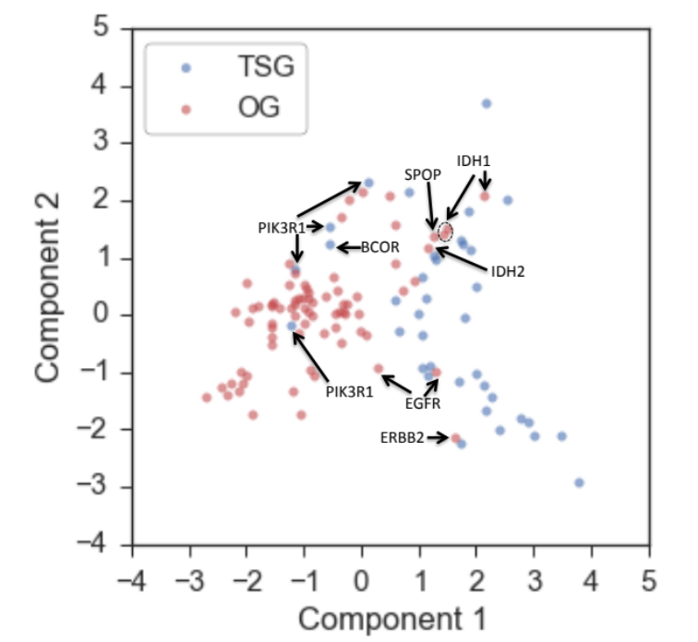

Fig S2: Eleven hotspot regions that are misclassified by Naive Bayes, according to Landscapes benchmark OG/TSG definitions. PCA plot of 114 tumor-type-specific regions in 19 OGs and 11 TSGs. Each dot is a region, and the Landscapes benchmark definitions are indicated by red (OG) and blue (TSG). The PCA plot is a dimension reduction of the six features used in the Naive Bayes classifier. A clustering pattern distinguishing OGs and TSGs can be seen, with indicated regions from genes in the "wrong" cluster.

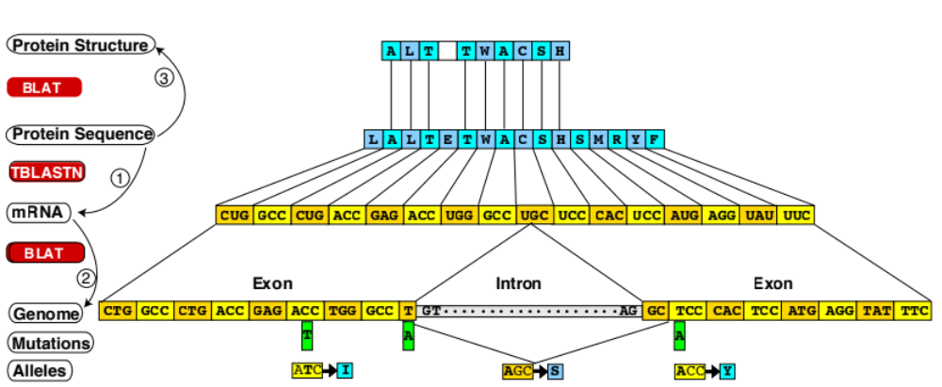

Fig S3. Mapping of genomic coordinates onto protein structures and models with a modified version of the TransMap algorithm. The mapping is done with three pairwise alignment steps, using tBLASTn and BLAT. Projection of protein sequence coordinates to mRNA transcript coordinates (1) and finally genomic coordinates (2) is done “top down”. The process enables handling of split codons, such as the “AGC” shown. Protein sequence coordinates are subsequently projected into the PDB coordinate system of protein structure (3).

Fig S4: Algorithmic flowchart for Hotspot Missense mutation Areas in Protein Structure (HotMAPS) algorithm. HotMAPS was run on 65,372 protein structures and models. For each structure or model k, mutations were mapped from TCGA genomic coordinates to 3D protein space and for each mutated residue, its observed local mutation density and empirical null were calculated. If p-values for the same residue differed across multiple structures/models, the minimum was used and adjusted for multiple hypotheses testing with the Benjamini-Hochberg algorithm. Hotspot regions were identified as connected components in a graph of significantly mutated residues.
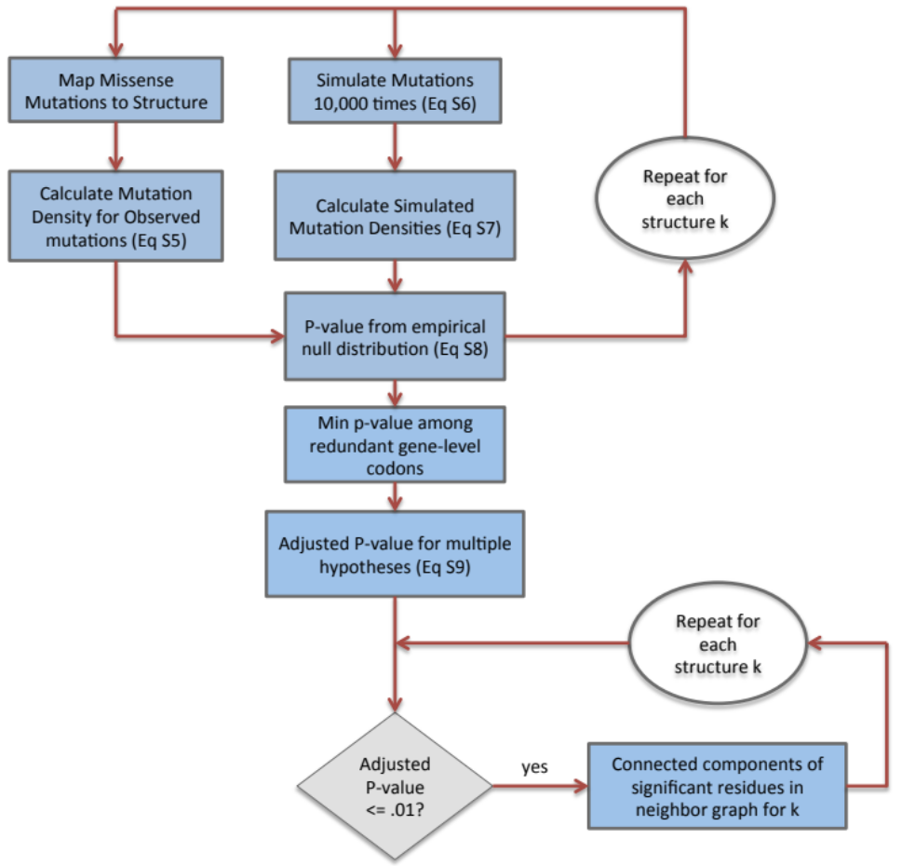
Fig S5: Example of unusual case where a single residue hotspot region can be found in 3D but not in 1D. Cartoon figure of a beta sheet conformation in protein 3D structure (black lines) with mutated residues shown as small circles containing the number of mutations. A. The center mutated residue has mutation density calculated by counting all mutations in a 10 angstrom sphere denoted by the large circle. The center residue is found to be significant by the 3D HotMAPS algorithm (colored red). B. Another mutated residue on the periphery is not deemed significant by 3D HotMAPS because there are not as many neighboring mutated residues. C. The 1D HotMAPS algorithm does not find any hotspot residues because the sequence window (rectangle) does not contain any neighboring mutated residues.

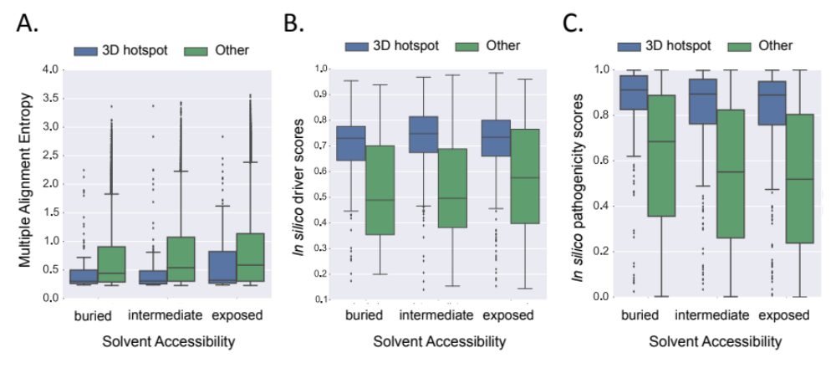
Fig S6: Solvent accessibility does not explain significant differences in vertebrate conservation, in silico driver scores, and in silico pathogenicity scores between mutated residues in HotMAPS 3D regions and other mutated residues. Even though conservation is correlated with solvent accessibility, differences in solvent accessibility do not explain the statistically significant differences observed. Shown are results after stratifying on whether a mutated residue is solvent exposed, intermediate, or buried. A. Hotspot regions are more conserved in vertebrate evolution (buried only: p=6.9E-06; intermediate only p=8.8E-12; exposed only: p=4.4E-08; Mann-Whitney U test) compared to other mutated residues. Multiple Alignment Entropy is calculated by the Shannon entropy of the protein translated 46-way vertebrate genome alignments from UCSC Genome Browser, which is a score that is lower for more conserved residues. B. Higher in silico driver scores from the CHASM algorithm (buried only: p=7.1E-10, intermediate only: p=6.1E-14; exposed only: p=1.1E-23; Mann-Whitney U test) compare to other mutations. C. Higher in silico pathogenicity scores from the VEST algorithm (buried only: p=2.2e-30, intermediate only: 6.9E-33, exposed only: 2.1E-50; Mann-Whitney U test) compared to other mutations.

