**Bamazon-cli Application**

**Customer View:**

Test Cases:

**Happy Path**

1. From the root directory bamazonCustomer.js, open git bash and enter***node bamazonCustormer.js***

Page displays the *products* table with a list of items and a user prompt to enter a *product_id*.

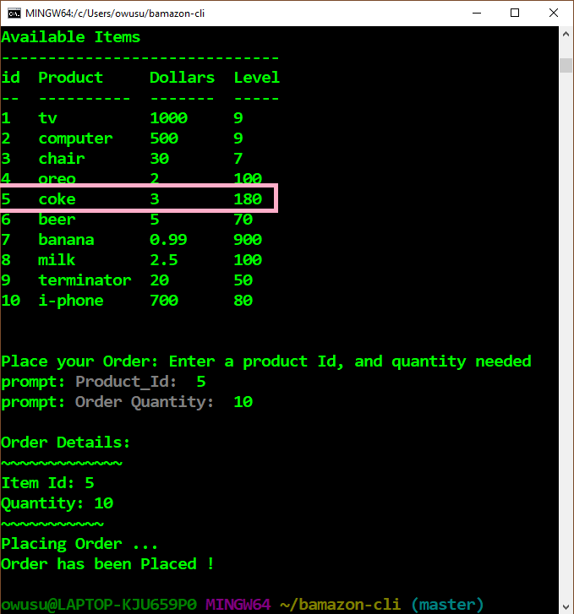

1. Run node bamazonCustomer.js again

-Verify the quantity of the product ordered above has been updated.

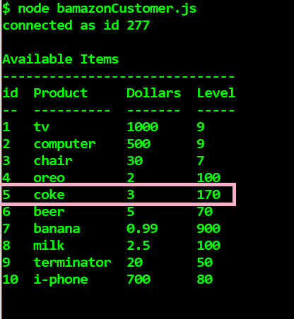

**Invalid Order Entry (invalid Quantity ordered)**

1. From the root directory bamazonCustomer.js, open git bash and enter *node* ***bamazonCustormer.js***
2. Enter a quantity greater than the stock level available.

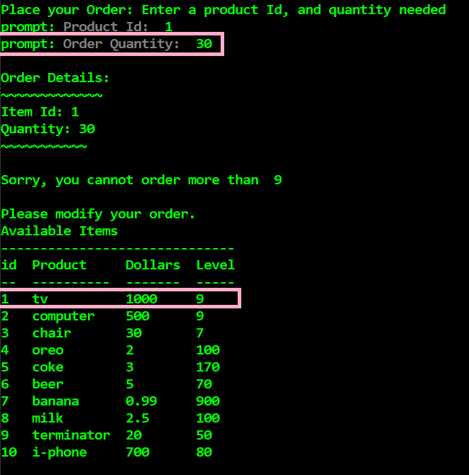

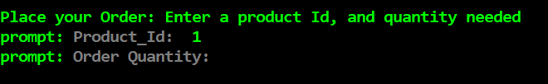

**Manager View:**

Test cases:

**Happy Path**

1. From the root directory bamazonCustomer.js, open git bash and enter***node bamazonManager.js***

Page displays a list of options; use the arrow keys to make a selection.

***Option 1: View Products for sale***

Description: This displays a table of all items in stock by: item_id, product_name, department_name, price, and stock_quantity.

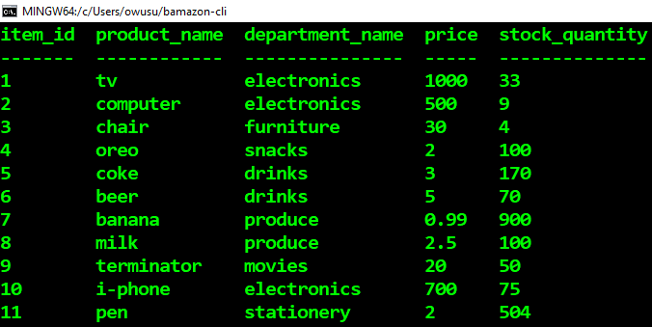

***Option 2: View Low Inventory***

Description: This displays a table of items with stock level below 5.

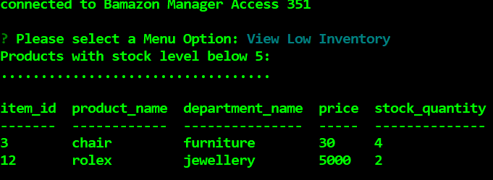

***Option 2: Add to Inventory***

Prompts user to update the stock level by specifying the item_id and quantity to be added.

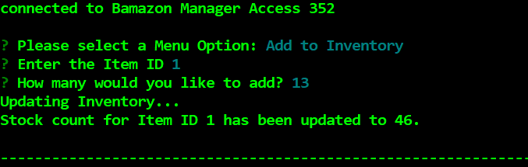

***Option 3: Add New product***

Prompts user to update the product by specifying a product_name, department_name, price and stock_quantity.

