In order to avoid misunderstandings, the following convention about the Euler and Cardan Orientation angles would be used in mrcore.

The mobile robot axis are:

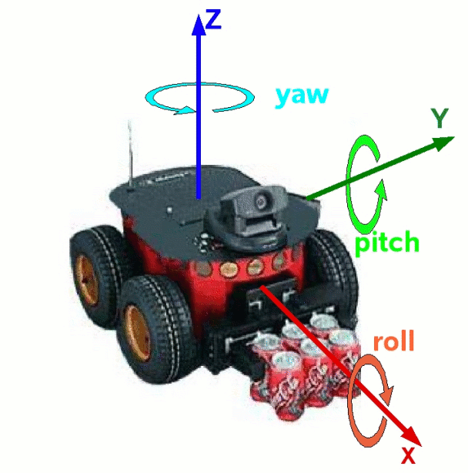

(Figure copied from player)

For orientation the mr uses the roll pitch yaw angles (XYZ convention)in a fixed world coordinate system. This is equivalent to euler angles (in a rotating coordinate system) in yaw pitch roll order (ZYX convention).

http://www.kuka.com/res/media/ef/armtutorial2/image165.gif

Where,

α is *yaw*

β is *pitch*

ϒ is *roll*.

It follows then that the rotation matrix has the following expression:

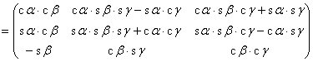

It represents (referred to intrinsic transformations):

The robot rotates *yaw* radians (α) around the Z axis. Then It rotates *pitch* radians (β) around its Y axis (therefore pitch is a measure of the horizontal slope in the forward direction of the robot. Finally rotate *roll* (ϒ ) radians around the X axis.

The same matrix represents a ϒ rotation (roll) around x, then a β rotation around the fixed Y, and finally a α rotation around the fixed Z axis.

As default, any function, method or constructor that requires the 3 orientation angles, they would be in the following order ROLL, PITCH and YAW (equivalent to Rotation X, Rotation Y, Rotation Z).

**Linear coordinate transformation**

http://www.kuka.com/res/media/ef/armtutorial2/image154.gif: = Basis vectors http://www.kuka.com/res/media/ef/armtutorial2/image155.gifof the new coordinate system

http://www.kuka.com/res/media/ef/armtutorial2/image156.gif: = Transformation matrix http://www.kuka.com/res/media/ef/armtutorial2/image157.gif

Coordinate transformation matrix:

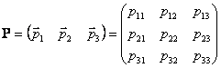

[1]

Coordinate transformation:

http://www.kuka.com/res/media/ef/armtutorial2/image159.gif

[2]

Orthogonality:

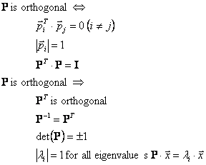

[3]

Coordinate system orientation:

http://www.kuka.com/res/media/ef/armtutorial2/image161.gif

[4]

Rotational transformation around axis x:

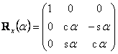

[5]

Rotational transformation around axis y:

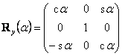

[6]

Rotational transformation around axis z:

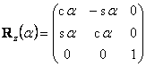

**Roll, pitch and yaw (RPY) angles**

RPY - rotation matrix (X, Y', Z'' rotation):

http://www.kuka.com/res/media/ef/armtutorial2/image165.gif



[8]

RPY angles from rotation a matrix http://www.kuka.com/res/media/ef/armtutorial2/image124.gif:

http://www.kuka.com/res/media/ef/armtutorial2/image167.gif

