GROUP 56 ICG GROUP PROJECT

GROUP MEMBERS

-FRANS NEKONGO 221004351(CREATION OF MODULES, FUNCTIONS, WEBSITE, PSEUDOCODE{TXT,PSEUDO},README,LINKS,co-creator of AYESHA BEAUTY CREATION DATABASE)

-TWAHAFA MWAETAKO 221087052(CREATION OF FLOWCHARTS)

- MITCHUM JANUARIE 221049924(co-creator OF DATABSE)

- BONIFATIUS SINONGE SINONGE 219050538(group member)

AYESHA BEAUTY APPLICATION

* Procedure AYEbeuaty(beauty, personal care, cosmetic sector)
* **Let** b= “beauty”, p= “personal care” and c= “cosmetic sector)

${B ←B}_{1}*B_{2}$

${ p}_{1}, p_{2 }←P$

${ b}_{1}, b_{2 }←B$

${C(p}_{1}, b_{2}) 0, i=0, j=0$

1. **repeat**
$i←i+1, { j}_{ }←j+1$

3. **for ${ b}_{1}, b_{2 }$** **do**
4. Determine scenario ϵ [1,6]


${ p}_{1}, p_{2 }←P\left(c` \right| c, { b}_{1}, b_{2 })$

${ b}_{1}, b_{2 }←B$

$\max_{b_{1}, b_{2 }}\left({ p}_{1}, p_{2 }{ b}_{1}, b_{2 }\right)$

8. **for ${ p}_{1}, p_{2 }$** **do** check
9. **if ${ d(p}_{1}, p_{2 })≤scenario threshold$** **then**
10. Update $ϴ_{i}, ϴ_{j }$ using ${ d(p}_{1}, p_{2 })$
11. **end**

pseudocode

STORE

 sales(){

   start

     prompt for username

       get username

         display items_in_stock

           if item is wanted

             add to cart

           else if

             cancel

           end if

         end

       end

     end

   end

  }

 pre_order(){

   start

     prompt username

       get username

         display items in data.pre_order

            if item is wanted add to cart

            else if cancel

           end if

         end

       end

     end

   end

  }

 items_in_stock(){

   start

     prompt for item code

       get iem code

         search data.stock for item code

           if item code visable

             print "item is in stock"

           else print"item not in stock"

           end if

         end

       end

     end

   end

  }

 new_arivals(){

    start

      prompt for item code

        get item code

          save item code to data.items_in_stock

         end

       end

     end

   end

  }

  remove_item(){

    start

      prompt item code

        get item code

          prompt data.items_in_stock for item code

            remove item code from data.items_in_stock

           end

         end

       end

     end

   end

  }

COMMUNITY HUB

 social_media(){

   start

     prompt for link

       get link

         redirect to account

         end

       end

     end

   end

 }

 website(){

   start

     prompt for link

       get link

         redirect to website

         end

       end

     end

   end

 }

HELP

 frequently_asked_questions(){

   start

      prompt question

        get question

            prompt FAQ.data for question

              if question present in FAQ.data

                prompt FAQ.data for answer to question

                  get answer

                    display answer

             else if save question to FAQ.data

               save question to FAQ.data_pending answer

                 display "question is being proccesed will get back to you shortly"

                end

             end if

           end

         end

      end

   end

  }

 AI assistant(){

   start

     launch AI

     end

   end

 }

REWARDS

 subscriptions(){

   start

     prompt for username

       if username found

         redirect to purchase track

       else if

         prompt for username=x

           insert value for x

             create username

               add username to data.subscription

             end

           end

         end

      end if

     end

   end

  }

 purchase_track(){

   start

     prompt for subscription for username.purchases

       get username.purchases

         display username.purchases=<60

           if purchases<=60 are ==4

             give discount of half for (1)product

             end

           end if

         end

       end

     end

   end

 }

FEEDBACK

 review(){

   start

     prompt username

       display star system

         enter value =<1 or >=5

           submit value

             enter comment

               save comment to data.comments

                 display "thank you for the review it is highly appreciated"

                 end

               end

             end

           end

         end

       end

     end

   end

  }

 survey(){

   start

     display questionare

       prompt answer questionare

         get answer

           save answer to data.questionare

           end

         end

       end

     end

   end

 }

HUMAN RESOURCES

  customer_care_line(){

    start

      display "TEL:+264-61-2367395

      end

   END

  }

  complaints(){

    start

      prompt for comment

        get comment

          save comment to comment.data_pending

          end

       end

     end

   end

  }

*FLOWCHARTS*

***STORE***

ITEMS_IN_STOCK()

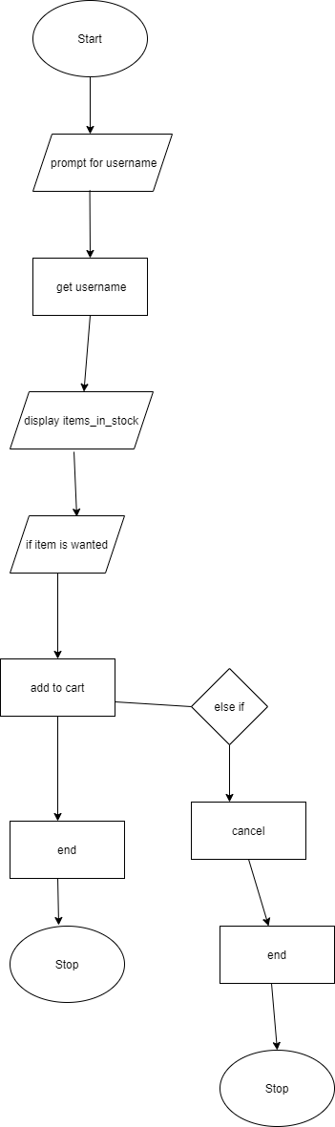

PRE_ORDER()

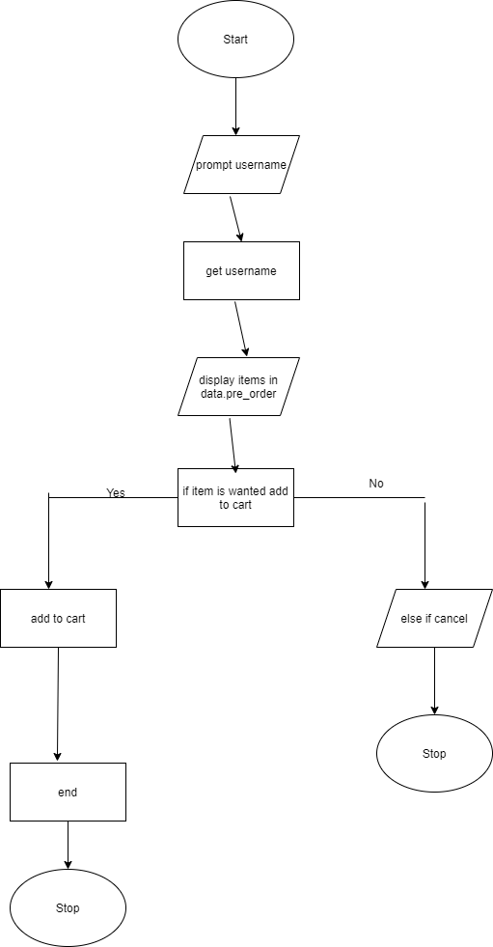

ITEM_IN_STOCK()

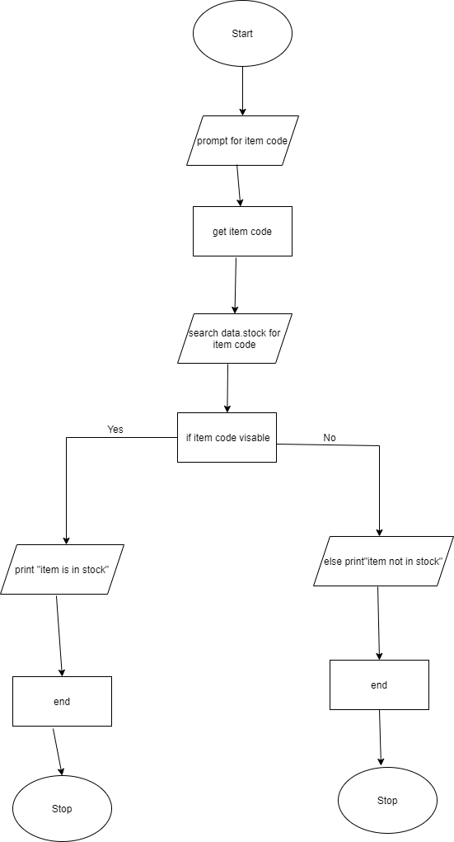

NEW_ARIVALS()

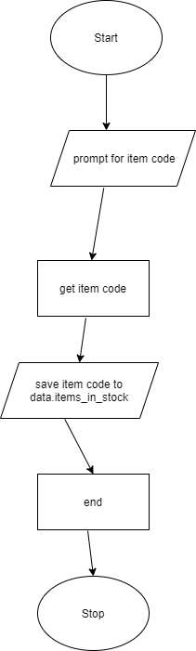

REMOVE_ITEM()

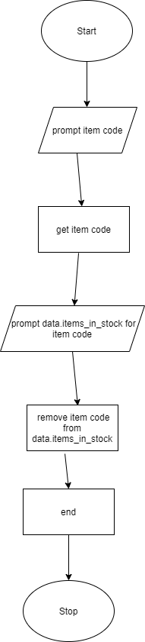

***COMMUNITY HUB***

SOCIAL_MEDIA()

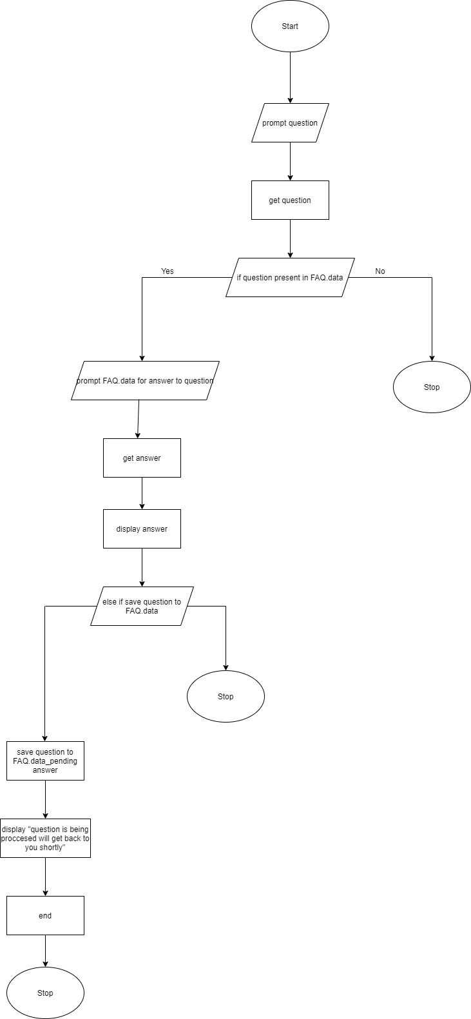

WEBSITE()

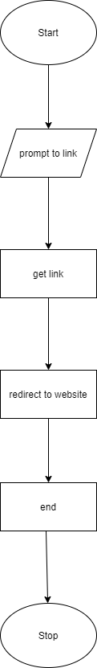

HELP

AI_ASSISTANT()

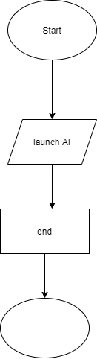

REWARDS

SUBSCRIPTION()

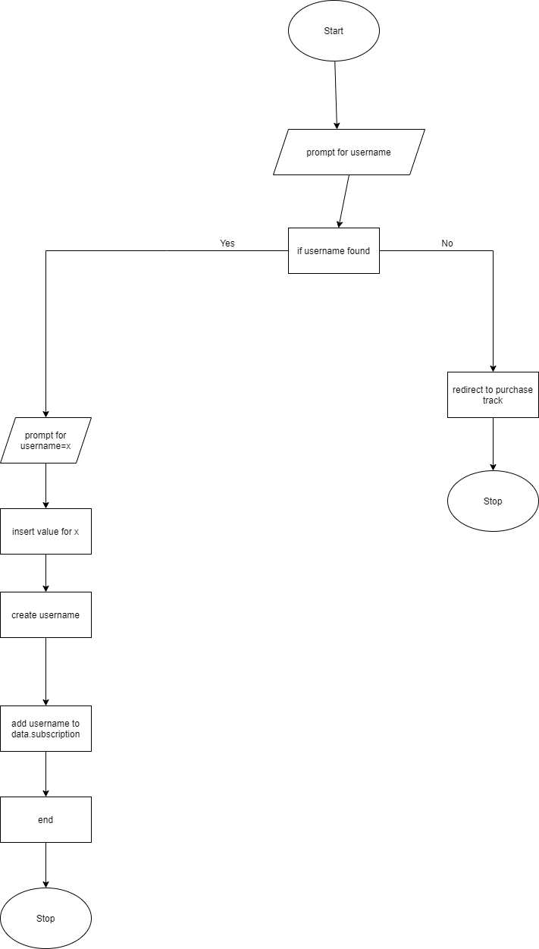

PURCHASE TRACK()

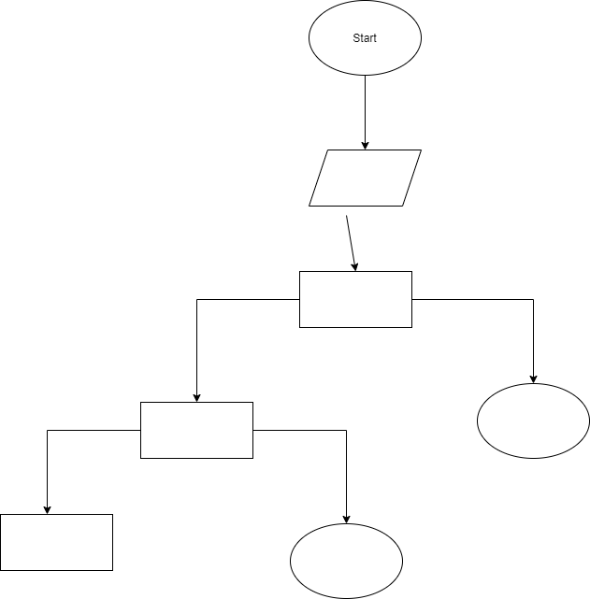

FEEDBACK

REVIEW()

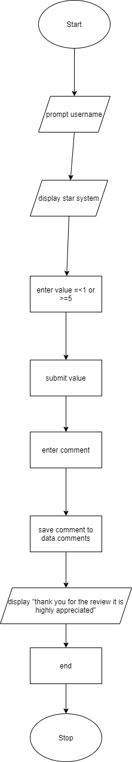

SURVEY()

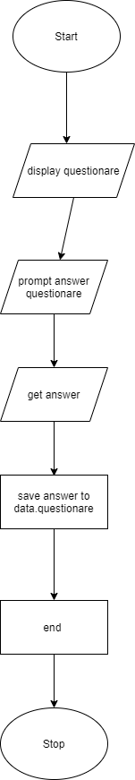

HUMAN RESOURCES

CUSTOMER_CARE_LINE()

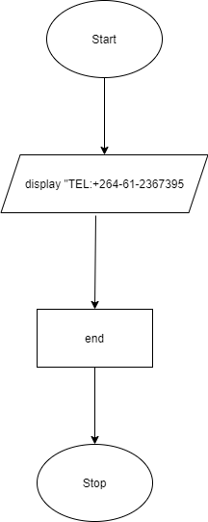

COMPLAINTS()

