${diagram.name}

Rootpackage = ${rootPackage.name}

[#list rootPackage.diagrams as diagram]

${diagram.name}

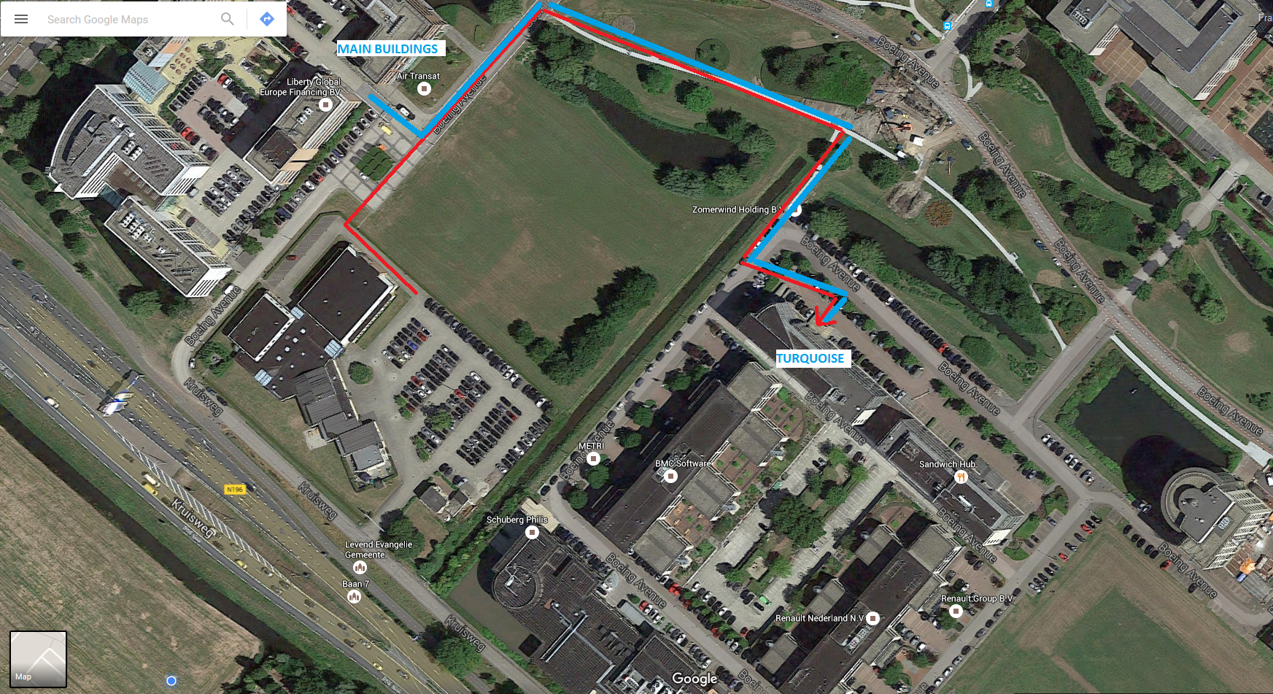

${connector.name} | ${connector.client.classifier.name} | ${connector.supplier.classifier.name} | ${connector.notes}

[/#list]

