${diagram.name}

Solution Design

Rootpackage = ${rootPackage.name}

[#list rootPackage.diagrams as diagram]

${diagram.name}

Landscape

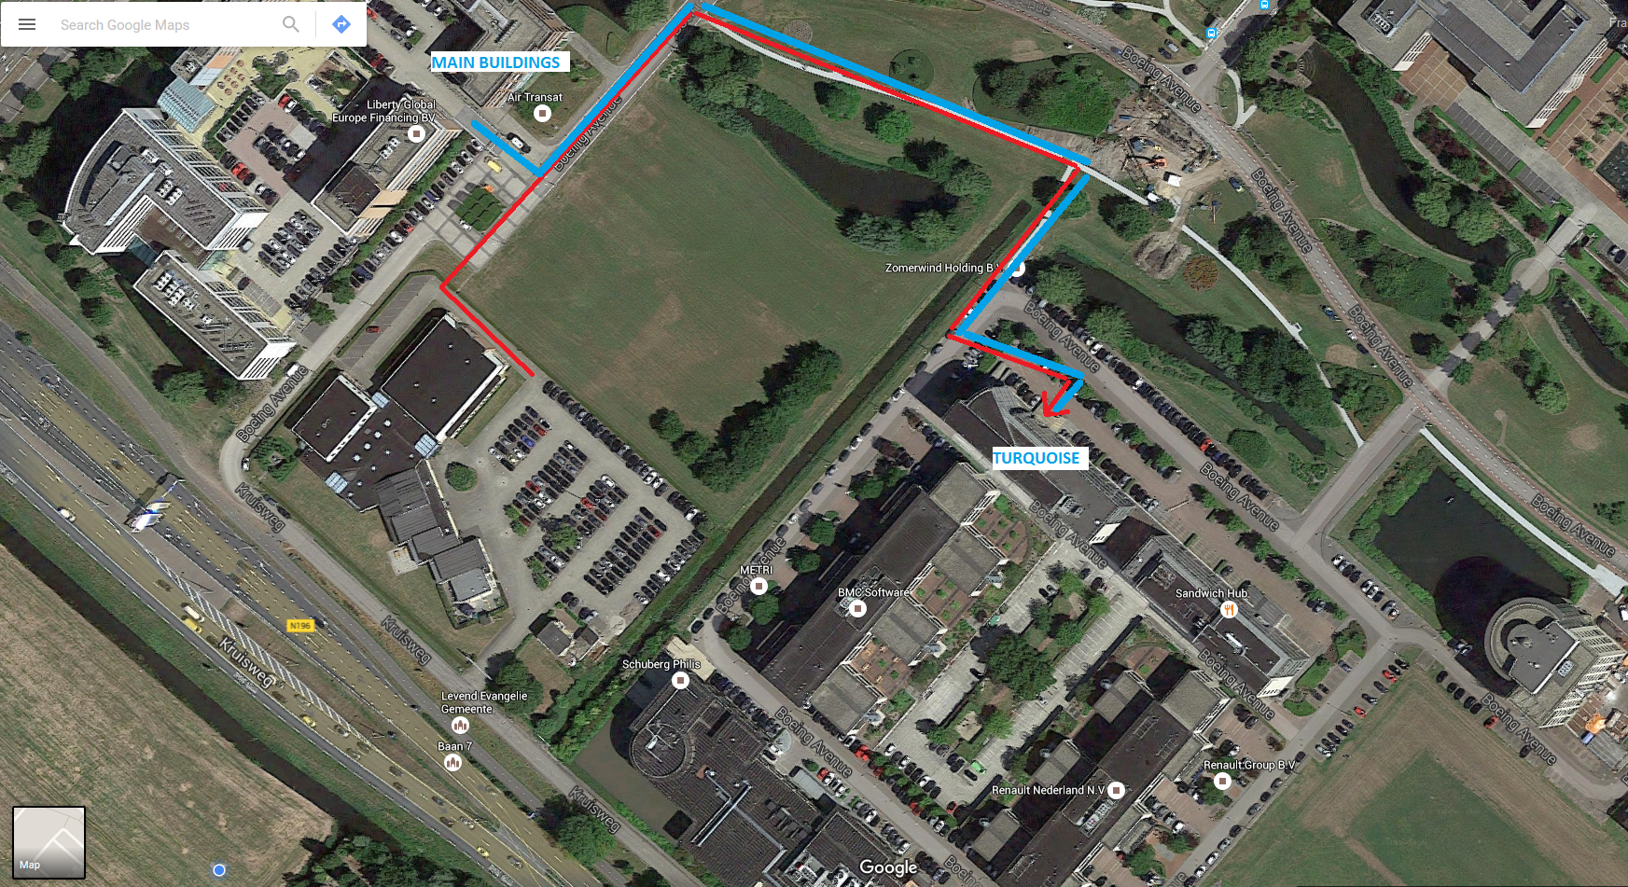

Interface Table

ID | From | To | Notes
${connector.name} | ${connector.client.classifier.name} | ${connector.supplier.classifier.name} | ${connector.notes}

Application Overview

Name | Notes | Countries | Impact | Delivered By
${object.element.classifier.name} | ${object.element.classifier.notes} | ${tag_by_name(object.element.classifier.taggedValues, "tenancy")} | ${object.element.version} | ${tag_by_name(object.element.classifier.taggedValues, "provider")}

Components
[#list diagram.diagramObjects as object]
[#if object.element.type == "Component"]

${object.element.classifier.name}

Description
${object.element.classifier.notes}

Impact
${object.element.notes}

[/#if]
[/#list]

[/#list]

