[#assign diagram = rootPackage.diagrams[0]]

Application Landscape

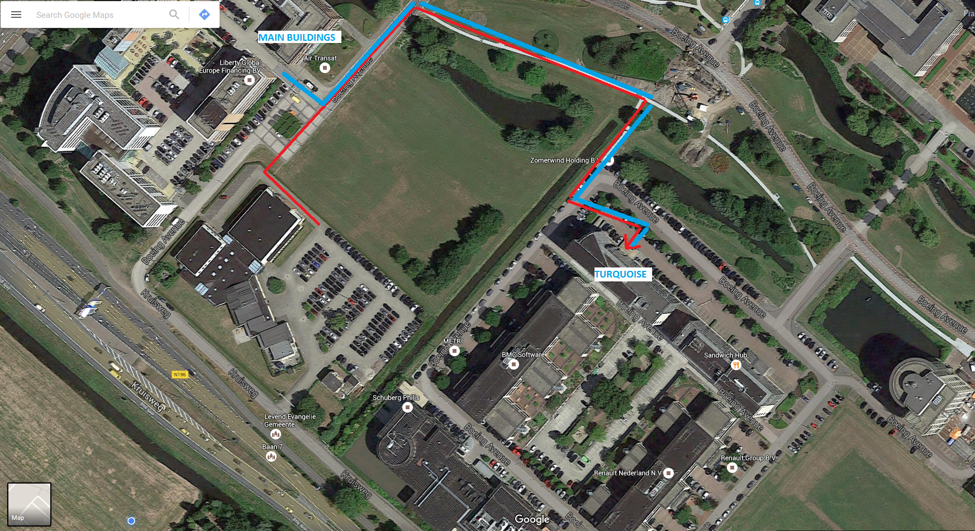

Interface Overview

ID | From | To | Notes
${connector.name} | ${show_name(connector.client)} | ${show_name(connector.supplier)} | ${connector.notes}

Application Overview

Name | Notes | Countries | Impact | Delivered By
${element.classifier.name} | ${element.classifier.notes} | ${show_tag(element.classifier, "tenancy")} | ${element.version} | ${show_tag(element.classifier, "provider")}

Components
[#list collect_component_elements(diagram) as element]

${element.classifier.name}
Description
${element.classifier.notes}
Impact
${element.notes}
[/#list]

