FAHA – Assignment 02

# Question 1: Understanding

I drew the graph in the R software. Here is the code used for the creation, followed by the graph itself.

library(tibble)  
library(ggplot2)  
corrs = c(rep(0, 29), seq(0, 0.62, 0.02), seq(0.64, 0.355, -0.015))  
df = tibble(years = 1940:2020, trend = corrs + 0.05, corrs = corrs + runif(81, 0, 0.1))  
  
ggplot(data = df, aes(x = years, y = corrs)) +  
 geom_line(linetype = 1) +  
 geom_line(aes(y = trend), color = 'blue', linetype = 2, size = 1.5 ) +  
 geom_vline(xintercept = c(1969, 2001), color = "red", linetype = 3) +  
 annotate("text", x = 1969, y = 0.75, label = "Since 1969 the correlation increases.",   
 color = "darkgreen") +  
 annotate("text", x = 2001, y = 0.05, label = "Since 2001 the correlation decreases.",   
 color = "darkgreen") +  
 annotate("text", x = 1954, y = 0.25, label = "Indiference period\n(1940-1969)") +  
 annotate("text", x = 1980, y = 0.55, label = "Differentiation period\n(1970-2000)") +  
 annotate("text", x = 2010, y = 0.25, label = "Equitation period\n(2001-2020)") +  
 labs(title = "Changes in average correlation between the gender of author and  
the presence of selected signalling words in blurbs over the course of time",  
 x = "Year of books' publication",   
 y = "Correlation between the gender of author  
and the presence of signaling words",  
caption = "Note: The dashed blue line indicates longitudinal trend in average correlation.  
The solid black line indicates average correlation for respective year.") +  
 theme_minimal()

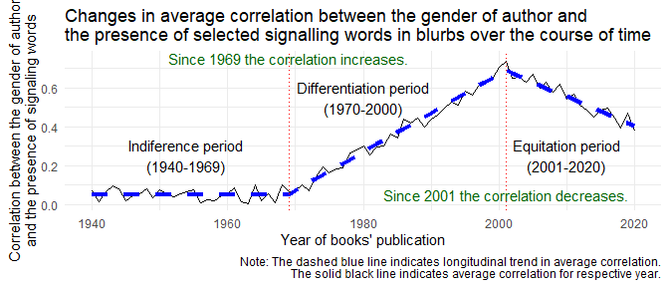

# Question 2: Application

## Question 2.1 – Novelty in the set of blurbs

### Mesuring novelty

We could measure novelty by finding new metaphors. More precisely, we could count how many new metaphors not used in past 5 years before blurb’s publication the blurb contains.

### Scenario description

The main idea is that raw reviews from academics and in newspapers are same, but a marketing department of publishing house chooses blurbs from raw reviews differently. My scenario is inspired by Simon’s lecture, specifically by his citation of Rebecca L. Spang’s e-mail (<https://youtu.be/8rDUREWVnEM?t=808>). Let’s suppose for the simplicity that the newspapers’ and academics’ reviews contain same number of new metaphors, i.e. the raw material for blurbs is homogeneous. But then the marketing department takes its turn – it excerpts for blurbs more often the passages with new metaphors from academics’ reviews and more often the passages with old, conservative and mainstream metaphors from newspapers’ reviews. The reason for the difference in blurbs is the strategic selection of the publishing house’s marketing department, not the differences in raw reviews.

### Why does the scenario emerged?

The root of scenario is the marketing department’s expectations of the public’s expectations. The employees in marketing department think that the public associates universities, academia and academics with novelty, reaching new horizons, inventions, ground-breaking theories etc. That is why they preferably excerpt the novel metaphor from academic’s review for the blurb, because it is coherent with novelty expectation of the public expected by marketing department. On the other hand the marketing department thinks that the public associates newspapers with mainstream, conservative, time-tested and solid ideas. That is why they preferably excerpt the old metaphors from newspaper’s review, because it is coherent with the solidity expectation of the public expected by marketing department. Expectations of expectations lead to strategic selection.

## Question 2.2 – Novelty and imitation across institutions

### Description of imitation and novelty

For distinguishing imitation and novelty we again use the 5 years window. The novelty we measure as a count of the metaphors not used in other blurbs in the 5 years before the publication of respective blurb. The imitation then we measure as a count of the metaphors that have been used in the 5 years before the respective blurb’s publication.

### Scenario description

### Why does the scenario lead to the imitation-versus-novelty pattern?