**Using the requirements below do next:**

- perform the requirements analysis (use criteria of good requirements)

- mark and evaluate defects

- write questions to Customer (up to 5 questions).

**Task *: Rewrite the requirements without bugs**

**Subject: Group_N Home_Task #3**

Questions to Customer:

1. I would like to clarify what problem will solve this “Family Database” application in your processing?
2. May I know who and where will use application?
3. I wonder is it separate application or it may be a part of complex data solution?
4. Let’s clarify the situation if family composition was changed or if family is incomplete?
5. I wonder why do you need to know height for Child (this data is changeable)?

**Requirements for the application under development**

**General conditions: The application is designed to collect information about the family, i.e. husband, wife, children. The application language is English.**

“*i.e.*” - unambiguousness

**1.** The application must support all versions of all operating systems.

“*must support all versions of all operating systems*” - feasibility, completeness

*Where will the application be runed (on personal computer, laptops, smartphones, tablets)*

*By “all versions” it is meant mostly widespread nowadays like Windows 10, Linux Ubunty18.5 and Apple OS for mac? Or you mean “old versions” like Windows XP or old versions of Linux Ubuntu required to be supported too?*

**2.** Information about each family ("family database") should be stored in 1 file, which can be saved with empty fields.

“*1 file, which can be saved with empty fields*” - completeness

*What should be the type of saved file (.doc,.txt)? Where should this file be saved (database, desktop)? What fields can be empty? What if all fields are empty?*

**3.** Several applications should be able to work simultaneously.

“*Several*” - unambiguousness

*Can one family card be open in different applications at same time?*

**4.** After starting the applications, the window should contain a menu with three standard buttons with tooltips ("New Database", "Open Database", "Save Database"). The "General" tab should be selected by default (see Figure 1).

“*see Figure 1*” - consistency

“*standard buttons with tooltips*” - unambiguousness, completeness

*Where is figure 1? How should we start the application? What is “standard button”? What is “General” tab? “New database” means a card for new family? What will be the name of buttons? Where should tooltips be shown?*

**4.1** These ("New, Open, Save") buttons should also be available for the other three tabs: "Husband", "wife", "Children". The "Save" button should not be available until the user clicks on the "New" or "Open" button.

“*wife*” - correctness and verifiability

"*New, Open, Save*" - consistency

“button should not be available” - completeness

**5.** To create a new family database, the user must click on the "New" button. The user can fill in the family description ("Description", see Appendix 2) and select the wedding date ("Date of marriage") using the calendar "Calendar" (Appendix 1).

“*see Appendix 2*” - correctness

“*fill in the family description*” - completeness

*What format of calendar should be dd/mm/yy or mm/dd/yy? Description or General? What should be in family description. Family name?*

**6.** To open an existing database, the user must click on the "Open" button, select a file in the dialog form and click "OK".

“*an existing database*” - completeness

*What types of files should be supported? What is we choose the file of wrong type?*

**6.1** If the user edits a new (or open) database, and then clicks on the "New" or "Open" buttons, the application should offer to save the current database (changes).

**7.** To save the current family database, the user must click "Save".

**7.1** The name of the saved database should be clearly visible.

“*clearly visible*” - unambiguousness

*Clearly visible where?*

**7.2** If the new database has not yet been edited, the "Save" button should not be available.

**7.3** If the user tries to save the database file under the name of an existing file, the application should display a warning (we’ll come up with a text later).

“display a warning” - completeness

*What is the naming standard of saving files? When later?*

**8.** Optionally, the application should support multiple languages.

“*multiple languages*” - unambiguousness, completeness

*What exactly languages should be supported? In what countries application will be used?*

**9.** The application should only allow filling in family data and storing such data. The application should not allow working with previously created family databases.

“*such data*” - unambiguousness

“*should not allow working with previously created family databases*” - modifiability

*What means work with previously created database? Created where?*

**10.** To enter information about the husband, the user must go to the "Husband" tab (see Figure 2)

“*Figure 2*” - correctness

*Appendix 2?*

**10.1** The following information can be stored about the husband: Name, Patronymic, Surname (see Appendix 3), birthday (Appendix 1).

“*Patronymic, Surname*” - correctness

“*(see Appendix 3), birthday (Appendix 1)*” - correctness

*No Patronymic field, husband card Appendix 2.*

**10.2** The "Age" field must have a default value. Field age should be R/O. Its value should be calculated as soon as the "Birth Day" field is filled.

“*should be R/O*” - unambiguousness

*R/O means read only?*

**11.** The application must support the functionality of entering and saving complete information about the wife.

“*information about the wife*” - completeness

*Card Wife should have same fields as card Husband?*

**12.** To enter information about children, the user must go to the "Children" tab (see Appendix 3).

“*to the "Children" tab*” - correctness

**13.** The table with the list of children (2 rows and 3 columns) should be empty for the new database. These three columns should have the names "Name" and "Height", respectively.

“*2 rows and 3 columns*” - correctness, completeness

*These three columns should have the names "Name" and "Height"* - completeness

"*Height*" - completeness

*What is the third column (birth date)? What is the measure of height (cm, inch)? What is we have more kids? Should there be a gender field?*

**13.1** Cells in the table cannot be edited, but they can be selected.

“*but they can be selected*” - feasibility

*Selected name field?*

**14.** User can add more than one child

“*add more than one child*” - completeness

*In what way? Can we delete child?*

# Appendix 1

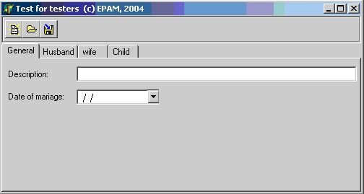

Appendix 2

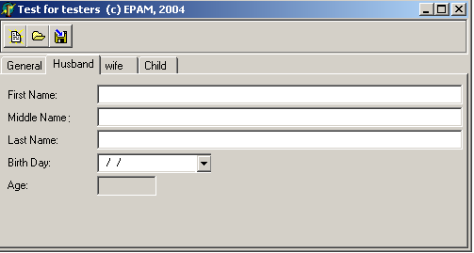

Appendix 3

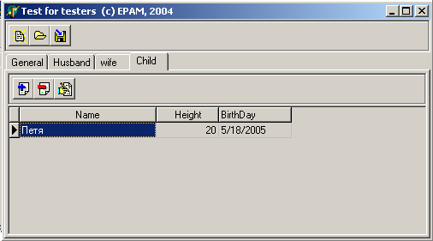

**Requirements “Family Database”**

*(after additional interview)*

Background: Requirements for the application under development

Purpose: To organize both development and testing process

Scope: Business requirements, user requirements

Audience: Management staff, project team

File: Family Requirements Database.docx

1. Project scope

Development of a tool to:

* + Collect information about family;
  + Use this information in working process;

1. Main goals

* + Provide the Customer with a quick and simple tool to create a family database in his procession.
  + Give the Customer possibility to create family database, modify family composition (husband, wife, children) and data.
  + Up to 5 applications should be able to work simultaneously.
  + The tool should not fail (for any reason) during its working process.

1. Criteria for main goal achievement
   * Application will be used only on Windows 10 operational system.
   * The application language is English.
   * All input fields should have correct input requirements. English letters for Description, First Name, Middle Name, Last Name. No other alphabets will be used.
2. Risks
   * Incorporate in existing database system of Customer processing.
   * Security (private information). Only director has full access.
3. System characteristics
   * SC –1: The application should run in Windows 10 environment. Will be started from icon on Desktop.
   * SC – 2: Application should be run by Python and Tkinger package.
   * SC – 3: The database should be integrated with customer MySQL database.
4. User requirements:
   * UR – 1: Start and stop the application.
     + UR – 1.1: The application should be started from pressing twice by left mouse button on application icon on Desktop.
     + UR – 1.2: The application shutdown by pressing close X sign at the top-right corner of window. Standard for Windows applications. Application asks to save before quit if has unsaved data.
   * UR – 2: The applications should save log file in setting folder. Accesible only for director.
   * UR – 3: User can create New Database by chosen New Database button. User can open existing database by pressing Open Database button. User can save opened database by pressing Save Database button.
   * UR – 4: User can fulfill and modify General (Appendix 1).
     + UR – 4.1: User can add Description. Up to 240 english letter symbols (UTF-8);
     + UR – 4.2: User can choose date of Marriage from Calendar in format DD/MM/YY:
   * UR – 5: User can fulfill Husband (Appendix 2) and Wife window (same interface as Husband):
     + UR – 5.1: User can enter Husband First Name, Middle Name, Last Name (only modern english letters, word from Title letter);
     + UR – 5.2: user can choose Birth Day from Calendar. Age will be added automatically. Field Age is not editable, read only R/O.
   * UR – 6: User can fulfill Children window (Appendix 3):
     + UR – 6.1: User can add a Child pressing Add Child button. User can delete a child pressing Delete Child button. User can edit Child card (height) pressing Edit Child button.
     + UR – 6.2: User chooses Child Birth Date from Calendar.
5. Business rules
   * BR – 1: User can save database with only one parent. Second parent fields can be empty. For incomplete family.
   * BR – 2: The application should be accessible only for authorized in Windows 10 system users.
   * BR – 3: The database should be accessible in CSV format for director.
6. Quality attributes
   * QA – 1: Database should be backuped every 2 days.
   * QA – 2: If the user edits a new or already opened database and then click on the New Database or Open Database button, the application should offer to save the current database (changes).
   * QA – 3: Up to 5 applications should be able to work simultaneously.
7. Limitations
   * L –1: The applications should be developed using Python as the Customer has Python specialist in office.
   * L –2: See QA –3.
8. Detailed specifications
   * *In process*