TA Hometask 1
(Frants Lis)

- //div[@id='nav-global-location-slot']
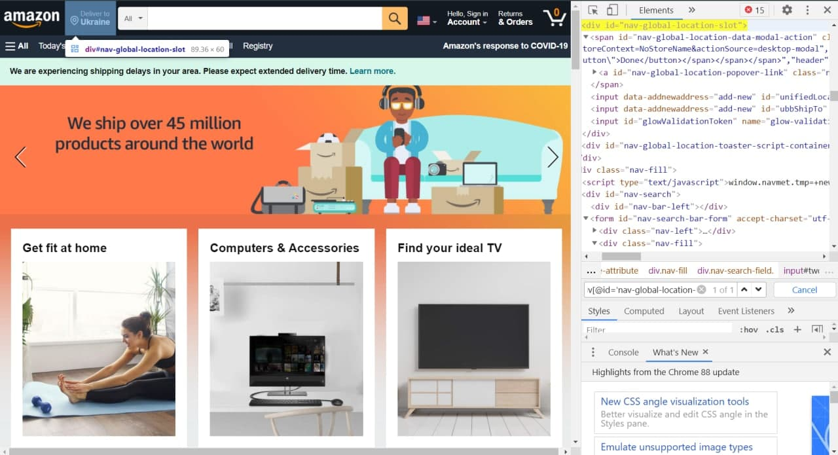

- //input[@id='twotabsearchtextbox']
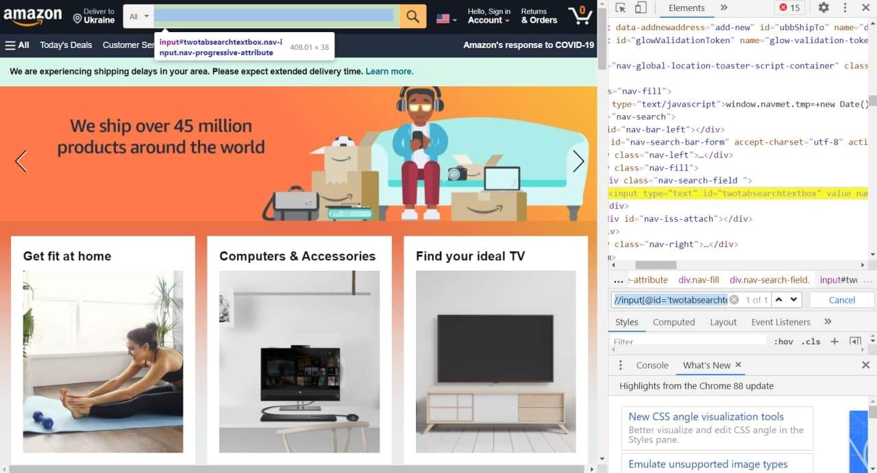

- //span[@class='a-size-base']
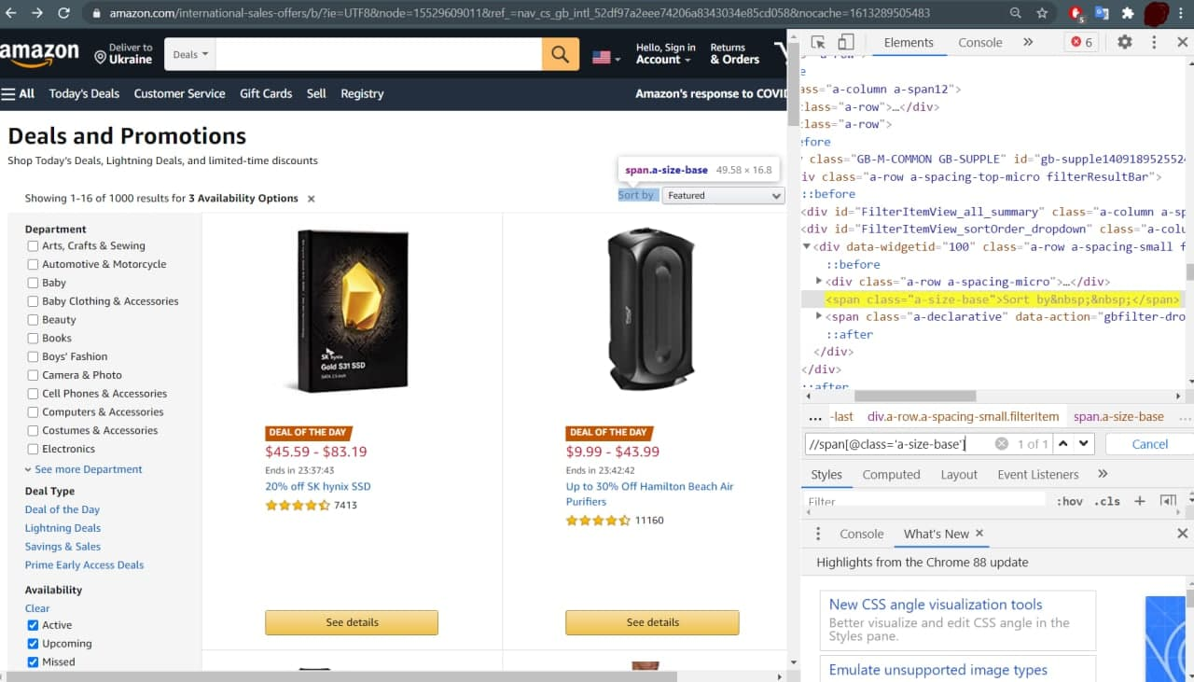

- //div[contains(@class,'vxd-music-bs ')]
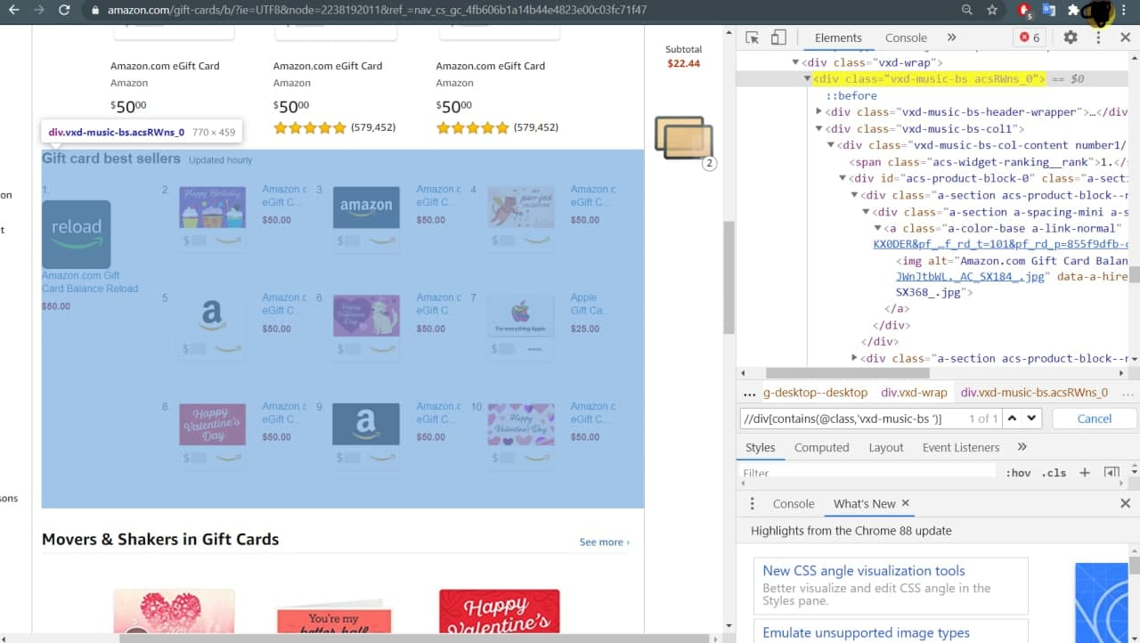

- //span[@class='a-list-item']/div[contains(@class,'a-section ')]/input[contains(@class,'a-declarative ')]
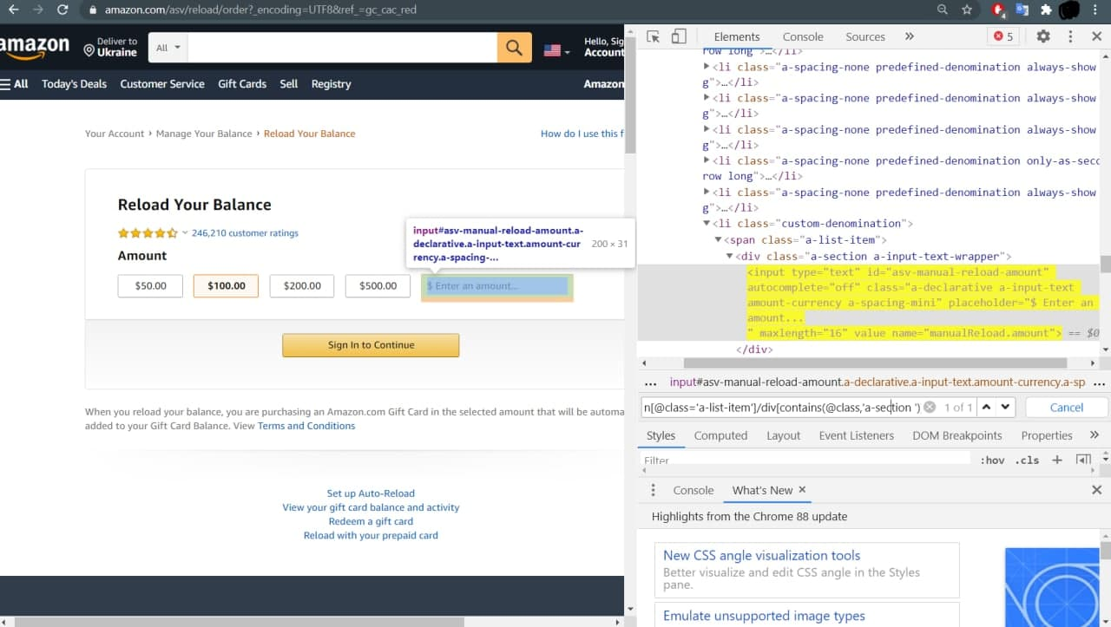

- //span[@id='icp-subtitle']
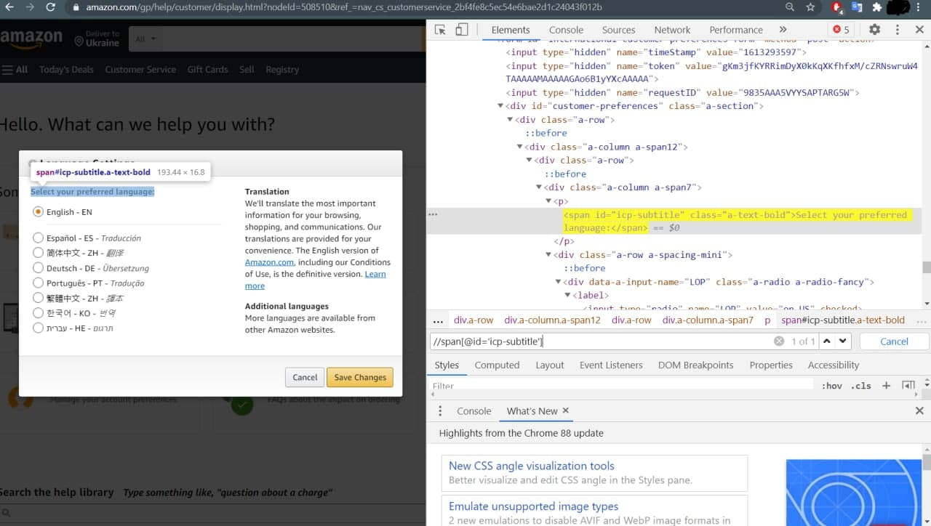

- //img[contains(@alt,'Digital')]
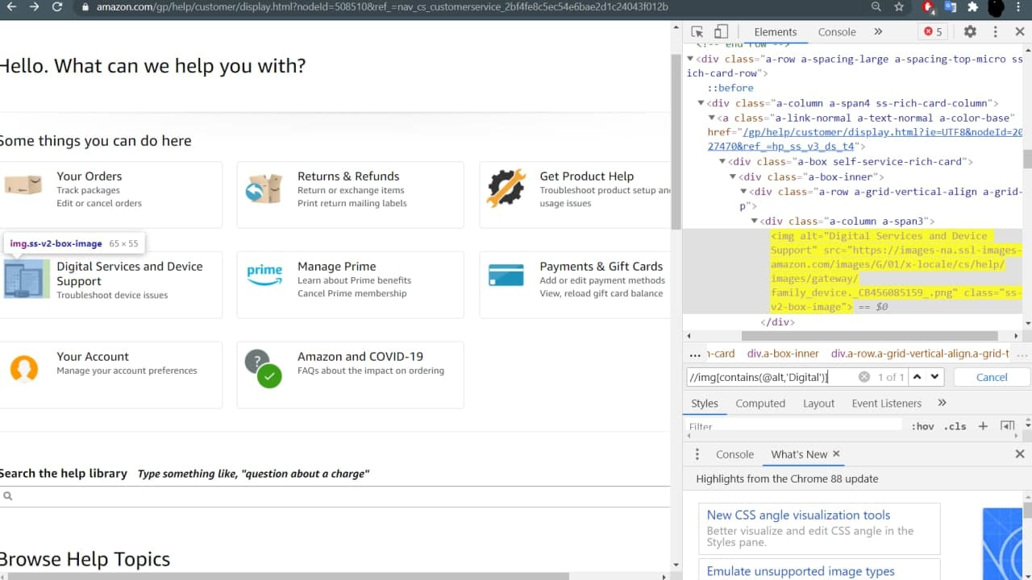

- //a[contains(@class,'link button')]
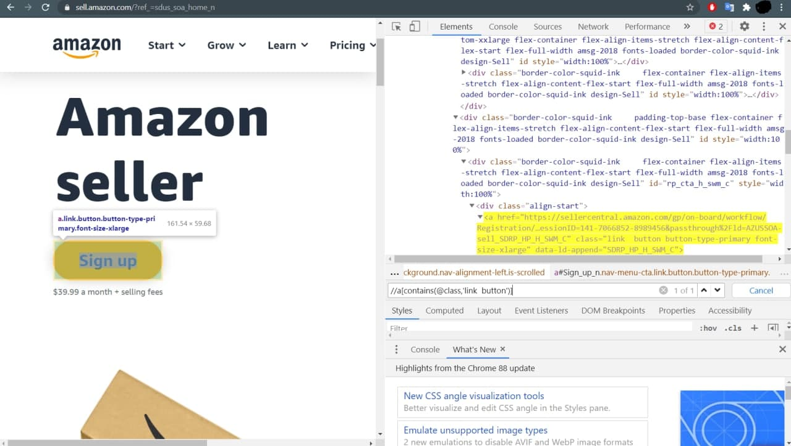

- //a[contains(@data-video-title,'Freshly Picked')]
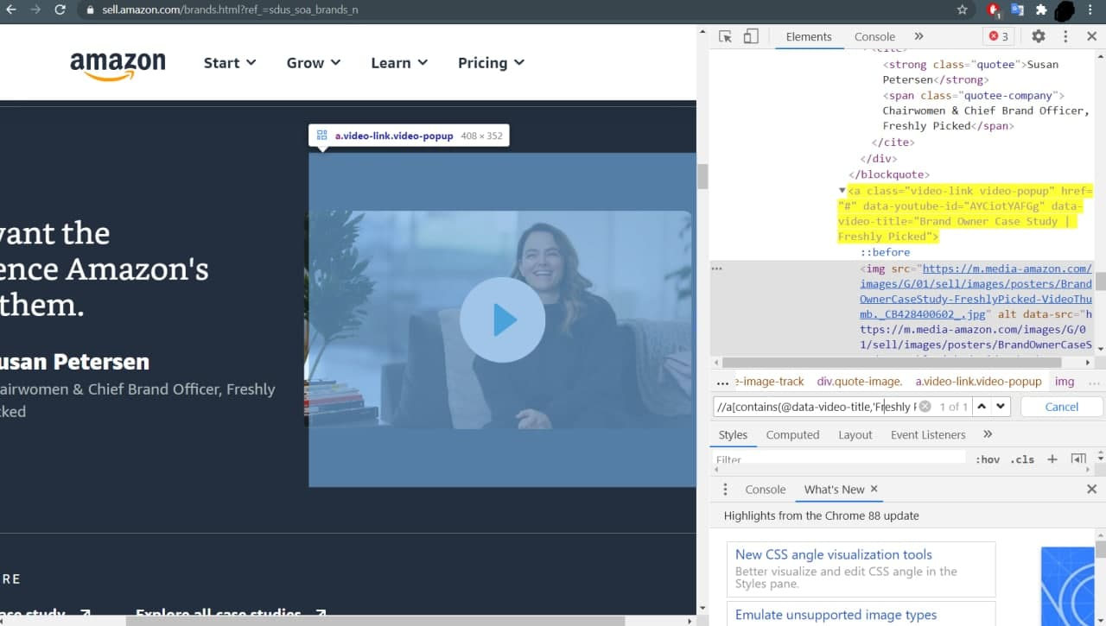

- //div[text()='$39.99 a month + selling fees']
