Business Process Management

-A different way of seeing applications-

Living in a world where everything needs to be fast, adaptable to change, optimized, with no errors, the need for software help became a necessity. This way the applications became part of our lives, not just for fun or communication, but for professional help too. One major area that helps many organizations to work properly is Business Process Managemnt or BPM.

So what is BPM? As it names stands, the process is the most important part, a process can be anything in our lives. Let’s take the following example: you want to go for a run. Going for a run is the main process. But in order to this activity, you need to do some tasks (this is a keyword in BPM). The first task is to change in proper clothes. The next task is putting you running shoes. Then you need to go outside. Finally you can run. But what if I tell you that tying your shoelaces can be a different procces with its own tasks. Each task can become a new process. It’s like inception. The deeper you go into an activity, the more complex it becomes.

And now you are thinking what connexion does it have with programming? Well, big organizations have many processes, internal or external, where many people work, from many different departments. In order to optimize the work applications bacame vital, applications that have the purpose to follow this procceses. But the development of a normal stand-alone application can cost many resources. So the normal way of delivering apps wasn’t the best choice.

BPM applications are developped with a platform like IBM BPM, Bonitta or Pegasus that helps you build an application even in two weeks that would normally need a few months for development. In the platform you design the flow of the process, the tasks, the user interface, the connections with a database, everything. It’s an all-in-one tool. All the platforms use the BPMN standard, business process model notation which is a graphycal representation of the process similar to the activity diagram from UML. Basically it is graphical programming. As for programming language, it depends on the tool. Usually they are java based tools. But you will end up working with HTML, CSS, javascript for the intarface too if you want something more costumized. Another plus of BPM is that it is easy to be understood by all the stake-holders: developers, business analysts, project maanger and QA.

Here is an example off how BPM works.

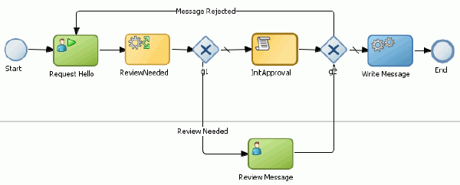

This process has two flows, the top swimlane is a flow designed for the system to do it automatically, while the bottom swimlane has a task for a human user.

Business Process Management is a different way of developing applications, it is faster, simplified, but it has its downsides as well. It is used mainly in big organizations and corporations. So the community isn’t so large, and the tools cost a lot. At least try it once!