Francisco Alba

Ejercicio 1

|  |  |  |  |  |  |
| --- | --- | --- | --- | --- | --- |
| 0 |  |  |  |  |  |
| 1 | 28 | 19 | 10 |  |  |
| 2 | 20 |  |  |  |  |
| 3 | 12 |  |  |  |  |
| 4 |  |  |  |  |  |
| 5 | 5 |  |  |  |  |
| 6 | 15 | 33 |  |  |  |
| 7 |  |  |  |  |  |
| 8 | 17 |  |  |  |  |

Ejercicio 3

A = (sqrt(5)-1)/2

h(k) = int(1000*(k*A % 1))

h(61) = 700

h(62) = 318

h(63) = 936

h(64) = 554

h(65) = 172

Ejercicio 10

1. h(k, i) = (k + i) mod 11

|  |  |  |  |  |  |  |  |  |  |  |
| --- | --- | --- | --- | --- | --- | --- | --- | --- | --- | --- |
| 22 | 88 |  |  | 4 | 15 | 28 | 17 | 59 | 31 | 10 |

1. h(k, i) = (k + i + 3i2) mod 11

|  |  |  |  |  |  |  |  |  |  |  |
| --- | --- | --- | --- | --- | --- | --- | --- | --- | --- | --- |
| 22 |  | 88 | 17 | 4 |  | 28 | 59 | 15 | 31 | 10 |

1. h(k, i) = (k + i(1 + (k mod 10))) mod 11

|  |  |  |  |  |  |  |  |  |  |  |
| --- | --- | --- | --- | --- | --- | --- | --- | --- | --- | --- |
| 22 |  | 59 | 17 | 4 | 15 | 28 | 88 |  | 31 | 10 |

Ejercicio 12

La tabla de hash resultante es la C, ya que contiene todos los elementos a insertar y los mismos no están encadenados (el direccionamiento abierto con exploración lineal no encadena los elementos).

Ejercicio 13

|  |  |  |  |  |  |  |  |  |  |  |
| --- | --- | --- | --- | --- | --- | --- | --- | --- | --- | --- |
| 0 |  |  | 0 |  |  | 0 |  |  | 0 |  |
| 1 |  |  | 1 |  |  | 1 |  |  | 1 |  |
| 2 | 42 |  | 2 | 42 |  | 2 | 42 |  | 2 | 42 |
| 3 | 52 |  | 3 | 23 |  | 3 | 23 |  | 3 | 33 |
| 4 | 34 |  | 4 | 34 |  | 4 | 34 |  | 4 | 23 |
| 5 | 23 |  | 5 | 52 |  | 5 | 52 |  | 5 | 34 |
| 6 | 46 |  | 6 | 33 |  | 6 | 46 |  | 6 | 46 |
| 7 | 33 |  | 7 | 46 |  | 7 | 33 |  | 7 | 52 |
| 8 |  |  | 8 |  |  | 8 |  |  | 8 |  |
| 9 |  |  | 9 |  |  | 9 |  |  | 9 |  |

1. (B) (C) (D)

Calculando el resultado de cada posible orden de inserción, es posible observar que la opción C permite llegar al resultado que se muestra como objetivo.

Ejercicio 2

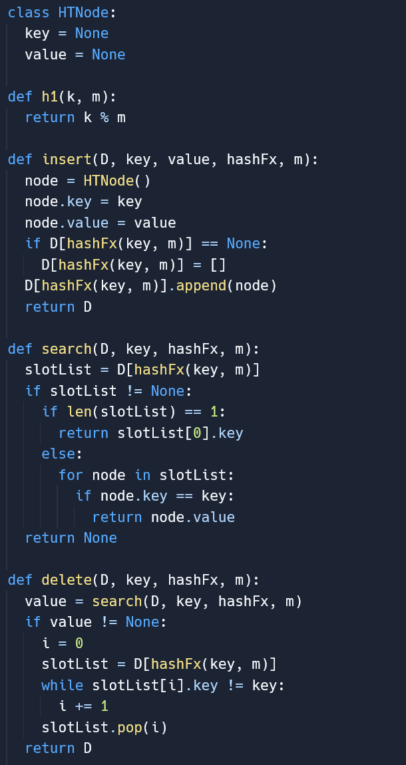

Ejercicio 4 Ejercicio 7

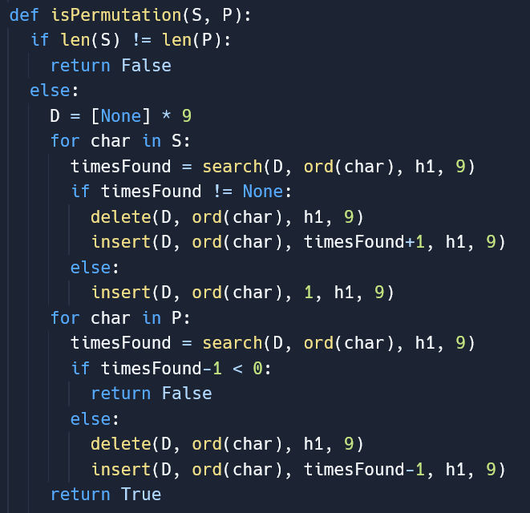 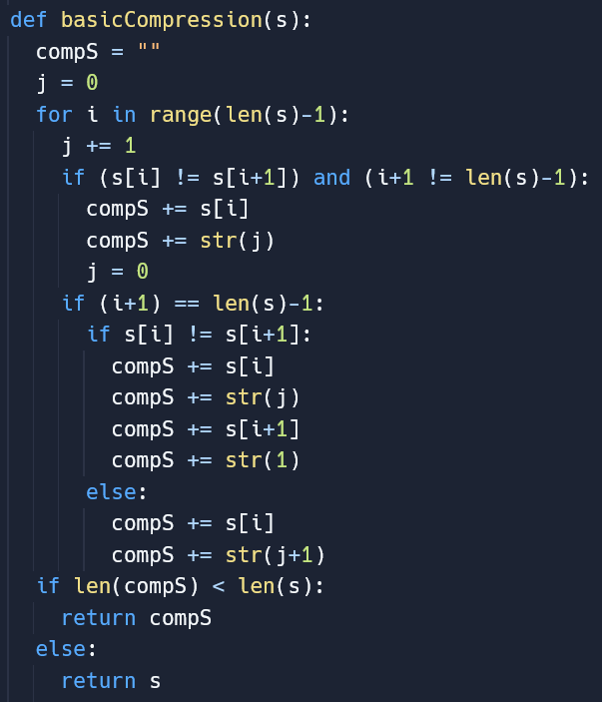

Ejercicio 5 Ejercicio 9

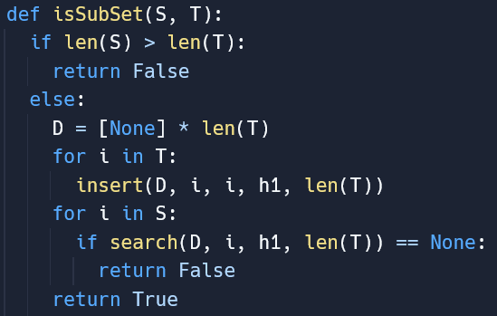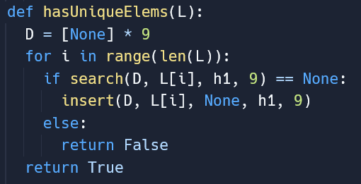  
Ejercicio 8

