Track 1: Programming Languages
Exercise 3: Modular Programming  Instruction: Write down your explanation or code below that will best solve the given problems. | Name: Francine Pascua_________  Date: August 26, 2026_________  Duration: 3 – 5 hours

- Study the out-of-standard pseudocode.
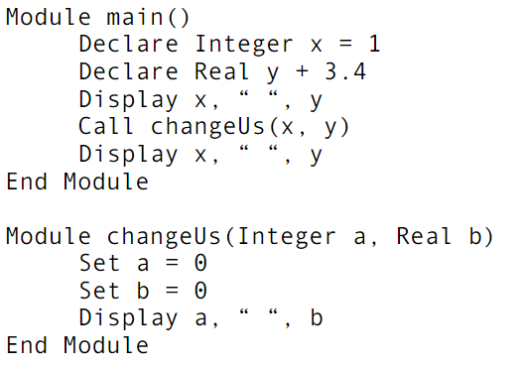
- What will the following pseudocode program display?
The pseudocode will display:
1 3.4  0 0  1 3.4 | From main(), Display x, “ “ , y
1 3.4  0 0  1 3.4 | From changeUs(x, y), Display a, “ “, b
1 3.4  0 0  1 3.4 | From main(),Display x, “ “ , y

- Rewrite the code using our text-based pseudocode.
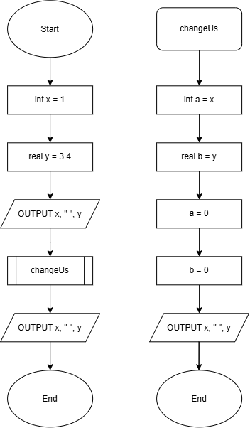
- Find the error in the following pseudocode and fix it. Your pseudocode should follow the Text-based Pseudocoding standard for modular programming.
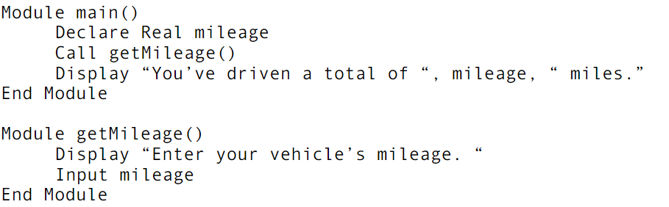

MODULE main()
DECLARE Real mileage
CALL getMileage()
DISPLAY “You’ve driven a total of ”, mileage, “miles.”
END MODULE

MODULE getMileage()
DECLARE Real mileage
DISPLAY “Enter your vehicle’s mileage.”
mileage ← USERINPUT
RETURN mileage
END MODULE

- Write subroutine guessColor() that performs the following: Asks a user to enter a number. If the number is between 0 and 10, prints the word blue. If the number is between 10 and 20, prints the word red. if the number is between 20 and 30, prints the word green. If it is any other number, prints that it is not a correct color option. Follow the ISO standard for pseudocoding, from subroutine naming convention down to the keywords we used in our discussions.

FUNCTION guessColor()
DECLARE Byte number
DISPLAY “Please enter a number from 0 to 30.”
number ← USERINPUT
IF number >= 0 AND number < 10 THEN
DISPLAY “blue”
ELSE IF number >= 10 AND number < 20 THEN
DISPLAY “red”
ELSE IF number >= 20 AND number < 30 THEN
DISPLAY “green”
ELSE
DISPLAY “That is not a correct color option.”
ENDIF
END FUNCTION

- Write a function pseudocode that takes an integer as a parameter and returns the difference between the integer’s cube and its square. Follow the ISO standard for pseudocoding, from subroutine naming convention down to the keywords we used in our discussions.

MODULE main()
DECLARE Integer parameter
DECLARE Integer difference
DISPLAY “Enter an integer.”
parameter ← USERINPUT
CALL calculateParameter()
DISPLAY “The difference between ”, parameter, “’s cube and square is: ”, difference
END MODULE

FUNCTION Integer calculateParameter(Integer parameter)
DECLARE Integer cube
DECLARE Integer square
DECLARE Integer difference
cube ← parameter*parameter*parameter
square ← parameter*parameter
difference ← cube – square
RETURN difference
END FUNCTION

- Write a pseudocode for the procedure that asks for input the length and width of a carpet (feet) and the price per square foot to clean the carpet. Calculate and output the area of the carpet (square feet) and the cost of cleaning the carpet if the cost is double for every square foot past the first 100. Follow the ISO standard for pseudocoding, from subroutine naming convention down to the keywords we used in our discussions.

MODULE main()
DECLARE Integer length
DECLARE Integer width
DECLARE Integer area
DECLARE Float totalCost
DISPLAY “Enter the length of the carpet.”
length ← USERINPUT
DISPLAY “Enter the width of the carpet.”
width ← USERINPUT
CALL calculateArea()
DISPLAY “Carpet Area: ”, area
CALL calculateCost()
DISPLAY “Cleaning Cost: ”, totalCost
END MODULE

FUNCTION Integer calculateArea(Integer length, width)
DECLARE Integer area
area = length*width
RETURN area
END FUNCTION

FUNCTION Integer calculateCost(Integer area)
DECLARE Float BASECOST
DECLARE Float additionalCost
DECLARE Float totalCost
DECLARE Byte additionalRate
BASECOST = 10.50 // made up a constant for the cost
additionalRate = 2 // to double when area > 100
IF area <= 100 THEN
totalCost = BASECOST
ELSE
additionalCost = additionalRate*BASECOST*(area-100)
totalCost = BASECOST + additionalCost
END IF
RETURN totalCost
END FUNCTION

- Write a pseudocode for the procedure that asks for input the number of honor points and credits for the 587 students, and calculate and output each student’s grade point average, honor points divided by credits. Follow the ISO standard for pseudocoding, from subroutine naming convention down to the keywords we used in our discussions.

MODULE main()
DECLARE Integer honorPoints
DECLARE Integer credits
DECLARE Float gradeAverage
DISPLAY “Enter your amount of honor points.”
honorPoints ← USERINPUT
DISPLAY “Enter your amount of credits.”
credits ← USERINPUT
CALL calculateHonor()
DISPLAY “Your grade point average is: ”, gradeAverage
END MODULE

FUNCTION Integer calculateHonor(Integer honorPoints, credits)
DECLARE Float gradeAverage
gradeAverage ← honorPoints / credits
RETURN gradeAverage
END MODULE

- Given the following maze,
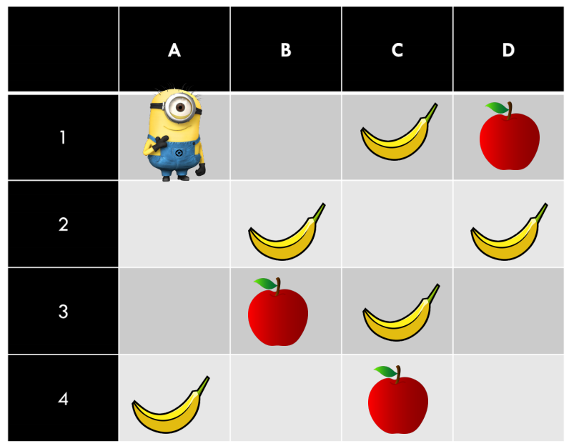
Write a complete algorithm to get Minion Stuart to move through the squares to gather bananas NOT apples. Verb like MOVE, FETCH, PICK, or anything related to the scenario can be used here to construct the methods. Make sure to show to the user all gathered bananas. Note: The scenario above shows one of the many snapshots of the game. (20 pts)
