
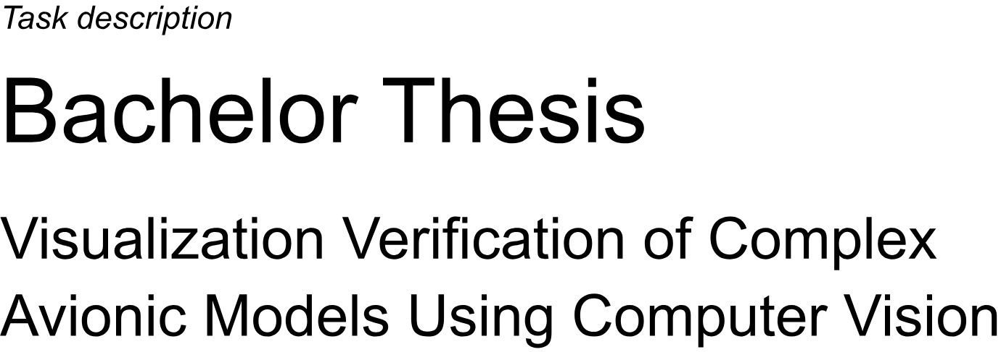
Thesis Task Description

In safety-critical systems, domain-specific modeling (DSM) still lacks sufficient automation, often requiring extensive manual effort. A key challenge is ensuring that visual representations are accurate without depending on manual verification processes. This raises the critical question: “Does what you see truly reflect what you get?”
The Institute of Aircraft Systems is conducting research into automated verification of visualizations, with a focus on block diagrams. As part of this effort, a proof of concept has been developed using a simple domain-specific language for the Functions Layer of the Open Avionics Architecture Model (OAAM).
The concept aims to verify whether a screenshot accurately represents a user model by relying on a visualization-defining model. The process involves the following steps:
1. Preprocessing: The screenshot is processed to isolate the block diagram and remove user interface artifacts.
2. Tokenization: The system identifies token types as specified in the visualization model.
3. Syntactical Analysis: The relative positioning of tokens is evaluated using the visualization model.
4. Model Instantiation: Based on the visualization model, the recognized tokens are assembled into a reconstructed model.
Finally, the reconstructed model is compared to the original model. Errors in visualization are identified and reported, both in a detailed report and, if feasible, as graphical overlays on the original model.

While the proof of concept demonstrates feasibility, it is limited to the basic Functions Layer and has been tested on only 14 cases.

Objective

The objective of this thesis is to extend and generalize the proof of concept to accommodate more domain-specific languages and additional test cases. In particular, the Hardware Editor and Allocations Editor—both of which feature more complex visualizations and hierarchies—shall be addressed.

Key tasks include exploring the limits of the existing concept, developing test cases that showcase the enhanced capabilities of the implementation and extending the verification approach to cover the broader scope of domain-specific languages.

Additionally, the thesis requires thorough documentation of the work and findings, as well as a final presentation to summarize the results.

Work items:
- Familiarization
  - Domain-specific modeling
  - Python
  - Computer Vision
  - limits of existing concept
- Concept development
  - Recognition of bigger block diagrams in the Functions Editor
  - Recognition of Intersections
  - Recognition of block diagrams with other token types
  - Recognition of rotated text in the Hardware Editor
  - Recognition of complex block diagrams using nested vertices and edges in the Allocations Editor
- Implementation of the solution
  - Implement the developed concepts
  - Where feasible, generalize the concepts for various block diagram languages
- Demonstration
  - Implement test cases showing the capabilities of implemented functionality
  - Validation and evaluation of the test cases
- Discussion
  - Evaluation of the feasibility of the provided proof of concepts and discussion of further improvements
- Documentation of the results
- Final presentation

Begin: 2024-10-07
End: 2025-02-07
Supervisor: Andreas Waldvogel
Examiner: Prof. Björn Annighöfer

Legal provisions: In principle, the student is not entitled to publish any work and research results of which he/she becomes aware during thesis to third parties without the permission of the supervisor. Concerning achieved research results the law about copyright and used protective right (“Bundesgesetzblatt” I/S. 1273, “Urheberschutzgesetz” of 09.09.1965) is valid. The student has the right to publish his/her findings, as far as no findings and achievements of the supervising institutes and companies are included. The guidelines for the preparation of the Bachelor's/Master's thesis issued by the field of study as well as the examination regulations must be considered.

