ITE 14 MIDTERM EXAM
ITE 14 - UX Concepts and Design
Questions and answer key
60 questions · 80 points · passing 50%
The parts come in this order for every student. On the website each computer shuffles the questions inside a part and the choices, so these numbers are the bank order, not what a student sees on screen.
Every question is all or nothing: a question with several parts earns its points only when every part is right.
You are on the Kwarto design team. These people send the messages above some questions.
• Joy: Incoming freshman from Abra you interviewed
• Kyle: Your groupmate
• Aira: Your groupmate
Parts
Part | Questions | Points
Part 1 · Empathize: Meet the freshmen | 1 to 3 | 6
Part 2 · Define: Name the problem | 4 to 6 | 4
Part 3 · How might we: Open it up | 7 to 15 | 12
Part 4 · Laws of UX: Design the screens | 16 to 37 | 29
Part 5 · Usability heuristics: Inspect the prototype | 38 to 51 | 18
Part 6 · System Usability Scale: Measure it | 52 to 60 | 11
Total | 60 | 80

QUESTIONS
PART 1 · EMPATHIZE: MEET THE FRESHMEN (3 questions, 6 points)
1. Sort into groups · 3 pts
Your team interviewed Joy, an incoming freshman from Abra, and followed her as she looked for a boarding house. Sort the sticky notes into her empathy map.
Groups: Says · Thinks · Does · Feels
1. "I just want a room that looks like the photos."
2. Nervous about living alone for the first time
3. Visits four boarding houses in one afternoon, then gives up
4. Wonders if the landlady will really return her deposit
5. Saves 30 listings from Facebook groups in one night
6. Believes every room near campus costs too much
7. "My parents will only say yes if they see the place first."
8. Relieved when a landlady replies within the hour
2. Matching · 2 pts
Your team used four ways to empathize with freshmen. Drag the method each activity is.
1. Talking one-on-one with Joy for 20 minutes about her first week in Baguio → __________
2. Watching freshmen compare rooms at a boarding house, without interrupting them → __________
3. Following one freshman for a whole Saturday as she visits rooms → __________
4. Staying a night in a bedspace yourself to feel what it is like → __________
Choices: Brainstorming · Immersion · Interview · Observation · Shadowing · Usability testing
3. Multiple choice · 1 pt
Why does the design thinking process start with Empathize?
a. So the team can choose the newest technology before anything else
b. So the client can approve a final design sooner and pay less
c. So the team designs for people's real needs, not its own guesses
d. So the team can skip testing, since users were already asked
PART 2 · DEFINE: NAME THE PROBLEM (3 questions, 4 points)
4. Sort into groups · 2 pts
Sort the team's notes: what they saw or heard (observations), and what they think it means (insights).
Groups: Observation · Insight
1. Joy saved 30 listings in one night
2. Freshmen trust people they know more than any listing
3. Paying early feels safer to freshmen than losing the room to someone else
4. Two freshmen paid a reservation fee after seeing only photos
5. Most freshmen asked a relative in Baguio to visit rooms for them
6. For far-away freshmen, the real cost of a visit is a lost day, not the fare
5. Put in order · 1 pt
Put the five stages of design thinking in order.
___ Empathize
___ Test
___ Ideate
___ Prototype
___ Define
6. Multiple choice · 1 pt
What does the Define stage give the team?
a. A SUS score and usability report for the app
b. A clickable prototype of the app, ready for users
c. A POV statement and a few How might we questions
d. A list of 50 ideas from the team's brainstorming
PART 3 · HOW MIGHT WE: OPEN IT UP (9 questions, 12 points)
7. Sort into groups · 2 pts
Sort these How might we (HMW) questions for Kwarto.
Groups: Too narrow · Just right · Too broad
1. HMW help freshmen tell a real listing from a fake one?
2. HMW add a 3D tour button to every listing?
3. HMW make college life better?
4. HMW send landladies an SMS when a student messages them?
5. HMW fix student housing in the Philippines?
6. HMW help freshmen compare rooms without visiting each one?
8. Multiple choice · 1 pt
Why does a HMW question say "might" instead of "should"?
a. It sounds more polite when the team shows it to the client
b. It frees the team to try ideas that may or may not work
c. It tells the team there is only one right answer to find
d. It means only the team leader may answer the question
9. Multiple choice · 1 pt
POV: "Freshmen from far provinces need to know a landlady is honest because they pay a reservation fee before they ever meet her." Which HMW question fits it best?
a. HMW add an ID check button to every landlady profile?
b. HMW make life easier for every college student in Baguio?
c. HMW get more landladies to sign up for Kwarto this year?
d. HMW help freshmen trust a landlady before they pay her?
10. Multiple choice · 1 pt
Kyle: Video calls with the landlady? That won't work. Reviews from past tenants? Won't work either. Next!
The team is brainstorming answers to a HMW question. Which brainstorming rule is Kyle breaking?
a. Stay focused on the topic
b. Be visual
c. Defer judgment
d. One conversation at a time
11. Put in order · 2 pts
Put the team's steps in order, from research to ideas.
___ Interview and observe freshmen
___ Pick a few ideas to prototype
___ Sort what you learned into an empathy map
___ Brainstorm many answers to one HMW
___ Write a POV statement
___ Turn the POV into How might we questions
12. Fill in the blanks · 2 pts
Complete the rule for a good How might we question.
A good HMW is broad enough ____(1)____, but narrow enough ____(2)____. "HMW add a chatbot?" is too ____(3)____, because it already names the solution.
(1) a. to allow many different solutions b. to cover every problem in the app c. that it needs no research behind it
(2) a. to have one right answer b. to give the ideas a clear direction c. to fit on one sticky note
(3) a. broad b. vague c. narrow
13. Multiple choice · 1 pt
After brainstorming, the team has 45 ideas for "HMW help freshmen trust a room before they travel to see it?" What should they do next?
a. Build all 45 ideas into the first version of Kwarto
b. Start over with a new HMW, since 45 ideas are too many
c. Vote on a few promising ideas and prototype those
d. Ask the client to pick one idea and build it in full
14. Tick all that apply · 1 pt
Which of these are rules for brainstorming? Tick all that apply.
a. Encourage wild ideas
b. Build on the ideas of others
c. Pick the best idea as early as possible
d. Go for quantity
e. Only share ideas you know can be built
15. Multiple choice · 1 pt
Where should a team's HMW questions come from?
a. The POV statement and the insights from research
b. The features that competing apps already have
c. The ideas the team liked before doing any research
d. The client's list of features for the first release
PART 4 · LAWS OF UX: DESIGN THE SCREENS (22 questions, 29 points)
16. Matching · 2 pts
Kwarto's search screen uses four laws of UX on purpose. Drag a law onto each numbered marker. (Marker 3 shows while the rooms are loading.)
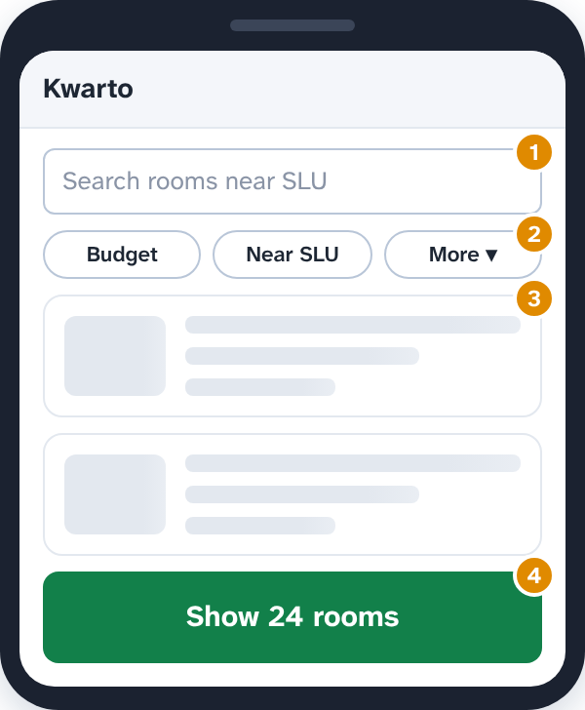
1. Marker 1 → __________
2. Marker 2 → __________
3. Marker 3 → __________
4. Marker 4 → __________
Choices: Doherty threshold · Fitts's law · Hick's law · Jakob's law · Law of Prägnanz · Parkinson's law
17. Sort into groups · 2 pts
Sort these changes to the Kwarto listing page by the Gestalt law each one uses.
Groups: Law of proximity · Law of similarity · Law of common region
1. Put the rent, deposit and fees inside one bordered box
2. Move the "Deposit" label closer to its own amount
3. Make every "Available" tag the same green pill
4. Give each room in the list its own card with a border
5. Style every link blue and underlined, unlike plain text
6. Leave more space between rooms than inside each room
18. Matching · 2 pts
Drag the law that explains what testers did.
1. They remembered the first and last rooms they viewed, but not the ones in between → __________
2. They filled in the last fields faster once the bar said "Profile 4 of 5 done" → __________
3. One kept thinking all day about the reservation form she left half done → __________
4. They judged Kwarto by a scary error at payment and the happy "Welcome home!" at the end → __________
Choices: Flow · Goal-gradient effect · Miller's law · Peak-end rule · Serial position effect · Zeigarnik effect
19. Matching · 2 pts
Drag the law behind each Kwarto decision.
1. The price box accepts "3500", "3,500" and "₱3.5k" → __________
2. 2 of the 10 screens cause 80% of complaints, so the team fixes those first → __________
3. Students thought "Reserve" made the room theirs, so the button now says "Send request" → __________
4. Sign-up fills in the name and course from the SLU account, so it takes 1 minute, not 10 → __________
Choices: Choice overload · Mental model · Occam's razor · Pareto principle · Parkinson's law · Postel's law
20. Fill in the blanks · 2 pts
Complete the sentences about cognitive load.
Cognitive load is the amount of ____(1)____ needed to understand and use an interface. Load that comes from the task itself is ____(2)____. Load from distractions and decoration is ____(3)____, and designers should cut it.
(1) a. mental resources b. screen space c. loading time
(2) a. extraneous b. intrinsic c. visual
(3) a. intrinsic b. visual c. extraneous
21. Click the part of the screen · 1 pt
Students often tap "Report" when they mean to tap "Call". Click the part of the screen that breaks Fitts's law.
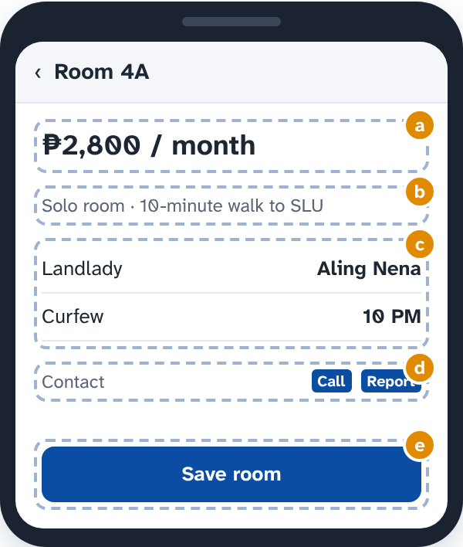
a. ₱2,800 / month
b. Solo room · 10-minute walk to SLU
c. List: Landlady Aling Nena, Curfew 10 PM
d. Contact, Button: Call, Button: Report
e. Button: Save room
22. Click the part of the screen · 1 pt
Landladies use this form to list a room. Click the field that breaks Tesler's law by making them do work the app could do.
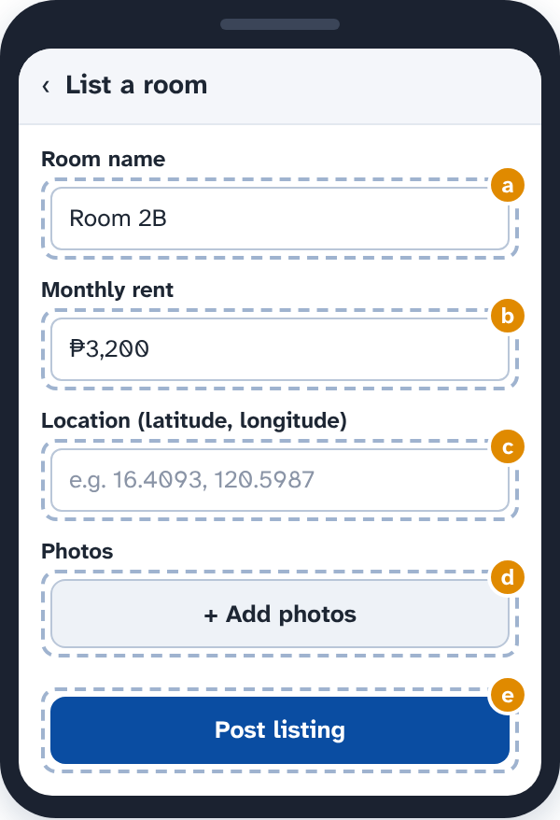
a. Text box: Room 2B
b. Text box: ₱3,200
c. Text box: e.g. 16.4093, 120.5987
d. Button: + Add photos
e. Button: Post listing
23. Multiple choice · 1 pt
In testing, students call the new Kwarto design "so clean and easy" and rate it highly, yet 3 of 5 could not find how to message a landlady. Which law explains the high ratings?
a. Jakob's law
b. Aesthetic-usability effect
c. Law of Prägnanz
d. Peak-end rule
24. Multiple choice · 1 pt
Kyle says the Kwarto menu can have at most 7 items "because of Miller's law." What is right?
a. He is right: menus with 8 or more items break the law
b. He is wrong: the law says no more than 3 items in any menu
c. Miller's law only applies to phone numbers and PIN codes
d. Don't use 7 ± 2 as a hard limit; chunk content instead
25. Multiple choice · 1 pt
Kwarto shows all 200 rooms near campus in one long list, with no filters or picks. Many freshmen close the app without choosing. Which law names this problem?
a. Postel's law
b. Law of proximity
c. Choice overload
d. Zeigarnik effect
26. Multiple choice · 1 pt
Kwarto shows its "Beware of fake listings" warning in a flashy, ad-like banner. Most students scroll right past it. Which law explains why?
a. Von Restorff effect
b. Selective attention
c. Goal-gradient effect
d. Occam's razor
27. Tick all that apply · 1 pt
Freshmen compare three saved rooms before choosing. Which changes go easy on their working memory? Tick all that apply.
a. Show the three rooms side by side in one table
b. Make them open each room's page and remember its price
c. Group the details into short, labeled chunks: price, rules, location
d. Hide the prices until they tap "Show price" on each room
e. Keep each saved room visible while they compare
28. Multiple choice · 1 pt
Aira makes every button on the listing page bright orange "so nothing gets missed." What does the Von Restorff effect say?
a. Good idea: more bright buttons means more taps on each one
b. Only the key action should stand out; if all do, none does
c. Orange is fine, but the buttons should also flash
d. Use red instead, since red is the most memorable color
29. Multiple choice · 1 pt
The team picks a simple house outline for Kwarto's app icon, not a detailed drawing of a boarding house. Which law supports this?
a. Law of similarity
b. Law of common region
c. Tesler's law
d. Law of Prägnanz
30. Multiple choice · 1 pt
Kwarto's "Find your room in 8 questions" quiz shows a "Rate us!" pop-up after question 3, and many freshmen quit. What does the law of flow suggest?
a. Remove the interruption so students can keep going
b. Show the pop-up after every question instead
c. Make the 8 questions harder so students stay focused
d. Keep the pop-up, since ratings help the app grow
31. Multiple choice · 1 pt
The reservation screen lists "Requested", "Accepted", "Paid" and "Moved in" as four loose words, and students don't see them as steps of one process. Which fix uses the law of uniform connectedness?
a. Make the four words bigger and bold
b. Show only the current step and hide the rest
c. Put each step on a screen of its own
d. Join the four steps with a line, like a delivery tracker
32. Click the part of the screen · 1 pt
The team wants Kwarto's sign-up form as short as it can be. Following Occam's razor, click the field to remove.
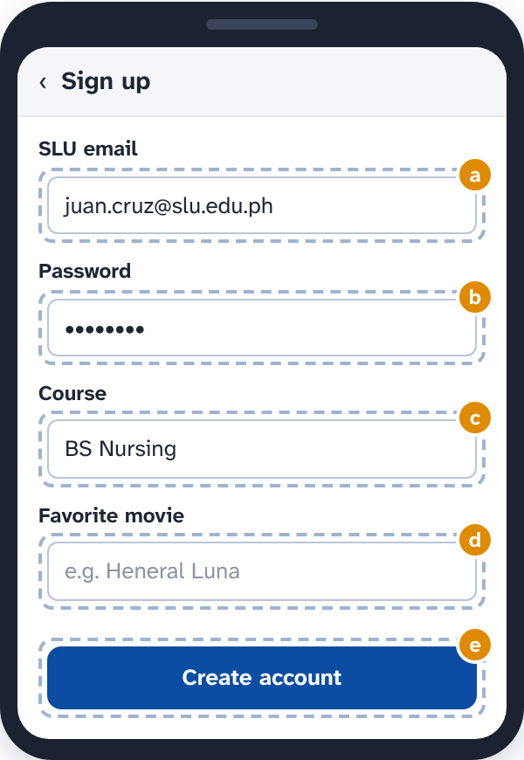
a. Text box: juan.cruz@slu.edu.ph
b. Text box: ••••••••
c. Text box: BS Nursing
d. Text box: e.g. Heneral Luna
e. Button: Create account
33. Multiple choice · 1 pt
Aira: 3 of 5 testers liked my Saved screen, so it works. The 2 who got lost just aren't used to apps.
Which law of UX should remind Aira to check her own thinking?
a. Cognitive bias
b. Peak-end rule
c. Law of similarity
d. Goal-gradient effect
34. Multiple choice · 1 pt
The team wrote a 6-page "How to use Kwarto" guide, but no tester opened it: they started tapping right away. What does the paradox of the active user suggest?
a. Make the guide longer, with more pictures
b. Put short tips inside the app, right where students need them
c. Make students read the guide before they can sign up
d. Remove all help, since nobody reads it anyway
35. Matching · 2 pts
Drag the law that explains each thing the team saw in testing.
1. Testers remembered the Search and Me tabs, but forgot the Saved tab in the middle → __________
2. Freshmen took much longer to choose when the filter showed 14 room types at once → __________
3. Testers kept missing the small "×" in the corner of the photo viewer → __________
4. Testers found "Reserve" fastest when it was the only orange button on the page → __________
Choices: Fitts's law · Hick's law · Law of Prägnanz · Serial position effect · Von Restorff effect · Zeigarnik effect
36. Fill in the blanks · 2 pts
Complete the sentences about chunking.
Chunking breaks information into ____(1)____. On the reservation receipt, Kwarto should show the code as ____(2)____.
(1) a. small groups that form a meaningful whole b. one long line, so nothing gets missed c. different colors, so each letter stands out
(2) a. KW482719365 b. KW 482 719 365 c. kw482719365
37. Multiple choice · 1 pt
Kwarto puts its back button at the bottom right and the profile icon at the top left, unlike the apps students already use. Testers keep getting lost. Which law explains why?
a. Jakob's law
b. Occam's razor
c. Tesler's law
d. Parkinson's law
PART 5 · USABILITY HEURISTICS: INSPECT THE PROTOTYPE (14 questions, 18 points)
38. Matching · 2 pts
Drag the heuristic each marker on this Reserve screen breaks. ("Cancel all" runs at once, with no "Are you sure?")
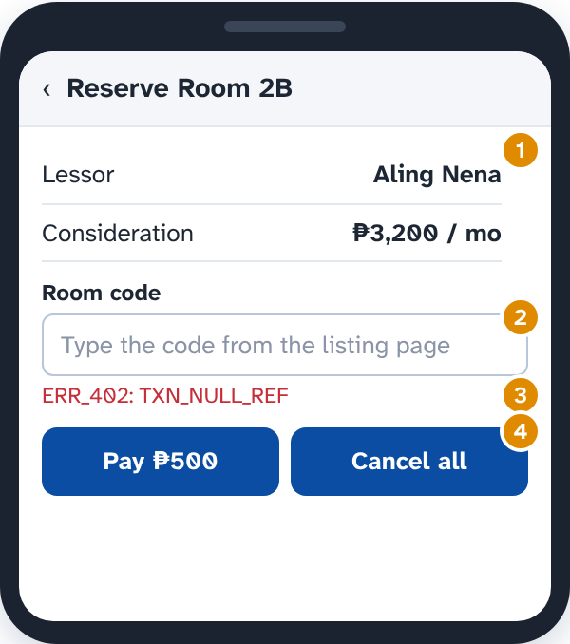
1. Marker 1 → __________
2. Marker 2 → __________
3. Marker 3 → __________
4. Marker 4 → __________
Choices: 1. Visibility of system status · 2. Match between system and the real world · 5. Error prevention · 6. Recognition rather than recall · 8. Aesthetic and minimalist design · 9. Help users recognize, diagnose, and recover from errors
39. Click the part of the screen · 1 pt
A student tapped "Remove" on Room 2B by mistake. Click the part of the screen that breaks User control and freedom.
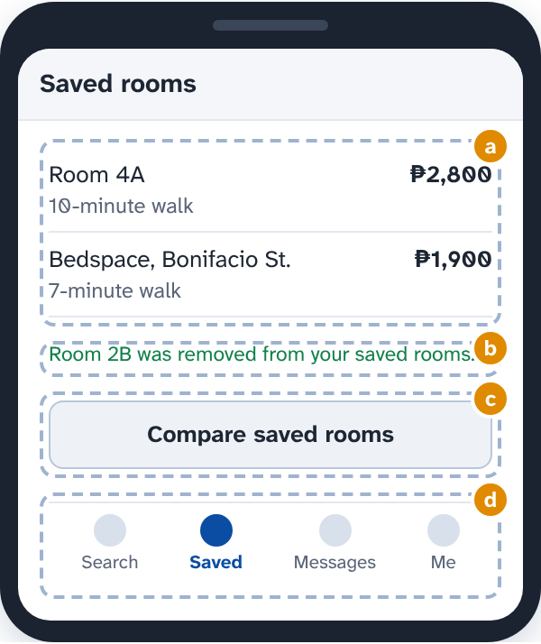
a. List: Room 4A 10-minute walk ₱2,800, Bedspace, Bonifacio St. 7-minute walk ₱1,900
b. Message: Room 2B was removed from your saved rooms.
c. Button: Compare saved rooms
d. Tab bar: Search, Saved, Messages, Me
40. Click the part of the screen · 1 pt
Click the part of this listing that breaks Aesthetic and minimalist design.
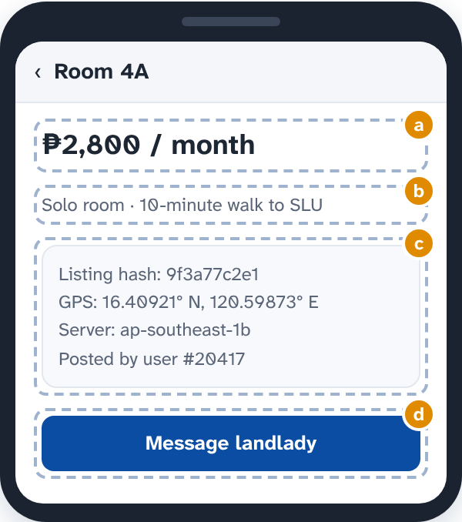
a. ₱2,800 / month
b. Solo room · 10-minute walk to SLU
c. Box: Listing hash: 9f3a77c2e1, GPS: 16.40921° N, 120.59873° E, Server: ap-southeast-1b, Posted by user #20417
d. Button: Message landlady
41. Click the part of the screen · 1 pt
Click the part of the screen that breaks Consistency and standards.
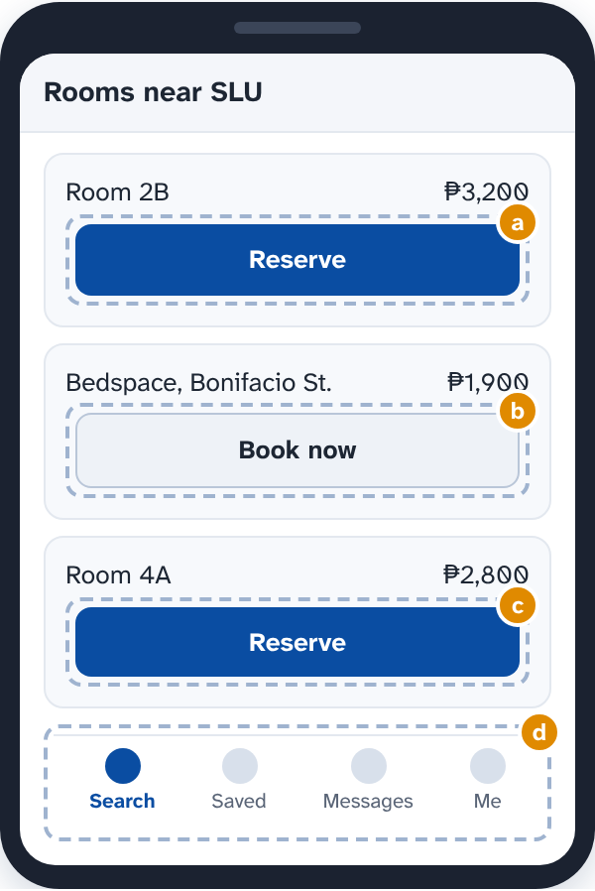
a. Button: Reserve
b. Button: Book now
c. Button: Reserve
d. Tab bar: Search, Saved, Messages, Me
42. Multiple choice · 1 pt
After a student taps "Send request", nothing on the screen changes for 8 seconds, so many tap it again and send the same request three times. Which heuristic does this break?
a. 4. Consistency and standards
b. 1. Visibility of system status
c. 7. Flexibility and efficiency of use
d. 10. Help and documentation
43. Multiple choice · 1 pt
Which three things decide how severe a usability problem is?
a. Who found it, on which phone, and on which day of the evaluation
b. How long it takes to fix, how much it costs, and who will fix it
c. How often it happens, how bad it is, and if users hit it again
d. Its color, where it sits on the screen, and how big it looks
44. Put in order · 2 pts
Put the steps of a heuristic evaluation of Kwarto in order.
___ Decide what to fix first
___ Rate the severity of each problem
___ The evaluators combine their lists
___ Choose the evaluators
___ Each evaluator goes through Kwarto alone, at least twice, noting each problem and the heuristic it breaks
45. Fill in the blanks · 2 pts
Complete the facts about heuristic evaluation.
Nielsen suggests ____(1)____ evaluators, because one evaluator alone finds only about ____(2)____ of the problems. It is done by ____(3)____, so it should be paired with usability testing.
(1) a. 1 or 2 b. 3 to 5 c. at least 20
(2) a. a third b. half c. all
(3) a. real users, not evaluators b. the developers who built it c. evaluators, not real users
46. Matching · 2 pts
The team fixed four problems in Kwarto. Drag the heuristic each fix follows.
1. An "Uploading your ID: 70%" bar shows while the photo uploads → __________
2. "Reserve" is now the word for reserving on every screen → __________
3. Landladies can long-press to mark many rooms "Taken" at once → __________
4. A "?" beside "Reservation fee" opens a two-line tip → __________
Choices: 1. Visibility of system status · 10. Help and documentation · 3. User control and freedom · 4. Consistency and standards · 7. Flexibility and efficiency of use · 8. Aesthetic and minimalist design
47. Multiple choice · 1 pt
What is the main difference between a heuristic evaluation and a usability test?
a. A heuristic evaluation needs at least 20 real users to be valid
b. Experts check it against rules; a usability test watches users
c. A usability test can only be done after the app is released
d. None; they are two names for exactly the same method
48. Multiple choice · 1 pt
When a payment fails, Kwarto only says "Something went wrong." Under heuristic 9, what should the message do?
a. Say what went wrong in plain words and how to fix it
b. Show the error code so the developers can fix it
c. Stay short, so the message does not scare students
d. Send the student to the help page that lists all errors
49. Multiple choice · 1 pt
Who wrote the 10 usability heuristics?
a. Jakob Nielsen and Rolf Molich, 1990
b. The Stanford d.school, for design thinking, 2005
c. Paul Fitts, in a study of pointing, 1954
d. Don Norman, in The Design of Everyday Things, 1988
50. Multiple choice · 1 pt
Before a landlady deletes a listing with 12 messages, Kwarto now asks: "Delete Room 2B and its 12 messages? This can't be undone." Which heuristic does this follow?
a. 2. Match between system and the real world
b. 6. Recognition rather than recall
c. 8. Aesthetic and minimalist design
d. 5. Error prevention
51. Multiple choice · 1 pt
Why does each evaluator go through Kwarto alone before the group meets?
a. So the whole evaluation takes less time to finish
b. So each evaluator can fix the problems they find right away
c. So the team can see who is the best evaluator
d. So they don't sway each other and find more problems
PART 6 · SYSTEM USABILITY SCALE: MEASURE IT (9 questions, 11 points)
52. Type a number · 2 pts
Aira: Here are our first tester's SUS answers for the Kwarto prototype (1 = strongly disagree, 5 = strongly agree).
Work out this tester's SUS score.
Item | Answer | Item | Answer
1 | 4 | 6 | 2
2 | 2 | 7 | 5
3 | 4 | 8 | 2
4 | 1 | 9 | 4
5 | 4 | 10 | 2

Answer: ______________
53. Multiple choice · 1 pt
The new Kwarto prototype scores 84 on SUS. What does that mean?
a. 84% of the testers were happy with it
b. It is just about average for an app
c. It is below average, since it is under 85
d. It is an A, in the top 10% of scores
54. Fill in the blanks · 2 pts
Five testers used the updated prototype. Work out the group's SUS result.
The group's SUS score is ____(1)____. Compared with the average of all SUS studies, that is ____(2)____.
Tester | SUS score
A | 72.5
B | 85
C | 60
D | 77.5
E | 65

(1) a. 68 b. 72 c. 360 d. 85
(2) a. below average b. above average, but not an A c. an A, in the top 10%
55. Multiple choice · 1 pt
Why are half of the SUS statements positive and half negative?
a. So the negative ones can be skipped when time is short
b. So people read each one instead of agreeing with everything
c. So the score can go below zero for really bad apps
d. So testers who had problems give lower scores than the others do
56. Multiple choice · 1 pt
Which SUS statement measures learnability?
a. I think that I would like to use this system frequently.
b. I found the various functions in this system were well integrated.
c. I needed to learn a lot of things before I could get going with this system.
d. I thought there was too much inconsistency in this system.
57. Click the part of the screen · 1 pt
Aira wrote up the SUS results. Click the line that is a mistake.
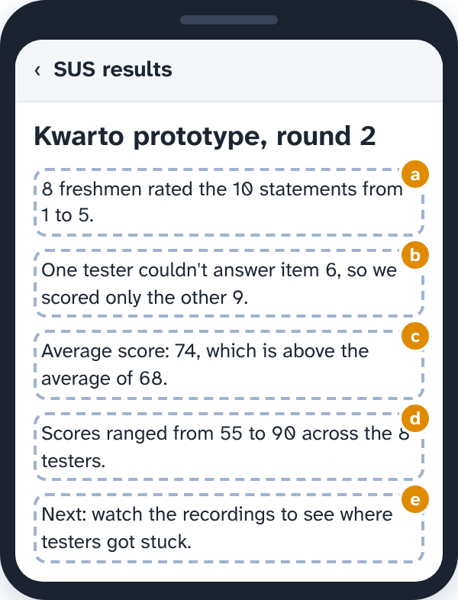
a. 8 freshmen rated the 10 statements from 1 to 5.
b. One tester couldn't answer item 6, so we scored only the other 9.
c. Average score: 74, which is above the average of 68.
d. Scores ranged from 55 to 90 across the 8 testers.
e. Next: watch the recordings to see where testers got stuck.
58. Multiple choice · 1 pt
Kyle: The old version scored 45 on SUS. So the Reserve screen must be the problem. Let's redesign it.
What is wrong with Kyle's conclusion?
a. Nothing: a score under 51 always points to the Reserve screen
b. A 45 is above average, so nothing needs redesigning
c. SUS shows overall usability, not which screen causes problems
d. SUS scores only count when more than 100 people answer
59. Multiple choice · 1 pt
When should testers fill in the SUS questionnaire?
a. Right after they use the prototype
b. A month after the test, once they have forgotten the details
c. Only if they failed at least one of the tasks
d. Before they see the prototype, to measure what they expect
60. Tick all that apply · 1 pt
Which of these are true about SUS? Tick all that apply.
a. It has 10 statements, each rated from 1 to 5
b. A score of 70 means 70% of users found the app usable
c. A score of about 68 is average
d. It tells you which screen to fix first
e. The odd-numbered statements are positive

ANSWER KEY
PART 1 · EMPATHIZE: MEET THE FRESHMEN (3 questions, 6 points)
1. (3 pts) Your team interviewed Joy, an incoming freshman from Abra, and followed her as she looked for a boarding house. Sort the sticky notes…
Says: (1) "I just want a room that looks like the photos."; (7) "My parents will only say yes if they see the place first."
Thinks: (4) Wonders if the landlady will really return her deposit; (6) Believes every room near campus costs too much
Does: (3) Visits four boarding houses in one afternoon, then gives up; (5) Saves 30 listings from Facebook groups in one night
Feels: (2) Nervous about living alone for the first time; (8) Relieved when a landlady replies within the hour
2. (2 pts) Your team used four ways to empathize with freshmen. Drag the method each activity is.
1. Talking one-on-one with Joy for 20 minutes about her first week in Baguio → Interview
2. Watching freshmen compare rooms at a boarding house, without interrupting them → Observation
3. Following one freshman for a whole Saturday as she visits rooms → Shadowing
4. Staying a night in a bedspace yourself to feel what it is like → Immersion
Not used: Usability testing; Brainstorming
3. (1 pt) Why does the design thinking process start with Empathize?
Answer: c. So the team designs for people's real needs, not its own guesses
PART 2 · DEFINE: NAME THE PROBLEM (3 questions, 4 points)
4. (2 pts) Sort the team's notes: what they saw or heard (observations), and what they think it means (insights).
Observation: (1) Joy saved 30 listings in one night; (4) Two freshmen paid a reservation fee after seeing only photos; (5) Most freshmen asked a relative in Baguio to visit rooms for them
Insight: (2) Freshmen trust people they know more than any listing; (3) Paying early feels safer to freshmen than losing the room to someone else; (6) For far-away freshmen, the real cost of a visit is a lost day, not the fare
5. (1 pt) Put the five stages of design thinking in order.
Correct order:
1. Empathize
2. Define
3. Ideate
4. Prototype
5. Test
(On the sheet, top to bottom: 1, 5, 3, 4, 2)
6. (1 pt) What does the Define stage give the team?
Answer: c. A POV statement and a few How might we questions
PART 3 · HOW MIGHT WE: OPEN IT UP (9 questions, 12 points)
7. (2 pts) Sort these How might we (HMW) questions for Kwarto.
Too narrow: (2) HMW add a 3D tour button to every listing?; (4) HMW send landladies an SMS when a student messages them?
Just right: (1) HMW help freshmen tell a real listing from a fake one?; (6) HMW help freshmen compare rooms without visiting each one?
Too broad: (3) HMW make college life better?; (5) HMW fix student housing in the Philippines?
8. (1 pt) Why does a HMW question say "might" instead of "should"?
Answer: b. It frees the team to try ideas that may or may not work
9. (1 pt) POV: "Freshmen from far provinces need to know a landlady is honest because they pay a reservation fee before they ever meet her." Which…
Answer: d. HMW help freshmen trust a landlady before they pay her?
10. (1 pt) The team is brainstorming answers to a HMW question. Which brainstorming rule is Kyle breaking?
Answer: c. Defer judgment
11. (2 pts) Put the team's steps in order, from research to ideas.
Correct order:
1. Interview and observe freshmen
2. Sort what you learned into an empathy map
3. Write a POV statement
4. Turn the POV into How might we questions
5. Brainstorm many answers to one HMW
6. Pick a few ideas to prototype
(On the sheet, top to bottom: 1, 6, 2, 5, 3, 4)
12. (2 pts) Complete the rule for a good How might we question.
(1) a. to allow many different solutions
(2) b. to give the ideas a clear direction
(3) c. narrow
13. (1 pt) After brainstorming, the team has 45 ideas for "HMW help freshmen trust a room before they travel to see it?" What should they do next?
Answer: c. Vote on a few promising ideas and prototype those
14. (1 pt) Which of these are rules for brainstorming? Tick all that apply.
Answer: a, b, d
a. Encourage wild ideas
b. Build on the ideas of others
d. Go for quantity
15. (1 pt) Where should a team's HMW questions come from?
Answer: a. The POV statement and the insights from research
PART 4 · LAWS OF UX: DESIGN THE SCREENS (22 questions, 29 points)
16. (2 pts) Kwarto's search screen uses four laws of UX on purpose. Drag a law onto each numbered marker. (Marker 3 shows while the rooms are loading.)
1. Marker 1 → Jakob's law
2. Marker 2 → Hick's law
3. Marker 3 → Doherty threshold
4. Marker 4 → Fitts's law
Not used: Law of Prägnanz; Parkinson's law
17. (2 pts) Sort these changes to the Kwarto listing page by the Gestalt law each one uses.
Law of proximity: (2) Move the "Deposit" label closer to its own amount; (6) Leave more space between rooms than inside each room
Law of similarity: (3) Make every "Available" tag the same green pill; (5) Style every link blue and underlined, unlike plain text
Law of common region: (1) Put the rent, deposit and fees inside one bordered box; (4) Give each room in the list its own card with a border
18. (2 pts) Drag the law that explains what testers did.
1. They remembered the first and last rooms they viewed, but not the ones in between → Serial position effect
2. They filled in the last fields faster once the bar said "Profile 4 of 5 done" → Goal-gradient effect
3. One kept thinking all day about the reservation form she left half done → Zeigarnik effect
4. They judged Kwarto by a scary error at payment and the happy "Welcome home!" at the end → Peak-end rule
Not used: Miller's law; Flow
19. (2 pts) Drag the law behind each Kwarto decision.
1. The price box accepts "3500", "3,500" and "₱3.5k" → Postel's law
2. 2 of the 10 screens cause 80% of complaints, so the team fixes those first → Pareto principle
3. Students thought "Reserve" made the room theirs, so the button now says "Send request" → Mental model
4. Sign-up fills in the name and course from the SLU account, so it takes 1 minute, not 10 → Parkinson's law
Not used: Occam's razor; Choice overload
20. (2 pts) Complete the sentences about cognitive load.
(1) a. mental resources
(2) b. intrinsic
(3) c. extraneous
21. (1 pt) Students often tap "Report" when they mean to tap "Call". Click the part of the screen that breaks Fitts's law.
Answer: d. Contact, Button: Call, Button: Report
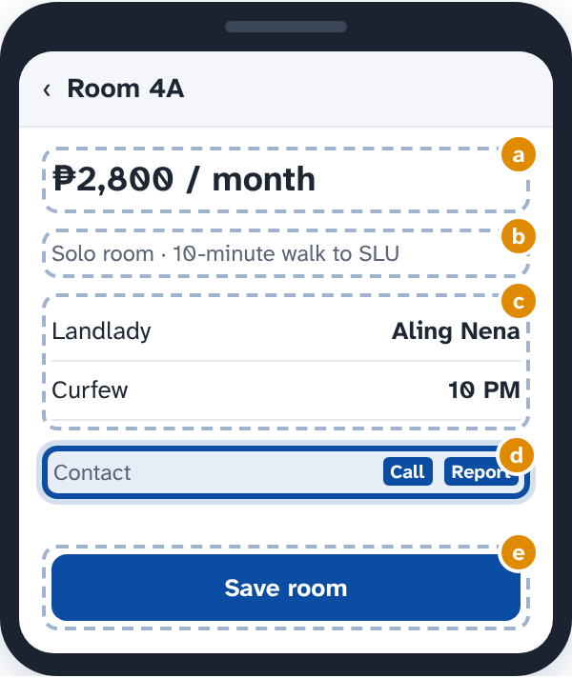
22. (1 pt) Landladies use this form to list a room. Click the field that breaks Tesler's law by making them do work the app could do.
Answer: c. Text box: e.g. 16.4093, 120.5987
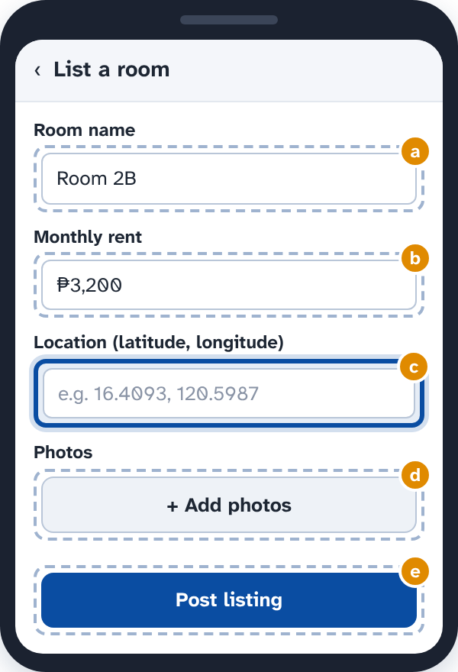
23. (1 pt) In testing, students call the new Kwarto design "so clean and easy" and rate it highly, yet 3 of 5 could not find how to message a…
Answer: b. Aesthetic-usability effect
24. (1 pt) Kyle says the Kwarto menu can have at most 7 items "because of Miller's law." What is right?
Answer: d. Don't use 7 ± 2 as a hard limit; chunk content instead
25. (1 pt) Kwarto shows all 200 rooms near campus in one long list, with no filters or picks. Many freshmen close the app without choosing. Which…
Answer: c. Choice overload
26. (1 pt) Kwarto shows its "Beware of fake listings" warning in a flashy, ad-like banner. Most students scroll right past it. Which law explains why?
Answer: b. Selective attention
27. (1 pt) Freshmen compare three saved rooms before choosing. Which changes go easy on their working memory? Tick all that apply.
Answer: a, c, e
a. Show the three rooms side by side in one table
c. Group the details into short, labeled chunks: price, rules, location
e. Keep each saved room visible while they compare
28. (1 pt) Aira makes every button on the listing page bright orange "so nothing gets missed." What does the Von Restorff effect say?
Answer: b. Only the key action should stand out; if all do, none does
29. (1 pt) The team picks a simple house outline for Kwarto's app icon, not a detailed drawing of a boarding house. Which law supports this?
Answer: d. Law of Prägnanz
30. (1 pt) Kwarto's "Find your room in 8 questions" quiz shows a "Rate us!" pop-up after question 3, and many freshmen quit. What does the law of…
Answer: a. Remove the interruption so students can keep going
31. (1 pt) The reservation screen lists "Requested", "Accepted", "Paid" and "Moved in" as four loose words, and students don't see them as steps of…
Answer: d. Join the four steps with a line, like a delivery tracker
32. (1 pt) The team wants Kwarto's sign-up form as short as it can be. Following Occam's razor, click the field to remove.
Answer: d. Text box: e.g. Heneral Luna
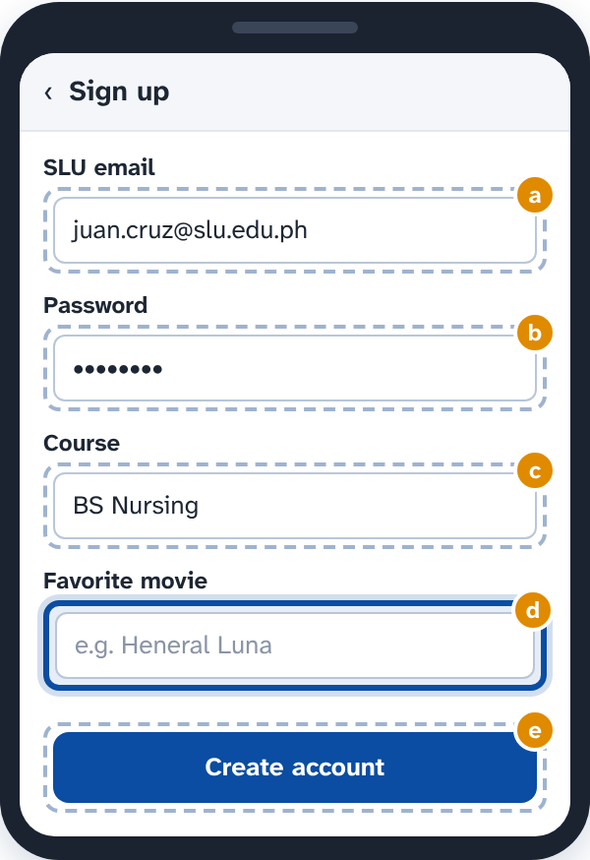
33. (1 pt) Which law of UX should remind Aira to check her own thinking?
Answer: a. Cognitive bias
34. (1 pt) The team wrote a 6-page "How to use Kwarto" guide, but no tester opened it: they started tapping right away. What does the paradox of…
Answer: b. Put short tips inside the app, right where students need them
35. (2 pts) Drag the law that explains each thing the team saw in testing.
1. Testers remembered the Search and Me tabs, but forgot the Saved tab in the middle → Serial position effect
2. Freshmen took much longer to choose when the filter showed 14 room types at once → Hick's law
3. Testers kept missing the small "×" in the corner of the photo viewer → Fitts's law
4. Testers found "Reserve" fastest when it was the only orange button on the page → Von Restorff effect
Not used: Law of Prägnanz; Zeigarnik effect
36. (2 pts) Complete the sentences about chunking.
(1) a. small groups that form a meaningful whole
(2) b. KW 482 719 365
37. (1 pt) Kwarto puts its back button at the bottom right and the profile icon at the top left, unlike the apps students already use. Testers keep…
Answer: a. Jakob's law
PART 5 · USABILITY HEURISTICS: INSPECT THE PROTOTYPE (14 questions, 18 points)
38. (2 pts) Drag the heuristic each marker on this Reserve screen breaks. ("Cancel all" runs at once, with no "Are you sure?")
1. Marker 1 → 2. Match between system and the real world
2. Marker 2 → 6. Recognition rather than recall
3. Marker 3 → 9. Help users recognize, diagnose, and recover from errors
4. Marker 4 → 5. Error prevention
Not used: 1. Visibility of system status; 8. Aesthetic and minimalist design
39. (1 pt) A student tapped "Remove" on Room 2B by mistake. Click the part of the screen that breaks User control and freedom.
Answer: b. Message: Room 2B was removed from your saved rooms.
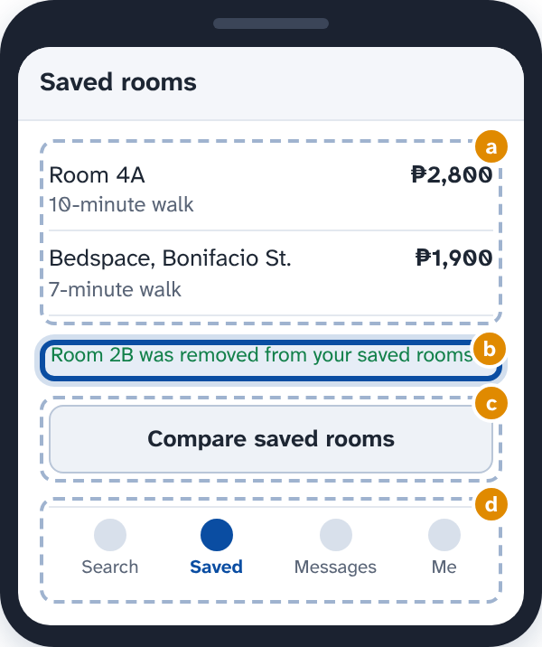
40. (1 pt) Click the part of this listing that breaks Aesthetic and minimalist design.
Answer: c. Box: Listing hash: 9f3a77c2e1, GPS: 16.40921° N, 120.59873° E, Server: ap-southeast-1b, Posted by user #20417
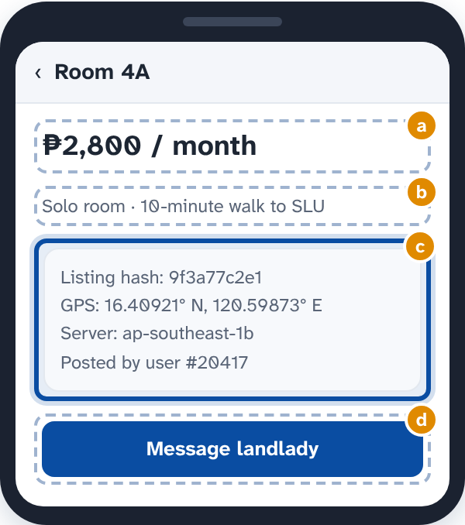
41. (1 pt) Click the part of the screen that breaks Consistency and standards.
Answer: b. Button: Book now
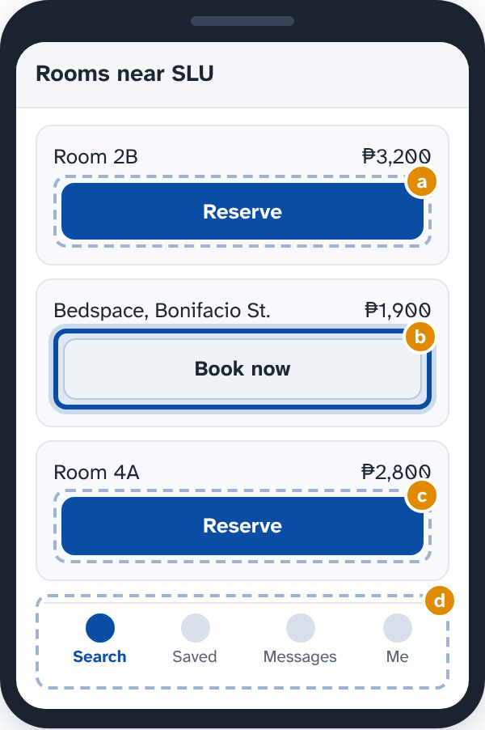
42. (1 pt) After a student taps "Send request", nothing on the screen changes for 8 seconds, so many tap it again and send the same request three…
Answer: b. 1. Visibility of system status
43. (1 pt) Which three things decide how severe a usability problem is?
Answer: c. How often it happens, how bad it is, and if users hit it again
44. (2 pts) Put the steps of a heuristic evaluation of Kwarto in order.
Correct order:
1. Choose the evaluators
2. Each evaluator goes through Kwarto alone, at least twice, noting each problem and the heuristic it breaks
3. The evaluators combine their lists
4. Rate the severity of each problem
5. Decide what to fix first
(On the sheet, top to bottom: 5, 4, 3, 1, 2)
45. (2 pts) Complete the facts about heuristic evaluation.
(1) b. 3 to 5
(2) a. a third
(3) c. evaluators, not real users
46. (2 pts) The team fixed four problems in Kwarto. Drag the heuristic each fix follows.
1. An "Uploading your ID: 70%" bar shows while the photo uploads → 1. Visibility of system status
2. "Reserve" is now the word for reserving on every screen → 4. Consistency and standards
3. Landladies can long-press to mark many rooms "Taken" at once → 7. Flexibility and efficiency of use
4. A "?" beside "Reservation fee" opens a two-line tip → 10. Help and documentation
Not used: 3. User control and freedom; 8. Aesthetic and minimalist design
47. (1 pt) What is the main difference between a heuristic evaluation and a usability test?
Answer: b. Experts check it against rules; a usability test watches users
48. (1 pt) When a payment fails, Kwarto only says "Something went wrong." Under heuristic 9, what should the message do?
Answer: a. Say what went wrong in plain words and how to fix it
49. (1 pt) Who wrote the 10 usability heuristics?
Answer: a. Jakob Nielsen and Rolf Molich, 1990
50. (1 pt) Before a landlady deletes a listing with 12 messages, Kwarto now asks: "Delete Room 2B and its 12 messages? This can't be undone." Which…
Answer: d. 5. Error prevention
51. (1 pt) Why does each evaluator go through Kwarto alone before the group meets?
Answer: d. So they don't sway each other and find more problems
PART 6 · SYSTEM USABILITY SCALE: MEASURE IT (9 questions, 11 points)
52. (2 pts) Work out this tester's SUS score.
Answer: 80
53. (1 pt) The new Kwarto prototype scores 84 on SUS. What does that mean?
Answer: d. It is an A, in the top 10% of scores
54. (2 pts) Five testers used the updated prototype. Work out the group's SUS result.
(1) b. 72
(2) b. above average, but not an A
55. (1 pt) Why are half of the SUS statements positive and half negative?
Answer: b. So people read each one instead of agreeing with everything
56. (1 pt) Which SUS statement measures learnability?
Answer: c. I needed to learn a lot of things before I could get going with this system.
57. (1 pt) Aira wrote up the SUS results. Click the line that is a mistake.
Answer: b. One tester couldn't answer item 6, so we scored only the other 9.
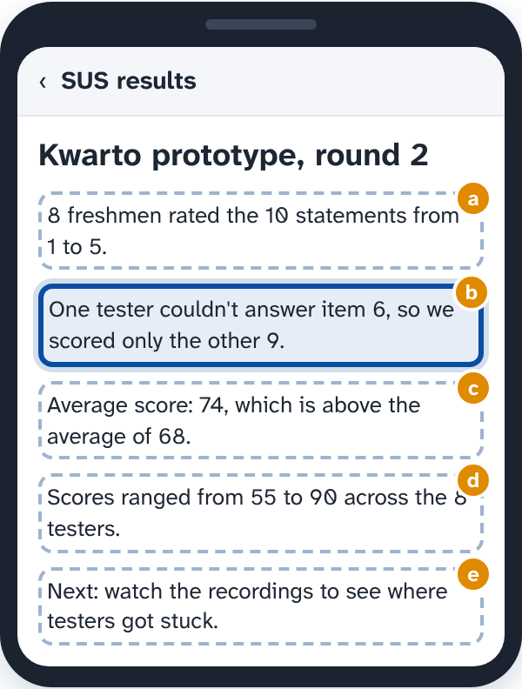
58. (1 pt) What is wrong with Kyle's conclusion?
Answer: c. SUS shows overall usability, not which screen causes problems
59. (1 pt) When should testers fill in the SUS questionnaire?
Answer: a. Right after they use the prototype
60. (1 pt) Which of these are true about SUS? Tick all that apply.
Answer: a, c, e
a. It has 10 statements, each rated from 1 to 5
c. A score of about 68 is average
e. The odd-numbered statements are positive

