ITE 30 MIDTERM EXAM
ITE 30 - IT CERTIFICATION AND REVIEW
Questions and answer key
46 questions · 100 points · passing 60%
Every student gets the questions in this numbered order on the website. Only the choices are shuffled on each computer, so the letters on screen may differ from the letters here.
Diagrams earn 1 point for each blank that is right. SQL questions earn part of the points when the query is close. Everything else is all or nothing.
Parts
Part | Questions | Points
Part 1 · AI and data analytics | 1 to 13 | 18
Part 2 · Database management | 14 to 30 | 33
Part 3 · Use case diagram | 31 to 32 | 9
Part 4 · ER diagram | 33 to 46 | 40
Total | 46 | 100

QUESTIONS
PART 1 · AI AND DATA ANALYTICS (13 questions, 18 points)
1. Multiple choice · 1 pt
A bank trains a model on 50,000 past loan applications, each one labeled "paid" or "defaulted", so that it can decide on new applications. Which kind of learning is this?
a. Unsupervised learning
b. Supervised learning
c. Reinforcement learning
d. Semi-supervised learning
2. Sort into groups · 2 pts
Sort each AI project by the kind of learning it uses.
Groups: Supervised · Unsupervised · Reinforcement
1. Predict the rent of a boarding house from past listings with known rents
2. Group LMS users by their study habits, with no groups given
3. A robot vacuum learns the room by earning rewards for every clean area
4. Tag photos of strawberry leaves as healthy or diseased, trained on labeled photos
5. Find unusual e-wallet transactions, with no examples of fraud to learn from
6. A game AI gets better by playing against itself thousands of times
3. Multiple choice · 1 pt
A hospital in Baguio wants a model that finds signs of pneumonia in chest X-ray images. Which neural network suits this job best?
a. RNN
b. DBN
c. CNN
d. A single perceptron with no hidden layer
4. Sort into groups · 2 pts
A milk tea chain's data team gets these requests. Sort each one by the kind of analytics it needs.
Groups: Descriptive · Diagnostic · Predictive · Prescriptive
1. Show last month's sales of every branch on a dashboard
2. Find out why the Session Road branch sold less in August
3. Forecast next month's demand for taro powder
4. Recommend how many staff each branch should schedule every hour
5. Count how many orders came from the delivery app this week
6. Dig into reviews to see what caused the drop in app ratings
7. Estimate which loyalty members are likely to stop buying
8. Choose the delivery route and time that cut fuel cost the most
5. Multiple choice · 1 pt
A milk tea shop mines a year of receipts and finds that customers who order taro milk tea often add extra pearls in the same order. Which data mining technique found this?
a. Classification
b. Regression
c. Association
d. Clustering
6. Multiple choice · 1 pt
A telco has the usage data of 2 million prepaid subscribers, with no groups or labels. Marketing wants to find groups of similar subscribers to send each group its own promo. Which technique fits?
a. Clustering
b. Classification
c. Regression
d. Association
7. Matching · 2 pts
Before typhoon season, a grocery chain looks at its sales from past typhoons. Drag each level onto what the chain has at that step.
1. Every receipt from every branch, just as it was printed → __________
2. Units sold per product in the week before each typhoon → __________
3. "Before a typhoon, canned sardines sell five times faster than usual" → __________
4. Shipping extra sardines to the branches in the next typhoon’s path → __________
Choices: Data · Information · Knowledge · Metadata · Wisdom
8. Multiple choice · 1 pt
The analytics team splits the Product dimension of its sales star schema into Product, Category and Brand tables, so category names are no longer repeated on every product. What has the schema become?
a. A star schema with a bigger fact table
b. A fact constellation
c. An OLTP schema
d. A snowflake schema
9. Multiple choice · 1 pt
The registrar collects every class's grades during the term, then computes all students' GWAs in one run after the last day of finals. Which kind of processing is this?
a. Online processing
b. Batch processing
c. Real-time processing
d. Distributed processing
10. Fill in the blanks · 2 pts
Choose the kind of data for each blank.
The analytics team gets three new sources. The enrollment table in MySQL is ____(1)____ data. The course catalog, sent as XML files, is ____(2)____ data. The recorded lecture videos are ____(3)____ data.
(1) a. structured b. semi-structured c. unstructured
(2) a. structured b. semi-structured c. unstructured
(3) a. structured b. semi-structured c. unstructured
11. Multiple choice · 1 pt
The campus Wi-Fi log grows by thousands of rows every second, and each row has to be stored the moment it arrives. Which V of big data does this show?
a. Velocity
b. Volume
c. Variety
d. Veracity
12. Matching · 2 pts
Drag the kind of NoSQL database that suits each job.
1. Look up each shopper's cart by the shopper's ID, very fast → __________
2. Keep each product as a JSON record, each with its own fields → __________
3. Find friends of friends in a social network → __________
4. Write billions of sensor readings, then read a few columns at a time → __________
Choices: Column family · Document · Graph · Key-value · Relational
13. Multiple choice · 1 pt
A social app keeps copies of each post on servers in three countries. Right after a like, the like count can differ between servers for a few seconds, then all of them show the same number. Which property of BASE is this?
a. Eventually consistent
b. Atomicity
c. Durability
d. Strong, immediate consistency
PART 2 · DATABASE MANAGEMENT (17 questions, 33 points)
14. Sort into groups · 2 pts
A team is designing the database of a boarding house. Sort each task by the design phase it belongs to.
Groups: Conceptual design · Logical design · Physical design
1. Draw an ER diagram of tenants, rooms and payments
2. Choose DECIMAL(8,2) for the amount column in MySQL
3. Turn the M:N between tenants and rooms into a table with two foreign keys
4. Decide that Tenant and Room have an M:N relationship
5. Add an index on the tenant's last name
6. Normalize the tables to 3NF
15. Matching · 2 pts
The registrar keeps every enrollment in this one table. Drag the anomaly onto each problem it causes.
student_no | name | course_code | course_title | grade
2231001 | Ana Cruz | ITE 30 | IT Certification and Review | 1.5
2231002 | Leo Ramos | ITE 30 | IT Certification and Review | 2.0
2231001 | Ana Cruz | ITE 14 | UX Concepts and Design | 1.75
2231003 | Ben Tan | CS 220 | Data Structures | 2.25

1. A new course, ITE 40 Cloud Computing, cannot be saved until a student enrolls in it → __________
2. Ben is the only student in CS 220. Deleting his row also loses the title "Data Structures" → __________
3. ITE 30 is renamed, but only its first row is changed, so ITE 30 now has two titles → __________
Choices: Deletion anomaly · Dirty read · Insertion anomaly · Lost update · Update anomaly
16. Multiple choice · 1 pt
A clerk tries to save a new student whose student_no, the primary key, is left blank (NULL). Which integrity rule rejects it?
a. Referential integrity
b. Domain integrity
c. User-defined integrity
d. Entity integrity
17. Multiple choice · 1 pt
The registrar lets advisers read the grades table but not change it, with GRANT SELECT ON grades TO adviser. Which group of SQL commands does GRANT belong to?
a. DDL
b. DML
c. TCL
d. DCL
18. Multiple choice · 1 pt
While T1 is moving a student from Section A to Section B, T2 runs a head count and finds the student in neither section. Which ACID property did the DBMS fail to keep?
a. Atomicity
b. Consistency
c. Isolation
d. Durability
19. Matching · 2 pts
Two transactions, T1 and T2, run at the same time with no locking. Drag the problem onto what happens.
1. T2 reads Ana's new balance before T1 commits. Then T1 rolls back. → __________
2. T1 reads a room's rent twice and gets ₱3,000, then ₱3,500, because T2 changed it and committed in between. → __________
3. T1 counts the vacant rooms twice. T2 adds a new vacant room in between, so the count goes from 4 to 5. → __________
4. T1 and T2 both read a stock of 10 and each sells 1 item. Both write 9. → __________
Choices: Deadlock · Dirty read · Lost update · Non-repeatable read · Phantom read
20. Multiple choice · 1 pt
An online shop's order search by customer name has become slow, and the DBA sees a full table scan on every search. What should the DBA try first?
a. Split the order table into one table for each customer
b. Add an index on customer_name
c. Turn off the transaction log
d. Move the order table into a view
21. Multiple choice · 1 pt
A school runs a full backup every Sunday and a differential backup every other night. The disk fails on Thursday morning. What does the DBA need to restore the database?
a. Only Sunday's full backup
b. Every nightly backup from Monday to Wednesday, applied one by one in order
c. Sunday's full backup and Wednesday night's differential
d. Only Wednesday night's differential
22. Multiple choice · 2 pts
The DBA moves the grades table to a faster disk and changes how its rows are stored. The enrollment app and its queries keep working with no changes. Which property of the three-schema architecture made this possible?
a. Logical data independence
b. Referential integrity
c. Physical data independence
d. Concurrency control by the DBMS
23. Multiple choice · 2 pts
The registrar's daily report joins five tables and has become slow. The team copies the program name into the student table so the report needs one join less, and accepts the repeated data. What is this?
a. Normalization
b. Table partitioning
c. Indexing
d. Denormalization
24. Matching · 2 pts
The team is writing the CREATE TABLE statement for the student table. Drag the constraint that enforces each rule.
1. Every student has a student_no, and no two students share one → __________
2. A student’s program_code must exist in the program table → __________
3. No two students can have the same slu_email → __________
4. year_level can only be 1, 2, 3 or 4 → __________
Choices: CHECK · DEFAULT · FOREIGN KEY · PRIMARY KEY · UNIQUE
25. Multiple choice · 2 pts
The loan table has 11 rows. Two of them have no return date yet (returned_on is NULL). What does SELECT COUNT(returned_on) FROM loan return?
a. 9
b. 11
c. 2
d. NULL, because some of the values are NULL
26. Multiple choice · 2 pts
The library combines the members from its Main campus list and its Maryheights campus list into one result. Members who use both campuses must appear twice, once for each list. Which set operator does this?
a. UNION
b. UNION ALL
c. INTERSECT
d. MINUS (EXCEPT)
27. Multiple choice · 2 pts
To list the loans that are not returned yet, a student writes SELECT * FROM loan WHERE returned_on = NULL. The loan table has 11 rows, and 2 of them have no return date (NULL). How many rows does the query return?
a. 0
b. 2
c. 11
d. It stops with an error, because a query cannot compare a column with NULL
28. Multiple choice · 2 pts
The librarian wants every member listed with the books they borrowed. Members who have never borrowed a book must still appear, with an empty title. Which join from member to loan does this?
a. INNER JOIN
b. LEFT OUTER JOIN
c. CROSS JOIN
d. A self join of the member table
29. Write a SQL query · 4 pts
Show the title and year of every book published after 2000, newest first.
Tables:
member (member_id, name, course)
book (book_id, title, year, shelf)
author (author_id, name)
book_author (book_id, author_id)
loan (loan_id, member_id, book_id, borrowed_on, due_on, returned_on)
Answer:

30. Write a SQL query · 4 pts
Join the tables to show the name of the member and the title of the book for every loan that has not been returned yet.
Tables:
member (member_id, name, course)
book (book_id, title, year, shelf)
author (author_id, name)
book_author (book_id, author_id)
loan (loan_id, member_id, book_id, borrowed_on, due_on, returned_on)
Answer:

PART 3 · USE CASE DIAGRAM (2 questions, 9 points)
31. Drag and drop onto a diagram · 5 pts
The clinic's requirements
• A Student books a clinic appointment online, and can also cancel one.
• Booking and cancelling always include checking the student's ID. The University ID system, an outside system, confirms it.
• While booking, a student may upload a medical certificate.
• The Nurse views the day's schedule.
Complete the use case diagram of the campus clinic's appointment system. Drag a symbol onto each numbered blank.
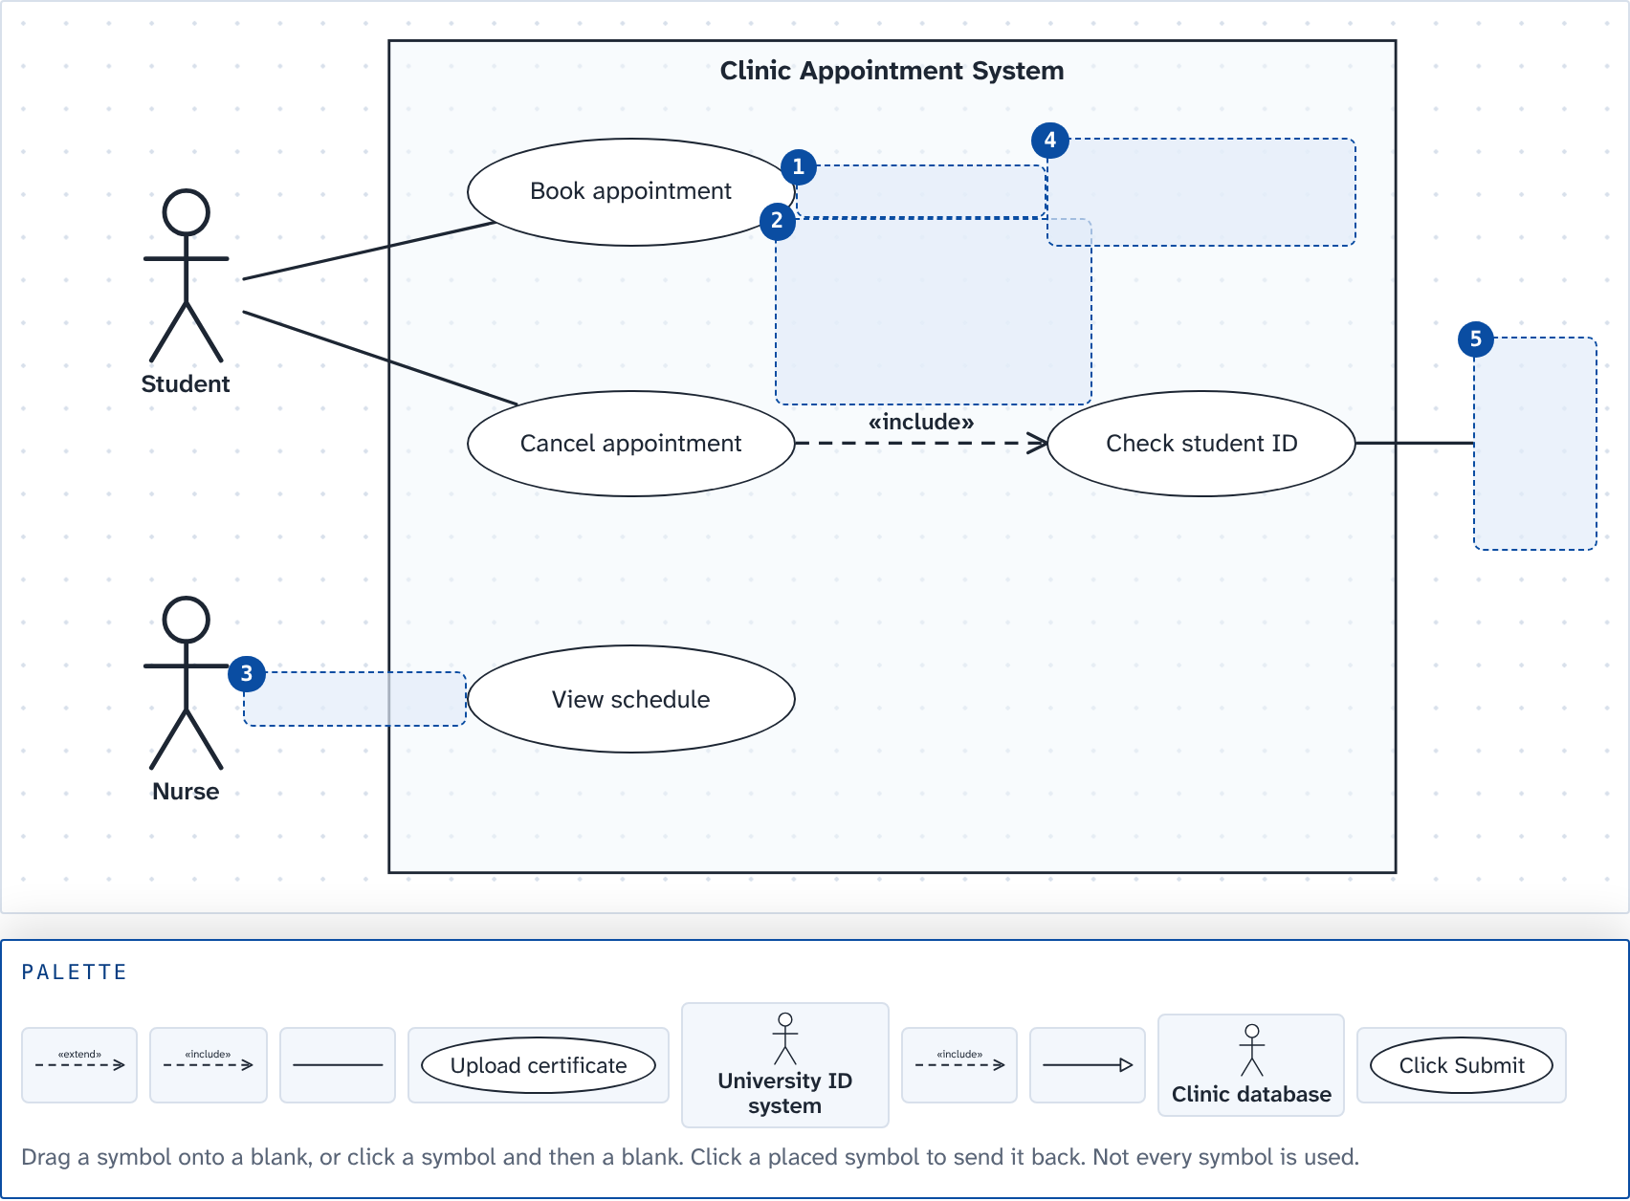
Blanks: 1 ____ 2 ____ 3 ____ 4 ____ 5 ____
32. Drag and drop onto a diagram · 4 pts
The app's requirements
• A Customer places an order. Placing an order always includes paying online, which goes through an outside Payment gateway.
• While placing an order, a customer may add a tip for the rider.
• A Premium customer is a special kind of customer who can also schedule an order in advance.
• A Rider delivers the order.
Complete the use case diagram of the food delivery app. Drag a symbol onto each numbered blank.
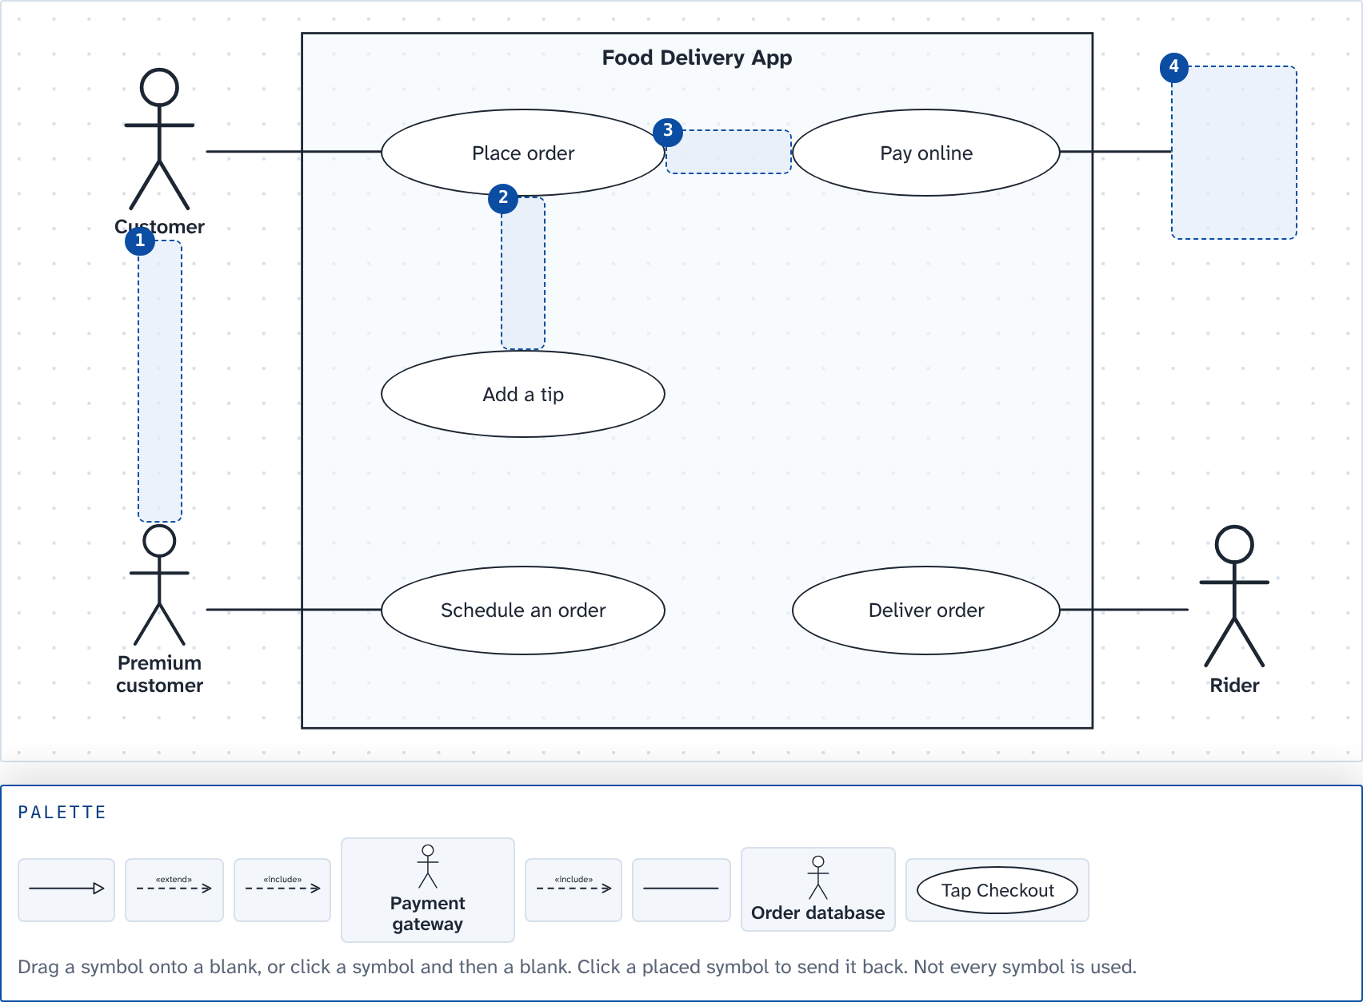
Blanks: 1 ____ 2 ____ 3 ____ 4 ____
PART 4 · ER DIAGRAM (14 questions, 40 points)
33. Drag and drop onto a diagram · 10 pts
Business rules of the enrollment system
• Saint Louis University is building one enrollment system that it will share with its partner universities.
• Rule 1. Each university has one or more schools. Each school belongs to exactly one university.
• Rule 2. Each school offers zero or more programs (a new school may have none yet). Each program is offered by exactly one school.
• Rule 3. Each school has one or more professors. Each professor belongs to exactly one school.
• Rule 4. Each student is enrolled in exactly one program. A program has zero or more students (a new program may have none yet).
Map rules 1 to 4 onto the ER diagram of SLU's enrollment system: drag a crow's foot mark onto each end of every line (1 to 8), then the foreign key column each table needs (9 and 10).
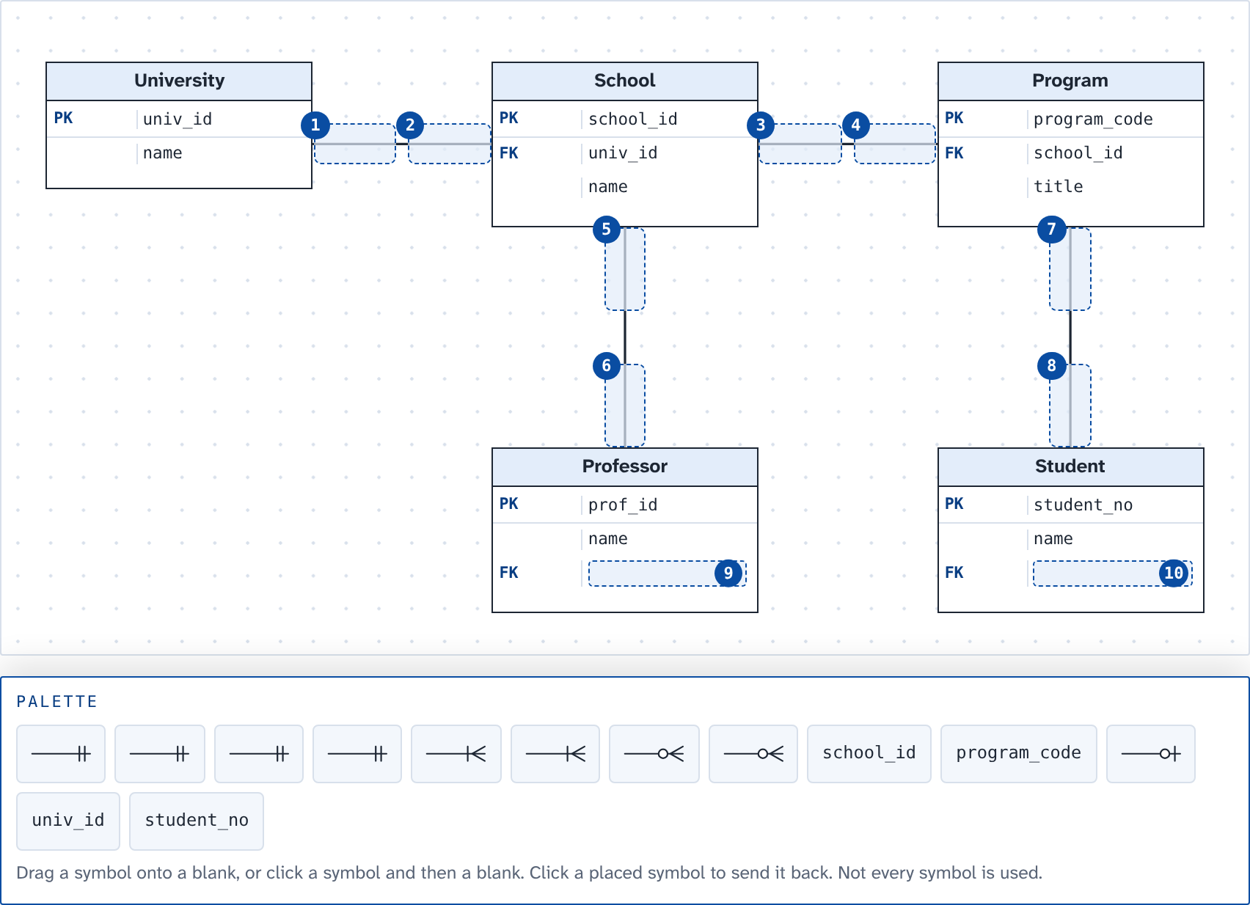
Blanks: 1 ____ 2 ____ 3 ____ 4 ____ 5 ____ 6 ____ 7 ____ 8 ____ 9 ____ 10 ____
34. Drag and drop onto a diagram · 10 pts
More business rules of the enrollment system
• Rule 5. Each course has zero or more sections each term. Each section is of exactly one course.
• Rule 6. Each section is handled by at most one professor (a new section can be "TBA"). A professor handles zero or more sections.
• Rule 7. A student enrolls in zero or more sections, and a section has zero or more students. Each enrollment keeps the final grade the student got in that section.
• Rule 8. Each school is headed by exactly one dean, who is one of its professors. A professor heads at most one school.
Map rules 5 to 7: drag a crow's foot mark onto each end of every line (1 to 8), then name the table that rule 7 needs (9) and put the final grade where it belongs (10).
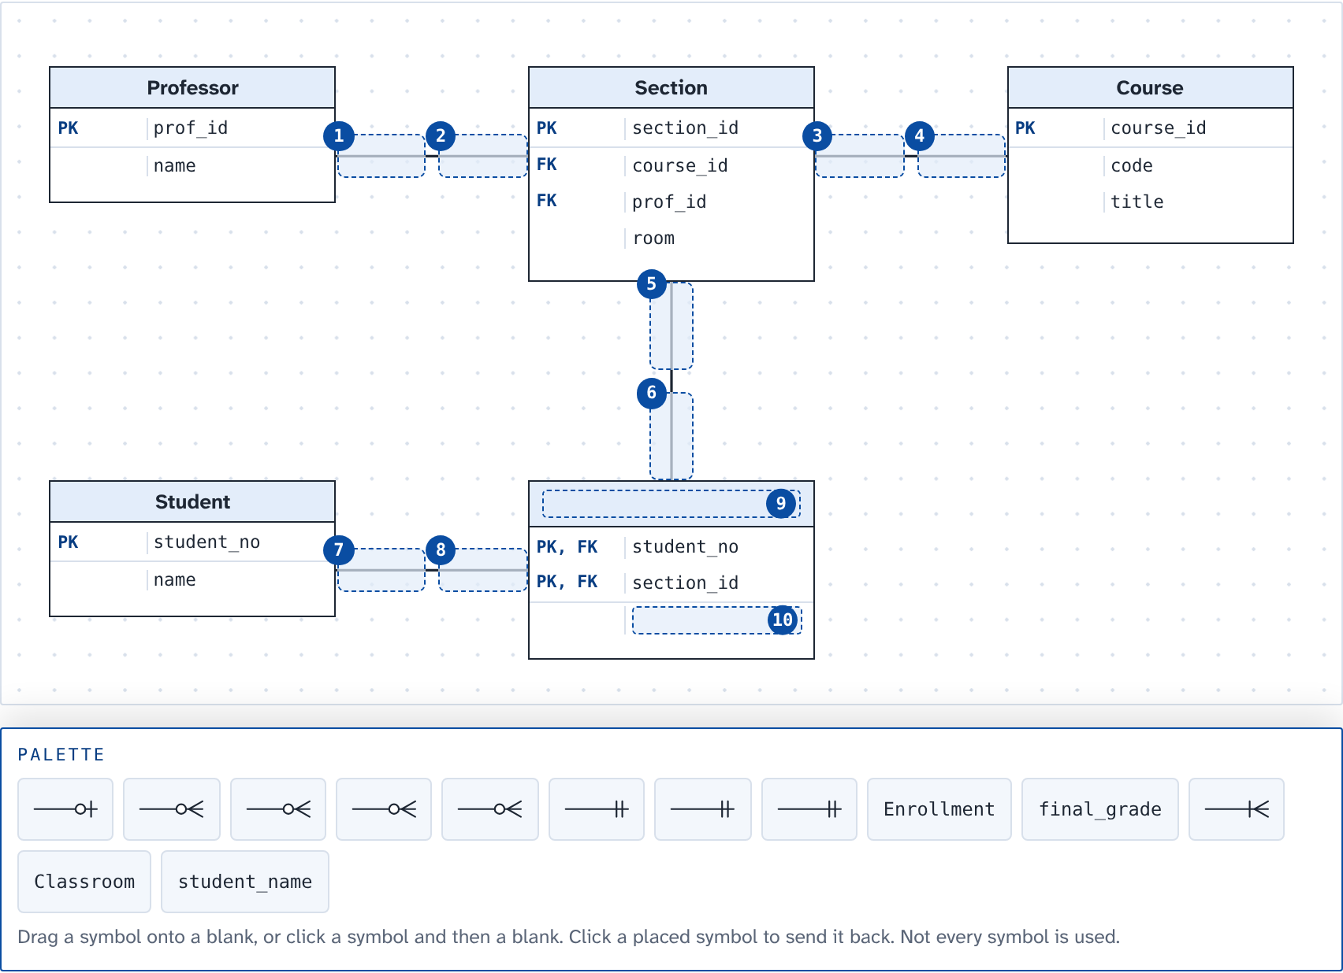
Blanks: 1 ____ 2 ____ 3 ____ 4 ____ 5 ____ 6 ____ 7 ____ 8 ____ 9 ____ 10 ____
35. Fill in the blanks · 3 pts
Business rules of the enrollment system
• Saint Louis University is building one enrollment system that it will share with its partner universities.
• Rule 1. Each university has one or more schools. Each school belongs to exactly one university.
• Rule 2. Each school offers zero or more programs (a new school may have none yet). Each program is offered by exactly one school.
• Rule 3. Each school has one or more professors. Each professor belongs to exactly one school.
• Rule 4. Each student is enrolled in exactly one program. A program has zero or more students (a new program may have none yet).
• Rule 5. Each course has zero or more sections each term. Each section is of exactly one course.
• Rule 6. Each section is handled by at most one professor (a new section can be "TBA"). A professor handles zero or more sections.
• Rule 7. A student enrolls in zero or more sections, and a section has zero or more students. Each enrollment keeps the final grade the student got in that section.
• Rule 8. Each school is headed by exactly one dean, who is one of its professors. A professor heads at most one school.
Choose the kind of relationship for each blank.
From the business rules, University to School is ____(1)____, Student to Section (rule 7) is ____(2)____, and the dean who heads a school (rule 8) makes Professor to School ____(3)____.
(1) a. 1:1 b. 1:N c. M:N
(2) a. 1:1 b. 1:N c. M:N
(3) a. 1:1 b. 1:N c. M:N
36. Multiple choice · 1 pt
Business rules of the enrollment system
• Saint Louis University is building one enrollment system that it will share with its partner universities.
• Rule 1. Each university has one or more schools. Each school belongs to exactly one university.
• Rule 2. Each school offers zero or more programs (a new school may have none yet). Each program is offered by exactly one school.
• Rule 3. Each school has one or more professors. Each professor belongs to exactly one school.
• Rule 4. Each student is enrolled in exactly one program. A program has zero or more students (a new program may have none yet).
Rule 3 says each professor belongs to exactly one school. In the tables, where does the foreign key for this relationship go?
a. prof_id in the school table
b. school_id in the professor table
c. Both: school_id in professor and prof_id in school
d. A new table holding school_id and prof_id
37. Multiple choice · 1 pt
Business rules of the enrollment system: same as question 36.
On the line between Program and Student, the mark next to Student is a circle and a crow's foot. What does that mark say?
a. Every student must be in at least one program
b. A student can be in many programs at once
c. Every program has at least one student
d. A program can have no students yet, or many
38. Multiple choice · 1 pt
More business rules of the enrollment system
• Rule 5. Each course has zero or more sections each term. Each section is of exactly one course.
• Rule 6. Each section is handled by at most one professor (a new section can be "TBA"). A professor handles zero or more sections.
• Rule 7. A student enrolls in zero or more sections, and a section has zero or more students. Each enrollment keeps the final grade the student got in that section.
• Rule 8. Each school is headed by exactly one dean, who is one of its professors. A professor heads at most one school.
The primary key of Enrollment is (student_no, section_id), and each of the two is also a foreign key. What kind of relationship joins Section and Enrollment?
a. Identifying
b. Non-identifying
c. Recursive
d. Optional
39. Multiple choice · 1 pt
Business rules of the enrollment system
• Saint Louis University is building one enrollment system that it will share with its partner universities.
• Rule 1. Each university has one or more schools. Each school belongs to exactly one university.
• Rule 2. Each school offers zero or more programs (a new school may have none yet). Each program is offered by exactly one school.
• Rule 3. Each school has one or more professors. Each professor belongs to exactly one school.
• Rule 4. Each student is enrolled in exactly one program. A program has zero or more students (a new program may have none yet).
SLU changes rule 2: a program can now be offered jointly by two or more schools. What must change in the design?
a. Nothing changes, because a 1:N relationship from School to Program already allows it
b. Add a second column, school_id2, to the program table
c. School to Program becomes M:N, so add a table with school_id and program_code
d. Move program_code into the school table
40. Multiple choice · 1 pt
In the student table, student_no and slu_email are each unique and minimal. The designers choose student_no as the primary key. What is slu_email now?
a. A foreign key
b. A composite primary key
c. An alternate key
d. A surrogate key
41. Multiple choice · 1 pt
A clerk tries to delete the School of Engineering while professors in the professor table still have its school_id. The DBMS refuses. Which integrity rule is this?
a. Entity integrity
b. Domain integrity
c. User-defined integrity
d. Referential integrity
42. Multiple choice · 1 pt
In an early model, a school has many professors and a school offers many sections, and there is no line between Professor and Section. The registrar can't tell which professor handles which section. What is the problem, and how is it fixed?

a. A chasm trap: make every section optional
b. A fan trap: relate Professor and Section directly
c. A fan trap: merge Professor and Section into one entity
d. A chasm trap: relate Professor and Section directly
43. Multiple choice · 1 pt
Some courses must be taken before another one: ITE 30 needs ITE 10 first. How should the design record each course’s prerequisite?
a. A prerequisite_id column in course, as a foreign key to course itself
b. A prerequisite_id column in section, as a foreign key to the professor table
c. A separate table that copies every course’s row from course
d. A prerequisite_id column in student, as a foreign key to course
44. Multiple choice · 1 pt
Course codes sometimes change when the curriculum is revised (IT 30 became ITE 30). So the design gives each course a number made by the system, course_id, as its primary key, and keeps the code as a normal column. What kind of key is course_id?
a. A natural key
b. An alternate key
c. A composite key
d. A surrogate key
45. Tick all that apply · 2 pts
Business rules of the enrollment system
• Saint Louis University is building one enrollment system that it will share with its partner universities.
• Rule 1. Each university has one or more schools. Each school belongs to exactly one university.
• Rule 2. Each school offers zero or more programs (a new school may have none yet). Each program is offered by exactly one school.
• Rule 3. Each school has one or more professors. Each professor belongs to exactly one school.
• Rule 4. Each student is enrolled in exactly one program. A program has zero or more students (a new program may have none yet).
• Rule 5. Each course has zero or more sections each term. Each section is of exactly one course.
• Rule 6. Each section is handled by at most one professor (a new section can be "TBA"). A professor handles zero or more sections.
• Rule 7. A student enrolls in zero or more sections, and a section has zero or more students. Each enrollment keeps the final grade the student got in that section.
• Rule 8. Each school is headed by exactly one dean, who is one of its professors. A professor heads at most one school.
Which statements about the design of SLU's enrollment system are true? Select all that apply.
a. The foreign key for rule 4 is program_code in the student table
b. Rule 7 needs a table of its own between Student and Section
c. final_grade belongs in the student table
d. Professor to Section is a 1:1 relationship
e. Rule 2 allows a school that has no programs yet
f. Each school can belong to two universities
46. Drag and drop onto a diagram · 6 pts
The clinic's business rules
• Each consultation is for exactly one student and is handled by exactly one nurse.
• A student can have zero or more consultations, and so can a nurse.
• Each nurse is assigned exactly one station. A station has at most one nurse, and some stations are empty.
Another system: the campus clinic. Drag a crow's foot mark onto each end of every line.
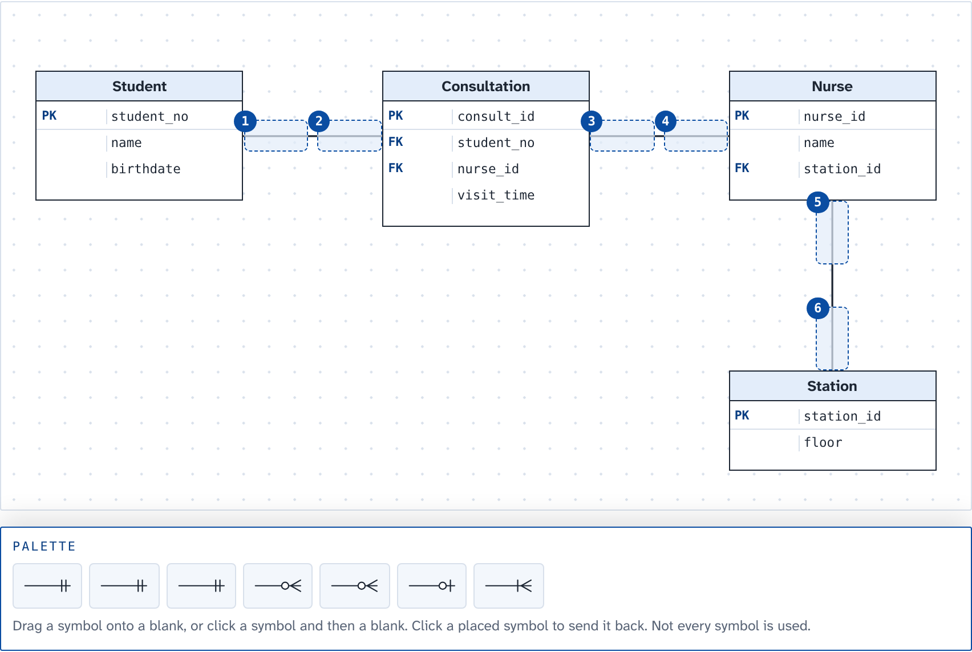
Blanks: 1 ____ 2 ____ 3 ____ 4 ____ 5 ____ 6 ____

ANSWER KEY
PART 1 · AI AND DATA ANALYTICS (13 questions, 18 points)
1. (1 pt) A bank trains a model on 50,000 past loan applications, each one labeled "paid" or "defaulted", so that it can decide on new…
Answer: b. Supervised learning
2. (2 pts) Sort each AI project by the kind of learning it uses.
Supervised: (1) Predict the rent of a boarding house from past listings with known rents; (4) Tag photos of strawberry leaves as healthy or diseased, trained on labeled photos
Unsupervised: (2) Group LMS users by their study habits, with no groups given; (5) Find unusual e-wallet transactions, with no examples of fraud to learn from
Reinforcement: (3) A robot vacuum learns the room by earning rewards for every clean area; (6) A game AI gets better by playing against itself thousands of times
3. (1 pt) A hospital in Baguio wants a model that finds signs of pneumonia in chest X-ray images. Which neural network suits this job best?
Answer: c. CNN
4. (2 pts) A milk tea chain's data team gets these requests. Sort each one by the kind of analytics it needs.
Descriptive: (1) Show last month's sales of every branch on a dashboard; (5) Count how many orders came from the delivery app this week
Diagnostic: (2) Find out why the Session Road branch sold less in August; (6) Dig into reviews to see what caused the drop in app ratings
Predictive: (3) Forecast next month's demand for taro powder; (7) Estimate which loyalty members are likely to stop buying
Prescriptive: (4) Recommend how many staff each branch should schedule every hour; (8) Choose the delivery route and time that cut fuel cost the most
5. (1 pt) A milk tea shop mines a year of receipts and finds that customers who order taro milk tea often add extra pearls in the same order.…
Answer: c. Association
6. (1 pt) A telco has the usage data of 2 million prepaid subscribers, with no groups or labels. Marketing wants to find groups of similar…
Answer: a. Clustering
7. (2 pts) Before typhoon season, a grocery chain looks at its sales from past typhoons. Drag each level onto what the chain has at that step.
1. Every receipt from every branch, just as it was printed → Data
2. Units sold per product in the week before each typhoon → Information
3. "Before a typhoon, canned sardines sell five times faster than usual" → Knowledge
4. Shipping extra sardines to the branches in the next typhoon’s path → Wisdom
Not used: Metadata
8. (1 pt) The analytics team splits the Product dimension of its sales star schema into Product, Category and Brand tables, so category names are…
Answer: d. A snowflake schema
9. (1 pt) The registrar collects every class's grades during the term, then computes all students' GWAs in one run after the last day of finals.…
Answer: b. Batch processing
10. (2 pts) Choose the kind of data for each blank.
(1) a. structured
(2) b. semi-structured
(3) c. unstructured
11. (1 pt) The campus Wi-Fi log grows by thousands of rows every second, and each row has to be stored the moment it arrives. Which V of big data…
Answer: a. Velocity
12. (2 pts) Drag the kind of NoSQL database that suits each job.
1. Look up each shopper's cart by the shopper's ID, very fast → Key-value
2. Keep each product as a JSON record, each with its own fields → Document
3. Find friends of friends in a social network → Graph
4. Write billions of sensor readings, then read a few columns at a time → Column family
Not used: Relational
13. (1 pt) A social app keeps copies of each post on servers in three countries. Right after a like, the like count can differ between servers for…
Answer: a. Eventually consistent
PART 2 · DATABASE MANAGEMENT (17 questions, 33 points)
14. (2 pts) A team is designing the database of a boarding house. Sort each task by the design phase it belongs to.
Conceptual design: (1) Draw an ER diagram of tenants, rooms and payments; (4) Decide that Tenant and Room have an M:N relationship
Logical design: (3) Turn the M:N between tenants and rooms into a table with two foreign keys; (6) Normalize the tables to 3NF
Physical design: (2) Choose DECIMAL(8,2) for the amount column in MySQL; (5) Add an index on the tenant's last name
15. (2 pts) The registrar keeps every enrollment in this one table. Drag the anomaly onto each problem it causes.
1. A new course, ITE 40 Cloud Computing, cannot be saved until a student enrolls in it → Insertion anomaly
2. Ben is the only student in CS 220. Deleting his row also loses the title "Data Structures" → Deletion anomaly
3. ITE 30 is renamed, but only its first row is changed, so ITE 30 now has two titles → Update anomaly
Not used: Dirty read; Lost update
16. (1 pt) A clerk tries to save a new student whose student_no, the primary key, is left blank (NULL). Which integrity rule rejects it?
Answer: d. Entity integrity
17. (1 pt) The registrar lets advisers read the grades table but not change it, with GRANT SELECT ON grades TO adviser. Which group of SQL…
Answer: d. DCL
18. (1 pt) While T1 is moving a student from Section A to Section B, T2 runs a head count and finds the student in neither section. Which ACID…
Answer: c. Isolation
19. (2 pts) Two transactions, T1 and T2, run at the same time with no locking. Drag the problem onto what happens.
1. T2 reads Ana's new balance before T1 commits. Then T1 rolls back. → Dirty read
2. T1 reads a room's rent twice and gets ₱3,000, then ₱3,500, because T2 changed it and committed in between. → Non-repeatable read
3. T1 counts the vacant rooms twice. T2 adds a new vacant room in between, so the count goes from 4 to 5. → Phantom read
4. T1 and T2 both read a stock of 10 and each sells 1 item. Both write 9. → Lost update
Not used: Deadlock
20. (1 pt) An online shop's order search by customer name has become slow, and the DBA sees a full table scan on every search. What should the DBA…
Answer: b. Add an index on customer_name
21. (1 pt) A school runs a full backup every Sunday and a differential backup every other night. The disk fails on Thursday morning. What does the…
Answer: c. Sunday's full backup and Wednesday night's differential
22. (2 pts) The DBA moves the grades table to a faster disk and changes how its rows are stored. The enrollment app and its queries keep working…
Answer: c. Physical data independence
23. (2 pts) The registrar's daily report joins five tables and has become slow. The team copies the program name into the student table so the…
Answer: d. Denormalization
24. (2 pts) The team is writing the CREATE TABLE statement for the student table. Drag the constraint that enforces each rule.
1. Every student has a student_no, and no two students share one → PRIMARY KEY
2. A student’s program_code must exist in the program table → FOREIGN KEY
3. No two students can have the same slu_email → UNIQUE
4. year_level can only be 1, 2, 3 or 4 → CHECK
Not used: DEFAULT
25. (2 pts) The loan table has 11 rows. Two of them have no return date yet (returned_on is NULL). What does SELECT COUNT(returned_on) FROM loan…
Answer: a. 9
26. (2 pts) The library combines the members from its Main campus list and its Maryheights campus list into one result. Members who use both…
Answer: b. UNION ALL
27. (2 pts) To list the loans that are not returned yet, a student writes SELECT * FROM loan WHERE returned_on = NULL. The loan table has 11 rows,…
Answer: a. 0
28. (2 pts) The librarian wants every member listed with the books they borrowed. Members who have never borrowed a book must still appear, with an…
Answer: b. LEFT OUTER JOIN
29. (4 pts) Show the title and year of every book published after 2000, newest first.
A correct query:
SELECT title, year FROM book WHERE year > 2000 ORDER BY year DESC
Rows must come in the asked order. Part of the points when the query is close.
30. (4 pts) Join the tables to show the name of the member and the title of the book for every loan that has not been returned yet.
A correct query:
SELECT m.name, b.title
FROM loan l
JOIN member m ON m.member_id = l.member_id
JOIN book b ON b.book_id = l.book_id
WHERE l.returned_on IS NULL
Part of the points when the query is close.
PART 3 · USE CASE DIAGRAM (2 questions, 9 points)
31. (5 pts) Complete the use case diagram of the campus clinic's appointment system. Drag a symbol onto each numbered blank.
Blank 1 → a dashed arrow marked extend
Blank 2 → a dashed arrow marked include
Blank 3 → a plain line
Blank 4 → an oval: Upload certificate
Blank 5 → a stick figure: University ID system
Not used: a dashed arrow marked include; a line with a hollow triangle; a stick figure: Clinic database; an oval: Click Submit
One point for each blank that is right.
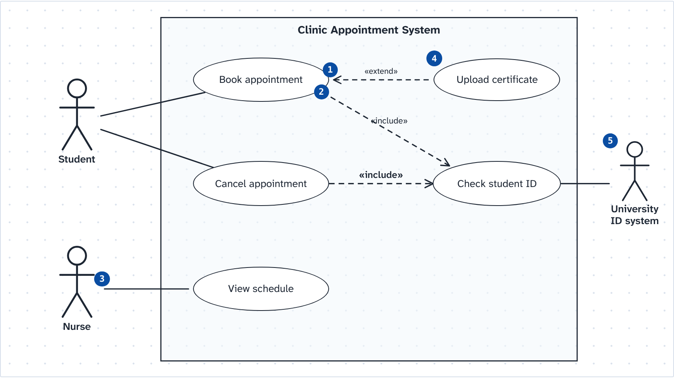
32. (4 pts) Complete the use case diagram of the food delivery app. Drag a symbol onto each numbered blank.
Blank 1 → a line with a hollow triangle
Blank 2 → a dashed arrow marked extend
Blank 3 → a dashed arrow marked include
Blank 4 → a stick figure: Payment gateway
Not used: a dashed arrow marked include; a plain line; a stick figure: Order database; an oval: Tap Checkout
One point for each blank that is right.
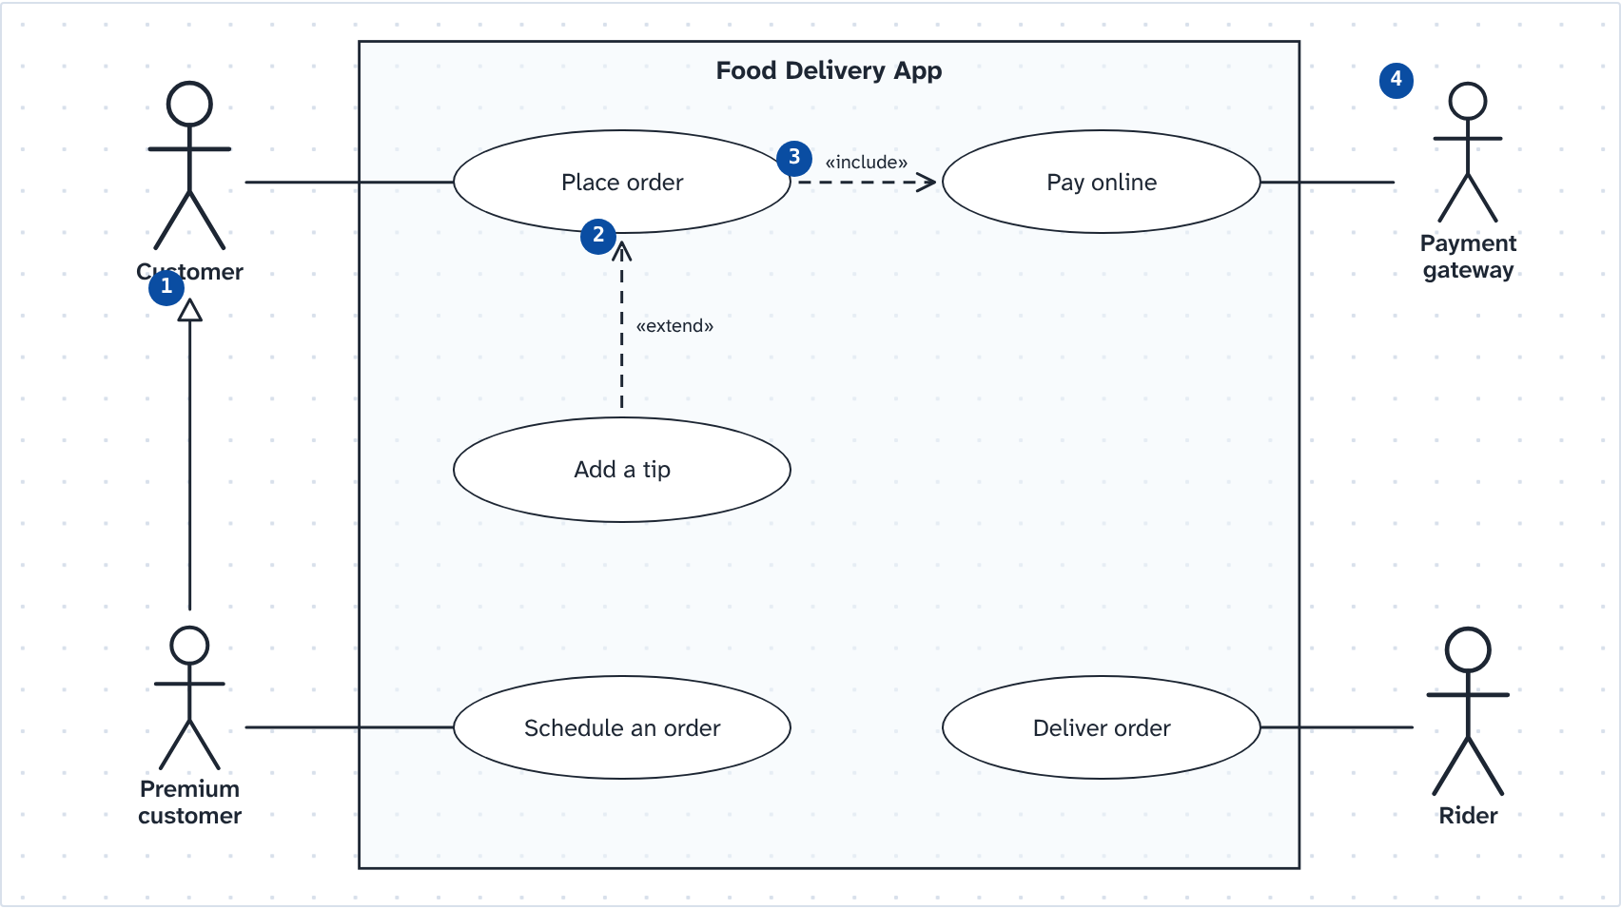
PART 4 · ER DIAGRAM (14 questions, 40 points)
33. (10 pts) Map rules 1 to 4 onto the ER diagram of SLU's enrollment system: drag a crow's foot mark onto each end of every line (1 to 8), then the…
Blank 1 → two bars
Blank 2 → a bar and a crow's foot
Blank 3 → two bars
Blank 4 → a circle and a crow's foot
Blank 5 → two bars
Blank 6 → a bar and a crow's foot
Blank 7 → two bars
Blank 8 → a circle and a crow's foot
Blank 9 → “school_id”
Blank 10 → “program_code”
Not used: a circle and a bar; “univ_id”; “student_no”
One point for each blank that is right.
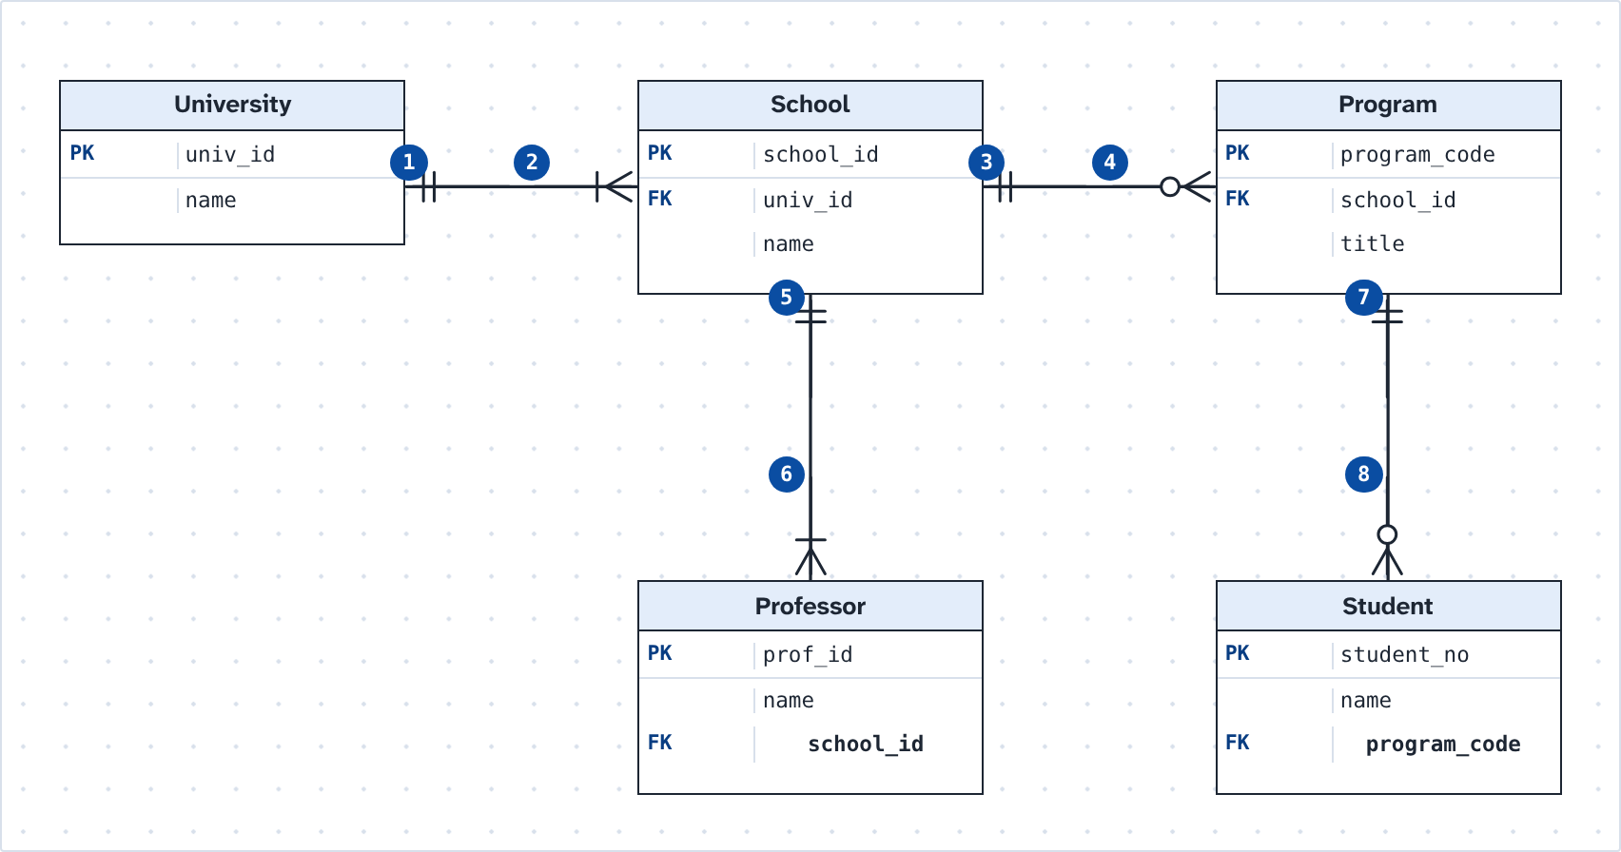
34. (10 pts) Map rules 5 to 7: drag a crow's foot mark onto each end of every line (1 to 8), then name the table that rule 7 needs (9) and put the…
Blank 1 → a circle and a bar
Blank 2 → a circle and a crow's foot
Blank 3 → a circle and a crow's foot
Blank 4 → two bars
Blank 5 → two bars
Blank 6 → a circle and a crow's foot
Blank 7 → two bars
Blank 8 → a circle and a crow's foot
Blank 9 → “Enrollment”
Blank 10 → “final_grade”
Not used: a bar and a crow's foot; “Classroom”; “student_name”
One point for each blank that is right.
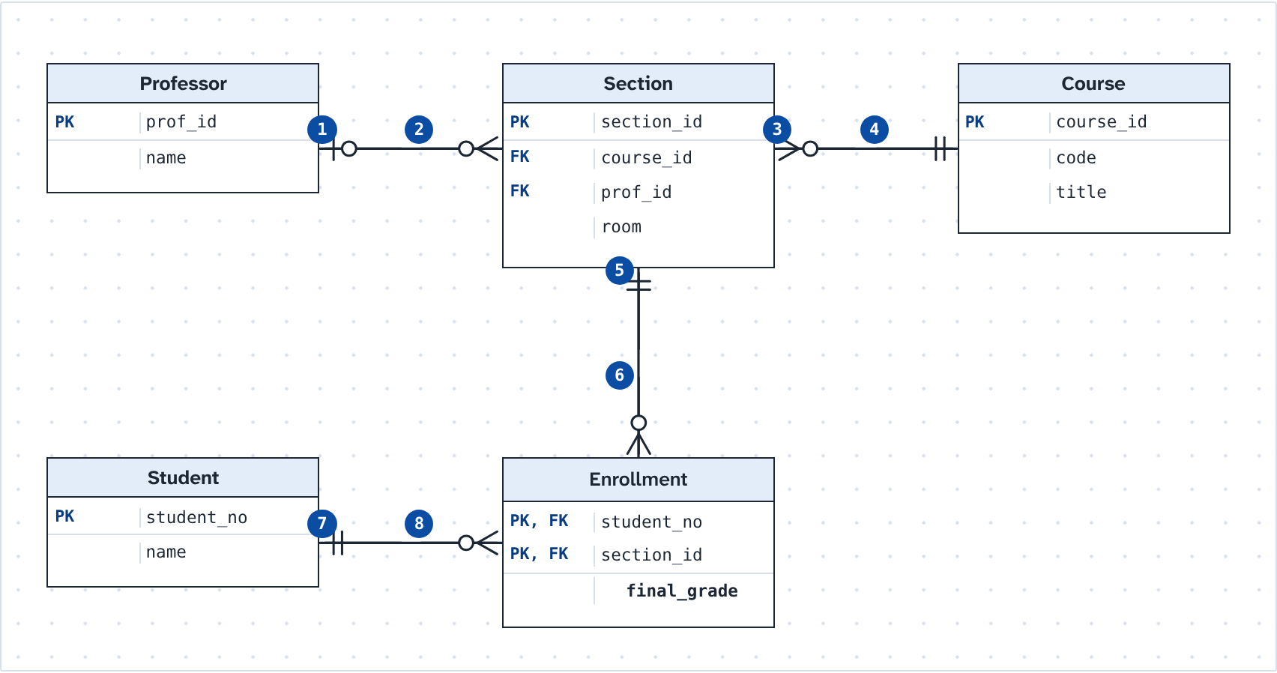
35. (3 pts) Choose the kind of relationship for each blank.
(1) b. 1:N
(2) c. M:N
(3) a. 1:1
36. (1 pt) Rule 3 says each professor belongs to exactly one school. In the tables, where does the foreign key for this relationship go?
Answer: b. school_id in the professor table
37. (1 pt) On the line between Program and Student, the mark next to Student is a circle and a crow's foot. What does that mark say?
Answer: d. A program can have no students yet, or many
38. (1 pt) The primary key of Enrollment is (student_no, section_id), and each of the two is also a foreign key. What kind of relationship joins…
Answer: a. Identifying
39. (1 pt) SLU changes rule 2: a program can now be offered jointly by two or more schools. What must change in the design?
Answer: c. School to Program becomes M:N, so add a table with school_id and program_code
40. (1 pt) In the student table, student_no and slu_email are each unique and minimal. The designers choose student_no as the primary key. What is…
Answer: c. An alternate key
41. (1 pt) A clerk tries to delete the School of Engineering while professors in the professor table still have its school_id. The DBMS refuses.…
Answer: d. Referential integrity
42. (1 pt) In an early model, a school has many professors and a school offers many sections, and there is no line between Professor and Section.…
Answer: b. A fan trap: relate Professor and Section directly
43. (1 pt) Some courses must be taken before another one: ITE 30 needs ITE 10 first. How should the design record each course’s prerequisite?
Answer: a. A prerequisite_id column in course, as a foreign key to course itself
44. (1 pt) Course codes sometimes change when the curriculum is revised (IT 30 became ITE 30). So the design gives each course a number made by the…
Answer: d. A surrogate key
45. (2 pts) Which statements about the design of SLU's enrollment system are true? Select all that apply.
Answer: a, b, e
a. The foreign key for rule 4 is program_code in the student table
b. Rule 7 needs a table of its own between Student and Section
e. Rule 2 allows a school that has no programs yet
46. (6 pts) Another system: the campus clinic. Drag a crow's foot mark onto each end of every line.
Blank 1 → two bars
Blank 2 → a circle and a crow's foot
Blank 3 → a circle and a crow's foot
Blank 4 → two bars
Blank 5 → a circle and a bar
Blank 6 → two bars
Not used: a bar and a crow's foot
One point for each blank that is right.


