EXT: Debugger
Extension Key: fh_debug
Language: en
Keywords: forDevelopers, forBeginners
Copyright 2010-2019, Franz Holzinger, <franz@ttproducts.de>

This document is published under the Open Content License
available from http://www.opencontent.org/opl.shtml

The content of this document is related to TYPO3
- a GNU/GPL CMS/Framework available from www.typo3.org
Table of Contents
EXT: Debugger 1
Introduction 3
What does it do? 3
Screenshots 4
Users manual 5
debug file 5
errorLog 5
devLog 5
Known problems 6
ChangeLog 7

Introduction

What does it do?
- This is a simple PHP debugger.
Put this into your PHP file:
debugBegin();
debug ($variable, '$variable');
debugEnd();
You can add the IP address for debug output in the EM. Enter the filename to put all output into a HTML file instead of the screen.
- You can see all the debug output if you use the debug file. Make sure you have the DEBUGFILEMODE set to 'o' for overwriting. Otherwise nothing will be written, if the file already has contents! And verify the starting date and time to see that the debug really has been written during your last PHP session.
- Read the EM for fh_debug. All documentation is directly written there.
- Support for the logging of errors into your own file instead of the PHP error_log file. Just insert lines like these into your PHP file for the TYPO3 Core or for a TYPO3 extension:
$backtrace = \JambageCom\Fhdebug\Utility\DebugFunctions::getTraceArray();
error_log('my debug code position 1 - backtrace: ' . print_r($backtrace, TRUE) . chr(13), 3, \JambageCom\Fhdebug\Utility\DebugFunctions::getErrorLogFilename());
- If you debug the TYPO3 Core on a place where the autoloader did not already include the files of fh_debug or in the file ext_localconf.php of a TYPO3 extension, you can use this approach example:
public function create($cacheIdentifier, $cacheObjectName, $backendObjectName, array $backendOptions = array()) {
class CacheFactory implements \TYPO3\CMS\Core\SingletonInterface {
// now add the following lines to generated the debug output
if (\TYPO3\CMS\Core\Utility\ExtensionManagementUtility::isLoaded('fh_debug')) {
require_once(\TYPO3\CMS\Core\Utility\ExtensionManagementUtility::extPath('fh_debug') . 'Classes/Utility/DebugFunctions.php'); // use t3lib_extMgm::extPath in TYPO3 4.5
// some configuration:
\JambageCom\Fhdebug\Utility\DebugFunctions::setErrorLogFile(''); // this is necessary if you use the error_log file
// if you use the debug HTML file:
\JambageCom\Fhdebug\Utility\DebugFunctions::setDebugFile('fileadmin/debug.html');

\JambageCom\Fhdebug\Utility\DebugFunctions::setDebugBegin(FALSE);
\JambageCom\Fhdebug\Utility\DebugFunctions::setRecursiveDepth('12');
\JambageCom\Fhdebug\Utility\DebugFunctions::setTraceDepth('12');
\JambageCom\Fhdebug\Utility\DebugFunctions::setAppendDepth('0');
\JambageCom\Fhdebug\Utility\DebugFunctions::setTypo3Mode('ALL');
\JambageCom\Fhdebug\Utility\DebugFunctions::setActive(TRUE);
\JambageCom\Fhdebug\Utility\DebugFunctions::initFile();

// show the values of some variables:
\JambageCom\Fhdebug\Utility\DebugFunctions::debug($cacheIdentifier, 'create $cacheIdentifier');
\JambageCom\Fhdebug\Utility\DebugFunctions::debug($cacheObjectName, 'create $cacheObjectName');
\JambageCom\Fhdebug\Utility\DebugFunctions::debug($backendObjectName, 'create $backendObjectName');
\JambageCom\Fhdebug\Utility\DebugFunctions::debug($backendOptions, 'create $backendOptions');
\JambageCom\Fhdebug\Utility\DebugFunctions::close();
}

Screenshots
Here you see what the extension does:

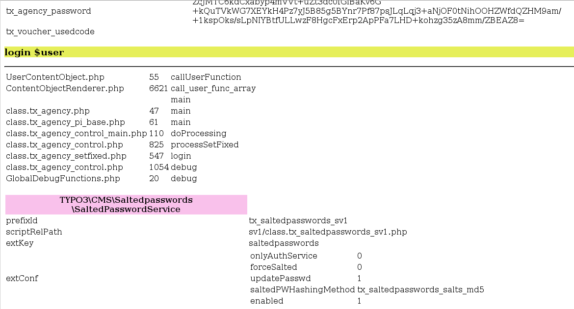
The debug info is stored as a HTML file. The variable name, contents and type are shown together with leading backtrace lines.

Users manual

debug file
Use the generated debug file, which by default is http://exampletypo3.com/fileadmin/debug.html.
You must add the '</body>' HTML tag to the end of the file. This is because the debugger does not know how many output you will add there if you use the append functionality.

In order to make sure that the debugging will be activated from the beginning of the TYPO3 process, you must follow this step. Add this line into your file typo3conf/AdditionalConfiguration.php. Maybe you need to create this file.
<?php
$GLOBALS['TYPO3_CONF_VARS']['SC_OPTIONS']['tslib/index_ts.php']['preprocessRequest'][] = 'JambageCom\\FhDebug\\Hooks\\CoreHooks->preprocessRequest';
?>

errorLog

The default error_log file of the extension fh_debug is “fileadmin/phpDebugErrorLog.txt”.
You can use the error_log in a case when there are troubles using the debug output file.

devLog
You can add calls to the devLog logging function to your PHP files.
This will be transformed into debug entries in the debug file.
Example:
$dataVar = array('important' => 'We need more cardboard', 'data' => 'size 1m x 0.5 m');
\TYPO3\CMS\Core\Utility\GeneralUtility::devLog($myDebug, 'myextensionkey', 0, $dataVar);

This will be transformed into debug entries of a variable named “$devLogArray” in the debug file.

Known problems
- If you want to debug the file ext_localconf.php, then make sure that fh_debug is installed before that extension. Otherwise the global error object is not initialized and nothing will be debugged.
- No debug output is shown with backend debugging:
Increase the numer 'Append [APPENDDEPTH]'. Sometimes the cached localconf.php is called several times. Then the debug output could have been overwritten by another PHP session. If you set this number high enough and repeat the execution of the PHP code, then in the end you will see its output.
- No debug output is shown from the file ext_localconf.php of my extension.
Make sure that the extension fh_debug has been installed before your extension. You can change the order in the variable $TYPO3_CONF_VARS['EXT']['extList'] of the file typo3conf/localconf.php .
- TYPO3 9.5.x has no global error object and no methods debugBegin and debugEnd.
Oops, an error occurred!
Call to undefined function debugBegin()
If you want to use fh_debug in TYPO3 9.5 for the debugging, then you must modify the file typo3/sysext/core/Resources/PHP/GlobalDebugFunctions.php on line 14 in this manner:
if (\TYPO3\CMS\Core\Utility\ExtensionManagementUtility::isLoaded('fh_debug')) {
\JambageCom\Fhdebug\Utility\DebugFunctions::debug($variable, $title);
} else {
\TYPO3\CMS\Core\Utility\DebugUtility::debug($variable, $title, $group);
}
See the folder Patches/TYPO3-9.5 in this extension. Copy the file GlobalDebugFunctions.php from there into your TYPO3 core. Overwrite the original TYPO3 core file.
Please add your comments and wishes to the bugtracker entry:
https://forge.typo3.org/issues/86220

- Check your PHP error_log file and give the write access rights to the debug file:
[Mon Jun 03 13:24:30 2013] [error] [client 85.197.0.222] PHP Warning: error_log(/var/www/mydomain/fileadmin/phpDebugErrorLog.txt): failed to open stream: Permission denied in /var/www/mydomain/trunk/typo3/ext/fh_debug/lib/class.tx_fhdebug.php on line 859, referer: http://www.mydomain.com/typo3/backend.php
- If you want to debug the file ext_localconf.php or ext_tables.php, then make sure that fh_debug has been installed before the extension which you want to debug.
- Some browser fail to load large HTML files with a size of about 100 MByte.
Use the split command to divide the debug.html into many files with sizes of 10 MByte:
split -b 10m fileadmin/debug.html
mv fileadmin/xak fileadmin/xak.htm

ChangeLog
- initial upload

