EXT: Message board
Extension Key: tt_board
Language: en
Keywords: forAdmins, forBeginners
Copyright 2000-2018, Franz Holzinger, <franz@ttproducts.de>

This document is published under the Open Content License
available from http://www.opencontent.org/opl.shtml

The content of this document is related to TYPO3
- a GNU/GPL CMS/Framework available from www.typo3.org
Table of Contents
EXT: Message board 1
Introduction 3
Version 4
Upgrade 4
Support 4
Administration 5
Important 5
Configuration 6
Spam: 6
Privacy Policy: 6
Captcha: 7
Files: 7
Description 7
Static template 7
forum view properties 8
board_submit.php properties 10
API: 11
Tutorial 12
Installation: 12
Changelog 20

Introduction
List type forum:
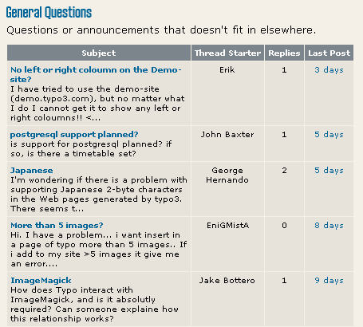
Tree type forum:

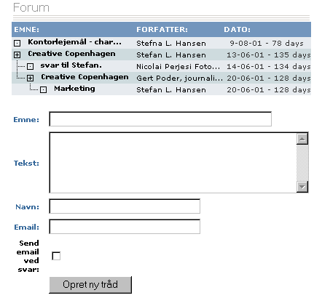

Version
This document is for version 1.10.0 of tt_board.

Upgrade
If you upgrade from Version 1.0.x you have to do the administrative steps under the topic 'Important'.
PHP 5.5, TYPO3 7.6, extension div2007 1.9.2 and extension tslib_fetce 0.4.0 are the minimum requirements.

Support
You can get support and installation service for this extension at https://jambage.com/kontakt/forum.html .

Administration

Important
Some of the TypoScript settings do not function via the constants field and must be entered in the setup field. Only those settings which can be found using the Constants Editor or in the file Configuration/TypoScript/Default/constants.txt are valid constants. You must include the “Message Board Setup” into your “include static from extensions” of your TYPO3 template setup. The ‘'Message Board CSS styles'’ are not required.

Use the flexforms in the plugin entry form to configure the plugin functionality.
To prevent from spammers you must set the memberOfGroups constant to the FE groups to which the FE users must belong to be able to post. If you still want to allow to post for everyone, then unset memberOfGroups.
Example Constants:
# allow postings to everybody. This might lead to many spam postings!

plugin.tt_board {
memberOfGroups =
}

Configuration

Spam:
Use the spamWords constant and add your own spam words in the Constants.
Example:
spamWords := addToList(bad phrase, V1agra, http)

Collect the IP addresses of the users you sent too many spams and protect your whole website by putting those IP addresses into your .htaccess file. Or insert it inside of the Directory clauses of an apache config file. See http://www.javascriptkit.com/howto/htaccess5.shtml
Example:
...
order allow,deny
deny from 195.225.177.12 87.118.112.253 81.177.14.45
allow from all
...

Privacy Policy:

You must set the constant PIDprivacyPolicy to the page id which shows your DSGVOor GDPR information. This is a legal requirement. You must use a front end registration extension to register the users. They must already have agreed to your privacy policy.
If you use the forum without logged in front end users, then a privacy policy checkbox will appear in the forum entry form. You can overwrite the default texts by the _LOCAL_LANG setup.

Example:
plugin.tt_board_list or plugin.tt_board_tree

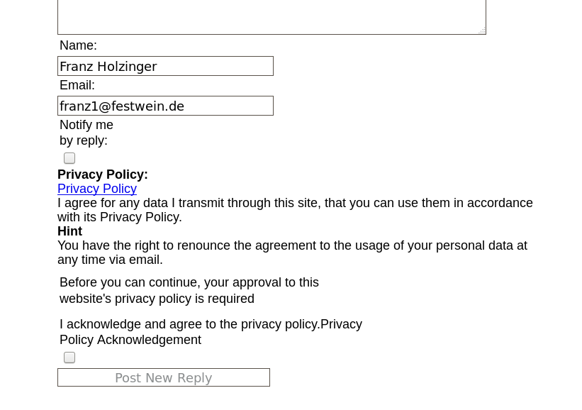
plugin.tt_board_list {
_LOCAL_LANG {
privacy_policy.title = PRIVACY AGREEMENT
privacy_policy.acknowledgement = The GDPR is applied.
privacy_policy.approval_required = You must approve it.
privacy_policy.acknowledged = You acknowledge to have read the privacy policy.
privacy_policy.acknowledged_2 = You acknowledge that your entered data may be processed according to GDPR.
privacy_policy.hint = You can withdraw this again.
privacy_policy.hint_1 = Just send us and email and your personal data will be removed.
}
}

Captcha:
Install the extension sr_freecap. The default constants is empty. Set the constants to “captcha = freecap”. This will enable the display of a captcha display in your post forms.
An alternative is the extension captcha. Set the constants to “captcha = captcha”.

Files:
File: | Description:
template folder:  board_template1.tmpl  board_template2.tmpl  board_template3.tmpl | Example templates.  'board_template1.tmpl' is default in static template 'plugin.tt_board_list'.  'board_template2.tmpl' is default in static template 'plugin.tt_board_tree'.

Description
This is the oldest forum/message board extension in TYPO3. It is not aimed at competing with those board products which features a lot community like features with user profiles. However a front end user login may be used to limit read/write access by simply access-restricting the very board elements and pages used for display and submission of data. Use this extension in combination with a front end user registration extension.

Example:
...

Static template

Setup: plugin.tt_board_list or plugin.tt_board_tree
Constant: plugin.tt_board

forum view properties
Property: | Data type: | Description: | Default:
templateFile | resource | The template-file.  See example in 'template/board_template1.tmpl'
pid_list | string /stdWrap | The pid's from where to fetch categories, forums and so on. Default is the current page. Accepts multiple pid's commaseparated!
PIDforum | int+ | PID for the forum page.  You can set this to change the page where the BACKLINK leeds to.
PIDprivacyPolicy | int+ | PID for the privacy policy page in the TYPO3 page tree. On this page you must publish the privacy policy according to DSGVO and GDPR. If you have set this page and no memberOfGroups is set, then an additional privacy confirmation checkbox will appear.
code | string /stdWrap | Code to define, what the script does. Case sensitive:  “Category, Forum: List” (LIST_CATEGORIES): List the first level of pages as categories and the second level as forums.  “Forum: List” (LIST_FORUMS): Lists the first level of pages as forums.  “Entry Form: General” (POSTFORM): Creates a form from which to post to the forum. If the GLOBAL-var "tt_board_uid" is set, the post is a reply to that item, else it's a new thread.  “Entry Form: Reply” (POSTFORM_REPLY): as above, but ONLY if "tt_board_uid" is set for a reply!  “Entry Form: New Thread” (POSTFORM_THREAD): as above, but ONLY if "tt_board_uid" is NOT set, which means "New Thread".  “Forum: Single” (FORUM) : Shows the content of the current forum (the pid('s)). If the GLOBAL-var "tt_board_uid" is set with a uid of a board-item, either this item is shown or the thread. Depends on config.  “Forum: Tree” (THREAD_TREE) : (tree only) tree of threads  “General: Help” (HELP) page.
defaultCode | string | The default code (see above) if the value is empty. By default it's not set and a help screen will appear
alternatingLayouts | integer | Defines number of alternatingLayouts to look for.  This script has the ability to alternate between the use of template-subparts. It goes like this:  If you define a subpart like "<!--###POST###--> ... <!--###POST###-->" this is used all the time.  If you define a similar subpart "<!--###POST_1###--> ... <!--###POST_1###-->" which might show another set of colors, this is used every second time instead of the default! This is because "alternateLayouts" is set to 2  If you define a similar subpart "<!--###POST_2###--> ... <!--###POST_2###-->" ... this will be used every third time IF (!) "alternateLayouts" is set to 3. If you do now set it to three, the first two will be used only. | 2
date_stdWrap | ->stdWrap | stdWrap for display of dates. Suggestion: date_stdWrap.strftime= %e-%m-%y
time_stdWrap | ->stdWrap | stdWrap for display of time. Suggestion: time_stdWrap.strftime= %H:%M:%S
age_stdWrap | ->stdWrap | stdWrap for display of ages. Suggestion: age_stdWrap.age = 1
dontParseContent | boolean | Normally the content which is output it htmlspecialchar'ed and nl2br'ed. This flag prevents that.
typolink | ->typolink | Used to generate the links.
tree | boolean | If set the items in the threads are accepted to be a tree and not just a list to the same parent. This means that replys, will get the current tt_board_uid as parent no matter what. This is only desirable, if your board has a genuine tree-structure.
iconCode | boolean | Enables the four icons below. The default without this is the examples you see below.
iconCode.joinBottom | string /stdWrap | HTML-Code for a "joinBottom" element in a tree-structure.  Eg "\-"
iconCode.join | string /stdWrap | as above, Eg. "|-"
iconCode.line | string /stdWrap | as above, Eg. "| "
iconCode.blank | string /stdWrap | as above, Eg. " "
iconCode.thread | string /stdWrap | The icon for an element with reply-elements (called a thread)
iconCode.end | string /stdWrap | The icon for an element without any replys (and "end")
emoticons | boolean | Enables emotion icons: :-) :) etc. | 1
allowCaching | boolean | If set, caching of the each page represented with a tt_board_uid is allowed to be cached.
displayCurrentRecord | boolean | If set, certain settings are manipulated in order to let the script render a single item - the $cObj->data.
wrap1 | -> stdWrap | Global Wrap 1. This will be splitted into the markers ###GW1B### and ###GW1E###. Don't change the input value by the settings, only wrap it in something.  Example:  wrap1.wrap = <b> |</b>
wrap2 | -> stdWrap | Global Wrap 2 (see above)
color1 | string /stdWrap | Value for ###GC1### marker (Global color 1)
color2 | string /stdWrap | Value for ###GC2### marker (Global color 2)
color3 | string /stdWrap | Value for ###GC3### marker (Global color 3)
code= POSTFORM, POSTFORM_REPLY, POSTFORM_THREAD
postform | (FORM-cObject) | Configuration of the form for posting replyes and possiply also new threads.  Note, that two hidden-fields are forcibly added to the form: "parent" and "pid" (using .dataArray keys 9997-9999)!
postform_newThread | (FORM-cObject) | If set, this is alternative configuration of the form for new threads. If not set, defaults to .postform
moderatorEmail | string | If set, this email-address will receive a mail whenever a new reply is submitted.
moderatorEmail_newThread | string | If set, this email-address will receive a mail when a new thread is created. If not set, defaults to .moderatorEmail
memberOfGroups | string | Comma separated list of FE groups which a user must belong to, so that the post forms are shown and the submission of a post is allowed.
code= LIST_CATEGORIES:
The following properties are all prepended list_categories.
noForums | boolean | Disables the view of forums. Default is to display forums in categories.
numberOfRecentPosts | integer | Set the number of recent posts in a forum to display together with the categories list. Zero will display none. | 0
title_stdWrap  subtitle_stdWrap  count_stdWrap  forum_title_stdWrap  forum_description_stdWrap  forum_posts_stdWrap  forum_threads_stdWrap  last_post_author_stdWrap  post_title_stdWrap  post_content_stdWrap  post_replies_stdWrap  post_author_stdWrap | ->stdWrap | stdWrap properties for markers.
cache_timeout | int | The number of seconds the page is cached. Default is 5 minutes. | 300
code= LIST_FORUMS
The following properties are all prepended list_forums.
numberOfRecentPosts |  | (Same as LIST_CATEGORIES equalent)
forum_title_stdWrap  forum_description_stdWrap  forum_posts_stdWrap  forum_threads_stdWrap  last_post_author_stdWrap  post_title_stdWrap  post_content_stdWrap  post_replies_stdWrap  post_author_stdWrap | ->stdWrap | stdWrap properties for markers.
cache_timeout | int | The number of seconds the page is cached. Default is 5 minutes. | 300
code= default
The following properties are all prepended view_thread.
single | boolean | If set, the items are displayed for the selves. Else the whole thread is normally displayed on one page. (This flag should probably be set together with the .tree-flag, if you use it, as this basically turns the board into a tree-like forum instead of a flat board-structure!  (default is false) | 0
post_thread_code_stdWrap  post_title_stdWrap  post_content_stdWrap  post_replies_stdWrap  post_author_stdWrap  forum_title_stdWrap | ->stdWrap | stdWrap properties for markers.
The following properties are all prepended list_threads or thread_tree.
thread_tree is config for the thread_tree which shows a list of the elements in the current thread.
post_thread_code_stdWrap  post_title_stdWrap  post_content_stdWrap  post_replies_stdWrap  post_author_stdWrap  last_post_author_stdWrap  forum_title_stdWrap | ->stdWrap | stdWrap properties for markers.
thread_limit | int | Max number of items | 50
[tsref:(script).boardLib]

Submit.php properties
See example in static template from extensions 'Board Old Style' (section FEData.tt_board)
Property: | Data type: | Description: | Default:
processScript.  sendToMailingList | boolean /properties | If enabled, a copy of the post is sent to the configured email address. This is useful if you want to integrate the forum with a mailing list.  On Typo3.com such a link is established. The reply address is set up in the Qmail MTA to pipe the content into a custom PHP shell-script which parses the email and inserts it into the forum.  Example from Typo3.com:  sendToMailingList=1  sendToMailingList {  email = typo3@netfielders.de  reply = [emailaddress which inserts into db]  namePrefix = Typo3Forum/  altSubject = Post from www.typo3.com  }
processScript.  notify | boolean | Enable email notification in forums.
processScript.  notify_from | string | "From" email header  Example:  TYPO3 forum <no_reply>
processScript.  newReply.msg | resource | Notification message template, first line is subject.  Example:  media/scripts/board_notify.txt
processScript.  newReply.didWhat | string | Example:  has just replied to a thread at
processScript.  newReply.subjectPrefix | string | Example:  Reply to post at
processScript.  newThread.* |  | Same as for newReply.  Properties:  .msg/.didWhat/.subjectPrefix
processScript.  debug | boolean | Outputs the mail information directly in browser. For debugging only.
clearCacheForPids | list of page id's | This list of page id's are cleared in addition to the cache for the page of the item submitted.
Constants:  moderatorEmail | string | Email address where to send the notification of new entries into the board.
Constants:  moderatorEmail_newThread | string | same as moderatorEmail, however only for new threads.
Constants:  emailCheck | boolean | If set the email address will be checked if it exists. Otherwise no entry will be made and an error message gets displayed.
Constants:  captcha | string | Usage of the captcha security string.  Set this to freecap and install sr_freecap.  Or set this to captcha and install captcha.
[tsref:(script).board_submit]

API:
File: | Description:
TODO | API which can be called from your extensions to comment the records in the single view.  See tt_products 2.9.0 for a working example.

Tutorial

Installation:
1. Install tt_board from the Extension Manager.
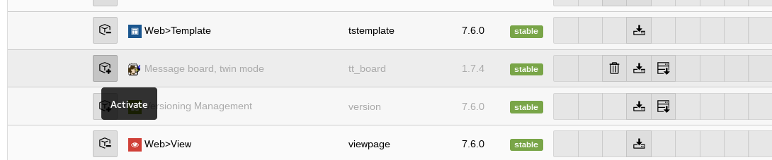
2. Look if tt_board has been installed.
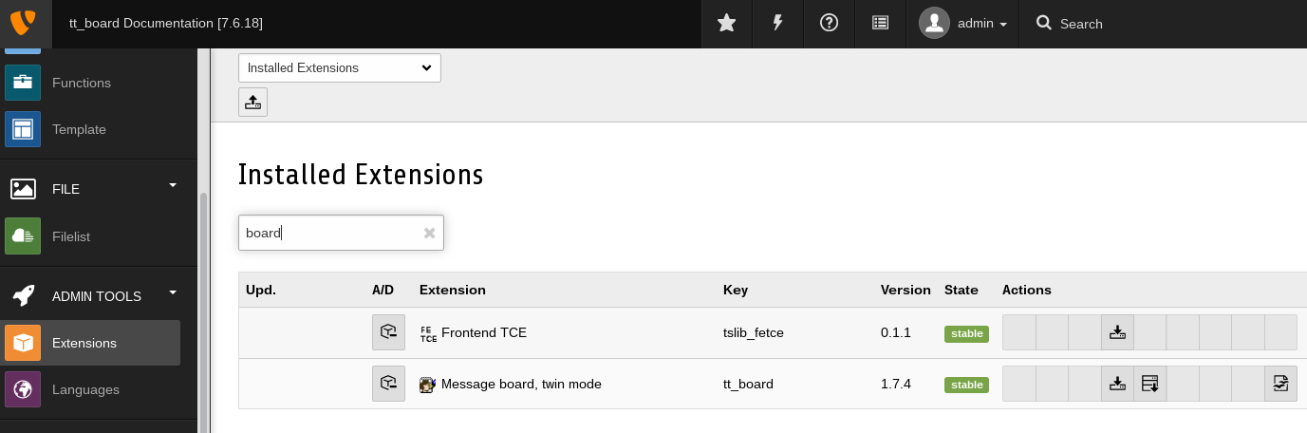
3. The Extension Manager should have installed all the dependant extensions automatically.

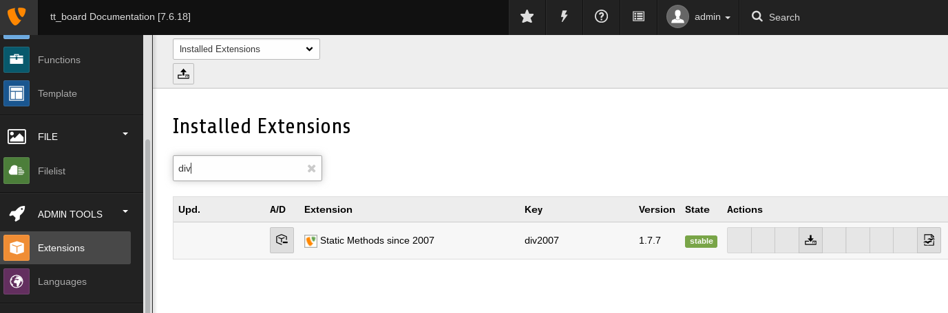

4. Choose or add a starting page for the forum.

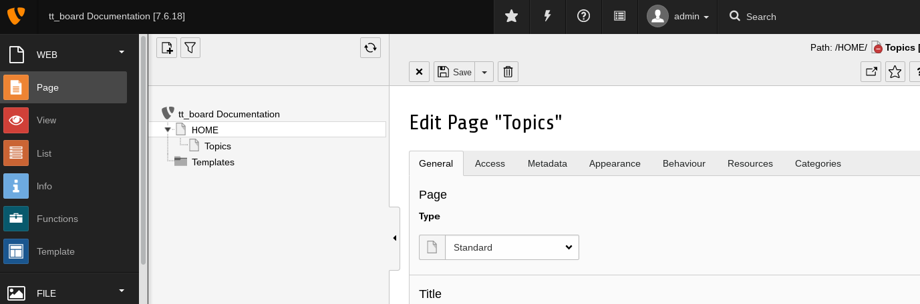
5. Add a new content element and choose the Message board plugin.

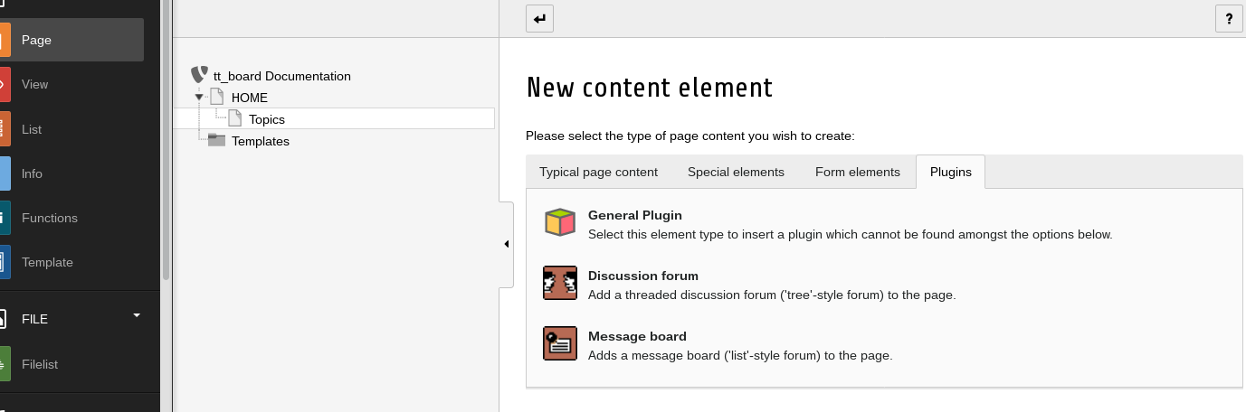
6. Insert the Plugin on your Topics page
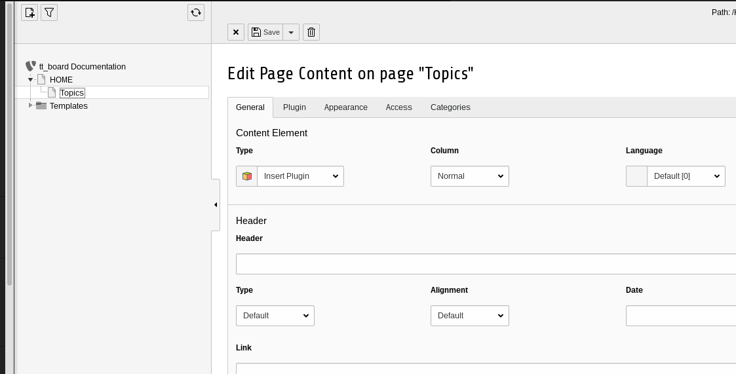

7. Select the Forum: List flexform of the Plugin “Board, List”
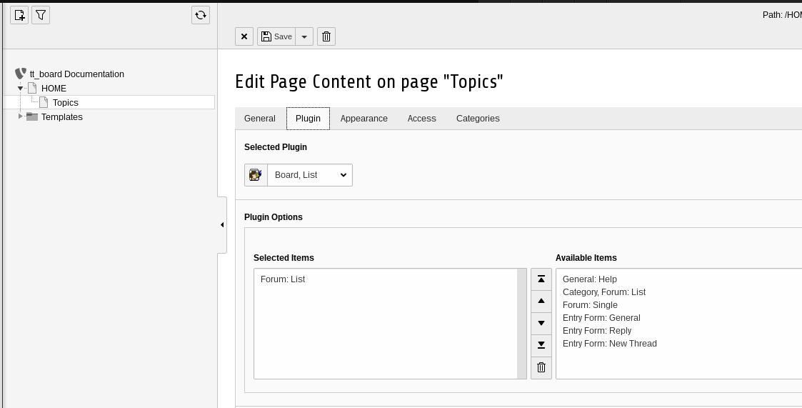
8. Check the codes in the page modul to be ‘LIST_FORUMS’.
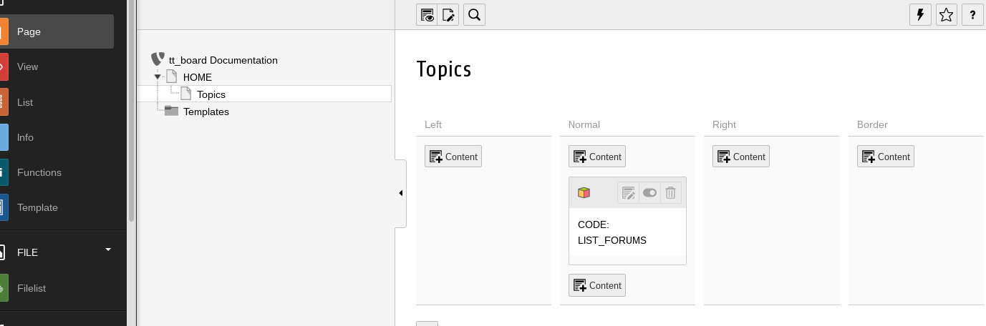
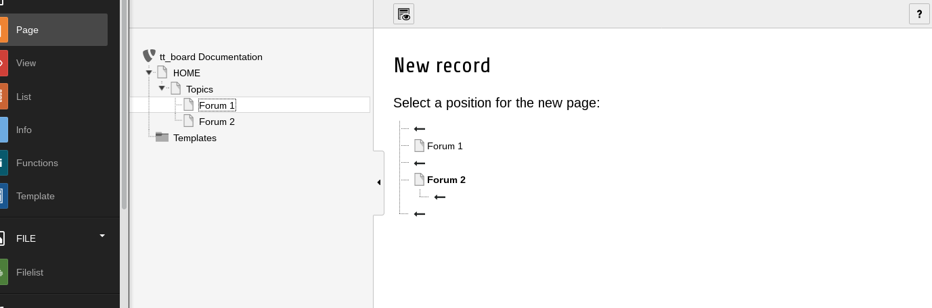
9. Add two subpages underneath the Topics page.

10. Add a discussion forum to the page “Forum 1”
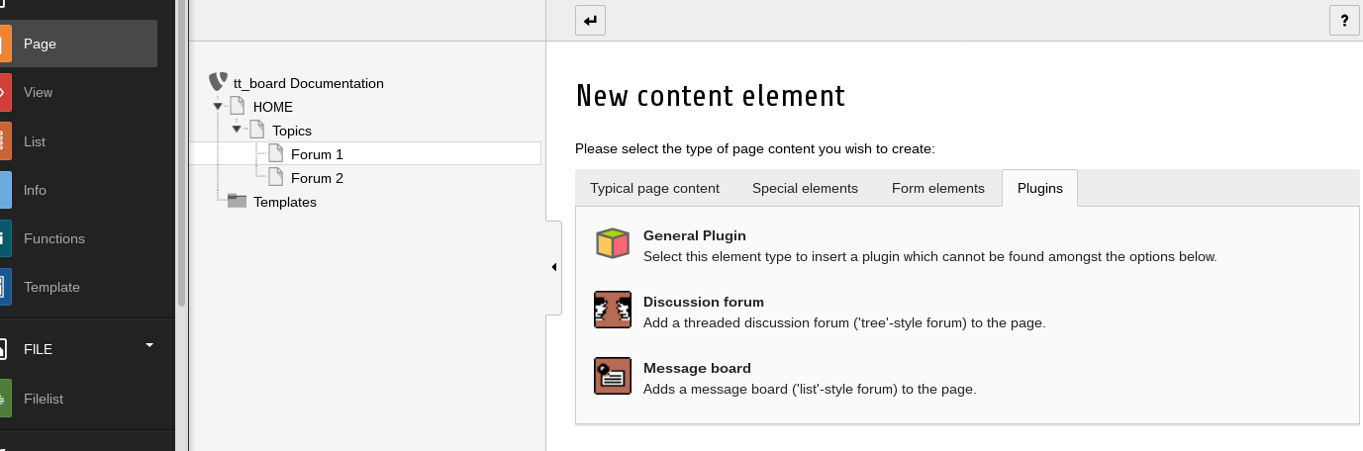

11. Insert the “Forum: Single” and “Entry Form: General” flexforms.
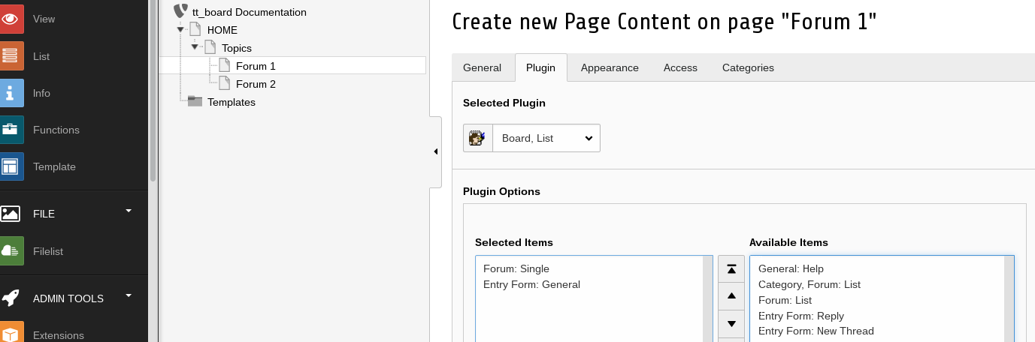

12. Add the Message board to the “Forum 2” page.

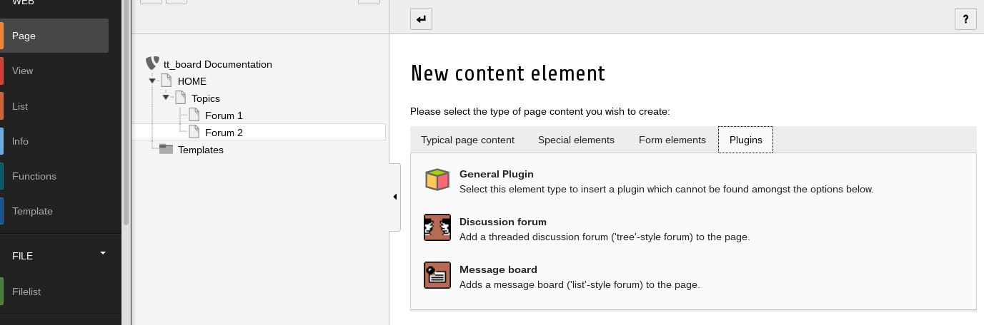

13. Insert the “Forum: Single” and “Entry Form: General” flexforms.
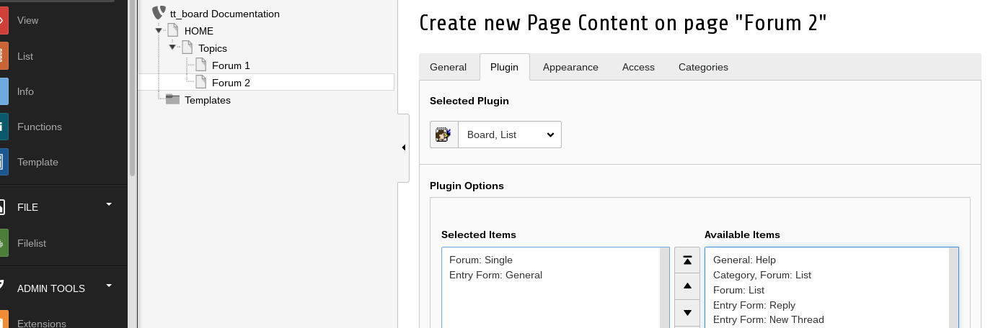
14. Create an extension template for tt_board in your Templates folder and call it “+ext: tt_board”
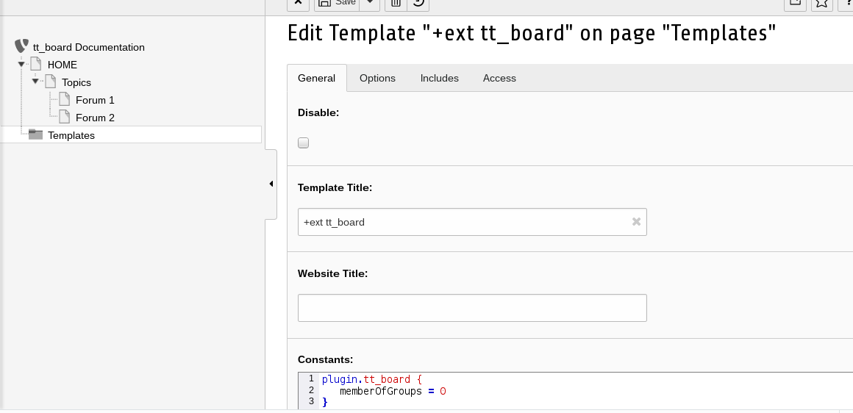
15. Insert the Constants.
plugin.tt_board {
memberOfGroups = 0
}

Insert the Setup.
FEData.tt_board.processScript {
sendToMailingList = 1
sendToMailingList {
email = franz@ttproducts.de
reply = franz@ttproducts.de
namePrefix = Typo3Forum
altSubject = Post from my Forum
}
}

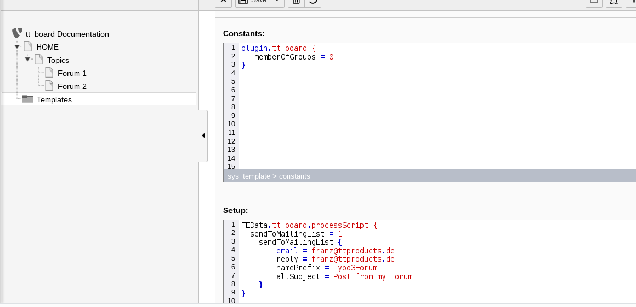

16. Add the CSS styles (or use your own CSS file) and the Message Board Setup under “Include static from extensions”.
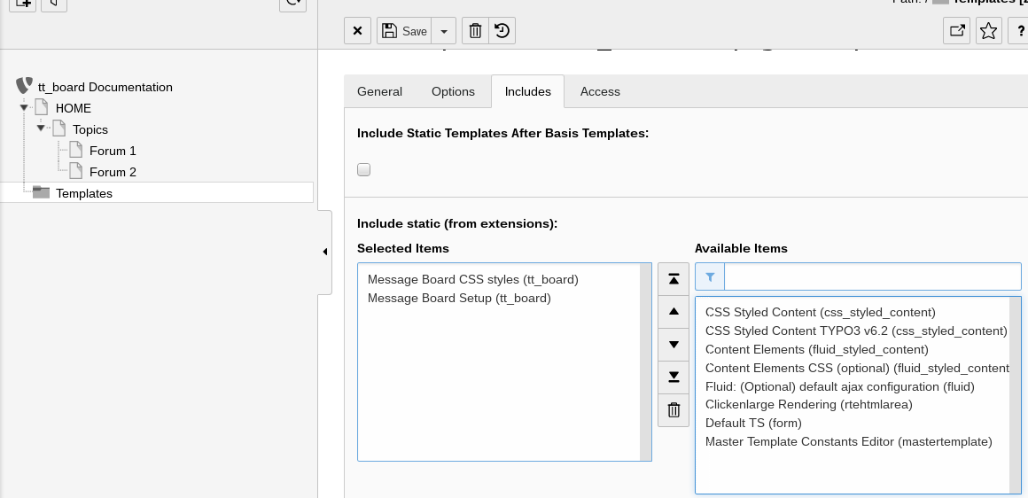
17. Edit your master template.

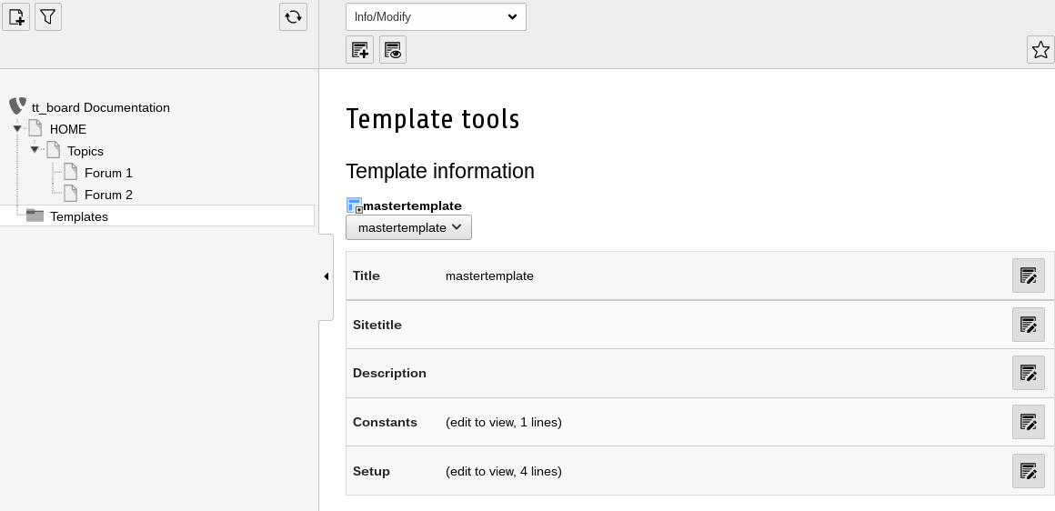

18. Include the “+ext: tt_board” from your master template under “Include Basis Template”.
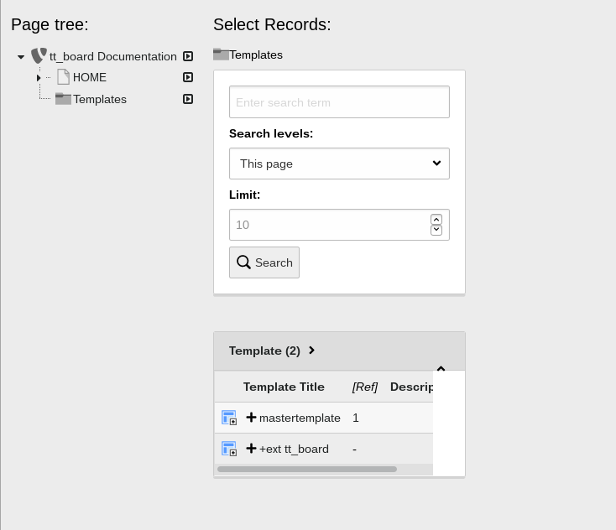
19. Check the result.
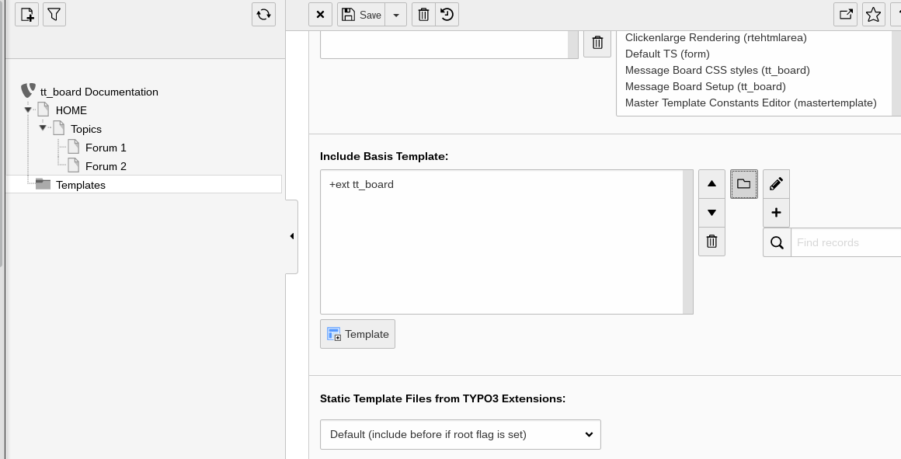

20. The two forums should be visible in the front end now.
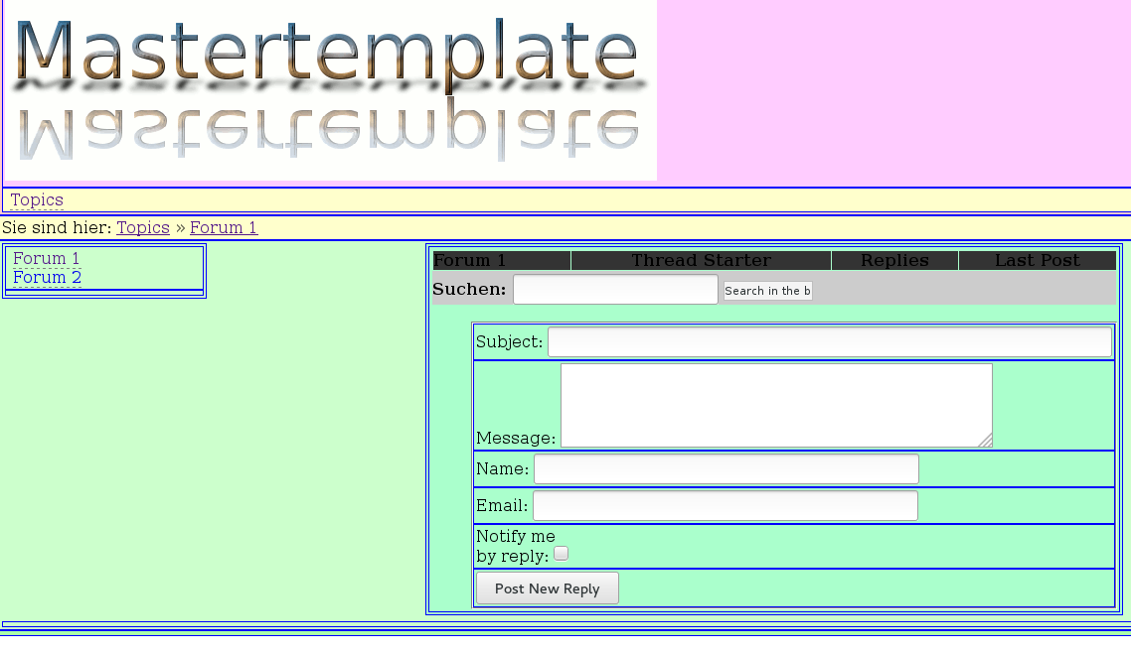

Changelog
See the file tt_board/ChangeLog for more details
- 21.08.2006 new ownership by Franz Holzinger. Extra frontend plugin for the board's tree view using the same codes and different template files. It uses now static template files. The CSS template must be used if you use CSS styled content which is the default for TYPO3 4.0.
- 3.09.2006 Use the flexforms now. Reenter every plugin and choose the appropriate flexform texts instead of the former code fields.
- 11.11.2006 11:11 Protection against spam words
- 25.11.2006 Store the IP addresses for every post. This could be used with your firewalls to prevent unwanted visitors ...
- 27.2.2007 Change the setup to have independant configuration for each code. Investigations made by Jo Hasenau.
- 17.10.2007 Usage of sr_freecap captcha in all post forms if it has been installed.
- 6.09.2008 Spam word detection and wrong captcha are shown in the entry form.
- 25.09.2008 Replace all tt_board_uid links by the prefixId parameter for uid.
- 21.10.2014 Ready for TYPO3 6.2. You must first install tslib_fetce.
- 8.9.2016 Ready for TYPO3 7.6.10
- 26.7.2017 Ready for TYPO3 8.x
- 9.6.2018 DSGVO, GDPR

