STAI Stability Analysis

Franziska Werner

29 10 2021

# Methods

@spielberger2010

## Participants

* trial 1: 105 participants
* trial 2: 87 participants

-> add: age, sex and education?

## Material

* description of context in which data was collected

## Data analysis

Analysis was conducted in R (R Core Team, 2017) and figures were produced using the package ggplot2 (Wickham, 2009).

# Results

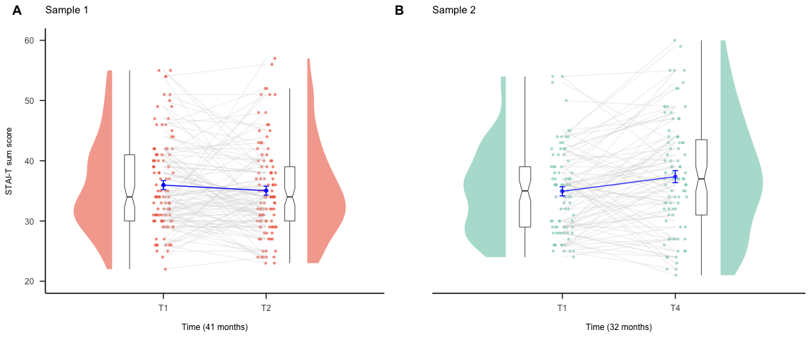

Illustration of STAI-T scores for (A) Study 1 in red and (B) Study 2 in green which depicts the sample average (blue) at both time-points (A: 41 month apart; B: 32 month apart), individual data points (A: red dots, B: green dots) as well as box and density plots at both time points. Note that the STAI-T scores of the same individual at both measurement time points are connected through a grey line.

(#tab:unnamed-chunk-8)

*Item Analysis and item stability.*

|  |  |  |  |  |  |  |  |
| --- | --- | --- | --- | --- | --- | --- | --- |
| Item | Discrimination | Difficulty | Discrimination | Difficulty | ICC(2,1) | LL | UL |
| 1 | .33 | .46 | .58 | .47 | .26** | .10 | .40 |
| 2 | .39 | .54 | .44 | .53 | .43** | .29 | .56 |
| 3 | .57 | .40 | .41 | .37 | .26** | .10 | .40 |
| 4 | .52 | .30 | .57 | .30 | .14 | -.02 | .30 |
| 5 | .37 | .45 | .36 | .43 | .40** | .25 | .52 |
| 6 | .44 | .57 | .43 | .56 | .04 | -.12 | .20 |
| 7 | .45 | .53 | .45 | .52 | .32** | .17 | .46 |
| 8 | .46 | .39 | .60 | .39 | .29** | .14 | .43 |
| 9 | .49 | .55 | .53 | .51 | .36** | .21 | .49 |
| 10 | .63 | .41 | .57 | .41 | .28** | .12 | .42 |
| 11 | .60 | .42 | .67 | .40 | .41** | .27 | .54 |
| 12 | .43 | .47 | .49 | .45 | .52** | .39 | .63 |
| 13 | .35 | .47 | .47 | .45 | .35** | .20 | .48 |
| 14 | .46 | .45 | .49 | .44 | .32** | .17 | .46 |
| 15 | .43 | .37 | .55 | .39 | .35** | .20 | .48 |
| 16 | .53 | .42 | .63 | .40 | .29** | .14 | .43 |
| 17 | .45 | .45 | .50 | .44 | .29** | .14 | .43 |
| 18 | .55 | .41 | .51 | .40 | .23** | .07 | .38 |
| 19 | .67 | .48 | .62 | .44 | .39** | .25 | .52 |
| 20 | .46 | .46 | .43 | .46 | .39** | .24 | .52 |

*Note.* Total number of participants was . Cronbach’s resulted in .87 and .89 for the first and the second measurement. \ The definition choice was absolute agreement. \ * < .05 ** < .01

(#tab:unnamed-chunk-11)

*Item Analysis and item stability.*

|  |  |  |  |  |  |  |  |
| --- | --- | --- | --- | --- | --- | --- | --- |
| Item | Discrimination | Difficulty | Discrimination | Difficulty | ICC(2,1) | LL | UL |
| 1 | .54 | .47 | .63 | .49 | .48** | .33 | .61 |
| 2 | .46 | .57 | .39 | .56 | .37** | .21 | .51 |
| 3 | .40 | .34 | .54 | .37 | .30** | .13 | .45 |
| 4 | .34 | .31 | .58 | .32 | .10 | -.08 | .27 |
| 5 | .35 | .43 | .49 | .41 | .45** | .29 | .58 |
| 6 | .50 | .57 | .41 | .58 | .22* | .05 | .38 |
| 7 | .35 | .45 | .58 | .52 | .38** | .22 | .52 |
| 8 | .50 | .39 | .57 | .41 | .30** | .14 | .46 |
| 9 | .51 | .51 | .67 | .56 | .35** | .19 | .49 |
| 10 | .66 | .41 | .67 | .46 | .49** | .34 | .62 |
| 11 | .66 | .43 | .61 | .44 | .52** | .38 | .64 |
| 12 | .44 | .43 | .59 | .47 | .47** | .33 | .60 |
| 13 | .26 | .45 | .60 | .46 | .48** | .34 | .61 |
| 14 | .33 | .46 | .47 | .49 | .13 | -.05 | .30 |
| 15 | .39 | .37 | .64 | .42 | .18* | .01 | .34 |
| 16 | .64 | .40 | .73 | .46 | .37** | .21 | .51 |
| 17 | .48 | .42 | .60 | .48 | .37** | .21 | .52 |
| 18 | .48 | .46 | .58 | .43 | .44** | .29 | .58 |
| 19 | .57 | .45 | .73 | .50 | .49** | .34 | .61 |
| 20 | .44 | .42 | .56 | .52 | .23** | .06 | .38 |

*Note.* Total number of participants was . Cronbach’s resulted in .87 and .92 for the first and the fourth measurement. \ The definition choice was absolute agreement. \ * < .05 ** < .01

## `geom_smooth()` using formula 'y ~ x'  
## `geom_smooth()` using formula 'y ~ x'

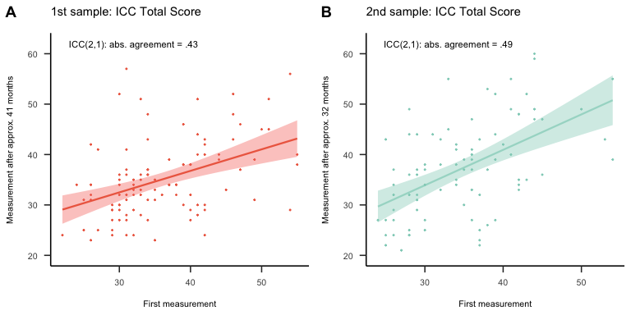

Retest Reliability. Shown are correlations in achieved total score between two measurements for sample one (A) and sample two (B). Single points represent individual participants.

The twofactorial ANOVA showed a temporal effect on the total score (, , , ), whereas the individual items had no effect (, , , ).

## Mixed Model Sample 1

## Linear mixed model fit by REML. t-tests use Satterthwaite's method [  
## lmerModLmerTest]  
## Formula: score ~ timepoint * item + (1 | id)  
## Data: tb.ANOVA.ID  
##   
## REML criterion at convergence: 24216.2  
##   
## Scaled residuals:   
## Min 1Q Median 3Q Max   
## -3.2584 -0.4604 0.0025 0.4730 3.3011   
##   
## Random effects:  
## Groups Name Variance Std.Dev.  
## id (Intercept) 40.45 6.360   
## Residual 16.85 4.105   
## Number of obs: 4200, groups: id, 105  
##   
## Fixed effects:  
## Estimate Std. Error df t value Pr(>|t|)   
## (Intercept) 3.596e+01 7.387e-01 2.036e+02 48.682 <2e-16 ***  
## timepoint2 -9.238e-01 5.665e-01 4.056e+03 -1.631 0.103   
## item2 -3.641e-13 5.665e-01 4.056e+03 0.000 1.000   
## item3 -3.641e-13 5.665e-01 4.056e+03 0.000 1.000   
## item4 -3.641e-13 5.665e-01 4.056e+03 0.000 1.000   
## item5 -3.641e-13 5.665e-01 4.056e+03 0.000 1.000   
## item6 -3.641e-13 5.665e-01 4.056e+03 0.000 1.000   
## item7 -3.641e-13 5.665e-01 4.056e+03 0.000 1.000   
## item8 -3.641e-13 5.665e-01 4.056e+03 0.000 1.000   
## item9 -3.641e-13 5.665e-01 4.056e+03 0.000 1.000   
## item10 -3.641e-13 5.665e-01 4.056e+03 0.000 1.000   
## item11 -3.641e-13 5.665e-01 4.056e+03 0.000 1.000   
## item12 -3.641e-13 5.665e-01 4.056e+03 0.000 1.000   
## item13 -3.641e-13 5.665e-01 4.056e+03 0.000 1.000   
## item14 -3.641e-13 5.665e-01 4.056e+03 0.000 1.000   
## item15 -3.641e-13 5.665e-01 4.056e+03 0.000 1.000   
## item16 -3.641e-13 5.665e-01 4.056e+03 0.000 1.000   
## item17 -3.641e-13 5.665e-01 4.056e+03 0.000 1.000   
## item18 -3.641e-13 5.665e-01 4.056e+03 0.000 1.000   
## item19 -3.641e-13 5.665e-01 4.056e+03 0.000 1.000   
## item20 -3.641e-13 5.665e-01 4.056e+03 0.000 1.000   
## timepoint2:item2 2.746e-15 8.011e-01 4.056e+03 0.000 1.000   
## timepoint2:item3 2.746e-15 8.011e-01 4.056e+03 0.000 1.000   
## timepoint2:item4 2.746e-15 8.011e-01 4.056e+03 0.000 1.000   
## timepoint2:item5 2.746e-15 8.011e-01 4.056e+03 0.000 1.000   
## timepoint2:item6 2.746e-15 8.011e-01 4.056e+03 0.000 1.000   
## timepoint2:item7 2.746e-15 8.011e-01 4.056e+03 0.000 1.000   
## timepoint2:item8 2.746e-15 8.011e-01 4.056e+03 0.000 1.000   
## timepoint2:item9 2.746e-15 8.011e-01 4.056e+03 0.000 1.000   
## timepoint2:item10 2.746e-15 8.011e-01 4.056e+03 0.000 1.000   
## timepoint2:item11 2.746e-15 8.011e-01 4.056e+03 0.000 1.000   
## timepoint2:item12 2.746e-15 8.011e-01 4.056e+03 0.000 1.000   
## timepoint2:item13 2.746e-15 8.011e-01 4.056e+03 0.000 1.000   
## timepoint2:item14 2.746e-15 8.011e-01 4.056e+03 0.000 1.000   
## timepoint2:item15 2.746e-15 8.011e-01 4.056e+03 0.000 1.000   
## timepoint2:item16 2.746e-15 8.011e-01 4.056e+03 0.000 1.000   
## timepoint2:item17 2.746e-15 8.011e-01 4.056e+03 0.000 1.000   
## timepoint2:item18 2.746e-15 8.011e-01 4.056e+03 0.000 1.000   
## timepoint2:item19 2.746e-15 8.011e-01 4.056e+03 0.000 1.000   
## timepoint2:item20 2.746e-15 8.011e-01 4.056e+03 0.000 1.000   
## ---  
## Signif. codes: 0 '***' 0.001 '**' 0.01 '*' 0.05 '.' 0.1 ' ' 1

##   
## Correlation matrix not shown by default, as p = 40 > 12.  
## Use print(summary(fitS1), correlation=TRUE) or  
## vcov(summary(fitS1)) if you need it

The twofactorial ANOVA showed that it made no difference in terms of total score whether participants completed the STAI-T before, during, or after lockdown (, , , ). Therefore, further analysis is done without differentiating between the three subgroups. Instead, we consider the complete data set.

### Mixed Model Sample 2

## Linear mixed model fit by REML. t-tests use Satterthwaite's method [  
## lmerModLmerTest]  
## Formula: score ~ timePoint * partLockdown * sex + (1 | id)  
## Data: tb.ANOVA2.ID  
##   
## REML criterion at convergence: 1145.1  
##   
## Scaled residuals:   
## Min 1Q Median 3Q Max   
## -2.02375 -0.52774 0.00793 0.46069 2.03383   
##   
## Random effects:  
## Groups Name Variance Std.Dev.  
## id (Intercept) 31.78 5.637   
## Residual 33.58 5.795   
## Number of obs: 174, groups: id, 87  
##   
## Fixed effects:  
## Estimate Std. Error df t value  
## (Intercept) 36.1176 1.9607 131.0255 18.420  
## timePoint4 2.8824 1.9876 81.0000 1.450  
## partLockdownbefore -0.9325 2.5030 131.0255 -0.373  
## partLockdownwithin 2.7285 2.9786 131.0255 0.916  
## sexmale -3.3176 4.1129 131.0255 -0.807  
## timePoint4:partLockdownbefore 0.8214 2.5373 81.0000 0.324  
## timePoint4:partLockdownwithin -1.7285 3.0194 81.0000 -0.572  
## timePoint4:sexmale -7.6824 4.1692 81.0000 -1.843  
## partLockdownbefore:sexmale 0.7640 4.7724 131.0255 0.160  
## partLockdownwithin:sexmale -4.5285 5.7303 131.0255 -0.790  
## timePoint4:partLockdownbefore:sexmale 6.3997 4.8378 81.0000 1.323  
## timePoint4:partLockdownwithin:sexmale 10.8618 5.8087 81.0000 1.870  
## Pr(>|t|)   
## (Intercept) <2e-16 ***  
## timePoint4 0.1509   
## partLockdownbefore 0.7101   
## partLockdownwithin 0.3613   
## sexmale 0.4213   
## timePoint4:partLockdownbefore 0.7470   
## timePoint4:partLockdownwithin 0.5686   
## timePoint4:sexmale 0.0690 .   
## partLockdownbefore:sexmale 0.8731   
## partLockdownwithin:sexmale 0.4308   
## timePoint4:partLockdownbefore:sexmale 0.1896   
## timePoint4:partLockdownwithin:sexmale 0.0651 .   
## ---  
## Signif. codes: 0 '***' 0.001 '**' 0.01 '*' 0.05 '.' 0.1 ' ' 1  
##   
## Correlation of Fixed Effects:  
## (Intr) tmPnt4 prtLckdwnb prtLckdwnw sexmal tmPnt4:prtLckdwnb  
## timePoint4 -0.507   
## prtLckdwnbf -0.783 0.397   
## prtLckdwnwt -0.658 0.334 0.516   
## sexmale -0.477 0.242 0.373 0.314   
## tmPnt4:prtLckdwnb 0.397 -0.783 -0.507 -0.261 -0.189   
## tmPnt4:prtLckdwnw 0.334 -0.658 -0.261 -0.507 -0.159 0.516   
## tmPnt4:sxml 0.242 -0.477 -0.189 -0.159 -0.507 0.373   
## prtLckdwnb: 0.411 -0.208 -0.524 -0.270 -0.862 0.266   
## prtLckdwnw: 0.342 -0.173 -0.268 -0.520 -0.718 0.136   
## tmPnt4:prtLckdwnb: -0.208 0.411 0.266 0.137 0.437 -0.524   
## tmPnt4:prtLckdwnw: -0.173 0.342 0.136 0.263 0.364 -0.268   
## tmPnt4:prtLckdwnw tmPn4: prtLckdwnb: prtLckdwnw:  
## timePoint4   
## prtLckdwnbf   
## prtLckdwnwt   
## sexmale   
## tmPnt4:prtLckdwnb   
## tmPnt4:prtLckdwnw   
## tmPnt4:sxml 0.314   
## prtLckdwnb: 0.137 0.437   
## prtLckdwnw: 0.263 0.364 0.619   
## tmPnt4:prtLckdwnb: -0.270 -0.862 -0.507 -0.314   
## tmPnt4:prtLckdwnw: -0.520 -0.718 -0.314 -0.507   
## tmPnt4:prtLckdwnb:  
## timePoint4   
## prtLckdwnbf   
## prtLckdwnwt   
## sexmale   
## tmPnt4:prtLckdwnb   
## tmPnt4:prtLckdwnw   
## tmPnt4:sxml   
## prtLckdwnb:   
## prtLckdwnw:   
## tmPnt4:prtLckdwnb:   
## tmPnt4:prtLckdwnw: 0.619

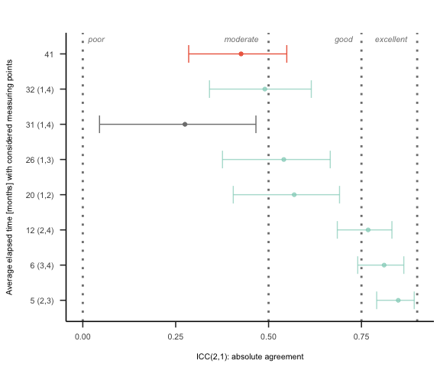

ICC for different samples and different time intervals with 95 % confidence intervals. The gray entry indicates the results for the STAI-S, the red one represents the results for the first sample (STAI-T) and the turquoise one represents the results for the second sample (STAI-T) with its different time intervals. Missing data in brackets indicate that there were only two mesaurements in total.