-On <http://182.75.35.86/foreversharp_1/index.php/> (Home Page) the menu ‘Steering wheel’ is highlighted.

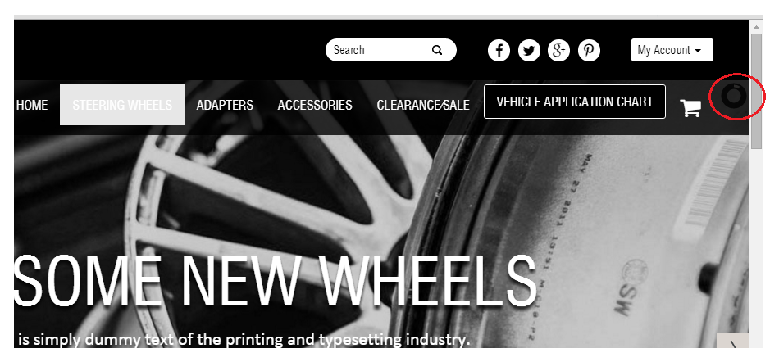

-Slider animation is having some issues while transition.

-<http://182.75.35.86/foreversharp_1/index.php/steering-wheels/https-fssteeringwheels-com-store-14-polished-muscle-half-wrap-steering-wheel-p-14559146.html> page the design is not proper.

-Home menu link is not working. My Account drop down is not working.