**Wendy Issues**

1.

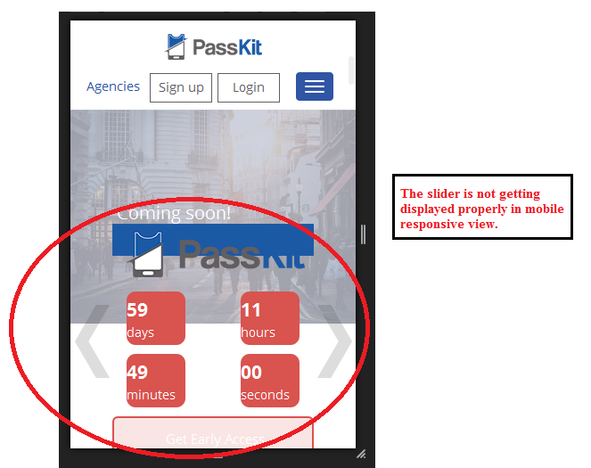

2.The first section i.e; <http://182.75.35.84/399_html/#1> is not displaying properly in tab view.