Good progress, please find here my comments:

The buttons left widget:

* I have noticed that the selection is only possible when the user click on the text. The selection should be possible when the user has the pointer on the button.
* The text changes to white only when user has the pointer over the text. The text should change even when the user has his pointer on the blue area of the button.
* Where are the settings?
* Where are messages?
* Profile, where are the functions to update or read the profile?
* Connections: how to add or search for connections?
* **The blog, how to add an article?**
  + The blog is a page where all blogs posts are gathered in one section, that means every body reads what all users are posting. It is a public page; user however can filter his own posts.

Please keep in mind the over all design of the blog:

* The left and right widget remains the same, however the mid section needs to look like: <http://buddywp.wpengine.com/blog/>
* The inner article needs to look like: <http://buddywp.wpengine.com/category-1/post-example-2/>

**The center area:**

1. The time for activity, please remove the grey background and turn the text into light grey.
2. The icon for changing the picture is gone?
3. Please remove the blue border.
4. The bar under the icons and text should be there only when the pointer is over it, there is not need to have the bar under when selected since already highlighted in blue.
5. What are the optimal sizes for the cover image and the picture? (Is it possible for a single user to have sliding cover pictures?)
6. The are where we read sorry, no members, change the color to white and the text to red. Apply this for all sections where warnings like this are.

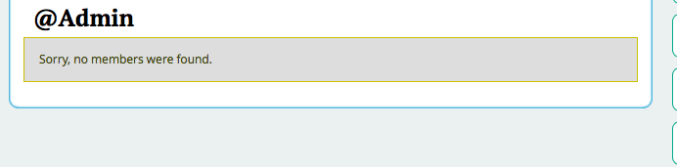

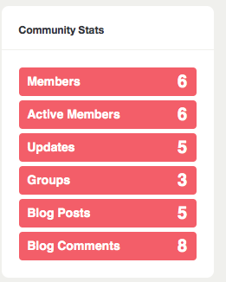The buttons right widget:

* Since these are not buttons, please maintain them green colored without any effect and the text to be white.
* Increase the font size of both widgets please; the number display is to be big.
* As requested this section needs to be collapsible.

Questions:

* Please confirm about the responsiveness.
* Please indicate when the French version is available.
* Why the entire platform has been affected by the changes: <http://182.75.35.84:83/dhaky_test/resumes/>