**Chinook Music Database schema:**

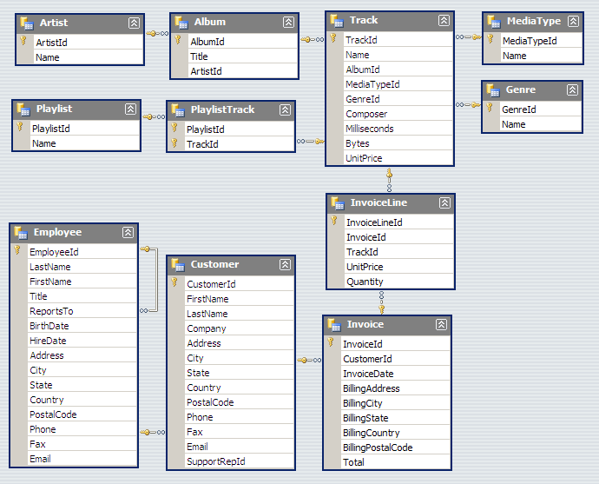

*SQL Queries are written on DB Browser (SQLite syntax)*

*Visualizations created in Jupyter Notebook with matplotlib library of Python.*

**Who are the top 10 artists contributing the most to total revenue, and how much has each contributed?**

**Query:**

**Output:**

**Visualization:**

**Summary:**

The band Iron **Maiden leads** the top contributor chart at Chinook Music Store, closely followed by **U2** and **Lost**.

Across the bar graph, we see a steady decline in contributions with no steep fluctuations across the artists. This data indicates a close competition among the artists.

If Chinook plans to host an event, this will give them an insight into how to allocate their funds while inviting artists to perform.

**Which albums hold the top 10 most sold songs?**

**Query:**

**Output:**

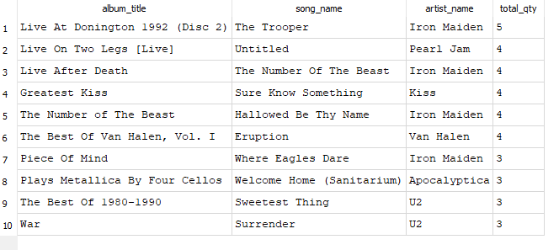

**Visualization:**

**Summary:**

The artist band **Iron Maiden** leads as the top contributor to revenue at Chinook Music Store, closely followed by **U2** and **Lost**.

Across the bar graph, we see a steady decline in contributions with no steep fluctuations across the artists. This indicates a close competition among the artists.

If Chinook plans to host an event, this will give them insight into how to allocate their funds while inviting artists to perform.

**Which are the top 10 genres sold (by quantity)?**

**Query:**

**Output:**

**Visualization:**

**Summary:**

By grouping the sales according to the genre reveals that **Rock** has sold an overwhelmingly high number of copies.

However, the data further shows that the sales are proportional to the number of tracks in each genre's collection.

This indicates that the disparity in sales among different genres is primarily due to the greater availability of tracks.

**Which artists have the highest number of albums?**

**Query:**

**Output:**

**Visualization:**

**Summary:**

**Iron Maiden** is the artist with the highest number of albums, leading with 21 albums. Following them are **Led Zeppelin** and **Deep Purple** with 14 and 11 albums respectively.

**Which are the top 3 selling artists of each genre?**

Query:

Output:

**Summary:**

We see a correlation between the total sales of the top performers and the rank of each genre as a whole. However, we see a break of pattern for the Latin Genre. The top 2 artists of Metal, **Metallica** and **Iron Maiden** both have a significantly higher number of quantity sold than Latin artists **Os Paralamas Do Sucesso and Chico Buarque**.