Design Documentation

1.Demonstrate your understanding of your site's audience

2. Demonstrate the design decisions made

The decisions which led to my final design was simplicity, and ease of use for the audience of my site. It was made so the page is easy to navigate through - displaying the information required easily. This is so employers don’t have to dig through it to find anything – it is all there ready to be viewed.

3. Demonstrate that you considered usability heuristics

4. Any wireframes

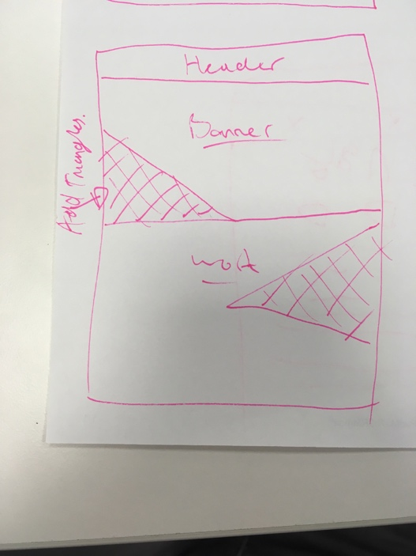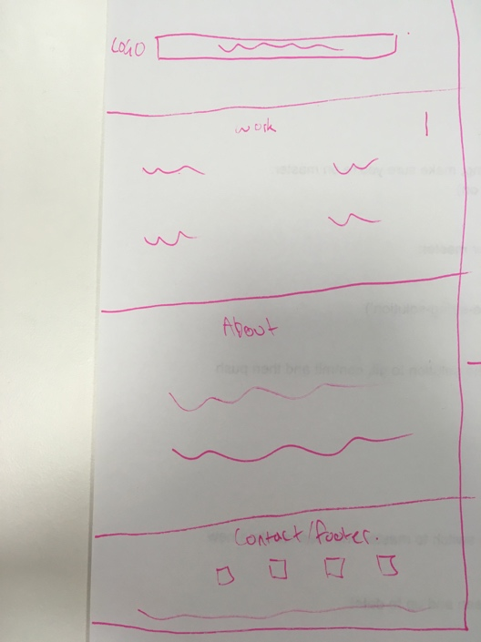

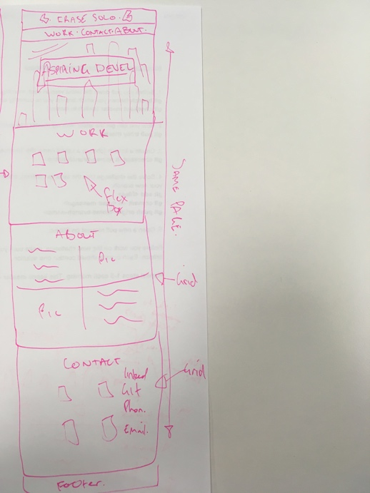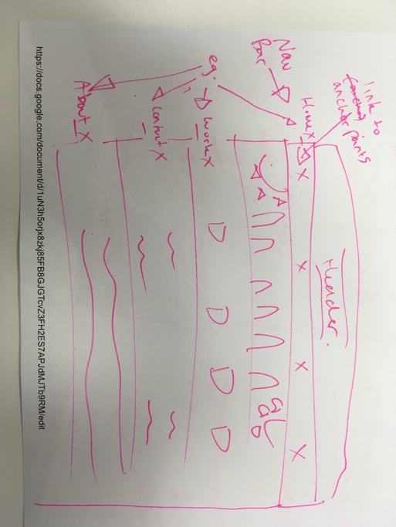

5. Style guide

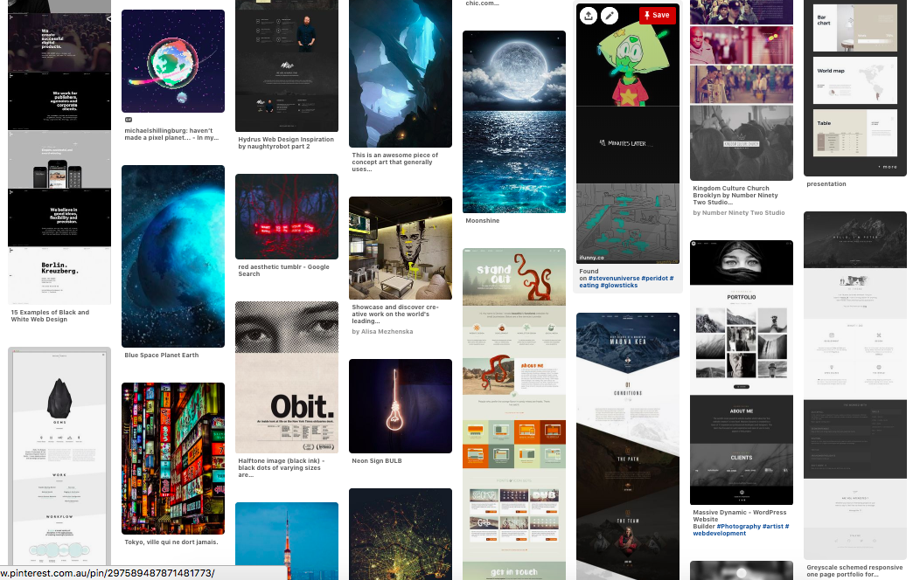

6. Personal Logo



Compliant website using HTML and CSS

Demonstrate knowledge of HTML and CSS:

1. Compliant HTML & CSS

2. Organised folder structure

yes

4. Meta tags

Yes

6. Contains a robots.txt

yes

7. Includes favicons

yes