**Practice html & CSS assignment evaluation**

The design I decided to choose for my website was a site to display photos that I have taken, with the idea of being a professional photographer. I have chosen to display three genres of photos and have made “separate webpages” for each. However, due to the assignment’s requirements of only one HTML file, I had to use internal page bookmark links to allow the user to jump between each page. I used a “page” class with different IDs to define each section as a page and then allow the links to find the correct page.

Instead of using the boring-looking text-based links to change between each page, I used buttons which react to the user’s mouse hovering over it. These buttons are white with a black outline and black text inside, once the user hovers over one, it will slightly increase in size with a small growing animation and the background will darken. This adds a sense of fun to the website and makes the user’s visit more enjoyable.

The website also contains an external link which allows the user to email me for any possible hiring for photos. For this, I used a simple mailto link causing the user to be taken straight to their chosen mail platform.

During the final stages of building this website, I decided to add a small hint of fun. I added the code that would invert the colours of the page title when hovered over, this is a small feature purely for fun.

For testing the site, I used Brave and Edge browsers, with Brave being a browser that runs off the Google Chrome framework. I found no issues or differences between these two browsers and when rescaling the window both followed the rescale code that I had written.

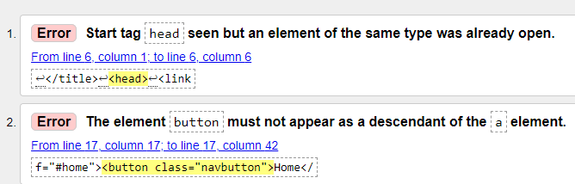After running the HTML checker, I found that I had a few different issues. I was able to fix the majority of these however these two remained.

I have had a good look at my code and at online help however, I couldn’t find a better way to write my code. This is where I am hoping to improve in HTML.

For the CSS tester, I ran it through and the site came back with no errors.

One of my only nit-picks about the website is that the start and end paragraphs are not long enough meaning that the Home and Contact us pages don’t fully appear as if there were their own page and instead look as if it is one big document, which of course it is.