Contacts Application User Interaction Plan
Frank Solomon
SDC330L Advanced Object-Oriented Programming Using Java LAB
1.5 Project Inheritance, Composition, and User Interactions
October 10, 2026

Project option and scope
I selected Option 1, the Rolodex/Contacts application. I will use a Java console application to manage business, family, and friend contacts. This document describes the intended user experience and includes screenshots of my Week 1 demonstration.
The current demonstration displays three fictional sample contacts, searches by the first letter of a last name, and exits through a numbered menu. Adding, removing, updating, and permanent database storage are planned features for later development.

Startup and menu selections
When the application starts, the user sees Project Week 1, the Contacts Application title, the assignment topic, and my name. A welcome message explains that the user should enter a menu number and press Enter. It also explains that the demonstration includes three sample contacts and that 0 exits the application.
The Week 1 menu offers 1 to display all contacts, 2 to search by last-name initial, and 0 to exit. After displaying results, the application returns to the menu. An invalid menu selection produces a message asking for 1, 2, or 0.

Displaying and finding contacts
Selecting 1 displays all three contact types as labeled blocks separated by dashed lines, followed by the total number of contacts. Each block includes the contact type, name, phone number, email, and mailing address. Business contacts also show company and job title; family contacts show the relationship; friend contacts show where we met.
Selecting 2 prompts for one letter. The application displays contacts whose last names begin with that letter, ignoring capitalization. If there are no matches, it displays a no-results message. Blank entries, numbers, and multiple characters are rejected with a request for exactly one letter.

Exiting the application
The application continues displaying the menu until the user selects 0. It then prints a thank-you and goodbye message and ends normally. The user does not need to close the terminal or shut down the computer.

Planned contact management interactions
I will expand the numbered menu while keeping the existing display, search, and exit choices. Each new action will guide the user through prompts and return to the main menu when finished.

Adding a contact
The user will choose Add Contact, select Business, Family, or Friend, and enter the name, phone, email, and address. The program will request the fields specific to that contact type. After validating required entries, it will save the contact and display confirmation.

Removing a contact
The user will choose Remove Contact and select a contact by a unique ID from a displayed list. The application will show the selected contact and ask for confirmation before removal. Cancelling will return to the menu without deleting the contact.

Updating a contact
The user will choose Update Contact, select an existing contact by ID, and choose the field to change. The current value will be displayed before the replacement is entered. The application will validate the entry, save the change, and confirm the update. Contact-specific fields and address fields will be included.

Inheritance and composition
Contact is the base class containing the common name, phone, email, and address information. BusinessContact, FamilyContact, and FriendContact extend Contact and add their own fields. Their overridden getContactInformation methods include both the shared information and the details specific to each contact type.
Composition is demonstrated by the Address object stored inside Contact. Address groups the street, city, state, and ZIP code. Each sample contact receives its own Address object. App creates the sample objects and handles the console menu, keeping user interaction separate from the data classes.

Plan for the remaining project requirements
The classes already use constructors, private fields, public methods, and documentation comments. The display loop uses Contact references to call the overridden child methods, providing a foundation for the formal polymorphism work in Week 2. I will add a display interface in Week 2 and make Contact abstract during the Week 3 work. SQLite storage will be implemented in Week 4 so contact changes remain available after the program closes. The Week 1 demo currently recreates its sample data each time it runs.

Welcome screen and main menu
Frank Solomon | SDC330L Week 1 Contacts Project
Figure 1. The welcome screen shows Project Week 1, the assignment topic, and Developer: Frank Solomon.
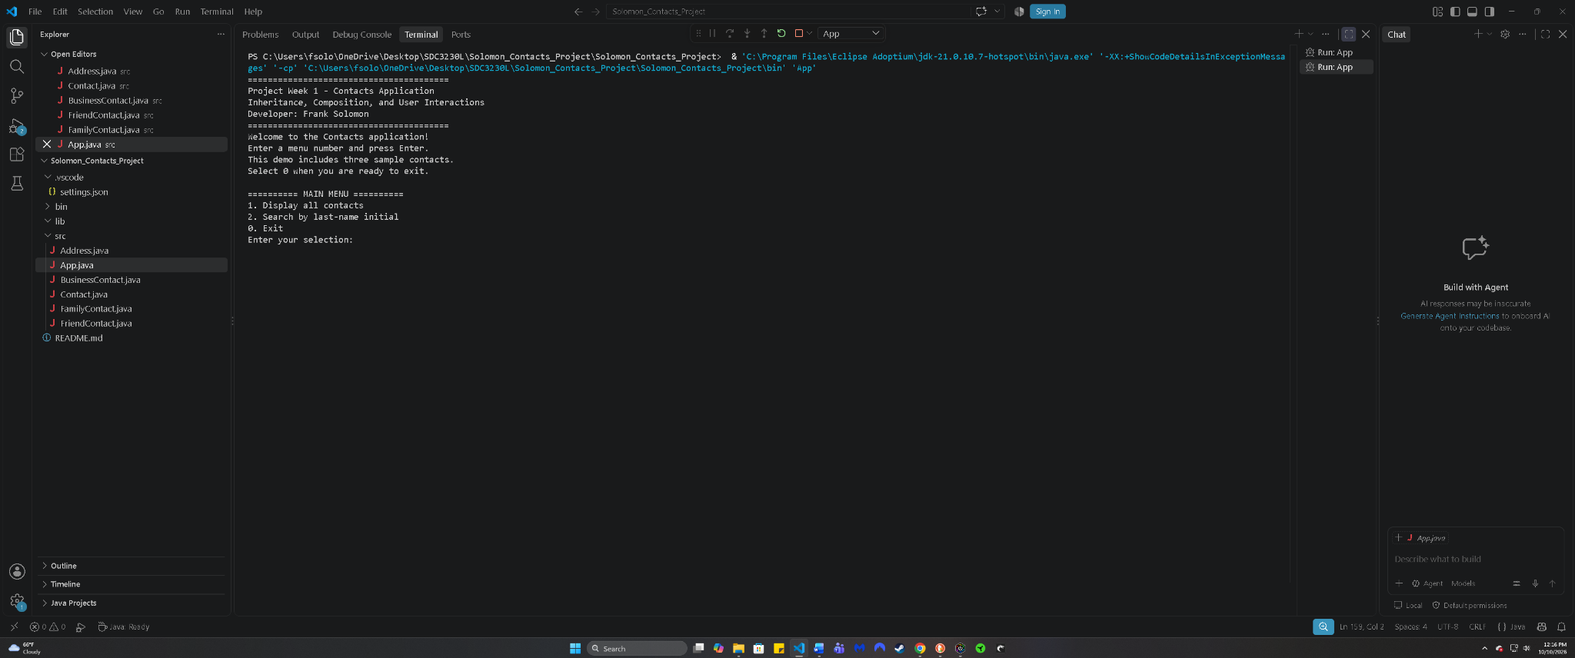
Original uncropped screenshot of my application running in VS Code.

All three contact types
Frank Solomon | SDC330L Week 1 Contacts Project
Figure 2. Selecting 1 displays the business, family, and friend contacts, including their addresses and type-specific details.
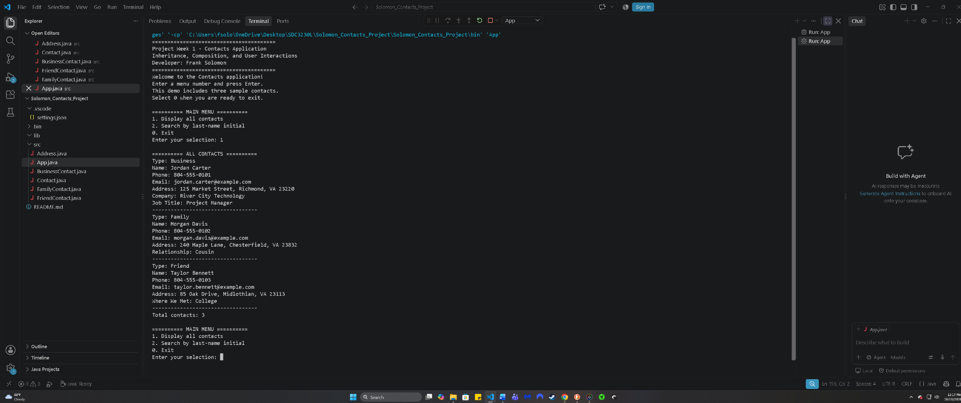
Original uncropped screenshot of my application running in VS Code.

Search by last name initial
Frank Solomon | SDC330L Week 1 Contacts Project
Figure 3. Entering lowercase c returns Jordan Carter and displays the menu again.
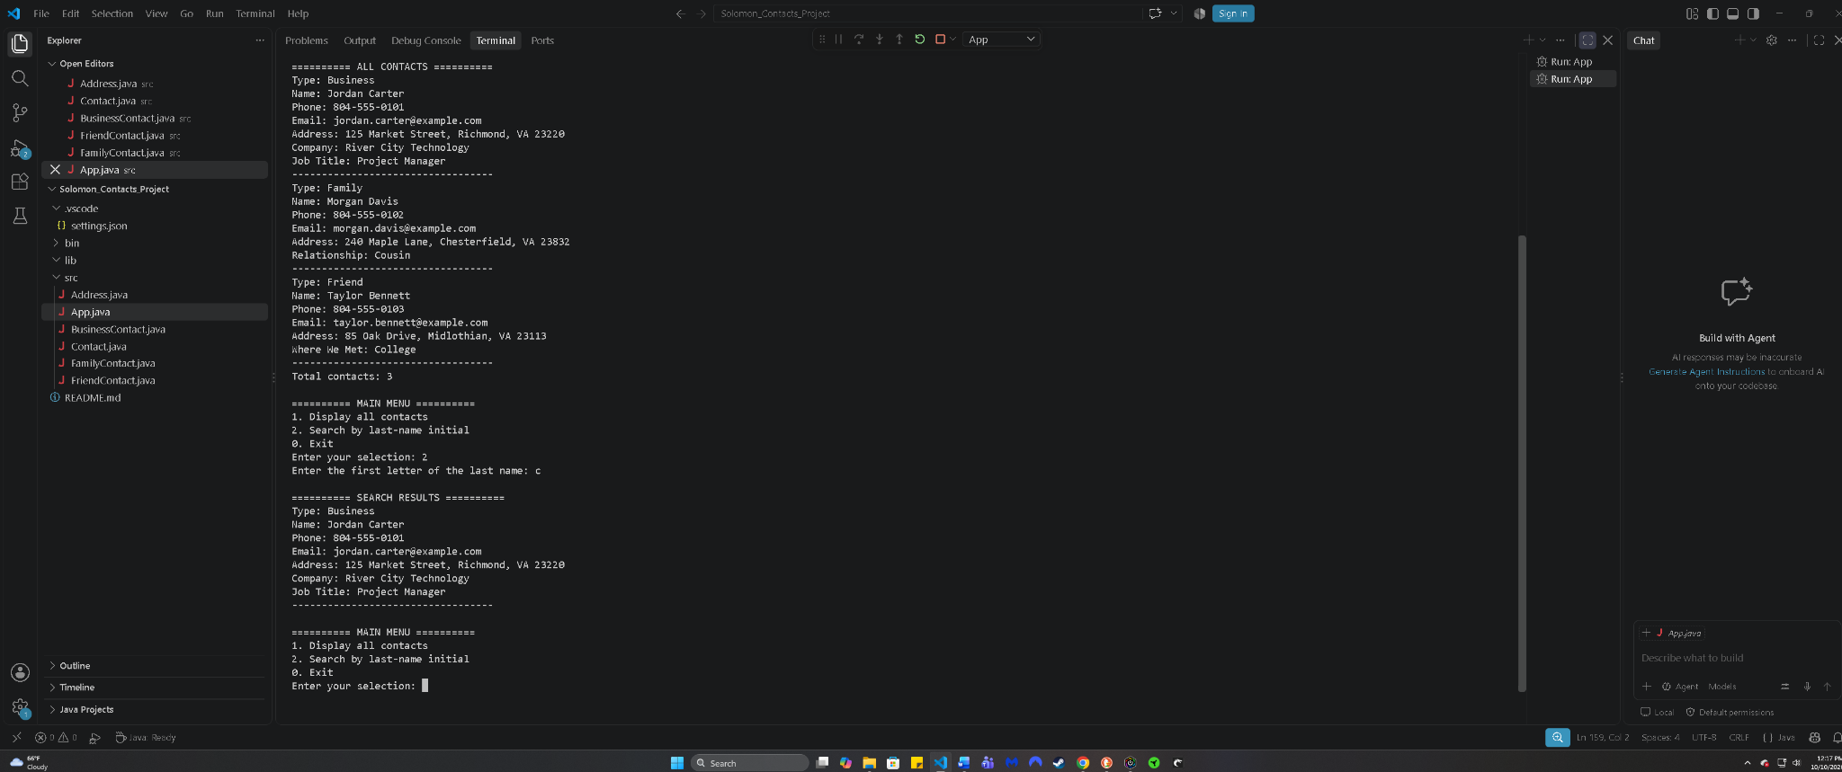
Original uncropped screenshot of my application running in VS Code.

Exit confirmation
Frank Solomon | SDC330L Week 1 Contacts Project
Figure 4. Selecting 0 displays the goodbye message and returns to the PowerShell prompt.
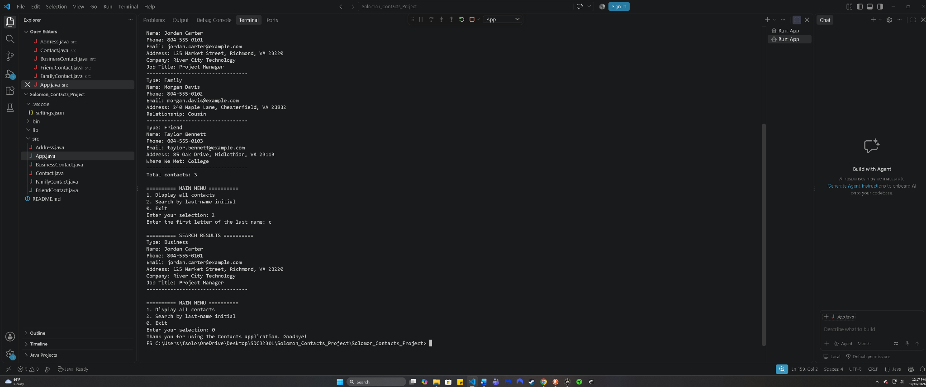
Original uncropped screenshot of my application running in VS Code.

