Contacts Application Software Design
Frank Solomon | ECPI University
SDC330L | 2.2 Project Software Design; Interfaces & Polymorphism
October 17, 2026
My project is Option 1, a Rolodex/Contacts application that manages business, family, and friend contacts through a Java console menu. This report describes the user interactions, class responsibilities, and object-oriented design. The Week 2 application adds a Displayable interface and uses polymorphism to display each contact type through a shared contract.

User interaction description

Startup and navigation
The welcome screen identifies Project Week 2, the Contacts Application, the assignment topic, and my name. Instructions explain how to enter a menu number and press Enter. The current menu offers 1 to display all contacts, 2 to search by last-name initial, and 0 to exit. The menu repeats after each display or search.

Display and search
Selecting 1 displays three fictional sample contacts. Each contact shows its type, name, phone, email, and address, followed by its type-specific details. The program reports the total number of contacts. Selecting 2 prompts for one letter and finds last names beginning with that letter regardless of capitalization. For example, lowercase c finds Jordan Carter.

Input handling and exit
An unsupported menu choice produces a request to enter 1, 2, or 0. A blank, numeric, or multiple-character search is rejected with a request for exactly one letter. A valid initial without matches produces a no-results message. Selecting 0 prints a thank-you and goodbye message and ends the application.

Planned contact management
Later versions will add, update, and remove contacts. Adding will prompt for a contact type, shared fields, address, and type-specific fields. Updating will select a contact by a unique ID and a field, show its current value, and validate the replacement. Removing will display the selected contact and request confirmation. Cancelling will return to the menu. SQLite storage will preserve changes between runs; the current demonstration recreates its sample data each time it starts.

Classes and interface
The Week 2 implementation contains six classes and one interface. Each data class has a constructor, private fields, and public access methods. App contains the entry point and private helper methods for the console workflow.

Displayable interface
Defines String getContactInformation(). It specifies the information-returning behavior without requiring particular fields or a particular contact type.

Contact class
Implements Displayable and stores firstName, lastName, phone, email, and an Address. Its constructor initializes these shared values. Getters and setters provide controlled access. getContactType() identifies the type; getContactInformation() formats shared details; toString() delegates to that information method.

BusinessContact class
Extends Contact and adds company and jobTitle, with a constructor and getters/setters. It overrides getContactType() and getContactInformation() to identify a business contact and include company and job title.

FamilyContact class
Extends Contact and adds relationship, with a constructor and getter/setter. It overrides getContactType() and getContactInformation() to include the family relationship.

FriendContact class
Extends Contact and adds whereWeMet, with a constructor and getter/setter. It overrides getContactType() and getContactInformation() to include where the friendship began.

Address class
Stores street, city, state, and zipCode. Its constructor and getters/setters manage address data, while toString() formats the mailing address. ZIP codes remain strings so leading zeros can be preserved.

App class
main() creates samples and runs the menu. createSampleContacts() instantiates the three subclasses and their addresses. displayMenu(), displayAllContacts(), and searchByLastName(Scanner) provide navigation, display, and searching. An ArrayList<Contact> holds the sample objects.

Object oriented relationships

Inheritance
Contact is the base class. BusinessContact, FamilyContact, and FriendContact inherit the shared contact fields through their parent and reuse its public methods. Each subclass calls super(...) to initialize common data and super.getContactInformation() to reuse the shared output. Their extra fields describe meaningful differences between contact types. A business contact is a contact, so this inheritance relationship fits the application.

Composition
Each Contact contains an Address object. An address belongs with contact information, but its formatting and fields are grouped in a separate class. The demonstration creates a separate address for each sample contact. Contact uses the address in its formatted output, allowing all three subclasses to reuse the same address behavior. Changes to Address can remain localized when its public contract stays compatible.

Interface and polymorphism
Displayable describes the ability to return displayable contact information. Contact implements the contract, and its subclasses inherit that contract while overriding the information method. The display-all loop uses a Displayable reference for each item in the contacts list. The same getContactInformation() call invokes the implementation for the actual BusinessContact, FamilyContact, or FriendContact object. This produces different type-specific details without separate display branches for each type.
The search loop uses Contact references so it can access getLastName(). After a match, its call to getContactInformation() also dispatches to the actual subclass. Thus, polymorphism supports both the interface-based display loop and the inheritance-based search results.

How the pieces work together
App creates Address and contact objects, stores the contacts in one collection, and selects display or search behavior from the menu. Contact formats the shared data, Address formats the address, and each subclass adds its own details. Displayable gives the display loop a small, consistent contract. This separates console navigation from data and formatting responsibilities, keeping changes easier to manage.

Plan for the complete application

Abstract base class
During the planned abstraction work, Contact will become abstract and getContactType() will become an abstract method implemented by the three subclasses. Shared fields, constructors, and the common getContactInformation() implementation will remain in Contact. This prevents generic Contact objects while preserving the existing subclass calls to super.getContactInformation(). Contact is still concrete in the Week 2 version.

Contact management and persistence
A planned ContactManager class will manage the contact collection and provide addContact, findById, findByLastNameInitial, updateContact, removeContact, and getAllContacts operations. App will gather user input and call these operations. A planned ContactRepository class will handle SQLite initialization, loading, inserting, updating, and deleting records so SQL stays separate from the console and contact classes. These two classes are future design elements and are not part of the Week 2 implementation.
Each stored contact will have a unique contact ID, a type, its shared fields, address fields, and the fields relevant to its subtype. On loading, ContactRepository will use the type to reconstruct a BusinessContact, FamilyContact, or FriendContact and its Address. ContactManager can then keep using Contact references and the display code can keep using Displayable references. Database writes will use parameterized statements.

Development checklist
Week 2 implements the display interface, subclass behavior, constructors, private data, public methods, composition, and a repeating console menu. The next stages will add the abstract base class, validated contact management operations, and SQLite CRUD. The design retains the current display, search, and exit behavior as those features are expanded.

Observed application results
The following screenshots show the application running in VS Code: the Week 2 welcome screen; all three contact types with a total of three; a lowercase c search returning Jordan Carter; and a normal exit returning control to PowerShell. The display results include business company/job title, family relationship, and where the friend was met.
The screenshots document the successful display, search, and exit paths. Invalid-input and no-match behavior are described from the application logic rather than shown in these captures.

Welcome screen and main menu
Frank Solomon | SDC330L Week 2 Contacts Project
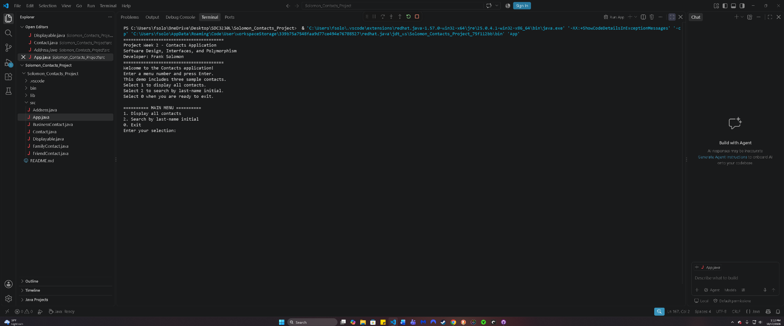
Figure 1. The Week 2 heading, assignment title, developer name, instructions, and numbered menu.
Original screenshot of the application running in VS Code.

All three contact types
Frank Solomon | SDC330L Week 2 Contacts Project
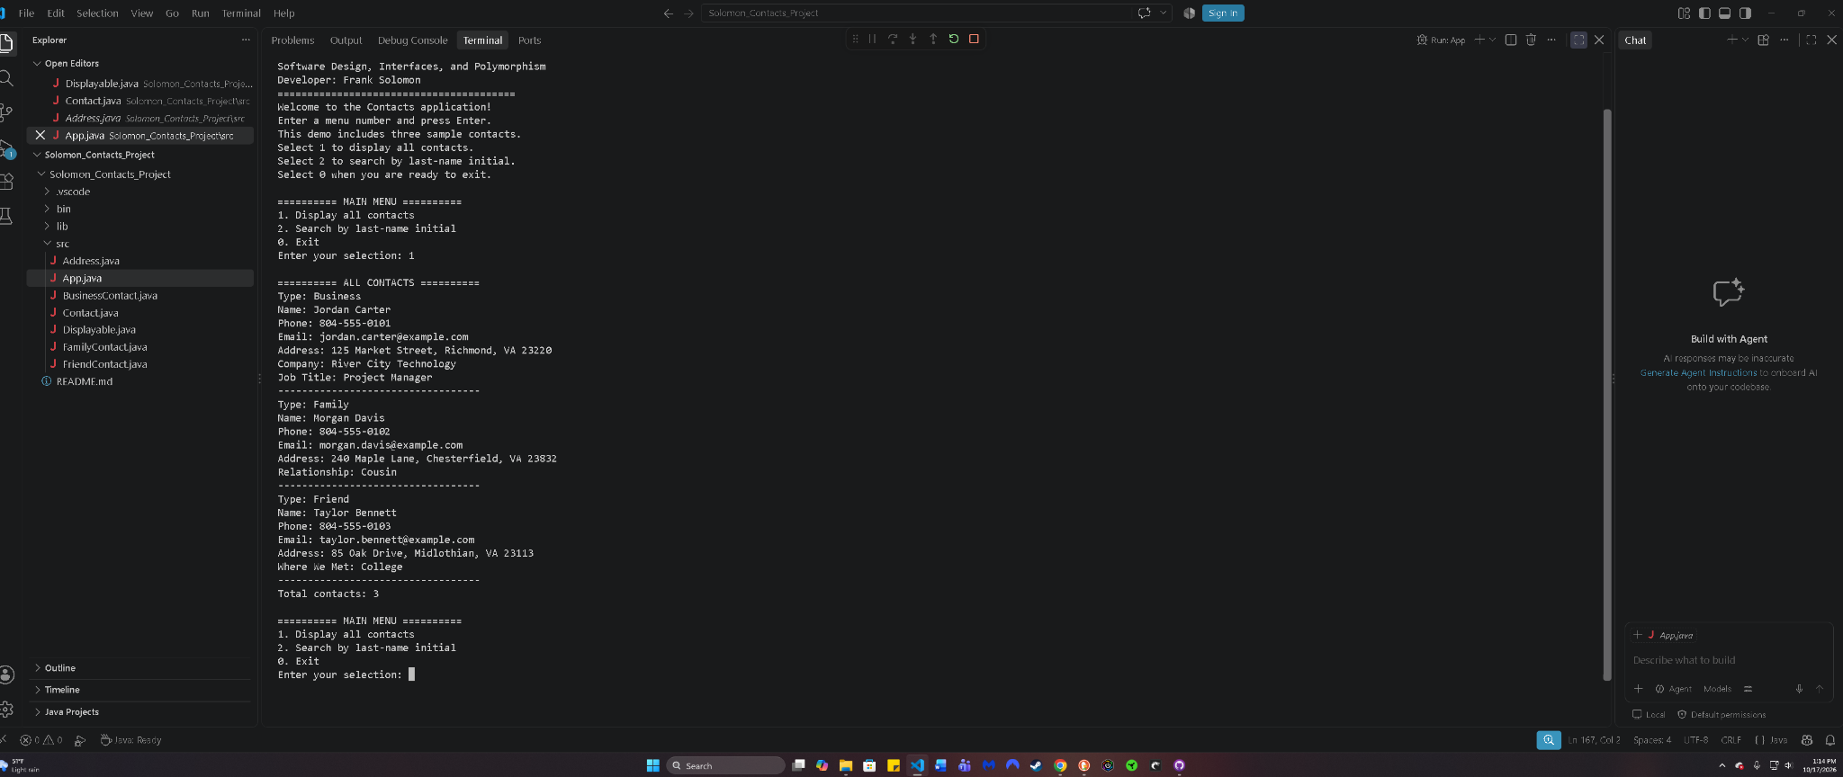
Figure 2. Business, family, and friend details are displayed through the shared interface, with Total contacts: 3.
Original screenshot of the application running in VS Code.

Search by last name initial
Frank Solomon | SDC330L Week 2 Contacts Project
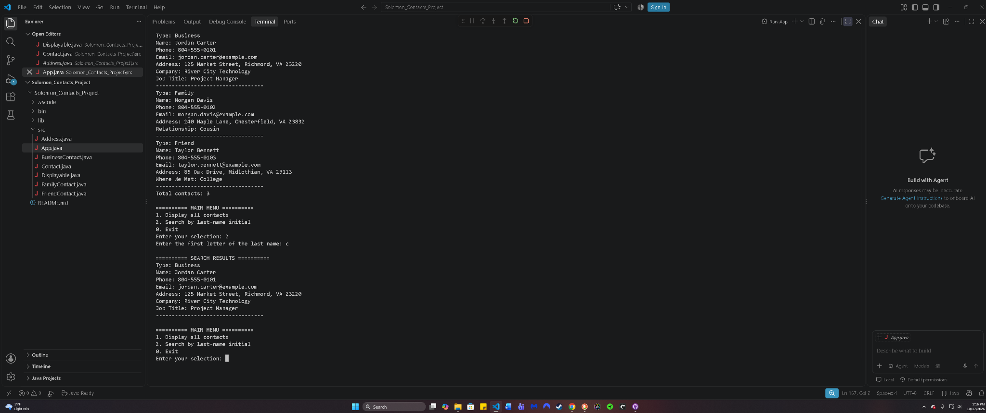
Figure 3. Entering lowercase c returns Jordan Carter with his business details and then redisplays the menu.
Original screenshot of the application running in VS Code.

Exit confirmation
Frank Solomon | SDC330L Week 2 Contacts Project
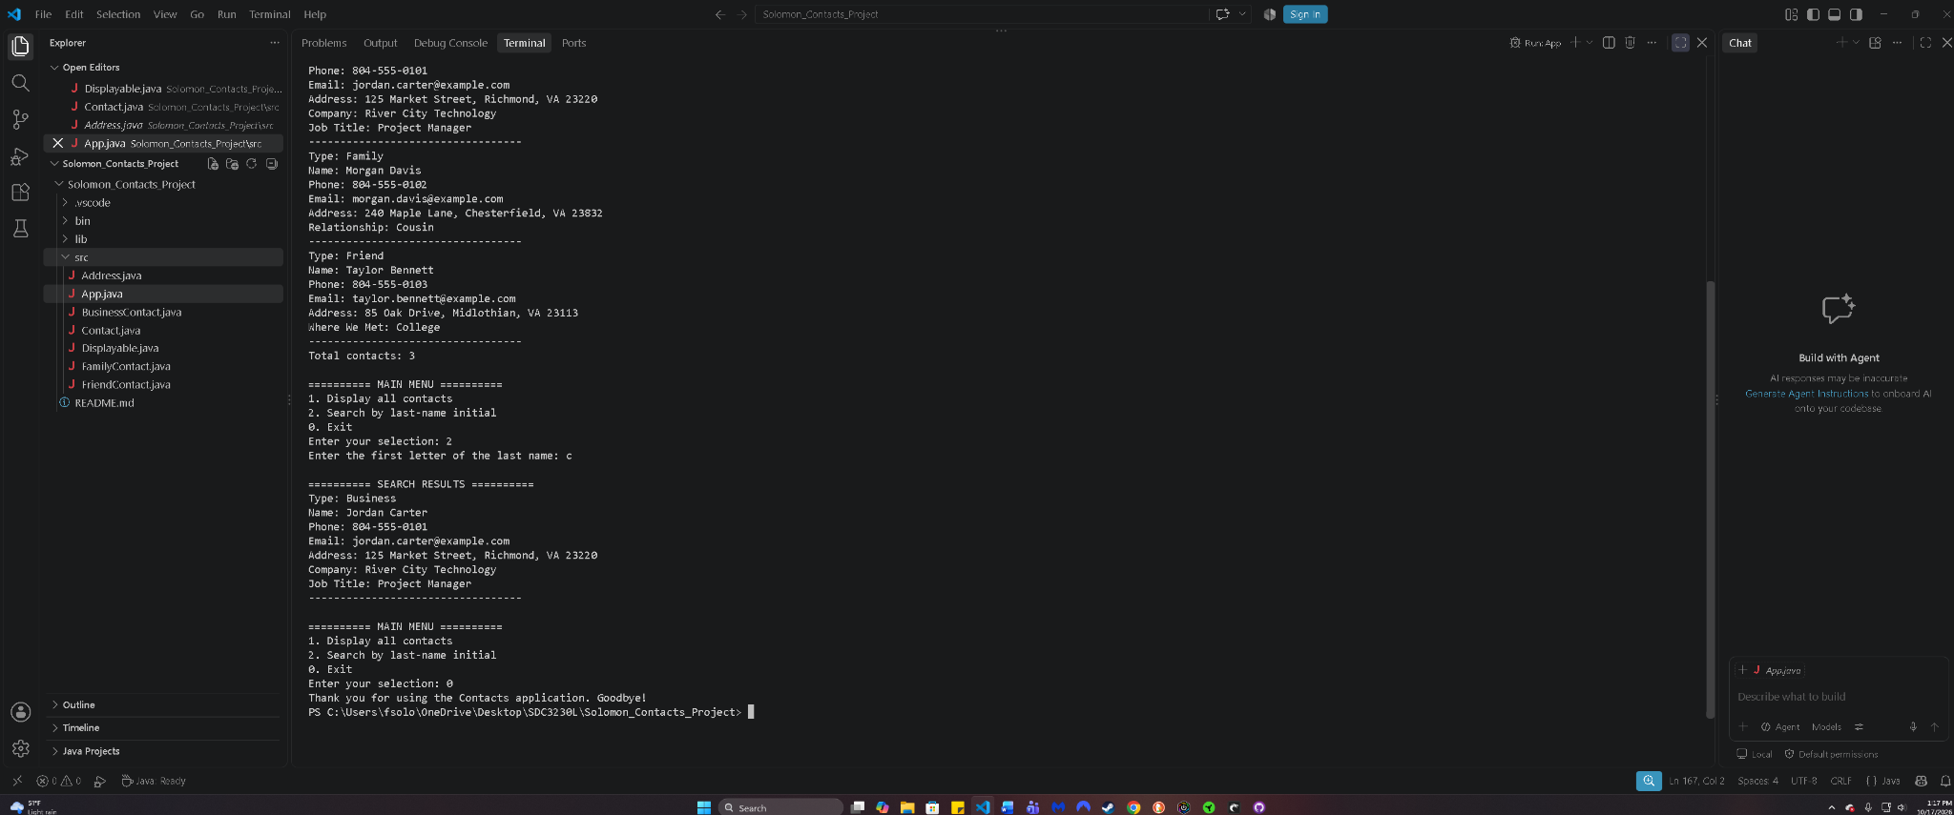
Figure 4. Selecting 0 prints the goodbye message and returns to the PowerShell prompt.
Original screenshot of the application running in VS Code.

GitHub: https://github.com/frasol2895/Solomon_Contacts_Project

