4.2 Project: Database Interactions
Frank Solomon | Project Week 4 | October 31, 2026
The Contacts application stores business, family, and friend contacts in SQLite. The menu provides instructions for displaying, searching, adding, updating, and deleting records. The included contacts.db contains three realistic fictional contacts.

Implementation
Contact is an abstract parent class. BusinessContact, FamilyContact, and FriendContact supply their contact types and specialized display information. Constructors initialize each object and its Address. Private fields protect internal data; public methods provide controlled access, and the protected Contact constructor supports subclass initialization. Source comments explain these concepts.
ContactRepository uses JDBC prepared statements for INSERT, SELECT, UPDATE, and DELETE. The contacts table stores common information, address fields, and type-specific details. SQLite assigns contact IDs, and saved changes remain available after the application closes. Deleted sample contacts are not automatically reinserted.

Verification
The application compiled for Java 17 and ran on Linux with the included SQLite JDBC dependencies. Execution checks passed for all four CRUD operations, persistence across separate launches, invalid menu input, missing IDs, and cancelled operations. The Windows launcher is included but was not tested on Windows.
The following panels capture actual program console output from these runs. Input was supplied automatically, so entered responses are not echoed and some prompts appear together. Repeated menus are omitted from panels 2–5 for readability.

Read: startup and saved contacts
Menu option 1 retrieves the three sample contacts from contacts.db and displays their IDs and information.
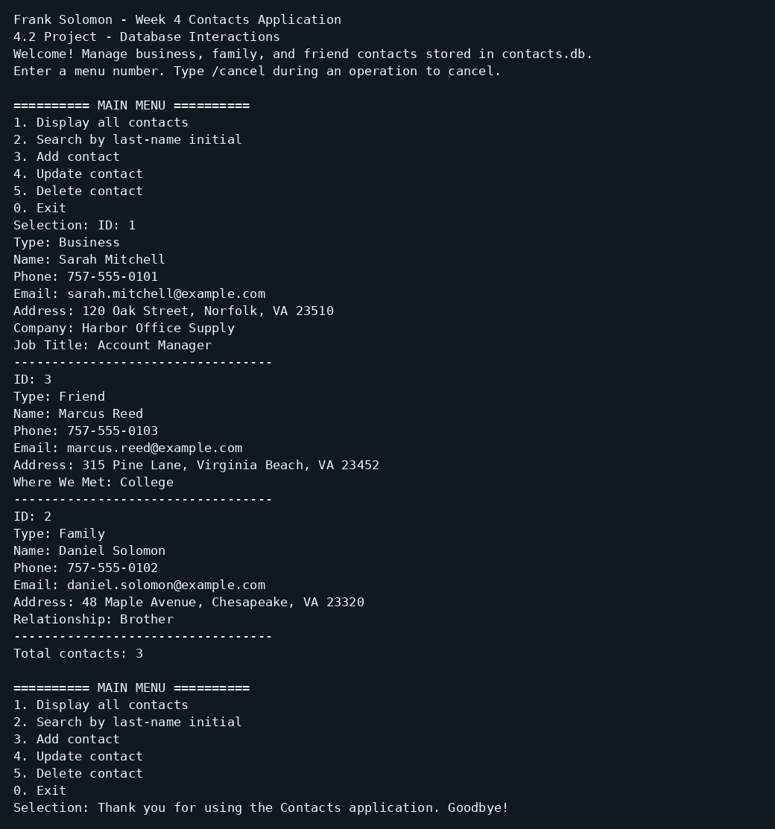

Create: add and retrieve a contact
Menu option 3 adds Emily Carter as a Friend contact. Searching for C retrieves the new record with ID 4.
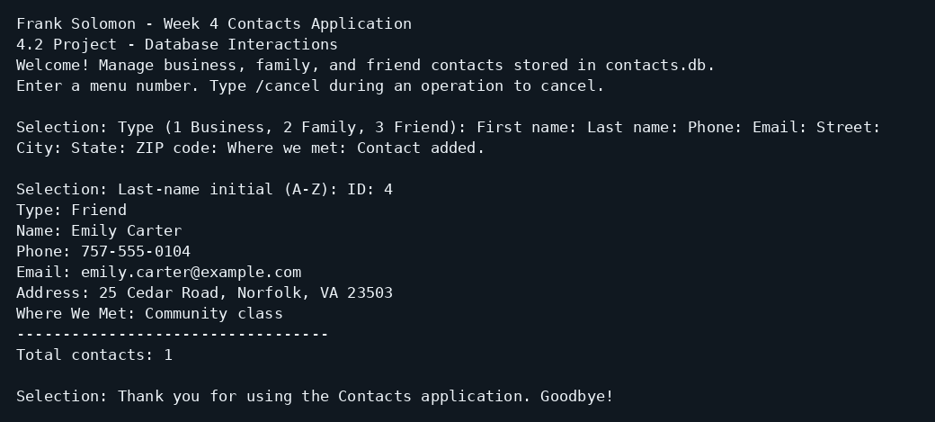

Update: change stored contact information
Menu option 4 changes contact 4's phone to 757-555-0199. A subsequent search displays the updated value.
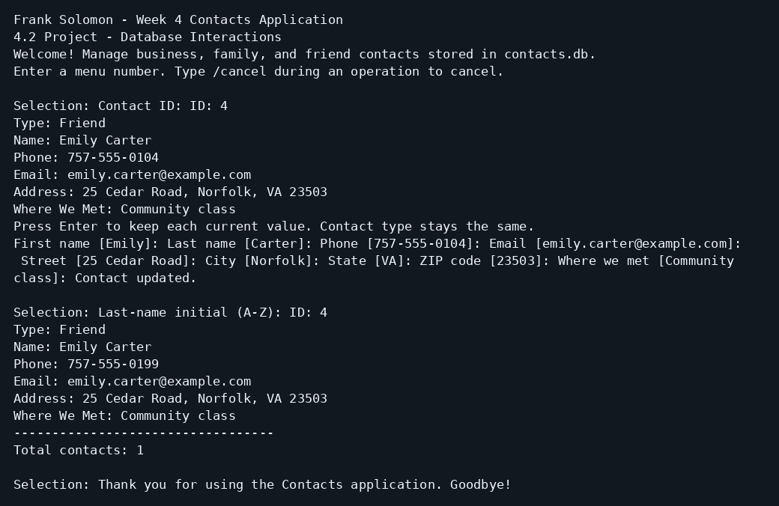

Persistence: retrieve after restarting
A separate application launch retrieves Emily Carter with the updated phone number, confirming that the change was stored in SQLite.
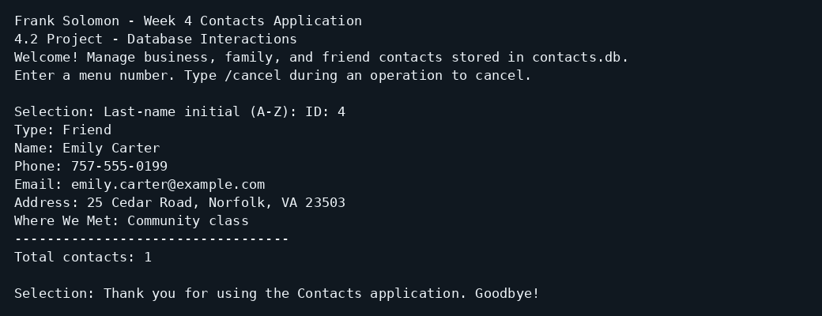

Delete: remove and verify
Menu option 5 deletes contact 4 after YES confirmation. Searching for C then returns zero contacts.


