Contacts Application
  - Project Week 3: Abstraction, Constructors, & Access Specifiers
Frank Solomon | ECPI University | SDC330L 3.2
October 24, 2026

Purpose and design progression
The Contacts application organizes business, family, and friend contacts through a console menu. It builds on the Week 2 design and retains the Displayable interface, shared contact fields, Address composition, and specialized contact classes. The program supports displaying, searching, adding, updating, and deleting contacts. Records are stored in memory during the session.

Abstraction
Contact is an abstract class because a generic contact does not identify a specific contact category. It stores common data and supplies shared validation and formatting. Its abstract getContactType() method requires BusinessContact, FamilyContact, and FriendContact to provide their own category. Contact cannot be instantiated directly; the application creates concrete subclasses instead.
Each subclass benefits from shared fields, a protected constructor, and the existing getContactInformation() implementation. The subclass calls super.getContactInformation() and appends its own details. This reduces duplicated code and keeps output consistent. The application displays contacts through Displayable references, so the appropriate subclass implementation runs automatically. Displayable defines the display contract, while Contact supplies reusable state and behavior.

Class relationships
Class / interface | Responsibility and relationship
Displayable | Declares getContactInformation().
Contact (abstract) | Implements Displayable; owns shared fields and an Address.
BusinessContact | Extends Contact; adds company and job title.
FamilyContact | Extends Contact; adds relationship.
FriendContact | Extends Contact; adds where the friends met.
Address | Stores street, city, state, and ZIP code.
ContactManager | Manages a private List<Contact> and session IDs.
App | Runs the console menu and creates sample objects.

Constructors
ContactManager has an explicit public no-argument constructor that creates an empty list and starts IDs at 1. Address and all concrete contact types have parameterized constructors. Each contact subclass calls super(...) to initialize shared fields through the protected Contact constructor.
Address also has a copy constructor, Address(Address source), which delegates to its four-argument constructor. Because the address values are strings, the new object has independent fields and can be edited without modifying the source address. The sample setup exercises this constructor for the friend address.
FriendContact has two constructor signatures. The full version accepts whereWeMet; the shorter version supplies "Not recorded" through this(...). The sample setup uses the shorter overload and then sets the meeting location to "College". This demonstrates flexible construction without duplicating validation. No-argument constructors are not added to contact classes because required contact information should be supplied when they are created.

Access specifiers and data protection
All instance fields in the domain classes are private. Public getters expose information, while public setters validate required text. ContactManager keeps its collection private and returns an unmodifiable list copy so callers cannot directly add or remove list members. The Contact objects themselves remain mutable through their public methods.
The Contact constructor and requireText helper are protected so subclasses can reuse initialization and validation. Java protected access also permits access within the same package. Address has a private validation helper because only Address uses it. App menu and input helpers are private; main is public as the application entry point.
Contact.assignId has package access, allowing ContactManager to assign an ID without making assignment public. It rejects nonpositive IDs and repeated assignment. All classes currently share the default package, so package access is a package-level restriction, not exclusive access for ContactManager.

User interaction and sample objects
The startup output identifies Project Week 3, the assignment topic, and Frank Solomon. A welcome message explains menu entry, cancellation, and session-only storage. Three fictional contacts demonstrate every concrete contact type: Jordan Carter (business), Morgan Davis (family), and Taylor Bennett (friend). Each has a phone number, email, mailing address, and subtype-specific information. Choosing 1 displays all records, including their contact categories.
Source headers identify the developer, date, assignment, and class purpose. Inline comments identify abstraction, constructor delegation and overloads, private data, protected reuse, and private application helpers.

Application running in VS Code
Figure 1. The Week 3 application displays the assignment title, Frank Solomon, welcome instructions, and all three sample contacts. Business, family, and friend records include their shared fields and subtype-specific details. The total is three, and the menu appears again after display.
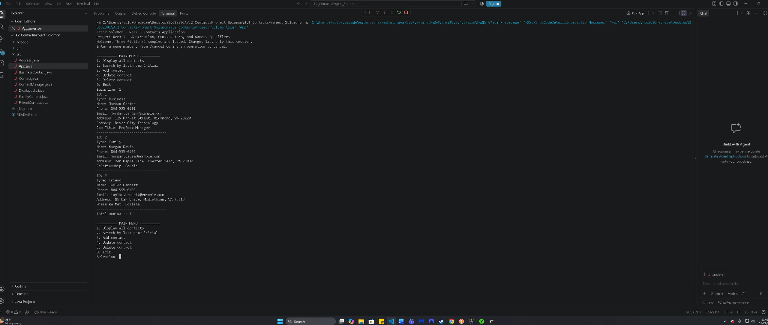
Observed result: the supplied VS Code capture shows successful startup and the Display all contacts operation. The Windows taskbar date and time are visible. This capture verifies display behavior; it does not establish that every menu operation was tested.

