The Psyche Symbols
360 Mirrors of Signal Shadow and Sovereignty

A Cult of Psyche degree symbol book

Original 2026 Edition

How to Read the Psyche Symbols
The Psyche Symbols are an original 360-degree image system built for reflective astrology, creative work, journaling, and conversation. The zodiac provides the sequence. Each degree provides a scene. The reader provides attention.
A symbol can reveal a tension without issuing a command. It may show what you desire, fear, repeat, protect, or refuse to name. It cannot remove your judgment. Treat every interpretation as a doorway you may enter, question, revise, or leave.
The reading anatomy has five parts. Interpretation studies the whole scene. Signal names the image's living capacity. Shadow names the distortion that may travel beside that capacity. Mirror asks a question that returns authority to the reader. Practice brings the symbol into an observable act.
The Cult of Psyche holds truth and mystery together. Read the symbol as symbol. Check facts as facts. Let intuition propose; let evidence correct; let consent govern what happens next.

The Twelve Chambers
Range | Sign | Chamber
1-30 | Aries | The First Signal
31-60 | Taurus | The Sacred Vessel
61-90 | Gemini | The Twin Transmission
91-120 | Cancer | The House of Memory
121-150 | Leo | The Living Flame
151-180 | Virgo | The Sacred Workshop
181-210 | Libra | The Hall of Mirrors
211-240 | Scorpio | The Descent Chamber
241-270 | Sagittarius | The Library Without Walls
271-300 | Capricorn | The Storm-Born Architect
301-330 | Aquarius | The Living Network
331-360 | Pisces | The Return to Mystery

Editorial Boundary
This is a project-owned original work. It does not reproduce historical Sabian symbol wording and should not be presented as an authorized historical Sabian edition.
The public CultCodex archive informed the book's vocabulary of signal, shadow, symbolic interpretation, consciousness, sovereignty, and living memory. CultCodex also marks its Psychenomicon material as mythic or symbolic interpretation rather than factual reporting. This book follows that boundary and excludes claims about real people.
Public reference consulted September 9, 2026: https://cultcodex.me/ and https://cultcodex.me/about/methodology

Aries
The First Signal
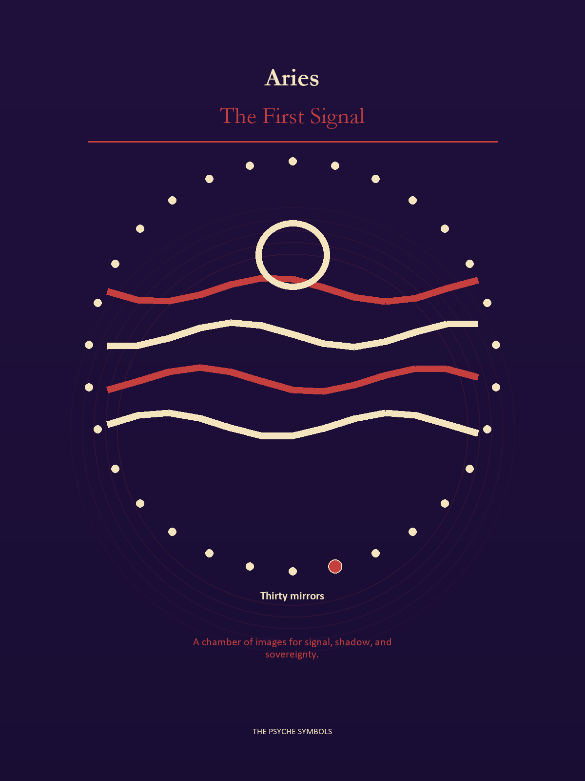
Aries asks what deserves a first move before certainty arrives. The First Signal carries heat, speed, and the danger of mistaking urgency for truth. Here the soul learns that beginning is an ethical act: it creates a path others may have to walk.

Degrees | Gate | Work
1-5 | Arrival | Meet the image before deciding what it means.
6-10 | Friction | Notice what pushes back and what that resistance protects.
11-15 | Revelation | Name the detail that changes the whole scene.
16-20 | Choice | Choose the act that preserves both truth and human dignity.
21-25 | Integration | Use the gift without feeding the shadow that travels beside it.
26-30 | Release | Keep the earned capacity and release the role that delivered it.

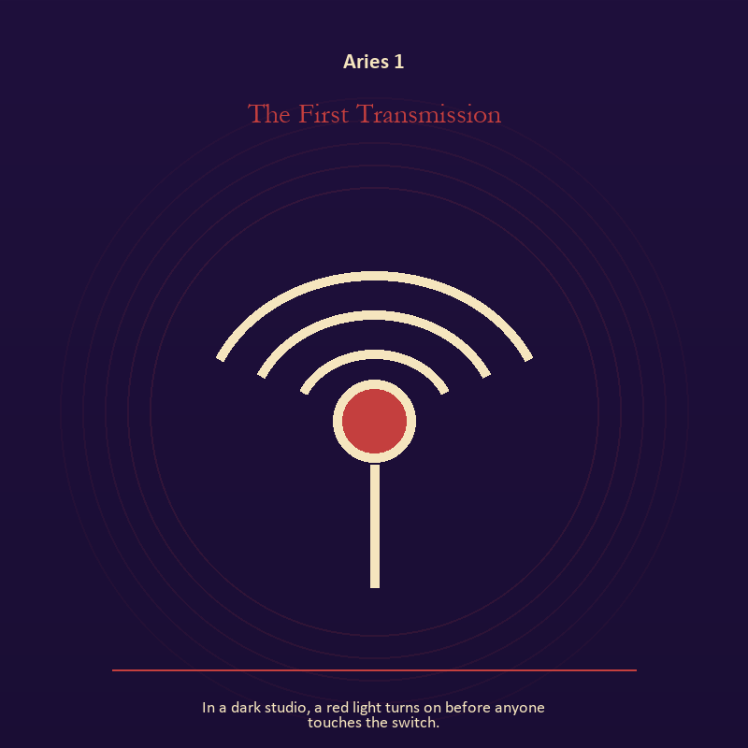

Aries 1 The First Transmission
In a dark studio, a red light turns on before anyone touches the switch.
INTERPRETATION In the First Transmission, the work of the Signal must answer to ignition, appetite, risk, and the courage to become visible. Within the First Transmission, signal imagery asks what is being transmitted beneath performance. At Aries 1, interference may come from fear, vanity, noise, or a container too narrow for the message. The same image also carries living fire; at Aries 1, a Lantern offers enough light for the next honest step. As an arrival degree, Aries 1 arrives before habit can tidy the evidence; notice what is present before deciding what it should become.
SIGNAL The usable force at Aries 1 is contact across distance joined to a truth made visible at the right scale; Aries gives it form by asking you to choose a clean beginning and let action test the idea.
SHADOW At Aries 1, the First Transmission can turn toward letting noise impersonate urgency and burning for recognition; watch for impulse dressed as destiny or courage performed for an audience.
MIRROR The question at Aries 1: what remains of your message when performance is removed?
PRACTICE Give Aries 1 a physical form; write the same message for a friend, an opponent, and your future self; then keep the sentence that stays true in all three versions.
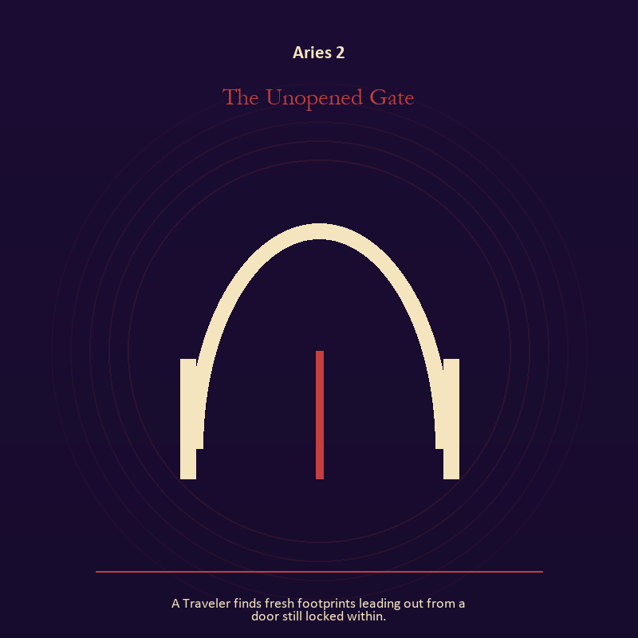

Aries 2 The Unopened Gate
A Traveler finds fresh footprints leading out from a door still locked within.
INTERPRETATION The Unopened Gate tests the threshold against ignition, appetite, risk, and the courage to become visible. Within the Unopened Gate, doors and roads turn inner change into an embodied decision. At Aries 2, the next room matters, but so does the condition under which it is entered. As an arrival degree, Aries 2 introduces the sign's raw material in an unguarded form; the first response matters less than the honest one.
SIGNAL At Aries 2, a boundary that clarifies freedom carries the signal; it stays honest when you choose a clean beginning and let action test the idea.
SHADOW The shadow at Aries 2 begins with crossing before consent; also watch for impulse dressed as destiny or courage performed for an audience.
MIRROR At Aries 2, what are you protecting by remaining on this side of the door?
PRACTICE Bring Aries 2 out of abstraction: stand at a literal doorway, name what you are leaving and what you refuse to abandon, then cross only if the answer feels clean.

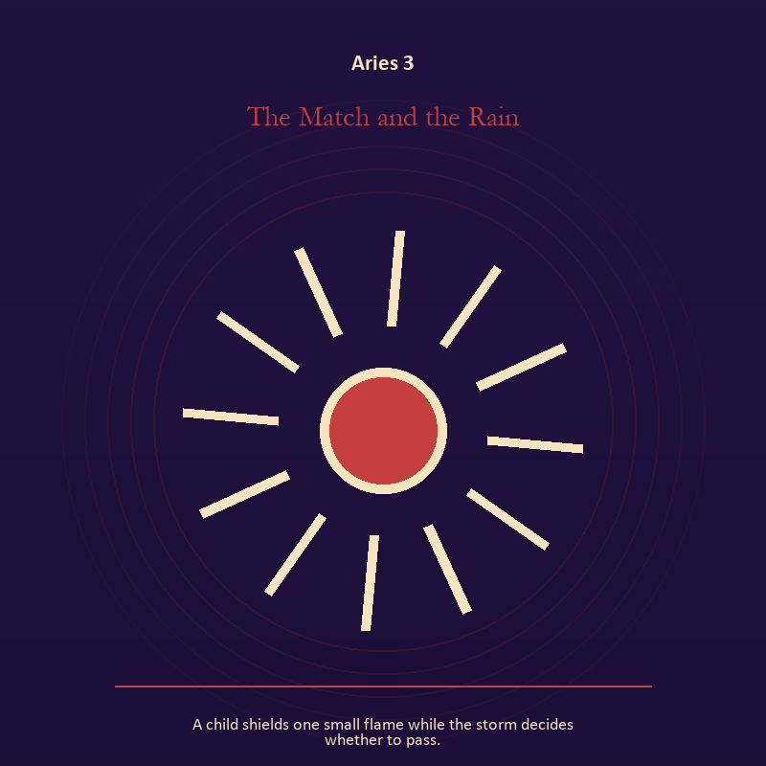

Aries 3 The Match and the Rain
A child shields one small flame while the storm decides whether to pass.
INTERPRETATION The Match and the Rain holds living fire against ignition, appetite, risk, and the courage to become visible. Within the Match and the Rain, a Lantern offers enough light for the next honest step. At Aries 3, it does not remove night, and its usefulness depends on how it is carried. The same image also carries living water; at Aries 3, a shore or vessel gives emotion a boundary without denying its depth. As an arrival degree, Aries 3 catches the first impulse before it turns into a role; give the image room to remain strange.
SIGNAL What can be carried forward from Aries 3 is attention with warmth joined to adaptation without self-erasure, tested by the need to choose a clean beginning and let action test the idea.
SHADOW At Aries 3, the image darkens through exposure without care and building a vessel too rigid for living water; watch for impulse dressed as destiny or courage performed for an audience.
MIRROR For Aries 3, how much light does the next step require, and who might it expose? From a second angle at Aries 3, where are you adapting wisely, and where are you disappearing?
PRACTICE For Aries 3, move one hidden concern into plain view by naming it to a trusted person.
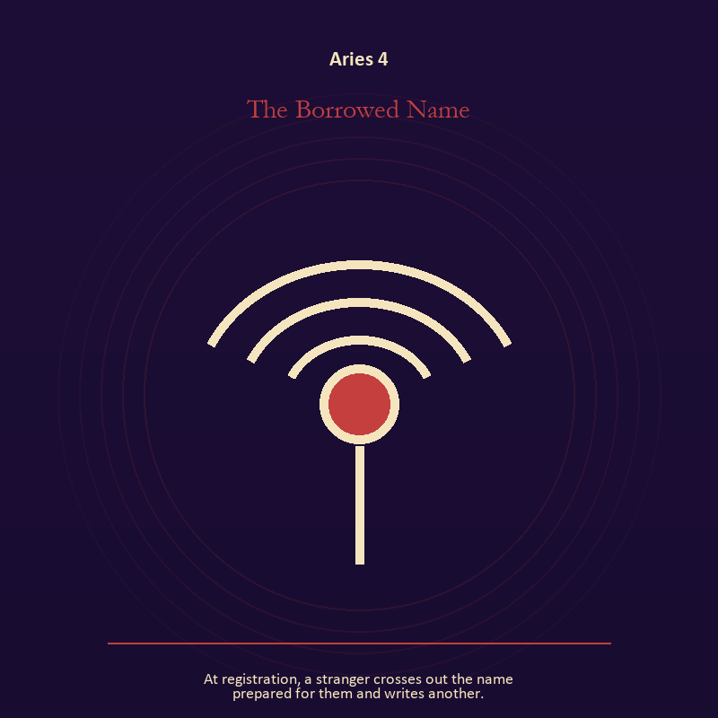

Aries 4 The Borrowed Name
At registration, a stranger crosses out the name prepared for them and writes another.
INTERPRETATION The Borrowed Name gives voice and naming consequences inside the First Signal. Within the Borrowed Name, voice turns inner pressure into shared consequence. At Aries 4, words can witness, summon, distort, repair, or conceal according to their precision and timing. The same image also carries identity; at Aries 4, a role organizes behavior but cannot contain the whole person. As an arrival degree, Aries 4 opens the chamber with no settled method; name the need, risk, or appetite that entered with it.
SIGNAL At Aries 4, a name that restores agency joined to the freedom to revise a name or role becomes the clean signal when Aries can choose a clean beginning and let action test the idea.
SHADOW The distortion at Aries 4 is speaking for someone whose voice is present and performance mistaken for selfhood; watch for impulse dressed as destiny or courage performed for an audience.
MIRROR With the Borrowed Name in mind at Aries 4, which word in this scene changes the power relationship?
PRACTICE Work with The Borrowed Name directly at Aries 4: give the current experience a temporary name and date it, leaving room for revision. For the second pressure at Aries 4, list the roles you carry; then mark each as chosen, inherited, temporary, or ready to release.

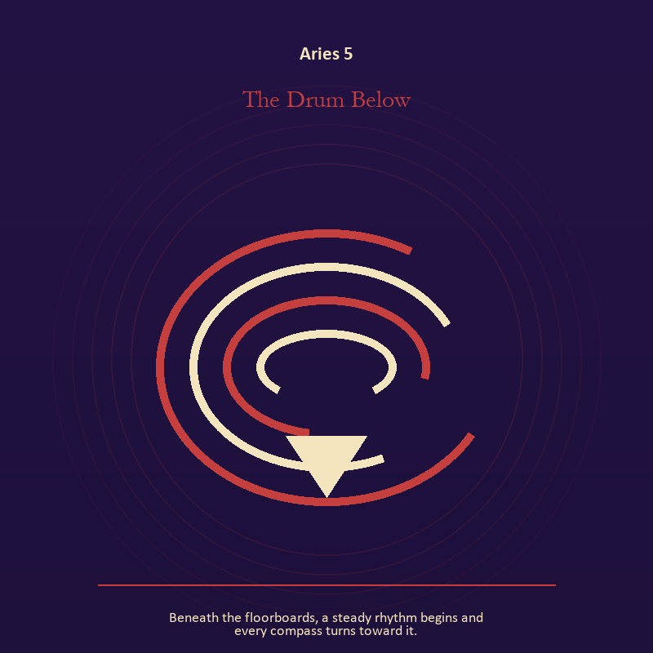

Aries 5 The Drum Below
Beneath the floorboards, a steady rhythm begins and every compass turns toward it.
INTERPRETATION The Drum Below puts the descent under pressure from ignition, appetite, risk, and the courage to become visible. Within the Drum Below, the underworld strips away rank and performance. At Aries 5, what remains must be handled as evidence of experience, not proof of every story built around it. As an arrival degree, Aries 5 shows the beginning before ownership hardens around it; let attention come before possession.
SIGNAL The usable force at Aries 5 is a wound converted into discernment; Aries gives it form by asking you to choose a clean beginning and let action test the idea.
SHADOW At Aries 5, the Drum Below can turn toward pain used as permanent jurisdiction; watch for impulse dressed as destiny or courage performed for an audience.
MIRROR The question at Aries 5: which part of the wound needs witness, and which part needs a boundary?
PRACTICE Give Aries 5 a physical form; write two columns titled KNOWN and INFERRED; then place every part of the story where it belongs.
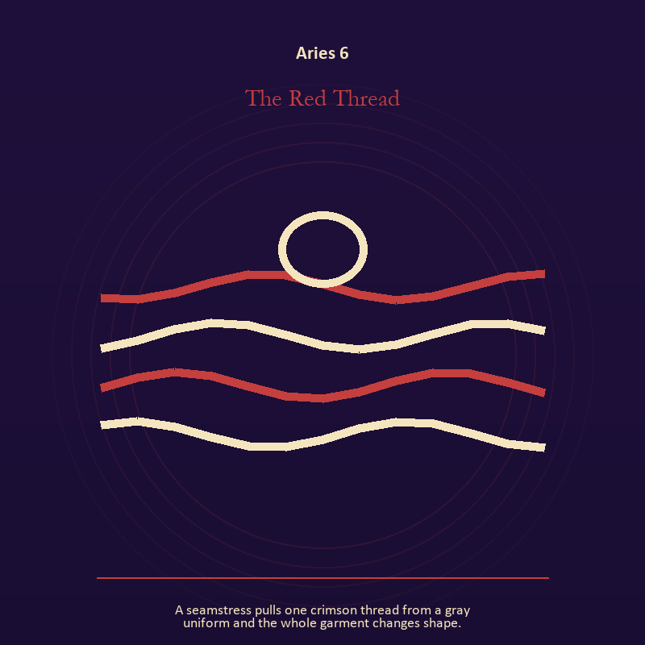

Aries 6 The Red Thread
A seamstress pulls one crimson thread from a gray uniform and the whole garment changes shape.
INTERPRETATION In the Red Thread, the work of craft and record must answer to ignition, appetite, risk, and the courage to become visible. Within the Red Thread, workshops honor correction. At Aries 6, a flaw becomes useful when it is found early, recorded honestly, and repaired without hiding the seam. The same image also carries identity; at Aries 6, masks and names can conceal, reveal, or give shape to a truth that plain speech cannot yet hold. As a friction degree, Aries 6 meets resistance, and that resistance reveals what the first impulse failed to consider.
SIGNAL At Aries 6, care made repeatable joined to a protective form used consciously carries the signal; it stays honest when you choose a clean beginning and let action test the idea.
SHADOW The shadow at Aries 6 begins with the tool becoming the master and a mask that can no longer be removed safely; also watch for impulse dressed as destiny or courage performed for an audience.
MIRROR At Aries 6, where would an honest repair remain visible? From a second angle at Aries 6, what does the mask make possible, and what does it cost to keep wearing it?
PRACTICE Bring Aries 6 out of abstraction: keep a brief record of what happened, what you expected, and what changed your mind.

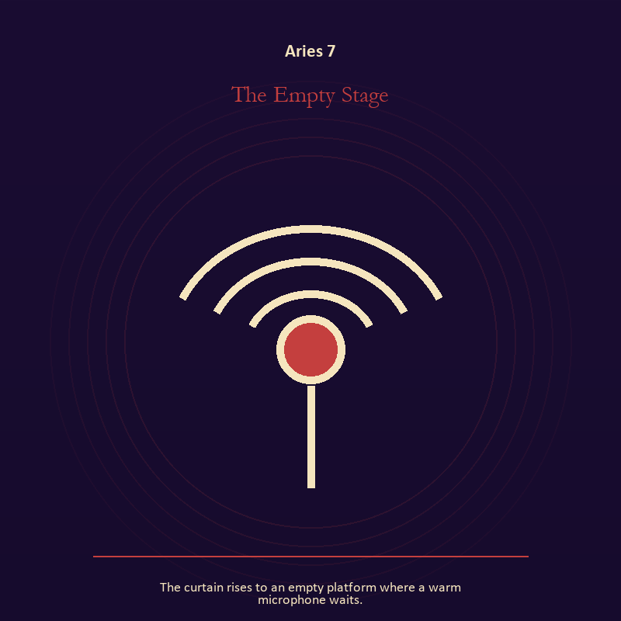

Aries 7 The Empty Stage
The curtain rises to an empty platform where a warm microphone waits.
INTERPRETATION The Empty Stage tests the Signal against ignition, appetite, risk, and the courage to become visible. Within the Empty Stage, signal imagery asks what is being transmitted beneath performance. At Aries 7, interference may come from fear, vanity, noise, or a container too narrow for the message. As a friction degree, Aries 7 places consequence beside desire; the obstruction may be an enemy, a limit, or a needed correction.
SIGNAL What can be carried forward from Aries 7 is contact across distance, tested by the need to choose a clean beginning and let action test the idea.
SHADOW At Aries 7, the image darkens through letting noise impersonate urgency; watch for impulse dressed as destiny or courage performed for an audience.
MIRROR For Aries 7, what remains of your message when performance is removed?
PRACTICE For Aries 7, write the same message for a friend, an opponent, and your future self; then keep the sentence that stays true in all three versions.
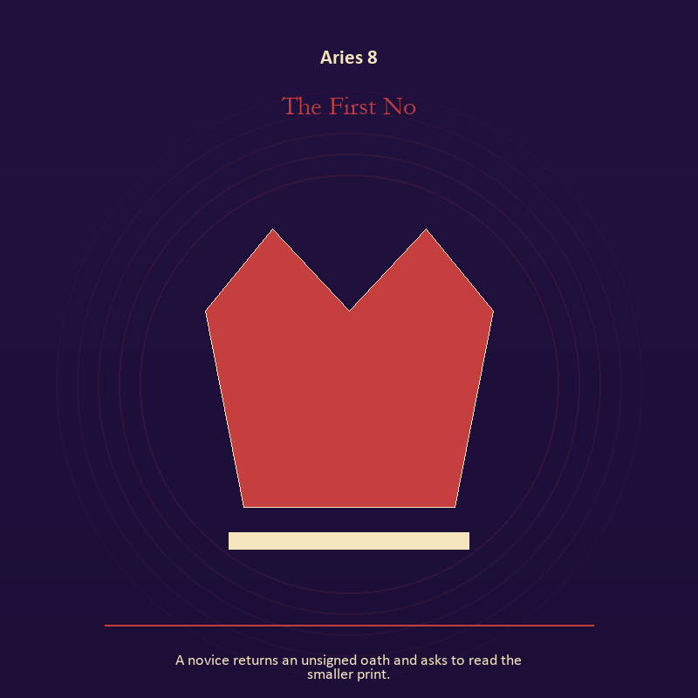

Aries 8 The First No
A novice returns an unsigned oath and asks to read the smaller print.
INTERPRETATION The First No holds authority against ignition, appetite, risk, and the courage to become visible. Within the First No, crowns, laws, offices, and verdicts turn private judgment into public consequence. At Aries 8, their legitimacy depends on restraint and correction. As a friction degree, Aries 8 tests whether the sign can change course without treating correction as defeat.
SIGNAL At Aries 8, a rule that protects the vulnerable person in the room becomes the clean signal when Aries can choose a clean beginning and let action test the idea.
SHADOW The distortion at Aries 8 is role mistaken for worth; watch for impulse dressed as destiny or courage performed for an audience.
MIRROR With the First No in mind at Aries 8, what would accountability require from the person holding the key?
PRACTICE Work with The First No directly at Aries 8: choose one decision you control and write down who can challenge it, correct it, and leave its consequences.

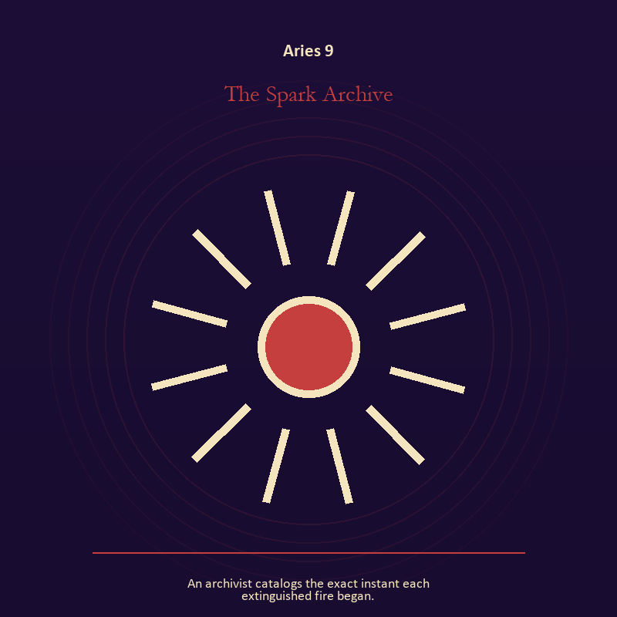

Aries 9 The Spark Archive
An archivist catalogs the exact instant each extinguished fire began.
INTERPRETATION The Spark Archive gives craft and record consequences inside the First Signal. Within the Spark Archive, workshops honor correction. At Aries 9, a flaw becomes useful when it is found early, recorded honestly, and repaired without hiding the seam. The same image also carries living fire; at Aries 9, fire gives change a visible cost. As a friction degree, Aries 9 brings another will, material limit, or inconvenient fact into the frame.
SIGNAL The usable force at Aries 9 is care made repeatable joined to courage that helps another see; Aries gives it form by asking you to choose a clean beginning and let action test the idea.
SHADOW At Aries 9, the Spark Archive can turn toward the tool becoming the master and mistaking brightness for moral authority; watch for impulse dressed as destiny or courage performed for an audience.
MIRROR The question at Aries 9: where would an honest repair remain visible? From a second angle at Aries 9, where has your fire become performance rather than warmth?
PRACTICE Give Aries 9 a physical form; keep a brief record of what happened, what you expected, and what changed your mind.
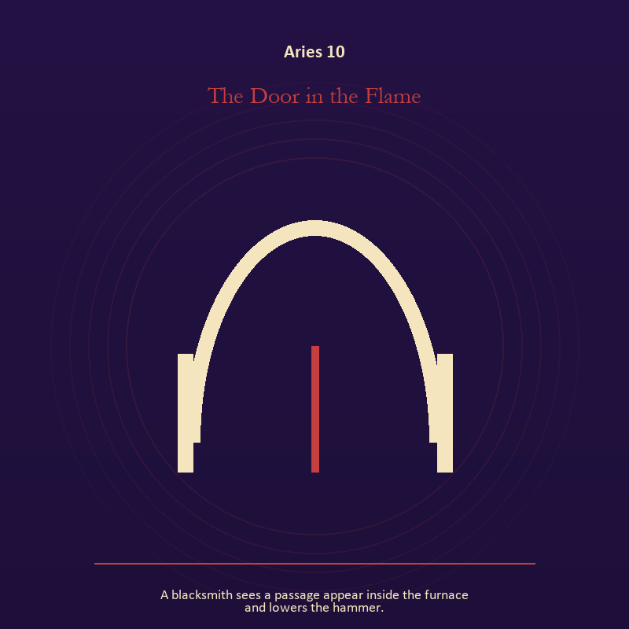

Aries 10 The Door in the Flame
A blacksmith sees a passage appear inside the furnace and lowers the hammer.
INTERPRETATION The Door in the Flame puts the threshold under pressure from ignition, appetite, risk, and the courage to become visible. Within the Door in the Flame, a threshold measures consent, timing, and consequence. At Aries 10, its presence asks whether passage is chosen, forced, delayed, or already under way. The same image also carries living fire; at Aries 10, a Lantern offers enough light for the next honest step. As a friction degree, Aries 10 slows the original motion long enough to expose what haste concealed.
SIGNAL At Aries 10, chosen change joined to a truth made visible at the right scale carries the signal; it stays honest when you choose a clean beginning and let action test the idea.
SHADOW The shadow at Aries 10 begins with waiting for permission that will never come and burning for recognition; also watch for impulse dressed as destiny or courage performed for an audience.
MIRROR At Aries 10, which threshold in your life requires consent rather than momentum?
PRACTICE Bring Aries 10 out of abstraction: write one sentence beginning, 'I may enter when,' and one beginning, 'I remain free to leave when.'.

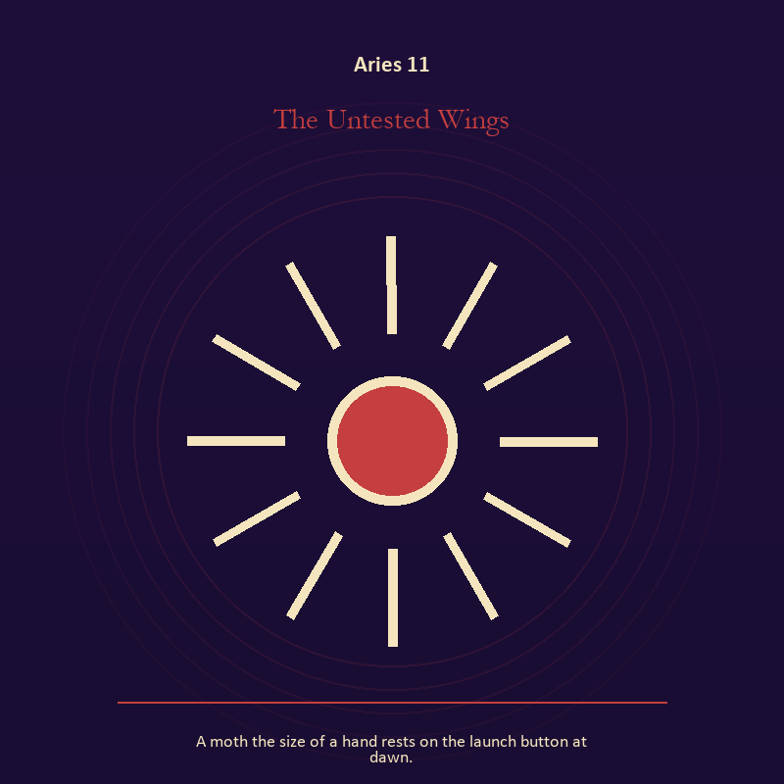

Aries 11 The Untested Wings
A moth the size of a hand rests on the launch button at dawn.
INTERPRETATION In the Untested Wings, the work of living fire must answer to ignition, appetite, risk, and the courage to become visible. Within the Untested Wings, fire gives change a visible cost. At Aries 11, something is illuminated here because something else is being spent. The same image also carries the body; at Aries 11, the body enters as witness, limit, appetite, labor, and home. As a revelation degree, Aries 11 reveals the mechanism under the mood; one concrete detail changes the reading.
SIGNAL What can be carried forward from Aries 11 is a truth made visible at the right scale joined to presence with weight and limits, tested by the need to choose a clean beginning and let action test the idea.
SHADOW At Aries 11, the image darkens through burning for recognition and treating exhaustion as devotion; watch for impulse dressed as destiny or courage performed for an audience.
MIRROR For Aries 11, where has your fire become performance rather than warmth?
PRACTICE For Aries 11, light one candle and give its entire burn to a single unfinished question.
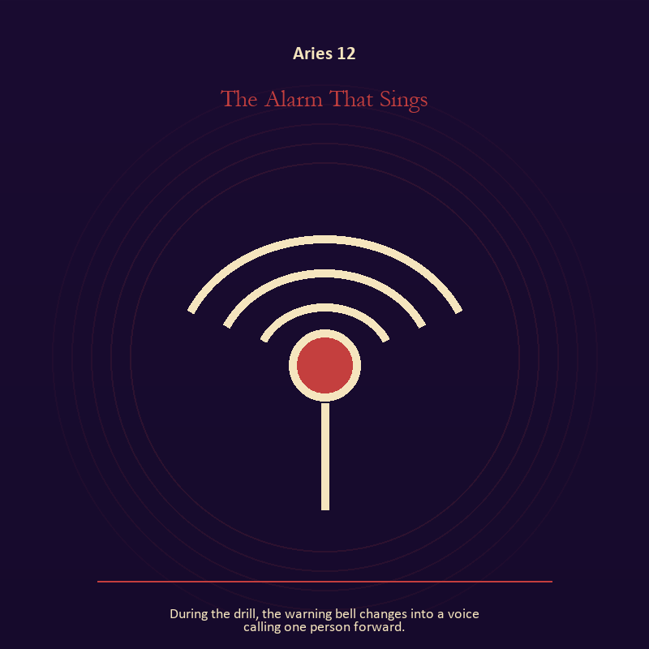

Aries 12 The Alarm That Sings
During the drill, the warning bell changes into a voice calling one person forward.
INTERPRETATION The Alarm That Sings tests voice and naming against ignition, appetite, risk, and the courage to become visible. Within the Alarm That Sings, naming creates a handle for experience, but the handle must remain smaller than the life it describes. At Aries 12, the image tests language against reality. The same image also carries relationship; at Aries 12, relationship imagery tests the fantasy that harmony requires sameness. As a revelation degree, Aries 12 moves the hidden arrangement into view, where it can be named without being exaggerated.
SIGNAL At Aries 12, speech with consequence joined to mutual responsibility becomes the clean signal when Aries can choose a clean beginning and let action test the idea.
SHADOW The distortion at Aries 12 is repeating a message until it sounds like evidence and the group protecting itself by sacrificing an outsider; watch for impulse dressed as destiny or courage performed for an audience.
MIRROR With the Alarm That Sings in mind at Aries 12, what are you naming accurately, and what remains larger than the name? From a second angle at Aries 12, where does responsibility belong, and where has it been displaced?
PRACTICE Work with The Alarm That Sings directly at Aries 12: listen to one person without planning your answer; then repeat their meaning before offering your own. For the second pressure at Aries 12, make one repair that does not require the other person to erase their account.

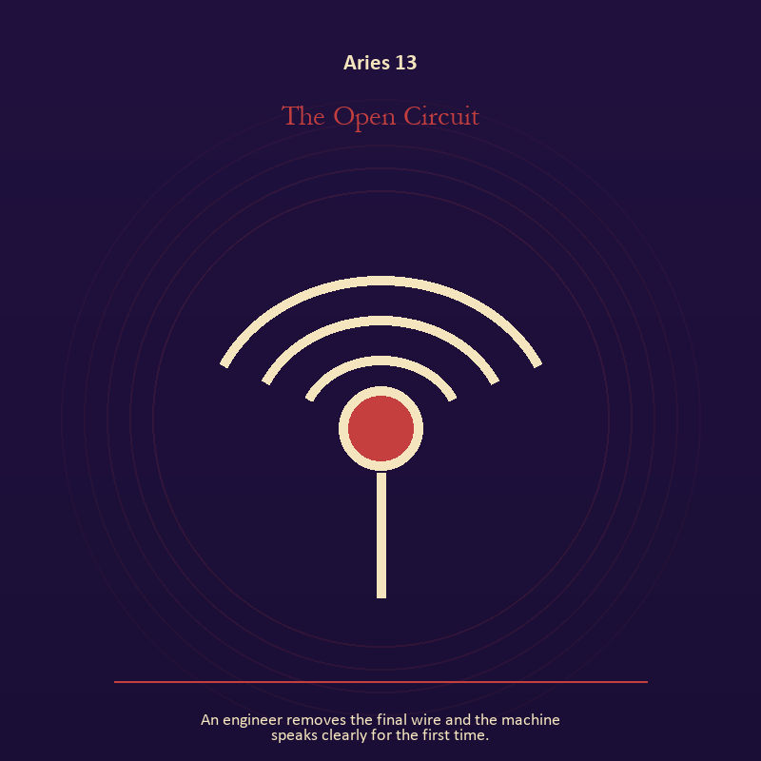

Aries 13 The Open Circuit
An engineer removes the final wire and the machine speaks clearly for the first time.
INTERPRETATION The Open Circuit holds the Signal against ignition, appetite, risk, and the courage to become visible. Within the Open Circuit, signal imagery asks what is being transmitted beneath performance. At Aries 13, interference may come from fear, vanity, noise, or a container too narrow for the message. The same image also carries voice and naming; at Aries 13, naming creates a handle for experience, but the handle must remain smaller than the life it describes. As a revelation degree, Aries 13 turns atmosphere into evidence; attend to the object or action that cannot be explained away.
SIGNAL The usable force at Aries 13 is contact across distance joined to listening precise enough to change the reply; Aries gives it form by asking you to choose a clean beginning and let action test the idea.
SHADOW At Aries 13, the Open Circuit can turn toward letting noise impersonate urgency and using language to outrun experience; watch for impulse dressed as destiny or courage performed for an audience.
MIRROR The question at Aries 13: what remains of your message when performance is removed?
PRACTICE Give Aries 13 a physical form; write the same message for a friend, an opponent, and your future self; then keep the sentence that stays true in all three versions.
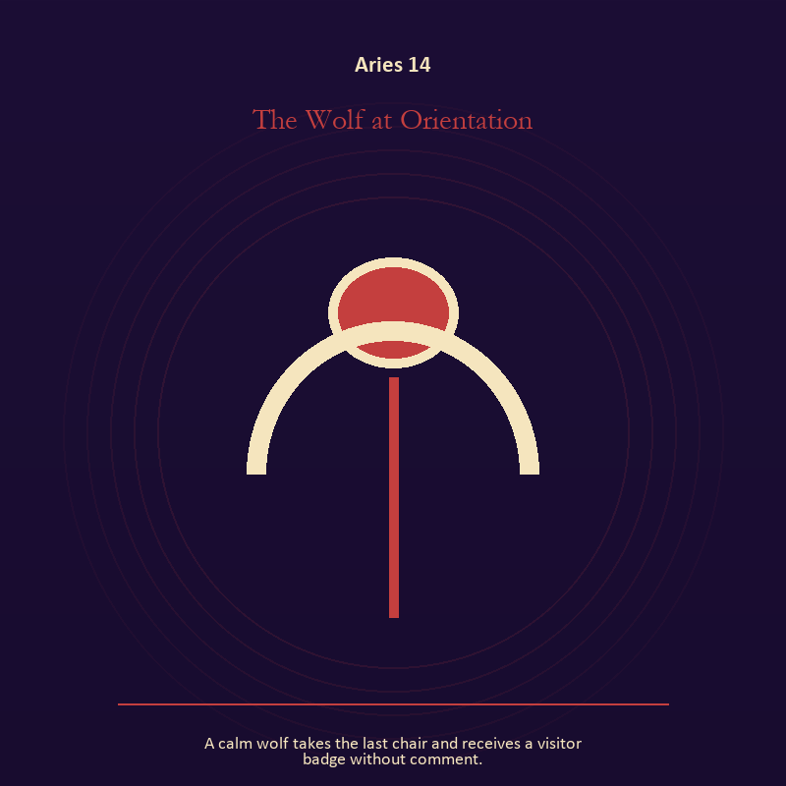

Aries 14 The Wolf at Orientation
A calm wolf takes the last chair and receives a visitor badge without comment.
INTERPRETATION The Wolf at Orientation gives the body consequences inside the First Signal. Within the Wolf at Orientation, bread, rest, touch, clothing, and shelter make spiritual language answer to material need. At Aries 14, an insight that harms the body requires correction. As a revelation degree, Aries 14 shows who carries the cost, who controls the passage, and what the scene refuses to hide.
SIGNAL At Aries 14, a decision the nervous system can inhabit carries the signal; it stays honest when you choose a clean beginning and let action test the idea.
SHADOW The shadow at Aries 14 begins with using transcendence to ignore need; also watch for impulse dressed as destiny or courage performed for an audience.
MIRROR At Aries 14, which need in this scene has been made too ordinary to mention?
PRACTICE Bring Aries 14 out of abstraction: eat, drink, rest, or move before making the interpretation more dramatic.

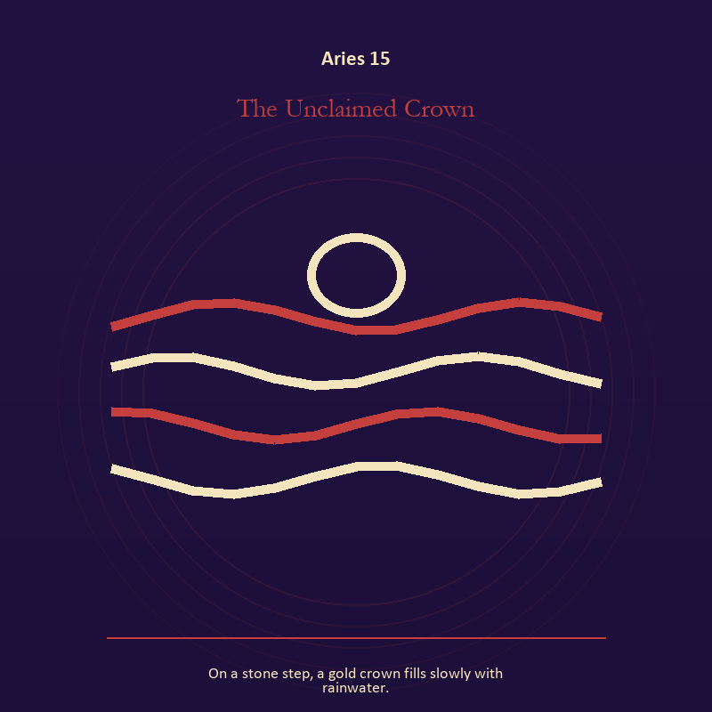

Aries 15 The Unclaimed Crown
On a stone step, a gold crown fills slowly with rainwater.
INTERPRETATION The Unclaimed Crown puts authority under pressure from ignition, appetite, risk, and the courage to become visible. Within the Unclaimed Crown, institutional objects reveal the bargain between role and person. At Aries 15, a title may organize service or become a mask that excuses harm. The same image also carries identity; at Aries 15, masks and names can conceal, reveal, or give shape to a truth that plain speech cannot yet hold. As a revelation degree, Aries 15 brings the middle truth forward, after the first story has lost its grip.
SIGNAL What can be carried forward from Aries 15 is stewardship with an exit plan joined to a protective form used consciously, tested by the need to choose a clean beginning and let action test the idea.
SHADOW At Aries 15, the image darkens through procedure used to avoid conscience and a mask that can no longer be removed safely; watch for impulse dressed as destiny or courage performed for an audience.
MIRROR For Aries 15, which part of this authority serves life, and which part serves its own continuation? From a second angle at Aries 15, what does the mask make possible, and what does it cost to keep wearing it?
PRACTICE For Aries 15, remove your title from a current problem and describe the duty that remains.
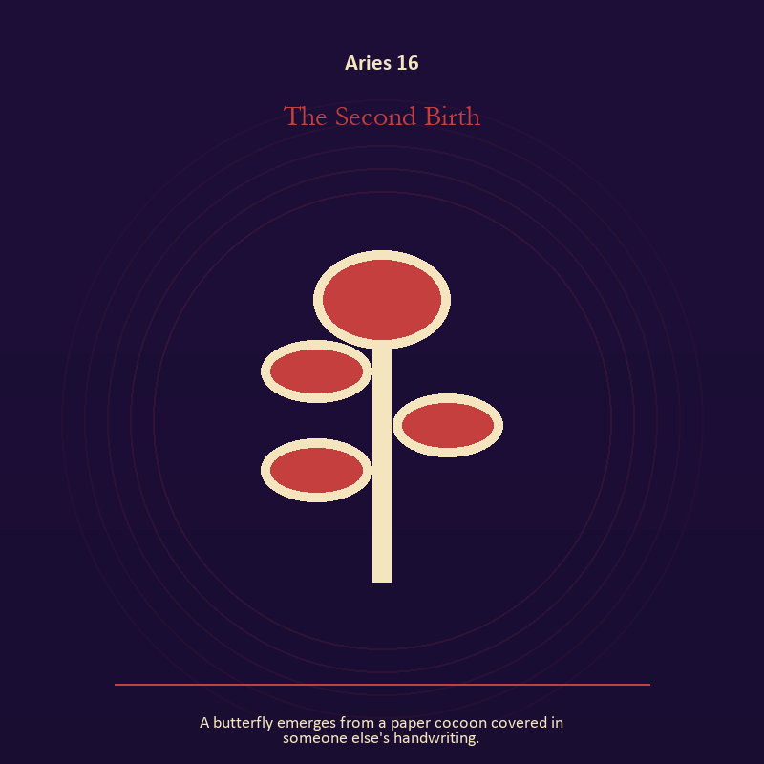

Aries 16 The Second Birth
A butterfly emerges from a paper cocoon covered in someone else's handwriting.
INTERPRETATION In the Second Birth, the work of growth must answer to ignition, appetite, risk, and the courage to become visible. Within the Second Birth, growth appears as vulnerable potential under specific conditions. At Aries 16, it requires time, nourishment, protection, and eventual release from the form that began it. As a choice degree, Aries 16 requires a choice with a human cost; insight alone no longer completes the work.
SIGNAL At Aries 16, care that honors timing becomes the clean signal when Aries can choose a clean beginning and let action test the idea.
SHADOW The distortion at Aries 16 is protecting potential so tightly that it cannot emerge; watch for impulse dressed as destiny or courage performed for an audience.
MIRROR With the Second Birth in mind at Aries 16, what is alive here but not ready to be displayed?
PRACTICE Work with The Second Birth directly at Aries 16: release one expectation about what the new form must resemble.

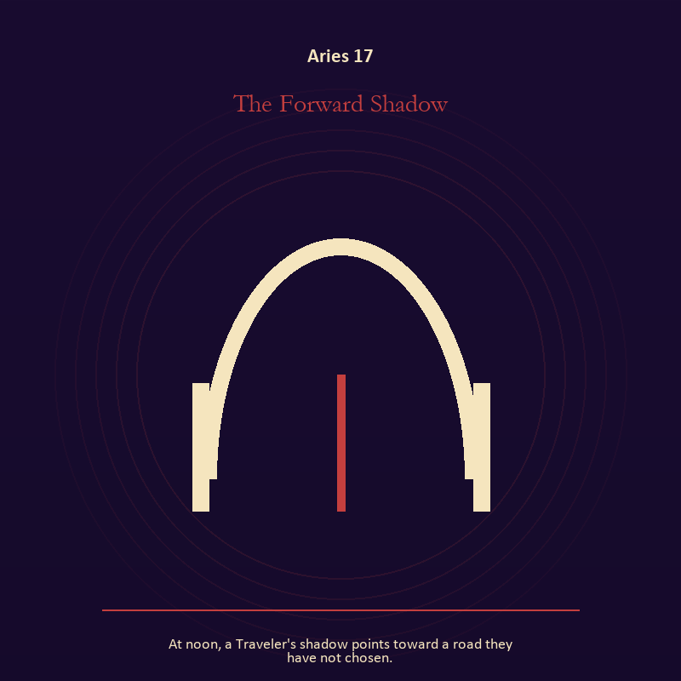

Aries 17 The Forward Shadow
At noon, a Traveler's shadow points toward a road they have not chosen.
INTERPRETATION The Forward Shadow tests the Mirror against ignition, appetite, risk, and the courage to become visible. Within the Forward Shadow, reflected images divide the observer from the observed self. At Aries 17, that gap can hold shame, vanity, curiosity, or the first honest revision of identity. The same image also carries the threshold; at Aries 17, a threshold measures consent, timing, and consequence. As a choice degree, Aries 17 asks what action preserves truth without using another person as material.
SIGNAL The usable force at Aries 17 is the courage to revise a familiar self-image joined to honest passage; Aries gives it form by asking you to choose a clean beginning and let action test the idea.
SHADOW At Aries 17, the Forward Shadow can turn toward mistaking appearance for character and guarding an obsolete enclosure; watch for impulse dressed as destiny or courage performed for an audience.
MIRROR The question at Aries 17: whose gaze have you installed inside your own Mirror?
PRACTICE Give Aries 17 a physical form; describe the scene without interpretation, then circle the detail you most want to praise or condemn.
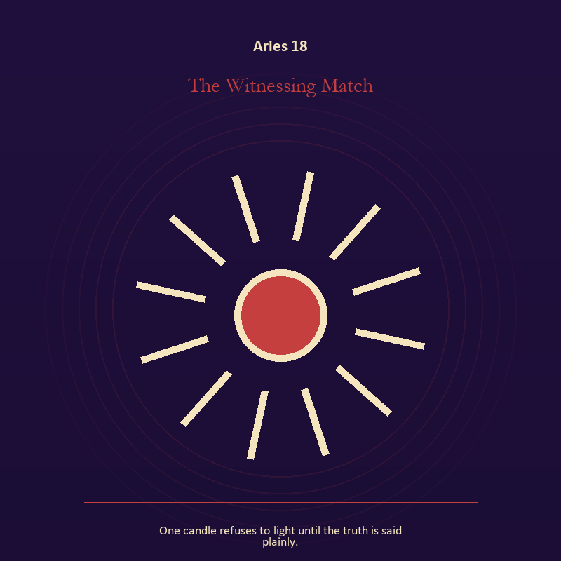

Aries 18 The Witnessing Match
One candle refuses to light until the truth is said plainly.
INTERPRETATION The Witnessing Match holds living fire against ignition, appetite, risk, and the courage to become visible. Within the Witnessing Match, a Lantern offers enough light for the next honest step. At Aries 18, it does not remove night, and its usefulness depends on how it is carried. The same image also carries voice and naming; at Aries 18, books, letters, bells, and songs extend speech beyond the speaker's body. As a choice degree, Aries 18 moves from recognition to conduct; the clean choice must survive outside the imagination.
SIGNAL At Aries 18, attention with warmth joined to a name that restores agency carries the signal; it stays honest when you choose a clean beginning and let action test the idea.
SHADOW The shadow at Aries 18 begins with exposure without care and speaking for someone whose voice is present; also watch for impulse dressed as destiny or courage performed for an audience.
MIRROR At Aries 18, how much light does the next step require, and who might it expose? From a second angle at Aries 18, what needs to be said plainly, and who has earned the right to hear it?
PRACTICE Bring Aries 18 out of abstraction: move one hidden concern into plain view by naming it to a trusted person.

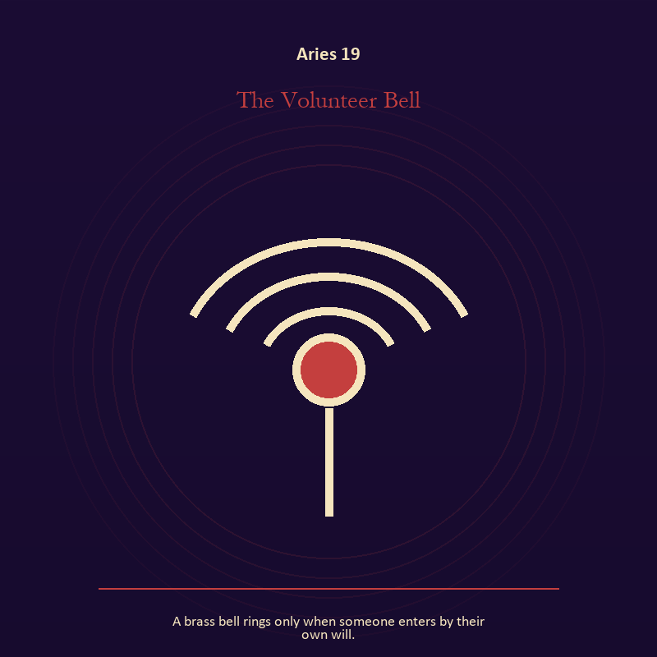

Aries 19 The Volunteer Bell
A brass bell rings only when someone enters by their own will.
INTERPRETATION The Volunteer Bell gives voice and naming consequences inside the First Signal. Within the Volunteer Bell, voice turns inner pressure into shared consequence. At Aries 19, words can witness, summon, distort, repair, or conceal according to their precision and timing. As a choice degree, Aries 19 tests whether awareness can become restraint, repair, refusal, or consent.
SIGNAL What can be carried forward from Aries 19 is a name that restores agency, tested by the need to choose a clean beginning and let action test the idea.
SHADOW At Aries 19, the image darkens through speaking for someone whose voice is present; watch for impulse dressed as destiny or courage performed for an audience.
MIRROR For Aries 19, which word in this scene changes the power relationship?
PRACTICE For Aries 19, give the current experience a temporary name and date it, leaving room for revision.
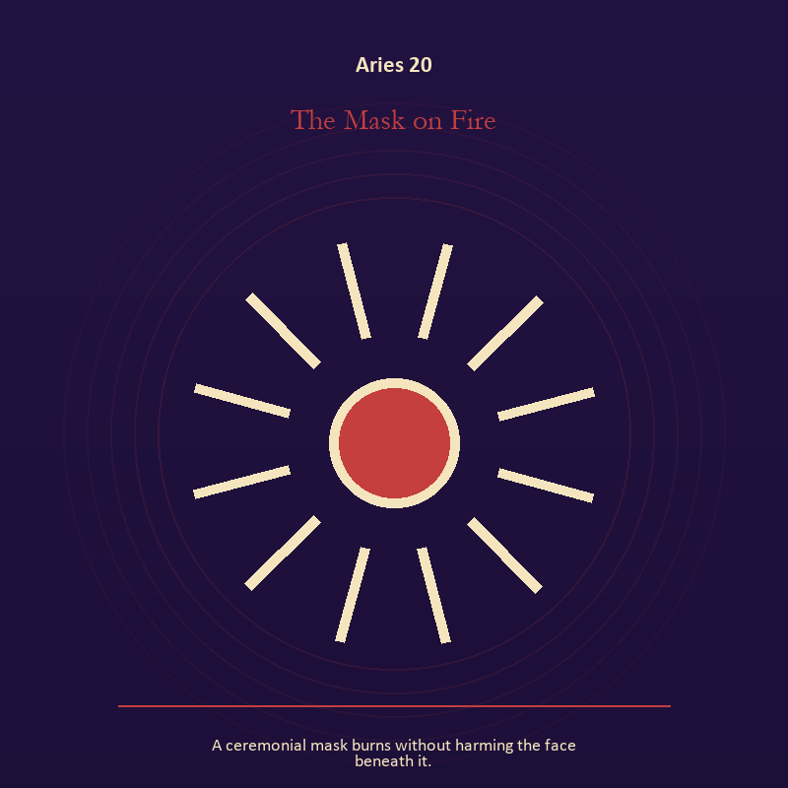

Aries 20 The Mask on Fire
A ceremonial mask burns without harming the face beneath it.
INTERPRETATION The Mask on Fire puts living fire under pressure from ignition, appetite, risk, and the courage to become visible. Within the Mask on Fire, fire gives change a visible cost. At Aries 20, something is illuminated here because something else is being spent. The same image also carries identity; at Aries 20, identity appears as something worn, spoken, assigned, revised, or returned. As a choice degree, Aries 20 places responsibility in the reader's hands without promising a painless answer.
SIGNAL At Aries 20, a truth made visible at the right scale joined to self-authorship becomes the clean signal when Aries can choose a clean beginning and let action test the idea.
SHADOW The distortion at Aries 20 is burning for recognition and an assigned identity accepted as fate; watch for impulse dressed as destiny or courage performed for an audience.
MIRROR With the Mask on Fire in mind at Aries 20, where has your fire become performance rather than warmth?
PRACTICE Work with The Mask on Fire directly at Aries 20: light one candle and give its entire burn to a single unfinished question. For the second pressure at Aries 20, write your name beside one quality no title can grant or remove.

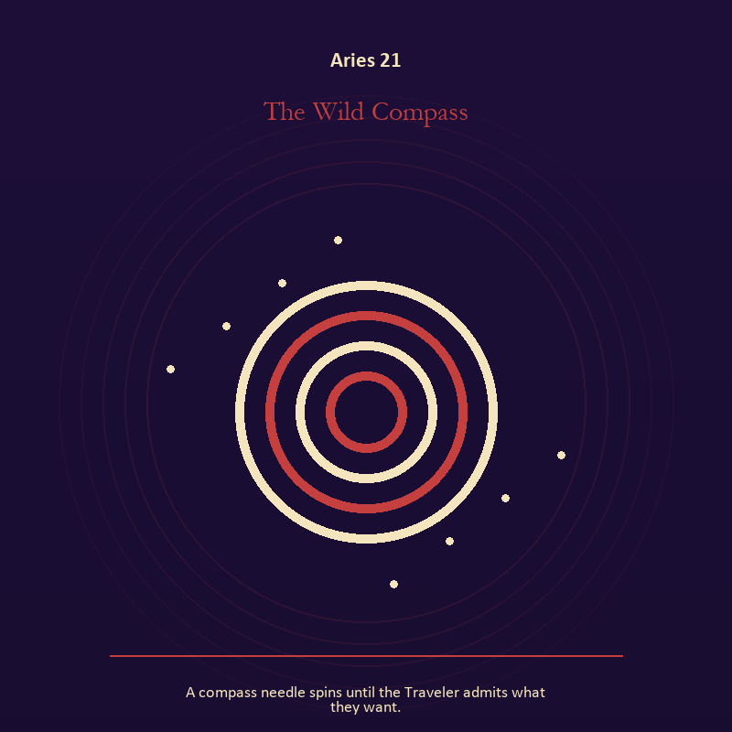

Aries 21 The Wild Compass
A compass needle spins until the Traveler admits what they want.
INTERPRETATION In the Wild Compass, the work of mystery must answer to ignition, appetite, risk, and the courage to become visible. Within the Wild Compass, the symbol remains useful when no single interpretation closes it. At Aries 21, its work is to make one hidden relationship visible enough to examine. As a integration degree, Aries 21 holds the gift beside its distortion; using one without feeding the other is the work.
SIGNAL The usable force at Aries 21 is attention without premature certainty; Aries gives it form by asking you to choose a clean beginning and let action test the idea.
SHADOW At Aries 21, the Wild Compass can turn toward using beauty to avoid the ordinary fact; watch for impulse dressed as destiny or courage performed for an audience.
MIRROR The question at Aries 21: what changes if the scene is a question rather than an answer?
PRACTICE Give Aries 21 a physical form; describe the scene to another person without explaining it, then notice what they ask first.
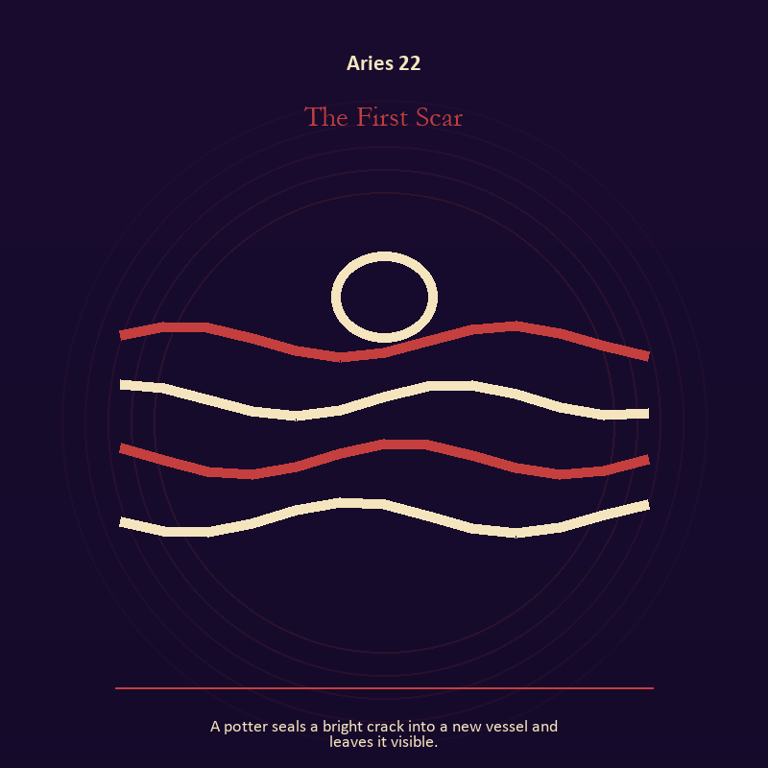

Aries 22 The First Scar
A potter seals a bright crack into a new vessel and leaves it visible.
INTERPRETATION The First Scar tests the descent against ignition, appetite, risk, and the courage to become visible. Within the First Scar, descent imagery carries what ordinary daylight has failed to resolve. At Aries 22, it asks for contact with the wound, bargain, fear, or grief beneath the public account. The same image also carries living water; at Aries 22, rain, tides, wells, and floods move private material into a shared landscape. As a integration degree, Aries 22 asks the sign to carry its strength without turning that strength into jurisdiction.
SIGNAL At Aries 22, contact with buried power joined to grief allowed to move carries the signal; it stays honest when you choose a clean beginning and let action test the idea.
SHADOW The shadow at Aries 22 begins with remaining underground after the danger has passed and drowning in another person's weather; also watch for impulse dressed as destiny or courage performed for an audience.
MIRROR At Aries 22, what difficult fact survives when the dramatic story is removed?
PRACTICE Bring Aries 22 out of abstraction: choose a trusted witness and tell the smallest complete truth you can safely tell.

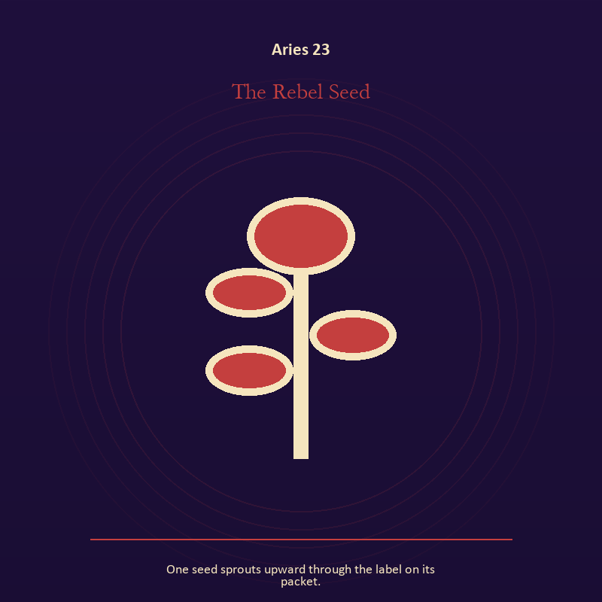

Aries 23 The Rebel Seed
One seed sprouts upward through the label on its packet.
INTERPRETATION The Rebel Seed holds growth against ignition, appetite, risk, and the courage to become visible. Within the Rebel Seed, seeds, children, roots, and gardens refuse the fantasy of instant transformation. At Aries 23, they make becoming physical, seasonal, and dependent on care. As a integration degree, Aries 23 joins capacity to consequence; what helps in one setting may harm in another.
SIGNAL What can be carried forward from Aries 23 is inheritance revised through living action, tested by the need to choose a clean beginning and let action test the idea.
SHADOW At Aries 23, the image darkens through forcing a season; watch for impulse dressed as destiny or courage performed for an audience.
MIRROR For Aries 23, which condition would help this growth, and which demand would deform it?
PRACTICE For Aries 23, tend one living thing and let its pace correct your schedule.
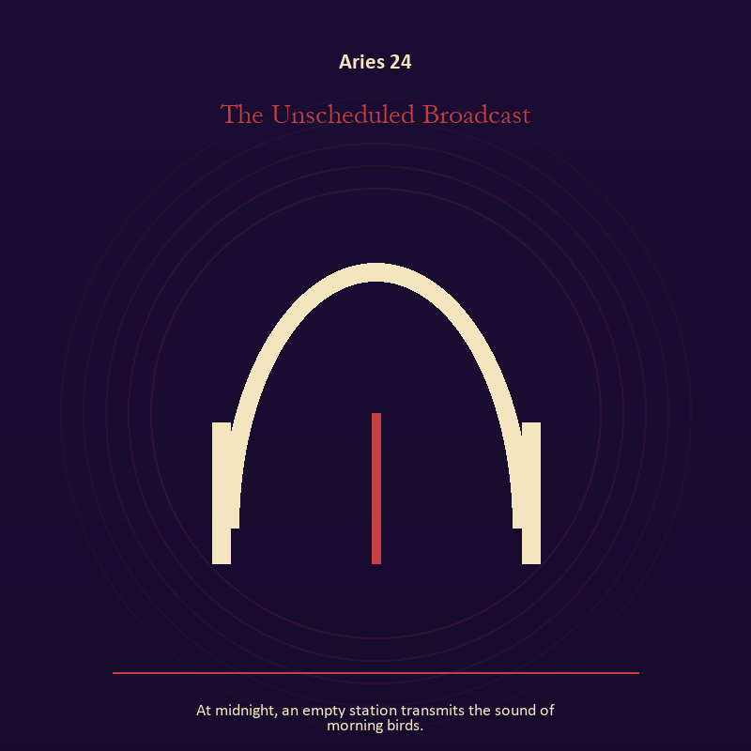

Aries 24 The Unscheduled Broadcast
At midnight, an empty station transmits the sound of morning birds.
INTERPRETATION The Unscheduled Broadcast gives the Signal consequences inside the First Signal. Within the Unscheduled Broadcast, machines in these symbols expose the difference between a living message and the equipment carrying it. At Aries 24, when the device fails, the signal may become easier to hear. The same image also carries the descent; at Aries 24, the underworld strips away rank and performance. As a integration degree, Aries 24 shows the mature tool and the temptation hidden inside its handle.
SIGNAL At Aries 24, clear transmission joined to contact with buried power becomes the clean signal when Aries can choose a clean beginning and let action test the idea.
SHADOW The distortion at Aries 24 is confusing reach with truth and remaining underground after the danger has passed; watch for impulse dressed as destiny or courage performed for an audience.
MIRROR With the Unscheduled Broadcast in mind at Aries 24, who is the real receiver of the signal you are sending? From a second angle at Aries 24, which part of the wound needs witness, and which part needs a boundary?
PRACTICE Work with The Unscheduled Broadcast directly at Aries 24: turn off one source of noise for an hour and notice what thought keeps returning. For the second pressure at Aries 24, choose a trusted witness and tell the smallest complete truth you can safely tell.

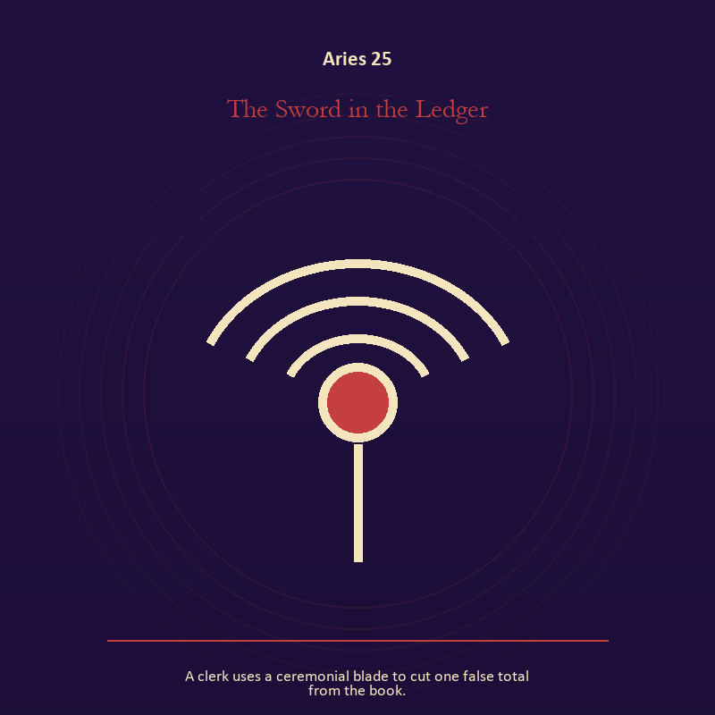

Aries 25 The Sword in the Ledger
A clerk uses a ceremonial blade to cut one false total from the book.
INTERPRETATION The Sword in the Ledger puts craft and record under pressure from ignition, appetite, risk, and the courage to become visible. Within the Sword in the Ledger, craft turns intention into a repeatable act with materials, limits, and evidence of failure. At Aries 25, the tool reveals the quality of attention brought to it. The same image also carries voice and naming; at Aries 25, naming creates a handle for experience, but the handle must remain smaller than the life it describes. As a integration degree, Aries 25 tests whether the lesson can be lived without becoming a new performance.
SIGNAL The usable force at Aries 25 is evidence preserved without spectacle joined to listening precise enough to change the reply; Aries gives it form by asking you to choose a clean beginning and let action test the idea.
SHADOW At Aries 25, the Sword in the Ledger can turn toward polish used to hide a structural weakness and using language to outrun experience; watch for impulse dressed as destiny or courage performed for an audience.
MIRROR The question at Aries 25: which part of this process can be checked rather than assumed?
PRACTICE Give Aries 25 a physical form; repair one useful object without disguising the place where it broke.
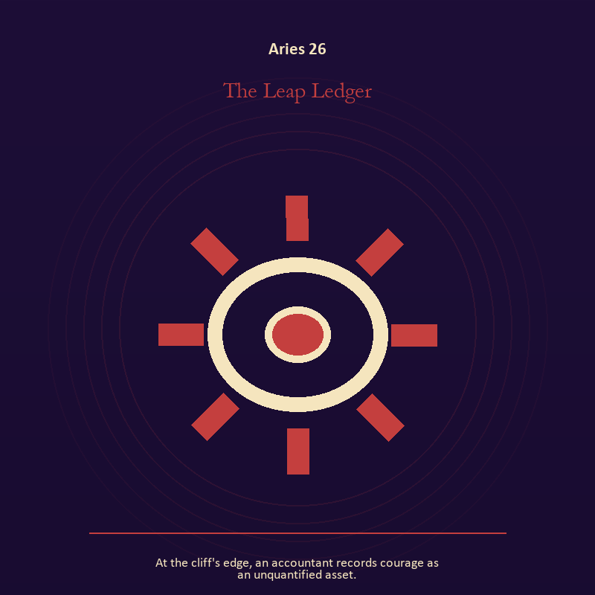

Aries 26 The Leap Ledger
At the cliff's edge, an accountant records courage as an unquantified asset.
INTERPRETATION In the Leap Ledger, the work of craft and record must answer to ignition, appetite, risk, and the courage to become visible. Within the Leap Ledger, ledgers, maps, machines, and archives make memory operational. At Aries 26, they can protect truth or compress living complexity until only the form remains. As a release degree, Aries 26 prepares the lesson to leave its original container; keep the capacity and loosen the role.
SIGNAL At Aries 26, a useful correction that outlives the moment carries the signal; it stays honest when you choose a clean beginning and let action test the idea.
SHADOW The shadow at Aries 26 begins with measurement mistaken for meaning; also watch for impulse dressed as destiny or courage performed for an audience.
MIRROR At Aries 26, what does the tool preserve, and what does it leave out?
PRACTICE Bring Aries 26 out of abstraction: inspect one repeated task and add a check that would catch the most expensive error.

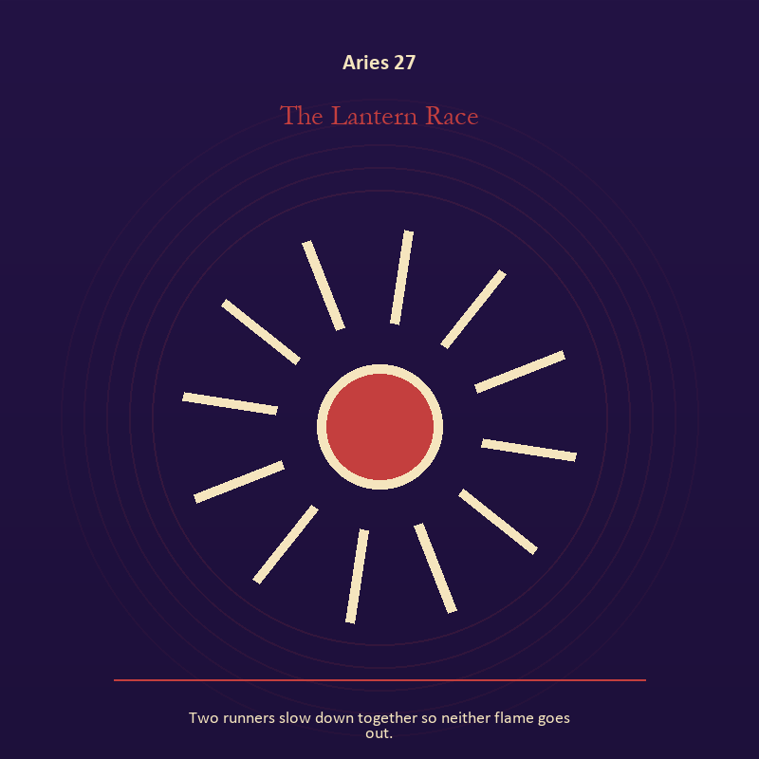

Aries 27 The Lantern Race
Two runners slow down together so neither flame goes out.
INTERPRETATION The Lantern Race tests living fire against ignition, appetite, risk, and the courage to become visible. Within the Lantern Race, a Lantern offers enough light for the next honest step. At Aries 27, it does not remove night, and its usefulness depends on how it is carried. The same image also carries relationship; at Aries 27, relationship imagery tests the fantasy that harmony requires sameness. As a release degree, Aries 27 asks what can be handed onward without demanding imitation or loyalty.
SIGNAL What can be carried forward from Aries 27 is attention with warmth joined to mutual responsibility, tested by the need to choose a clean beginning and let action test the idea.
SHADOW At Aries 27, the image darkens through exposure without care and the group protecting itself by sacrificing an outsider; watch for impulse dressed as destiny or courage performed for an audience.
MIRROR For Aries 27, how much light does the next step require, and who might it expose? From a second angle at Aries 27, where does responsibility belong, and where has it been displaced?
PRACTICE For Aries 27, move one hidden concern into plain view by naming it to a trusted person.
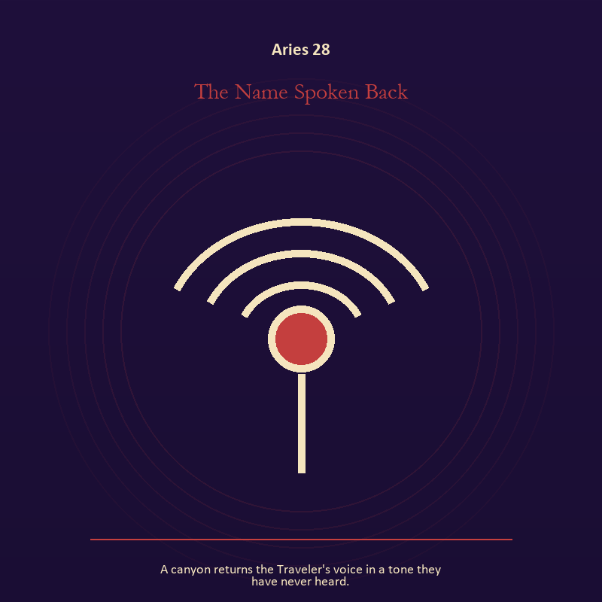

Aries 28 The Name Spoken Back
A canyon returns the Traveler's voice in a tone they have never heard.
INTERPRETATION The Name Spoken Back holds voice and naming against ignition, appetite, risk, and the courage to become visible. Within the Name Spoken Back, voice turns inner pressure into shared consequence. At Aries 28, words can witness, summon, distort, repair, or conceal according to their precision and timing. The same image also carries identity; at Aries 28, a role organizes behavior but cannot contain the whole person. As a release degree, Aries 28 turns completion into transfer; the work survives by changing hands.
SIGNAL At Aries 28, a name that restores agency joined to the freedom to revise a name or role becomes the clean signal when Aries can choose a clean beginning and let action test the idea.
SHADOW The distortion at Aries 28 is speaking for someone whose voice is present and performance mistaken for selfhood; watch for impulse dressed as destiny or courage performed for an audience.
MIRROR With the Name Spoken Back in mind at Aries 28, which word in this scene changes the power relationship?
PRACTICE Work with The Name Spoken Back directly at Aries 28: give the current experience a temporary name and date it, leaving room for revision. For the second pressure at Aries 28, list the roles you carry; then mark each as chosen, inherited, temporary, or ready to release.

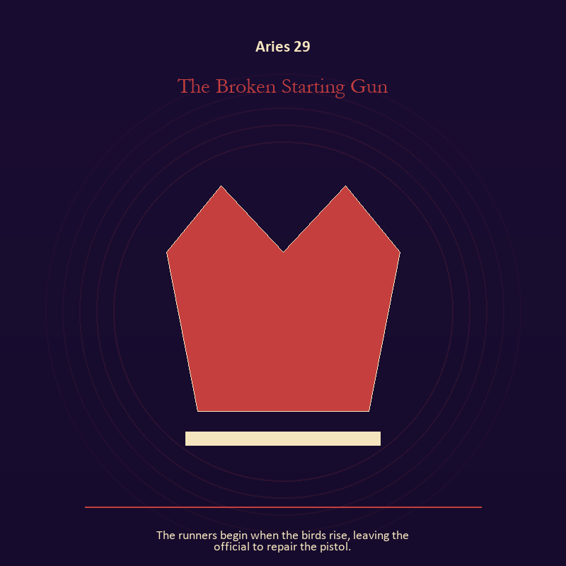

Aries 29 The Broken Starting Gun
The runners begin when the birds rise, leaving the official to repair the pistol.
INTERPRETATION The Broken Starting Gun gives authority consequences inside the First Signal. Within the Broken Starting Gun, crowns, laws, offices, and verdicts turn private judgment into public consequence. At Aries 29, their legitimacy depends on restraint and correction. As a release degree, Aries 29 lets the sign set down the identity built around its ordeal.
SIGNAL The usable force at Aries 29 is a rule that protects the vulnerable person in the room; Aries gives it form by asking you to choose a clean beginning and let action test the idea.
SHADOW At Aries 29, the Broken Starting Gun can turn toward role mistaken for worth; watch for impulse dressed as destiny or courage performed for an audience.
MIRROR The question at Aries 29: what would accountability require from the person holding the key?
PRACTICE Give Aries 29 a physical form; choose one decision you control and write down who can challenge it, correct it, and leave its consequences.
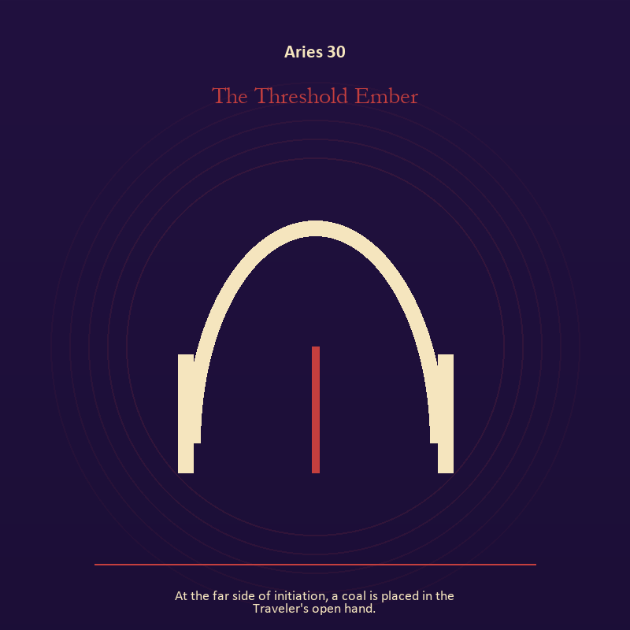

Aries 30 The Threshold Ember
At the far side of initiation, a coal is placed in the Traveler's open hand.
INTERPRETATION The Threshold Ember puts the threshold under pressure from ignition, appetite, risk, and the courage to become visible. Within the Threshold Ember, a boundary can protect life, restrict it, or clarify the terms of meeting. At Aries 30, the surrounding action reveals which function is active here. The same image also carries living fire; at Aries 30, fire gives change a visible cost. As a release degree, Aries 30 returns the earned knowledge to ordinary life, where another cycle can use it.
SIGNAL At Aries 30, honest passage joined to courage that helps another see carries the signal; it stays honest when you choose a clean beginning and let action test the idea.
SHADOW The shadow at Aries 30 begins with guarding an obsolete enclosure and mistaking brightness for moral authority; also watch for impulse dressed as destiny or courage performed for an audience.
MIRROR At Aries 30, what would make the next step chosen rather than compelled? From a second angle at Aries 30, where has your fire become performance rather than warmth?
PRACTICE Bring Aries 30 out of abstraction: draw the boundary as a line on paper; then mark the gate, the guard, and the person who holds the key.

Taurus
The Sacred Vessel
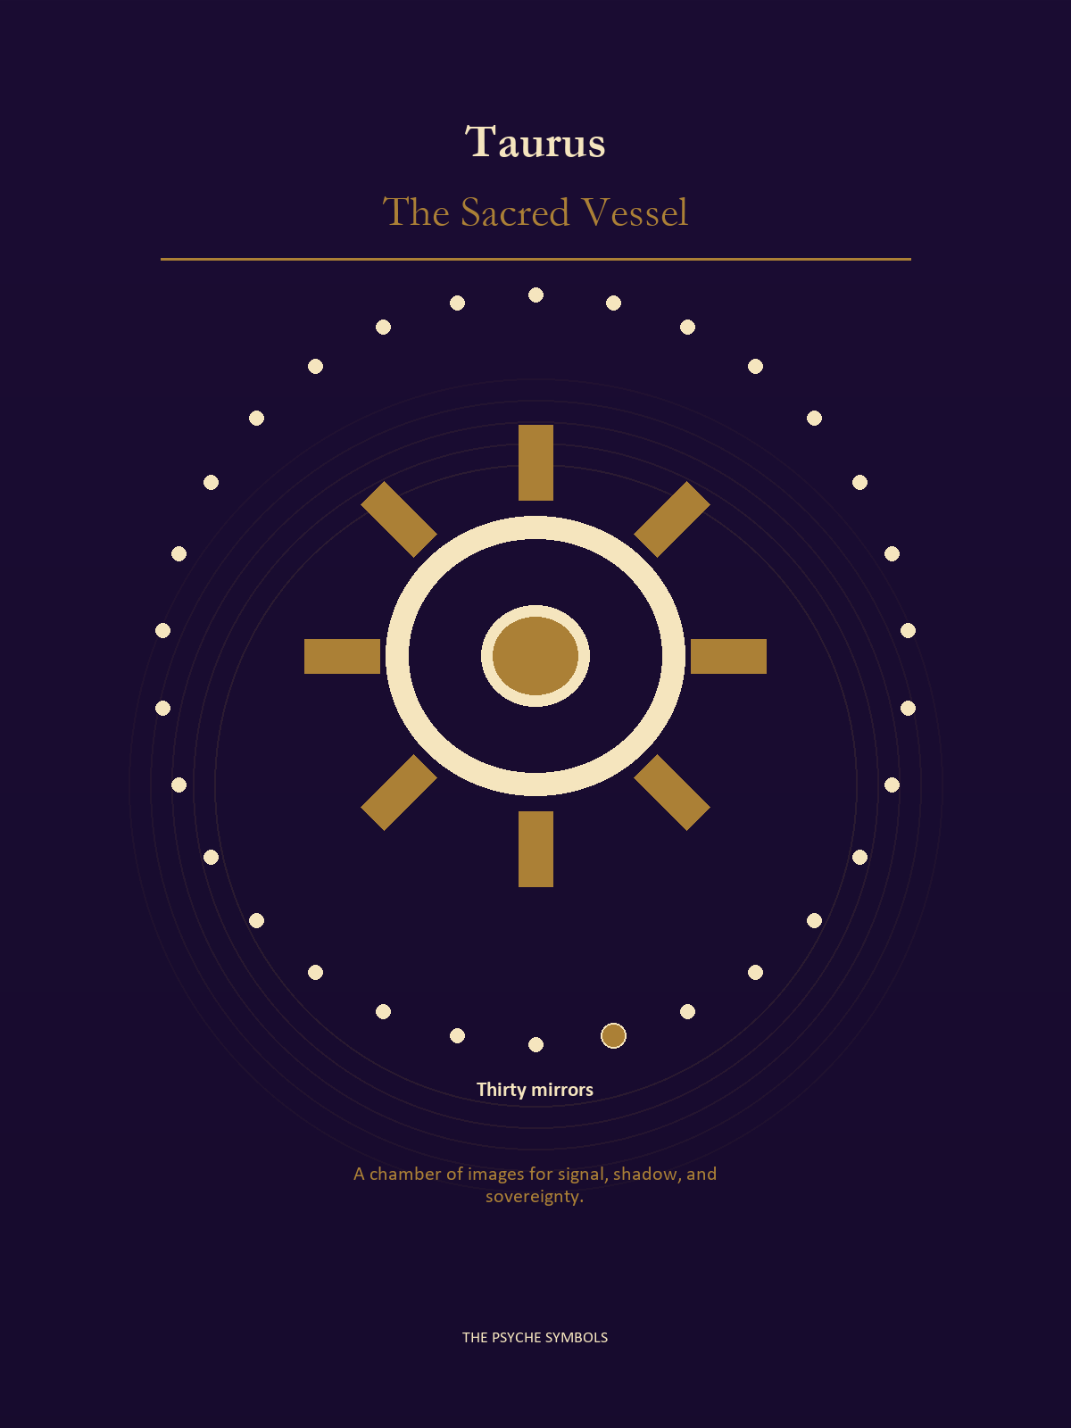
Taurus asks whether the signal can live in the body without becoming another possession. The Sacred Vessel turns attention toward weight, time, touch, food, money, and the terms of enough. Here value is proven by what can be tended, shared, repaired, and lived with after desire cools.

Degrees | Gate | Work
1-5 | Arrival | Meet the image before deciding what it means.
6-10 | Friction | Notice what pushes back and what that resistance protects.
11-15 | Revelation | Name the detail that changes the whole scene.
16-20 | Choice | Choose the act that preserves both truth and human dignity.
21-25 | Integration | Use the gift without feeding the shadow that travels beside it.
26-30 | Release | Keep the earned capacity and release the role that delivered it.

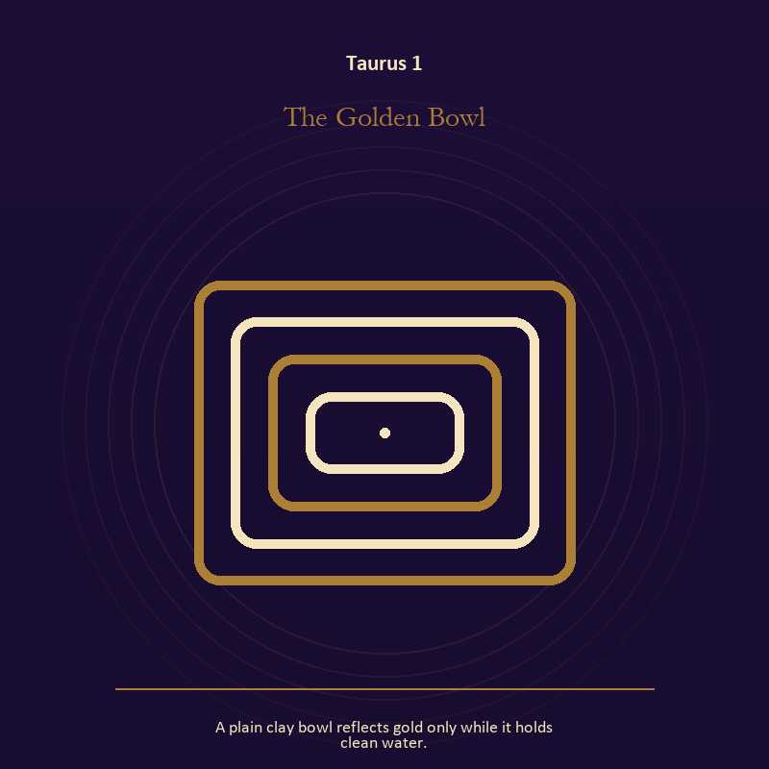

Taurus 1 The Golden Bowl
A plain clay bowl reflects gold only while it holds clean water.
INTERPRETATION In the Golden Bowl, the work of living water must answer to the body, enoughness, patient craft, and values that survive pressure. Within the Golden Bowl, water carries feeling, memory, adaptation, and forces too large for command. At Taurus 1, its shape comes from the vessel, but its movement remains its own. The same image also carries the Mirror; at Taurus 1, a shadow proves that something real stands in the light, while a reflection shows only an angle. As an arrival degree, Taurus 1 arrives before habit can tidy the evidence; notice what is present before deciding what it should become.
SIGNAL What can be carried forward from Taurus 1 is adaptation without self-erasure joined to the courage to revise a familiar self-image, tested by the need to give the insight a durable form and a humane pace.
SHADOW At Taurus 1, the image darkens through building a vessel too rigid for living water and mistaking appearance for character; notice where comfort has become custody or scarcity has become an identity.
MIRROR For Taurus 1, what feeling needs a vessel rather than a solution?
PRACTICE For Taurus 1, wash your hands with attention and decide what belongs to you after the water stops.
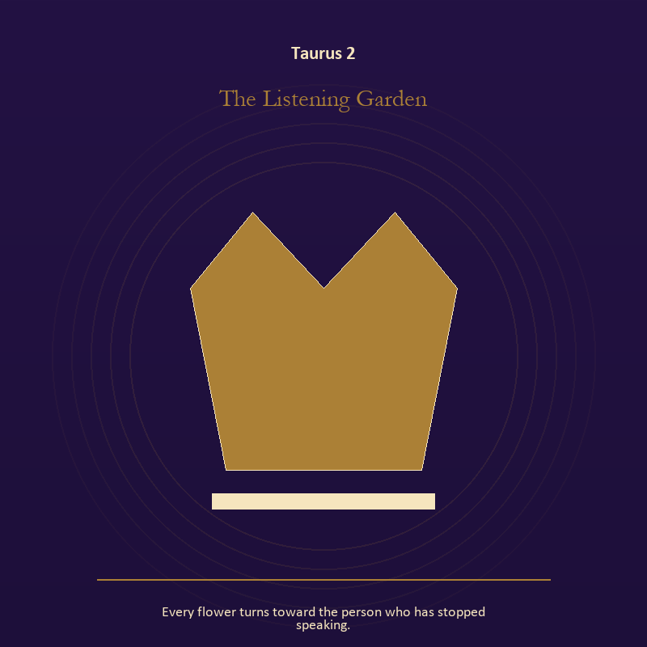

Taurus 2 The Listening Garden
Every flower turns toward the person who has stopped speaking.
INTERPRETATION The Listening Garden tests growth against the body, enoughness, patient craft, and values that survive pressure. Within the Listening Garden, seeds, children, roots, and gardens refuse the fantasy of instant transformation. At Taurus 2, they make becoming physical, seasonal, and dependent on care. The same image also carries relationship; at Taurus 2, more than one will is active in this scene. As an arrival degree, Taurus 2 introduces the sign's raw material in an unguarded form; the first response matters less than the honest one.
SIGNAL At Taurus 2, inheritance revised through living action joined to contact without capture becomes the clean signal when Taurus can give the insight a durable form and a humane pace.
SHADOW The distortion at Taurus 2 is forcing a season and projection mistaken for intimacy; notice where comfort has become custody or scarcity has become an identity.
MIRROR With the Listening Garden in mind at Taurus 2, which condition would help this growth, and which demand would deform it?
PRACTICE Work with The Listening Garden directly at Taurus 2: tend one living thing and let its pace correct your schedule. For the second pressure at Taurus 2, name one need, one boundary, and one freedom that belong to each person in the scene.

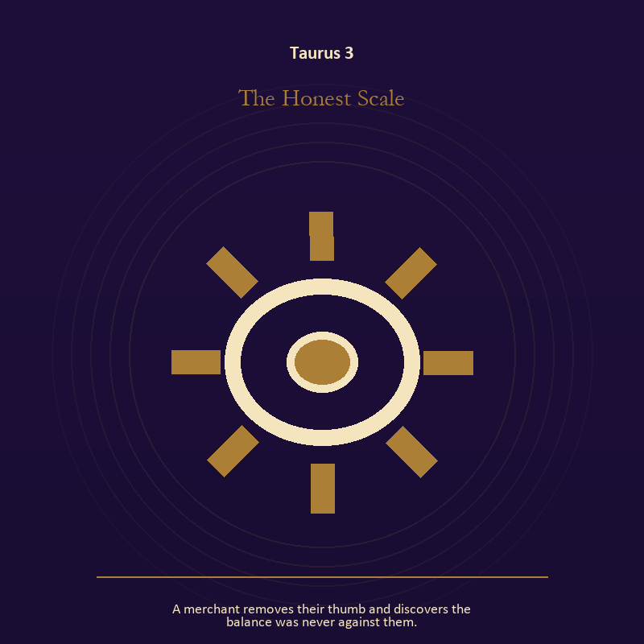

Taurus 3 The Honest Scale
A merchant removes their thumb and discovers the balance was never against them.
INTERPRETATION The Honest Scale holds craft and record against the body, enoughness, patient craft, and values that survive pressure. Within the Honest Scale, workshops honor correction. At Taurus 3, a flaw becomes useful when it is found early, recorded honestly, and repaired without hiding the seam. As an arrival degree, Taurus 3 catches the first impulse before it turns into a role; give the image room to remain strange.
SIGNAL The usable force at Taurus 3 is care made repeatable; Taurus gives it form by asking you to give the insight a durable form and a humane pace.
SHADOW At Taurus 3, the Honest Scale can turn toward the tool becoming the master; notice where comfort has become custody or scarcity has become an identity.
MIRROR The question at Taurus 3: where would an honest repair remain visible?
PRACTICE Give Taurus 3 a physical form; keep a brief record of what happened, what you expected, and what changed your mind.
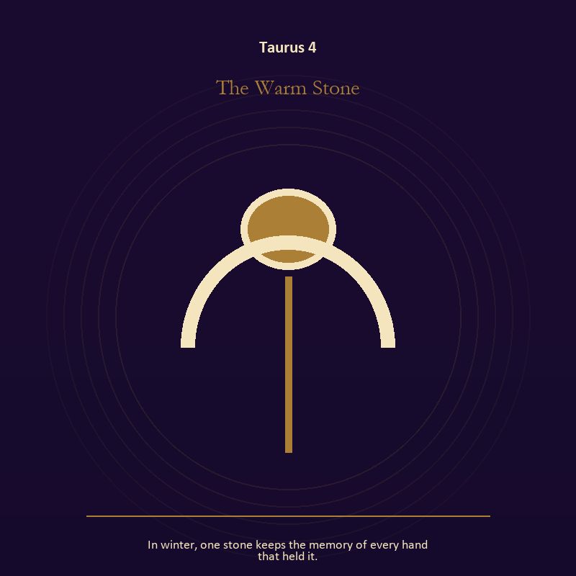

Taurus 4 The Warm Stone
In winter, one stone keeps the memory of every hand that held it.
INTERPRETATION The Warm Stone gives the body consequences inside the Sacred Vessel. Within the Warm Stone, the body enters as witness, limit, appetite, labor, and home. At Taurus 4, its response may reveal what the mind has explained away. As an arrival degree, Taurus 4 opens the chamber with no settled method; name the need, risk, or appetite that entered with it.
SIGNAL At Taurus 4, care made material carries the signal; it stays honest when you give the insight a durable form and a humane pace.
SHADOW The shadow at Taurus 4 begins with letting appetite make the whole decision; also notice where comfort has become custody or scarcity has become an identity.
MIRROR At Taurus 4, what does your body know before your argument begins?
PRACTICE Bring Taurus 4 out of abstraction: choose the next action that your body can repeat without punishment.

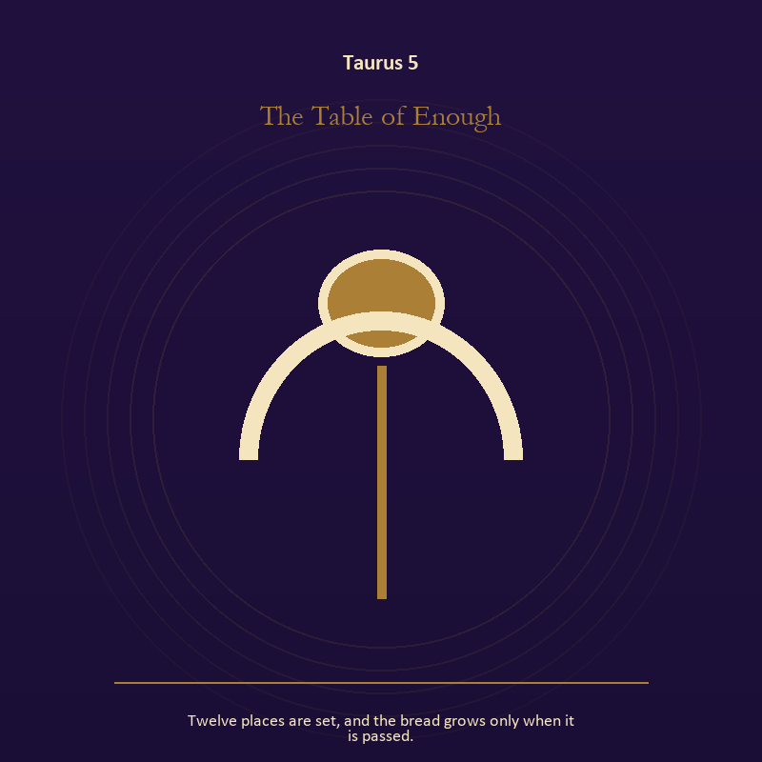

Taurus 5 The Table of Enough
Twelve places are set, and the bread grows only when it is passed.
INTERPRETATION The Table of Enough puts the body under pressure from the body, enoughness, patient craft, and values that survive pressure. Within the Table of Enough, bread, rest, touch, clothing, and shelter make spiritual language answer to material need. At Taurus 5, an insight that harms the body requires correction. As an arrival degree, Taurus 5 shows the beginning before ownership hardens around it; let attention come before possession.
SIGNAL What can be carried forward from Taurus 5 is a decision the nervous system can inhabit, tested by the need to give the insight a durable form and a humane pace.
SHADOW At Taurus 5, the image darkens through using transcendence to ignore need; notice where comfort has become custody or scarcity has become an identity.
MIRROR For Taurus 5, which need in this scene has been made too ordinary to mention?
PRACTICE For Taurus 5, eat, drink, rest, or move before making the interpretation more dramatic.
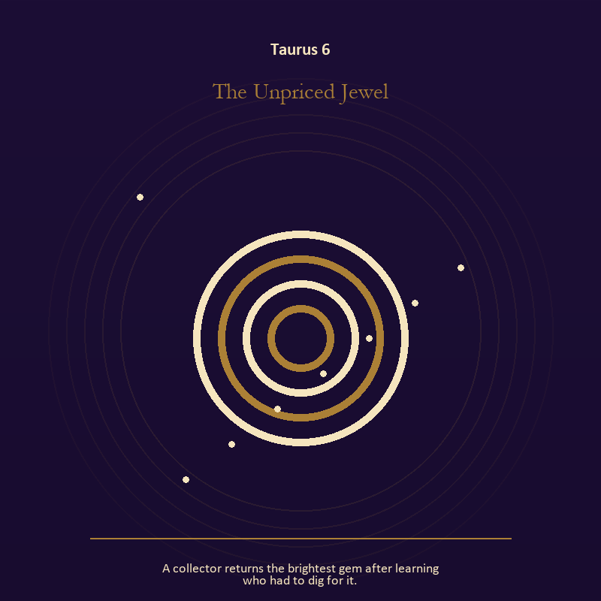

Taurus 6 The Unpriced Jewel
A collector returns the brightest gem after learning who had to dig for it.
INTERPRETATION In the Unpriced Jewel, the work of mystery must answer to the body, enoughness, patient craft, and values that survive pressure. Within the Unpriced Jewel, the symbol remains useful when no single interpretation closes it. At Taurus 6, its work is to make one hidden relationship visible enough to examine. As a friction degree, Taurus 6 meets resistance, and that resistance reveals what the first impulse failed to consider.
SIGNAL At Taurus 6, attention without premature certainty becomes the clean signal when Taurus can give the insight a durable form and a humane pace.
SHADOW The distortion at Taurus 6 is using beauty to avoid the ordinary fact; notice where comfort has become custody or scarcity has become an identity.
MIRROR With the Unpriced Jewel in mind at Taurus 6, what changes if the scene is a question rather than an answer?
PRACTICE Work with The Unpriced Jewel directly at Taurus 6: describe the scene to another person without explaining it, then notice what they ask first.

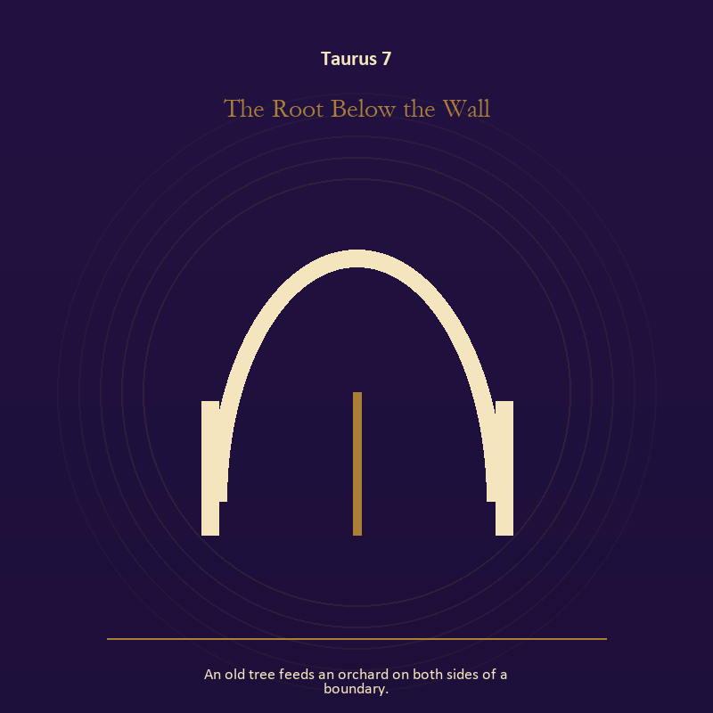

Taurus 7 The Root Below the Wall
An old tree feeds an orchard on both sides of a boundary.
INTERPRETATION The Root Below the Wall tests growth against the body, enoughness, patient craft, and values that survive pressure. Within the Root Below the Wall, growth appears as vulnerable potential under specific conditions. At Taurus 7, it requires time, nourishment, protection, and eventual release from the form that began it. The same image also carries the descent; at Taurus 7, ash, bones, scars, and sealed rooms preserve consequences. As a friction degree, Taurus 7 places consequence beside desire; the obstruction may be an enemy, a limit, or a needed correction.
SIGNAL The usable force at Taurus 7 is care that honors timing joined to a wound converted into discernment; Taurus gives it form by asking you to give the insight a durable form and a humane pace.
SHADOW At Taurus 7, the Root Below the Wall can turn toward protecting potential so tightly that it cannot emerge and pain used as permanent jurisdiction; notice where comfort has become custody or scarcity has become an identity.
MIRROR The question at Taurus 7: what is alive here but not ready to be displayed?
PRACTICE Give Taurus 7 a physical form; release one expectation about what the new form must resemble.
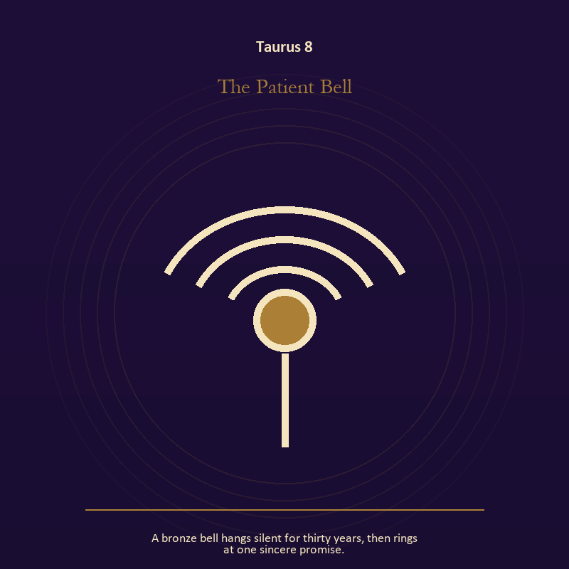

Taurus 8 The Patient Bell
A bronze bell hangs silent for thirty years, then rings at one sincere promise.
INTERPRETATION The Patient Bell holds voice and naming against the body, enoughness, patient craft, and values that survive pressure. Within the Patient Bell, books, letters, bells, and songs extend speech beyond the speaker's body. At Taurus 8, the message acquires a life that intention can no longer fully govern. As a friction degree, Taurus 8 tests whether the sign can change course without treating correction as defeat.
SIGNAL At Taurus 8, listening precise enough to change the reply carries the signal; it stays honest when you give the insight a durable form and a humane pace.
SHADOW The shadow at Taurus 8 begins with using language to outrun experience; also notice where comfort has become custody or scarcity has become an identity.
MIRROR At Taurus 8, what needs to be said plainly, and who has earned the right to hear it?
PRACTICE Bring Taurus 8 out of abstraction: write the sentence you keep rehearsing, remove every accusation you cannot prove, and read what remains aloud.

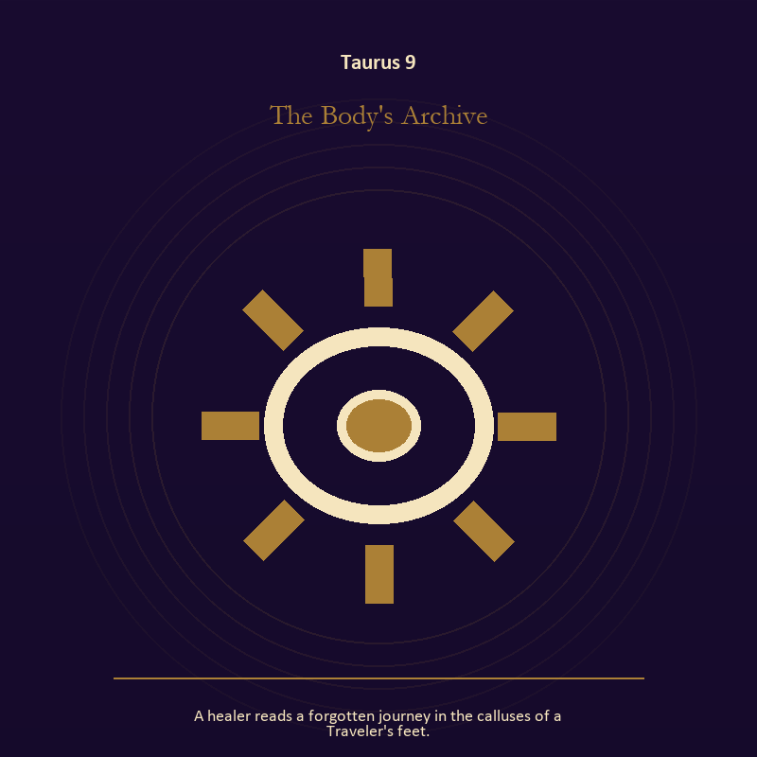

Taurus 9 The Body's Archive
A healer reads a forgotten journey in the calluses of a Traveler's feet.
INTERPRETATION The Body's Archive gives craft and record consequences inside the Sacred Vessel. Within the Body's Archive, workshops honor correction. At Taurus 9, a flaw becomes useful when it is found early, recorded honestly, and repaired without hiding the seam. The same image also carries the body; at Taurus 9, bread, rest, touch, clothing, and shelter make spiritual language answer to material need. As a friction degree, Taurus 9 brings another will, material limit, or inconvenient fact into the frame.
SIGNAL What can be carried forward from Taurus 9 is care made repeatable joined to care made material, tested by the need to give the insight a durable form and a humane pace.
SHADOW At Taurus 9, the image darkens through the tool becoming the master and letting appetite make the whole decision; notice where comfort has become custody or scarcity has become an identity.
MIRROR For Taurus 9, where would an honest repair remain visible? From a second angle at Taurus 9, which need in this scene has been made too ordinary to mention?
PRACTICE For Taurus 9, keep a brief record of what happened, what you expected, and what changed your mind.
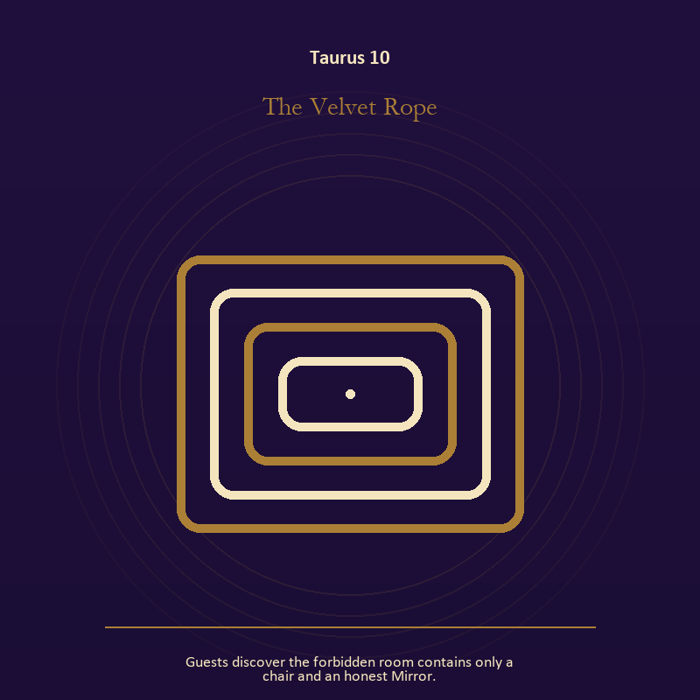

Taurus 10 The Velvet Rope
Guests discover the forbidden room contains only a chair and an honest Mirror.
INTERPRETATION The Velvet Rope puts the Mirror under pressure from the body, enoughness, patient craft, and values that survive pressure. Within the Velvet Rope, the Mirror returns perception without guaranteeing accuracy. At Taurus 10, it reveals projection, self-image, and the temptation to kneel before a reflection. The same image also carries the body; at Taurus 10, embodiment gives every choice a pace and a cost. As a friction degree, Taurus 10 slows the original motion long enough to expose what haste concealed.
SIGNAL At Taurus 10, a projection reclaimed joined to a decision the nervous system can inhabit becomes the clean signal when Taurus can give the insight a durable form and a humane pace.
SHADOW The distortion at Taurus 10 is letting shame dictate what the Mirror may show and using transcendence to ignore need; notice where comfort has become custody or scarcity has become an identity.
MIRROR With the Velvet Rope in mind at Taurus 10, what are you seeing clearly, and what may be projection?
PRACTICE Work with The Velvet Rope directly at Taurus 10: look into a Mirror for one minute and name facts only; then notice when judgment tries to enter as description. For the second pressure at Taurus 10, eat, drink, rest, or move before making the interpretation more dramatic.

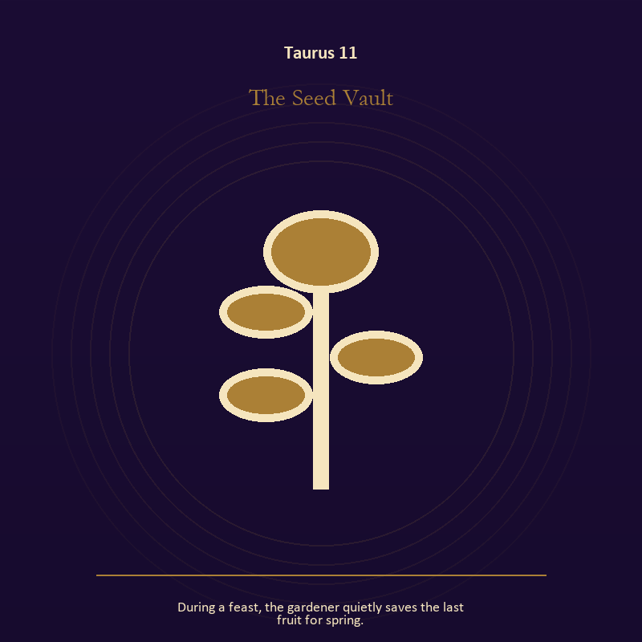

Taurus 11 The Seed Vault
During a feast, the gardener quietly saves the last fruit for spring.
INTERPRETATION In the Seed Vault, the work of growth must answer to the body, enoughness, patient craft, and values that survive pressure. Within the Seed Vault, seeds, children, roots, and gardens refuse the fantasy of instant transformation. At Taurus 11, they make becoming physical, seasonal, and dependent on care. As a revelation degree, Taurus 11 reveals the mechanism under the mood; one concrete detail changes the reading.
SIGNAL The usable force at Taurus 11 is inheritance revised through living action; Taurus gives it form by asking you to give the insight a durable form and a humane pace.
SHADOW At Taurus 11, the Seed Vault can turn toward forcing a season; notice where comfort has become custody or scarcity has become an identity.
MIRROR The question at Taurus 11: which condition would help this growth, and which demand would deform it?
PRACTICE Give Taurus 11 a physical form; tend one living thing and let its pace correct your schedule.
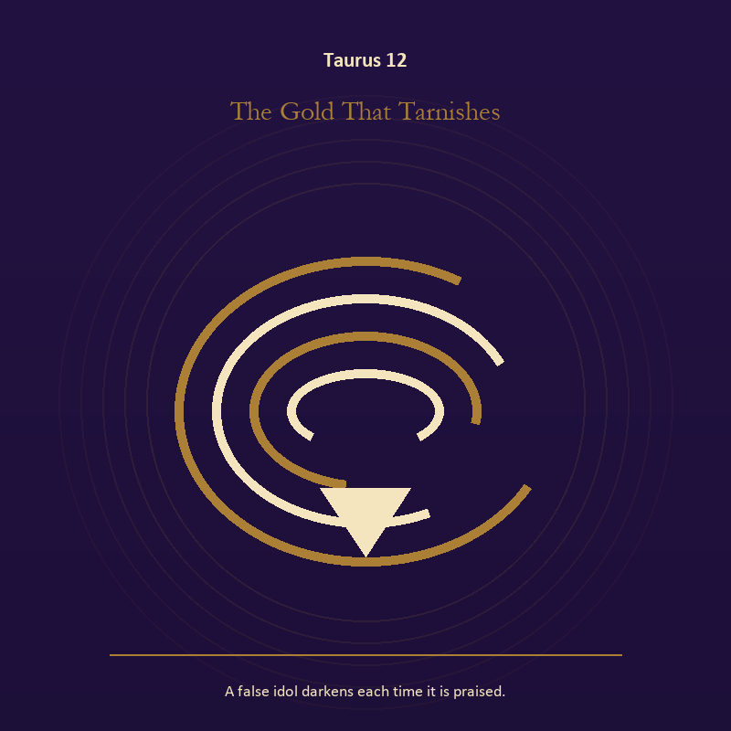

Taurus 12 The Gold That Tarnishes
A false idol darkens each time it is praised.
INTERPRETATION The Gold That Tarnishes tests mystery against the body, enoughness, patient craft, and values that survive pressure. Within the Gold That Tarnishes, the symbol remains useful when no single interpretation closes it. At Taurus 12, its work is to make one hidden relationship visible enough to examine. As a revelation degree, Taurus 12 moves the hidden arrangement into view, where it can be named without being exaggerated.
SIGNAL At Taurus 12, attention without premature certainty carries the signal; it stays honest when you give the insight a durable form and a humane pace.
SHADOW The shadow at Taurus 12 begins with using beauty to avoid the ordinary fact; also notice where comfort has become custody or scarcity has become an identity.
MIRROR At Taurus 12, what changes if the scene is a question rather than an answer?
PRACTICE Bring Taurus 12 out of abstraction: describe the scene to another person without explaining it, then notice what they ask first.

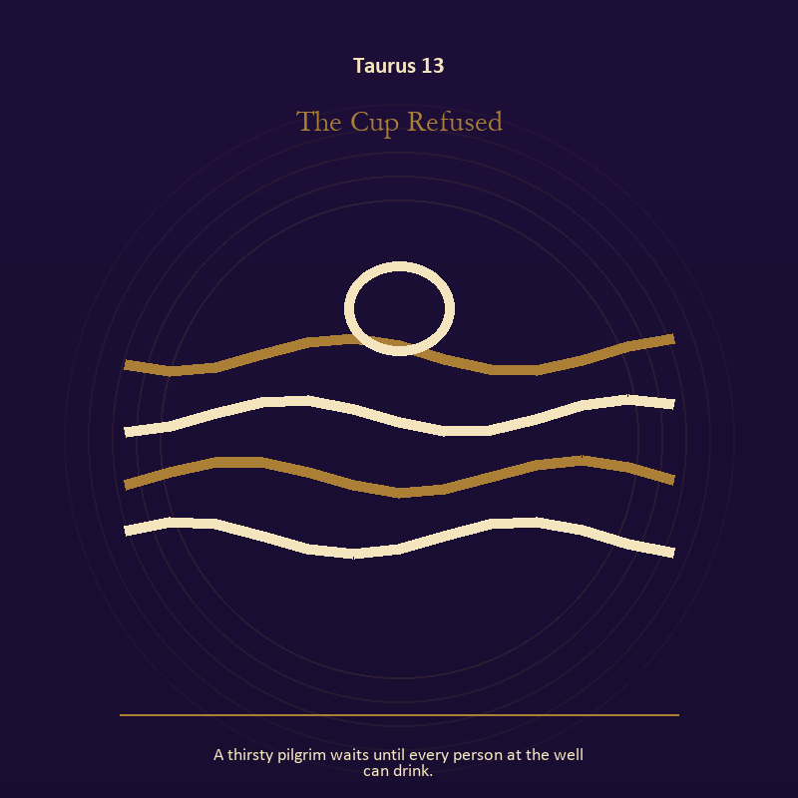

Taurus 13 The Cup Refused
A thirsty pilgrim waits until every person at the well can drink.
INTERPRETATION The Cup Refused holds living water against the body, enoughness, patient craft, and values that survive pressure. Within the Cup Refused, water carries feeling, memory, adaptation, and forces too large for command. At Taurus 13, its shape comes from the vessel, but its movement remains its own. The same image also carries relationship; at Taurus 13, the shared object in the scene carries an agreement. As a revelation degree, Taurus 13 turns atmosphere into evidence; attend to the object or action that cannot be explained away.
SIGNAL What can be carried forward from Taurus 13 is adaptation without self-erasure joined to difference held without humiliation, tested by the need to give the insight a durable form and a humane pace.
SHADOW At Taurus 13, the image darkens through building a vessel too rigid for living water and harmony purchased by one person's silence; notice where comfort has become custody or scarcity has become an identity.
MIRROR For Taurus 13, what feeling needs a vessel rather than a solution?
PRACTICE For Taurus 13, wash your hands with attention and decide what belongs to you after the water stops.
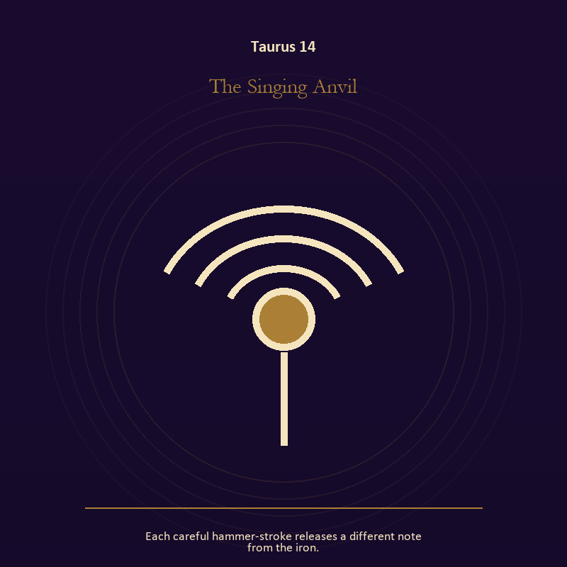

Taurus 14 The Singing Anvil
Each careful hammer-stroke releases a different note from the iron.
INTERPRETATION The Singing Anvil gives voice and naming consequences inside the Sacred Vessel. Within the Singing Anvil, books, letters, bells, and songs extend speech beyond the speaker's body. At Taurus 14, the message acquires a life that intention can no longer fully govern. As a revelation degree, Taurus 14 shows who carries the cost, who controls the passage, and what the scene refuses to hide.
SIGNAL At Taurus 14, listening precise enough to change the reply becomes the clean signal when Taurus can give the insight a durable form and a humane pace.
SHADOW The distortion at Taurus 14 is using language to outrun experience; notice where comfort has become custody or scarcity has become an identity.
MIRROR With the Singing Anvil in mind at Taurus 14, what needs to be said plainly, and who has earned the right to hear it?
PRACTICE Work with The Singing Anvil directly at Taurus 14: write the sentence you keep rehearsing, remove every accusation you cannot prove, and read what remains aloud.

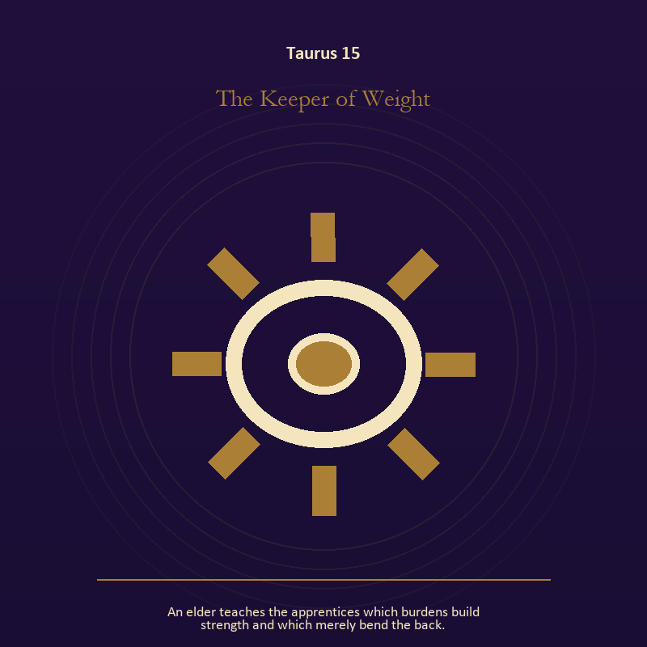

Taurus 15 The Keeper of Weight
An elder teaches the apprentices which burdens build strength and which merely bend the back.
INTERPRETATION The Keeper of Weight puts craft and record under pressure from the body, enoughness, patient craft, and values that survive pressure. Within the Keeper of Weight, workshops honor correction. At Taurus 15, a flaw becomes useful when it is found early, recorded honestly, and repaired without hiding the seam. The same image also carries the body; at Taurus 15, bread, rest, touch, clothing, and shelter make spiritual language answer to material need. As a revelation degree, Taurus 15 brings the middle truth forward, after the first story has lost its grip.
SIGNAL The usable force at Taurus 15 is care made repeatable joined to care made material; Taurus gives it form by asking you to give the insight a durable form and a humane pace.
SHADOW At Taurus 15, the Keeper of Weight can turn toward the tool becoming the master and letting appetite make the whole decision; notice where comfort has become custody or scarcity has become an identity.
MIRROR The question at Taurus 15: where would an honest repair remain visible? From a second angle at Taurus 15, which need in this scene has been made too ordinary to mention?
PRACTICE Give Taurus 15 a physical form; keep a brief record of what happened, what you expected, and what changed your mind.
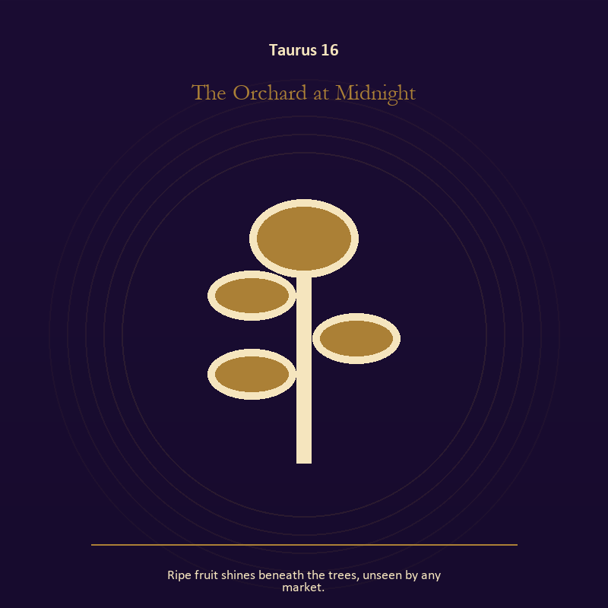

Taurus 16 The Orchard at Midnight
Ripe fruit shines beneath the trees, unseen by any market.
INTERPRETATION In the Orchard at Midnight, the work of growth must answer to the body, enoughness, patient craft, and values that survive pressure. Within the Orchard at Midnight, growth appears as vulnerable potential under specific conditions. At Taurus 16, it requires time, nourishment, protection, and eventual release from the form that began it. The same image also carries the descent; at Taurus 16, ash, bones, scars, and sealed rooms preserve consequences. As a choice degree, Taurus 16 requires a choice with a human cost; insight alone no longer completes the work.
SIGNAL At Taurus 16, care that honors timing joined to a wound converted into discernment carries the signal; it stays honest when you give the insight a durable form and a humane pace.
SHADOW The shadow at Taurus 16 begins with protecting potential so tightly that it cannot emerge and pain used as permanent jurisdiction; also notice where comfort has become custody or scarcity has become an identity.
MIRROR At Taurus 16, what is alive here but not ready to be displayed?
PRACTICE Bring Taurus 16 out of abstraction: release one expectation about what the new form must resemble.

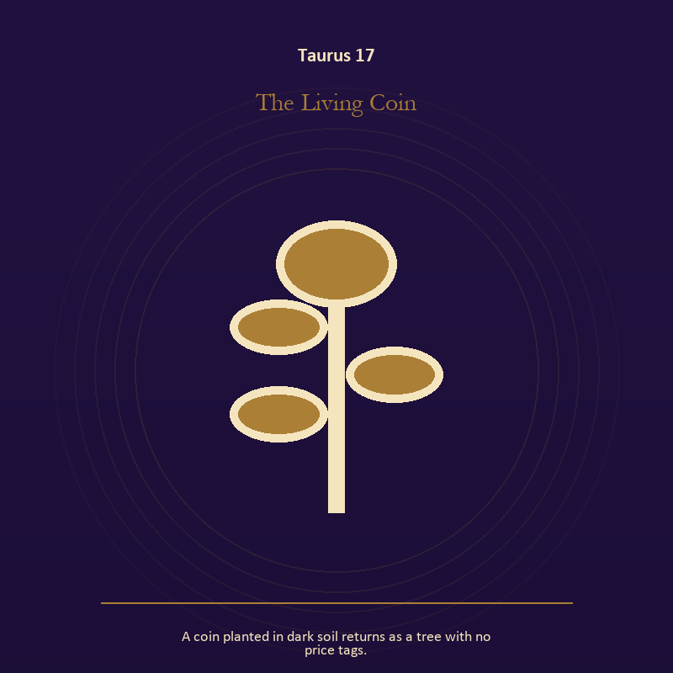

Taurus 17 The Living Coin
A coin planted in dark soil returns as a tree with no price tags.
INTERPRETATION The Living Coin tests growth against the body, enoughness, patient craft, and values that survive pressure. Within the Living Coin, seeds, children, roots, and gardens refuse the fantasy of instant transformation. At Taurus 17, they make becoming physical, seasonal, and dependent on care. The same image also carries the descent; at Taurus 17, descent imagery carries what ordinary daylight has failed to resolve. As a choice degree, Taurus 17 asks what action preserves truth without using another person as material.
SIGNAL What can be carried forward from Taurus 17 is inheritance revised through living action joined to truth that survives loss, tested by the need to give the insight a durable form and a humane pace.
SHADOW At Taurus 17, the image darkens through forcing a season and suspicion filling gaps in the record; notice where comfort has become custody or scarcity has become an identity.
MIRROR For Taurus 17, which condition would help this growth, and which demand would deform it?
PRACTICE For Taurus 17, tend one living thing and let its pace correct your schedule.
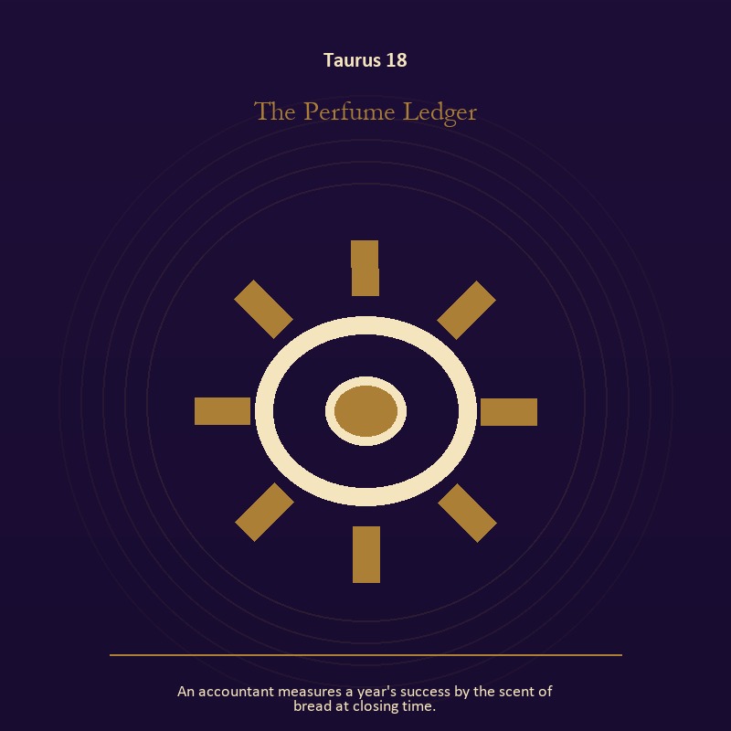

Taurus 18 The Perfume Ledger
An accountant measures a year's success by the scent of bread at closing time.
INTERPRETATION The Perfume Ledger holds craft and record against the body, enoughness, patient craft, and values that survive pressure. Within the Perfume Ledger, workshops honor correction. At Taurus 18, a flaw becomes useful when it is found early, recorded honestly, and repaired without hiding the seam. The same image also carries the body; at Taurus 18, bread, rest, touch, clothing, and shelter make spiritual language answer to material need. As a choice degree, Taurus 18 moves from recognition to conduct; the clean choice must survive outside the imagination.
SIGNAL At Taurus 18, care made repeatable joined to care made material becomes the clean signal when Taurus can give the insight a durable form and a humane pace.
SHADOW The distortion at Taurus 18 is the tool becoming the master and letting appetite make the whole decision; notice where comfort has become custody or scarcity has become an identity.
MIRROR With the Perfume Ledger in mind at Taurus 18, where would an honest repair remain visible? From a second angle at Taurus 18, which need in this scene has been made too ordinary to mention?
PRACTICE Work with The Perfume Ledger directly at Taurus 18: keep a brief record of what happened, what you expected, and what changed your mind. For the second pressure at Taurus 18, choose the next action that your body can repeat without punishment.



Taurus 19 The Unbroken Cup
A ceremonial cup survives the fall but spills what was never meant to be kept.
INTERPRETATION The Unbroken Cup gives living water consequences inside the Sacred Vessel. Within the Unbroken Cup, water carries feeling, memory, adaptation, and forces too large for command. At Taurus 19, its shape comes from the vessel, but its movement remains its own. As a choice degree, Taurus 19 tests whether awareness can become restraint, repair, refusal, or consent.
SIGNAL The usable force at Taurus 19 is adaptation without self-erasure; Taurus gives it form by asking you to give the insight a durable form and a humane pace.
SHADOW At Taurus 19, the Unbroken Cup can turn toward building a vessel too rigid for living water; notice where comfort has become custody or scarcity has become an identity.
MIRROR The question at Taurus 19: what feeling needs a vessel rather than a solution?
PRACTICE Give Taurus 19 a physical form; wash your hands with attention and decide what belongs to you after the water stops.
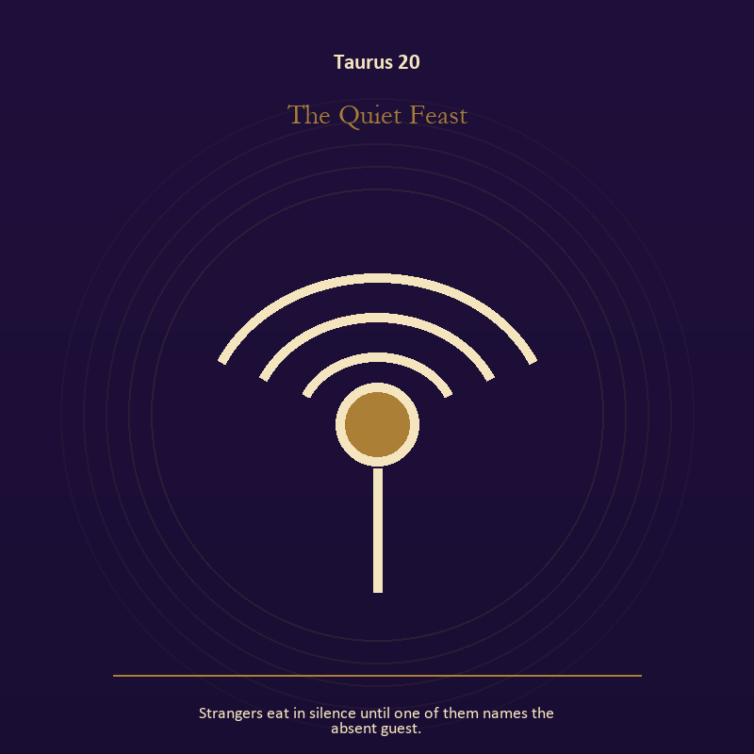

Taurus 20 The Quiet Feast
Strangers eat in silence until one of them names the absent guest.
INTERPRETATION The Quiet Feast puts relationship under pressure from the body, enoughness, patient craft, and values that survive pressure. Within the Quiet Feast, relationship imagery tests the fantasy that harmony requires sameness. At Taurus 20, a living bond can hold difference, correction, privacy, and departure. The same image also carries the body; at Taurus 20, the body enters as witness, limit, appetite, labor, and home. As a choice degree, Taurus 20 places responsibility in the reader's hands without promising a painless answer.
SIGNAL At Taurus 20, difference held without humiliation joined to presence with weight and limits carries the signal; it stays honest when you give the insight a durable form and a humane pace.
SHADOW The shadow at Taurus 20 begins with harmony purchased by one person's silence and treating exhaustion as devotion; also notice where comfort has become custody or scarcity has become an identity.
MIRROR At Taurus 20, where does responsibility belong, and where has it been displaced?
PRACTICE Bring Taurus 20 out of abstraction: ask the other person what they believe the agreement is, then compare it with your own version.

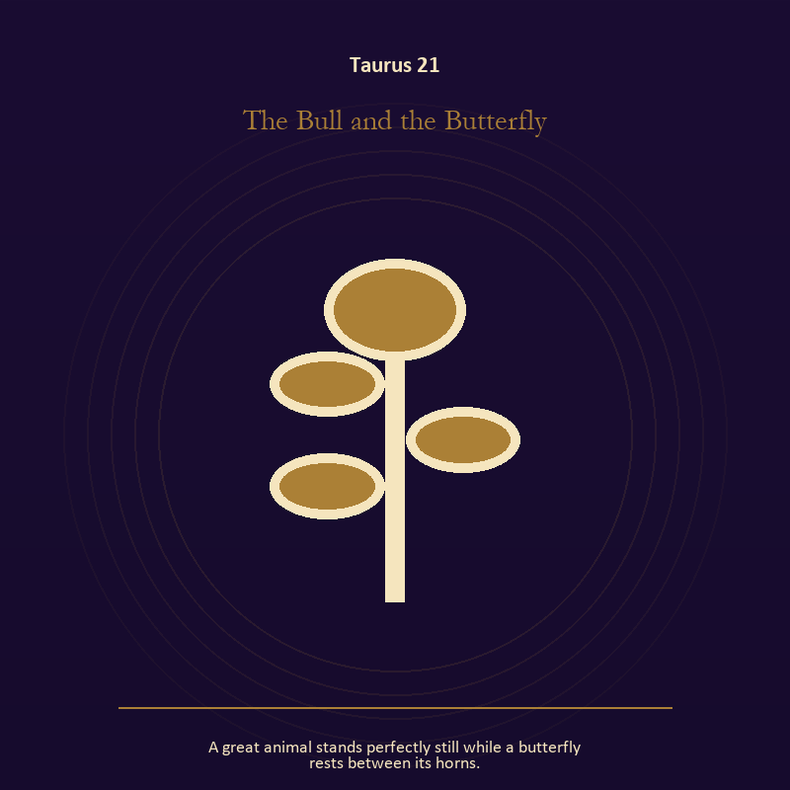

Taurus 21 The Bull and the Butterfly
A great animal stands perfectly still while a butterfly rests between its horns.
INTERPRETATION In the Bull and the Butterfly, the work of growth must answer to the body, enoughness, patient craft, and values that survive pressure. Within the Bull and the Butterfly, new life carries inherited material without being sentenced to repeat it. At Taurus 21, the image asks what must be tended and what must be allowed to change form. As a integration degree, Taurus 21 holds the gift beside its distortion; using one without feeding the other is the work.
SIGNAL What can be carried forward from Taurus 21 is patient becoming, tested by the need to give the insight a durable form and a humane pace.
SHADOW At Taurus 21, the image darkens through claiming ownership over another's growth; notice where comfort has become custody or scarcity has become an identity.
MIRROR For Taurus 21, what can you tend without claiming the outcome?
PRACTICE For Taurus 21, name the smallest repeatable condition that would help this beginning survive a week.


Taurus 22 The Locked Pantry
The key appears only after the keeper admits there is more than enough.
INTERPRETATION The Locked Pantry tests craft and record against the body, enoughness, patient craft, and values that survive pressure. Within the Locked Pantry, craft turns intention into a repeatable act with materials, limits, and evidence of failure. At Taurus 22, the tool reveals the quality of attention brought to it. As a integration degree, Taurus 22 asks the sign to carry its strength without turning that strength into jurisdiction.
SIGNAL At Taurus 22, evidence preserved without spectacle becomes the clean signal when Taurus can give the insight a durable form and a humane pace.
SHADOW The distortion at Taurus 22 is polish used to hide a structural weakness; notice where comfort has become custody or scarcity has become an identity.
MIRROR With the Locked Pantry in mind at Taurus 22, which part of this process can be checked rather than assumed?
PRACTICE Work with The Locked Pantry directly at Taurus 22: repair one useful object without disguising the place where it broke.

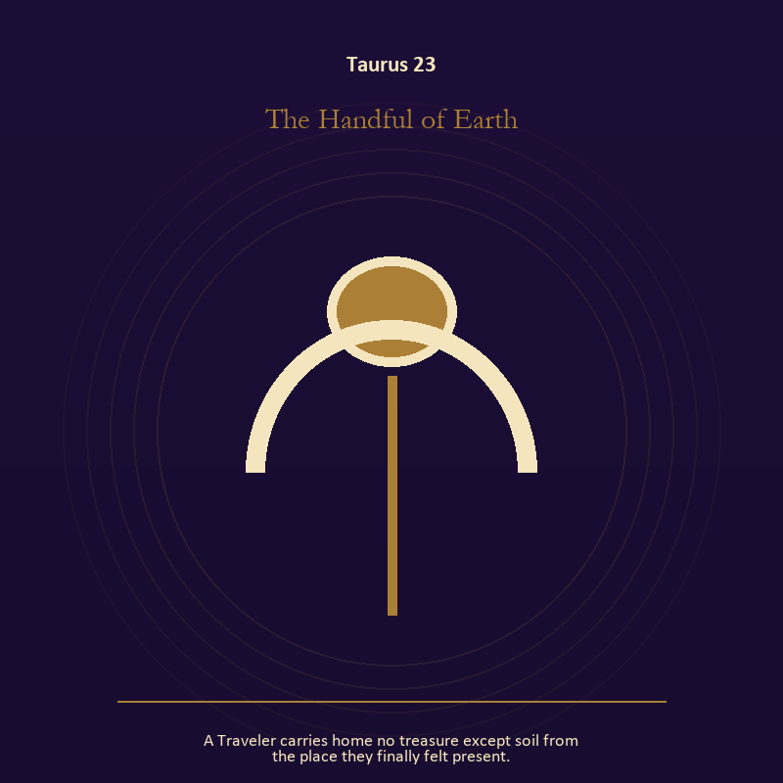

Taurus 23 The Handful of Earth
A Traveler carries home no treasure except soil from the place they finally felt present.
INTERPRETATION The Handful of Earth holds mystery against the body, enoughness, patient craft, and values that survive pressure. Within the Handful of Earth, this image invites attention before conclusion. At Taurus 23, its strange fact creates a pressure point where memory, desire, fear, and choice can speak indirectly. As a integration degree, Taurus 23 joins capacity to consequence; what helps in one setting may harm in another.
SIGNAL The usable force at Taurus 23 is an unanswered image that keeps thought alive; Taurus gives it form by asking you to give the insight a durable form and a humane pace.
SHADOW At Taurus 23, the Handful of Earth can turn toward forcing a prophecy from ambiguity; notice where comfort has become custody or scarcity has become an identity.
MIRROR The question at Taurus 23: what ordinary fact sits beneath the strange image?
PRACTICE Give Taurus 23 a physical form; copy the image by hand, underline three concrete nouns, and write one association for each.
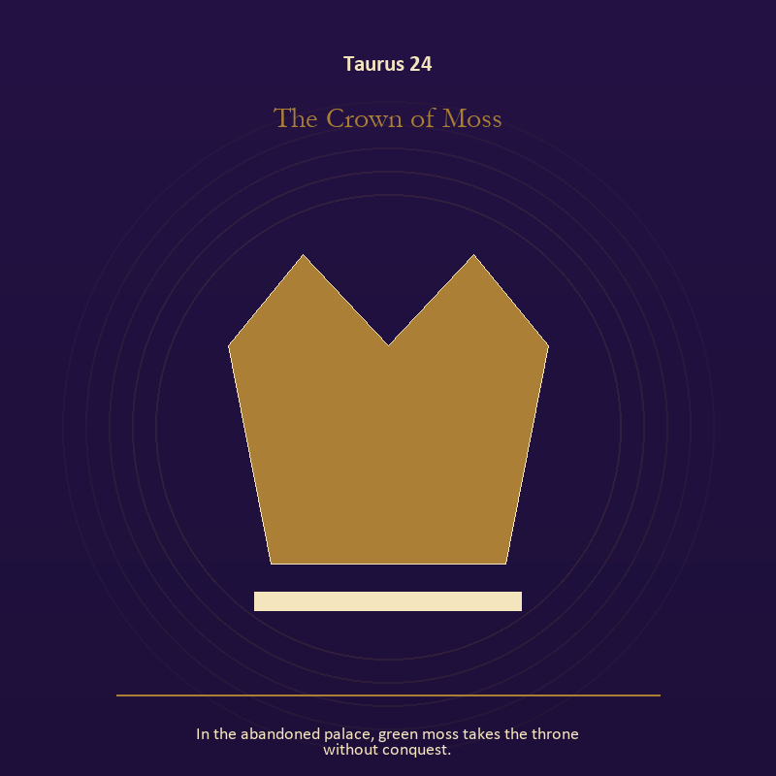

Taurus 24 The Crown of Moss
In the abandoned palace, green moss takes the throne without conquest.
INTERPRETATION The Crown of Moss gives authority consequences inside the Sacred Vessel. Within the Crown of Moss, institutional objects reveal the bargain between role and person. At Taurus 24, a title may organize service or become a mask that excuses harm. The same image also carries growth; at Taurus 24, seeds, children, roots, and gardens refuse the fantasy of instant transformation. As a integration degree, Taurus 24 shows the mature tool and the temptation hidden inside its handle.
SIGNAL At Taurus 24, stewardship with an exit plan joined to care that honors timing carries the signal; it stays honest when you give the insight a durable form and a humane pace.
SHADOW The shadow at Taurus 24 begins with procedure used to avoid conscience and protecting potential so tightly that it cannot emerge; also notice where comfort has become custody or scarcity has become an identity.
MIRROR At Taurus 24, which part of this authority serves life, and which part serves its own continuation? From a second angle at Taurus 24, which condition would help this growth, and which demand would deform it?
PRACTICE Bring Taurus 24 out of abstraction: remove your title from a current problem and describe the duty that remains.

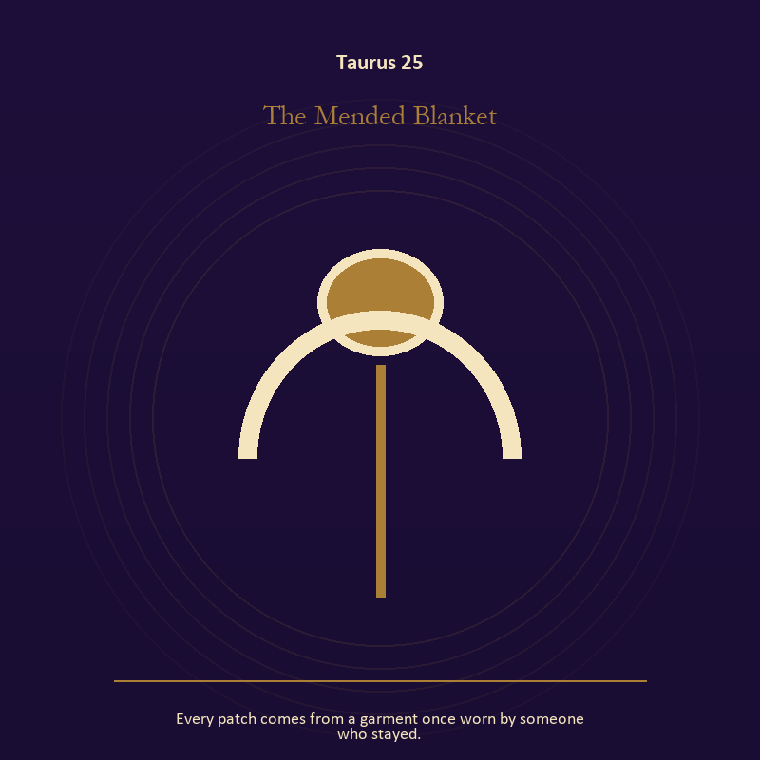

Taurus 25 The Mended Blanket
Every patch comes from a garment once worn by someone who stayed.
INTERPRETATION The Mended Blanket puts the body under pressure from the body, enoughness, patient craft, and values that survive pressure. Within the Mended Blanket, the body enters as witness, limit, appetite, labor, and home. At Taurus 25, its response may reveal what the mind has explained away. As a integration degree, Taurus 25 tests whether the lesson can be lived without becoming a new performance.
SIGNAL What can be carried forward from Taurus 25 is care made material, tested by the need to give the insight a durable form and a humane pace.
SHADOW At Taurus 25, the image darkens through letting appetite make the whole decision; notice where comfort has become custody or scarcity has become an identity.
MIRROR For Taurus 25, what does your body know before your argument begins?
PRACTICE For Taurus 25, choose the next action that your body can repeat without punishment.
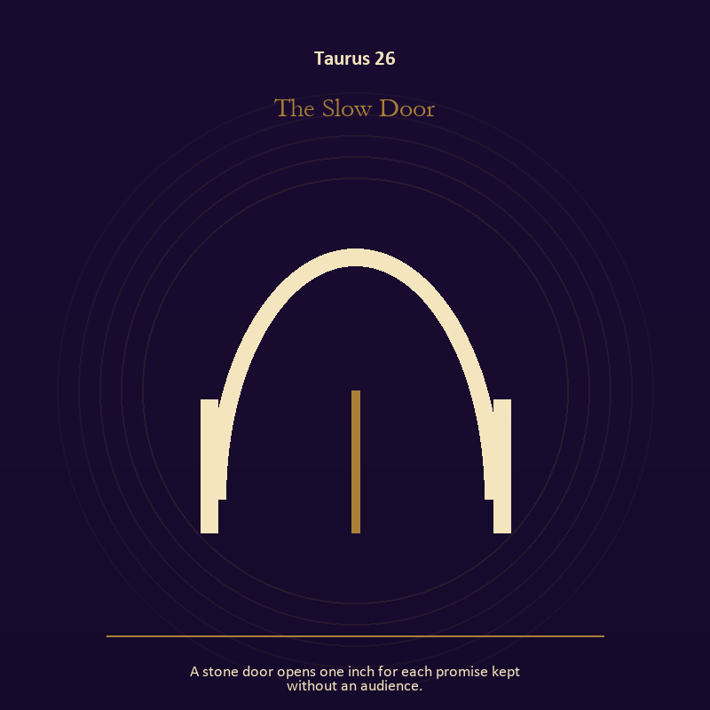

Taurus 26 The Slow Door
A stone door opens one inch for each promise kept without an audience.
INTERPRETATION In the Slow Door, the work of the threshold must answer to the body, enoughness, patient craft, and values that survive pressure. Within the Slow Door, doors and roads turn inner change into an embodied decision. At Taurus 26, the next room matters, but so does the condition under which it is entered. As a release degree, Taurus 26 prepares the lesson to leave its original container; keep the capacity and loosen the role.
SIGNAL At Taurus 26, a boundary that clarifies freedom becomes the clean signal when Taurus can give the insight a durable form and a humane pace.
SHADOW The distortion at Taurus 26 is crossing before consent; notice where comfort has become custody or scarcity has become an identity.
MIRROR With the Slow Door in mind at Taurus 26, what are you protecting by remaining on this side of the door?
PRACTICE Work with The Slow Door directly at Taurus 26: stand at a literal doorway, name what you are leaving and what you refuse to abandon, then cross only if the answer feels clean.

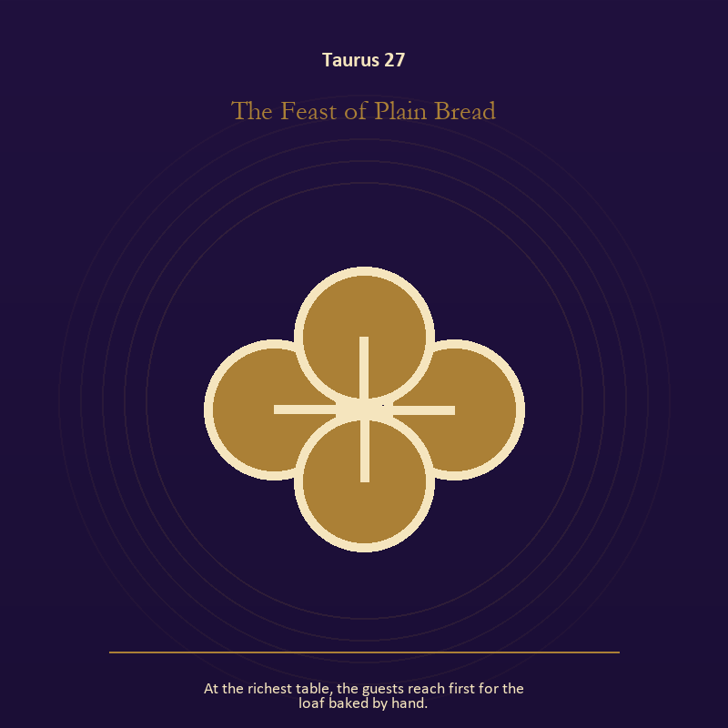

Taurus 27 The Feast of Plain Bread
At the richest table, the guests reach first for the loaf baked by hand.
INTERPRETATION The Feast of Plain Bread tests the body against the body, enoughness, patient craft, and values that survive pressure. Within the Feast of Plain Bread, embodiment gives every choice a pace and a cost. At Taurus 27, the scene asks whether the person can remain present inside the experience being interpreted. As a release degree, Taurus 27 asks what can be handed onward without demanding imitation or loyalty.
SIGNAL The usable force at Taurus 27 is presence with weight and limits; Taurus gives it form by asking you to give the insight a durable form and a humane pace.
SHADOW At Taurus 27, the Feast of Plain Bread can turn toward treating exhaustion as devotion; notice where comfort has become custody or scarcity has become an identity.
MIRROR The question at Taurus 27: can the choice be lived at the pace your body can sustain?
PRACTICE Give Taurus 27 a physical form; place both feet on the floor and name five physical facts about the present moment.
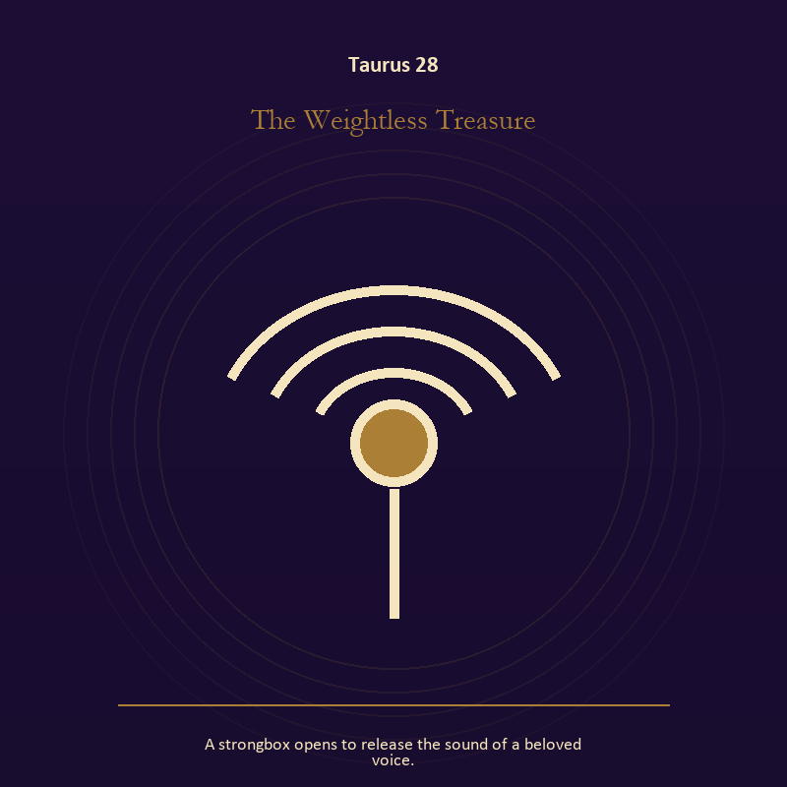

Taurus 28 The Weightless Treasure
A strongbox opens to release the sound of a beloved voice.
INTERPRETATION The Weightless Treasure holds voice and naming against the body, enoughness, patient craft, and values that survive pressure. Within the Weightless Treasure, voice turns inner pressure into shared consequence. At Taurus 28, words can witness, summon, distort, repair, or conceal according to their precision and timing. As a release degree, Taurus 28 turns completion into transfer; the work survives by changing hands.
SIGNAL At Taurus 28, a name that restores agency carries the signal; it stays honest when you give the insight a durable form and a humane pace.
SHADOW The shadow at Taurus 28 begins with speaking for someone whose voice is present; also notice where comfort has become custody or scarcity has become an identity.
MIRROR At Taurus 28, which word in this scene changes the power relationship?
PRACTICE Bring Taurus 28 out of abstraction: give the current experience a temporary name and date it, leaving room for revision.

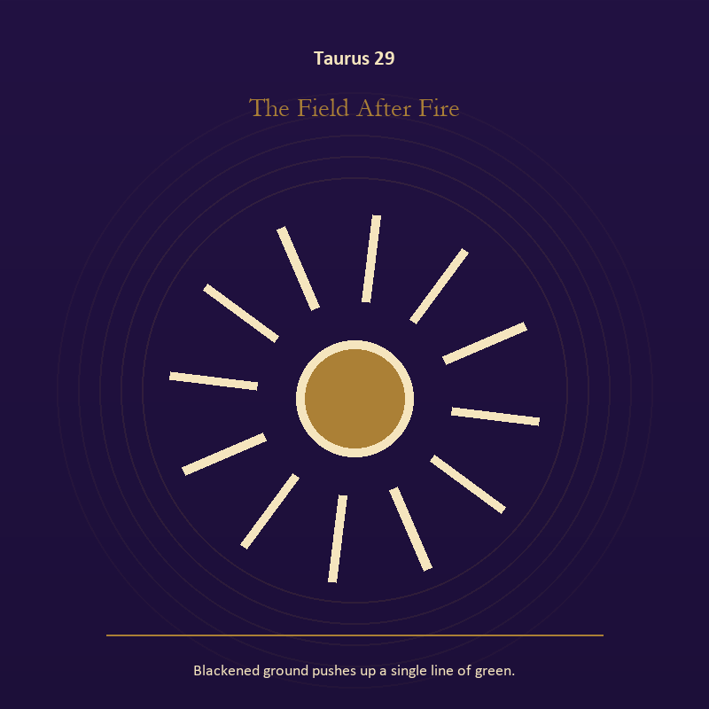

Taurus 29 The Field After Fire
Blackened ground pushes up a single line of green.
INTERPRETATION The Field After Fire gives living fire consequences inside the Sacred Vessel. Within the Field After Fire, fire gives change a visible cost. At Taurus 29, something is illuminated here because something else is being spent. The same image also carries growth; at Taurus 29, growth appears as vulnerable potential under specific conditions. As a release degree, Taurus 29 lets the sign set down the identity built around its ordeal.
SIGNAL What can be carried forward from Taurus 29 is a truth made visible at the right scale joined to patient becoming, tested by the need to give the insight a durable form and a humane pace.
SHADOW At Taurus 29, the image darkens through burning for recognition and claiming ownership over another's growth; notice where comfort has become custody or scarcity has become an identity.
MIRROR For Taurus 29, where has your fire become performance rather than warmth?
PRACTICE For Taurus 29, light one candle and give its entire burn to a single unfinished question.
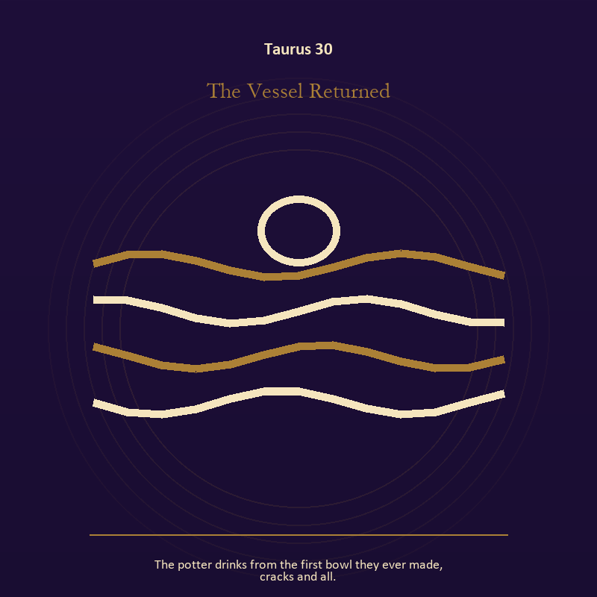

Taurus 30 The Vessel Returned
The potter drinks from the first bowl they ever made, cracks and all.
INTERPRETATION The Vessel Returned puts living water under pressure from the body, enoughness, patient craft, and values that survive pressure. Within the Vessel Returned, rain, tides, wells, and floods move private material into a shared landscape. At Taurus 30, what was hidden becomes environmental and must be answered together. The same image also carries craft and record; at Taurus 30, ledgers, maps, machines, and archives make memory operational. As a release degree, Taurus 30 returns the earned knowledge to ordinary life, where another cycle can use it.
SIGNAL At Taurus 30, feeling with a living boundary joined to evidence preserved without spectacle becomes the clean signal when Taurus can give the insight a durable form and a humane pace.
SHADOW The distortion at Taurus 30 is using mystery to avoid a fact and polish used to hide a structural weakness; notice where comfort has become custody or scarcity has become an identity.
MIRROR With the Vessel Returned in mind at Taurus 30, what has the tide exposed that cannot be covered again? From a second angle at Taurus 30, what does the tool preserve, and what does it leave out?
PRACTICE Work with The Vessel Returned directly at Taurus 30: write the feeling as weather, then add the exact fact occurring beneath that weather. For the second pressure at Taurus 30, repair one useful object without disguising the place where it broke.

Gemini
The Twin Transmission
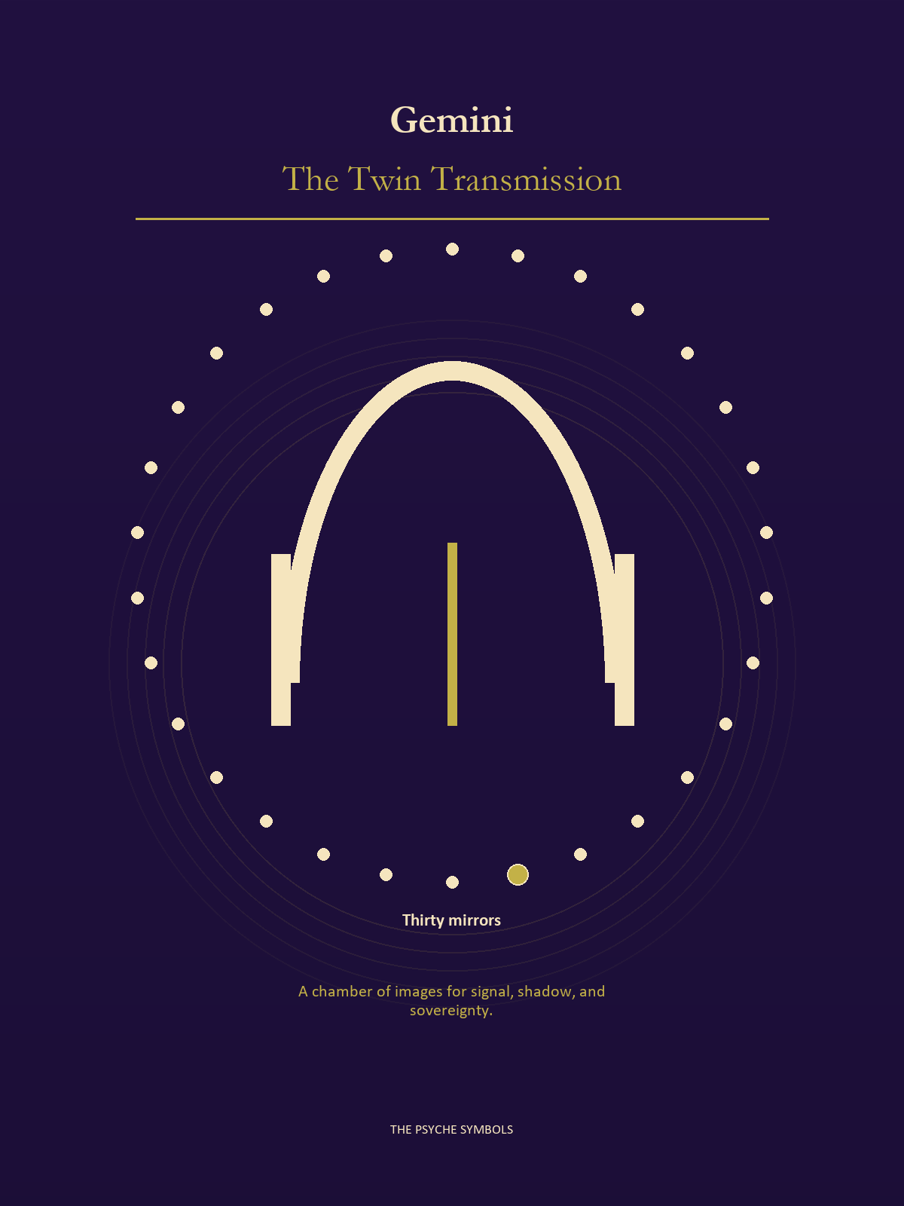
Gemini splits the signal so it can question itself. The Twin Transmission tests messages, names, omissions, echoes, and the stories created between speaker and listener. Here intelligence stays alive by changing its language when the evidence changes.

Degrees | Gate | Work
1-5 | Arrival | Meet the image before deciding what it means.
6-10 | Friction | Notice what pushes back and what that resistance protects.
11-15 | Revelation | Name the detail that changes the whole scene.
16-20 | Choice | Choose the act that preserves both truth and human dignity.
21-25 | Integration | Use the gift without feeding the shadow that travels beside it.
26-30 | Release | Keep the earned capacity and release the role that delivered it.

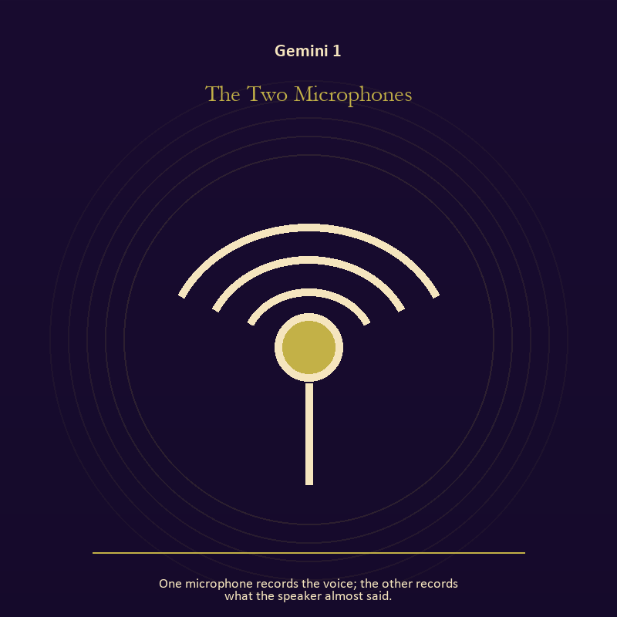

Gemini 1 The Two Microphones
One microphone records the voice; the other records what the speaker almost said.
INTERPRETATION In the Two Microphones, the work of relationship must answer to language, curiosity, contradiction, and bridges between separate minds. Within the Two Microphones, more than one will is active in this scene. At Gemini 1, meaning emerges through distance, consent, conflict, care, and the terms under which contact continues. The same image also carries the Signal; at Gemini 1, machines in these symbols expose the difference between a living message and the equipment carrying it. As an arrival degree, Gemini 1 arrives before habit can tidy the evidence; notice what is present before deciding what it should become.
SIGNAL The usable force at Gemini 1 is mutual responsibility joined to a message that survives its container; Gemini gives it form by asking you to ask the second question and describe what you heard before answering.
SHADOW At Gemini 1, the Two Microphones can turn toward the group protecting itself by sacrificing an outsider and performing instead of speaking; beware speed without listening, cleverness without stakes, and rumor wearing the clothes of inquiry.
MIRROR The question at Gemini 1: what agreement is operating here even if nobody has spoken it?
PRACTICE Give Gemini 1 a physical form; make one repair that does not require the other person to erase their account.
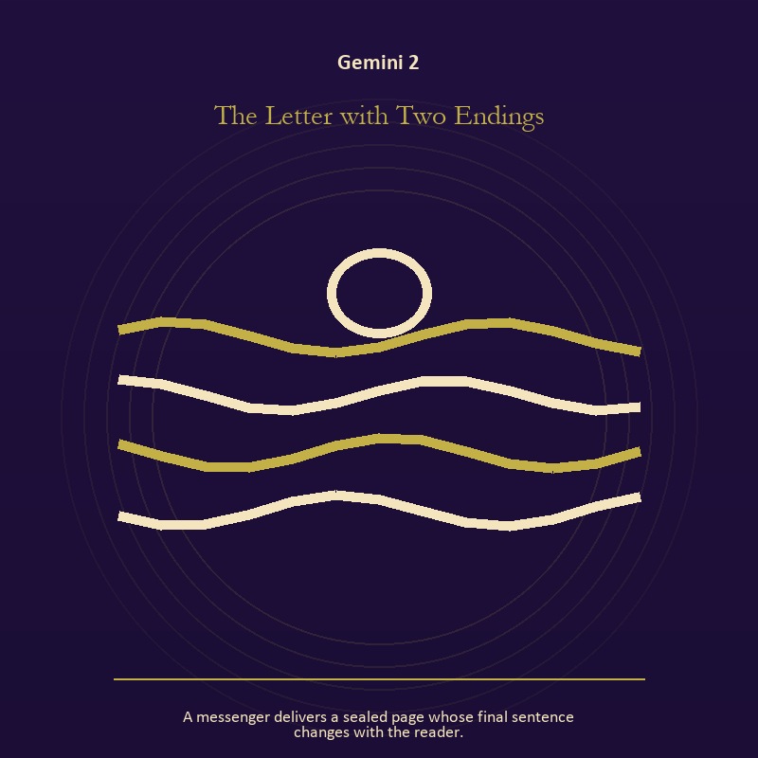

Gemini 2 The Letter with Two Endings
A messenger delivers a sealed page whose final sentence changes with the reader.
INTERPRETATION The Letter with Two Endings tests voice and naming against language, curiosity, contradiction, and bridges between separate minds. Within the Letter with Two Endings, books, letters, bells, and songs extend speech beyond the speaker's body. At Gemini 2, the message acquires a life that intention can no longer fully govern. The same image also carries relationship; at Gemini 2, more than one will is active in this scene. As an arrival degree, Gemini 2 introduces the sign's raw material in an unguarded form; the first response matters less than the honest one.
SIGNAL At Gemini 2, listening precise enough to change the reply joined to contact without capture carries the signal; it stays honest when you ask the second question and describe what you heard before answering.
SHADOW The shadow at Gemini 2 begins with using language to outrun experience and projection mistaken for intimacy; also beware speed without listening, cleverness without stakes, and rumor wearing the clothes of inquiry.
MIRROR At Gemini 2, what needs to be said plainly, and who has earned the right to hear it?
PRACTICE Bring Gemini 2 out of abstraction: write the sentence you keep rehearsing, remove every accusation you cannot prove, and read what remains aloud.

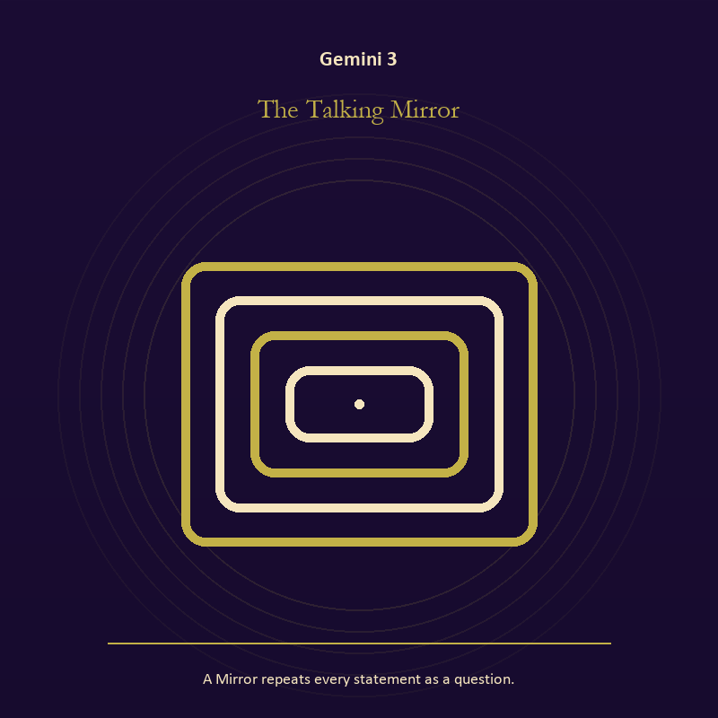

Gemini 3 The Talking Mirror
A Mirror repeats every statement as a question.
INTERPRETATION The Talking Mirror holds the Mirror against language, curiosity, contradiction, and bridges between separate minds. Within the Talking Mirror, a shadow proves that something real stands in the light, while a reflection shows only an angle. At Gemini 3, neither is the whole person. The same image also carries voice and naming; at Gemini 3, books, letters, bells, and songs extend speech beyond the speaker's body. As an arrival degree, Gemini 3 catches the first impulse before it turns into a role; give the image room to remain strange.
SIGNAL What can be carried forward from Gemini 3 is self-recognition without self-worship joined to a name that restores agency, tested by the need to ask the second question and describe what you heard before answering.
SHADOW At Gemini 3, the image darkens through assigning your hidden material to someone else and speaking for someone whose voice is present; beware speed without listening, cleverness without stakes, and rumor wearing the clothes of inquiry.
MIRROR For Gemini 3, which part of the reflection is asking to be reclaimed rather than judged? From a second angle at Gemini 3, what needs to be said plainly, and who has earned the right to hear it?
PRACTICE For Gemini 3, write two accounts of the same conflict: one from your position and one from the person you cannot understand.
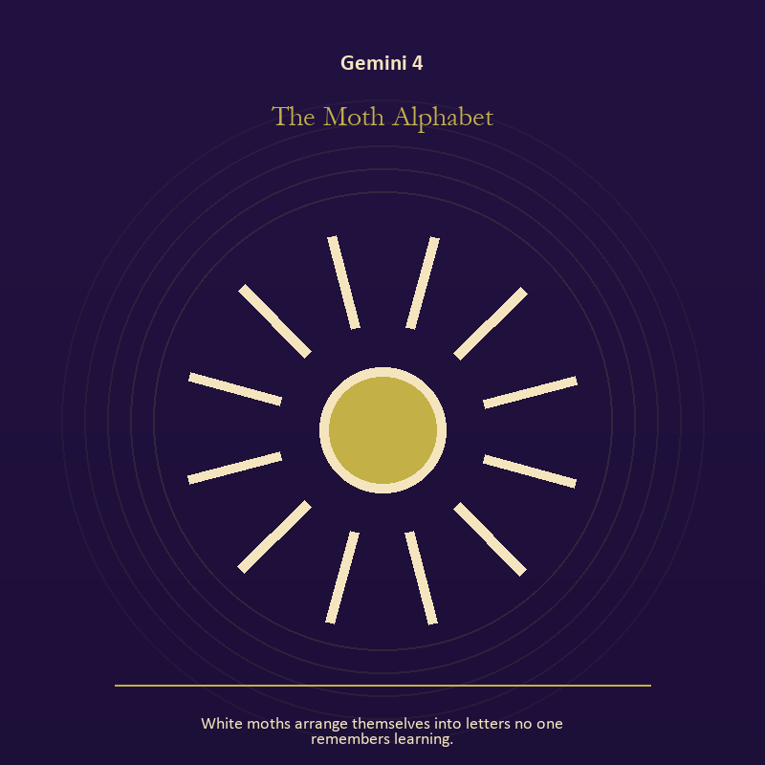

Gemini 4 The Moth Alphabet
White moths arrange themselves into letters no one remembers learning.
INTERPRETATION The Moth Alphabet gives mystery consequences inside the Twin Transmission. Within the Moth Alphabet, the scene behaves like a dream with its own exact logic. At Gemini 4, meaning lives in the relationship between figure, place, action, and the detail that refuses ordinary explanation. As an arrival degree, Gemini 4 opens the chamber with no settled method; name the need, risk, or appetite that entered with it.
SIGNAL At Gemini 4, imagination disciplined by the scene becomes the clean signal when Gemini can ask the second question and describe what you heard before answering.
SHADOW The distortion at Gemini 4 is mistaking intensity for accuracy; beware speed without listening, cleverness without stakes, and rumor wearing the clothes of inquiry.
MIRROR With the Moth Alphabet in mind at Gemini 4, which detail keeps returning after the rest of the scene fades?
PRACTICE Work with The Moth Alphabet directly at Gemini 4: keep the image nearby for one day and record only the moments when it returns on its own.

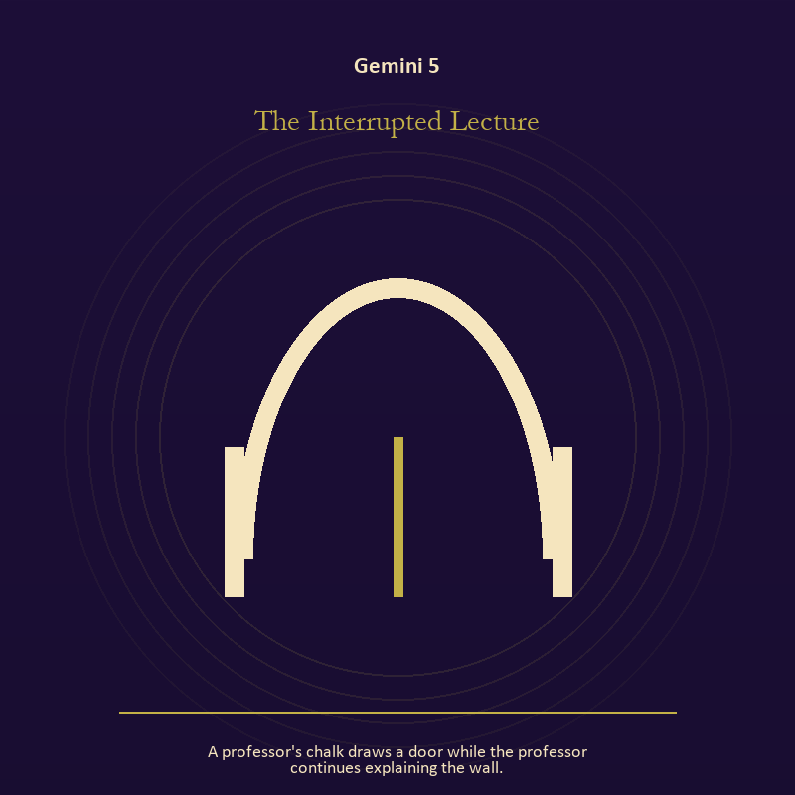

Gemini 5 The Interrupted Lecture
A professor's chalk draws a door while the professor continues explaining the wall.
INTERPRETATION The Interrupted Lecture puts voice and naming under pressure from language, curiosity, contradiction, and bridges between separate minds. Within the Interrupted Lecture, books, letters, bells, and songs extend speech beyond the speaker's body. At Gemini 5, the message acquires a life that intention can no longer fully govern. The same image also carries the threshold; at Gemini 5, a threshold measures consent, timing, and consequence. As an arrival degree, Gemini 5 shows the beginning before ownership hardens around it; let attention come before possession.
SIGNAL The usable force at Gemini 5 is listening precise enough to change the reply joined to honest passage; Gemini gives it form by asking you to ask the second question and describe what you heard before answering.
SHADOW At Gemini 5, the Interrupted Lecture can turn toward using language to outrun experience and guarding an obsolete enclosure; beware speed without listening, cleverness without stakes, and rumor wearing the clothes of inquiry.
MIRROR The question at Gemini 5: what needs to be said plainly, and who has earned the right to hear it?
PRACTICE Give Gemini 5 a physical form; write the sentence you keep rehearsing, remove every accusation you cannot prove, and read what remains aloud.
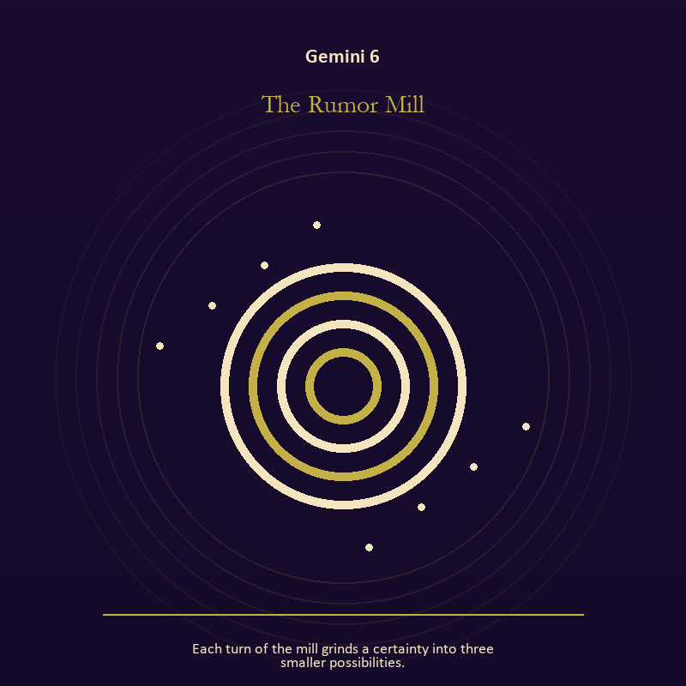

Gemini 6 The Rumor Mill
Each turn of the mill grinds a certainty into three smaller possibilities.
INTERPRETATION In the Rumor Mill, the work of mystery must answer to language, curiosity, contradiction, and bridges between separate minds. Within the Rumor Mill, the symbol remains useful when no single interpretation closes it. At Gemini 6, its work is to make one hidden relationship visible enough to examine. As a friction degree, Gemini 6 meets resistance, and that resistance reveals what the first impulse failed to consider.
SIGNAL At Gemini 6, attention without premature certainty carries the signal; it stays honest when you ask the second question and describe what you heard before answering.
SHADOW The shadow at Gemini 6 begins with using beauty to avoid the ordinary fact; also beware speed without listening, cleverness without stakes, and rumor wearing the clothes of inquiry.
MIRROR At Gemini 6, what changes if the scene is a question rather than an answer?
PRACTICE Bring Gemini 6 out of abstraction: describe the scene to another person without explaining it, then notice what they ask first.

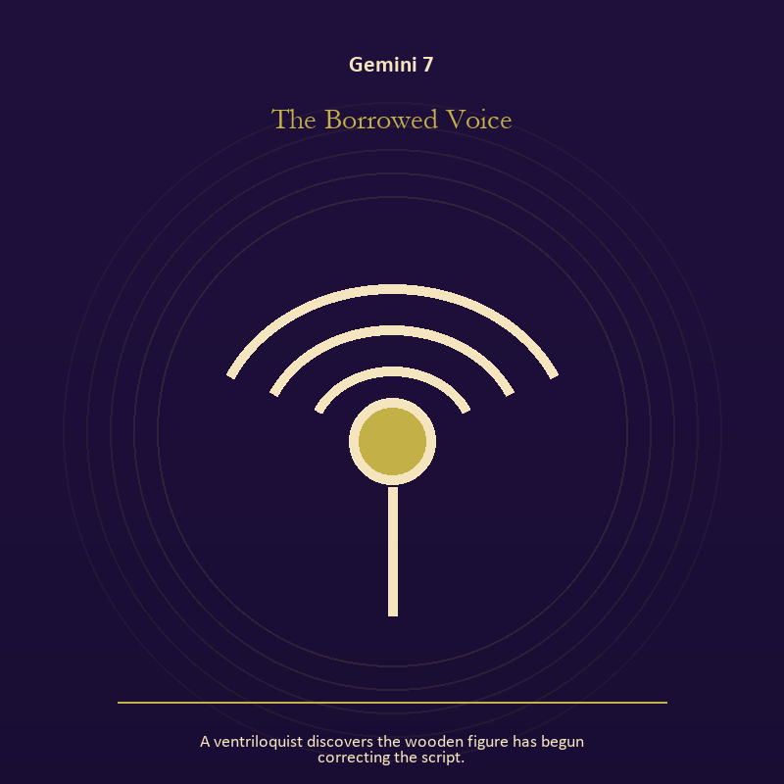

Gemini 7 The Borrowed Voice
A ventriloquist discovers the wooden figure has begun correcting the script.
INTERPRETATION The Borrowed Voice tests voice and naming against language, curiosity, contradiction, and bridges between separate minds. Within the Borrowed Voice, voice turns inner pressure into shared consequence. At Gemini 7, words can witness, summon, distort, repair, or conceal according to their precision and timing. As a friction degree, Gemini 7 places consequence beside desire; the obstruction may be an enemy, a limit, or a needed correction.
SIGNAL What can be carried forward from Gemini 7 is a name that restores agency, tested by the need to ask the second question and describe what you heard before answering.
SHADOW At Gemini 7, the image darkens through speaking for someone whose voice is present; beware speed without listening, cleverness without stakes, and rumor wearing the clothes of inquiry.
MIRROR For Gemini 7, which word in this scene changes the power relationship?
PRACTICE For Gemini 7, give the current experience a temporary name and date it, leaving room for revision.
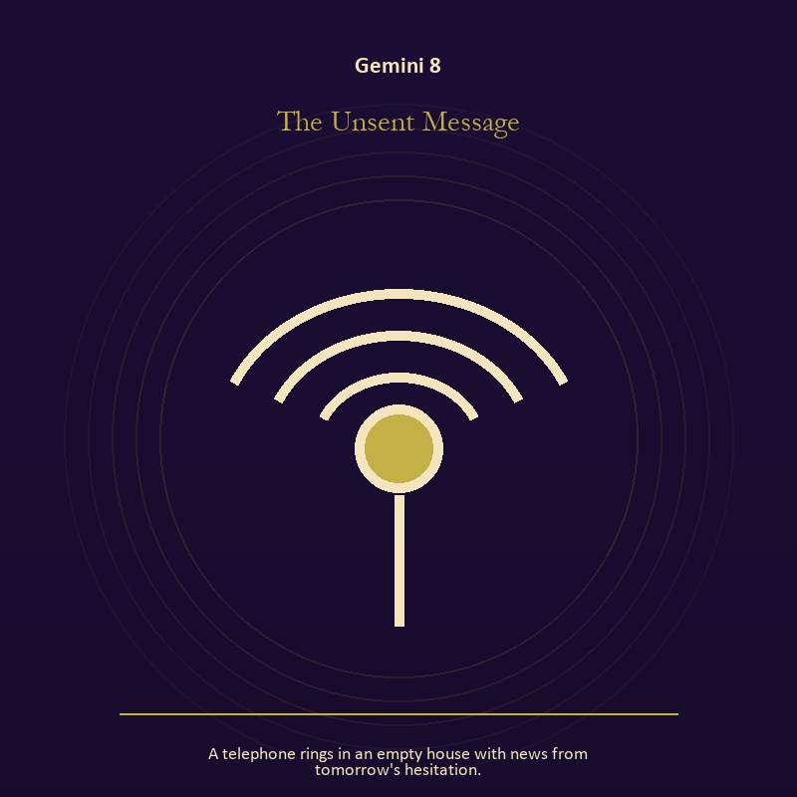

Gemini 8 The Unsent Message
A telephone rings in an empty house with news from tomorrow's hesitation.
INTERPRETATION The Unsent Message holds voice and naming against language, curiosity, contradiction, and bridges between separate minds. Within the Unsent Message, books, letters, bells, and songs extend speech beyond the speaker's body. At Gemini 8, the message acquires a life that intention can no longer fully govern. The same image also carries the Signal; at Gemini 8, signal imagery asks what is being transmitted beneath performance. As a friction degree, Gemini 8 tests whether the sign can change course without treating correction as defeat.
SIGNAL At Gemini 8, listening precise enough to change the reply joined to clear transmission becomes the clean signal when Gemini can ask the second question and describe what you heard before answering.
SHADOW The distortion at Gemini 8 is using language to outrun experience and confusing reach with truth; beware speed without listening, cleverness without stakes, and rumor wearing the clothes of inquiry.
MIRROR With the Unsent Message in mind at Gemini 8, what needs to be said plainly, and who has earned the right to hear it?
PRACTICE Work with The Unsent Message directly at Gemini 8: write the sentence you keep rehearsing, remove every accusation you cannot prove, and read what remains aloud. For the second pressure at Gemini 8, turn off one source of noise for an hour and notice what thought keeps returning.

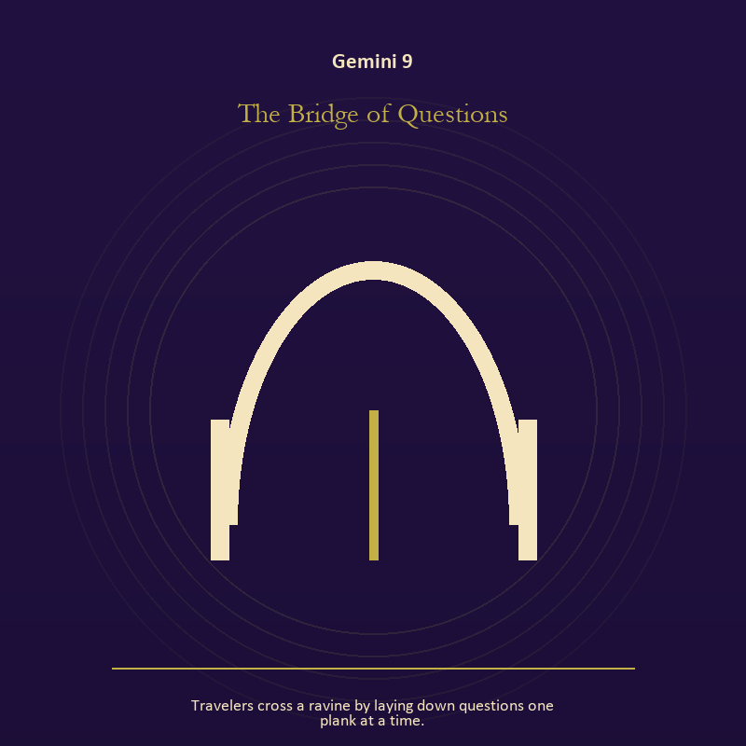

Gemini 9 The Bridge of Questions
Travelers cross a ravine by laying down questions one plank at a time.
INTERPRETATION The Bridge of Questions gives the threshold consequences inside the Twin Transmission. Within the Bridge of Questions, a boundary can protect life, restrict it, or clarify the terms of meeting. At Gemini 9, the surrounding action reveals which function is active here. As a friction degree, Gemini 9 brings another will, material limit, or inconvenient fact into the frame.
SIGNAL The usable force at Gemini 9 is honest passage; Gemini gives it form by asking you to ask the second question and describe what you heard before answering.
SHADOW At Gemini 9, the Bridge of Questions can turn toward guarding an obsolete enclosure; beware speed without listening, cleverness without stakes, and rumor wearing the clothes of inquiry.
MIRROR The question at Gemini 9: what would make the next step chosen rather than compelled?
PRACTICE Give Gemini 9 a physical form; draw the boundary as a line on paper; then mark the gate, the guard, and the person who holds the key.
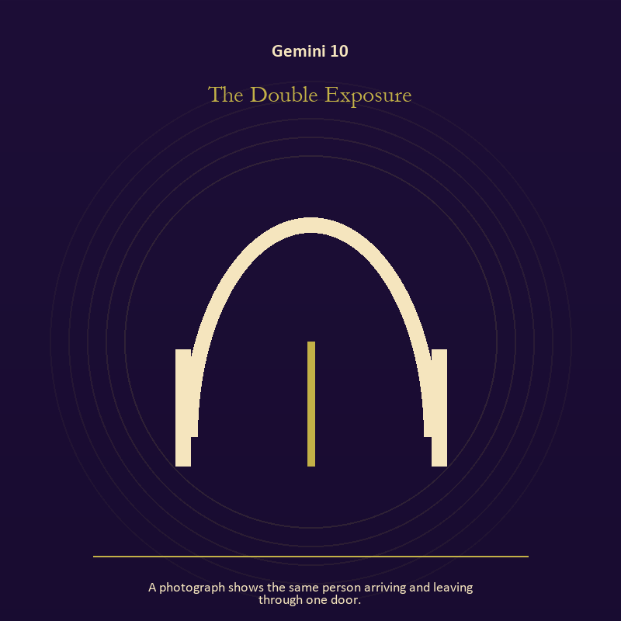

Gemini 10 The Double Exposure
A photograph shows the same person arriving and leaving through one door.
INTERPRETATION The Double Exposure puts the threshold under pressure from language, curiosity, contradiction, and bridges between separate minds. Within the Double Exposure, a threshold measures consent, timing, and consequence. At Gemini 10, its presence asks whether passage is chosen, forced, delayed, or already under way. The same image also carries the Mirror; at Gemini 10, a shadow proves that something real stands in the light, while a reflection shows only an angle. As a friction degree, Gemini 10 slows the original motion long enough to expose what haste concealed.
SIGNAL At Gemini 10, chosen change joined to the courage to revise a familiar self-image carries the signal; it stays honest when you ask the second question and describe what you heard before answering.
SHADOW The shadow at Gemini 10 begins with waiting for permission that will never come and mistaking appearance for character; also beware speed without listening, cleverness without stakes, and rumor wearing the clothes of inquiry.
MIRROR At Gemini 10, which threshold in your life requires consent rather than momentum?
PRACTICE Bring Gemini 10 out of abstraction: write one sentence beginning, 'I may enter when,' and one beginning, 'I remain free to leave when.'.

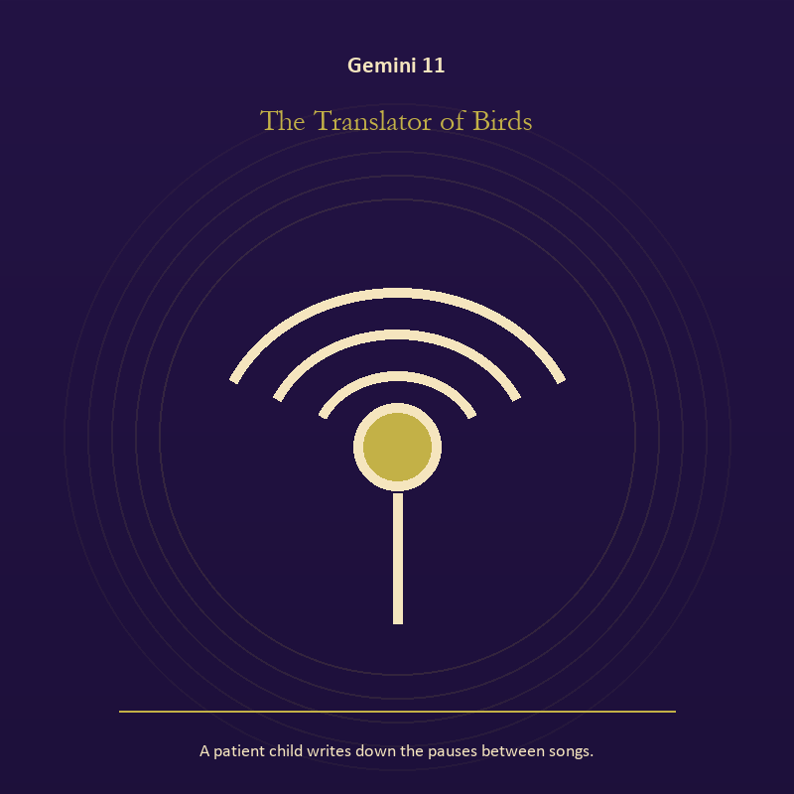

Gemini 11 The Translator of Birds
A patient child writes down the pauses between songs.
INTERPRETATION In the Translator of Birds, the work of growth must answer to language, curiosity, contradiction, and bridges between separate minds. Within the Translator of Birds, seeds, children, roots, and gardens refuse the fantasy of instant transformation. At Gemini 11, they make becoming physical, seasonal, and dependent on care. As a revelation degree, Gemini 11 reveals the mechanism under the mood; one concrete detail changes the reading.
SIGNAL What can be carried forward from Gemini 11 is inheritance revised through living action, tested by the need to ask the second question and describe what you heard before answering.
SHADOW At Gemini 11, the image darkens through forcing a season; beware speed without listening, cleverness without stakes, and rumor wearing the clothes of inquiry.
MIRROR For Gemini 11, which condition would help this growth, and which demand would deform it?
PRACTICE For Gemini 11, tend one living thing and let its pace correct your schedule.
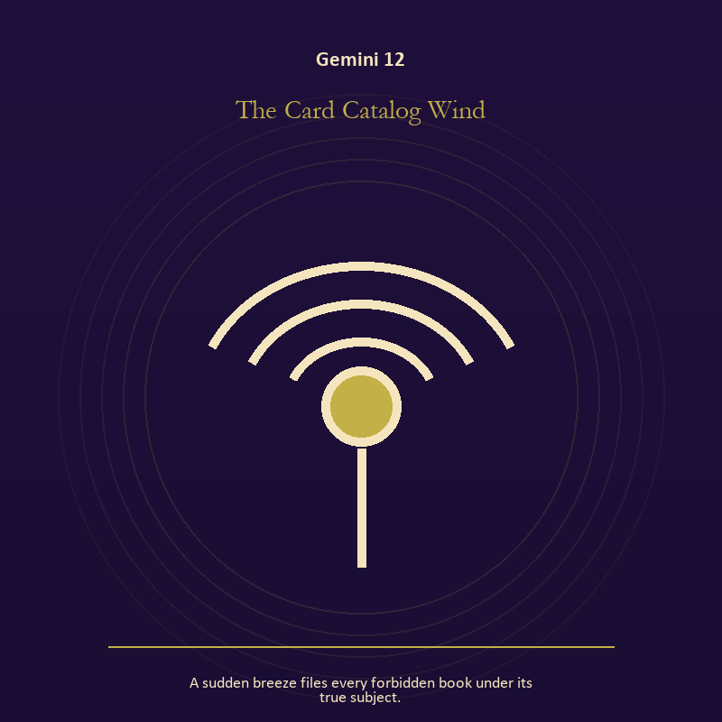

Gemini 12 The Card Catalog Wind
A sudden breeze files every forbidden book under its true subject.
INTERPRETATION The Card Catalog Wind tests voice and naming against language, curiosity, contradiction, and bridges between separate minds. Within the Card Catalog Wind, naming creates a handle for experience, but the handle must remain smaller than the life it describes. At Gemini 12, the image tests language against reality. As a revelation degree, Gemini 12 moves the hidden arrangement into view, where it can be named without being exaggerated.
SIGNAL At Gemini 12, speech with consequence becomes the clean signal when Gemini can ask the second question and describe what you heard before answering.
SHADOW The distortion at Gemini 12 is repeating a message until it sounds like evidence; beware speed without listening, cleverness without stakes, and rumor wearing the clothes of inquiry.
MIRROR With the Card Catalog Wind in mind at Gemini 12, what are you naming accurately, and what remains larger than the name?
PRACTICE Work with The Card Catalog Wind directly at Gemini 12: listen to one person without planning your answer; then repeat their meaning before offering your own.

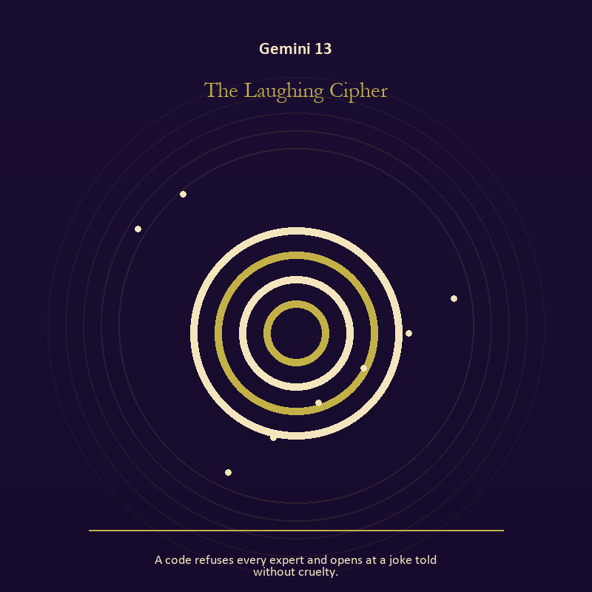

Gemini 13 The Laughing Cipher
A code refuses every expert and opens at a joke told without cruelty.
INTERPRETATION The Laughing Cipher holds mystery against language, curiosity, contradiction, and bridges between separate minds. Within the Laughing Cipher, the scene behaves like a dream with its own exact logic. At Gemini 13, meaning lives in the relationship between figure, place, action, and the detail that refuses ordinary explanation. As a revelation degree, Gemini 13 turns atmosphere into evidence; attend to the object or action that cannot be explained away.
SIGNAL The usable force at Gemini 13 is imagination disciplined by the scene; Gemini gives it form by asking you to ask the second question and describe what you heard before answering.
SHADOW At Gemini 13, the Laughing Cipher can turn toward mistaking intensity for accuracy; beware speed without listening, cleverness without stakes, and rumor wearing the clothes of inquiry.
MIRROR The question at Gemini 13: which detail keeps returning after the rest of the scene fades?
PRACTICE Give Gemini 13 a physical form; keep the image nearby for one day and record only the moments when it returns on its own.
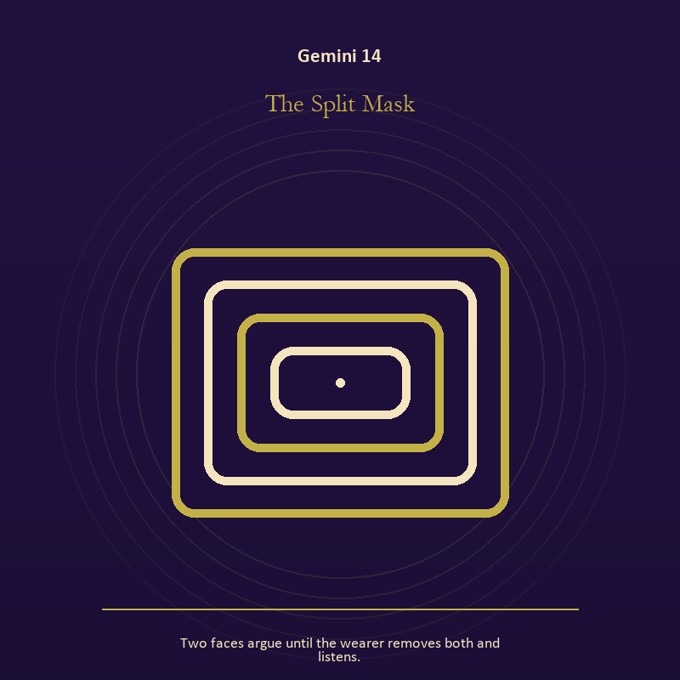

Gemini 14 The Split Mask
Two faces argue until the wearer removes both and listens.
INTERPRETATION The Split Mask gives identity consequences inside the Twin Transmission. Within the Split Mask, masks and names can conceal, reveal, or give shape to a truth that plain speech cannot yet hold. At Gemini 14, their value depends on whether removal remains possible. The same image also carries relationship; at Gemini 14, more than one will is active in this scene. As a revelation degree, Gemini 14 shows who carries the cost, who controls the passage, and what the scene refuses to hide.
SIGNAL At Gemini 14, the freedom to revise a name or role joined to contact without capture carries the signal; it stays honest when you ask the second question and describe what you heard before answering.
SHADOW The shadow at Gemini 14 begins with performance mistaken for selfhood and projection mistaken for intimacy; also beware speed without listening, cleverness without stakes, and rumor wearing the clothes of inquiry.
MIRROR At Gemini 14, what does the mask make possible, and what does it cost to keep wearing it?
PRACTICE Bring Gemini 14 out of abstraction: list the roles you carry; then mark each as chosen, inherited, temporary, or ready to release.

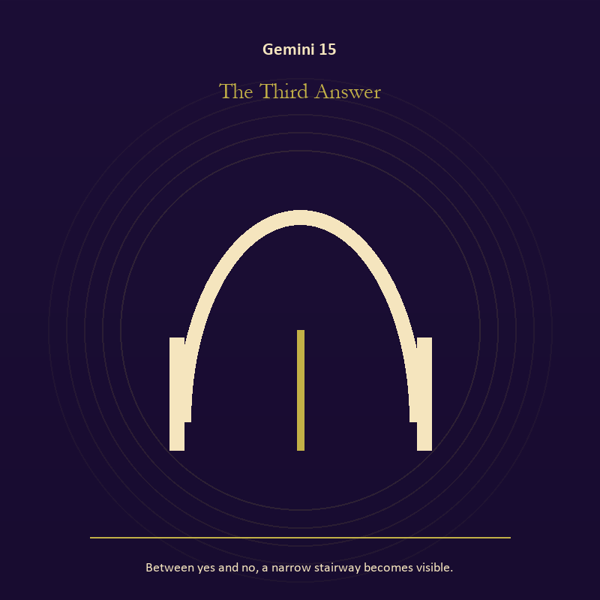

Gemini 15 The Third Answer
Between yes and no, a narrow stairway becomes visible.
INTERPRETATION The Third Answer puts voice and naming under pressure from language, curiosity, contradiction, and bridges between separate minds. Within the Third Answer, naming creates a handle for experience, but the handle must remain smaller than the life it describes. At Gemini 15, the image tests language against reality. As a revelation degree, Gemini 15 brings the middle truth forward, after the first story has lost its grip.
SIGNAL What can be carried forward from Gemini 15 is speech with consequence, tested by the need to ask the second question and describe what you heard before answering.
SHADOW At Gemini 15, the image darkens through repeating a message until it sounds like evidence; beware speed without listening, cleverness without stakes, and rumor wearing the clothes of inquiry.
MIRROR For Gemini 15, what are you naming accurately, and what remains larger than the name?
PRACTICE For Gemini 15, listen to one person without planning your answer; then repeat their meaning before offering your own.
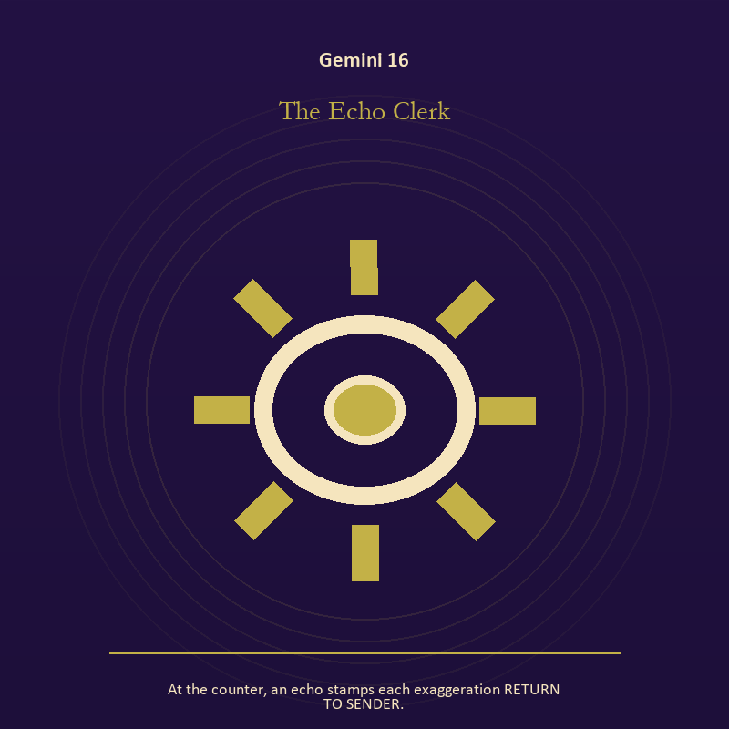

Gemini 16 The Echo Clerk
At the counter, an echo stamps each exaggeration RETURN TO SENDER.
INTERPRETATION In the Echo Clerk, the work of craft and record must answer to language, curiosity, contradiction, and bridges between separate minds. Within the Echo Clerk, craft turns intention into a repeatable act with materials, limits, and evidence of failure. At Gemini 16, the tool reveals the quality of attention brought to it. As a choice degree, Gemini 16 requires a choice with a human cost; insight alone no longer completes the work.
SIGNAL At Gemini 16, evidence preserved without spectacle becomes the clean signal when Gemini can ask the second question and describe what you heard before answering.
SHADOW The distortion at Gemini 16 is polish used to hide a structural weakness; beware speed without listening, cleverness without stakes, and rumor wearing the clothes of inquiry.
MIRROR With the Echo Clerk in mind at Gemini 16, which part of this process can be checked rather than assumed?
PRACTICE Work with The Echo Clerk directly at Gemini 16: repair one useful object without disguising the place where it broke.

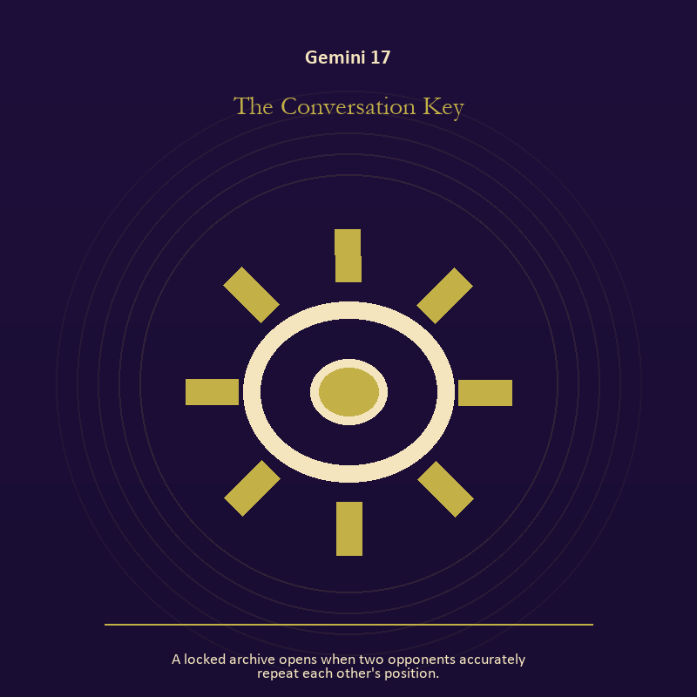

Gemini 17 The Conversation Key
A locked archive opens when two opponents accurately repeat each other's position.
INTERPRETATION The Conversation Key tests craft and record against language, curiosity, contradiction, and bridges between separate minds. Within the Conversation Key, ledgers, maps, machines, and archives make memory operational. At Gemini 17, they can protect truth or compress living complexity until only the form remains. The same image also carries relationship; at Gemini 17, more than one will is active in this scene. As a choice degree, Gemini 17 asks what action preserves truth without using another person as material.
SIGNAL The usable force at Gemini 17 is a useful correction that outlives the moment joined to contact without capture; Gemini gives it form by asking you to ask the second question and describe what you heard before answering.
SHADOW At Gemini 17, the Conversation Key can turn toward measurement mistaken for meaning and projection mistaken for intimacy; beware speed without listening, cleverness without stakes, and rumor wearing the clothes of inquiry.
MIRROR The question at Gemini 17: what does the tool preserve, and what does it leave out?
PRACTICE Give Gemini 17 a physical form; inspect one repeated task and add a check that would catch the most expensive error.
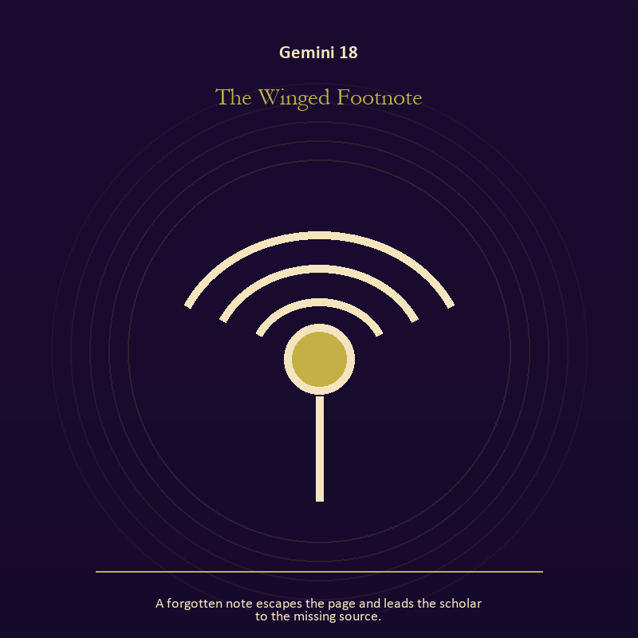

Gemini 18 The Winged Footnote
A forgotten note escapes the page and leads the scholar to the missing source.
INTERPRETATION The Winged Footnote holds voice and naming against language, curiosity, contradiction, and bridges between separate minds. Within the Winged Footnote, naming creates a handle for experience, but the handle must remain smaller than the life it describes. At Gemini 18, the image tests language against reality. As a choice degree, Gemini 18 moves from recognition to conduct; the clean choice must survive outside the imagination.
SIGNAL At Gemini 18, speech with consequence carries the signal; it stays honest when you ask the second question and describe what you heard before answering.
SHADOW The shadow at Gemini 18 begins with repeating a message until it sounds like evidence; also beware speed without listening, cleverness without stakes, and rumor wearing the clothes of inquiry.
MIRROR At Gemini 18, what are you naming accurately, and what remains larger than the name?
PRACTICE Bring Gemini 18 out of abstraction: listen to one person without planning your answer; then repeat their meaning before offering your own.

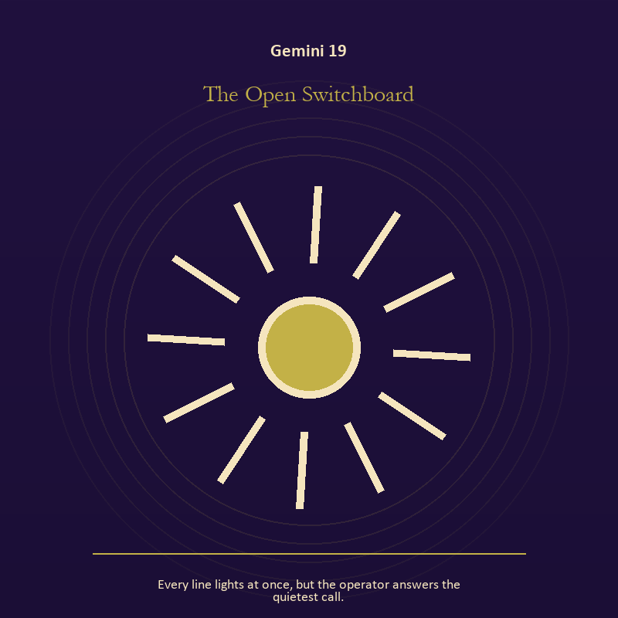

Gemini 19 The Open Switchboard
Every line lights at once, but the operator answers the quietest call.
INTERPRETATION The Open Switchboard gives mystery consequences inside the Twin Transmission. Within the Open Switchboard, the scene behaves like a dream with its own exact logic. At Gemini 19, meaning lives in the relationship between figure, place, action, and the detail that refuses ordinary explanation. As a choice degree, Gemini 19 tests whether awareness can become restraint, repair, refusal, or consent.
SIGNAL What can be carried forward from Gemini 19 is imagination disciplined by the scene, tested by the need to ask the second question and describe what you heard before answering.
SHADOW At Gemini 19, the image darkens through mistaking intensity for accuracy; beware speed without listening, cleverness without stakes, and rumor wearing the clothes of inquiry.
MIRROR For Gemini 19, which detail keeps returning after the rest of the scene fades?
PRACTICE For Gemini 19, keep the image nearby for one day and record only the moments when it returns on its own.
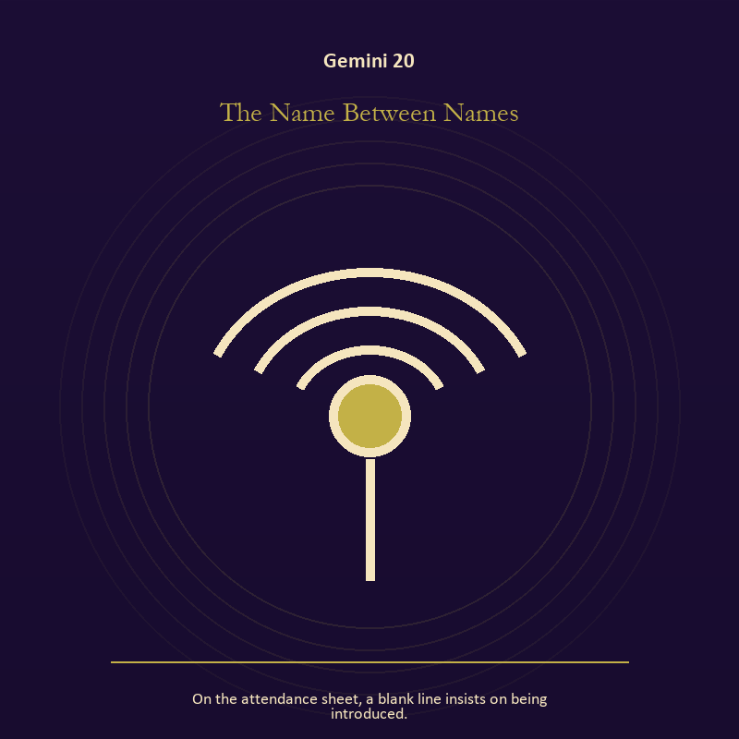

Gemini 20 The Name Between Names
On the attendance sheet, a blank line insists on being introduced.
INTERPRETATION The Name Between Names puts voice and naming under pressure from language, curiosity, contradiction, and bridges between separate minds. Within the Name Between Names, books, letters, bells, and songs extend speech beyond the speaker's body. At Gemini 20, the message acquires a life that intention can no longer fully govern. The same image also carries identity; at Gemini 20, identity appears as something worn, spoken, assigned, revised, or returned. As a choice degree, Gemini 20 places responsibility in the reader's hands without promising a painless answer.
SIGNAL At Gemini 20, listening precise enough to change the reply joined to self-authorship becomes the clean signal when Gemini can ask the second question and describe what you heard before answering.
SHADOW The distortion at Gemini 20 is using language to outrun experience and an assigned identity accepted as fate; beware speed without listening, cleverness without stakes, and rumor wearing the clothes of inquiry.
MIRROR With the Name Between Names in mind at Gemini 20, what needs to be said plainly, and who has earned the right to hear it?
PRACTICE Work with The Name Between Names directly at Gemini 20: write the sentence you keep rehearsing, remove every accusation you cannot prove, and read what remains aloud. For the second pressure at Gemini 20, write your name beside one quality no title can grant or remove.

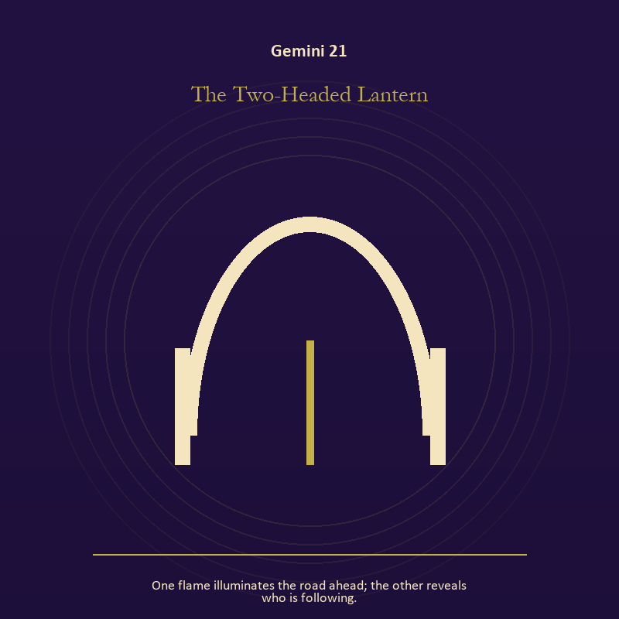

Gemini 21 The Two-Headed Lantern
One flame illuminates the road ahead; the other reveals who is following.
INTERPRETATION In the Two-Headed Lantern, the work of living fire must answer to language, curiosity, contradiction, and bridges between separate minds. Within the Two-Headed Lantern, a Lantern offers enough light for the next honest step. At Gemini 21, it does not remove night, and its usefulness depends on how it is carried. The same image also carries relationship; at Gemini 21, relationship imagery tests the fantasy that harmony requires sameness. As a integration degree, Gemini 21 holds the gift beside its distortion; using one without feeding the other is the work.
SIGNAL The usable force at Gemini 21 is attention with warmth joined to mutual responsibility; Gemini gives it form by asking you to ask the second question and describe what you heard before answering.
SHADOW At Gemini 21, the Two-Headed Lantern can turn toward exposure without care and the group protecting itself by sacrificing an outsider; beware speed without listening, cleverness without stakes, and rumor wearing the clothes of inquiry.
MIRROR The question at Gemini 21: how much light does the next step require, and who might it expose? From a second angle at Gemini 21, where does responsibility belong, and where has it been displaced?
PRACTICE Give Gemini 21 a physical form; move one hidden concern into plain view by naming it to a trusted person.
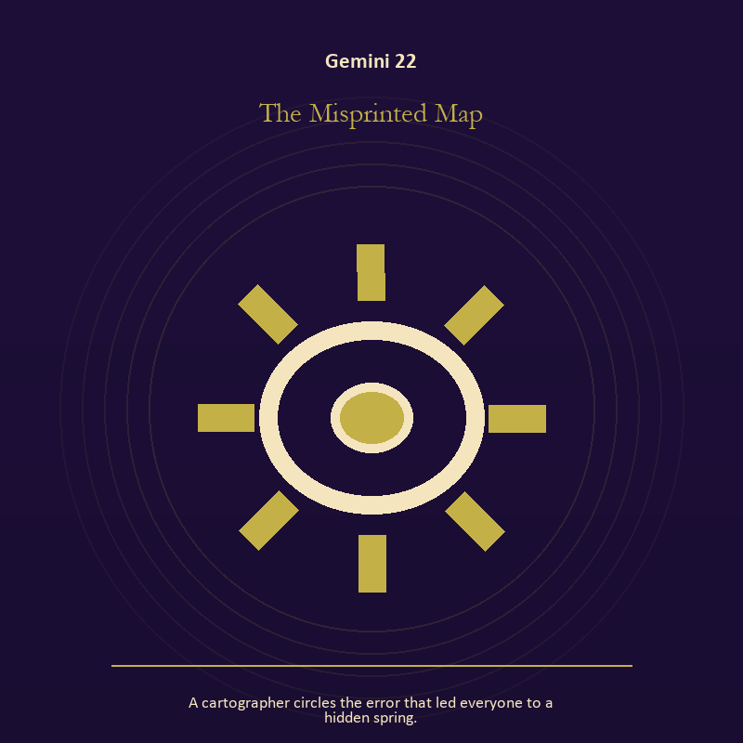

Gemini 22 The Misprinted Map
A cartographer circles the error that led everyone to a hidden spring.
INTERPRETATION The Misprinted Map tests craft and record against language, curiosity, contradiction, and bridges between separate minds. Within the Misprinted Map, craft turns intention into a repeatable act with materials, limits, and evidence of failure. At Gemini 22, the tool reveals the quality of attention brought to it. As a integration degree, Gemini 22 asks the sign to carry its strength without turning that strength into jurisdiction.
SIGNAL At Gemini 22, evidence preserved without spectacle carries the signal; it stays honest when you ask the second question and describe what you heard before answering.
SHADOW The shadow at Gemini 22 begins with polish used to hide a structural weakness; also beware speed without listening, cleverness without stakes, and rumor wearing the clothes of inquiry.
MIRROR At Gemini 22, which part of this process can be checked rather than assumed?
PRACTICE Bring Gemini 22 out of abstraction: repair one useful object without disguising the place where it broke.

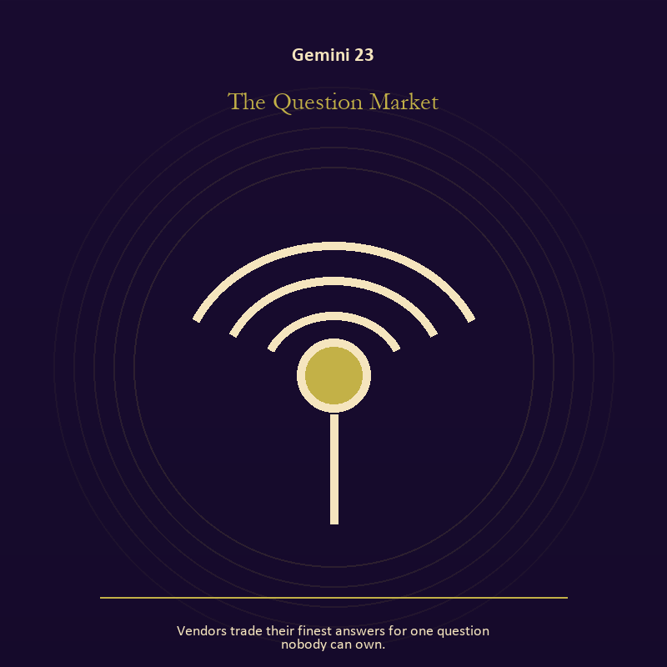

Gemini 23 The Question Market
Vendors trade their finest answers for one question nobody can own.
INTERPRETATION The Question Market holds voice and naming against language, curiosity, contradiction, and bridges between separate minds. Within the Question Market, books, letters, bells, and songs extend speech beyond the speaker's body. At Gemini 23, the message acquires a life that intention can no longer fully govern. As a integration degree, Gemini 23 joins capacity to consequence; what helps in one setting may harm in another.
SIGNAL What can be carried forward from Gemini 23 is listening precise enough to change the reply, tested by the need to ask the second question and describe what you heard before answering.
SHADOW At Gemini 23, the image darkens through using language to outrun experience; beware speed without listening, cleverness without stakes, and rumor wearing the clothes of inquiry.
MIRROR For Gemini 23, what needs to be said plainly, and who has earned the right to hear it?
PRACTICE For Gemini 23, write the sentence you keep rehearsing, remove every accusation you cannot prove, and read what remains aloud.
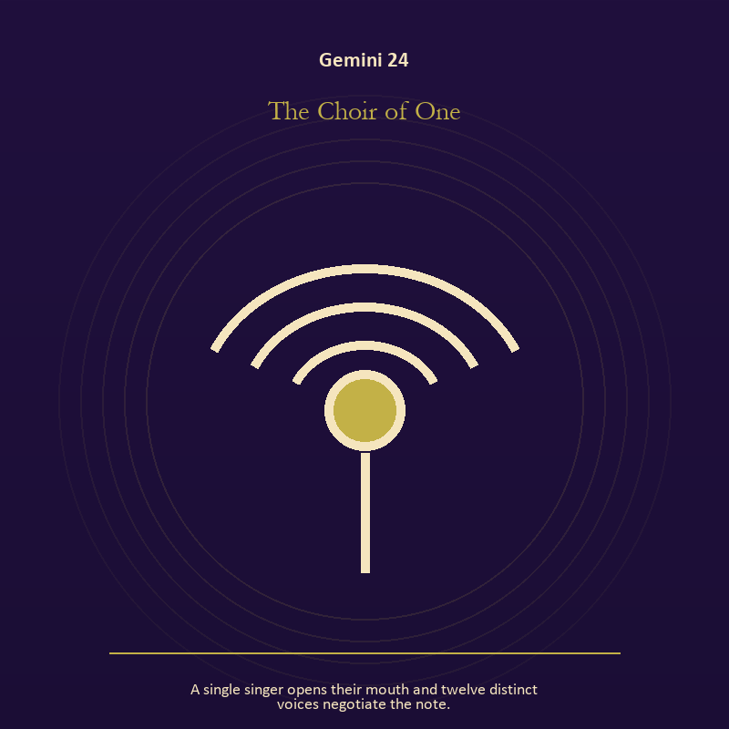

Gemini 24 The Choir of One
A single singer opens their mouth and twelve distinct voices negotiate the note.
INTERPRETATION The Choir of One gives voice and naming consequences inside the Twin Transmission. Within the Choir of One, naming creates a handle for experience, but the handle must remain smaller than the life it describes. At Gemini 24, the image tests language against reality. The same image also carries relationship; at Gemini 24, relationship imagery tests the fantasy that harmony requires sameness. As a integration degree, Gemini 24 shows the mature tool and the temptation hidden inside its handle.
SIGNAL At Gemini 24, speech with consequence joined to mutual responsibility becomes the clean signal when Gemini can ask the second question and describe what you heard before answering.
SHADOW The distortion at Gemini 24 is repeating a message until it sounds like evidence and the group protecting itself by sacrificing an outsider; beware speed without listening, cleverness without stakes, and rumor wearing the clothes of inquiry.
MIRROR With the Choir of One in mind at Gemini 24, what are you naming accurately, and what remains larger than the name? From a second angle at Gemini 24, where does responsibility belong, and where has it been displaced?
PRACTICE Work with The Choir of One directly at Gemini 24: listen to one person without planning your answer; then repeat their meaning before offering your own. For the second pressure at Gemini 24, make one repair that does not require the other person to erase their account.

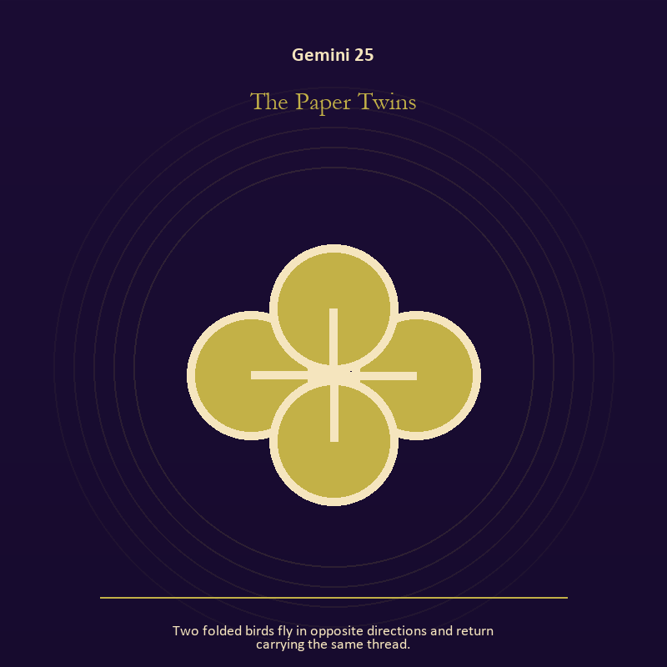

Gemini 25 The Paper Twins
Two folded birds fly in opposite directions and return carrying the same thread.
INTERPRETATION The Paper Twins puts relationship under pressure from language, curiosity, contradiction, and bridges between separate minds. Within the Paper Twins, more than one will is active in this scene. At Gemini 25, meaning emerges through distance, consent, conflict, care, and the terms under which contact continues. As a integration degree, Gemini 25 tests whether the lesson can be lived without becoming a new performance.
SIGNAL The usable force at Gemini 25 is mutual responsibility; Gemini gives it form by asking you to ask the second question and describe what you heard before answering.
SHADOW At Gemini 25, the Paper Twins can turn toward the group protecting itself by sacrificing an outsider; beware speed without listening, cleverness without stakes, and rumor wearing the clothes of inquiry.
MIRROR The question at Gemini 25: what agreement is operating here even if nobody has spoken it?
PRACTICE Give Gemini 25 a physical form; make one repair that does not require the other person to erase their account.
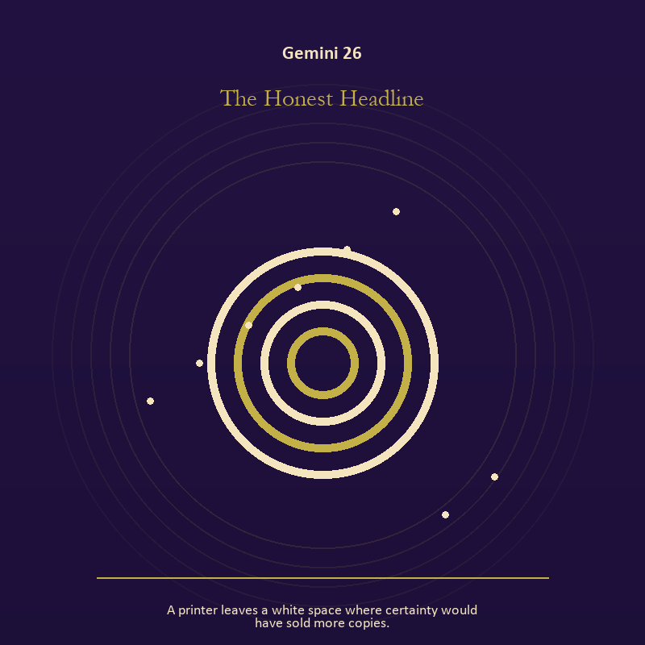

Gemini 26 The Honest Headline
A printer leaves a white space where certainty would have sold more copies.
INTERPRETATION In the Honest Headline, the work of mystery must answer to language, curiosity, contradiction, and bridges between separate minds. Within the Honest Headline, this image invites attention before conclusion. At Gemini 26, its strange fact creates a pressure point where memory, desire, fear, and choice can speak indirectly. As a release degree, Gemini 26 prepares the lesson to leave its original container; keep the capacity and loosen the role.
SIGNAL At Gemini 26, an unanswered image that keeps thought alive carries the signal; it stays honest when you ask the second question and describe what you heard before answering.
SHADOW The shadow at Gemini 26 begins with forcing a prophecy from ambiguity; also beware speed without listening, cleverness without stakes, and rumor wearing the clothes of inquiry.
MIRROR At Gemini 26, what ordinary fact sits beneath the strange image?
PRACTICE Bring Gemini 26 out of abstraction: copy the image by hand, underline three concrete nouns, and write one association for each.

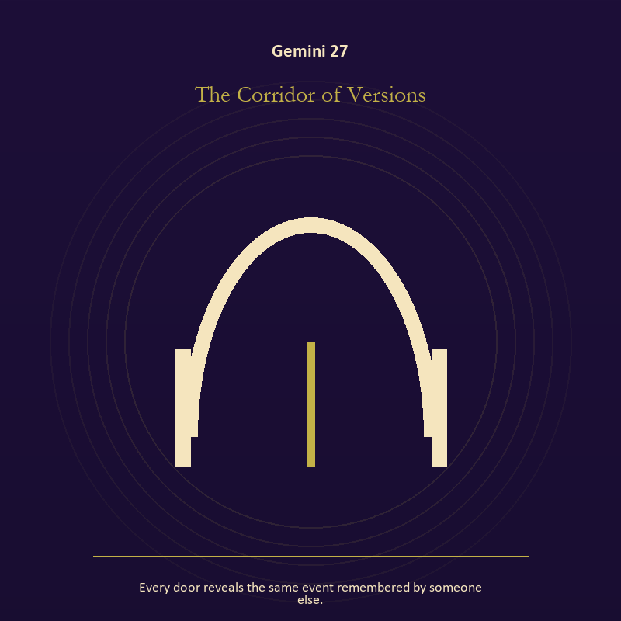

Gemini 27 The Corridor of Versions
Every door reveals the same event remembered by someone else.
INTERPRETATION The Corridor of Versions tests the threshold against language, curiosity, contradiction, and bridges between separate minds. Within the Corridor of Versions, a boundary can protect life, restrict it, or clarify the terms of meeting. At Gemini 27, the surrounding action reveals which function is active here. As a release degree, Gemini 27 asks what can be handed onward without demanding imitation or loyalty.
SIGNAL What can be carried forward from Gemini 27 is honest passage, tested by the need to ask the second question and describe what you heard before answering.
SHADOW At Gemini 27, the image darkens through guarding an obsolete enclosure; beware speed without listening, cleverness without stakes, and rumor wearing the clothes of inquiry.
MIRROR For Gemini 27, what would make the next step chosen rather than compelled?
PRACTICE For Gemini 27, draw the boundary as a line on paper; then mark the gate, the guard, and the person who holds the key.
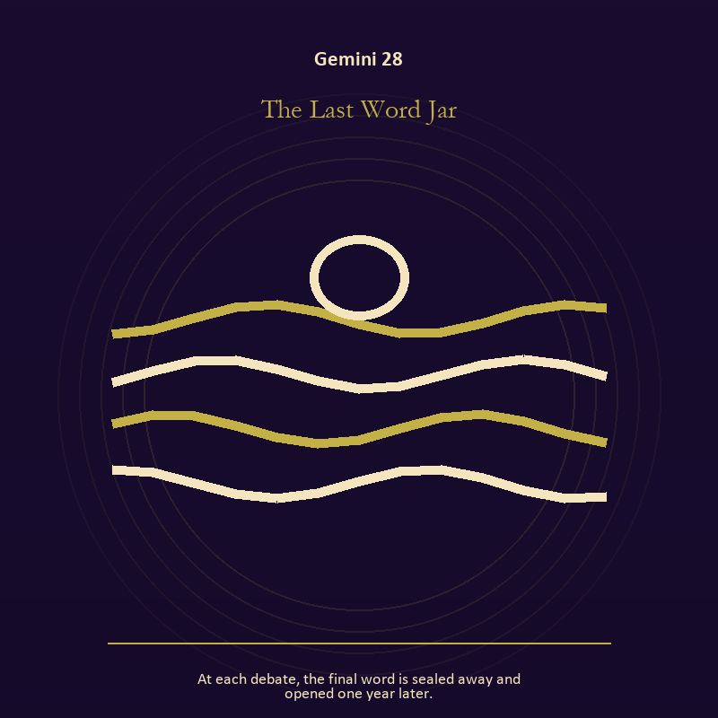

Gemini 28 The Last Word Jar
At each debate, the final word is sealed away and opened one year later.
INTERPRETATION The Last Word Jar holds voice and naming against language, curiosity, contradiction, and bridges between separate minds. Within the Last Word Jar, voice turns inner pressure into shared consequence. At Gemini 28, words can witness, summon, distort, repair, or conceal according to their precision and timing. As a release degree, Gemini 28 turns completion into transfer; the work survives by changing hands.
SIGNAL At Gemini 28, a name that restores agency becomes the clean signal when Gemini can ask the second question and describe what you heard before answering.
SHADOW The distortion at Gemini 28 is speaking for someone whose voice is present; beware speed without listening, cleverness without stakes, and rumor wearing the clothes of inquiry.
MIRROR With the Last Word Jar in mind at Gemini 28, which word in this scene changes the power relationship?
PRACTICE Work with The Last Word Jar directly at Gemini 28: give the current experience a temporary name and date it, leaving room for revision.

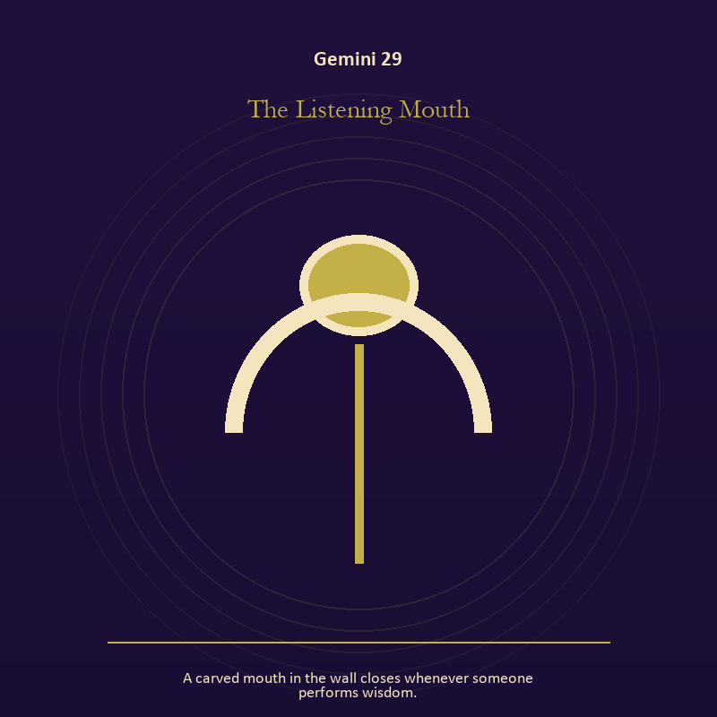

Gemini 29 The Listening Mouth
A carved mouth in the wall closes whenever someone performs wisdom.
INTERPRETATION The Listening Mouth gives the body consequences inside the Twin Transmission. Within the Listening Mouth, bread, rest, touch, clothing, and shelter make spiritual language answer to material need. At Gemini 29, an insight that harms the body requires correction. As a release degree, Gemini 29 lets the sign set down the identity built around its ordeal.
SIGNAL The usable force at Gemini 29 is a decision the nervous system can inhabit; Gemini gives it form by asking you to ask the second question and describe what you heard before answering.
SHADOW At Gemini 29, the Listening Mouth can turn toward using transcendence to ignore need; beware speed without listening, cleverness without stakes, and rumor wearing the clothes of inquiry.
MIRROR The question at Gemini 29: which need in this scene has been made too ordinary to mention?
PRACTICE Give Gemini 29 a physical form; eat, drink, rest, or move before making the interpretation more dramatic.
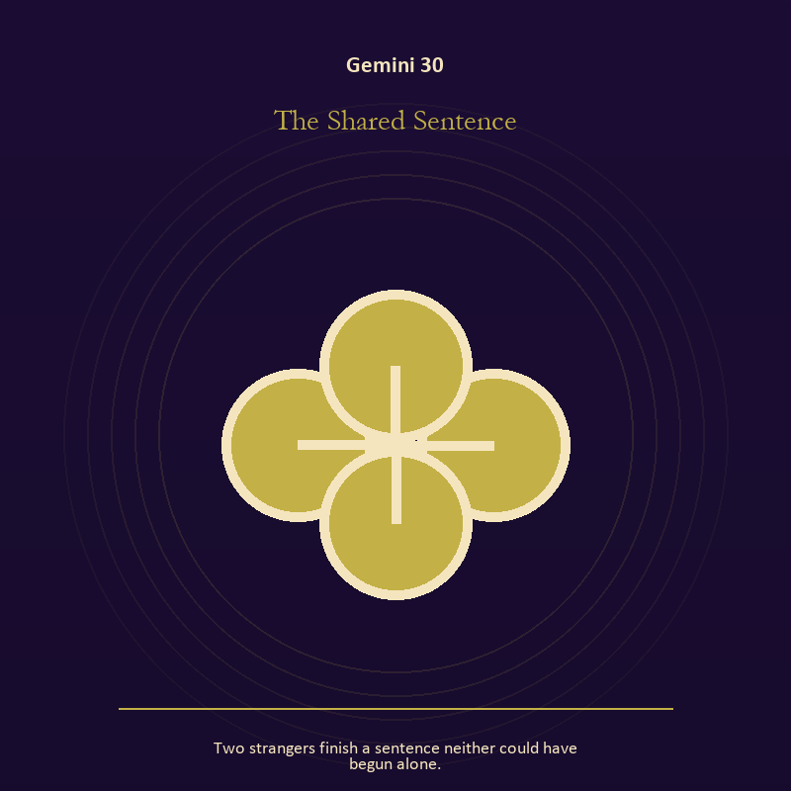

Gemini 30 The Shared Sentence
Two strangers finish a sentence neither could have begun alone.
INTERPRETATION The Shared Sentence puts relationship under pressure from language, curiosity, contradiction, and bridges between separate minds. Within the Shared Sentence, the shared object in the scene carries an agreement. At Gemini 30, its condition reveals whether responsibility is mutual, hidden, refused, or unevenly assigned. As a release degree, Gemini 30 returns the earned knowledge to ordinary life, where another cycle can use it.
SIGNAL At Gemini 30, contact without capture carries the signal; it stays honest when you ask the second question and describe what you heard before answering.
SHADOW The shadow at Gemini 30 begins with projection mistaken for intimacy; also beware speed without listening, cleverness without stakes, and rumor wearing the clothes of inquiry.
MIRROR At Gemini 30, can this bond survive an honest difference and a visible exit?
PRACTICE Bring Gemini 30 out of abstraction: name one need, one boundary, and one freedom that belong to each person in the scene.

Cancer
The House of Memory
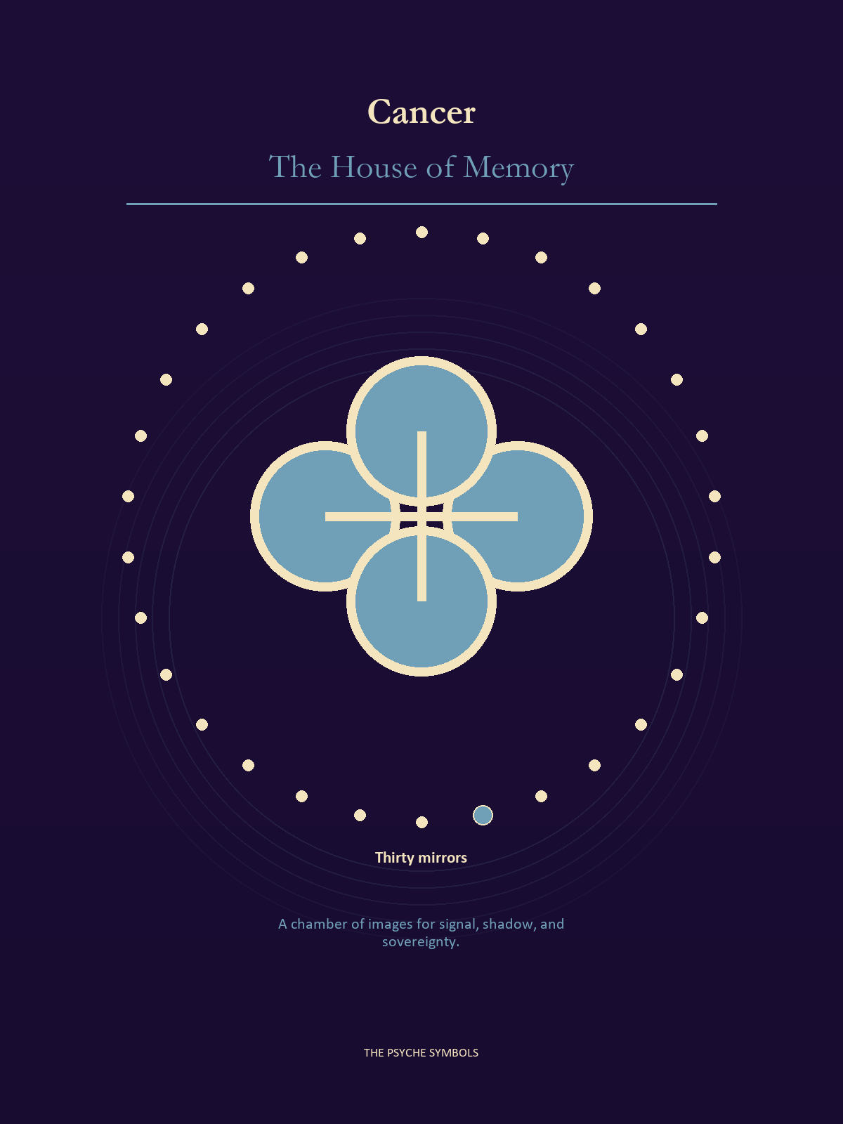
Cancer asks what the soul calls home and what that home asks in return. The House of Memory holds family stories, chosen kin, old grief, nourishment, and the boundary around vulnerable life. Here care grows strong enough to protect without imprisoning the person it loves.

Degrees | Gate | Work
1-5 | Arrival | Meet the image before deciding what it means.
6-10 | Friction | Notice what pushes back and what that resistance protects.
11-15 | Revelation | Name the detail that changes the whole scene.
16-20 | Choice | Choose the act that preserves both truth and human dignity.
21-25 | Integration | Use the gift without feeding the shadow that travels beside it.
26-30 | Release | Keep the earned capacity and release the role that delivered it.

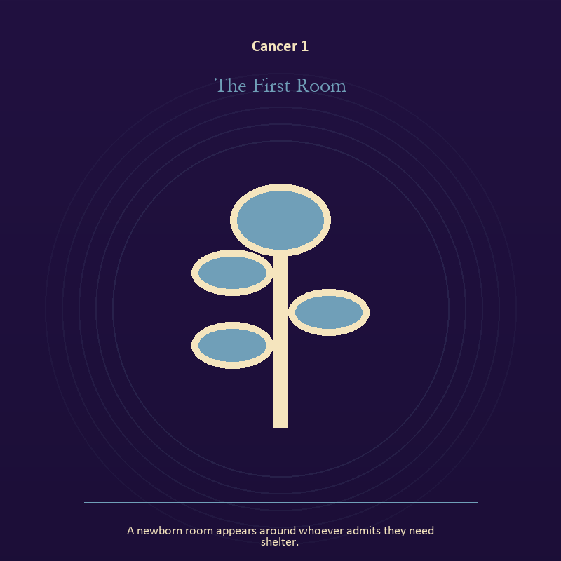

Cancer 1 The First Room
A newborn room appears around whoever admits they need shelter.
INTERPRETATION In the First Room, the work of growth must answer to belonging, protection, inheritance, and the tenderness that opens a door. Within the First Room, growth appears as vulnerable potential under specific conditions. At Cancer 1, it requires time, nourishment, protection, and eventual release from the form that began it. As an arrival degree, Cancer 1 arrives before habit can tidy the evidence; notice what is present before deciding what it should become.
SIGNAL What can be carried forward from Cancer 1 is care that honors timing, tested by the need to offer shelter that leaves the door visible.
SHADOW At Cancer 1, the image darkens through protecting potential so tightly that it cannot emerge; watch protection harden into control or memory become a reason to repeat the wound.
MIRROR For Cancer 1, what is alive here but not ready to be displayed?
PRACTICE For Cancer 1, release one expectation about what the new form must resemble.
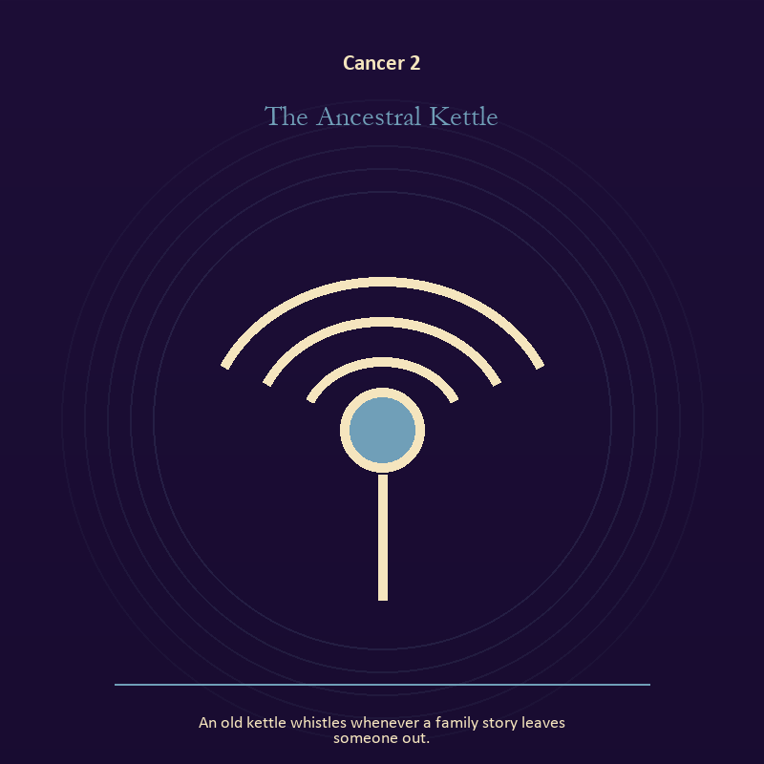

Cancer 2 The Ancestral Kettle
An old kettle whistles whenever a family story leaves someone out.
INTERPRETATION The Ancestral Kettle tests voice and naming against belonging, protection, inheritance, and the tenderness that opens a door. Within the Ancestral Kettle, books, letters, bells, and songs extend speech beyond the speaker's body. At Cancer 2, the message acquires a life that intention can no longer fully govern. The same image also carries relationship; at Cancer 2, more than one will is active in this scene. As an arrival degree, Cancer 2 introduces the sign's raw material in an unguarded form; the first response matters less than the honest one.
SIGNAL At Cancer 2, listening precise enough to change the reply joined to contact without capture becomes the clean signal when Cancer can offer shelter that leaves the door visible.
SHADOW The distortion at Cancer 2 is using language to outrun experience and projection mistaken for intimacy; watch protection harden into control or memory become a reason to repeat the wound.
MIRROR With the Ancestral Kettle in mind at Cancer 2, what needs to be said plainly, and who has earned the right to hear it?
PRACTICE Work with The Ancestral Kettle directly at Cancer 2: write the sentence you keep rehearsing, remove every accusation you cannot prove, and read what remains aloud. For the second pressure at Cancer 2, name one need, one boundary, and one freedom that belong to each person in the scene.

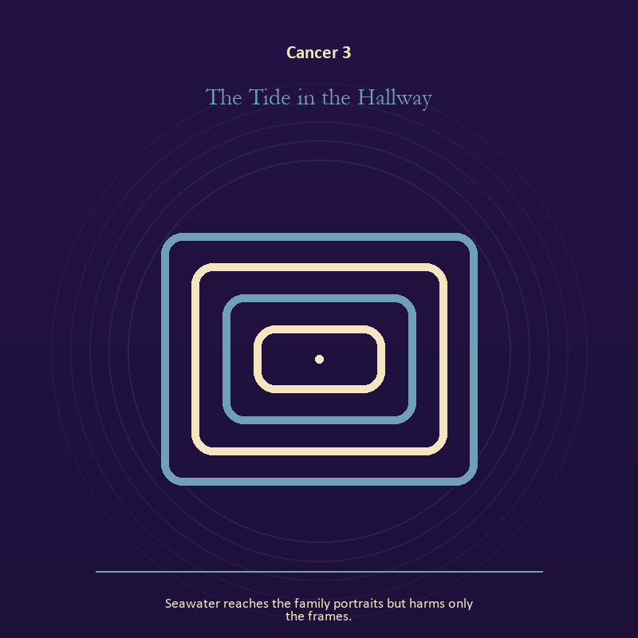

Cancer 3 The Tide in the Hallway
Seawater reaches the family portraits but harms only the frames.
INTERPRETATION The Tide in the Hallway holds living water against belonging, protection, inheritance, and the tenderness that opens a door. Within the Tide in the Hallway, rain, tides, wells, and floods move private material into a shared landscape. At Cancer 3, what was hidden becomes environmental and must be answered together. The same image also carries relationship; at Cancer 3, relationship imagery tests the fantasy that harmony requires sameness. As an arrival degree, Cancer 3 catches the first impulse before it turns into a role; give the image room to remain strange.
SIGNAL The usable force at Cancer 3 is feeling with a living boundary joined to mutual responsibility; Cancer gives it form by asking you to offer shelter that leaves the door visible.
SHADOW At Cancer 3, the Tide in the Hallway can turn toward using mystery to avoid a fact and the group protecting itself by sacrificing an outsider; watch protection harden into control or memory become a reason to repeat the wound.
MIRROR The question at Cancer 3: what has the tide exposed that cannot be covered again? From a second angle at Cancer 3, where does responsibility belong, and where has it been displaced?
PRACTICE Give Cancer 3 a physical form; write the feeling as weather, then add the exact fact occurring beneath that weather.
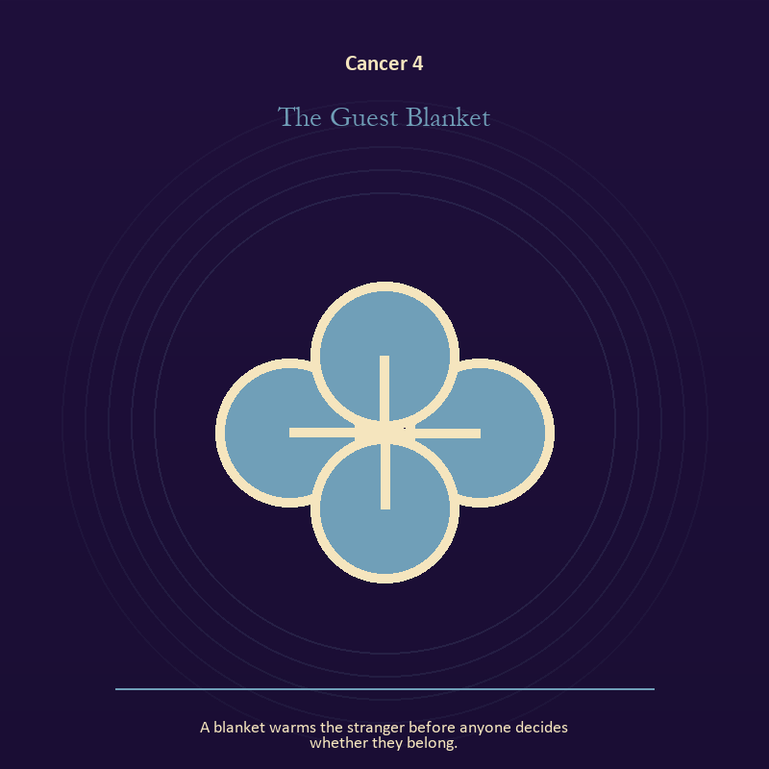

Cancer 4 The Guest Blanket
A blanket warms the stranger before anyone decides whether they belong.
INTERPRETATION The Guest Blanket gives relationship consequences inside the House of Memory. Within the Guest Blanket, more than one will is active in this scene. At Cancer 4, meaning emerges through distance, consent, conflict, care, and the terms under which contact continues. The same image also carries the body; at Cancer 4, embodiment gives every choice a pace and a cost. As an arrival degree, Cancer 4 opens the chamber with no settled method; name the need, risk, or appetite that entered with it.
SIGNAL At Cancer 4, mutual responsibility joined to a decision the nervous system can inhabit carries the signal; it stays honest when you offer shelter that leaves the door visible.
SHADOW The shadow at Cancer 4 begins with the group protecting itself by sacrificing an outsider and using transcendence to ignore need; also watch protection harden into control or memory become a reason to repeat the wound.
MIRROR At Cancer 4, what agreement is operating here even if nobody has spoken it?
PRACTICE Bring Cancer 4 out of abstraction: make one repair that does not require the other person to erase their account.

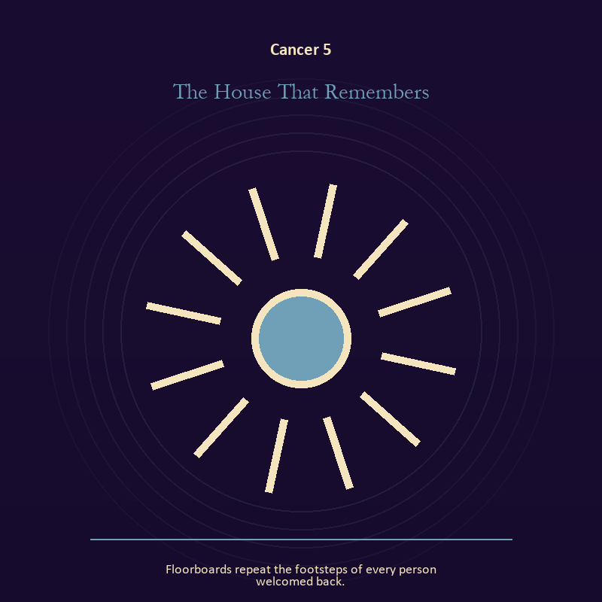

Cancer 5 The House That Remembers
Floorboards repeat the footsteps of every person welcomed back.
INTERPRETATION The House That Remembers puts relationship under pressure from belonging, protection, inheritance, and the tenderness that opens a door. Within the House That Remembers, relationship imagery tests the fantasy that harmony requires sameness. At Cancer 5, a living bond can hold difference, correction, privacy, and departure. The same image also carries the body; at Cancer 5, the body enters as witness, limit, appetite, labor, and home. As an arrival degree, Cancer 5 shows the beginning before ownership hardens around it; let attention come before possession.
SIGNAL What can be carried forward from Cancer 5 is difference held without humiliation joined to presence with weight and limits, tested by the need to offer shelter that leaves the door visible.
SHADOW At Cancer 5, the image darkens through harmony purchased by one person's silence and treating exhaustion as devotion; watch protection harden into control or memory become a reason to repeat the wound.
MIRROR For Cancer 5, where does responsibility belong, and where has it been displaced?
PRACTICE For Cancer 5, ask the other person what they believe the agreement is, then compare it with your own version.
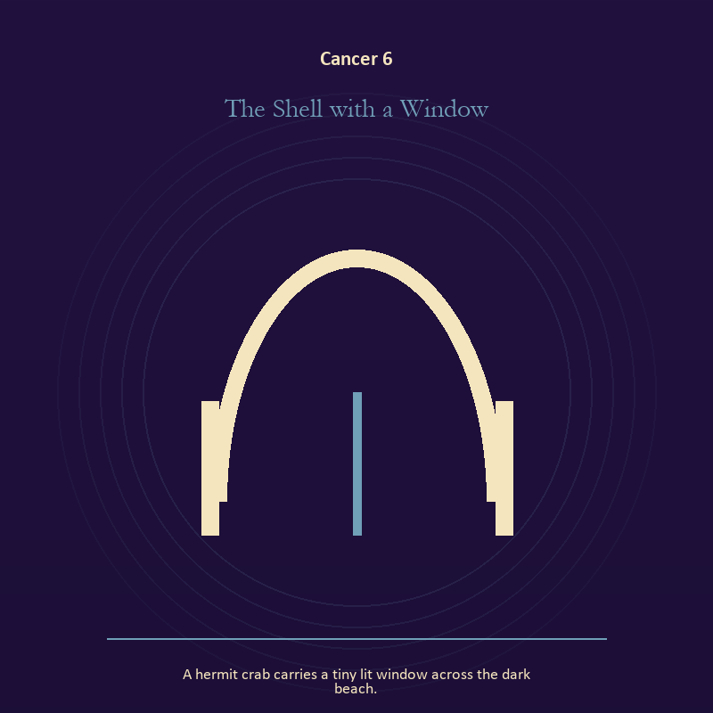

Cancer 6 The Shell with a Window
A hermit crab carries a tiny lit window across the dark beach.
INTERPRETATION In the Shell with a Window, the work of the threshold must answer to belonging, protection, inheritance, and the tenderness that opens a door. Within the Shell with a Window, a boundary can protect life, restrict it, or clarify the terms of meeting. At Cancer 6, the surrounding action reveals which function is active here. The same image also carries the descent; at Cancer 6, the underworld strips away rank and performance. As a friction degree, Cancer 6 meets resistance, and that resistance reveals what the first impulse failed to consider.
SIGNAL At Cancer 6, honest passage joined to contact with buried power becomes the clean signal when Cancer can offer shelter that leaves the door visible.
SHADOW The distortion at Cancer 6 is guarding an obsolete enclosure and remaining underground after the danger has passed; watch protection harden into control or memory become a reason to repeat the wound.
MIRROR With the Shell with a Window in mind at Cancer 6, what would make the next step chosen rather than compelled? From a second angle at Cancer 6, which part of the wound needs witness, and which part needs a boundary?
PRACTICE Work with The Shell with a Window directly at Cancer 6: draw the boundary as a line on paper; then mark the gate, the guard, and the person who holds the key. For the second pressure at Cancer 6, choose a trusted witness and tell the smallest complete truth you can safely tell.

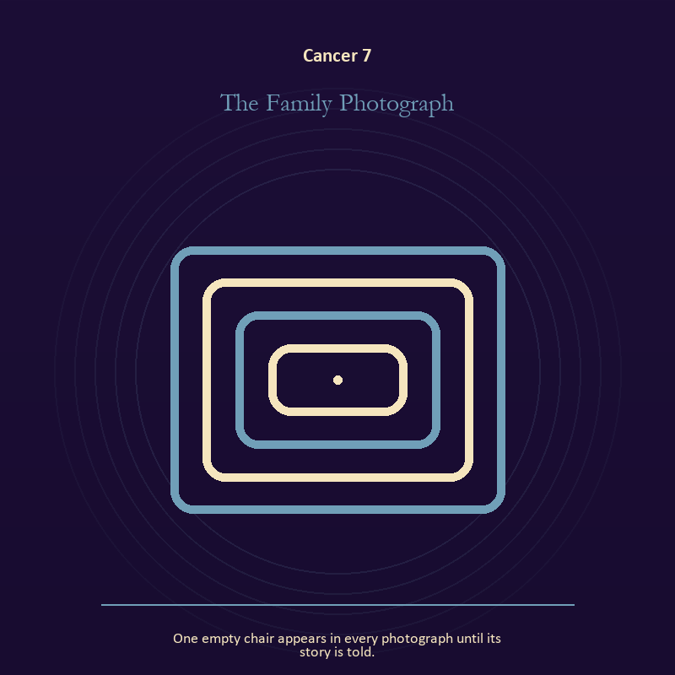

Cancer 7 The Family Photograph
One empty chair appears in every photograph until its story is told.
INTERPRETATION The Family Photograph tests the Mirror against belonging, protection, inheritance, and the tenderness that opens a door. Within the Family Photograph, the Mirror returns perception without guaranteeing accuracy. At Cancer 7, it reveals projection, self-image, and the temptation to kneel before a reflection. The same image also carries relationship; at Cancer 7, the shared object in the scene carries an agreement. As a friction degree, Cancer 7 places consequence beside desire; the obstruction may be an enemy, a limit, or a needed correction.
SIGNAL The usable force at Cancer 7 is a projection reclaimed joined to difference held without humiliation; Cancer gives it form by asking you to offer shelter that leaves the door visible.
SHADOW At Cancer 7, the Family Photograph can turn toward letting shame dictate what the Mirror may show and harmony purchased by one person's silence; watch protection harden into control or memory become a reason to repeat the wound.
MIRROR The question at Cancer 7: what are you seeing clearly, and what may be projection?
PRACTICE Give Cancer 7 a physical form; look into a Mirror for one minute and name facts only; then notice when judgment tries to enter as description.
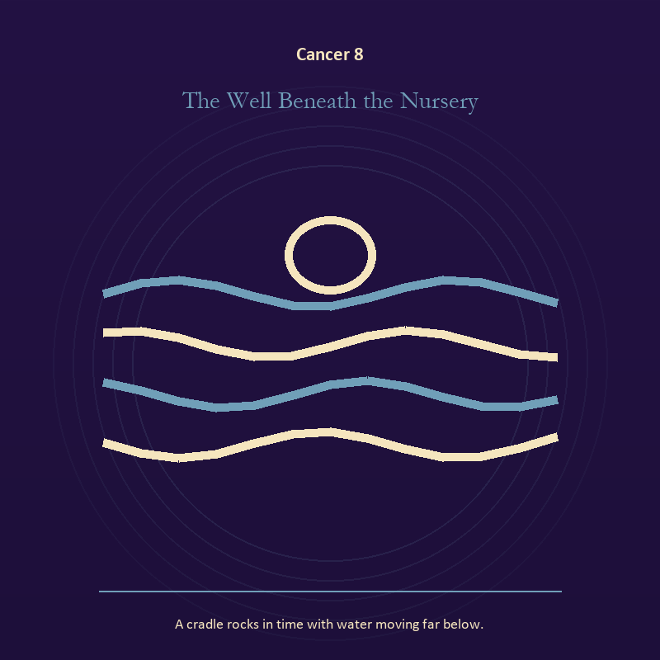

Cancer 8 The Well Beneath the Nursery
A cradle rocks in time with water moving far below.
INTERPRETATION The Well Beneath the Nursery holds living water against belonging, protection, inheritance, and the tenderness that opens a door. Within the Well Beneath the Nursery, a shore or vessel gives emotion a boundary without denying its depth. At Cancer 8, the scene asks whether the feeling needs containment, release, or witness. The same image also carries the descent; at Cancer 8, descent imagery carries what ordinary daylight has failed to resolve. As a friction degree, Cancer 8 tests whether the sign can change course without treating correction as defeat.
SIGNAL At Cancer 8, grief allowed to move joined to truth that survives loss carries the signal; it stays honest when you offer shelter that leaves the door visible.
SHADOW The shadow at Cancer 8 begins with drowning in another person's weather and suspicion filling gaps in the record; also watch protection harden into control or memory become a reason to repeat the wound.
MIRROR At Cancer 8, where are you adapting wisely, and where are you disappearing?
PRACTICE Bring Cancer 8 out of abstraction: pour water slowly between two vessels and name what must change shape without losing its substance.

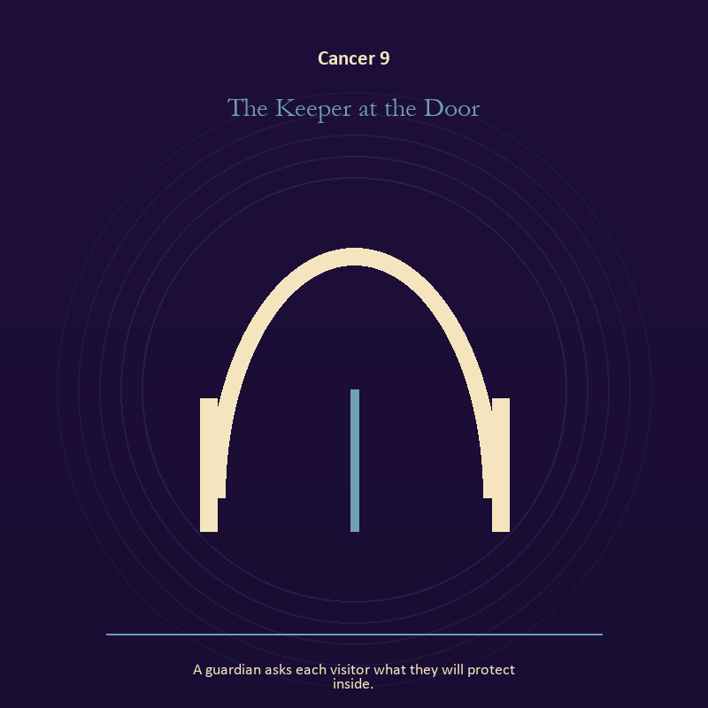

Cancer 9 The Keeper at the Door
A guardian asks each visitor what they will protect inside.
INTERPRETATION The Keeper at the Door gives the threshold consequences inside the House of Memory. Within the Keeper at the Door, a boundary can protect life, restrict it, or clarify the terms of meeting. At Cancer 9, the surrounding action reveals which function is active here. As a friction degree, Cancer 9 brings another will, material limit, or inconvenient fact into the frame.
SIGNAL What can be carried forward from Cancer 9 is honest passage, tested by the need to offer shelter that leaves the door visible.
SHADOW At Cancer 9, the image darkens through guarding an obsolete enclosure; watch protection harden into control or memory become a reason to repeat the wound.
MIRROR For Cancer 9, what would make the next step chosen rather than compelled?
PRACTICE For Cancer 9, draw the boundary as a line on paper; then mark the gate, the guard, and the person who holds the key.
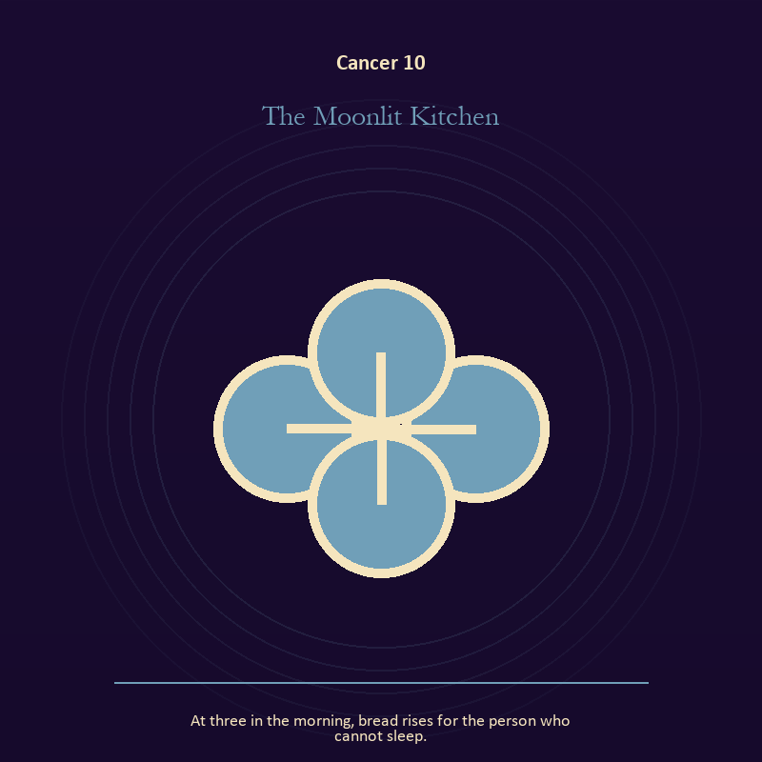

Cancer 10 The Moonlit Kitchen
At three in the morning, bread rises for the person who cannot sleep.
INTERPRETATION The Moonlit Kitchen puts relationship under pressure from belonging, protection, inheritance, and the tenderness that opens a door. Within the Moonlit Kitchen, more than one will is active in this scene. At Cancer 10, meaning emerges through distance, consent, conflict, care, and the terms under which contact continues. The same image also carries the body; at Cancer 10, embodiment gives every choice a pace and a cost. As a friction degree, Cancer 10 slows the original motion long enough to expose what haste concealed.
SIGNAL At Cancer 10, mutual responsibility joined to a decision the nervous system can inhabit becomes the clean signal when Cancer can offer shelter that leaves the door visible.
SHADOW The distortion at Cancer 10 is the group protecting itself by sacrificing an outsider and using transcendence to ignore need; watch protection harden into control or memory become a reason to repeat the wound.
MIRROR With the Moonlit Kitchen in mind at Cancer 10, what agreement is operating here even if nobody has spoken it?
PRACTICE Work with The Moonlit Kitchen directly at Cancer 10: make one repair that does not require the other person to erase their account. For the second pressure at Cancer 10, eat, drink, rest, or move before making the interpretation more dramatic.

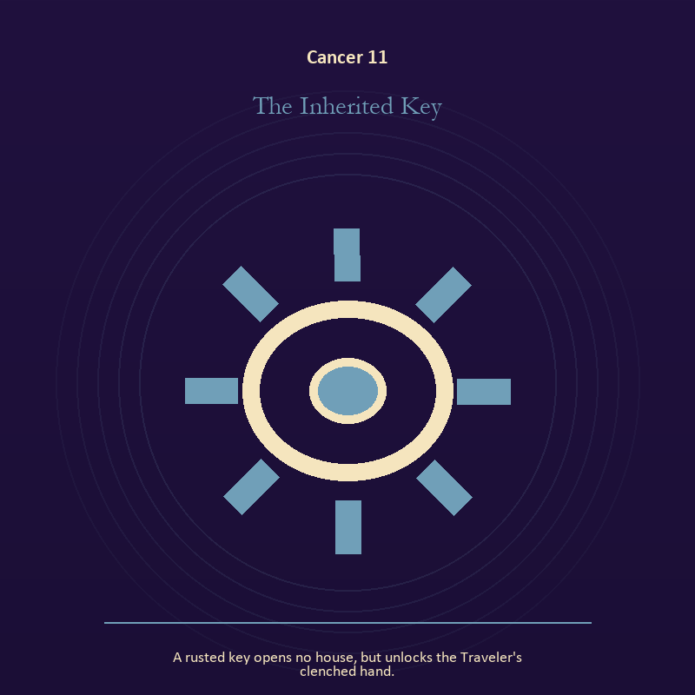

Cancer 11 The Inherited Key
A rusted key opens no house, but unlocks the Traveler's clenched hand.
INTERPRETATION In the Inherited Key, the work of craft and record must answer to belonging, protection, inheritance, and the tenderness that opens a door. Within the Inherited Key, ledgers, maps, machines, and archives make memory operational. At Cancer 11, they can protect truth or compress living complexity until only the form remains. The same image also carries the body; at Cancer 11, the body enters as witness, limit, appetite, labor, and home. As a revelation degree, Cancer 11 reveals the mechanism under the mood; one concrete detail changes the reading.
SIGNAL The usable force at Cancer 11 is a useful correction that outlives the moment joined to presence with weight and limits; Cancer gives it form by asking you to offer shelter that leaves the door visible.
SHADOW At Cancer 11, the Inherited Key can turn toward measurement mistaken for meaning and treating exhaustion as devotion; watch protection harden into control or memory become a reason to repeat the wound.
MIRROR The question at Cancer 11: what does the tool preserve, and what does it leave out?
PRACTICE Give Cancer 11 a physical form; inspect one repeated task and add a check that would catch the most expensive error.
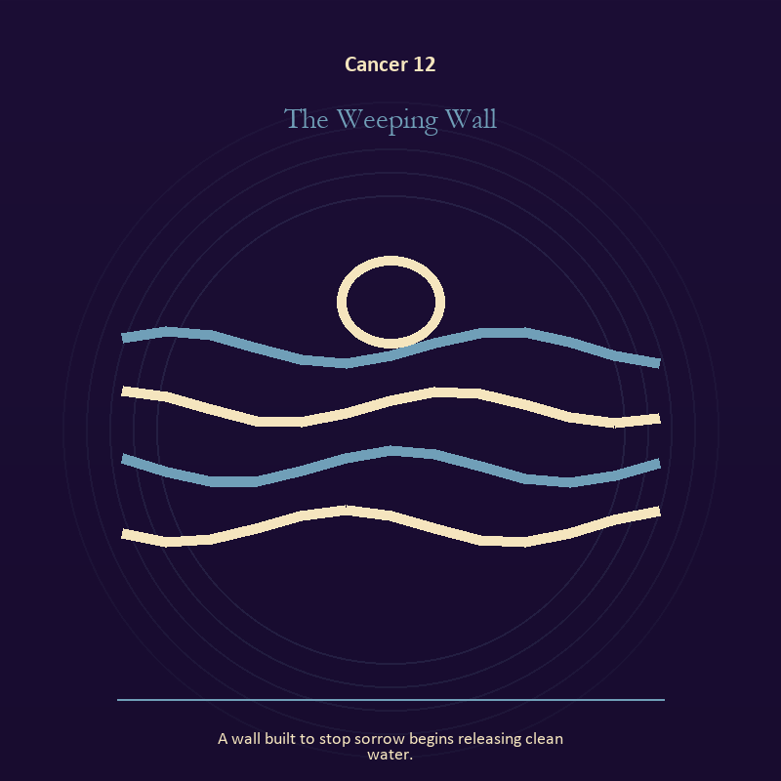

Cancer 12 The Weeping Wall
A wall built to stop sorrow begins releasing clean water.
INTERPRETATION The Weeping Wall tests living water against belonging, protection, inheritance, and the tenderness that opens a door. Within the Weeping Wall, rain, tides, wells, and floods move private material into a shared landscape. At Cancer 12, what was hidden becomes environmental and must be answered together. As a revelation degree, Cancer 12 moves the hidden arrangement into view, where it can be named without being exaggerated.
SIGNAL At Cancer 12, feeling with a living boundary carries the signal; it stays honest when you offer shelter that leaves the door visible.
SHADOW The shadow at Cancer 12 begins with using mystery to avoid a fact; also watch protection harden into control or memory become a reason to repeat the wound.
MIRROR At Cancer 12, what has the tide exposed that cannot be covered again?
PRACTICE Bring Cancer 12 out of abstraction: write the feeling as weather, then add the exact fact occurring beneath that weather.

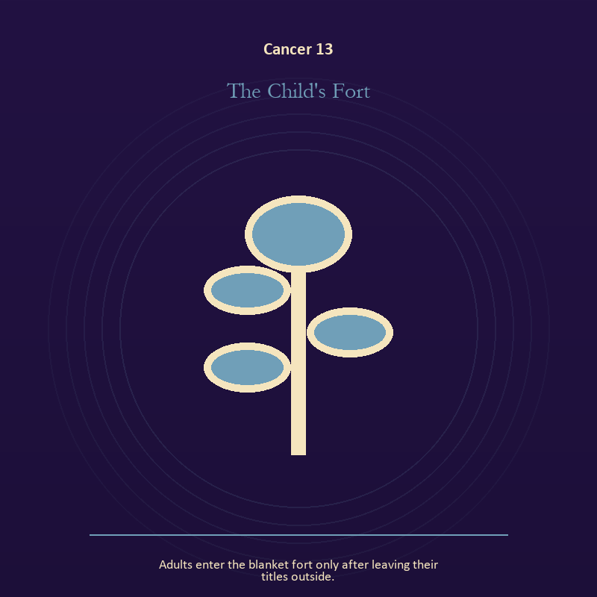

Cancer 13 The Child's Fort
Adults enter the blanket fort only after leaving their titles outside.
INTERPRETATION The Child's Fort holds growth against belonging, protection, inheritance, and the tenderness that opens a door. Within the Child's Fort, growth appears as vulnerable potential under specific conditions. At Cancer 13, it requires time, nourishment, protection, and eventual release from the form that began it. The same image also carries the body; at Cancer 13, embodiment gives every choice a pace and a cost. As a revelation degree, Cancer 13 turns atmosphere into evidence; attend to the object or action that cannot be explained away.
SIGNAL What can be carried forward from Cancer 13 is care that honors timing joined to a decision the nervous system can inhabit, tested by the need to offer shelter that leaves the door visible.
SHADOW At Cancer 13, the image darkens through protecting potential so tightly that it cannot emerge and using transcendence to ignore need; watch protection harden into control or memory become a reason to repeat the wound.
MIRROR For Cancer 13, what is alive here but not ready to be displayed?
PRACTICE For Cancer 13, release one expectation about what the new form must resemble.
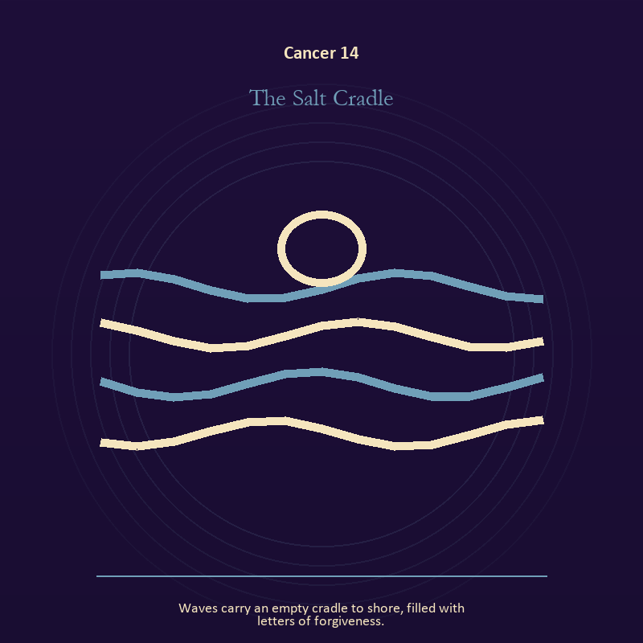

Cancer 14 The Salt Cradle
Waves carry an empty cradle to shore, filled with letters of forgiveness.
INTERPRETATION The Salt Cradle gives living water consequences inside the House of Memory. Within the Salt Cradle, a shore or vessel gives emotion a boundary without denying its depth. At Cancer 14, the scene asks whether the feeling needs containment, release, or witness. As a revelation degree, Cancer 14 shows who carries the cost, who controls the passage, and what the scene refuses to hide.
SIGNAL At Cancer 14, grief allowed to move becomes the clean signal when Cancer can offer shelter that leaves the door visible.
SHADOW The distortion at Cancer 14 is drowning in another person's weather; watch protection harden into control or memory become a reason to repeat the wound.
MIRROR With the Salt Cradle in mind at Cancer 14, where are you adapting wisely, and where are you disappearing?
PRACTICE Work with The Salt Cradle directly at Cancer 14: pour water slowly between two vessels and name what must change shape without losing its substance.

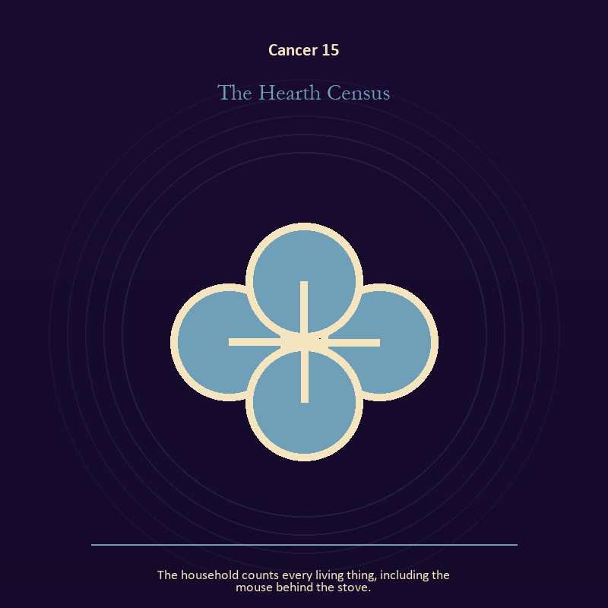

Cancer 15 The Hearth Census
The household counts every living thing, including the mouse behind the stove.
INTERPRETATION The Hearth Census puts relationship under pressure from belonging, protection, inheritance, and the tenderness that opens a door. Within the Hearth Census, the shared object in the scene carries an agreement. At Cancer 15, its condition reveals whether responsibility is mutual, hidden, refused, or unevenly assigned. As a revelation degree, Cancer 15 brings the middle truth forward, after the first story has lost its grip.
SIGNAL The usable force at Cancer 15 is contact without capture; Cancer gives it form by asking you to offer shelter that leaves the door visible.
SHADOW At Cancer 15, the Hearth Census can turn toward projection mistaken for intimacy; watch protection harden into control or memory become a reason to repeat the wound.
MIRROR The question at Cancer 15: can this bond survive an honest difference and a visible exit?
PRACTICE Give Cancer 15 a physical form; name one need, one boundary, and one freedom that belong to each person in the scene.
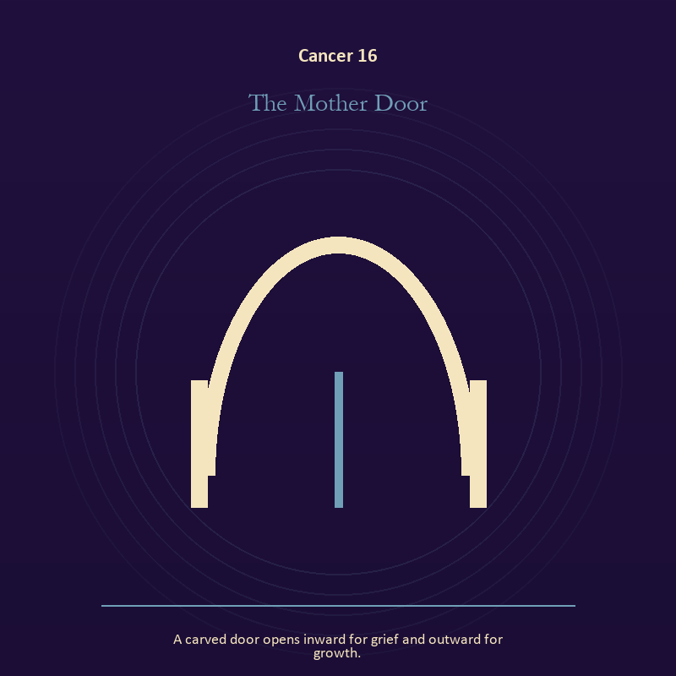

Cancer 16 The Mother Door
A carved door opens inward for grief and outward for growth.
INTERPRETATION In the Mother Door, the work of the threshold must answer to belonging, protection, inheritance, and the tenderness that opens a door. Within the Mother Door, a threshold measures consent, timing, and consequence. At Cancer 16, its presence asks whether passage is chosen, forced, delayed, or already under way. As a choice degree, Cancer 16 requires a choice with a human cost; insight alone no longer completes the work.
SIGNAL At Cancer 16, chosen change carries the signal; it stays honest when you offer shelter that leaves the door visible.
SHADOW The shadow at Cancer 16 begins with waiting for permission that will never come; also watch protection harden into control or memory become a reason to repeat the wound.
MIRROR At Cancer 16, which threshold in your life requires consent rather than momentum?
PRACTICE Bring Cancer 16 out of abstraction: write one sentence beginning, 'I may enter when,' and one beginning, 'I remain free to leave when.'.

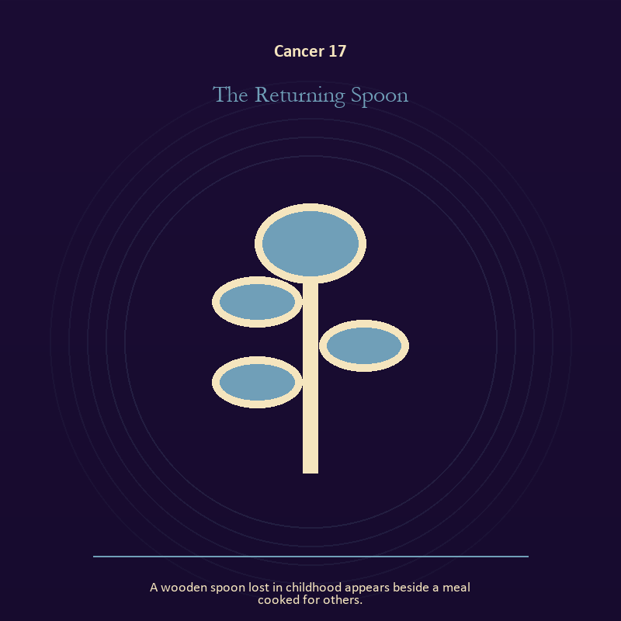

Cancer 17 The Returning Spoon
A wooden spoon lost in childhood appears beside a meal cooked for others.
INTERPRETATION The Returning Spoon tests the body against belonging, protection, inheritance, and the tenderness that opens a door. Within the Returning Spoon, bread, rest, touch, clothing, and shelter make spiritual language answer to material need. At Cancer 17, an insight that harms the body requires correction. As a choice degree, Cancer 17 asks what action preserves truth without using another person as material.
SIGNAL What can be carried forward from Cancer 17 is a decision the nervous system can inhabit, tested by the need to offer shelter that leaves the door visible.
SHADOW At Cancer 17, the image darkens through using transcendence to ignore need; watch protection harden into control or memory become a reason to repeat the wound.
MIRROR For Cancer 17, which need in this scene has been made too ordinary to mention?
PRACTICE For Cancer 17, eat, drink, rest, or move before making the interpretation more dramatic.
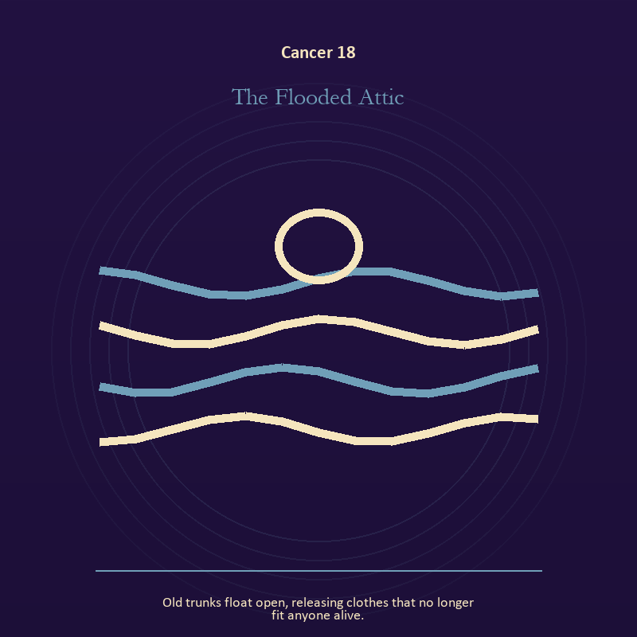

Cancer 18 The Flooded Attic
Old trunks float open, releasing clothes that no longer fit anyone alive.
INTERPRETATION The Flooded Attic holds identity against belonging, protection, inheritance, and the tenderness that opens a door. Within the Flooded Attic, a role organizes behavior but cannot contain the whole person. At Cancer 18, trouble begins when the costume demands loyalty after its work is done. The same image also carries the body; at Cancer 18, bread, rest, touch, clothing, and shelter make spiritual language answer to material need. As a choice degree, Cancer 18 moves from recognition to conduct; the clean choice must survive outside the imagination.
SIGNAL At Cancer 18, self-authorship joined to care made material becomes the clean signal when Cancer can offer shelter that leaves the door visible.
SHADOW The distortion at Cancer 18 is an assigned identity accepted as fate and letting appetite make the whole decision; watch protection harden into control or memory become a reason to repeat the wound.
MIRROR With the Flooded Attic in mind at Cancer 18, who remains when the title is set down? From a second angle at Cancer 18, which need in this scene has been made too ordinary to mention?
PRACTICE Work with The Flooded Attic directly at Cancer 18: write your name beside one quality no title can grant or remove. For the second pressure at Cancer 18, choose the next action that your body can repeat without punishment.

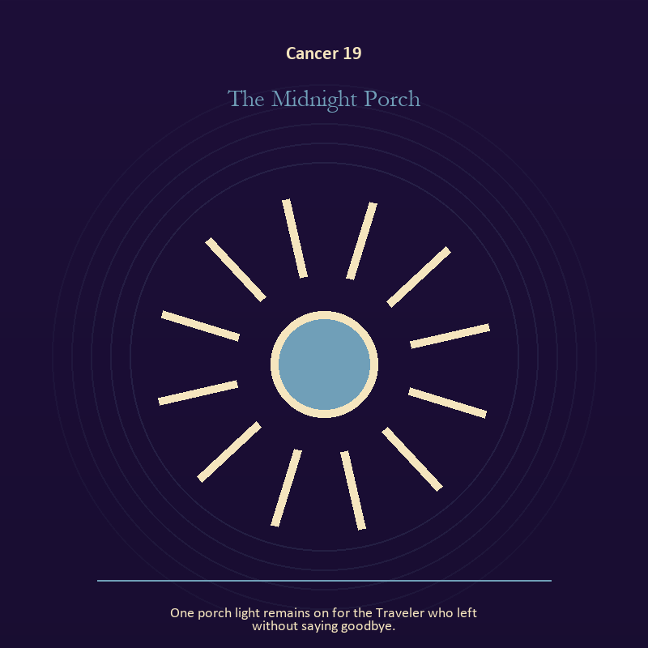

Cancer 19 The Midnight Porch
One porch light remains on for the Traveler who left without saying goodbye.
INTERPRETATION The Midnight Porch gives the descent consequences inside the House of Memory. Within the Midnight Porch, descent imagery carries what ordinary daylight has failed to resolve. At Cancer 19, it asks for contact with the wound, bargain, fear, or grief beneath the public account. The same image also carries living fire; at Cancer 19, a Lantern offers enough light for the next honest step. As a choice degree, Cancer 19 tests whether awareness can become restraint, repair, refusal, or consent.
SIGNAL The usable force at Cancer 19 is contact with buried power joined to a truth made visible at the right scale; Cancer gives it form by asking you to offer shelter that leaves the door visible.
SHADOW At Cancer 19, the Midnight Porch can turn toward remaining underground after the danger has passed and burning for recognition; watch protection harden into control or memory become a reason to repeat the wound.
MIRROR The question at Cancer 19: what difficult fact survives when the dramatic story is removed?
PRACTICE Give Cancer 19 a physical form; choose a trusted witness and tell the smallest complete truth you can safely tell.
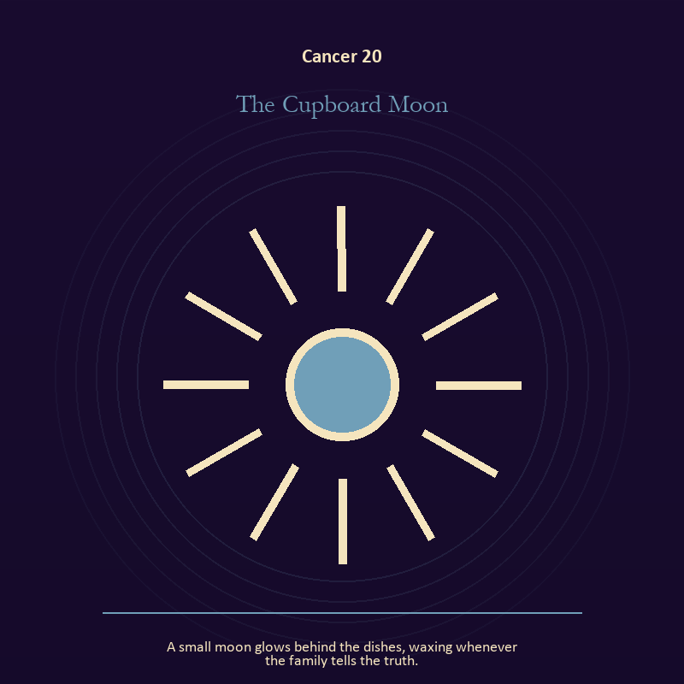

Cancer 20 The Cupboard Moon
A small moon glows behind the dishes, waxing whenever the family tells the truth.
INTERPRETATION The Cupboard Moon puts relationship under pressure from belonging, protection, inheritance, and the tenderness that opens a door. Within the Cupboard Moon, relationship imagery tests the fantasy that harmony requires sameness. At Cancer 20, a living bond can hold difference, correction, privacy, and departure. As a choice degree, Cancer 20 places responsibility in the reader's hands without promising a painless answer.
SIGNAL At Cancer 20, difference held without humiliation carries the signal; it stays honest when you offer shelter that leaves the door visible.
SHADOW The shadow at Cancer 20 begins with harmony purchased by one person's silence; also watch protection harden into control or memory become a reason to repeat the wound.
MIRROR At Cancer 20, where does responsibility belong, and where has it been displaced?
PRACTICE Bring Cancer 20 out of abstraction: ask the other person what they believe the agreement is, then compare it with your own version.

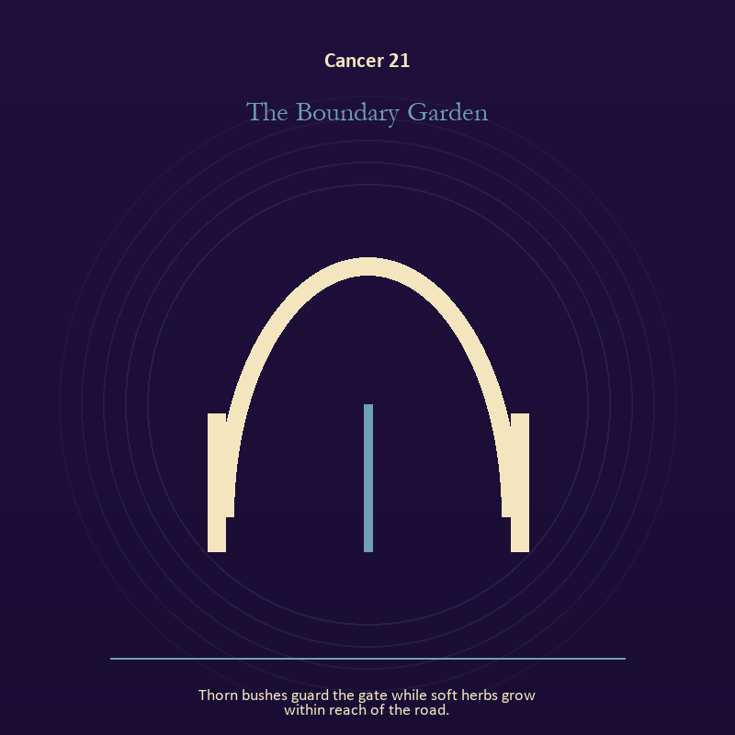

Cancer 21 The Boundary Garden
Thorn bushes guard the gate while soft herbs grow within reach of the road.
INTERPRETATION In the Boundary Garden, the work of the threshold must answer to belonging, protection, inheritance, and the tenderness that opens a door. Within the Boundary Garden, a boundary can protect life, restrict it, or clarify the terms of meeting. At Cancer 21, the surrounding action reveals which function is active here. The same image also carries growth; at Cancer 21, seeds, children, roots, and gardens refuse the fantasy of instant transformation. As a integration degree, Cancer 21 holds the gift beside its distortion; using one without feeding the other is the work.
SIGNAL What can be carried forward from Cancer 21 is honest passage joined to care that honors timing, tested by the need to offer shelter that leaves the door visible.
SHADOW At Cancer 21, the image darkens through guarding an obsolete enclosure and protecting potential so tightly that it cannot emerge; watch protection harden into control or memory become a reason to repeat the wound.
MIRROR For Cancer 21, what would make the next step chosen rather than compelled? From a second angle at Cancer 21, which condition would help this growth, and which demand would deform it?
PRACTICE For Cancer 21, draw the boundary as a line on paper; then mark the gate, the guard, and the person who holds the key.
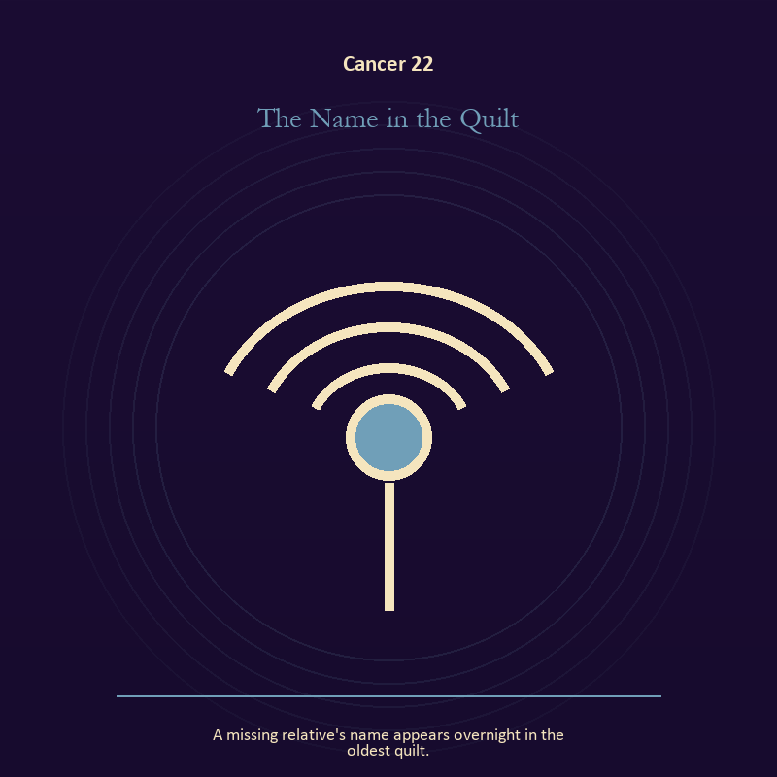

Cancer 22 The Name in the Quilt
A missing relative's name appears overnight in the oldest quilt.
INTERPRETATION The Name in the Quilt tests voice and naming against belonging, protection, inheritance, and the tenderness that opens a door. Within the Name in the Quilt, voice turns inner pressure into shared consequence. At Cancer 22, words can witness, summon, distort, repair, or conceal according to their precision and timing. The same image also carries identity; at Cancer 22, a role organizes behavior but cannot contain the whole person. As a integration degree, Cancer 22 asks the sign to carry its strength without turning that strength into jurisdiction.
SIGNAL At Cancer 22, a name that restores agency joined to the freedom to revise a name or role becomes the clean signal when Cancer can offer shelter that leaves the door visible.
SHADOW The distortion at Cancer 22 is speaking for someone whose voice is present and performance mistaken for selfhood; watch protection harden into control or memory become a reason to repeat the wound.
MIRROR With the Name in the Quilt in mind at Cancer 22, which word in this scene changes the power relationship?
PRACTICE Work with The Name in the Quilt directly at Cancer 22: give the current experience a temporary name and date it, leaving room for revision. For the second pressure at Cancer 22, list the roles you carry; then mark each as chosen, inherited, temporary, or ready to release.

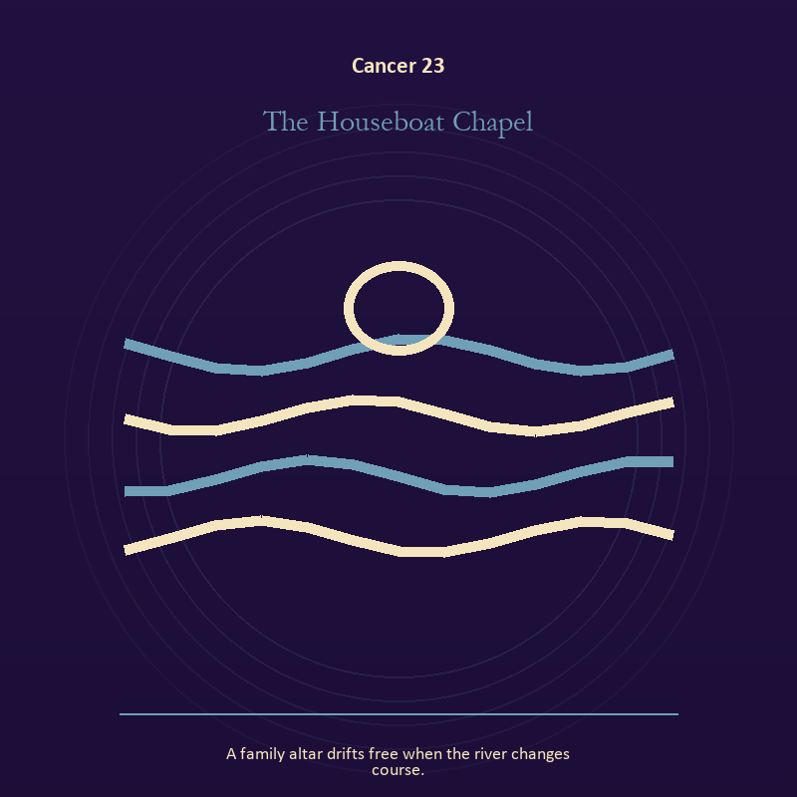

Cancer 23 The Houseboat Chapel
A family altar drifts free when the river changes course.
INTERPRETATION The Houseboat Chapel holds living water against belonging, protection, inheritance, and the tenderness that opens a door. Within the Houseboat Chapel, a shore or vessel gives emotion a boundary without denying its depth. At Cancer 23, the scene asks whether the feeling needs containment, release, or witness. The same image also carries relationship; at Cancer 23, more than one will is active in this scene. As a integration degree, Cancer 23 joins capacity to consequence; what helps in one setting may harm in another.
SIGNAL The usable force at Cancer 23 is grief allowed to move joined to contact without capture; Cancer gives it form by asking you to offer shelter that leaves the door visible.
SHADOW At Cancer 23, the Houseboat Chapel can turn toward drowning in another person's weather and projection mistaken for intimacy; watch protection harden into control or memory become a reason to repeat the wound.
MIRROR The question at Cancer 23: where are you adapting wisely, and where are you disappearing?
PRACTICE Give Cancer 23 a physical form; pour water slowly between two vessels and name what must change shape without losing its substance.
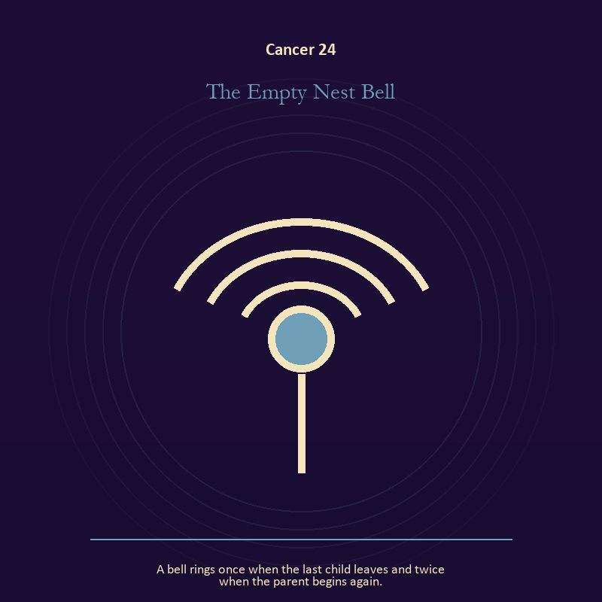

Cancer 24 The Empty Nest Bell
A bell rings once when the last child leaves and twice when the parent begins again.
INTERPRETATION The Empty Nest Bell gives voice and naming consequences inside the House of Memory. Within the Empty Nest Bell, naming creates a handle for experience, but the handle must remain smaller than the life it describes. At Cancer 24, the image tests language against reality. The same image also carries growth; at Cancer 24, seeds, children, roots, and gardens refuse the fantasy of instant transformation. As a integration degree, Cancer 24 shows the mature tool and the temptation hidden inside its handle.
SIGNAL At Cancer 24, speech with consequence joined to care that honors timing carries the signal; it stays honest when you offer shelter that leaves the door visible.
SHADOW The shadow at Cancer 24 begins with repeating a message until it sounds like evidence and protecting potential so tightly that it cannot emerge; also watch protection harden into control or memory become a reason to repeat the wound.
MIRROR At Cancer 24, what are you naming accurately, and what remains larger than the name? From a second angle at Cancer 24, which condition would help this growth, and which demand would deform it?
PRACTICE Bring Cancer 24 out of abstraction: listen to one person without planning your answer; then repeat their meaning before offering your own.

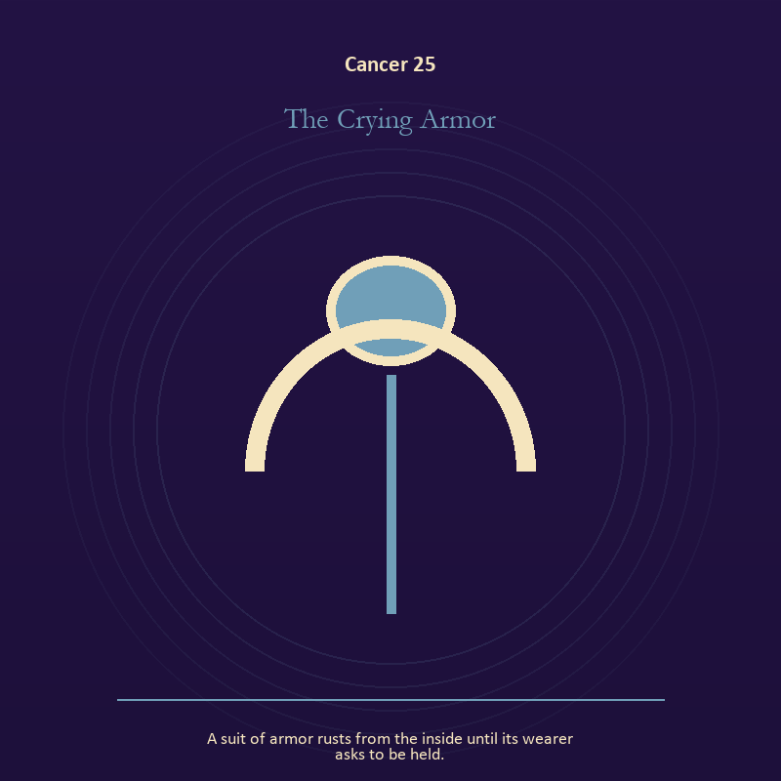

Cancer 25 The Crying Armor
A suit of armor rusts from the inside until its wearer asks to be held.
INTERPRETATION The Crying Armor puts the body under pressure from belonging, protection, inheritance, and the tenderness that opens a door. Within the Crying Armor, the body enters as witness, limit, appetite, labor, and home. At Cancer 25, its response may reveal what the mind has explained away. As a integration degree, Cancer 25 tests whether the lesson can be lived without becoming a new performance.
SIGNAL What can be carried forward from Cancer 25 is care made material, tested by the need to offer shelter that leaves the door visible.
SHADOW At Cancer 25, the image darkens through letting appetite make the whole decision; watch protection harden into control or memory become a reason to repeat the wound.
MIRROR For Cancer 25, what does your body know before your argument begins?
PRACTICE For Cancer 25, choose the next action that your body can repeat without punishment.
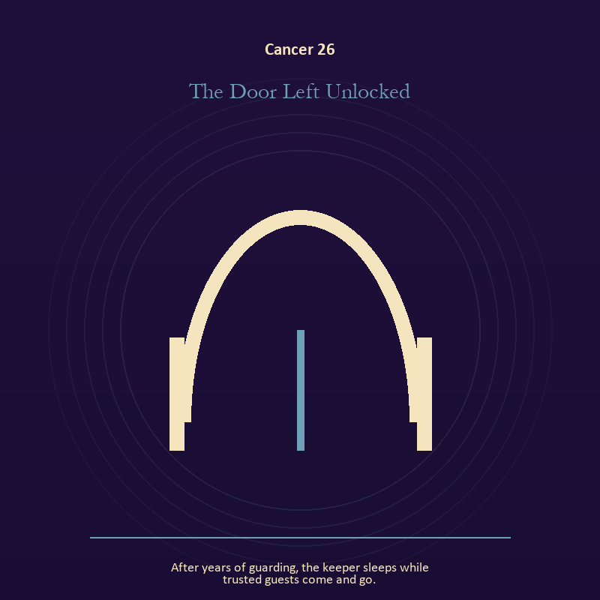

Cancer 26 The Door Left Unlocked
After years of guarding, the keeper sleeps while trusted guests come and go.
INTERPRETATION In the Door Left Unlocked, the work of the threshold must answer to belonging, protection, inheritance, and the tenderness that opens a door. Within the Door Left Unlocked, doors and roads turn inner change into an embodied decision. At Cancer 26, the next room matters, but so does the condition under which it is entered. As a release degree, Cancer 26 prepares the lesson to leave its original container; keep the capacity and loosen the role.
SIGNAL At Cancer 26, a boundary that clarifies freedom becomes the clean signal when Cancer can offer shelter that leaves the door visible.
SHADOW The distortion at Cancer 26 is crossing before consent; watch protection harden into control or memory become a reason to repeat the wound.
MIRROR With the Door Left Unlocked in mind at Cancer 26, what are you protecting by remaining on this side of the door?
PRACTICE Work with The Door Left Unlocked directly at Cancer 26: stand at a literal doorway, name what you are leaving and what you refuse to abandon, then cross only if the answer feels clean.

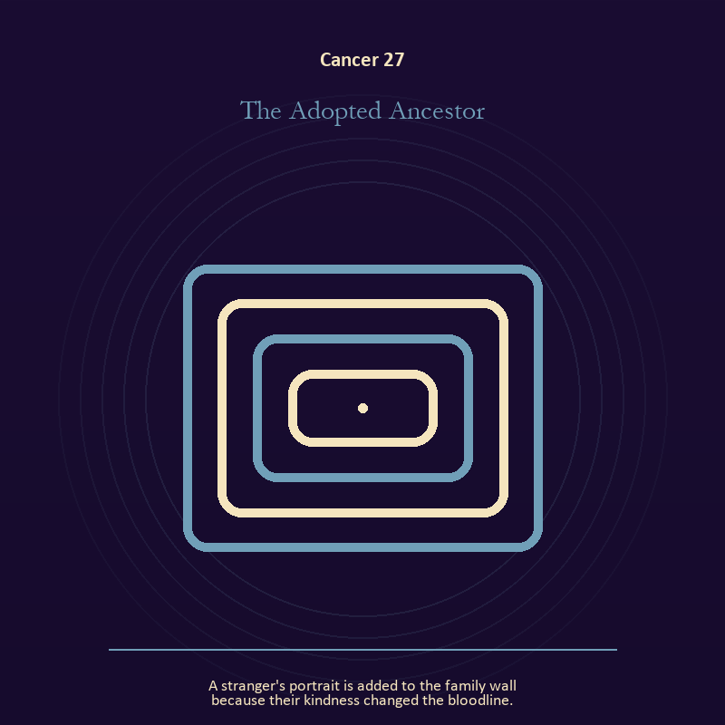

Cancer 27 The Adopted Ancestor
A stranger's portrait is added to the family wall because their kindness changed the bloodline.
INTERPRETATION The Adopted Ancestor tests the Mirror against belonging, protection, inheritance, and the tenderness that opens a door. Within the Adopted Ancestor, a shadow proves that something real stands in the light, while a reflection shows only an angle. At Cancer 27, neither is the whole person. The same image also carries relationship; at Cancer 27, relationship imagery tests the fantasy that harmony requires sameness. As a release degree, Cancer 27 asks what can be handed onward without demanding imitation or loyalty.
SIGNAL The usable force at Cancer 27 is self-recognition without self-worship joined to mutual responsibility; Cancer gives it form by asking you to offer shelter that leaves the door visible.
SHADOW At Cancer 27, the Adopted Ancestor can turn toward assigning your hidden material to someone else and the group protecting itself by sacrificing an outsider; watch protection harden into control or memory become a reason to repeat the wound.
MIRROR The question at Cancer 27: which part of the reflection is asking to be reclaimed rather than judged? From a second angle at Cancer 27, where does responsibility belong, and where has it been displaced?
PRACTICE Give Cancer 27 a physical form; write two accounts of the same conflict: one from your position and one from the person you cannot understand.
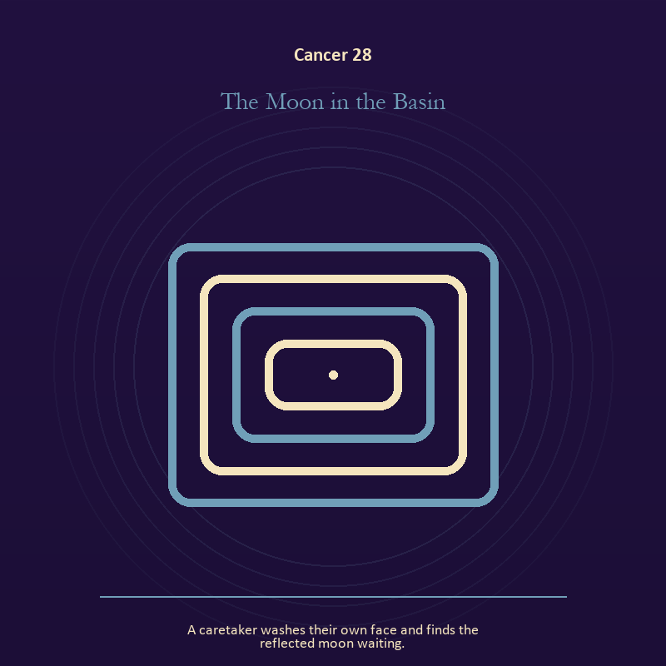

Cancer 28 The Moon in the Basin
A caretaker washes their own face and finds the reflected moon waiting.
INTERPRETATION The Moon in the Basin holds the Mirror against belonging, protection, inheritance, and the tenderness that opens a door. Within the Moon in the Basin, the Mirror returns perception without guaranteeing accuracy. At Cancer 28, it reveals projection, self-image, and the temptation to kneel before a reflection. The same image also carries identity; at Cancer 28, a role organizes behavior but cannot contain the whole person. As a release degree, Cancer 28 turns completion into transfer; the work survives by changing hands.
SIGNAL At Cancer 28, a projection reclaimed joined to the freedom to revise a name or role carries the signal; it stays honest when you offer shelter that leaves the door visible.
SHADOW The shadow at Cancer 28 begins with letting shame dictate what the Mirror may show and performance mistaken for selfhood; also watch protection harden into control or memory become a reason to repeat the wound.
MIRROR At Cancer 28, what are you seeing clearly, and what may be projection?
PRACTICE Bring Cancer 28 out of abstraction: look into a Mirror for one minute and name facts only; then notice when judgment tries to enter as description.

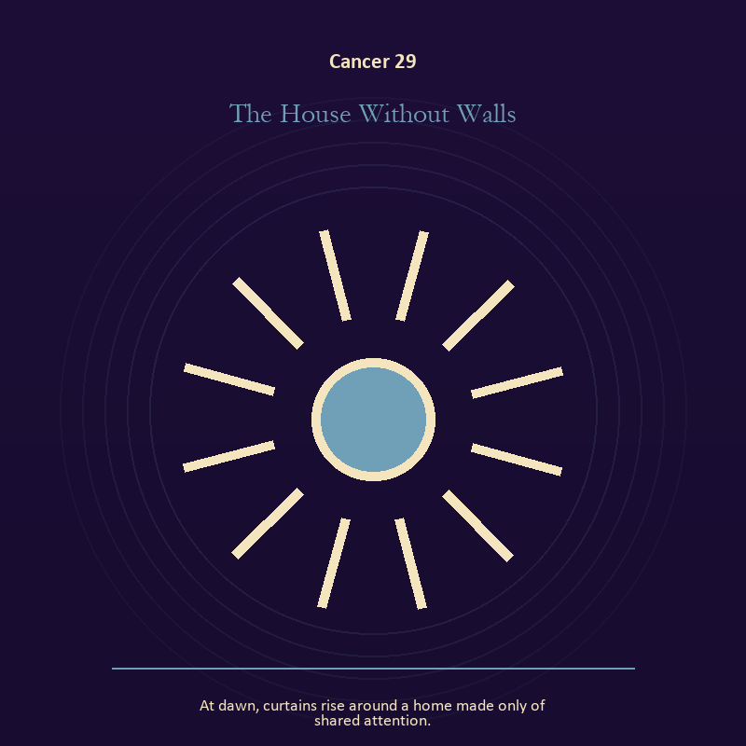

Cancer 29 The House Without Walls
At dawn, curtains rise around a home made only of shared attention.
INTERPRETATION The House Without Walls gives living fire consequences inside the House of Memory. Within the House Without Walls, fire gives change a visible cost. At Cancer 29, something is illuminated here because something else is being spent. The same image also carries relationship; at Cancer 29, more than one will is active in this scene. As a release degree, Cancer 29 lets the sign set down the identity built around its ordeal.
SIGNAL What can be carried forward from Cancer 29 is a truth made visible at the right scale joined to contact without capture, tested by the need to offer shelter that leaves the door visible.
SHADOW At Cancer 29, the image darkens through burning for recognition and projection mistaken for intimacy; watch protection harden into control or memory become a reason to repeat the wound.
MIRROR For Cancer 29, where has your fire become performance rather than warmth?
PRACTICE For Cancer 29, light one candle and give its entire burn to a single unfinished question.
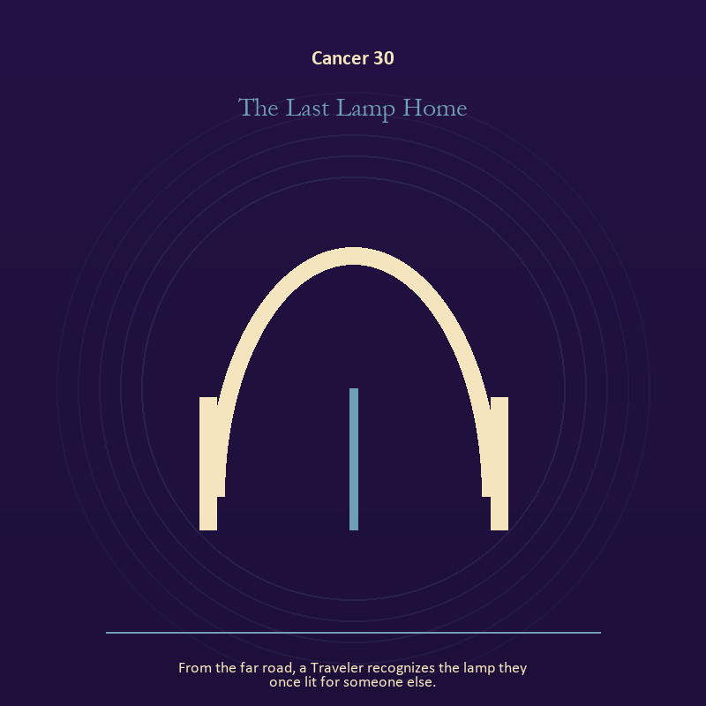

Cancer 30 The Last Lamp Home
From the far road, a Traveler recognizes the lamp they once lit for someone else.
INTERPRETATION The Last Lamp Home puts living fire under pressure from belonging, protection, inheritance, and the tenderness that opens a door. Within the Last Lamp Home, a Lantern offers enough light for the next honest step. At Cancer 30, it does not remove night, and its usefulness depends on how it is carried. The same image also carries the threshold; at Cancer 30, doors and roads turn inner change into an embodied decision. As a release degree, Cancer 30 returns the earned knowledge to ordinary life, where another cycle can use it.
SIGNAL At Cancer 30, attention with warmth joined to chosen change becomes the clean signal when Cancer can offer shelter that leaves the door visible.
SHADOW The distortion at Cancer 30 is exposure without care and waiting for permission that will never come; watch protection harden into control or memory become a reason to repeat the wound.
MIRROR With the Last Lamp Home in mind at Cancer 30, how much light does the next step require, and who might it expose? From a second angle at Cancer 30, what are you protecting by remaining on this side of the door?
PRACTICE Work with The Last Lamp Home directly at Cancer 30: move one hidden concern into plain view by naming it to a trusted person. For the second pressure at Cancer 30, write one sentence beginning, 'I may enter when,' and one beginning, 'I remain free to leave when.'.

Leo
The Living Flame
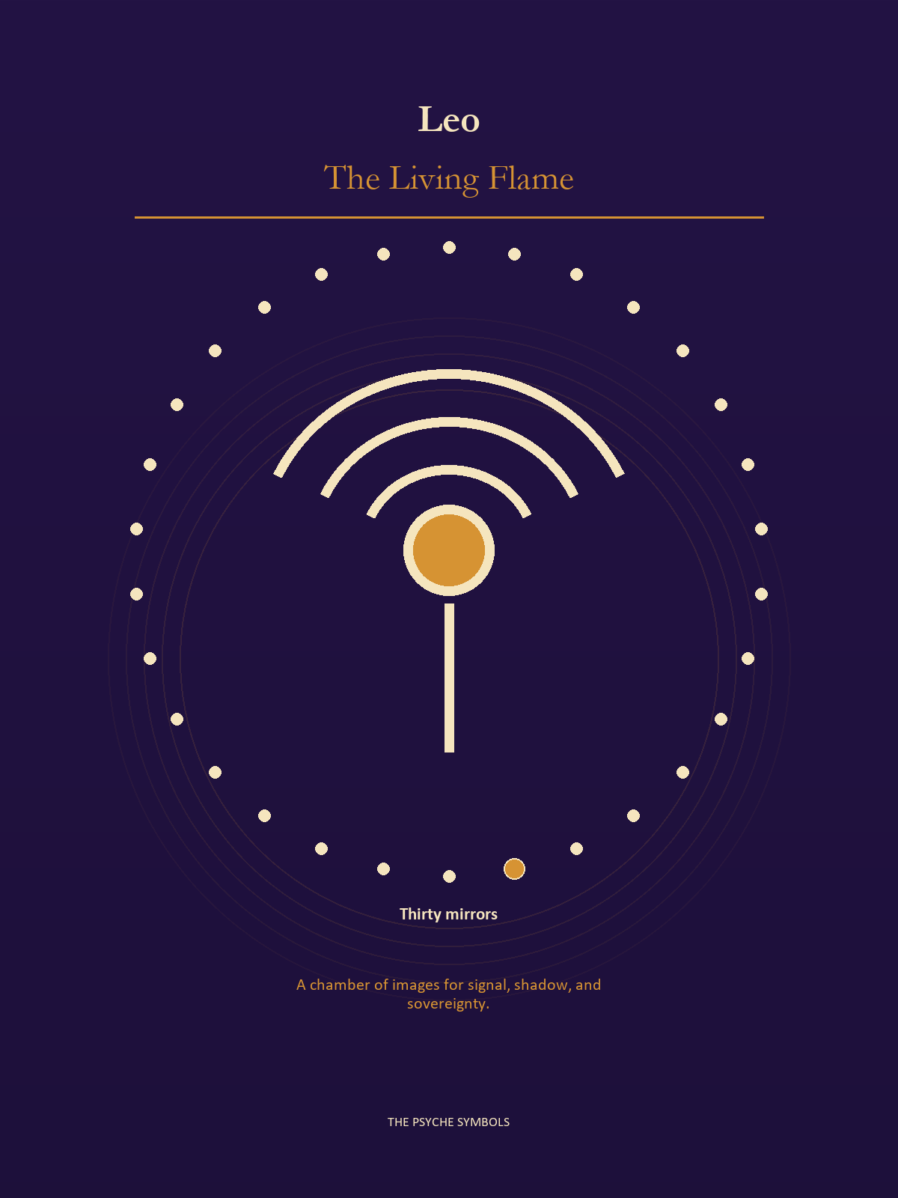
Leo brings the hidden fire into view and asks who the performance serves. The Living Flame concerns authorship, delight, pride, risk, recognition, and the courage to be seen before the work is perfect. Here sovereignty means generating warmth without making every witness kneel to it.

Degrees | Gate | Work
1-5 | Arrival | Meet the image before deciding what it means.
6-10 | Friction | Notice what pushes back and what that resistance protects.
11-15 | Revelation | Name the detail that changes the whole scene.
16-20 | Choice | Choose the act that preserves both truth and human dignity.
21-25 | Integration | Use the gift without feeding the shadow that travels beside it.
26-30 | Release | Keep the earned capacity and release the role that delivered it.

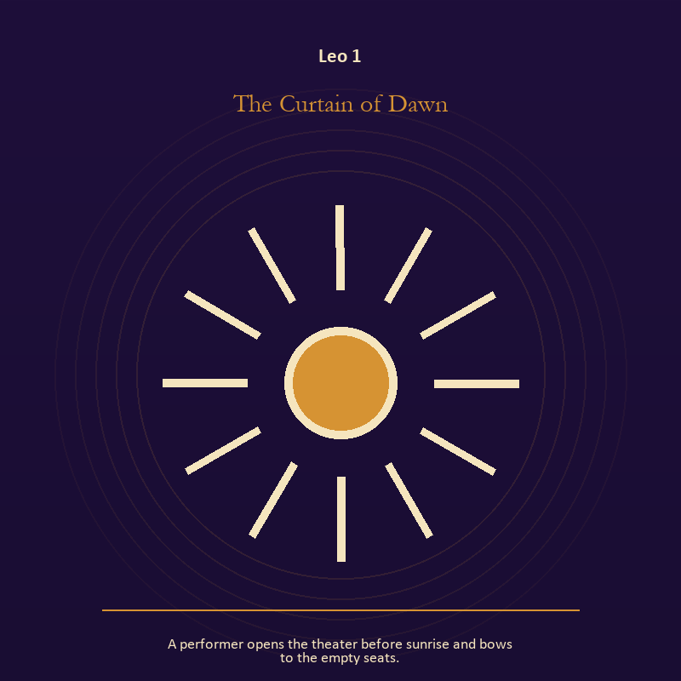

Leo 1 The Curtain of Dawn
A performer opens the theater before sunrise and bows to the empty seats.
INTERPRETATION In the Curtain of Dawn, the work of living fire must answer to creative heat, play, dignity, and the difference between radiance and applause. Within the Curtain of Dawn, light represents directed attention. At Leo 1, it can warm, expose, guide, consume, or turn a person into a spectacle depending on who controls it. As an arrival degree, Leo 1 arrives before habit can tidy the evidence; notice what is present before deciding what it should become.
SIGNAL The usable force at Leo 1 is courage that helps another see; Leo gives it form by asking you to make the honest gesture large enough to be seen.
SHADOW At Leo 1, the Curtain of Dawn can turn toward mistaking brightness for moral authority; notice when expression becomes display or dignity depends on winning the room.
MIRROR The question at Leo 1: what deserves the full light of your attention now?
PRACTICE Give Leo 1 a physical form; choose one person or project that needs warmth rather than intensity and act accordingly.
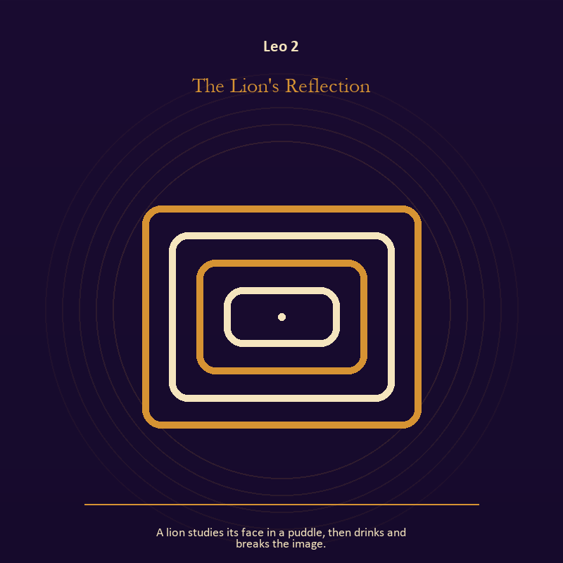

Leo 2 The Lion's Reflection
A lion studies its face in a puddle, then drinks and breaks the image.
INTERPRETATION The Lion's Reflection tests the Mirror against creative heat, play, dignity, and the difference between radiance and applause. Within the Lion's Reflection, reflected images divide the observer from the observed self. At Leo 2, that gap can hold shame, vanity, curiosity, or the first honest revision of identity. The same image also carries identity; at Leo 2, identity appears as something worn, spoken, assigned, revised, or returned. As an arrival degree, Leo 2 introduces the sign's raw material in an unguarded form; the first response matters less than the honest one.
SIGNAL At Leo 2, the courage to revise a familiar self-image joined to self-authorship carries the signal; it stays honest when you make the honest gesture large enough to be seen.
SHADOW The shadow at Leo 2 begins with mistaking appearance for character and an assigned identity accepted as fate; also notice when expression becomes display or dignity depends on winning the room.
MIRROR At Leo 2, whose gaze have you installed inside your own Mirror?
PRACTICE Bring Leo 2 out of abstraction: describe the scene without interpretation, then circle the detail you most want to praise or condemn.

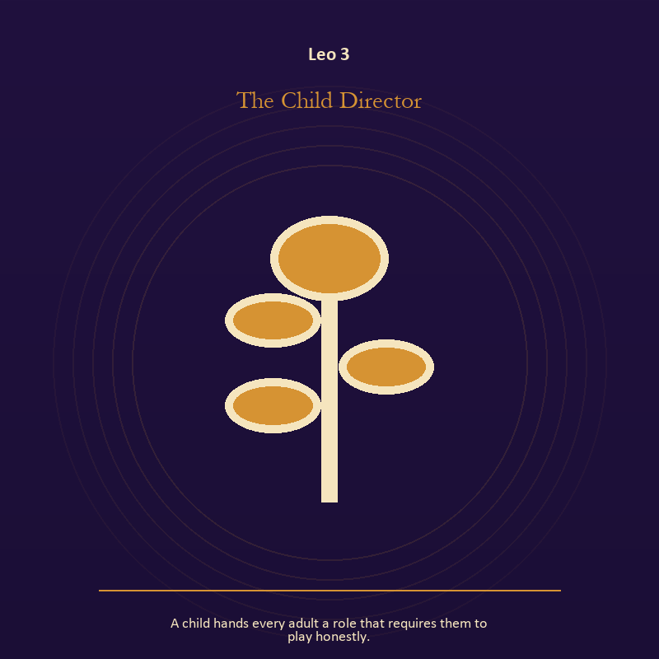

Leo 3 The Child Director
A child hands every adult a role that requires them to play honestly.
INTERPRETATION The Child Director holds growth against creative heat, play, dignity, and the difference between radiance and applause. Within the Child Director, new life carries inherited material without being sentenced to repeat it. At Leo 3, the image asks what must be tended and what must be allowed to change form. The same image also carries relationship; at Leo 3, relationship imagery tests the fantasy that harmony requires sameness. As an arrival degree, Leo 3 catches the first impulse before it turns into a role; give the image room to remain strange.
SIGNAL What can be carried forward from Leo 3 is patient becoming joined to mutual responsibility, tested by the need to make the honest gesture large enough to be seen.
SHADOW At Leo 3, the image darkens through claiming ownership over another's growth and the group protecting itself by sacrificing an outsider; notice when expression becomes display or dignity depends on winning the room.
MIRROR For Leo 3, what can you tend without claiming the outcome? From a second angle at Leo 3, where does responsibility belong, and where has it been displaced?
PRACTICE For Leo 3, name the smallest repeatable condition that would help this beginning survive a week.


Leo 4 The Unplugged Spotlight
A warm circle of light follows the person who stops seeking it.
INTERPRETATION The Unplugged Spotlight gives living fire consequences inside the Living Flame. Within the Unplugged Spotlight, light represents directed attention. At Leo 4, it can warm, expose, guide, consume, or turn a person into a spectacle depending on who controls it. The same image also carries relationship; at Leo 4, the shared object in the scene carries an agreement. As an arrival degree, Leo 4 opens the chamber with no settled method; name the need, risk, or appetite that entered with it.
SIGNAL At Leo 4, courage that helps another see joined to difference held without humiliation becomes the clean signal when Leo can make the honest gesture large enough to be seen.
SHADOW The distortion at Leo 4 is mistaking brightness for moral authority and harmony purchased by one person's silence; notice when expression becomes display or dignity depends on winning the room.
MIRROR With the Unplugged Spotlight in mind at Leo 4, what deserves the full light of your attention now?
PRACTICE Work with The Unplugged Spotlight directly at Leo 4: choose one person or project that needs warmth rather than intensity and act accordingly. For the second pressure at Leo 4, ask the other person what they believe the agreement is, then compare it with your own version.

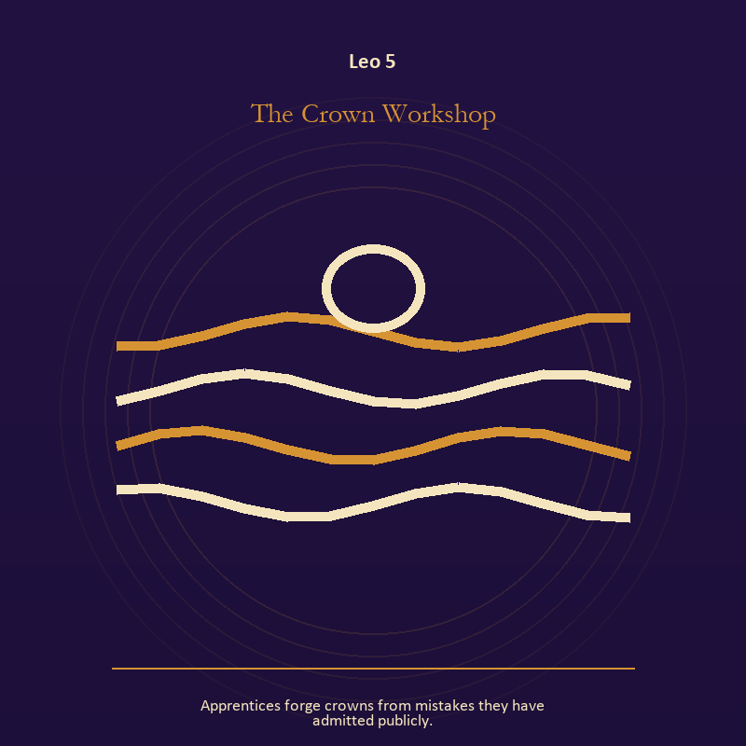

Leo 5 The Crown Workshop
Apprentices forge crowns from mistakes they have admitted publicly.
INTERPRETATION The Crown Workshop puts authority under pressure from creative heat, play, dignity, and the difference between radiance and applause. Within the Crown Workshop, crowns, laws, offices, and verdicts turn private judgment into public consequence. At Leo 5, their legitimacy depends on restraint and correction. The same image also carries craft and record; at Leo 5, craft turns intention into a repeatable act with materials, limits, and evidence of failure. As an arrival degree, Leo 5 shows the beginning before ownership hardens around it; let attention come before possession.
SIGNAL The usable force at Leo 5 is a rule that protects the vulnerable person in the room joined to care made repeatable; Leo gives it form by asking you to make the honest gesture large enough to be seen.
SHADOW At Leo 5, the Crown Workshop can turn toward role mistaken for worth and the tool becoming the master; notice when expression becomes display or dignity depends on winning the room.
MIRROR The question at Leo 5: what would accountability require from the person holding the key?
PRACTICE Give Leo 5 a physical form; choose one decision you control and write down who can challenge it, correct it, and leave its consequences.
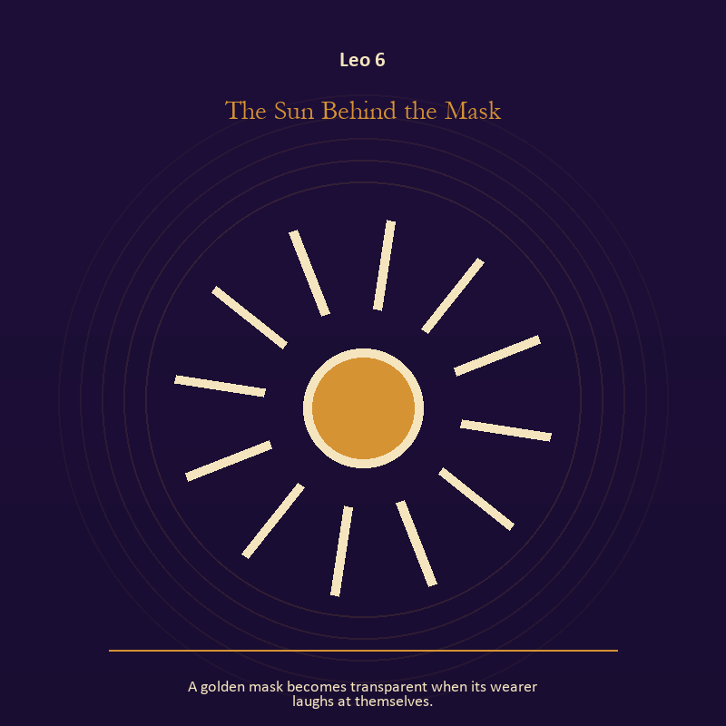

Leo 6 The Sun Behind the Mask
A golden mask becomes transparent when its wearer laughs at themselves.
INTERPRETATION In the Sun Behind the Mask, the work of living fire must answer to creative heat, play, dignity, and the difference between radiance and applause. Within the Sun Behind the Mask, a Lantern offers enough light for the next honest step. At Leo 6, it does not remove night, and its usefulness depends on how it is carried. The same image also carries identity; at Leo 6, masks and names can conceal, reveal, or give shape to a truth that plain speech cannot yet hold. As a friction degree, Leo 6 meets resistance, and that resistance reveals what the first impulse failed to consider.
SIGNAL At Leo 6, attention with warmth joined to a protective form used consciously carries the signal; it stays honest when you make the honest gesture large enough to be seen.
SHADOW The shadow at Leo 6 begins with exposure without care and a mask that can no longer be removed safely; also notice when expression becomes display or dignity depends on winning the room.
MIRROR At Leo 6, how much light does the next step require, and who might it expose? From a second angle at Leo 6, what does the mask make possible, and what does it cost to keep wearing it?
PRACTICE Bring Leo 6 out of abstraction: move one hidden concern into plain view by naming it to a trusted person.

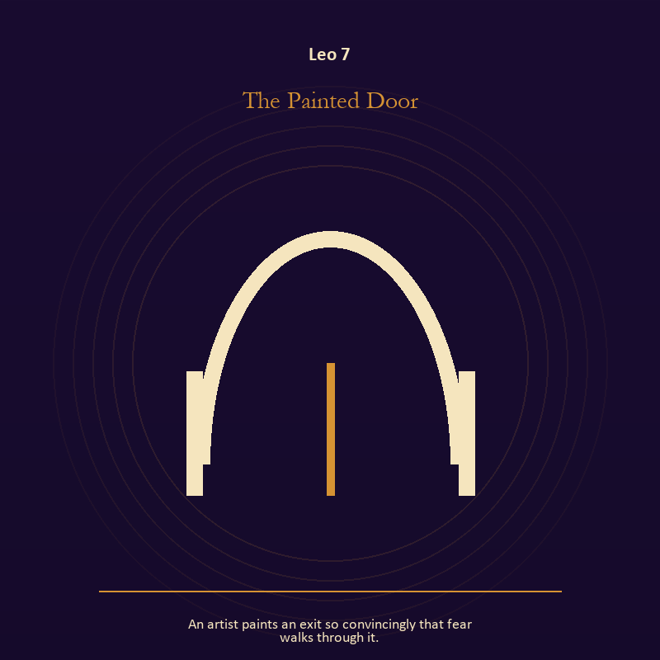

Leo 7 The Painted Door
An artist paints an exit so convincingly that fear walks through it.
INTERPRETATION The Painted Door tests the threshold against creative heat, play, dignity, and the difference between radiance and applause. Within the Painted Door, a threshold measures consent, timing, and consequence. At Leo 7, its presence asks whether passage is chosen, forced, delayed, or already under way. The same image also carries craft and record; at Leo 7, workshops honor correction. As a friction degree, Leo 7 places consequence beside desire; the obstruction may be an enemy, a limit, or a needed correction.
SIGNAL What can be carried forward from Leo 7 is chosen change joined to a useful correction that outlives the moment, tested by the need to make the honest gesture large enough to be seen.
SHADOW At Leo 7, the image darkens through waiting for permission that will never come and measurement mistaken for meaning; notice when expression becomes display or dignity depends on winning the room.
MIRROR For Leo 7, which threshold in your life requires consent rather than momentum?
PRACTICE For Leo 7, write one sentence beginning, 'I may enter when,' and one beginning, 'I remain free to leave when.'.
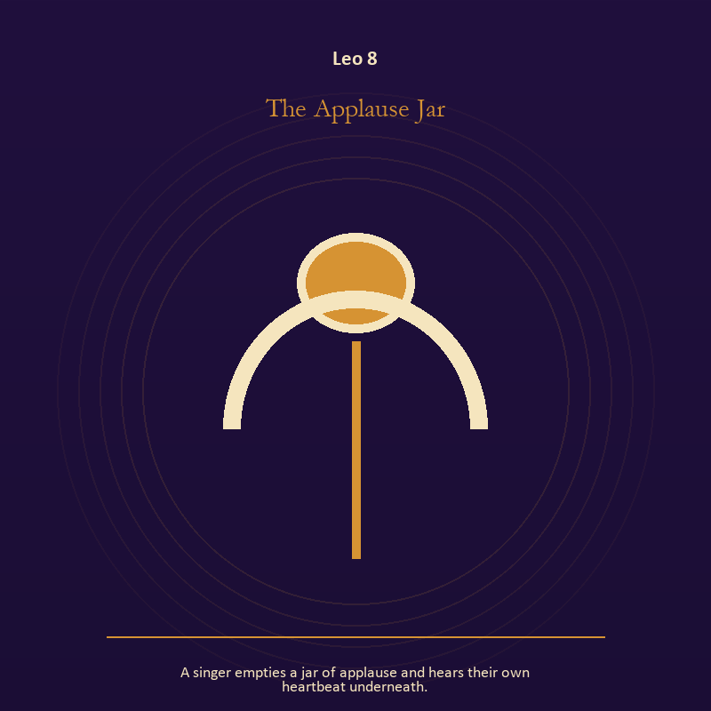

Leo 8 The Applause Jar
A singer empties a jar of applause and hears their own heartbeat underneath.
INTERPRETATION The Applause Jar holds mystery against creative heat, play, dignity, and the difference between radiance and applause. Within the Applause Jar, this image invites attention before conclusion. At Leo 8, its strange fact creates a pressure point where memory, desire, fear, and choice can speak indirectly. As a friction degree, Leo 8 tests whether the sign can change course without treating correction as defeat.
SIGNAL At Leo 8, an unanswered image that keeps thought alive becomes the clean signal when Leo can make the honest gesture large enough to be seen.
SHADOW The distortion at Leo 8 is forcing a prophecy from ambiguity; notice when expression becomes display or dignity depends on winning the room.
MIRROR With the Applause Jar in mind at Leo 8, what ordinary fact sits beneath the strange image?
PRACTICE Work with The Applause Jar directly at Leo 8: copy the image by hand, underline three concrete nouns, and write one association for each.

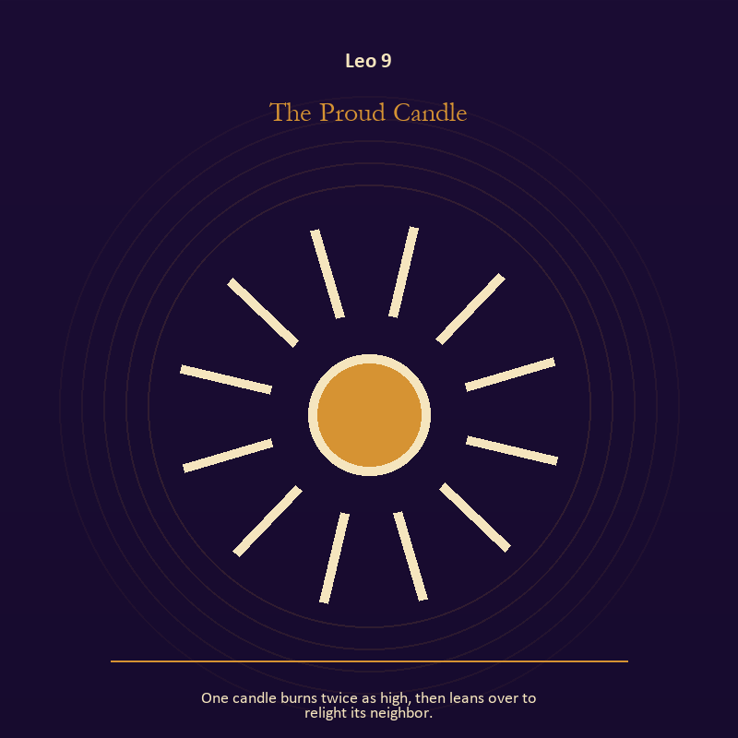

Leo 9 The Proud Candle
One candle burns twice as high, then leans over to relight its neighbor.
INTERPRETATION The Proud Candle gives living fire consequences inside the Living Flame. Within the Proud Candle, a Lantern offers enough light for the next honest step. At Leo 9, it does not remove night, and its usefulness depends on how it is carried. The same image also carries relationship; at Leo 9, relationship imagery tests the fantasy that harmony requires sameness. As a friction degree, Leo 9 brings another will, material limit, or inconvenient fact into the frame.
SIGNAL The usable force at Leo 9 is attention with warmth joined to mutual responsibility; Leo gives it form by asking you to make the honest gesture large enough to be seen.
SHADOW At Leo 9, the Proud Candle can turn toward exposure without care and the group protecting itself by sacrificing an outsider; notice when expression becomes display or dignity depends on winning the room.
MIRROR The question at Leo 9: how much light does the next step require, and who might it expose? From a second angle at Leo 9, where does responsibility belong, and where has it been displaced?
PRACTICE Give Leo 9 a physical form; move one hidden concern into plain view by naming it to a trusted person.
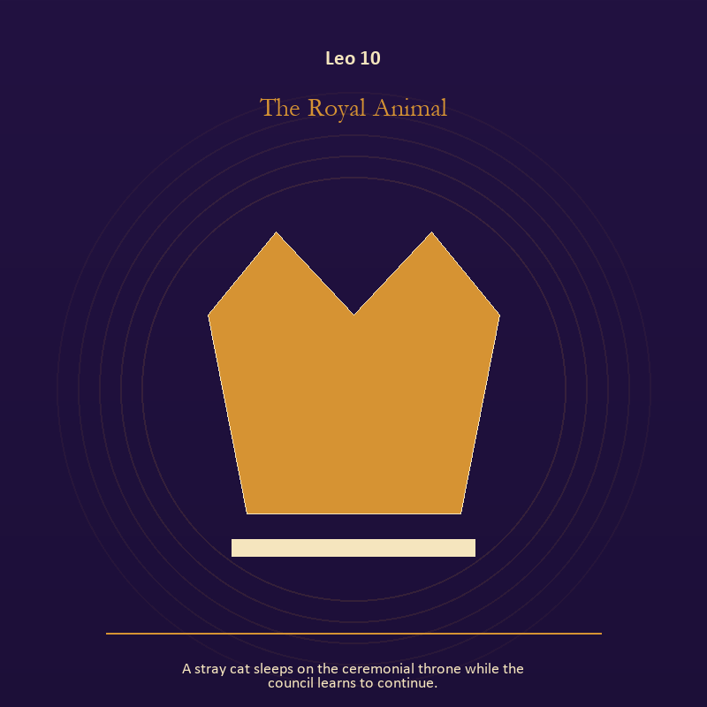

Leo 10 The Royal Animal
A stray cat sleeps on the ceremonial throne while the council learns to continue.
INTERPRETATION The Royal Animal puts authority under pressure from creative heat, play, dignity, and the difference between radiance and applause. Within the Royal Animal, authority is shown as a tool with weight, limits, witnesses, and an eventual transfer. At Leo 10, the symbol asks whom power protects when nobody is applauding. The same image also carries relationship; at Leo 10, the shared object in the scene carries an agreement. As a friction degree, Leo 10 slows the original motion long enough to expose what haste concealed.
SIGNAL At Leo 10, power made answerable joined to difference held without humiliation carries the signal; it stays honest when you make the honest gesture large enough to be seen.
SHADOW The shadow at Leo 10 begins with authority defending itself against correction and harmony purchased by one person's silence; also notice when expression becomes display or dignity depends on winning the room.
MIRROR At Leo 10, who carries the cost of the decision made here?
PRACTICE Bring Leo 10 out of abstraction: inspect one standing rule by asking how it treats the person with the least power.

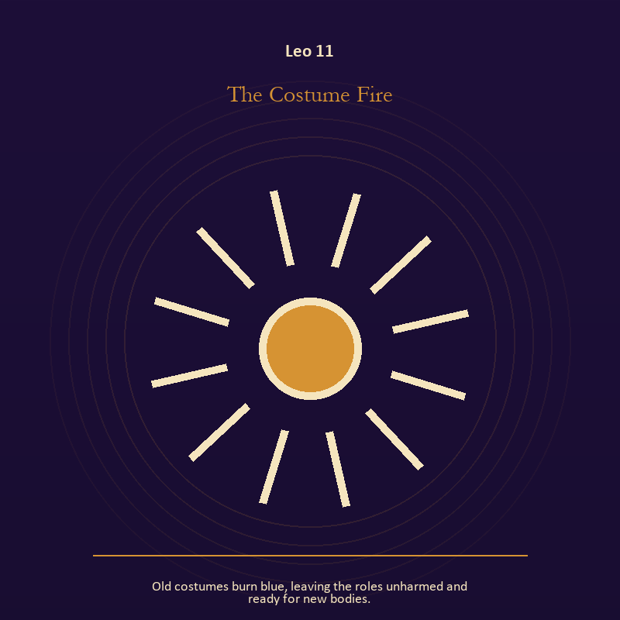

Leo 11 The Costume Fire
Old costumes burn blue, leaving the roles unharmed and ready for new bodies.
INTERPRETATION In the Costume Fire, the work of living fire must answer to creative heat, play, dignity, and the difference between radiance and applause. Within the Costume Fire, fire gives change a visible cost. At Leo 11, something is illuminated here because something else is being spent. The same image also carries identity; at Leo 11, identity appears as something worn, spoken, assigned, revised, or returned. As a revelation degree, Leo 11 reveals the mechanism under the mood; one concrete detail changes the reading.
SIGNAL What can be carried forward from Leo 11 is a truth made visible at the right scale joined to self-authorship, tested by the need to make the honest gesture large enough to be seen.
SHADOW At Leo 11, the image darkens through burning for recognition and an assigned identity accepted as fate; notice when expression becomes display or dignity depends on winning the room.
MIRROR For Leo 11, where has your fire become performance rather than warmth?
PRACTICE For Leo 11, light one candle and give its entire burn to a single unfinished question.
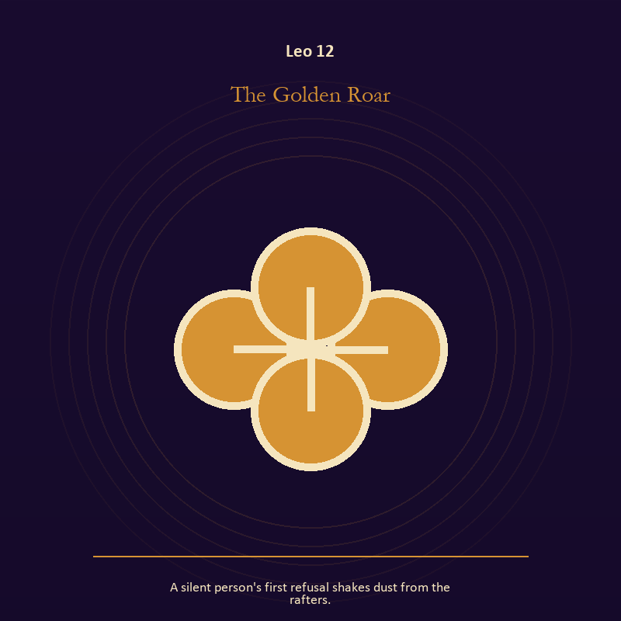

Leo 12 The Golden Roar
A silent person's first refusal shakes dust from the rafters.
INTERPRETATION The Golden Roar tests relationship against creative heat, play, dignity, and the difference between radiance and applause. Within the Golden Roar, the shared object in the scene carries an agreement. At Leo 12, its condition reveals whether responsibility is mutual, hidden, refused, or unevenly assigned. As a revelation degree, Leo 12 moves the hidden arrangement into view, where it can be named without being exaggerated.
SIGNAL At Leo 12, contact without capture becomes the clean signal when Leo can make the honest gesture large enough to be seen.
SHADOW The distortion at Leo 12 is projection mistaken for intimacy; notice when expression becomes display or dignity depends on winning the room.
MIRROR With the Golden Roar in mind at Leo 12, can this bond survive an honest difference and a visible exit?
PRACTICE Work with The Golden Roar directly at Leo 12: name one need, one boundary, and one freedom that belong to each person in the scene.

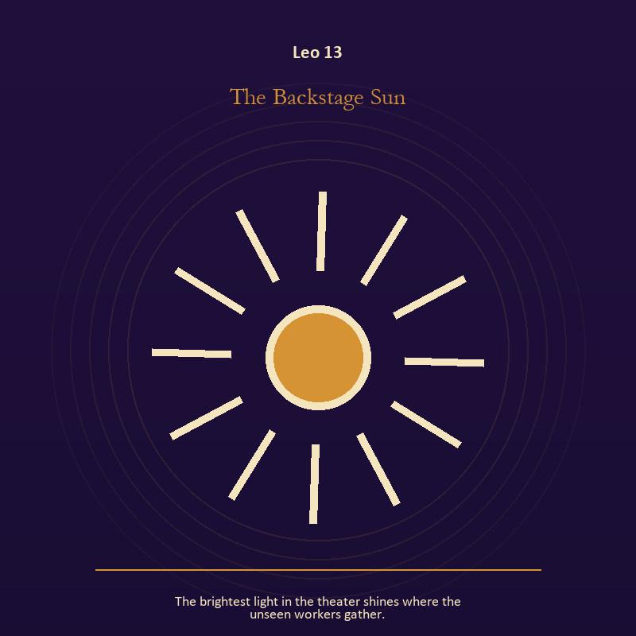

Leo 13 The Backstage Sun
The brightest light in the theater shines where the unseen workers gather.
INTERPRETATION The Backstage Sun holds living fire against creative heat, play, dignity, and the difference between radiance and applause. Within the Backstage Sun, light represents directed attention. At Leo 13, it can warm, expose, guide, consume, or turn a person into a spectacle depending on who controls it. As a revelation degree, Leo 13 turns atmosphere into evidence; attend to the object or action that cannot be explained away.
SIGNAL The usable force at Leo 13 is courage that helps another see; Leo gives it form by asking you to make the honest gesture large enough to be seen.
SHADOW At Leo 13, the Backstage Sun can turn toward mistaking brightness for moral authority; notice when expression becomes display or dignity depends on winning the room.
MIRROR The question at Leo 13: what deserves the full light of your attention now?
PRACTICE Give Leo 13 a physical form; choose one person or project that needs warmth rather than intensity and act accordingly.
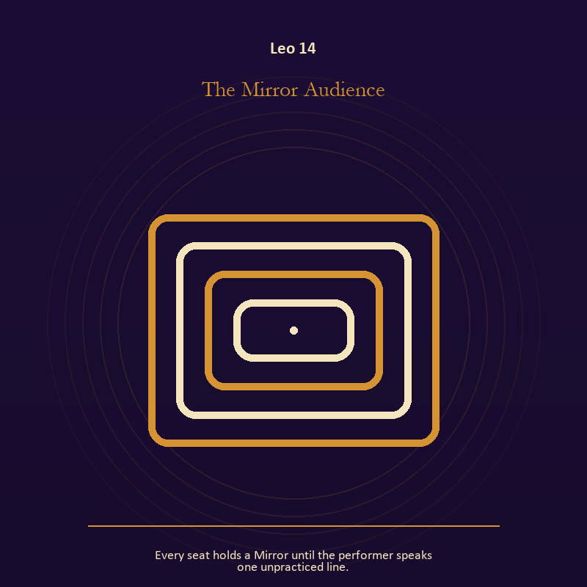

Leo 14 The Mirror Audience
Every seat holds a Mirror until the performer speaks one unpracticed line.
INTERPRETATION The Mirror Audience gives the Mirror consequences inside the Living Flame. Within the Mirror Audience, reflected images divide the observer from the observed self. At Leo 14, that gap can hold shame, vanity, curiosity, or the first honest revision of identity. The same image also carries voice and naming; at Leo 14, voice turns inner pressure into shared consequence. As a revelation degree, Leo 14 shows who carries the cost, who controls the passage, and what the scene refuses to hide.
SIGNAL At Leo 14, the courage to revise a familiar self-image joined to speech with consequence carries the signal; it stays honest when you make the honest gesture large enough to be seen.
SHADOW The shadow at Leo 14 begins with mistaking appearance for character and repeating a message until it sounds like evidence; also notice when expression becomes display or dignity depends on winning the room.
MIRROR At Leo 14, whose gaze have you installed inside your own Mirror?
PRACTICE Bring Leo 14 out of abstraction: describe the scene without interpretation, then circle the detail you most want to praise or condemn.

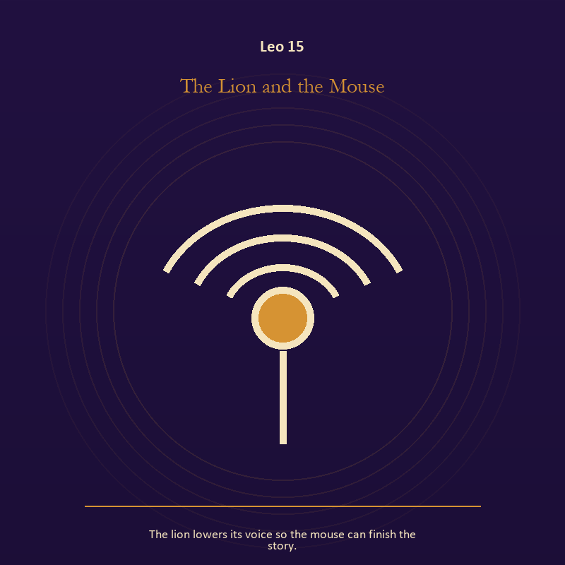

Leo 15 The Lion and the Mouse
The lion lowers its voice so the mouse can finish the story.
INTERPRETATION The Lion and the Mouse puts voice and naming under pressure from creative heat, play, dignity, and the difference between radiance and applause. Within the Lion and the Mouse, naming creates a handle for experience, but the handle must remain smaller than the life it describes. At Leo 15, the image tests language against reality. As a revelation degree, Leo 15 brings the middle truth forward, after the first story has lost its grip.
SIGNAL What can be carried forward from Leo 15 is speech with consequence, tested by the need to make the honest gesture large enough to be seen.
SHADOW At Leo 15, the image darkens through repeating a message until it sounds like evidence; notice when expression becomes display or dignity depends on winning the room.
MIRROR For Leo 15, what are you naming accurately, and what remains larger than the name?
PRACTICE For Leo 15, listen to one person without planning your answer; then repeat their meaning before offering your own.
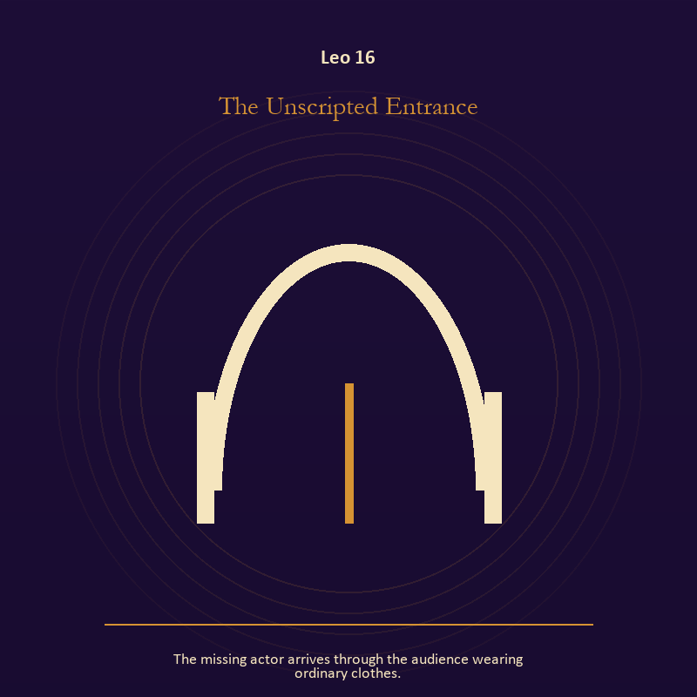

Leo 16 The Unscripted Entrance
The missing actor arrives through the audience wearing ordinary clothes.
INTERPRETATION In the Unscripted Entrance, the work of the threshold must answer to creative heat, play, dignity, and the difference between radiance and applause. Within the Unscripted Entrance, a threshold measures consent, timing, and consequence. At Leo 16, its presence asks whether passage is chosen, forced, delayed, or already under way. The same image also carries identity; at Leo 16, a role organizes behavior but cannot contain the whole person. As a choice degree, Leo 16 requires a choice with a human cost; insight alone no longer completes the work.
SIGNAL At Leo 16, chosen change joined to the freedom to revise a name or role becomes the clean signal when Leo can make the honest gesture large enough to be seen.
SHADOW The distortion at Leo 16 is waiting for permission that will never come and performance mistaken for selfhood; notice when expression becomes display or dignity depends on winning the room.
MIRROR With the Unscripted Entrance in mind at Leo 16, which threshold in your life requires consent rather than momentum?
PRACTICE Work with The Unscripted Entrance directly at Leo 16: write one sentence beginning, 'I may enter when,' and one beginning, 'I remain free to leave when.'. For the second pressure at Leo 16, list the roles you carry; then mark each as chosen, inherited, temporary, or ready to release.

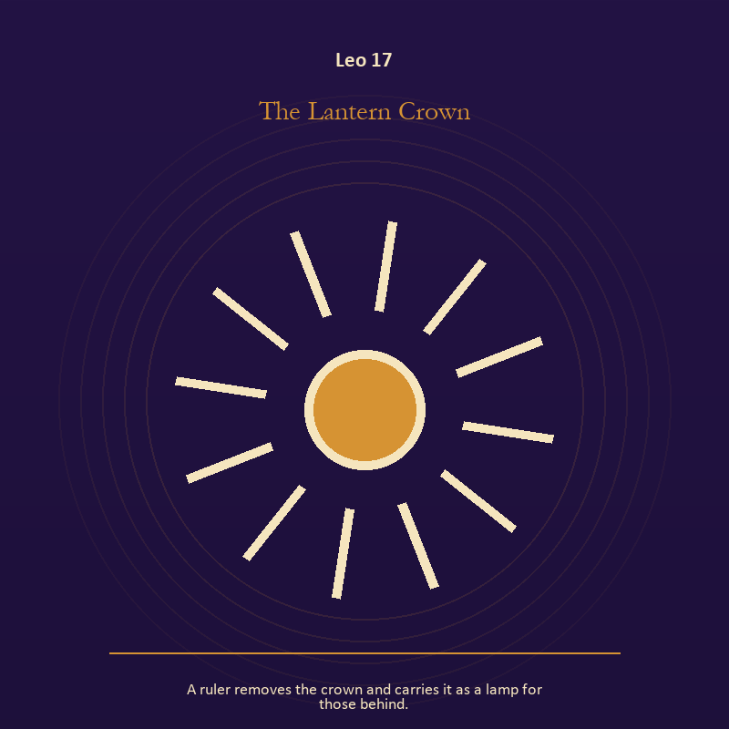

Leo 17 The Lantern Crown
A ruler removes the crown and carries it as a lamp for those behind.
INTERPRETATION The Lantern Crown tests living fire against creative heat, play, dignity, and the difference between radiance and applause. Within the Lantern Crown, fire gives change a visible cost. At Leo 17, something is illuminated here because something else is being spent. The same image also carries authority; at Leo 17, authority is shown as a tool with weight, limits, witnesses, and an eventual transfer. As a choice degree, Leo 17 asks what action preserves truth without using another person as material.
SIGNAL The usable force at Leo 17 is a truth made visible at the right scale joined to stewardship with an exit plan; Leo gives it form by asking you to make the honest gesture large enough to be seen.
SHADOW At Leo 17, the Lantern Crown can turn toward burning for recognition and procedure used to avoid conscience; notice when expression becomes display or dignity depends on winning the room.
MIRROR The question at Leo 17: where has your fire become performance rather than warmth?
PRACTICE Give Leo 17 a physical form; light one candle and give its entire burn to a single unfinished question.
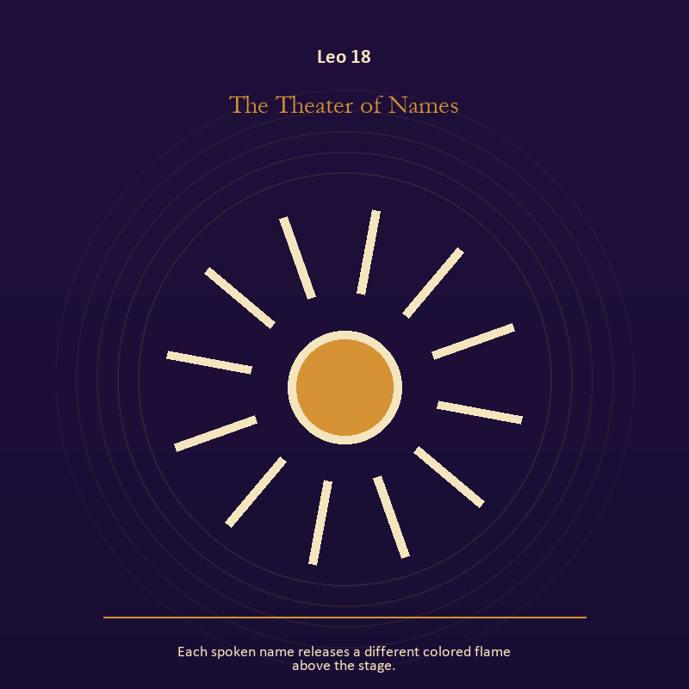

Leo 18 The Theater of Names
Each spoken name releases a different colored flame above the stage.
INTERPRETATION The Theater of Names holds living fire against creative heat, play, dignity, and the difference between radiance and applause. Within the Theater of Names, a Lantern offers enough light for the next honest step. At Leo 18, it does not remove night, and its usefulness depends on how it is carried. The same image also carries voice and naming; at Leo 18, books, letters, bells, and songs extend speech beyond the speaker's body. As a choice degree, Leo 18 moves from recognition to conduct; the clean choice must survive outside the imagination.
SIGNAL At Leo 18, attention with warmth joined to a name that restores agency carries the signal; it stays honest when you make the honest gesture large enough to be seen.
SHADOW The shadow at Leo 18 begins with exposure without care and speaking for someone whose voice is present; also notice when expression becomes display or dignity depends on winning the room.
MIRROR At Leo 18, how much light does the next step require, and who might it expose? From a second angle at Leo 18, what needs to be said plainly, and who has earned the right to hear it?
PRACTICE Bring Leo 18 out of abstraction: move one hidden concern into plain view by naming it to a trusted person.

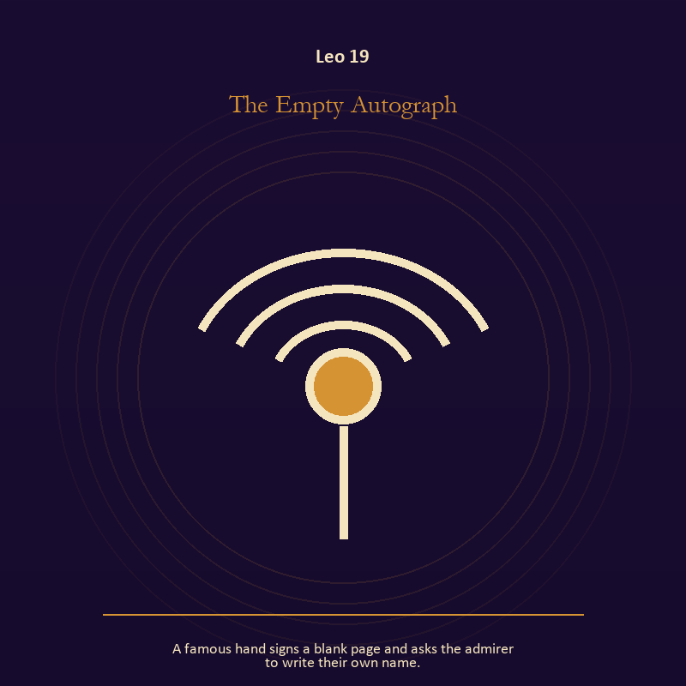

Leo 19 The Empty Autograph
A famous hand signs a blank page and asks the admirer to write their own name.
INTERPRETATION The Empty Autograph gives voice and naming consequences inside the Living Flame. Within the Empty Autograph, voice turns inner pressure into shared consequence. At Leo 19, words can witness, summon, distort, repair, or conceal according to their precision and timing. The same image also carries identity; at Leo 19, a role organizes behavior but cannot contain the whole person. As a choice degree, Leo 19 tests whether awareness can become restraint, repair, refusal, or consent.
SIGNAL What can be carried forward from Leo 19 is a name that restores agency joined to the freedom to revise a name or role, tested by the need to make the honest gesture large enough to be seen.
SHADOW At Leo 19, the image darkens through speaking for someone whose voice is present and performance mistaken for selfhood; notice when expression becomes display or dignity depends on winning the room.
MIRROR For Leo 19, which word in this scene changes the power relationship?
PRACTICE For Leo 19, give the current experience a temporary name and date it, leaving room for revision.
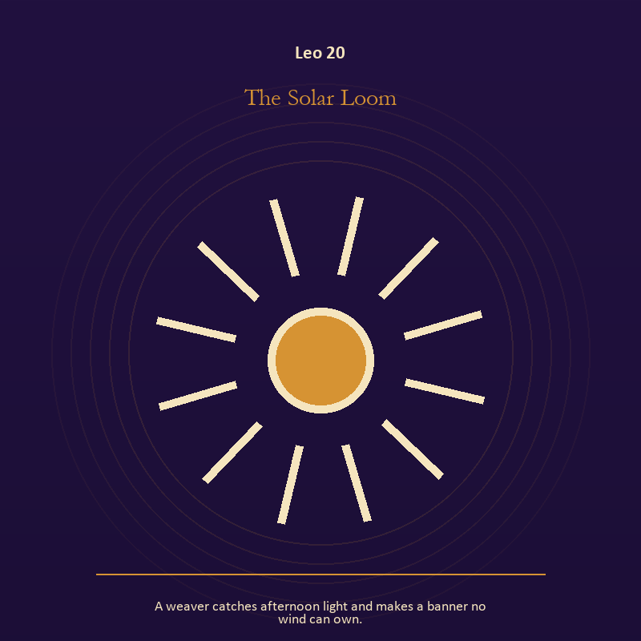

Leo 20 The Solar Loom
A weaver catches afternoon light and makes a banner no wind can own.
INTERPRETATION The Solar Loom puts living fire under pressure from creative heat, play, dignity, and the difference between radiance and applause. Within the Solar Loom, fire gives change a visible cost. At Leo 20, something is illuminated here because something else is being spent. The same image also carries craft and record; at Leo 20, craft turns intention into a repeatable act with materials, limits, and evidence of failure. As a choice degree, Leo 20 places responsibility in the reader's hands without promising a painless answer.
SIGNAL At Leo 20, a truth made visible at the right scale joined to care made repeatable becomes the clean signal when Leo can make the honest gesture large enough to be seen.
SHADOW The distortion at Leo 20 is burning for recognition and the tool becoming the master; notice when expression becomes display or dignity depends on winning the room.
MIRROR With the Solar Loom in mind at Leo 20, where has your fire become performance rather than warmth?
PRACTICE Work with The Solar Loom directly at Leo 20: light one candle and give its entire burn to a single unfinished question. For the second pressure at Leo 20, keep a brief record of what happened, what you expected, and what changed your mind.

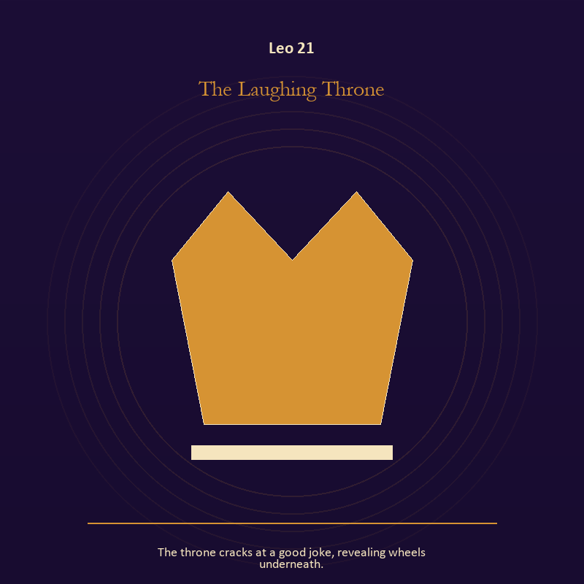

Leo 21 The Laughing Throne
The throne cracks at a good joke, revealing wheels underneath.
INTERPRETATION In the Laughing Throne, the work of authority must answer to creative heat, play, dignity, and the difference between radiance and applause. Within the Laughing Throne, institutional objects reveal the bargain between role and person. At Leo 21, a title may organize service or become a mask that excuses harm. As a integration degree, Leo 21 holds the gift beside its distortion; using one without feeding the other is the work.
SIGNAL The usable force at Leo 21 is stewardship with an exit plan; Leo gives it form by asking you to make the honest gesture large enough to be seen.
SHADOW At Leo 21, the Laughing Throne can turn toward procedure used to avoid conscience; notice when expression becomes display or dignity depends on winning the room.
MIRROR The question at Leo 21: which part of this authority serves life, and which part serves its own continuation?
PRACTICE Give Leo 21 a physical form; remove your title from a current problem and describe the duty that remains.
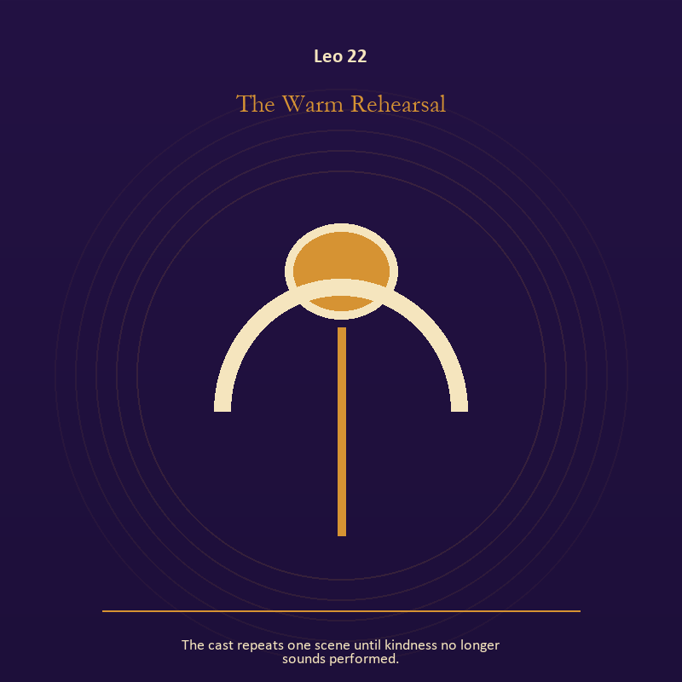

Leo 22 The Warm Rehearsal
The cast repeats one scene until kindness no longer sounds performed.
INTERPRETATION The Warm Rehearsal tests mystery against creative heat, play, dignity, and the difference between radiance and applause. Within the Warm Rehearsal, the scene behaves like a dream with its own exact logic. At Leo 22, meaning lives in the relationship between figure, place, action, and the detail that refuses ordinary explanation. As a integration degree, Leo 22 asks the sign to carry its strength without turning that strength into jurisdiction.
SIGNAL At Leo 22, imagination disciplined by the scene carries the signal; it stays honest when you make the honest gesture large enough to be seen.
SHADOW The shadow at Leo 22 begins with mistaking intensity for accuracy; also notice when expression becomes display or dignity depends on winning the room.
MIRROR At Leo 22, which detail keeps returning after the rest of the scene fades?
PRACTICE Bring Leo 22 out of abstraction: keep the image nearby for one day and record only the moments when it returns on its own.

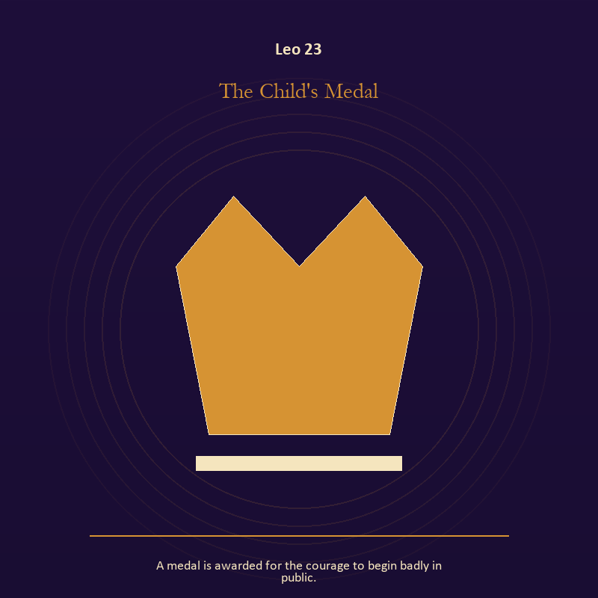

Leo 23 The Child's Medal
A medal is awarded for the courage to begin badly in public.
INTERPRETATION The Child's Medal holds authority against creative heat, play, dignity, and the difference between radiance and applause. Within the Child's Medal, crowns, laws, offices, and verdicts turn private judgment into public consequence. At Leo 23, their legitimacy depends on restraint and correction. The same image also carries growth; at Leo 23, growth appears as vulnerable potential under specific conditions. As a integration degree, Leo 23 joins capacity to consequence; what helps in one setting may harm in another.
SIGNAL What can be carried forward from Leo 23 is a rule that protects the vulnerable person in the room joined to patient becoming, tested by the need to make the honest gesture large enough to be seen.
SHADOW At Leo 23, the image darkens through role mistaken for worth and claiming ownership over another's growth; notice when expression becomes display or dignity depends on winning the room.
MIRROR For Leo 23, what would accountability require from the person holding the key?
PRACTICE For Leo 23, choose one decision you control and write down who can challenge it, correct it, and leave its consequences.
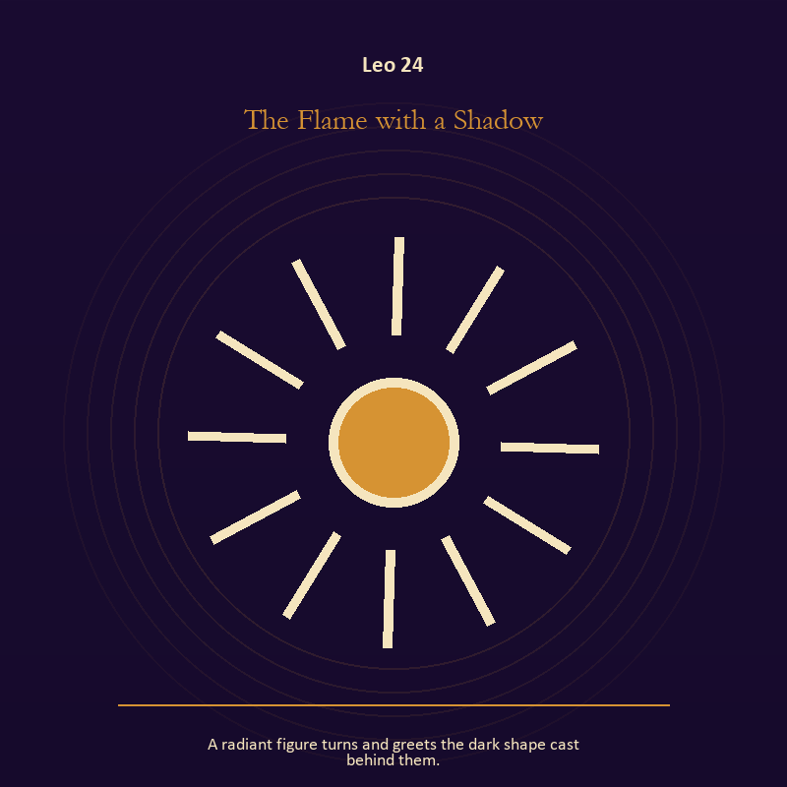

Leo 24 The Flame with a Shadow
A radiant figure turns and greets the dark shape cast behind them.
INTERPRETATION The Flame with a Shadow gives living fire consequences inside the Living Flame. Within the Flame with a Shadow, a Lantern offers enough light for the next honest step. At Leo 24, it does not remove night, and its usefulness depends on how it is carried. The same image also carries the Mirror; at Leo 24, reflected images divide the observer from the observed self. As a integration degree, Leo 24 shows the mature tool and the temptation hidden inside its handle.
SIGNAL At Leo 24, attention with warmth joined to a projection reclaimed becomes the clean signal when Leo can make the honest gesture large enough to be seen.
SHADOW The distortion at Leo 24 is exposure without care and letting shame dictate what the Mirror may show; notice when expression becomes display or dignity depends on winning the room.
MIRROR With the Flame with a Shadow in mind at Leo 24, how much light does the next step require, and who might it expose? From a second angle at Leo 24, whose gaze have you installed inside your own Mirror?
PRACTICE Work with The Flame with a Shadow directly at Leo 24: move one hidden concern into plain view by naming it to a trusted person. For the second pressure at Leo 24, look into a Mirror for one minute and name facts only; then notice when judgment tries to enter as description.

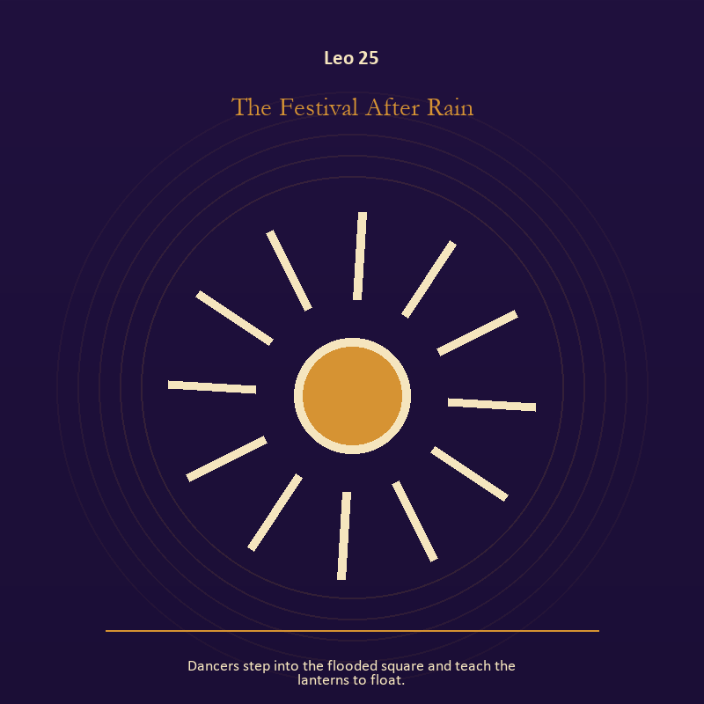

Leo 25 The Festival After Rain
Dancers step into the flooded square and teach the lanterns to float.
INTERPRETATION The Festival After Rain puts living water under pressure from creative heat, play, dignity, and the difference between radiance and applause. Within the Festival After Rain, water carries feeling, memory, adaptation, and forces too large for command. At Leo 25, its shape comes from the vessel, but its movement remains its own. As a integration degree, Leo 25 tests whether the lesson can be lived without becoming a new performance.
SIGNAL The usable force at Leo 25 is adaptation without self-erasure; Leo gives it form by asking you to make the honest gesture large enough to be seen.
SHADOW At Leo 25, the Festival After Rain can turn toward building a vessel too rigid for living water; notice when expression becomes display or dignity depends on winning the room.
MIRROR The question at Leo 25: what feeling needs a vessel rather than a solution?
PRACTICE Give Leo 25 a physical form; wash your hands with attention and decide what belongs to you after the water stops.
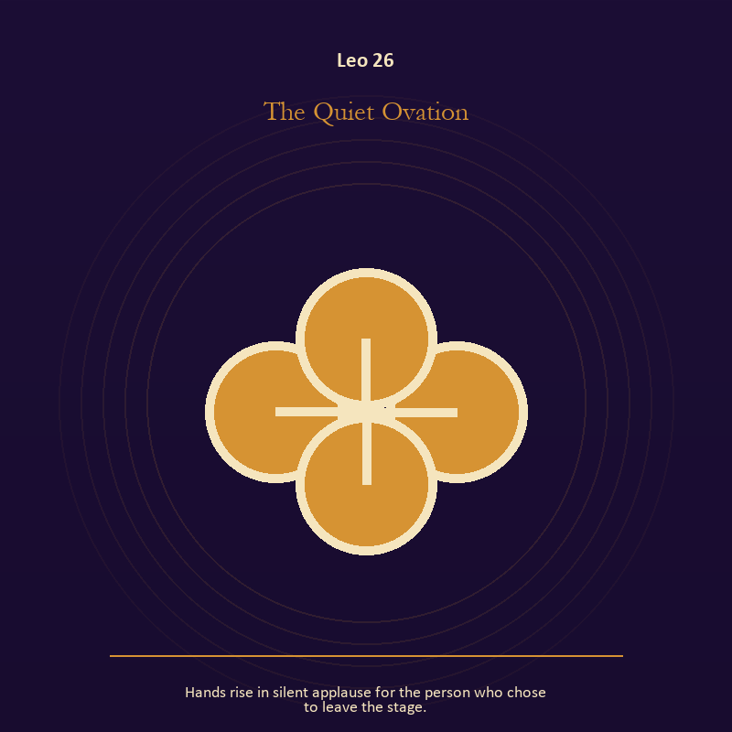

Leo 26 The Quiet Ovation
Hands rise in silent applause for the person who chose to leave the stage.
INTERPRETATION In the Quiet Ovation, the work of relationship must answer to creative heat, play, dignity, and the difference between radiance and applause. Within the Quiet Ovation, relationship imagery tests the fantasy that harmony requires sameness. At Leo 26, a living bond can hold difference, correction, privacy, and departure. As a release degree, Leo 26 prepares the lesson to leave its original container; keep the capacity and loosen the role.
SIGNAL At Leo 26, difference held without humiliation carries the signal; it stays honest when you make the honest gesture large enough to be seen.
SHADOW The shadow at Leo 26 begins with harmony purchased by one person's silence; also notice when expression becomes display or dignity depends on winning the room.
MIRROR At Leo 26, where does responsibility belong, and where has it been displaced?
PRACTICE Bring Leo 26 out of abstraction: ask the other person what they believe the agreement is, then compare it with your own version.

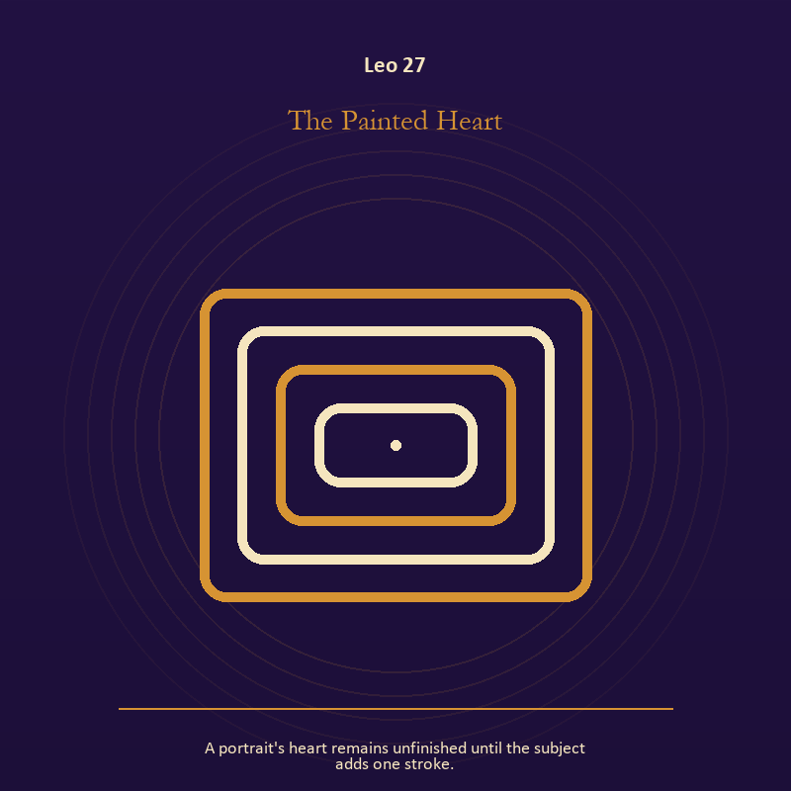

Leo 27 The Painted Heart
A portrait's heart remains unfinished until the subject adds one stroke.
INTERPRETATION The Painted Heart tests the body against creative heat, play, dignity, and the difference between radiance and applause. Within the Painted Heart, embodiment gives every choice a pace and a cost. At Leo 27, the scene asks whether the person can remain present inside the experience being interpreted. The same image also carries the Mirror; at Leo 27, reflected images divide the observer from the observed self. As a release degree, Leo 27 asks what can be handed onward without demanding imitation or loyalty.
SIGNAL What can be carried forward from Leo 27 is presence with weight and limits joined to a projection reclaimed, tested by the need to make the honest gesture large enough to be seen.
SHADOW At Leo 27, the image darkens through treating exhaustion as devotion and letting shame dictate what the Mirror may show; notice when expression becomes display or dignity depends on winning the room.
MIRROR For Leo 27, can the choice be lived at the pace your body can sustain? From a second angle at Leo 27, whose gaze have you installed inside your own Mirror?
PRACTICE For Leo 27, place both feet on the floor and name five physical facts about the present moment.
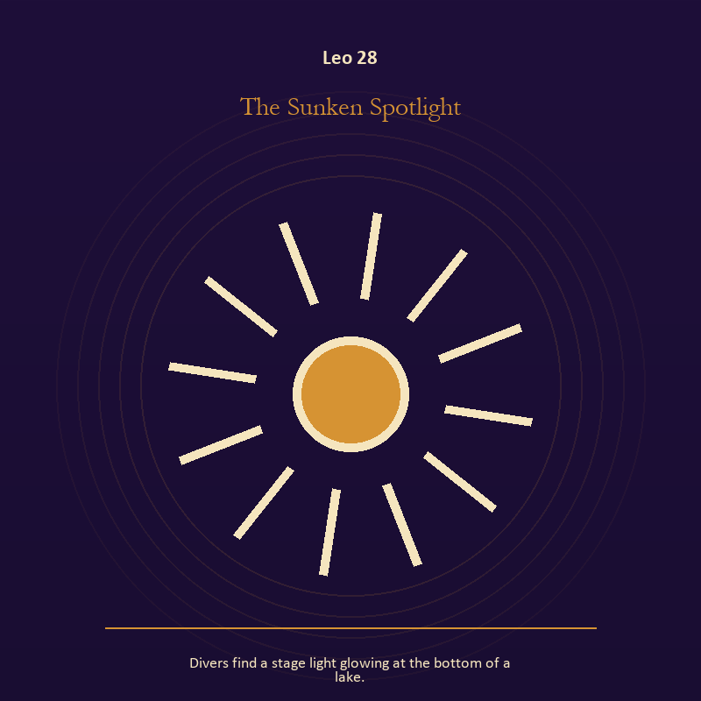

Leo 28 The Sunken Spotlight
Divers find a stage light glowing at the bottom of a lake.
INTERPRETATION The Sunken Spotlight holds living fire against creative heat, play, dignity, and the difference between radiance and applause. Within the Sunken Spotlight, light represents directed attention. At Leo 28, it can warm, expose, guide, consume, or turn a person into a spectacle depending on who controls it. The same image also carries living water; at Leo 28, rain, tides, wells, and floods move private material into a shared landscape. As a release degree, Leo 28 turns completion into transfer; the work survives by changing hands.
SIGNAL At Leo 28, courage that helps another see joined to grief allowed to move becomes the clean signal when Leo can make the honest gesture large enough to be seen.
SHADOW The distortion at Leo 28 is mistaking brightness for moral authority and drowning in another person's weather; notice when expression becomes display or dignity depends on winning the room.
MIRROR With the Sunken Spotlight in mind at Leo 28, what deserves the full light of your attention now?
PRACTICE Work with The Sunken Spotlight directly at Leo 28: choose one person or project that needs warmth rather than intensity and act accordingly. For the second pressure at Leo 28, pour water slowly between two vessels and name what must change shape without losing its substance.

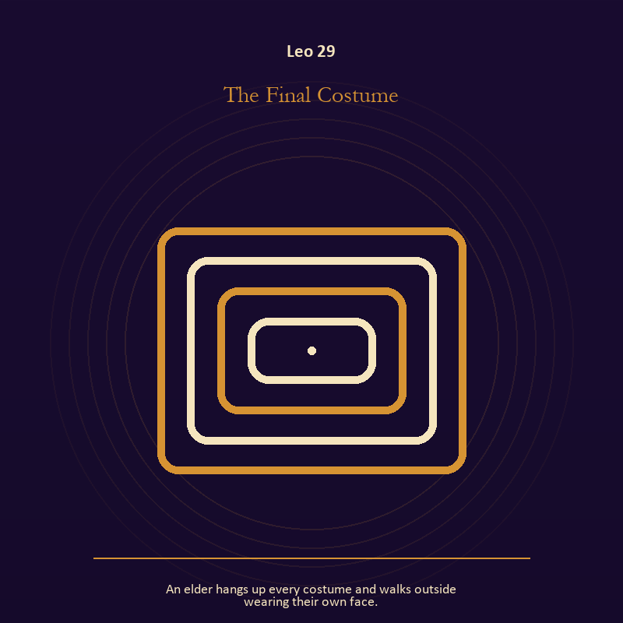

Leo 29 The Final Costume
An elder hangs up every costume and walks outside wearing their own face.
INTERPRETATION The Final Costume gives identity consequences inside the Living Flame. Within the Final Costume, masks and names can conceal, reveal, or give shape to a truth that plain speech cannot yet hold. At Leo 29, their value depends on whether removal remains possible. The same image also carries the Mirror; at Leo 29, the Mirror returns perception without guaranteeing accuracy. As a release degree, Leo 29 lets the sign set down the identity built around its ordeal.
SIGNAL The usable force at Leo 29 is the freedom to revise a name or role joined to self-recognition without self-worship; Leo gives it form by asking you to make the honest gesture large enough to be seen.
SHADOW At Leo 29, the Final Costume can turn toward performance mistaken for selfhood and assigning your hidden material to someone else; notice when expression becomes display or dignity depends on winning the room.
MIRROR The question at Leo 29: what does the mask make possible, and what does it cost to keep wearing it?
PRACTICE Give Leo 29 a physical form; list the roles you carry; then mark each as chosen, inherited, temporary, or ready to release.
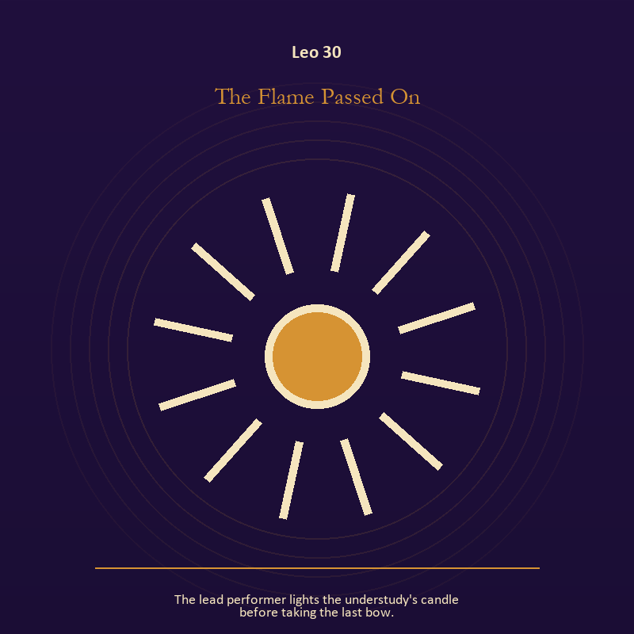

Leo 30 The Flame Passed On
The lead performer lights the understudy's candle before taking the last bow.
INTERPRETATION The Flame Passed On puts living fire under pressure from creative heat, play, dignity, and the difference between radiance and applause. Within the Flame Passed On, a Lantern offers enough light for the next honest step. At Leo 30, it does not remove night, and its usefulness depends on how it is carried. As a release degree, Leo 30 returns the earned knowledge to ordinary life, where another cycle can use it.
SIGNAL At Leo 30, attention with warmth carries the signal; it stays honest when you make the honest gesture large enough to be seen.
SHADOW The shadow at Leo 30 begins with exposure without care; also notice when expression becomes display or dignity depends on winning the room.
MIRROR At Leo 30, how much light does the next step require, and who might it expose?
PRACTICE Bring Leo 30 out of abstraction: move one hidden concern into plain view by naming it to a trusted person.

Virgo
The Sacred Workshop
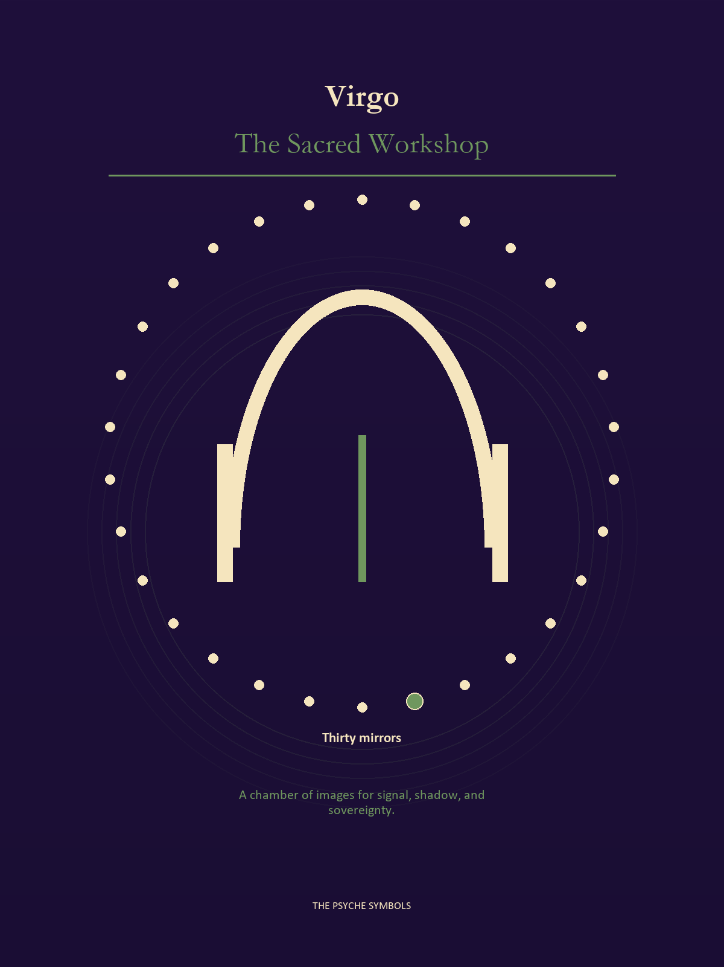
Virgo carries the vision into the workshop and asks what must be cleaned, tested, or repaired. The Sacred Workshop values method, care, evidence, limits, and the unnoticed labor that keeps the Lantern lit. Here discernment protects mystery from carelessness without pretending every mystery can be solved.

Degrees | Gate | Work
1-5 | Arrival | Meet the image before deciding what it means.
6-10 | Friction | Notice what pushes back and what that resistance protects.
11-15 | Revelation | Name the detail that changes the whole scene.
16-20 | Choice | Choose the act that preserves both truth and human dignity.
21-25 | Integration | Use the gift without feeding the shadow that travels beside it.
26-30 | Release | Keep the earned capacity and release the role that delivered it.

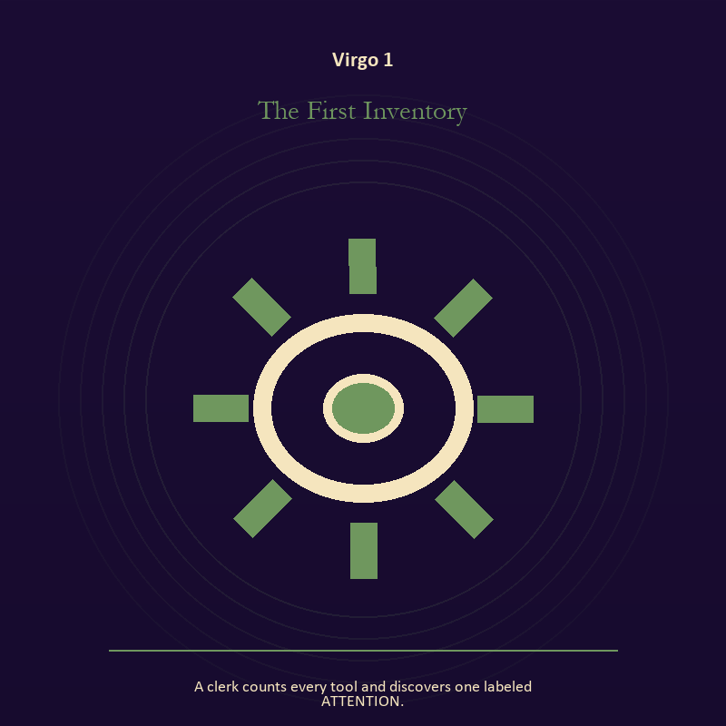

Virgo 1 The First Inventory
A clerk counts every tool and discovers one labeled ATTENTION.
INTERPRETATION In the First Inventory, the work of craft and record must answer to discernment, service, repair, and devotion measured by what works. Within the First Inventory, craft turns intention into a repeatable act with materials, limits, and evidence of failure. At Virgo 1, the tool reveals the quality of attention brought to it. As an arrival degree, Virgo 1 arrives before habit can tidy the evidence; notice what is present before deciding what it should become.
SIGNAL What can be carried forward from Virgo 1 is evidence preserved without spectacle, tested by the need to make one useful correction and record what remains uncertain.
SHADOW At Virgo 1, the image darkens through polish used to hide a structural weakness; watch precision become punishment, service erase the server, or method pretend to be wisdom.
MIRROR For Virgo 1, which part of this process can be checked rather than assumed?
PRACTICE For Virgo 1, repair one useful object without disguising the place where it broke.
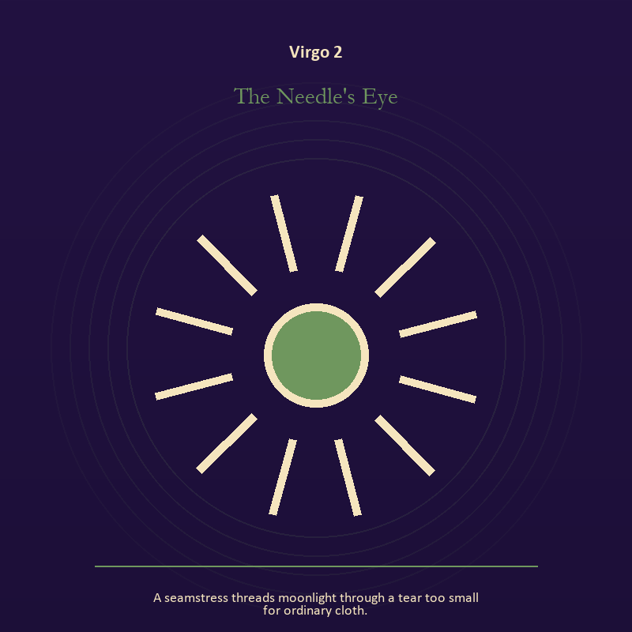

Virgo 2 The Needle's Eye
A seamstress threads moonlight through a tear too small for ordinary cloth.
INTERPRETATION The Needle's Eye tests craft and record against discernment, service, repair, and devotion measured by what works. Within the Needle's Eye, ledgers, maps, machines, and archives make memory operational. At Virgo 2, they can protect truth or compress living complexity until only the form remains. As an arrival degree, Virgo 2 introduces the sign's raw material in an unguarded form; the first response matters less than the honest one.
SIGNAL At Virgo 2, a useful correction that outlives the moment becomes the clean signal when Virgo can make one useful correction and record what remains uncertain.
SHADOW The distortion at Virgo 2 is measurement mistaken for meaning; watch precision become punishment, service erase the server, or method pretend to be wisdom.
MIRROR With the Needle's Eye in mind at Virgo 2, what does the tool preserve, and what does it leave out?
PRACTICE Work with The Needle's Eye directly at Virgo 2: inspect one repeated task and add a check that would catch the most expensive error.

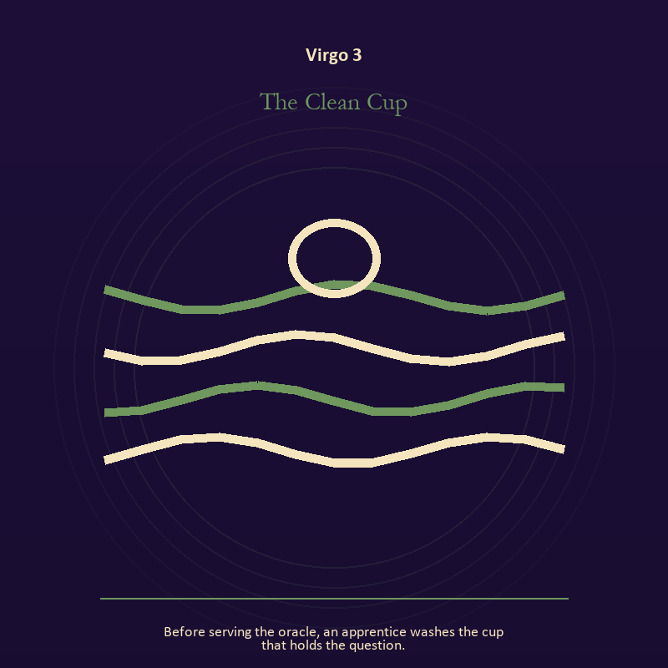

Virgo 3 The Clean Cup
Before serving the oracle, an apprentice washes the cup that holds the question.
INTERPRETATION The Clean Cup holds living water against discernment, service, repair, and devotion measured by what works. Within the Clean Cup, rain, tides, wells, and floods move private material into a shared landscape. At Virgo 3, what was hidden becomes environmental and must be answered together. The same image also carries voice and naming; at Virgo 3, books, letters, bells, and songs extend speech beyond the speaker's body. As an arrival degree, Virgo 3 catches the first impulse before it turns into a role; give the image room to remain strange.
SIGNAL The usable force at Virgo 3 is feeling with a living boundary joined to a name that restores agency; Virgo gives it form by asking you to make one useful correction and record what remains uncertain.
SHADOW At Virgo 3, the Clean Cup can turn toward using mystery to avoid a fact and speaking for someone whose voice is present; watch precision become punishment, service erase the server, or method pretend to be wisdom.
MIRROR The question at Virgo 3: what has the tide exposed that cannot be covered again? From a second angle at Virgo 3, what needs to be said plainly, and who has earned the right to hear it?
PRACTICE Give Virgo 3 a physical form; write the feeling as weather, then add the exact fact occurring beneath that weather.
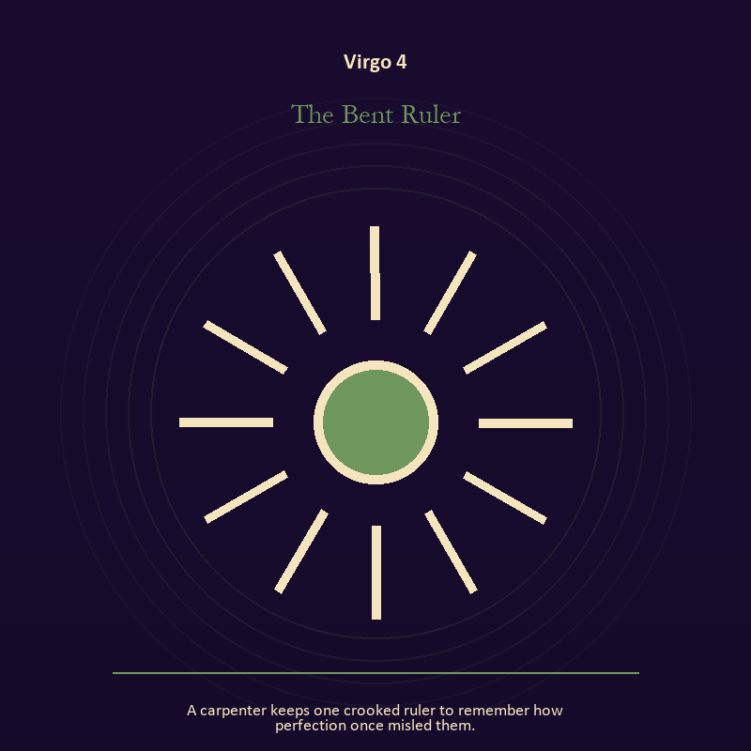

Virgo 4 The Bent Ruler
A carpenter keeps one crooked ruler to remember how perfection once misled them.
INTERPRETATION The Bent Ruler gives mystery consequences inside the Sacred Workshop. Within the Bent Ruler, the scene behaves like a dream with its own exact logic. At Virgo 4, meaning lives in the relationship between figure, place, action, and the detail that refuses ordinary explanation. As an arrival degree, Virgo 4 opens the chamber with no settled method; name the need, risk, or appetite that entered with it.
SIGNAL At Virgo 4, imagination disciplined by the scene carries the signal; it stays honest when you make one useful correction and record what remains uncertain.
SHADOW The shadow at Virgo 4 begins with mistaking intensity for accuracy; also watch precision become punishment, service erase the server, or method pretend to be wisdom.
MIRROR At Virgo 4, which detail keeps returning after the rest of the scene fades?
PRACTICE Bring Virgo 4 out of abstraction: keep the image nearby for one day and record only the moments when it returns on its own.

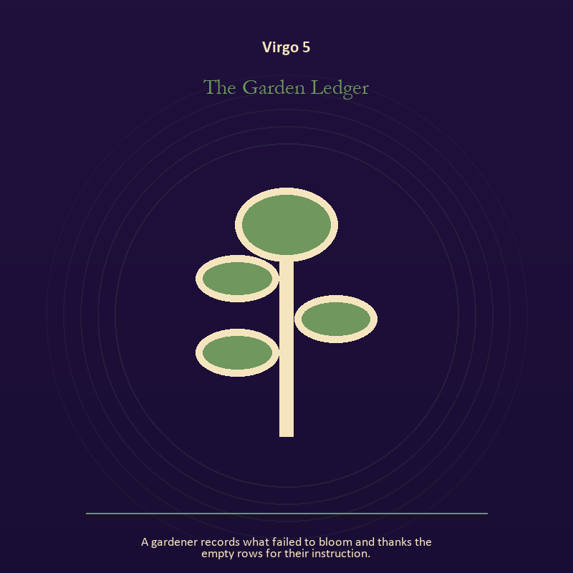

Virgo 5 The Garden Ledger
A gardener records what failed to bloom and thanks the empty rows for their instruction.
INTERPRETATION The Garden Ledger puts growth under pressure from discernment, service, repair, and devotion measured by what works. Within the Garden Ledger, seeds, children, roots, and gardens refuse the fantasy of instant transformation. At Virgo 5, they make becoming physical, seasonal, and dependent on care. The same image also carries craft and record; at Virgo 5, craft turns intention into a repeatable act with materials, limits, and evidence of failure. As an arrival degree, Virgo 5 shows the beginning before ownership hardens around it; let attention come before possession.
SIGNAL What can be carried forward from Virgo 5 is inheritance revised through living action joined to care made repeatable, tested by the need to make one useful correction and record what remains uncertain.
SHADOW At Virgo 5, the image darkens through forcing a season and the tool becoming the master; watch precision become punishment, service erase the server, or method pretend to be wisdom.
MIRROR For Virgo 5, which condition would help this growth, and which demand would deform it?
PRACTICE For Virgo 5, tend one living thing and let its pace correct your schedule.
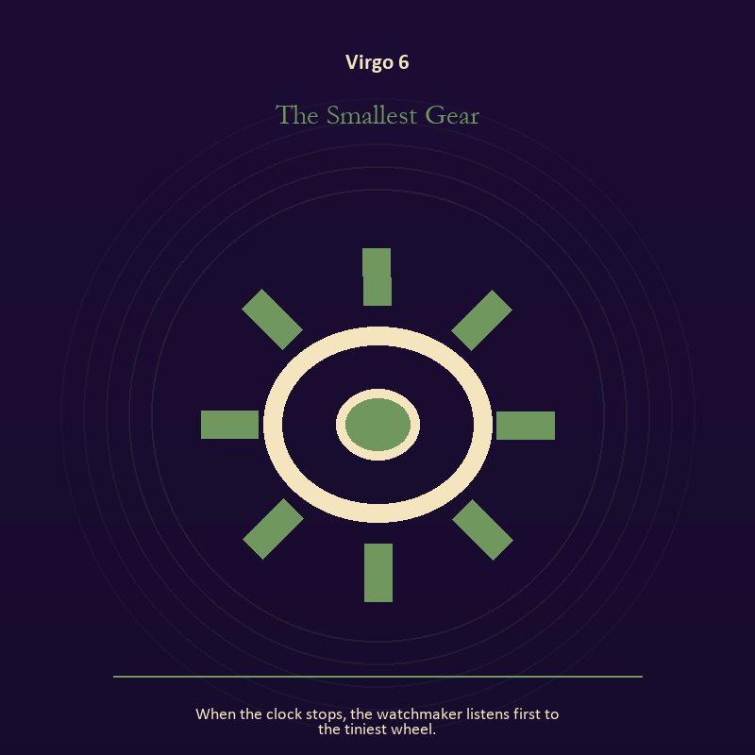

Virgo 6 The Smallest Gear
When the clock stops, the watchmaker listens first to the tiniest wheel.
INTERPRETATION In the Smallest Gear, the work of craft and record must answer to discernment, service, repair, and devotion measured by what works. Within the Smallest Gear, workshops honor correction. At Virgo 6, a flaw becomes useful when it is found early, recorded honestly, and repaired without hiding the seam. As a friction degree, Virgo 6 meets resistance, and that resistance reveals what the first impulse failed to consider.
SIGNAL At Virgo 6, care made repeatable becomes the clean signal when Virgo can make one useful correction and record what remains uncertain.
SHADOW The distortion at Virgo 6 is the tool becoming the master; watch precision become punishment, service erase the server, or method pretend to be wisdom.
MIRROR With the Smallest Gear in mind at Virgo 6, where would an honest repair remain visible?
PRACTICE Work with The Smallest Gear directly at Virgo 6: keep a brief record of what happened, what you expected, and what changed your mind.

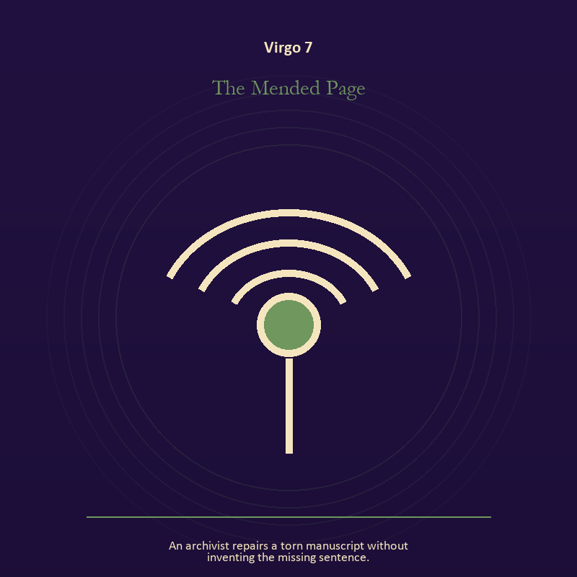

Virgo 7 The Mended Page
An archivist repairs a torn manuscript without inventing the missing sentence.
INTERPRETATION The Mended Page tests voice and naming against discernment, service, repair, and devotion measured by what works. Within the Mended Page, voice turns inner pressure into shared consequence. At Virgo 7, words can witness, summon, distort, repair, or conceal according to their precision and timing. As a friction degree, Virgo 7 places consequence beside desire; the obstruction may be an enemy, a limit, or a needed correction.
SIGNAL The usable force at Virgo 7 is a name that restores agency; Virgo gives it form by asking you to make one useful correction and record what remains uncertain.
SHADOW At Virgo 7, the Mended Page can turn toward speaking for someone whose voice is present; watch precision become punishment, service erase the server, or method pretend to be wisdom.
MIRROR The question at Virgo 7: which word in this scene changes the power relationship?
PRACTICE Give Virgo 7 a physical form; give the current experience a temporary name and date it, leaving room for revision.
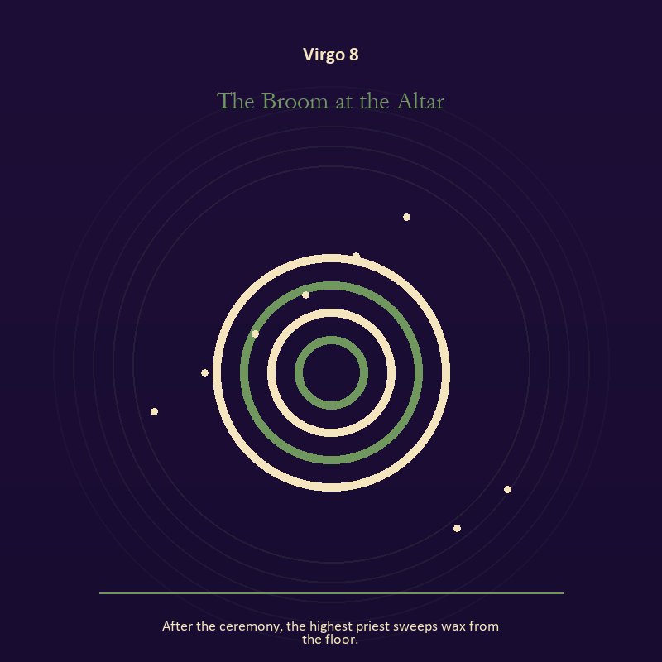

Virgo 8 The Broom at the Altar
After the ceremony, the highest priest sweeps wax from the floor.
INTERPRETATION The Broom at the Altar holds mystery against discernment, service, repair, and devotion measured by what works. Within the Broom at the Altar, this image invites attention before conclusion. At Virgo 8, its strange fact creates a pressure point where memory, desire, fear, and choice can speak indirectly. As a friction degree, Virgo 8 tests whether the sign can change course without treating correction as defeat.
SIGNAL At Virgo 8, an unanswered image that keeps thought alive carries the signal; it stays honest when you make one useful correction and record what remains uncertain.
SHADOW The shadow at Virgo 8 begins with forcing a prophecy from ambiguity; also watch precision become punishment, service erase the server, or method pretend to be wisdom.
MIRROR At Virgo 8, what ordinary fact sits beneath the strange image?
PRACTICE Bring Virgo 8 out of abstraction: copy the image by hand, underline three concrete nouns, and write one association for each.

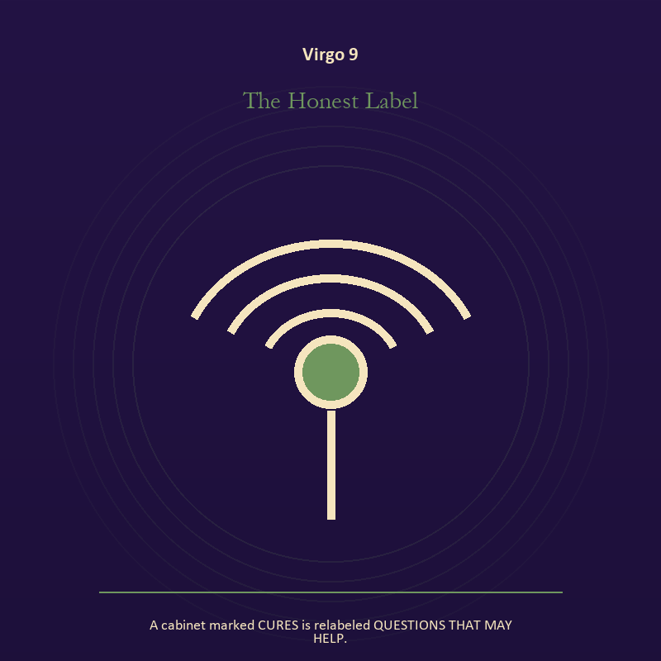

Virgo 9 The Honest Label
A cabinet marked CURES is relabeled QUESTIONS THAT MAY HELP.
INTERPRETATION The Honest Label gives mystery consequences inside the Sacred Workshop. Within the Honest Label, the symbol remains useful when no single interpretation closes it. At Virgo 9, its work is to make one hidden relationship visible enough to examine. As a friction degree, Virgo 9 brings another will, material limit, or inconvenient fact into the frame.
SIGNAL What can be carried forward from Virgo 9 is attention without premature certainty, tested by the need to make one useful correction and record what remains uncertain.
SHADOW At Virgo 9, the image darkens through using beauty to avoid the ordinary fact; watch precision become punishment, service erase the server, or method pretend to be wisdom.
MIRROR For Virgo 9, what changes if the scene is a question rather than an answer?
PRACTICE For Virgo 9, describe the scene to another person without explaining it, then notice what they ask first.
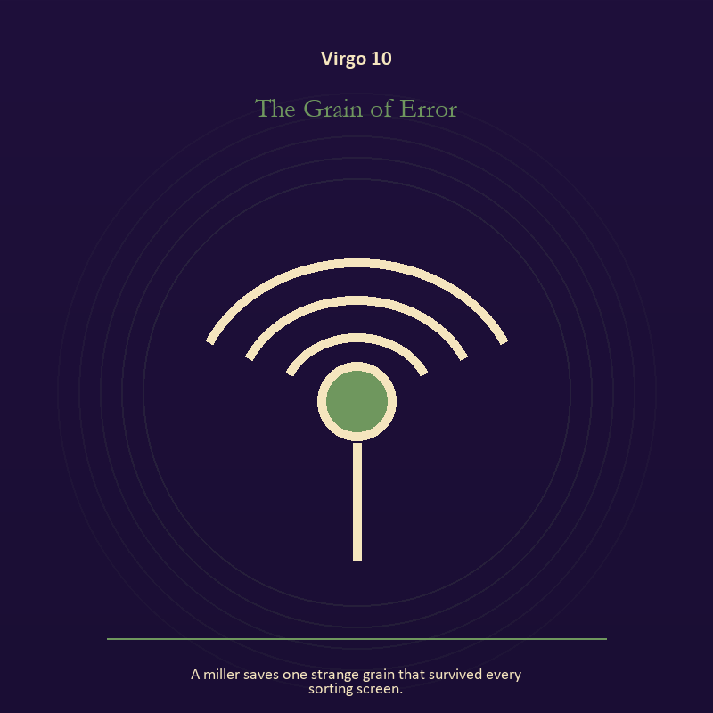

Virgo 10 The Grain of Error
A miller saves one strange grain that survived every sorting screen.
INTERPRETATION The Grain of Error puts the Signal under pressure from discernment, service, repair, and devotion measured by what works. Within the Grain of Error, signal imagery asks what is being transmitted beneath performance. At Virgo 10, interference may come from fear, vanity, noise, or a container too narrow for the message. As a friction degree, Virgo 10 slows the original motion long enough to expose what haste concealed.
SIGNAL At Virgo 10, contact across distance becomes the clean signal when Virgo can make one useful correction and record what remains uncertain.
SHADOW The distortion at Virgo 10 is letting noise impersonate urgency; watch precision become punishment, service erase the server, or method pretend to be wisdom.
MIRROR With the Grain of Error in mind at Virgo 10, what remains of your message when performance is removed?
PRACTICE Work with The Grain of Error directly at Virgo 10: write the same message for a friend, an opponent, and your future self; then keep the sentence that stays true in all three versions.

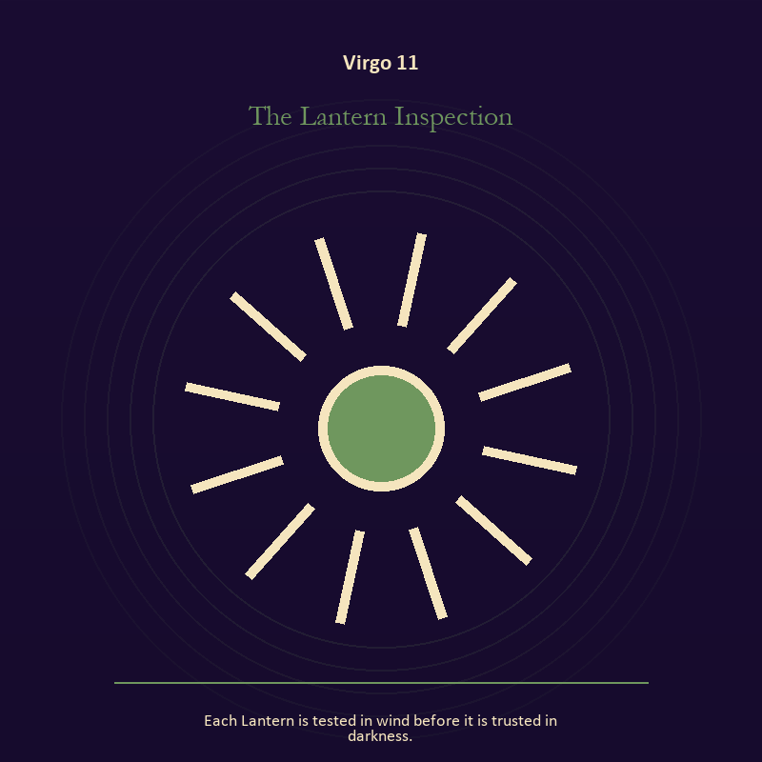

Virgo 11 The Lantern Inspection
Each Lantern is tested in wind before it is trusted in darkness.
INTERPRETATION In the Lantern Inspection, the work of living fire must answer to discernment, service, repair, and devotion measured by what works. Within the Lantern Inspection, fire gives change a visible cost. At Virgo 11, something is illuminated here because something else is being spent. As a revelation degree, Virgo 11 reveals the mechanism under the mood; one concrete detail changes the reading.
SIGNAL The usable force at Virgo 11 is a truth made visible at the right scale; Virgo gives it form by asking you to make one useful correction and record what remains uncertain.
SHADOW At Virgo 11, the Lantern Inspection can turn toward burning for recognition; watch precision become punishment, service erase the server, or method pretend to be wisdom.
MIRROR The question at Virgo 11: where has your fire become performance rather than warmth?
PRACTICE Give Virgo 11 a physical form; light one candle and give its entire burn to a single unfinished question.
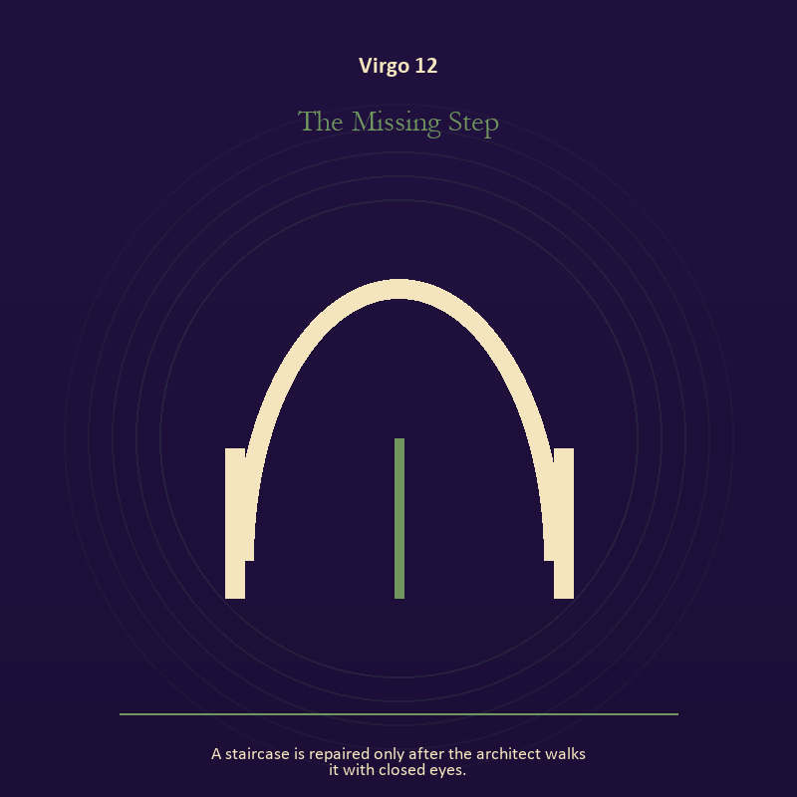

Virgo 12 The Missing Step
A staircase is repaired only after the architect walks it with closed eyes.
INTERPRETATION The Missing Step tests the Mirror against discernment, service, repair, and devotion measured by what works. Within the Missing Step, a shadow proves that something real stands in the light, while a reflection shows only an angle. At Virgo 12, neither is the whole person. The same image also carries craft and record; at Virgo 12, ledgers, maps, machines, and archives make memory operational. As a revelation degree, Virgo 12 moves the hidden arrangement into view, where it can be named without being exaggerated.
SIGNAL At Virgo 12, self-recognition without self-worship joined to evidence preserved without spectacle carries the signal; it stays honest when you make one useful correction and record what remains uncertain.
SHADOW The shadow at Virgo 12 begins with assigning your hidden material to someone else and polish used to hide a structural weakness; also watch precision become punishment, service erase the server, or method pretend to be wisdom.
MIRROR At Virgo 12, which part of the reflection is asking to be reclaimed rather than judged? From a second angle at Virgo 12, what does the tool preserve, and what does it leave out?
PRACTICE Bring Virgo 12 out of abstraction: write two accounts of the same conflict: one from your position and one from the person you cannot understand.

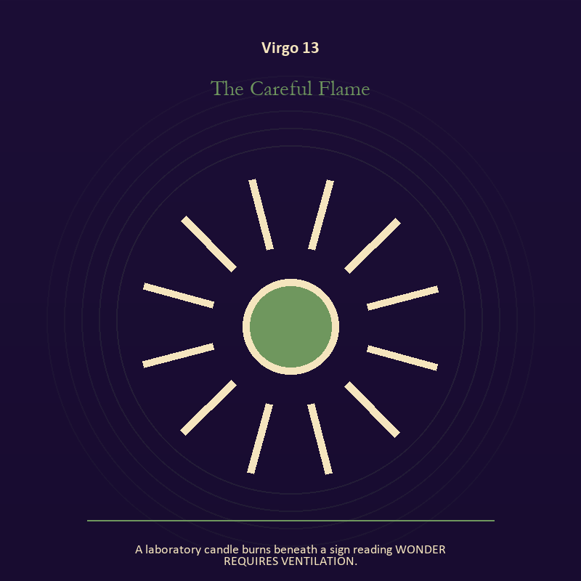

Virgo 13 The Careful Flame
A laboratory candle burns beneath a sign reading WONDER REQUIRES VENTILATION.
INTERPRETATION The Careful Flame holds living fire against discernment, service, repair, and devotion measured by what works. Within the Careful Flame, light represents directed attention. At Virgo 13, it can warm, expose, guide, consume, or turn a person into a spectacle depending on who controls it. As a revelation degree, Virgo 13 turns atmosphere into evidence; attend to the object or action that cannot be explained away.
SIGNAL What can be carried forward from Virgo 13 is courage that helps another see, tested by the need to make one useful correction and record what remains uncertain.
SHADOW At Virgo 13, the image darkens through mistaking brightness for moral authority; watch precision become punishment, service erase the server, or method pretend to be wisdom.
MIRROR For Virgo 13, what deserves the full light of your attention now?
PRACTICE For Virgo 13, choose one person or project that needs warmth rather than intensity and act accordingly.
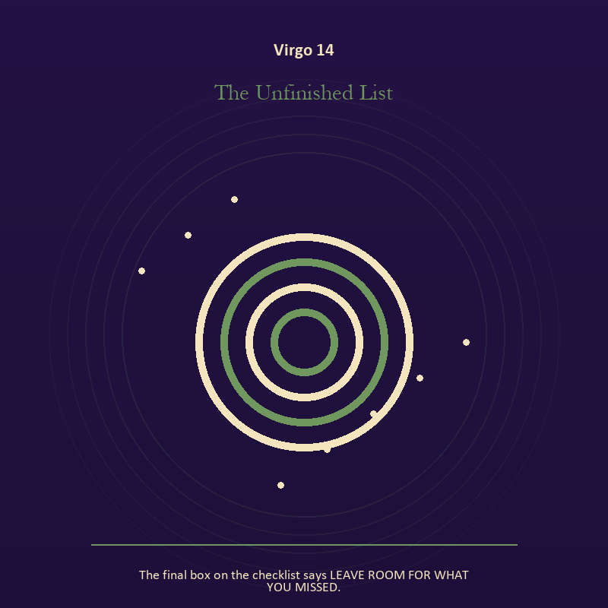

Virgo 14 The Unfinished List
The final box on the checklist says LEAVE ROOM FOR WHAT YOU MISSED.
INTERPRETATION The Unfinished List gives mystery consequences inside the Sacred Workshop. Within the Unfinished List, this image invites attention before conclusion. At Virgo 14, its strange fact creates a pressure point where memory, desire, fear, and choice can speak indirectly. As a revelation degree, Virgo 14 shows who carries the cost, who controls the passage, and what the scene refuses to hide.
SIGNAL At Virgo 14, an unanswered image that keeps thought alive becomes the clean signal when Virgo can make one useful correction and record what remains uncertain.
SHADOW The distortion at Virgo 14 is forcing a prophecy from ambiguity; watch precision become punishment, service erase the server, or method pretend to be wisdom.
MIRROR With the Unfinished List in mind at Virgo 14, what ordinary fact sits beneath the strange image?
PRACTICE Work with The Unfinished List directly at Virgo 14: copy the image by hand, underline three concrete nouns, and write one association for each.

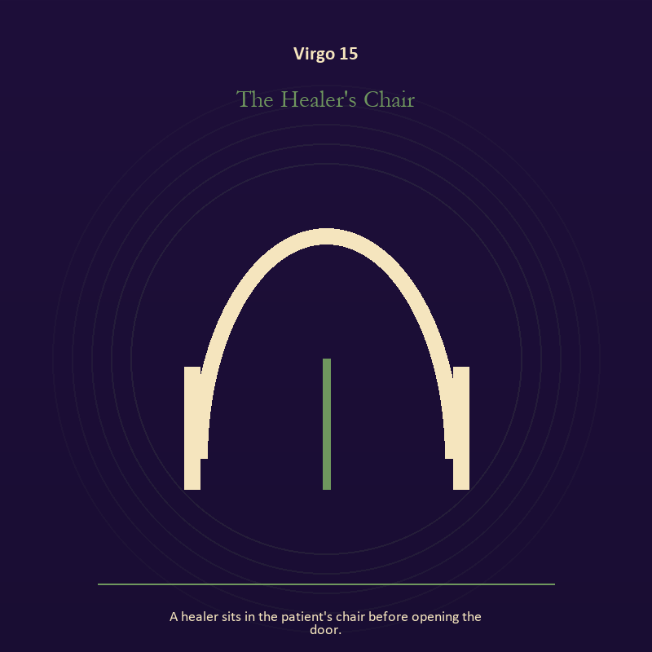

Virgo 15 The Healer's Chair
A healer sits in the patient's chair before opening the door.
INTERPRETATION The Healer's Chair puts the body under pressure from discernment, service, repair, and devotion measured by what works. Within the Healer's Chair, embodiment gives every choice a pace and a cost. At Virgo 15, the scene asks whether the person can remain present inside the experience being interpreted. The same image also carries the threshold; at Virgo 15, doors and roads turn inner change into an embodied decision. As a revelation degree, Virgo 15 brings the middle truth forward, after the first story has lost its grip.
SIGNAL The usable force at Virgo 15 is presence with weight and limits joined to chosen change; Virgo gives it form by asking you to make one useful correction and record what remains uncertain.
SHADOW At Virgo 15, the Healer's Chair can turn toward treating exhaustion as devotion and waiting for permission that will never come; watch precision become punishment, service erase the server, or method pretend to be wisdom.
MIRROR The question at Virgo 15: can the choice be lived at the pace your body can sustain? From a second angle at Virgo 15, what are you protecting by remaining on this side of the door?
PRACTICE Give Virgo 15 a physical form; place both feet on the floor and name five physical facts about the present moment.
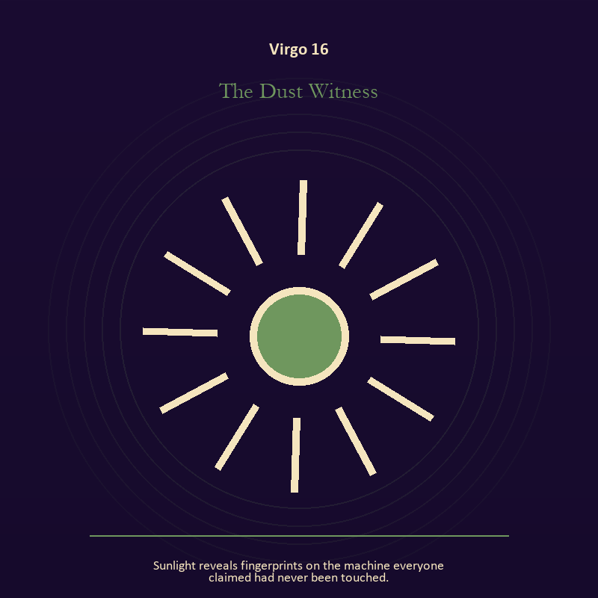

Virgo 16 The Dust Witness
Sunlight reveals fingerprints on the machine everyone claimed had never been touched.
INTERPRETATION In the Dust Witness, the work of craft and record must answer to discernment, service, repair, and devotion measured by what works. Within the Dust Witness, craft turns intention into a repeatable act with materials, limits, and evidence of failure. At Virgo 16, the tool reveals the quality of attention brought to it. As a choice degree, Virgo 16 requires a choice with a human cost; insight alone no longer completes the work.
SIGNAL At Virgo 16, evidence preserved without spectacle carries the signal; it stays honest when you make one useful correction and record what remains uncertain.
SHADOW The shadow at Virgo 16 begins with polish used to hide a structural weakness; also watch precision become punishment, service erase the server, or method pretend to be wisdom.
MIRROR At Virgo 16, which part of this process can be checked rather than assumed?
PRACTICE Bring Virgo 16 out of abstraction: repair one useful object without disguising the place where it broke.

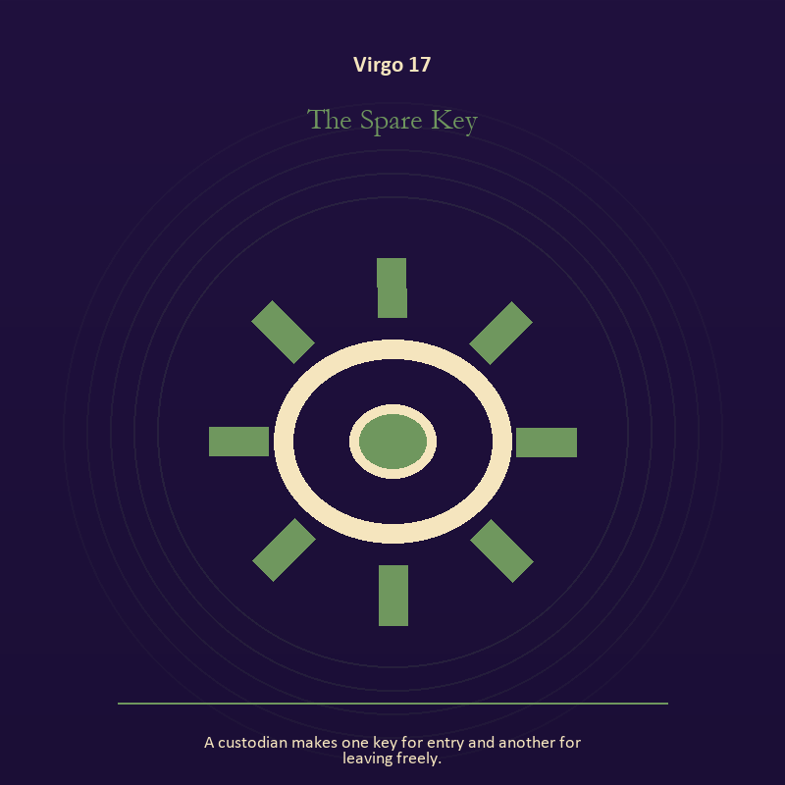

Virgo 17 The Spare Key
A custodian makes one key for entry and another for leaving freely.
INTERPRETATION The Spare Key tests craft and record against discernment, service, repair, and devotion measured by what works. Within the Spare Key, ledgers, maps, machines, and archives make memory operational. At Virgo 17, they can protect truth or compress living complexity until only the form remains. The same image also carries relationship; at Virgo 17, more than one will is active in this scene. As a choice degree, Virgo 17 asks what action preserves truth without using another person as material.
SIGNAL What can be carried forward from Virgo 17 is a useful correction that outlives the moment joined to contact without capture, tested by the need to make one useful correction and record what remains uncertain.
SHADOW At Virgo 17, the image darkens through measurement mistaken for meaning and projection mistaken for intimacy; watch precision become punishment, service erase the server, or method pretend to be wisdom.
MIRROR For Virgo 17, what does the tool preserve, and what does it leave out?
PRACTICE For Virgo 17, inspect one repeated task and add a check that would catch the most expensive error.
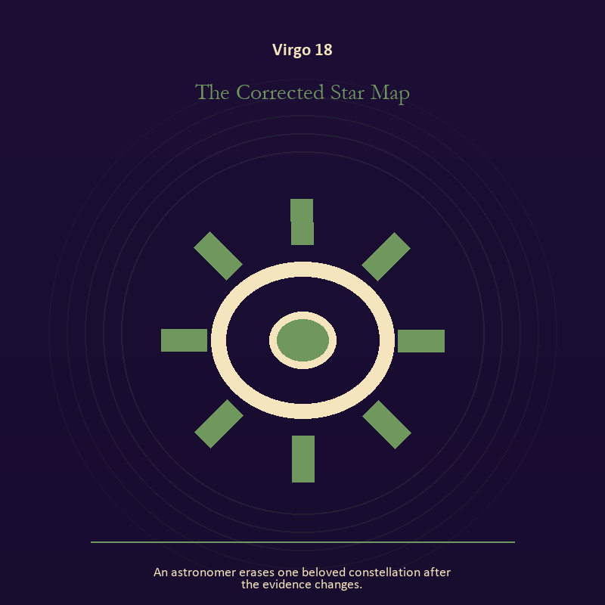

Virgo 18 The Corrected Star Map
An astronomer erases one beloved constellation after the evidence changes.
INTERPRETATION The Corrected Star Map holds craft and record against discernment, service, repair, and devotion measured by what works. Within the Corrected Star Map, workshops honor correction. At Virgo 18, a flaw becomes useful when it is found early, recorded honestly, and repaired without hiding the seam. As a choice degree, Virgo 18 moves from recognition to conduct; the clean choice must survive outside the imagination.
SIGNAL At Virgo 18, care made repeatable becomes the clean signal when Virgo can make one useful correction and record what remains uncertain.
SHADOW The distortion at Virgo 18 is the tool becoming the master; watch precision become punishment, service erase the server, or method pretend to be wisdom.
MIRROR With the Corrected Star Map in mind at Virgo 18, where would an honest repair remain visible?
PRACTICE Work with The Corrected Star Map directly at Virgo 18: keep a brief record of what happened, what you expected, and what changed your mind.

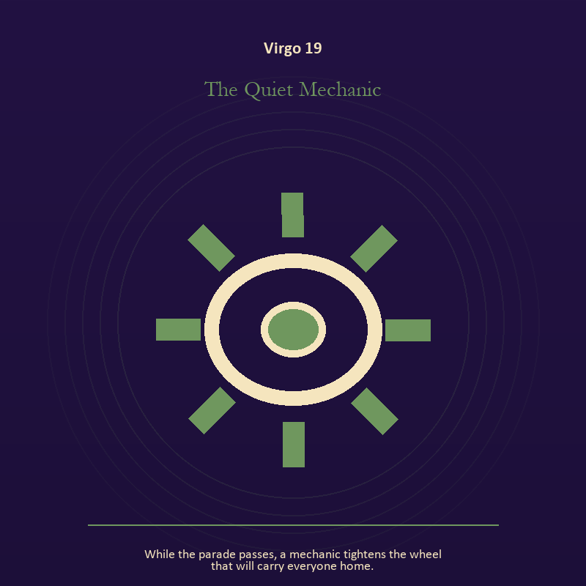

Virgo 19 The Quiet Mechanic
While the parade passes, a mechanic tightens the wheel that will carry everyone home.
INTERPRETATION The Quiet Mechanic gives craft and record consequences inside the Sacred Workshop. Within the Quiet Mechanic, craft turns intention into a repeatable act with materials, limits, and evidence of failure. At Virgo 19, the tool reveals the quality of attention brought to it. As a choice degree, Virgo 19 tests whether awareness can become restraint, repair, refusal, or consent.
SIGNAL The usable force at Virgo 19 is evidence preserved without spectacle; Virgo gives it form by asking you to make one useful correction and record what remains uncertain.
SHADOW At Virgo 19, the Quiet Mechanic can turn toward polish used to hide a structural weakness; watch precision become punishment, service erase the server, or method pretend to be wisdom.
MIRROR The question at Virgo 19: which part of this process can be checked rather than assumed?
PRACTICE Give Virgo 19 a physical form; repair one useful object without disguising the place where it broke.
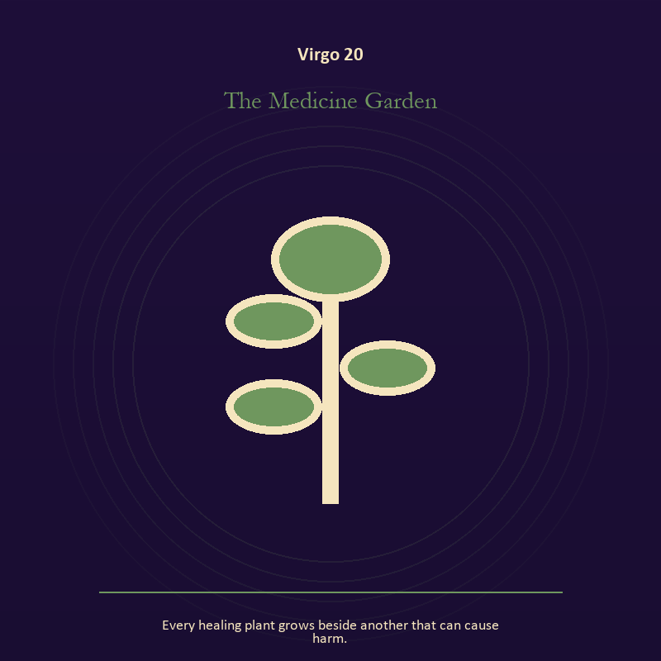

Virgo 20 The Medicine Garden
Every healing plant grows beside another that can cause harm.
INTERPRETATION The Medicine Garden puts growth under pressure from discernment, service, repair, and devotion measured by what works. Within the Medicine Garden, seeds, children, roots, and gardens refuse the fantasy of instant transformation. At Virgo 20, they make becoming physical, seasonal, and dependent on care. The same image also carries relationship; at Virgo 20, more than one will is active in this scene. As a choice degree, Virgo 20 places responsibility in the reader's hands without promising a painless answer.
SIGNAL At Virgo 20, inheritance revised through living action joined to contact without capture carries the signal; it stays honest when you make one useful correction and record what remains uncertain.
SHADOW The shadow at Virgo 20 begins with forcing a season and projection mistaken for intimacy; also watch precision become punishment, service erase the server, or method pretend to be wisdom.
MIRROR At Virgo 20, which condition would help this growth, and which demand would deform it?
PRACTICE Bring Virgo 20 out of abstraction: tend one living thing and let its pace correct your schedule.

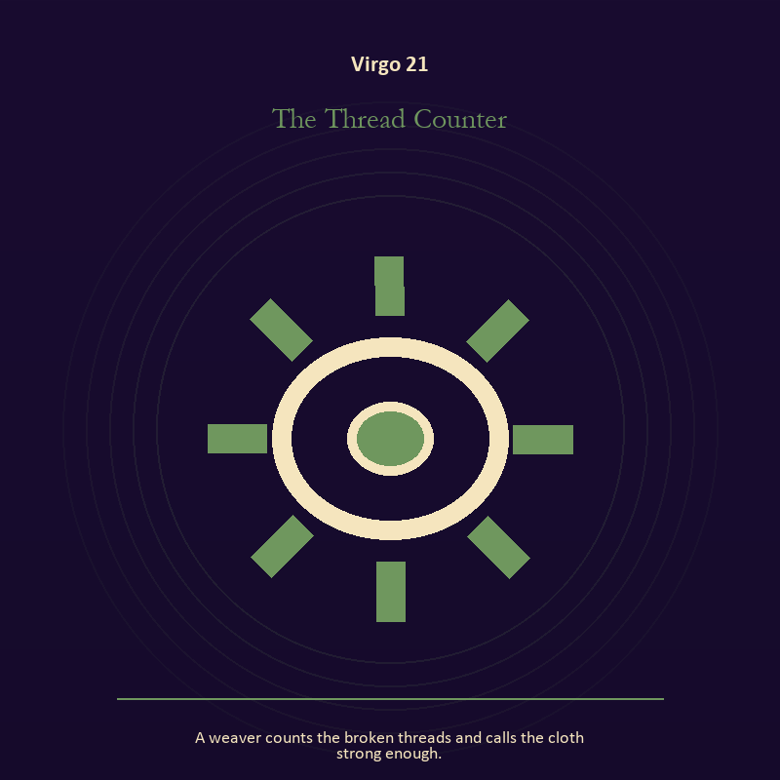

Virgo 21 The Thread Counter
A weaver counts the broken threads and calls the cloth strong enough.
INTERPRETATION In the Thread Counter, the work of craft and record must answer to discernment, service, repair, and devotion measured by what works. Within the Thread Counter, workshops honor correction. At Virgo 21, a flaw becomes useful when it is found early, recorded honestly, and repaired without hiding the seam. As a integration degree, Virgo 21 holds the gift beside its distortion; using one without feeding the other is the work.
SIGNAL What can be carried forward from Virgo 21 is care made repeatable, tested by the need to make one useful correction and record what remains uncertain.
SHADOW At Virgo 21, the image darkens through the tool becoming the master; watch precision become punishment, service erase the server, or method pretend to be wisdom.
MIRROR For Virgo 21, where would an honest repair remain visible?
PRACTICE For Virgo 21, keep a brief record of what happened, what you expected, and what changed your mind.
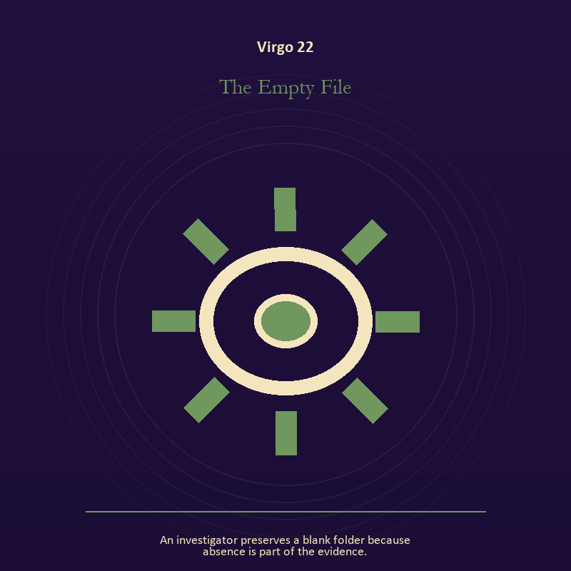

Virgo 22 The Empty File
An investigator preserves a blank folder because absence is part of the evidence.
INTERPRETATION The Empty File tests craft and record against discernment, service, repair, and devotion measured by what works. Within the Empty File, craft turns intention into a repeatable act with materials, limits, and evidence of failure. At Virgo 22, the tool reveals the quality of attention brought to it. As a integration degree, Virgo 22 asks the sign to carry its strength without turning that strength into jurisdiction.
SIGNAL At Virgo 22, evidence preserved without spectacle becomes the clean signal when Virgo can make one useful correction and record what remains uncertain.
SHADOW The distortion at Virgo 22 is polish used to hide a structural weakness; watch precision become punishment, service erase the server, or method pretend to be wisdom.
MIRROR With the Empty File in mind at Virgo 22, which part of this process can be checked rather than assumed?
PRACTICE Work with The Empty File directly at Virgo 22: repair one useful object without disguising the place where it broke.

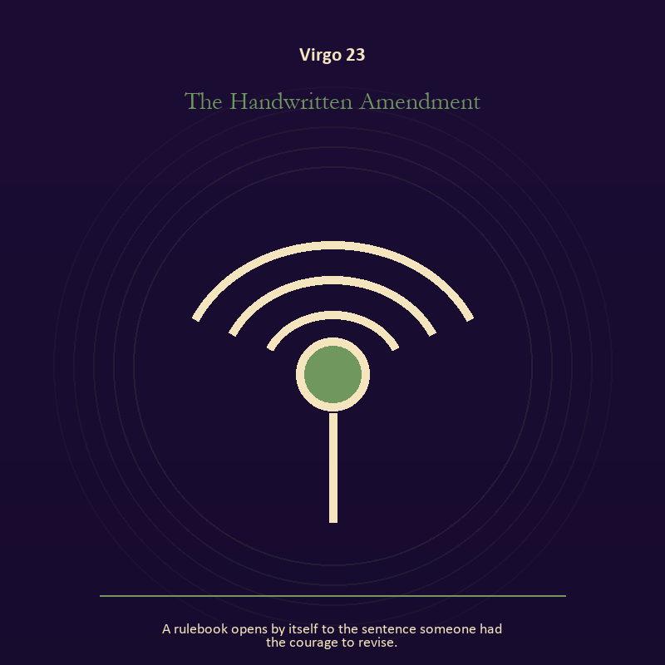

Virgo 23 The Handwritten Amendment
A rulebook opens by itself to the sentence someone had the courage to revise.
INTERPRETATION The Handwritten Amendment holds mystery against discernment, service, repair, and devotion measured by what works. Within the Handwritten Amendment, this image invites attention before conclusion. At Virgo 23, its strange fact creates a pressure point where memory, desire, fear, and choice can speak indirectly. As a integration degree, Virgo 23 joins capacity to consequence; what helps in one setting may harm in another.
SIGNAL The usable force at Virgo 23 is an unanswered image that keeps thought alive; Virgo gives it form by asking you to make one useful correction and record what remains uncertain.
SHADOW At Virgo 23, the Handwritten Amendment can turn toward forcing a prophecy from ambiguity; watch precision become punishment, service erase the server, or method pretend to be wisdom.
MIRROR The question at Virgo 23: what ordinary fact sits beneath the strange image?
PRACTICE Give Virgo 23 a physical form; copy the image by hand, underline three concrete nouns, and write one association for each.
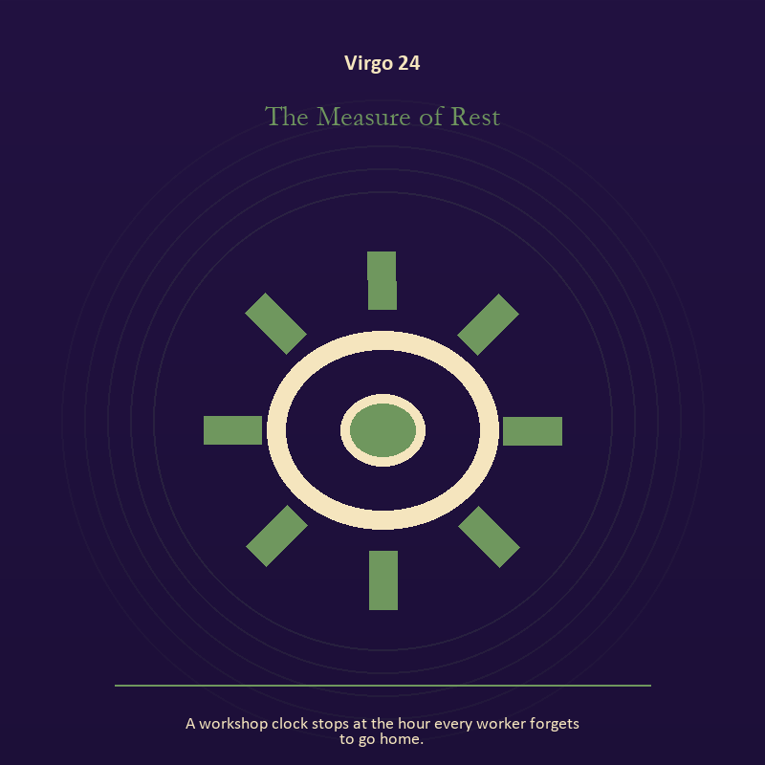

Virgo 24 The Measure of Rest
A workshop clock stops at the hour every worker forgets to go home.
INTERPRETATION The Measure of Rest gives craft and record consequences inside the Sacred Workshop. Within the Measure of Rest, workshops honor correction. At Virgo 24, a flaw becomes useful when it is found early, recorded honestly, and repaired without hiding the seam. The same image also carries the body; at Virgo 24, bread, rest, touch, clothing, and shelter make spiritual language answer to material need. As a integration degree, Virgo 24 shows the mature tool and the temptation hidden inside its handle.
SIGNAL At Virgo 24, care made repeatable joined to care made material carries the signal; it stays honest when you make one useful correction and record what remains uncertain.
SHADOW The shadow at Virgo 24 begins with the tool becoming the master and letting appetite make the whole decision; also watch precision become punishment, service erase the server, or method pretend to be wisdom.
MIRROR At Virgo 24, where would an honest repair remain visible? From a second angle at Virgo 24, which need in this scene has been made too ordinary to mention?
PRACTICE Bring Virgo 24 out of abstraction: keep a brief record of what happened, what you expected, and what changed your mind.

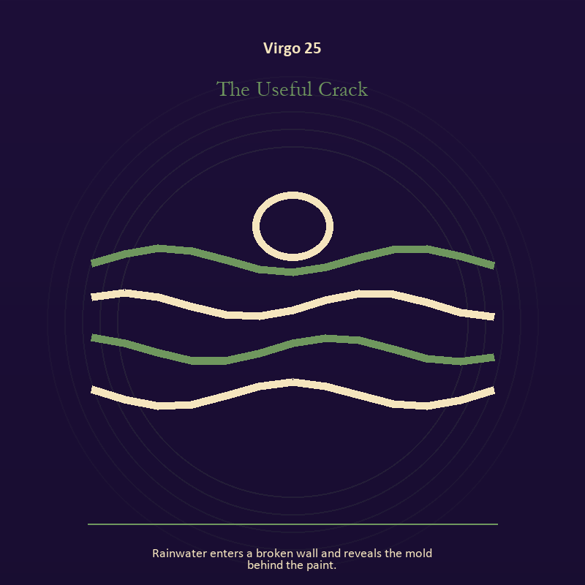

Virgo 25 The Useful Crack
Rainwater enters a broken wall and reveals the mold behind the paint.
INTERPRETATION The Useful Crack puts craft and record under pressure from discernment, service, repair, and devotion measured by what works. Within the Useful Crack, craft turns intention into a repeatable act with materials, limits, and evidence of failure. At Virgo 25, the tool reveals the quality of attention brought to it. As a integration degree, Virgo 25 tests whether the lesson can be lived without becoming a new performance.
SIGNAL What can be carried forward from Virgo 25 is evidence preserved without spectacle, tested by the need to make one useful correction and record what remains uncertain.
SHADOW At Virgo 25, the image darkens through polish used to hide a structural weakness; watch precision become punishment, service erase the server, or method pretend to be wisdom.
MIRROR For Virgo 25, which part of this process can be checked rather than assumed?
PRACTICE For Virgo 25, repair one useful object without disguising the place where it broke.
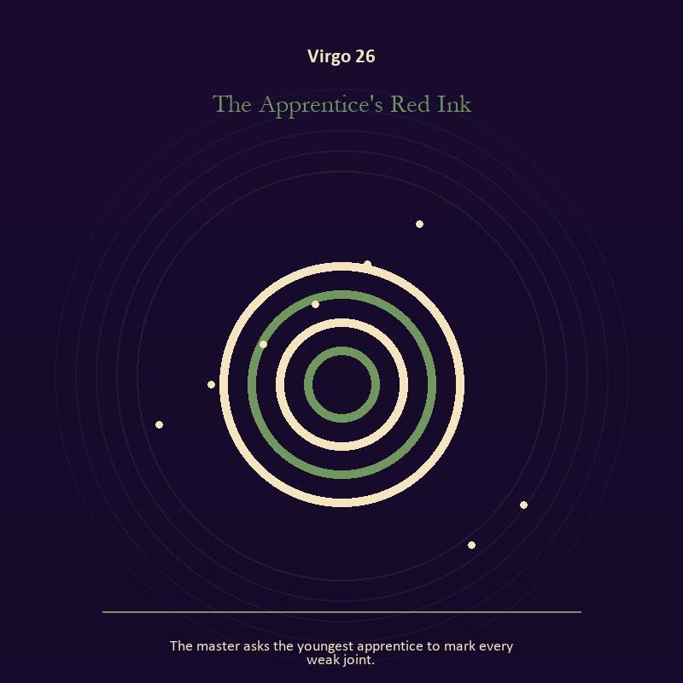

Virgo 26 The Apprentice's Red Ink
The master asks the youngest apprentice to mark every weak joint.
INTERPRETATION In the Apprentice's Red Ink, the work of mystery must answer to discernment, service, repair, and devotion measured by what works. Within the Apprentice's Red Ink, this image invites attention before conclusion. At Virgo 26, its strange fact creates a pressure point where memory, desire, fear, and choice can speak indirectly. As a release degree, Virgo 26 prepares the lesson to leave its original container; keep the capacity and loosen the role.
SIGNAL At Virgo 26, an unanswered image that keeps thought alive becomes the clean signal when Virgo can make one useful correction and record what remains uncertain.
SHADOW The distortion at Virgo 26 is forcing a prophecy from ambiguity; watch precision become punishment, service erase the server, or method pretend to be wisdom.
MIRROR With the Apprentice's Red Ink in mind at Virgo 26, what ordinary fact sits beneath the strange image?
PRACTICE Work with The Apprentice's Red Ink directly at Virgo 26: copy the image by hand, underline three concrete nouns, and write one association for each.

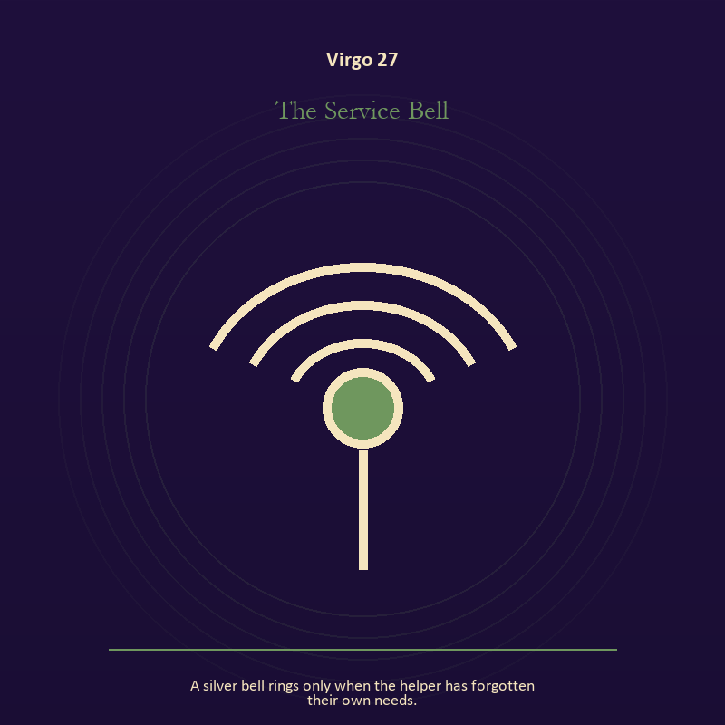

Virgo 27 The Service Bell
A silver bell rings only when the helper has forgotten their own needs.
INTERPRETATION The Service Bell tests voice and naming against discernment, service, repair, and devotion measured by what works. Within the Service Bell, naming creates a handle for experience, but the handle must remain smaller than the life it describes. At Virgo 27, the image tests language against reality. As a release degree, Virgo 27 asks what can be handed onward without demanding imitation or loyalty.
SIGNAL The usable force at Virgo 27 is speech with consequence; Virgo gives it form by asking you to make one useful correction and record what remains uncertain.
SHADOW At Virgo 27, the Service Bell can turn toward repeating a message until it sounds like evidence; watch precision become punishment, service erase the server, or method pretend to be wisdom.
MIRROR The question at Virgo 27: what are you naming accurately, and what remains larger than the name?
PRACTICE Give Virgo 27 a physical form; listen to one person without planning your answer; then repeat their meaning before offering your own.


Virgo 28 The Patient Machine
A machine refuses to start until every safety guard is restored.
INTERPRETATION The Patient Machine holds craft and record against discernment, service, repair, and devotion measured by what works. Within the Patient Machine, craft turns intention into a repeatable act with materials, limits, and evidence of failure. At Virgo 28, the tool reveals the quality of attention brought to it. As a release degree, Virgo 28 turns completion into transfer; the work survives by changing hands.
SIGNAL At Virgo 28, evidence preserved without spectacle carries the signal; it stays honest when you make one useful correction and record what remains uncertain.
SHADOW The shadow at Virgo 28 begins with polish used to hide a structural weakness; also watch precision become punishment, service erase the server, or method pretend to be wisdom.
MIRROR At Virgo 28, which part of this process can be checked rather than assumed?
PRACTICE Bring Virgo 28 out of abstraction: repair one useful object without disguising the place where it broke.

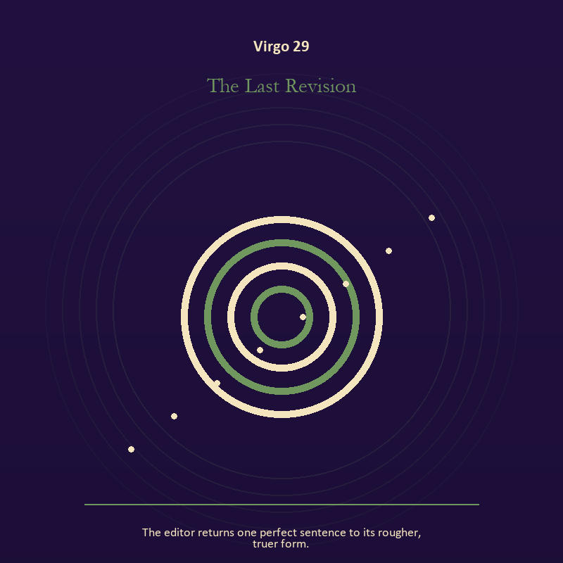

Virgo 29 The Last Revision
The editor returns one perfect sentence to its rougher, truer form.
INTERPRETATION The Last Revision gives mystery consequences inside the Sacred Workshop. Within the Last Revision, this image invites attention before conclusion. At Virgo 29, its strange fact creates a pressure point where memory, desire, fear, and choice can speak indirectly. As a release degree, Virgo 29 lets the sign set down the identity built around its ordeal.
SIGNAL What can be carried forward from Virgo 29 is an unanswered image that keeps thought alive, tested by the need to make one useful correction and record what remains uncertain.
SHADOW At Virgo 29, the image darkens through forcing a prophecy from ambiguity; watch precision become punishment, service erase the server, or method pretend to be wisdom.
MIRROR For Virgo 29, what ordinary fact sits beneath the strange image?
PRACTICE For Virgo 29, copy the image by hand, underline three concrete nouns, and write one association for each.
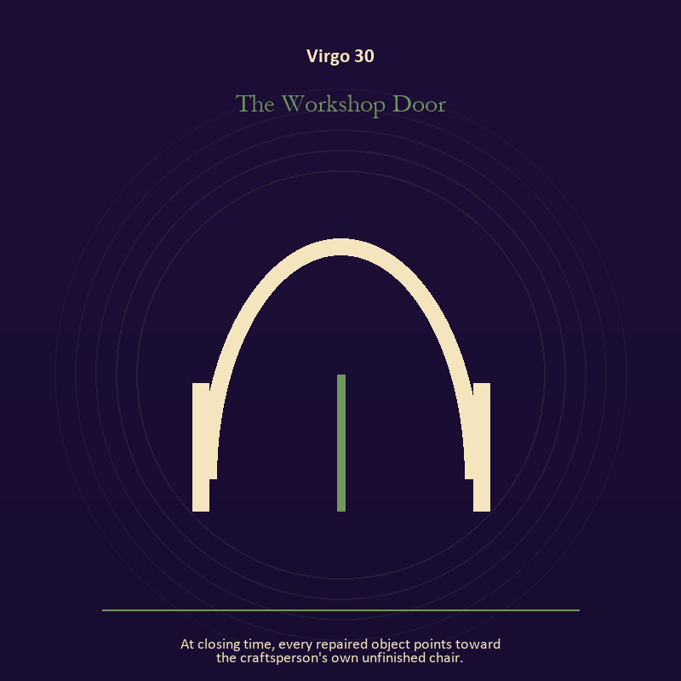

Virgo 30 The Workshop Door
At closing time, every repaired object points toward the craftsperson's own unfinished chair.
INTERPRETATION The Workshop Door puts the threshold under pressure from discernment, service, repair, and devotion measured by what works. Within the Workshop Door, a boundary can protect life, restrict it, or clarify the terms of meeting. At Virgo 30, the surrounding action reveals which function is active here. The same image also carries craft and record; at Virgo 30, ledgers, maps, machines, and archives make memory operational. As a release degree, Virgo 30 returns the earned knowledge to ordinary life, where another cycle can use it.
SIGNAL At Virgo 30, honest passage joined to evidence preserved without spectacle becomes the clean signal when Virgo can make one useful correction and record what remains uncertain.
SHADOW The distortion at Virgo 30 is guarding an obsolete enclosure and polish used to hide a structural weakness; watch precision become punishment, service erase the server, or method pretend to be wisdom.
MIRROR With the Workshop Door in mind at Virgo 30, what would make the next step chosen rather than compelled? From a second angle at Virgo 30, what does the tool preserve, and what does it leave out?
PRACTICE Work with The Workshop Door directly at Virgo 30: draw the boundary as a line on paper; then mark the gate, the guard, and the person who holds the key. For the second pressure at Virgo 30, repair one useful object without disguising the place where it broke.

Libra
The Hall of Mirrors
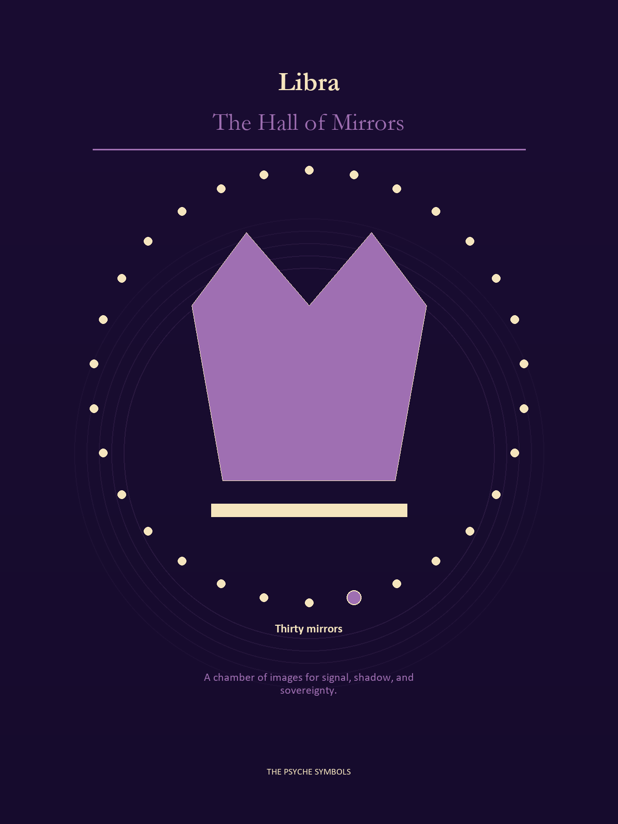
Libra places another person inside the frame and changes the meaning of every choice. The Hall of Mirrors tests fairness, attraction, projection, agreement, repair, and the right to leave. Here balance is an active adjustment made by people willing to see the weight they bring into the room.

Degrees | Gate | Work
1-5 | Arrival | Meet the image before deciding what it means.
6-10 | Friction | Notice what pushes back and what that resistance protects.
11-15 | Revelation | Name the detail that changes the whole scene.
16-20 | Choice | Choose the act that preserves both truth and human dignity.
21-25 | Integration | Use the gift without feeding the shadow that travels beside it.
26-30 | Release | Keep the earned capacity and release the role that delivered it.

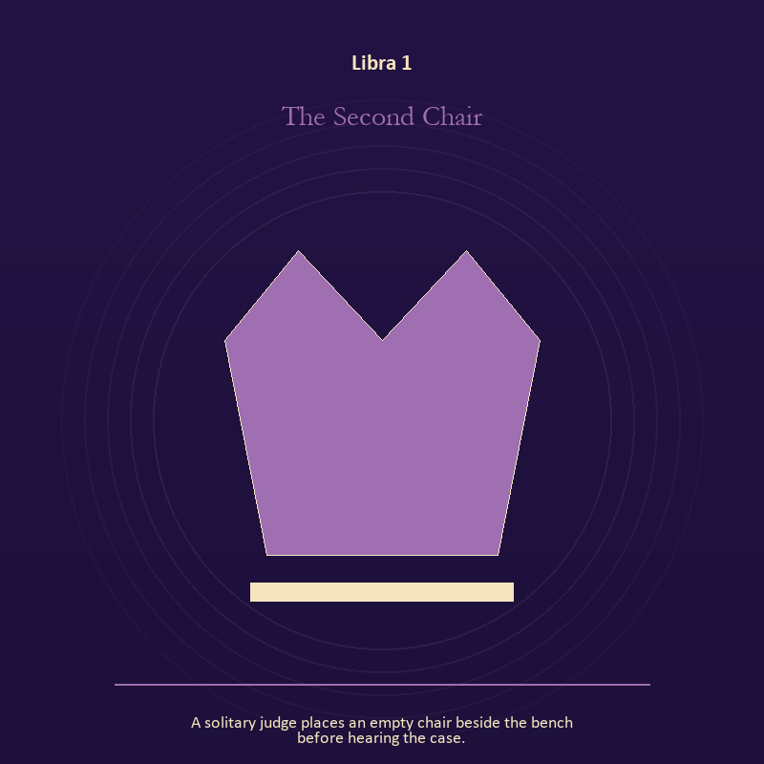

Libra 1 The Second Chair
A solitary judge places an empty chair beside the bench before hearing the case.
INTERPRETATION In the Second Chair, the work of the body must answer to relation, proportion, projection, and the ethics of holding two truths. Within the Second Chair, the body enters as witness, limit, appetite, labor, and home. At Libra 1, its response may reveal what the mind has explained away. The same image also carries authority; at Libra 1, institutional objects reveal the bargain between role and person. As an arrival degree, Libra 1 arrives before habit can tidy the evidence; notice what is present before deciding what it should become.
SIGNAL The usable force at Libra 1 is care made material joined to a rule that protects the vulnerable person in the room; Libra gives it form by asking you to make room for the other account without surrendering your own perception.
SHADOW At Libra 1, the Second Chair can turn toward letting appetite make the whole decision and role mistaken for worth; beware peace purchased with silence, charm used as pressure, or fairness reduced to appearances.
MIRROR The question at Libra 1: what does your body know before your argument begins?
PRACTICE Give Libra 1 a physical form; choose the next action that your body can repeat without punishment.
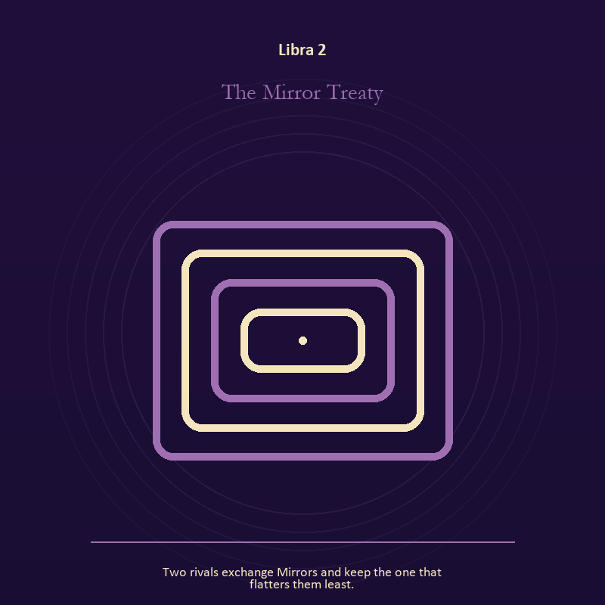

Libra 2 The Mirror Treaty
Two rivals exchange Mirrors and keep the one that flatters them least.
INTERPRETATION The Mirror Treaty tests the Mirror against relation, proportion, projection, and the ethics of holding two truths. Within the Mirror Treaty, reflected images divide the observer from the observed self. At Libra 2, that gap can hold shame, vanity, curiosity, or the first honest revision of identity. The same image also carries relationship; at Libra 2, more than one will is active in this scene. As an arrival degree, Libra 2 introduces the sign's raw material in an unguarded form; the first response matters less than the honest one.
SIGNAL At Libra 2, the courage to revise a familiar self-image joined to contact without capture carries the signal; it stays honest when you make room for the other account without surrendering your own perception.
SHADOW The shadow at Libra 2 begins with mistaking appearance for character and projection mistaken for intimacy; also beware peace purchased with silence, charm used as pressure, or fairness reduced to appearances.
MIRROR At Libra 2, whose gaze have you installed inside your own Mirror?
PRACTICE Bring Libra 2 out of abstraction: describe the scene without interpretation, then circle the detail you most want to praise or condemn.

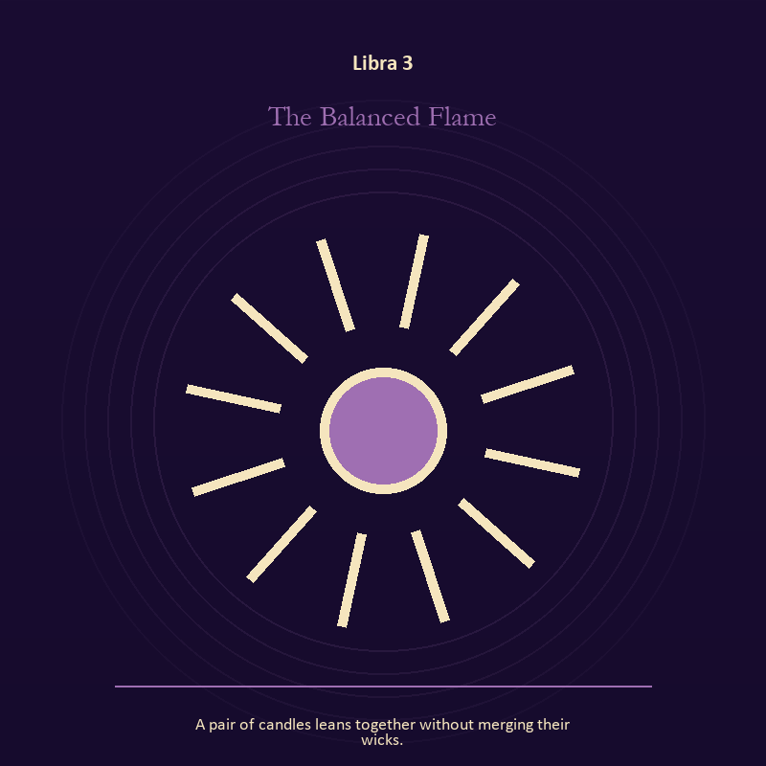

Libra 3 The Balanced Flame
A pair of candles leans together without merging their wicks.
INTERPRETATION The Balanced Flame holds living fire against relation, proportion, projection, and the ethics of holding two truths. Within the Balanced Flame, a Lantern offers enough light for the next honest step. At Libra 3, it does not remove night, and its usefulness depends on how it is carried. The same image also carries relationship; at Libra 3, relationship imagery tests the fantasy that harmony requires sameness. As an arrival degree, Libra 3 catches the first impulse before it turns into a role; give the image room to remain strange.
SIGNAL What can be carried forward from Libra 3 is attention with warmth joined to mutual responsibility, tested by the need to make room for the other account without surrendering your own perception.
SHADOW At Libra 3, the image darkens through exposure without care and the group protecting itself by sacrificing an outsider; beware peace purchased with silence, charm used as pressure, or fairness reduced to appearances.
MIRROR For Libra 3, how much light does the next step require, and who might it expose? From a second angle at Libra 3, where does responsibility belong, and where has it been displaced?
PRACTICE For Libra 3, move one hidden concern into plain view by naming it to a trusted person.
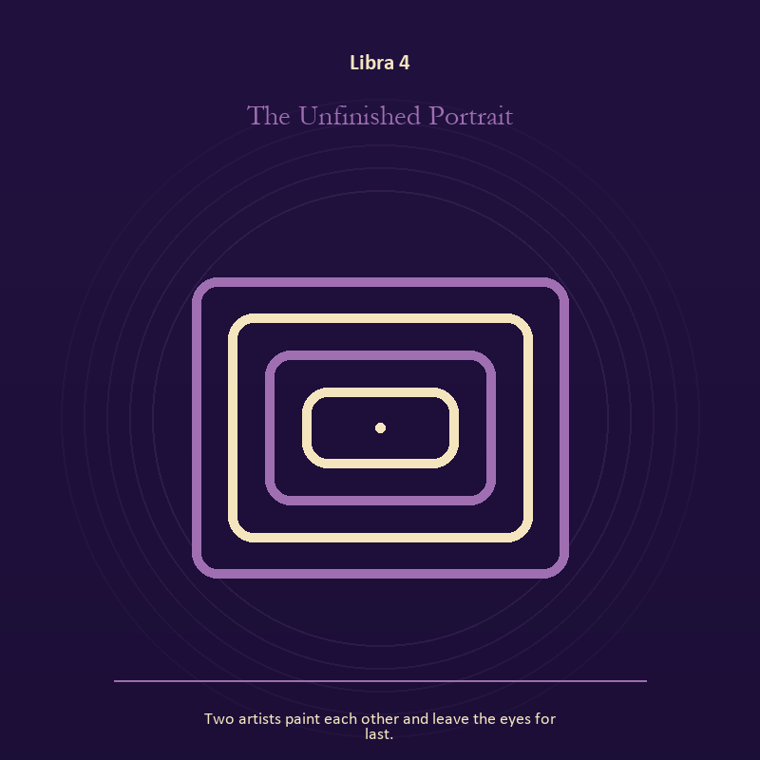

Libra 4 The Unfinished Portrait
Two artists paint each other and leave the eyes for last.
INTERPRETATION The Unfinished Portrait gives the Mirror consequences inside the Hall of Mirrors. Within the Unfinished Portrait, the Mirror returns perception without guaranteeing accuracy. At Libra 4, it reveals projection, self-image, and the temptation to kneel before a reflection. The same image also carries identity; at Libra 4, a role organizes behavior but cannot contain the whole person. As an arrival degree, Libra 4 opens the chamber with no settled method; name the need, risk, or appetite that entered with it.
SIGNAL At Libra 4, a projection reclaimed joined to the freedom to revise a name or role becomes the clean signal when Libra can make room for the other account without surrendering your own perception.
SHADOW The distortion at Libra 4 is letting shame dictate what the Mirror may show and performance mistaken for selfhood; beware peace purchased with silence, charm used as pressure, or fairness reduced to appearances.
MIRROR With the Unfinished Portrait in mind at Libra 4, what are you seeing clearly, and what may be projection?
PRACTICE Work with The Unfinished Portrait directly at Libra 4: look into a Mirror for one minute and name facts only; then notice when judgment tries to enter as description. For the second pressure at Libra 4, list the roles you carry; then mark each as chosen, inherited, temporary, or ready to release.

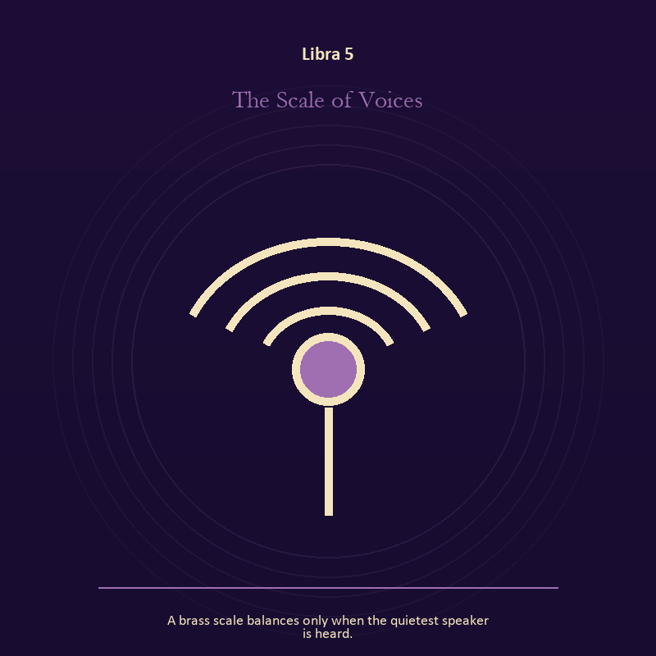

Libra 5 The Scale of Voices
A brass scale balances only when the quietest speaker is heard.
INTERPRETATION The Scale of Voices puts craft and record under pressure from relation, proportion, projection, and the ethics of holding two truths. Within the Scale of Voices, ledgers, maps, machines, and archives make memory operational. At Libra 5, they can protect truth or compress living complexity until only the form remains. As an arrival degree, Libra 5 shows the beginning before ownership hardens around it; let attention come before possession.
SIGNAL The usable force at Libra 5 is a useful correction that outlives the moment; Libra gives it form by asking you to make room for the other account without surrendering your own perception.
SHADOW At Libra 5, the Scale of Voices can turn toward measurement mistaken for meaning; beware peace purchased with silence, charm used as pressure, or fairness reduced to appearances.
MIRROR The question at Libra 5: what does the tool preserve, and what does it leave out?
PRACTICE Give Libra 5 a physical form; inspect one repeated task and add a check that would catch the most expensive error.
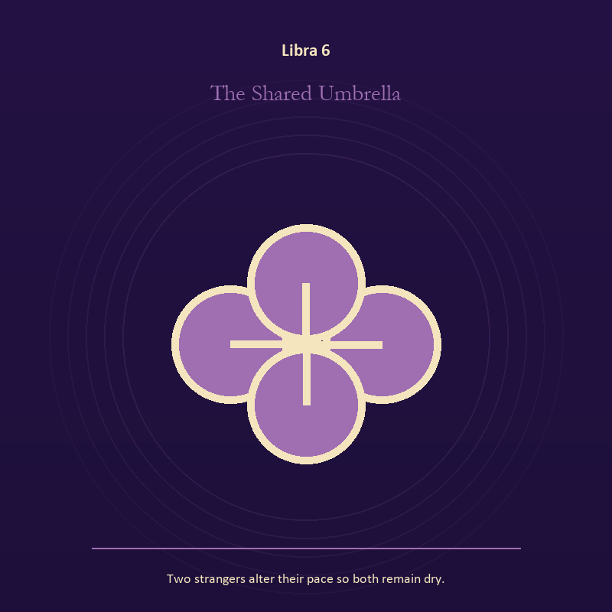

Libra 6 The Shared Umbrella
Two strangers alter their pace so both remain dry.
INTERPRETATION In the Shared Umbrella, the work of relationship must answer to relation, proportion, projection, and the ethics of holding two truths. Within the Shared Umbrella, the shared object in the scene carries an agreement. At Libra 6, its condition reveals whether responsibility is mutual, hidden, refused, or unevenly assigned. As a friction degree, Libra 6 meets resistance, and that resistance reveals what the first impulse failed to consider.
SIGNAL At Libra 6, contact without capture carries the signal; it stays honest when you make room for the other account without surrendering your own perception.
SHADOW The shadow at Libra 6 begins with projection mistaken for intimacy; also beware peace purchased with silence, charm used as pressure, or fairness reduced to appearances.
MIRROR At Libra 6, can this bond survive an honest difference and a visible exit?
PRACTICE Bring Libra 6 out of abstraction: name one need, one boundary, and one freedom that belong to each person in the scene.

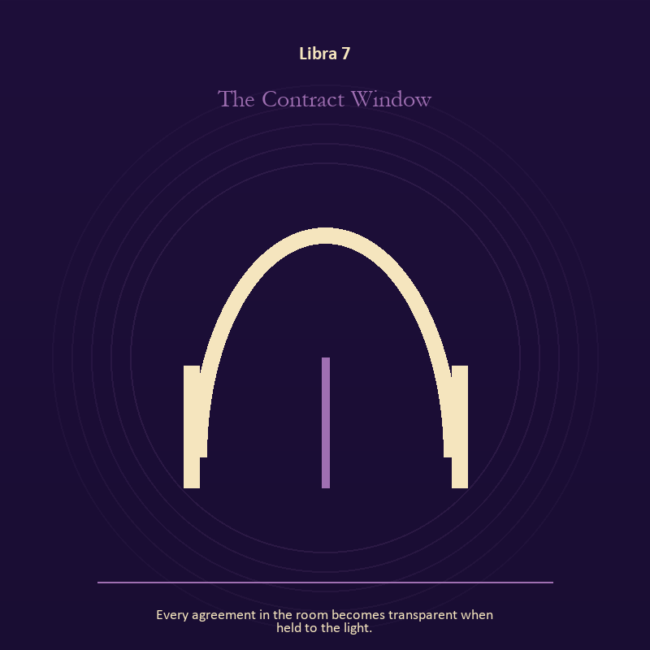

Libra 7 The Contract Window
Every agreement in the room becomes transparent when held to the light.
INTERPRETATION The Contract Window tests the threshold against relation, proportion, projection, and the ethics of holding two truths. Within the Contract Window, a threshold measures consent, timing, and consequence. At Libra 7, its presence asks whether passage is chosen, forced, delayed, or already under way. The same image also carries authority; at Libra 7, institutional objects reveal the bargain between role and person. As a friction degree, Libra 7 places consequence beside desire; the obstruction may be an enemy, a limit, or a needed correction.
SIGNAL What can be carried forward from Libra 7 is chosen change joined to a rule that protects the vulnerable person in the room, tested by the need to make room for the other account without surrendering your own perception.
SHADOW At Libra 7, the image darkens through waiting for permission that will never come and role mistaken for worth; beware peace purchased with silence, charm used as pressure, or fairness reduced to appearances.
MIRROR For Libra 7, which threshold in your life requires consent rather than momentum?
PRACTICE For Libra 7, write one sentence beginning, 'I may enter when,' and one beginning, 'I remain free to leave when.'.
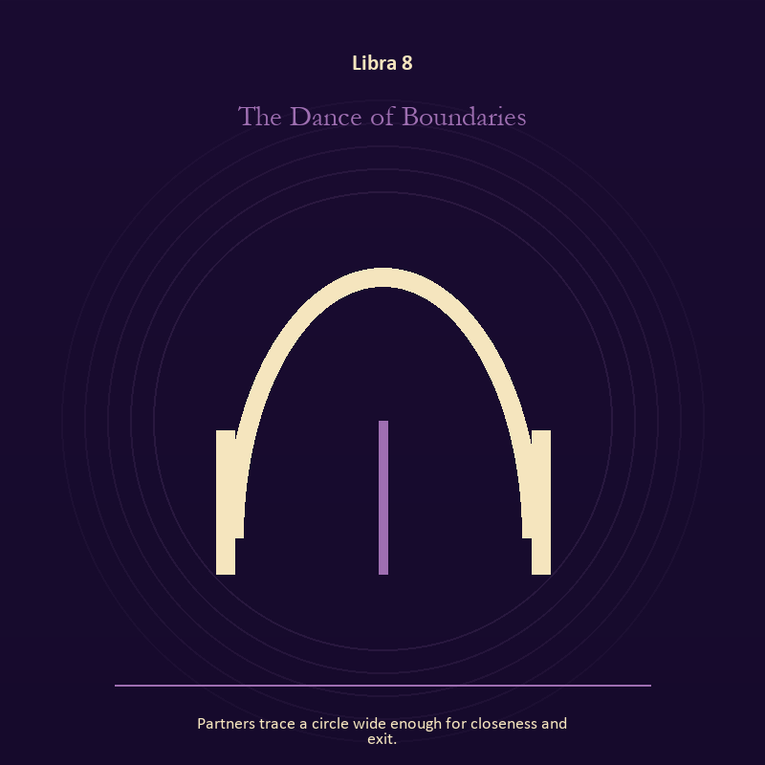

Libra 8 The Dance of Boundaries
Partners trace a circle wide enough for closeness and exit.
INTERPRETATION The Dance of Boundaries holds the threshold against relation, proportion, projection, and the ethics of holding two truths. Within the Dance of Boundaries, doors and roads turn inner change into an embodied decision. At Libra 8, the next room matters, but so does the condition under which it is entered. As a friction degree, Libra 8 tests whether the sign can change course without treating correction as defeat.
SIGNAL At Libra 8, a boundary that clarifies freedom becomes the clean signal when Libra can make room for the other account without surrendering your own perception.
SHADOW The distortion at Libra 8 is crossing before consent; beware peace purchased with silence, charm used as pressure, or fairness reduced to appearances.
MIRROR With the Dance of Boundaries in mind at Libra 8, what are you protecting by remaining on this side of the door?
PRACTICE Work with The Dance of Boundaries directly at Libra 8: stand at a literal doorway, name what you are leaving and what you refuse to abandon, then cross only if the answer feels clean.

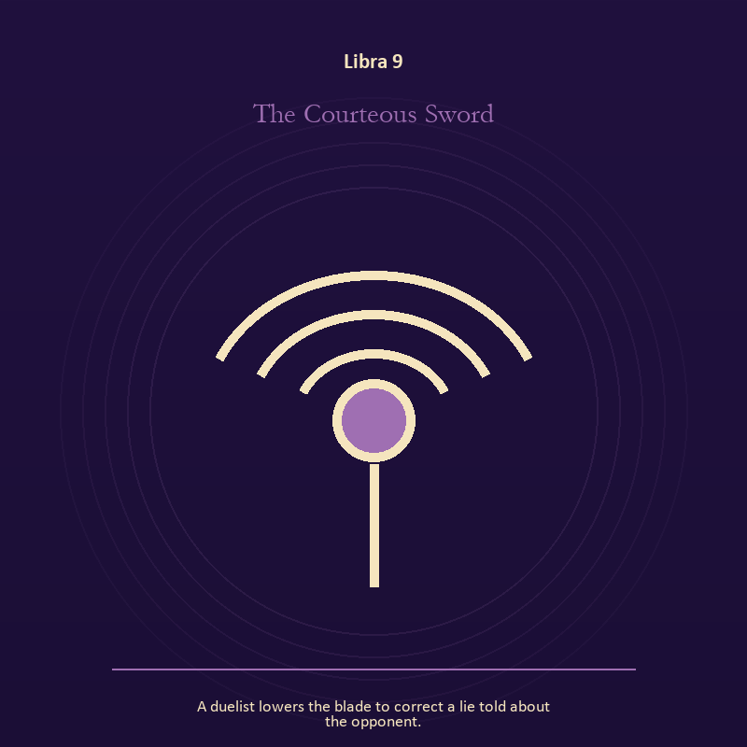

Libra 9 The Courteous Sword
A duelist lowers the blade to correct a lie told about the opponent.
INTERPRETATION The Courteous Sword gives relationship consequences inside the Hall of Mirrors. Within the Courteous Sword, the shared object in the scene carries an agreement. At Libra 9, its condition reveals whether responsibility is mutual, hidden, refused, or unevenly assigned. As a friction degree, Libra 9 brings another will, material limit, or inconvenient fact into the frame.
SIGNAL The usable force at Libra 9 is contact without capture; Libra gives it form by asking you to make room for the other account without surrendering your own perception.
SHADOW At Libra 9, the Courteous Sword can turn toward projection mistaken for intimacy; beware peace purchased with silence, charm used as pressure, or fairness reduced to appearances.
MIRROR The question at Libra 9: can this bond survive an honest difference and a visible exit?
PRACTICE Give Libra 9 a physical form; name one need, one boundary, and one freedom that belong to each person in the scene.
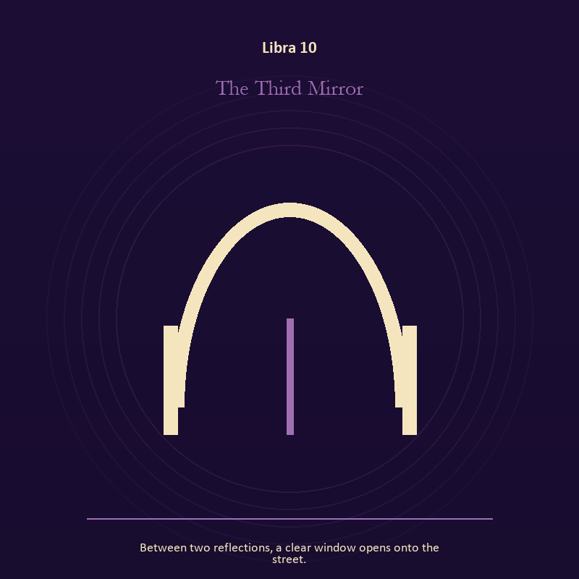

Libra 10 The Third Mirror
Between two reflections, a clear window opens onto the street.
INTERPRETATION The Third Mirror puts the Mirror under pressure from relation, proportion, projection, and the ethics of holding two truths. Within the Third Mirror, the Mirror returns perception without guaranteeing accuracy. At Libra 10, it reveals projection, self-image, and the temptation to kneel before a reflection. The same image also carries the threshold; at Libra 10, a boundary can protect life, restrict it, or clarify the terms of meeting. As a friction degree, Libra 10 slows the original motion long enough to expose what haste concealed.
SIGNAL At Libra 10, a projection reclaimed joined to a boundary that clarifies freedom carries the signal; it stays honest when you make room for the other account without surrendering your own perception.
SHADOW The shadow at Libra 10 begins with letting shame dictate what the Mirror may show and crossing before consent; also beware peace purchased with silence, charm used as pressure, or fairness reduced to appearances.
MIRROR At Libra 10, what are you seeing clearly, and what may be projection?
PRACTICE Bring Libra 10 out of abstraction: look into a Mirror for one minute and name facts only; then notice when judgment tries to enter as description.

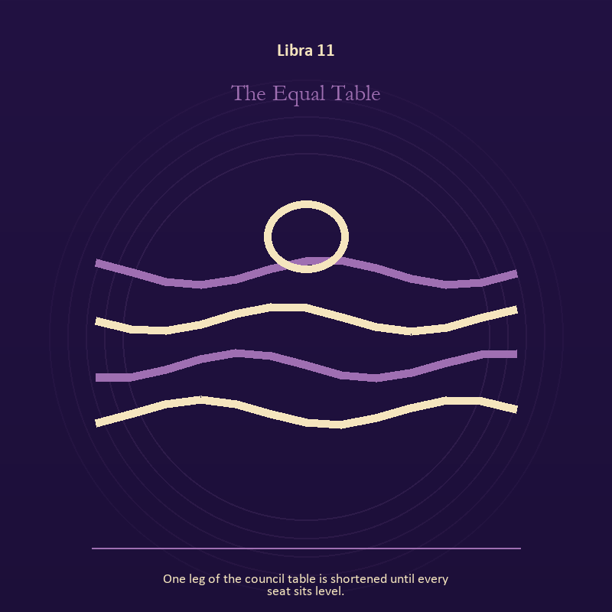

Libra 11 The Equal Table
One leg of the council table is shortened until every seat sits level.
INTERPRETATION In the Equal Table, the work of authority must answer to relation, proportion, projection, and the ethics of holding two truths. Within the Equal Table, crowns, laws, offices, and verdicts turn private judgment into public consequence. At Libra 11, their legitimacy depends on restraint and correction. The same image also carries relationship; at Libra 11, more than one will is active in this scene. As a revelation degree, Libra 11 reveals the mechanism under the mood; one concrete detail changes the reading.
SIGNAL What can be carried forward from Libra 11 is a rule that protects the vulnerable person in the room joined to contact without capture, tested by the need to make room for the other account without surrendering your own perception.
SHADOW At Libra 11, the image darkens through role mistaken for worth and projection mistaken for intimacy; beware peace purchased with silence, charm used as pressure, or fairness reduced to appearances.
MIRROR For Libra 11, what would accountability require from the person holding the key?
PRACTICE For Libra 11, choose one decision you control and write down who can challenge it, correct it, and leave its consequences.
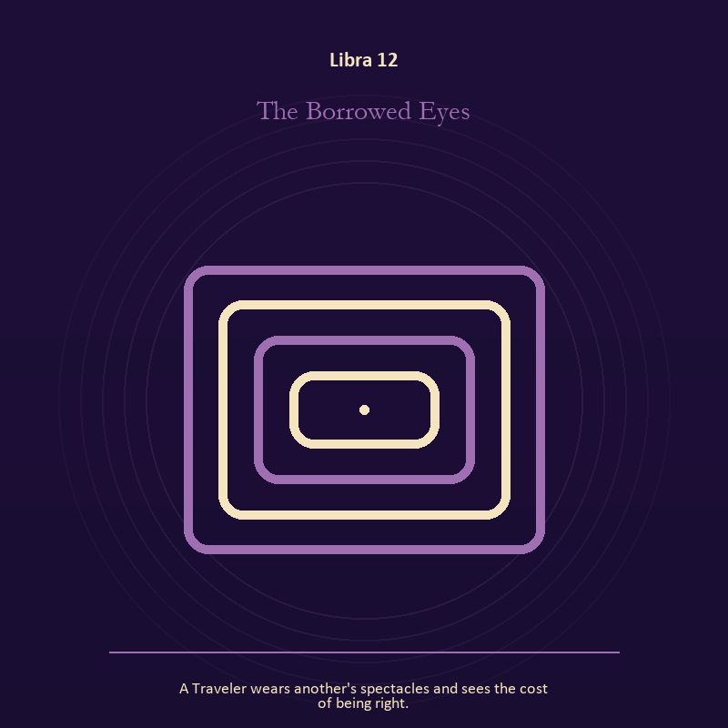

Libra 12 The Borrowed Eyes
A Traveler wears another's spectacles and sees the cost of being right.
INTERPRETATION The Borrowed Eyes tests the Mirror against relation, proportion, projection, and the ethics of holding two truths. Within the Borrowed Eyes, a shadow proves that something real stands in the light, while a reflection shows only an angle. At Libra 12, neither is the whole person. The same image also carries relationship; at Libra 12, relationship imagery tests the fantasy that harmony requires sameness. As a revelation degree, Libra 12 moves the hidden arrangement into view, where it can be named without being exaggerated.
SIGNAL At Libra 12, self-recognition without self-worship joined to mutual responsibility becomes the clean signal when Libra can make room for the other account without surrendering your own perception.
SHADOW The distortion at Libra 12 is assigning your hidden material to someone else and the group protecting itself by sacrificing an outsider; beware peace purchased with silence, charm used as pressure, or fairness reduced to appearances.
MIRROR With the Borrowed Eyes in mind at Libra 12, which part of the reflection is asking to be reclaimed rather than judged? From a second angle at Libra 12, where does responsibility belong, and where has it been displaced?
PRACTICE Work with The Borrowed Eyes directly at Libra 12: write two accounts of the same conflict: one from your position and one from the person you cannot understand. For the second pressure at Libra 12, make one repair that does not require the other person to erase their account.

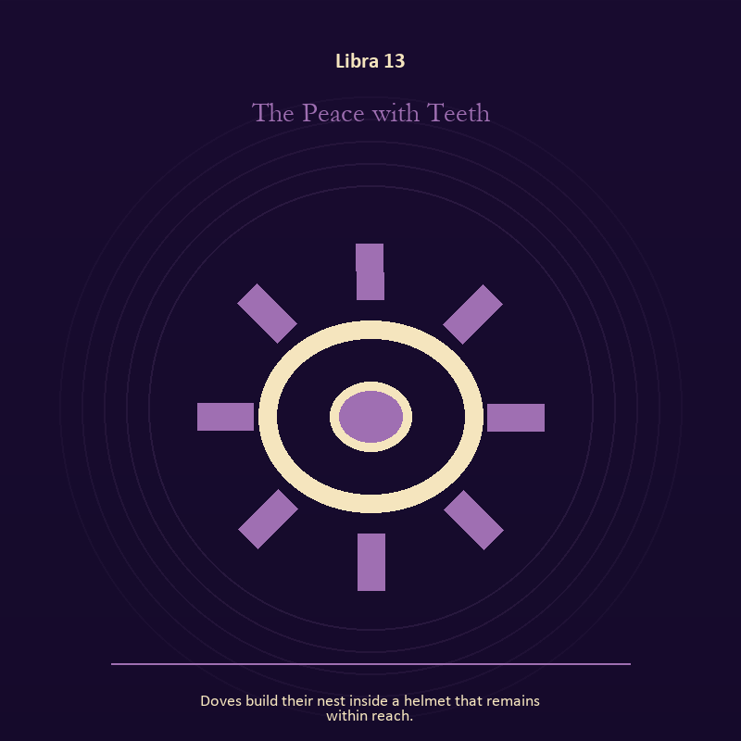

Libra 13 The Peace with Teeth
Doves build their nest inside a helmet that remains within reach.
INTERPRETATION The Peace with Teeth holds craft and record against relation, proportion, projection, and the ethics of holding two truths. Within the Peace with Teeth, craft turns intention into a repeatable act with materials, limits, and evidence of failure. At Libra 13, the tool reveals the quality of attention brought to it. As a revelation degree, Libra 13 turns atmosphere into evidence; attend to the object or action that cannot be explained away.
SIGNAL The usable force at Libra 13 is evidence preserved without spectacle; Libra gives it form by asking you to make room for the other account without surrendering your own perception.
SHADOW At Libra 13, the Peace with Teeth can turn toward polish used to hide a structural weakness; beware peace purchased with silence, charm used as pressure, or fairness reduced to appearances.
MIRROR The question at Libra 13: which part of this process can be checked rather than assumed?
PRACTICE Give Libra 13 a physical form; repair one useful object without disguising the place where it broke.
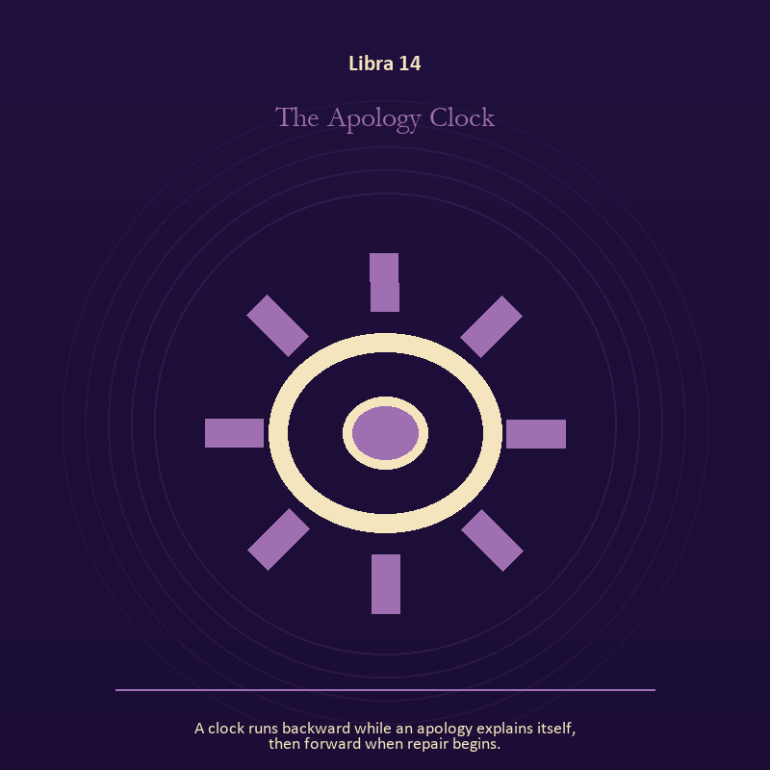

Libra 14 The Apology Clock
A clock runs backward while an apology explains itself, then forward when repair begins.
INTERPRETATION The Apology Clock gives craft and record consequences inside the Hall of Mirrors. Within the Apology Clock, ledgers, maps, machines, and archives make memory operational. At Libra 14, they can protect truth or compress living complexity until only the form remains. As a revelation degree, Libra 14 shows who carries the cost, who controls the passage, and what the scene refuses to hide.
SIGNAL At Libra 14, a useful correction that outlives the moment carries the signal; it stays honest when you make room for the other account without surrendering your own perception.
SHADOW The shadow at Libra 14 begins with measurement mistaken for meaning; also beware peace purchased with silence, charm used as pressure, or fairness reduced to appearances.
MIRROR At Libra 14, what does the tool preserve, and what does it leave out?
PRACTICE Bring Libra 14 out of abstraction: inspect one repeated task and add a check that would catch the most expensive error.

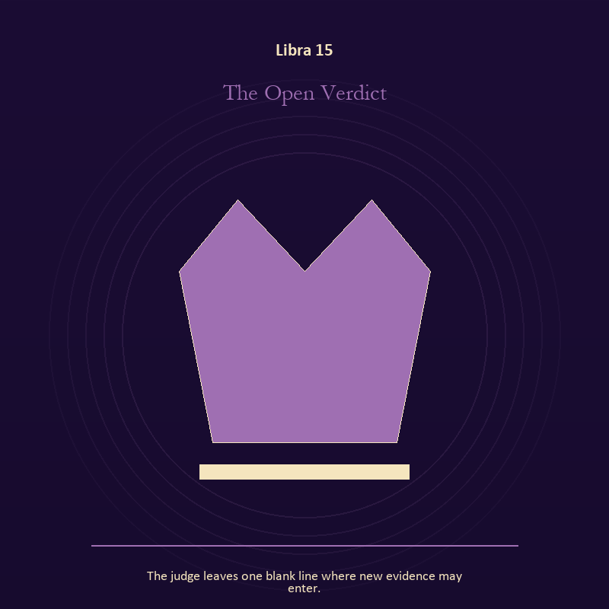

Libra 15 The Open Verdict
The judge leaves one blank line where new evidence may enter.
INTERPRETATION The Open Verdict puts authority under pressure from relation, proportion, projection, and the ethics of holding two truths. Within the Open Verdict, institutional objects reveal the bargain between role and person. At Libra 15, a title may organize service or become a mask that excuses harm. As a revelation degree, Libra 15 brings the middle truth forward, after the first story has lost its grip.
SIGNAL What can be carried forward from Libra 15 is stewardship with an exit plan, tested by the need to make room for the other account without surrendering your own perception.
SHADOW At Libra 15, the image darkens through procedure used to avoid conscience; beware peace purchased with silence, charm used as pressure, or fairness reduced to appearances.
MIRROR For Libra 15, which part of this authority serves life, and which part serves its own continuation?
PRACTICE For Libra 15, remove your title from a current problem and describe the duty that remains.
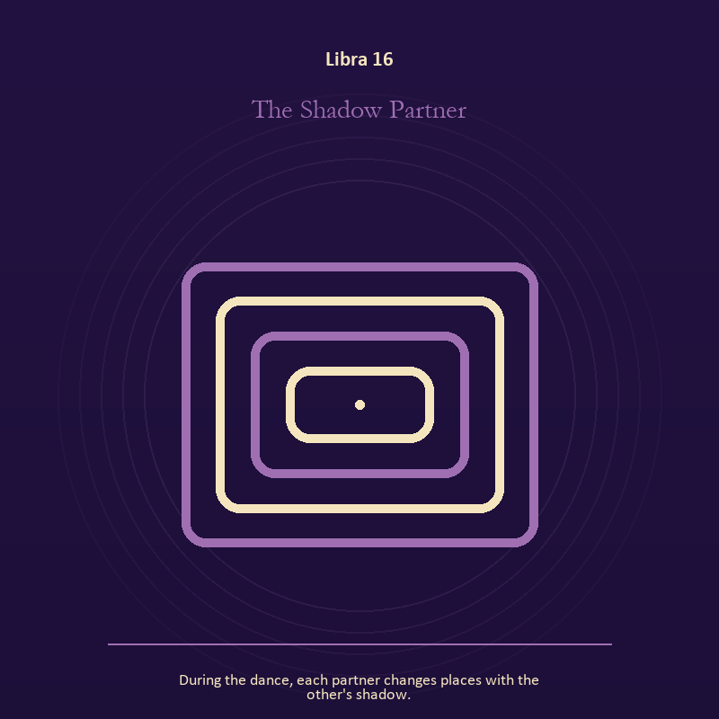

Libra 16 The Shadow Partner
During the dance, each partner changes places with the other's shadow.
INTERPRETATION In the Shadow Partner, the work of the Mirror must answer to relation, proportion, projection, and the ethics of holding two truths. Within the Shadow Partner, the Mirror returns perception without guaranteeing accuracy. At Libra 16, it reveals projection, self-image, and the temptation to kneel before a reflection. The same image also carries relationship; at Libra 16, the shared object in the scene carries an agreement. As a choice degree, Libra 16 requires a choice with a human cost; insight alone no longer completes the work.
SIGNAL At Libra 16, a projection reclaimed joined to difference held without humiliation becomes the clean signal when Libra can make room for the other account without surrendering your own perception.
SHADOW The distortion at Libra 16 is letting shame dictate what the Mirror may show and harmony purchased by one person's silence; beware peace purchased with silence, charm used as pressure, or fairness reduced to appearances.
MIRROR With the Shadow Partner in mind at Libra 16, what are you seeing clearly, and what may be projection?
PRACTICE Work with The Shadow Partner directly at Libra 16: look into a Mirror for one minute and name facts only; then notice when judgment tries to enter as description. For the second pressure at Libra 16, ask the other person what they believe the agreement is, then compare it with your own version.

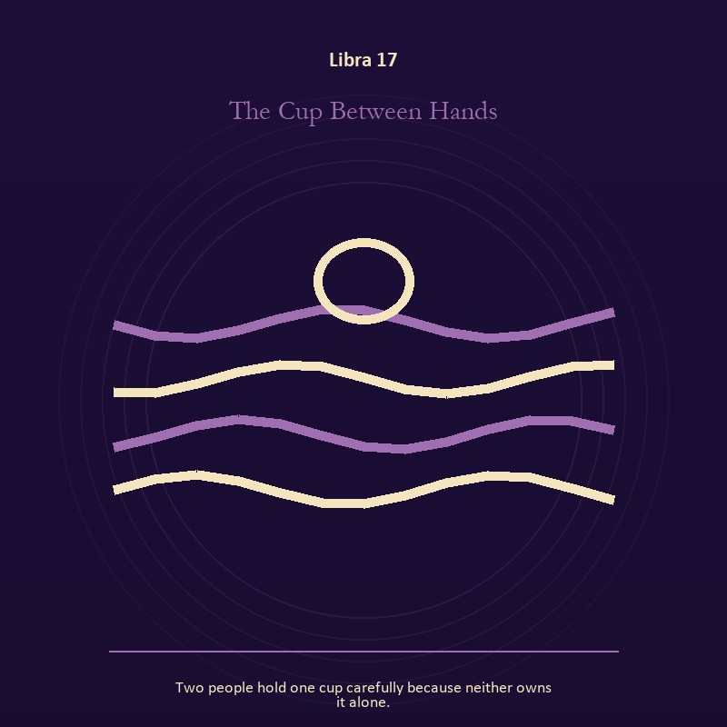

Libra 17 The Cup Between Hands
Two people hold one cup carefully because neither owns it alone.
INTERPRETATION The Cup Between Hands tests living water against relation, proportion, projection, and the ethics of holding two truths. Within the Cup Between Hands, a shore or vessel gives emotion a boundary without denying its depth. At Libra 17, the scene asks whether the feeling needs containment, release, or witness. The same image also carries relationship; at Libra 17, more than one will is active in this scene. As a choice degree, Libra 17 asks what action preserves truth without using another person as material.
SIGNAL The usable force at Libra 17 is grief allowed to move joined to contact without capture; Libra gives it form by asking you to make room for the other account without surrendering your own perception.
SHADOW At Libra 17, the Cup Between Hands can turn toward drowning in another person's weather and projection mistaken for intimacy; beware peace purchased with silence, charm used as pressure, or fairness reduced to appearances.
MIRROR The question at Libra 17: where are you adapting wisely, and where are you disappearing?
PRACTICE Give Libra 17 a physical form; pour water slowly between two vessels and name what must change shape without losing its substance.
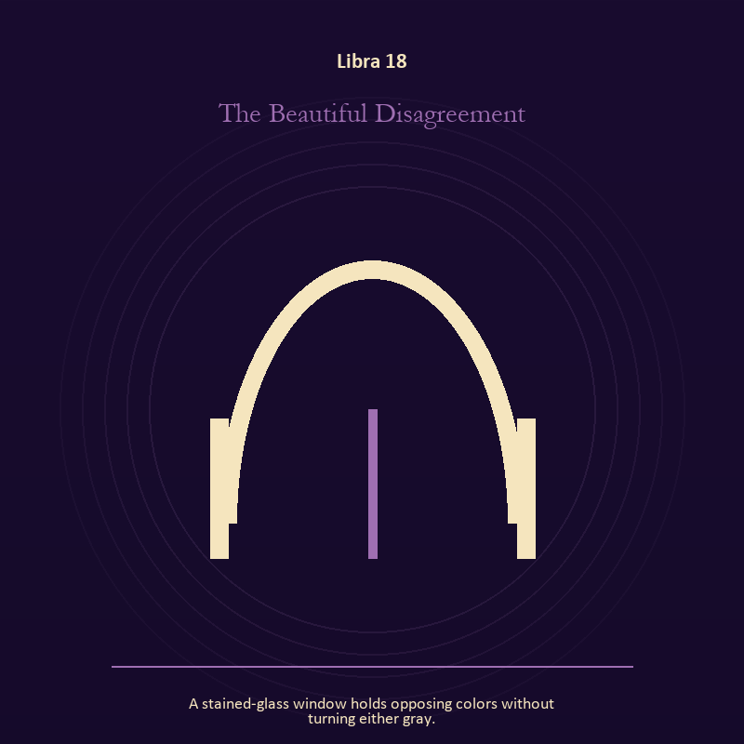

Libra 18 The Beautiful Disagreement
A stained-glass window holds opposing colors without turning either gray.
INTERPRETATION The Beautiful Disagreement holds the threshold against relation, proportion, projection, and the ethics of holding two truths. Within the Beautiful Disagreement, a boundary can protect life, restrict it, or clarify the terms of meeting. At Libra 18, the surrounding action reveals which function is active here. As a choice degree, Libra 18 moves from recognition to conduct; the clean choice must survive outside the imagination.
SIGNAL At Libra 18, honest passage carries the signal; it stays honest when you make room for the other account without surrendering your own perception.
SHADOW The shadow at Libra 18 begins with guarding an obsolete enclosure; also beware peace purchased with silence, charm used as pressure, or fairness reduced to appearances.
MIRROR At Libra 18, what would make the next step chosen rather than compelled?
PRACTICE Bring Libra 18 out of abstraction: draw the boundary as a line on paper; then mark the gate, the guard, and the person who holds the key.

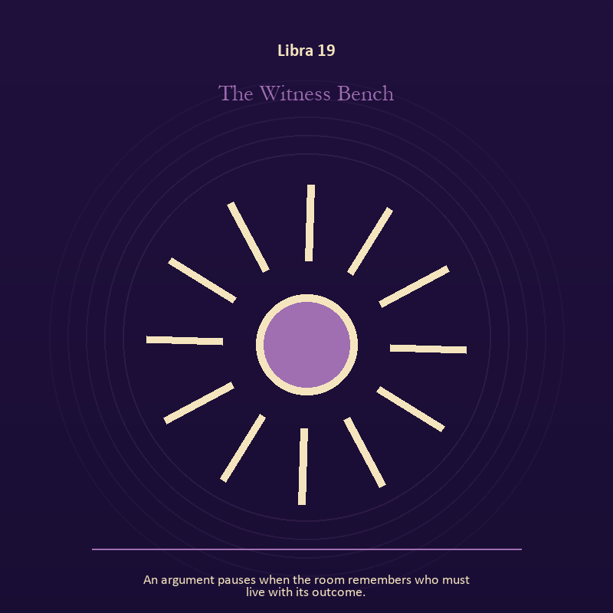

Libra 19 The Witness Bench
An argument pauses when the room remembers who must live with its outcome.
INTERPRETATION The Witness Bench gives mystery consequences inside the Hall of Mirrors. Within the Witness Bench, the scene behaves like a dream with its own exact logic. At Libra 19, meaning lives in the relationship between figure, place, action, and the detail that refuses ordinary explanation. As a choice degree, Libra 19 tests whether awareness can become restraint, repair, refusal, or consent.
SIGNAL What can be carried forward from Libra 19 is imagination disciplined by the scene, tested by the need to make room for the other account without surrendering your own perception.
SHADOW At Libra 19, the image darkens through mistaking intensity for accuracy; beware peace purchased with silence, charm used as pressure, or fairness reduced to appearances.
MIRROR For Libra 19, which detail keeps returning after the rest of the scene fades?
PRACTICE For Libra 19, keep the image nearby for one day and record only the moments when it returns on its own.


Libra 20 The Unmatched Gloves
Two different gloves warm the same pair of hands.
INTERPRETATION The Unmatched Gloves puts relationship under pressure from relation, proportion, projection, and the ethics of holding two truths. Within the Unmatched Gloves, relationship imagery tests the fantasy that harmony requires sameness. At Libra 20, a living bond can hold difference, correction, privacy, and departure. As a choice degree, Libra 20 places responsibility in the reader's hands without promising a painless answer.
SIGNAL At Libra 20, difference held without humiliation becomes the clean signal when Libra can make room for the other account without surrendering your own perception.
SHADOW The distortion at Libra 20 is harmony purchased by one person's silence; beware peace purchased with silence, charm used as pressure, or fairness reduced to appearances.
MIRROR With the Unmatched Gloves in mind at Libra 20, where does responsibility belong, and where has it been displaced?
PRACTICE Work with The Unmatched Gloves directly at Libra 20: ask the other person what they believe the agreement is, then compare it with your own version.

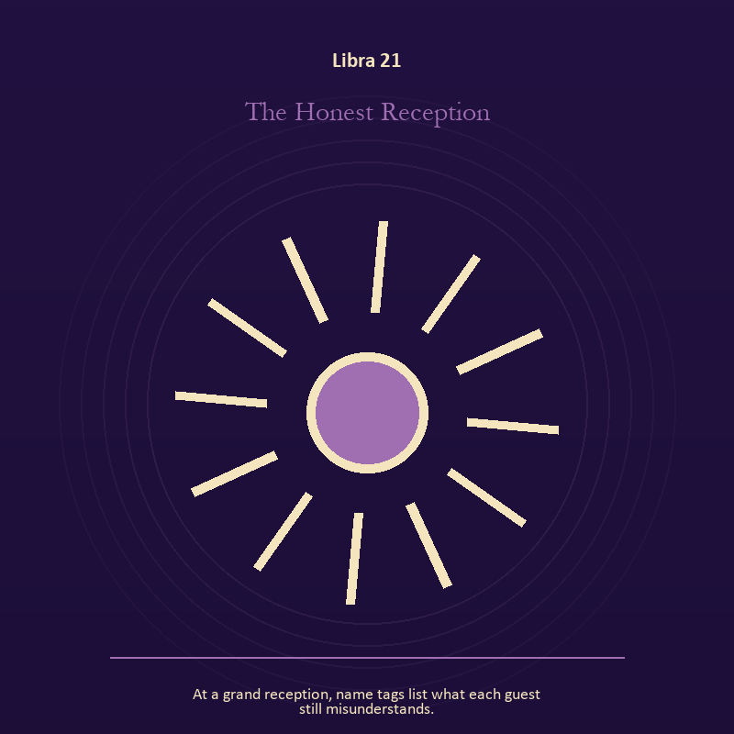

Libra 21 The Honest Reception
At a grand reception, name tags list what each guest still misunderstands.
INTERPRETATION In the Honest Reception, the work of voice and naming must answer to relation, proportion, projection, and the ethics of holding two truths. Within the Honest Reception, naming creates a handle for experience, but the handle must remain smaller than the life it describes. At Libra 21, the image tests language against reality. The same image also carries relationship; at Libra 21, relationship imagery tests the fantasy that harmony requires sameness. As a integration degree, Libra 21 holds the gift beside its distortion; using one without feeding the other is the work.
SIGNAL The usable force at Libra 21 is speech with consequence joined to mutual responsibility; Libra gives it form by asking you to make room for the other account without surrendering your own perception.
SHADOW At Libra 21, the Honest Reception can turn toward repeating a message until it sounds like evidence and the group protecting itself by sacrificing an outsider; beware peace purchased with silence, charm used as pressure, or fairness reduced to appearances.
MIRROR The question at Libra 21: what are you naming accurately, and what remains larger than the name? From a second angle at Libra 21, where does responsibility belong, and where has it been displaced?
PRACTICE Give Libra 21 a physical form; listen to one person without planning your answer; then repeat their meaning before offering your own.
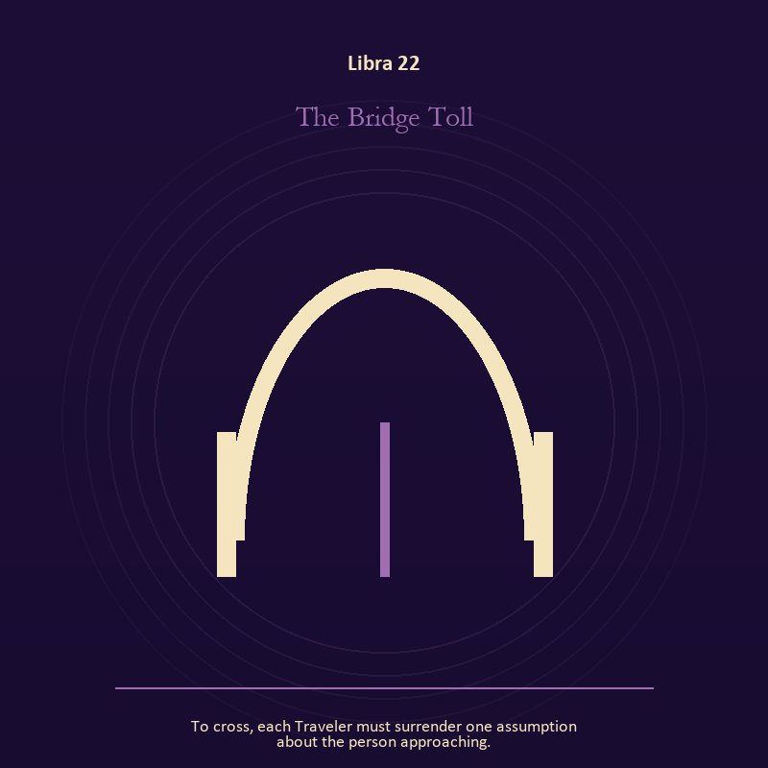

Libra 22 The Bridge Toll
To cross, each Traveler must surrender one assumption about the person approaching.
INTERPRETATION The Bridge Toll tests the threshold against relation, proportion, projection, and the ethics of holding two truths. Within the Bridge Toll, a threshold measures consent, timing, and consequence. At Libra 22, its presence asks whether passage is chosen, forced, delayed, or already under way. The same image also carries relationship; at Libra 22, the shared object in the scene carries an agreement. As a integration degree, Libra 22 asks the sign to carry its strength without turning that strength into jurisdiction.
SIGNAL At Libra 22, chosen change joined to difference held without humiliation carries the signal; it stays honest when you make room for the other account without surrendering your own perception.
SHADOW The shadow at Libra 22 begins with waiting for permission that will never come and harmony purchased by one person's silence; also beware peace purchased with silence, charm used as pressure, or fairness reduced to appearances.
MIRROR At Libra 22, which threshold in your life requires consent rather than momentum?
PRACTICE Bring Libra 22 out of abstraction: write one sentence beginning, 'I may enter when,' and one beginning, 'I remain free to leave when.'.

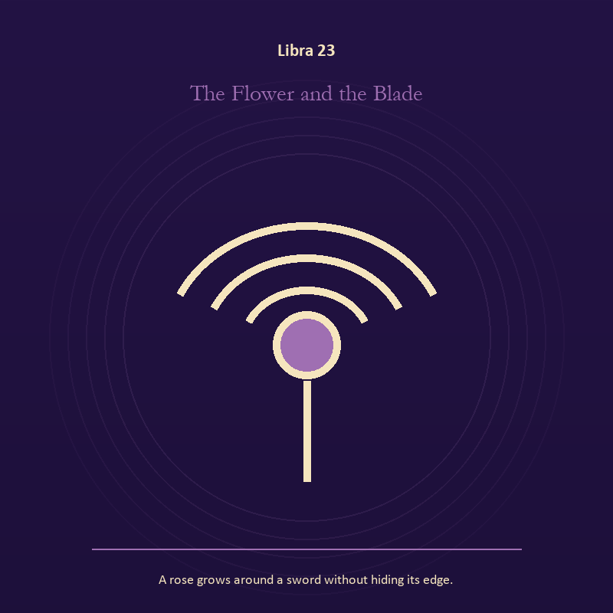

Libra 23 The Flower and the Blade
A rose grows around a sword without hiding its edge.
INTERPRETATION The Flower and the Blade holds growth against relation, proportion, projection, and the ethics of holding two truths. Within the Flower and the Blade, seeds, children, roots, and gardens refuse the fantasy of instant transformation. At Libra 23, they make becoming physical, seasonal, and dependent on care. As a integration degree, Libra 23 joins capacity to consequence; what helps in one setting may harm in another.
SIGNAL What can be carried forward from Libra 23 is inheritance revised through living action, tested by the need to make room for the other account without surrendering your own perception.
SHADOW At Libra 23, the image darkens through forcing a season; beware peace purchased with silence, charm used as pressure, or fairness reduced to appearances.
MIRROR For Libra 23, which condition would help this growth, and which demand would deform it?
PRACTICE For Libra 23, tend one living thing and let its pace correct your schedule.
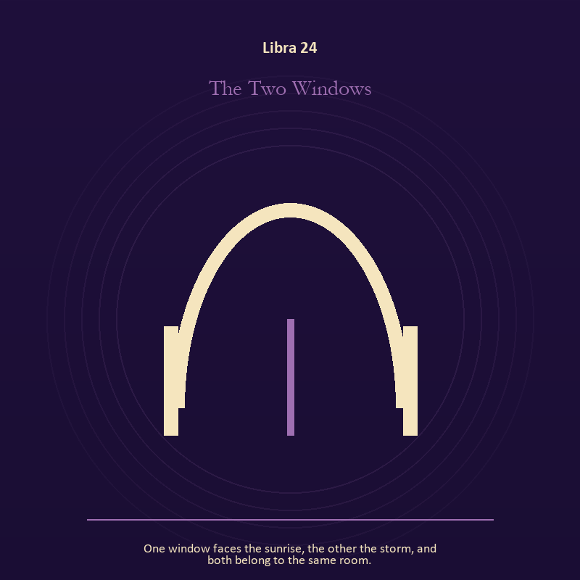

Libra 24 The Two Windows
One window faces the sunrise, the other the storm, and both belong to the same room.
INTERPRETATION The Two Windows gives relationship consequences inside the Hall of Mirrors. Within the Two Windows, the shared object in the scene carries an agreement. At Libra 24, its condition reveals whether responsibility is mutual, hidden, refused, or unevenly assigned. The same image also carries the threshold; at Libra 24, doors and roads turn inner change into an embodied decision. As a integration degree, Libra 24 shows the mature tool and the temptation hidden inside its handle.
SIGNAL At Libra 24, contact without capture joined to chosen change becomes the clean signal when Libra can make room for the other account without surrendering your own perception.
SHADOW The distortion at Libra 24 is projection mistaken for intimacy and waiting for permission that will never come; beware peace purchased with silence, charm used as pressure, or fairness reduced to appearances.
MIRROR With the Two Windows in mind at Libra 24, can this bond survive an honest difference and a visible exit? From a second angle at Libra 24, what are you protecting by remaining on this side of the door?
PRACTICE Work with The Two Windows directly at Libra 24: name one need, one boundary, and one freedom that belong to each person in the scene. For the second pressure at Libra 24, write one sentence beginning, 'I may enter when,' and one beginning, 'I remain free to leave when.'.

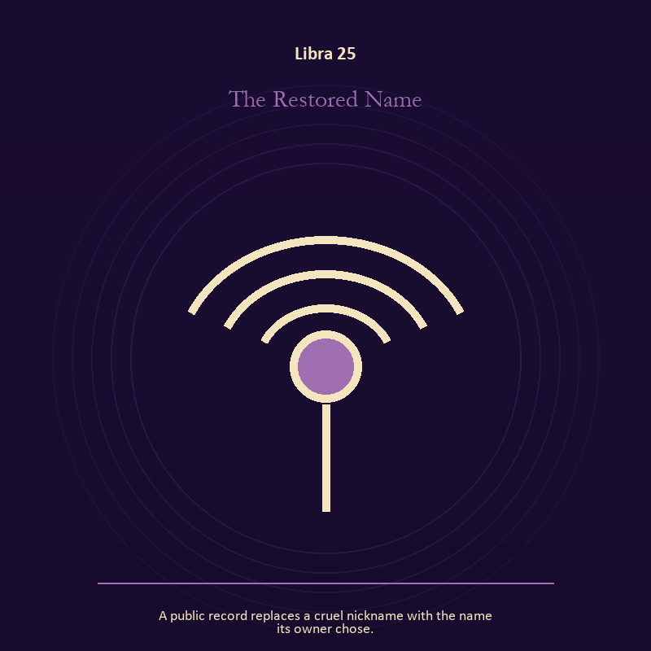

Libra 25 The Restored Name
A public record replaces a cruel nickname with the name its owner chose.
INTERPRETATION The Restored Name puts voice and naming under pressure from relation, proportion, projection, and the ethics of holding two truths. Within the Restored Name, voice turns inner pressure into shared consequence. At Libra 25, words can witness, summon, distort, repair, or conceal according to their precision and timing. The same image also carries identity; at Libra 25, a role organizes behavior but cannot contain the whole person. As a integration degree, Libra 25 tests whether the lesson can be lived without becoming a new performance.
SIGNAL The usable force at Libra 25 is a name that restores agency joined to the freedom to revise a name or role; Libra gives it form by asking you to make room for the other account without surrendering your own perception.
SHADOW At Libra 25, the Restored Name can turn toward speaking for someone whose voice is present and performance mistaken for selfhood; beware peace purchased with silence, charm used as pressure, or fairness reduced to appearances.
MIRROR The question at Libra 25: which word in this scene changes the power relationship?
PRACTICE Give Libra 25 a physical form; give the current experience a temporary name and date it, leaving room for revision.
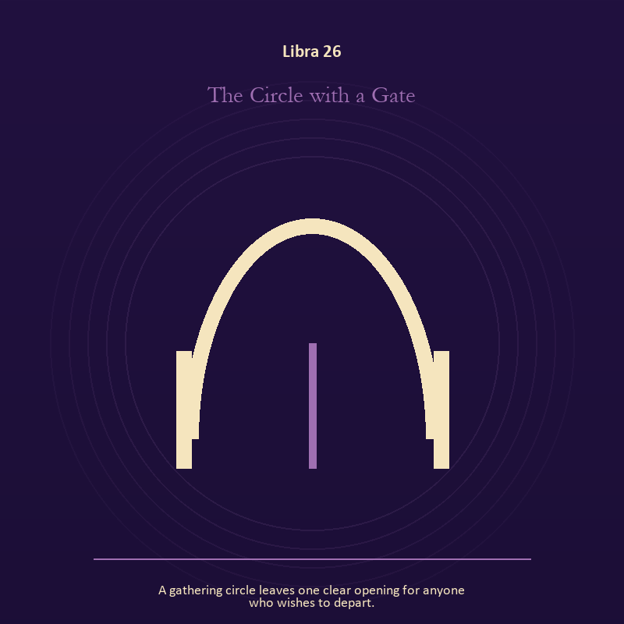

Libra 26 The Circle with a Gate
A gathering circle leaves one clear opening for anyone who wishes to depart.
INTERPRETATION In the Circle with a Gate, the work of the threshold must answer to relation, proportion, projection, and the ethics of holding two truths. Within the Circle with a Gate, doors and roads turn inner change into an embodied decision. At Libra 26, the next room matters, but so does the condition under which it is entered. As a release degree, Libra 26 prepares the lesson to leave its original container; keep the capacity and loosen the role.
SIGNAL At Libra 26, a boundary that clarifies freedom carries the signal; it stays honest when you make room for the other account without surrendering your own perception.
SHADOW The shadow at Libra 26 begins with crossing before consent; also beware peace purchased with silence, charm used as pressure, or fairness reduced to appearances.
MIRROR At Libra 26, what are you protecting by remaining on this side of the door?
PRACTICE Bring Libra 26 out of abstraction: stand at a literal doorway, name what you are leaving and what you refuse to abandon, then cross only if the answer feels clean.

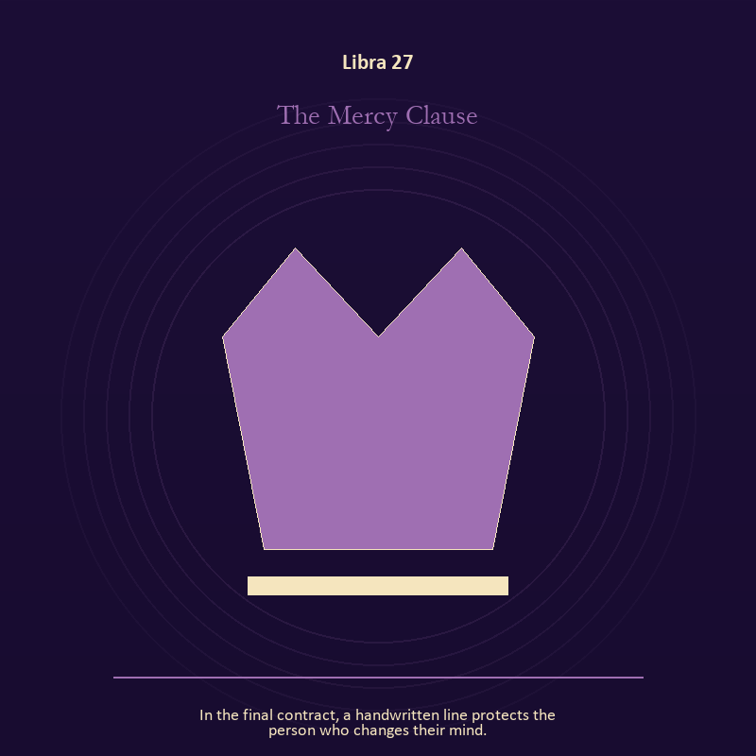

Libra 27 The Mercy Clause
In the final contract, a handwritten line protects the person who changes their mind.
INTERPRETATION The Mercy Clause tests authority against relation, proportion, projection, and the ethics of holding two truths. Within the Mercy Clause, institutional objects reveal the bargain between role and person. At Libra 27, a title may organize service or become a mask that excuses harm. The same image also carries relationship; at Libra 27, relationship imagery tests the fantasy that harmony requires sameness. As a release degree, Libra 27 asks what can be handed onward without demanding imitation or loyalty.
SIGNAL What can be carried forward from Libra 27 is stewardship with an exit plan joined to mutual responsibility, tested by the need to make room for the other account without surrendering your own perception.
SHADOW At Libra 27, the image darkens through procedure used to avoid conscience and the group protecting itself by sacrificing an outsider; beware peace purchased with silence, charm used as pressure, or fairness reduced to appearances.
MIRROR For Libra 27, which part of this authority serves life, and which part serves its own continuation? From a second angle at Libra 27, where does responsibility belong, and where has it been displaced?
PRACTICE For Libra 27, remove your title from a current problem and describe the duty that remains.
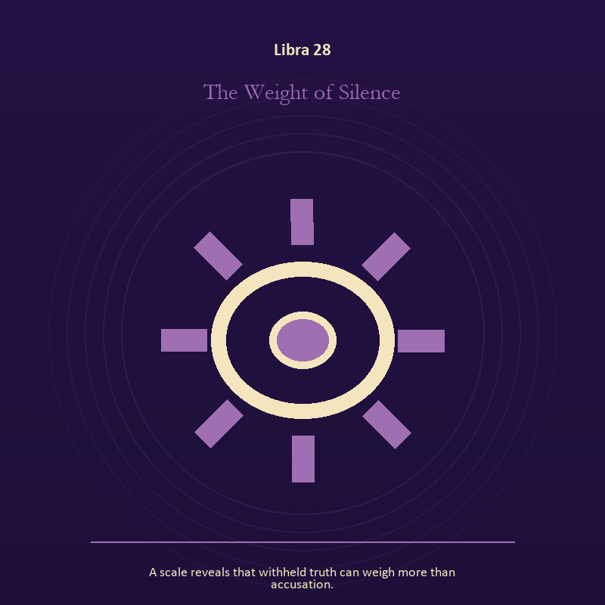

Libra 28 The Weight of Silence
A scale reveals that withheld truth can weigh more than accusation.
INTERPRETATION The Weight of Silence holds craft and record against relation, proportion, projection, and the ethics of holding two truths. Within the Weight of Silence, craft turns intention into a repeatable act with materials, limits, and evidence of failure. At Libra 28, the tool reveals the quality of attention brought to it. As a release degree, Libra 28 turns completion into transfer; the work survives by changing hands.
SIGNAL At Libra 28, evidence preserved without spectacle becomes the clean signal when Libra can make room for the other account without surrendering your own perception.
SHADOW The distortion at Libra 28 is polish used to hide a structural weakness; beware peace purchased with silence, charm used as pressure, or fairness reduced to appearances.
MIRROR With the Weight of Silence in mind at Libra 28, which part of this process can be checked rather than assumed?
PRACTICE Work with The Weight of Silence directly at Libra 28: repair one useful object without disguising the place where it broke.

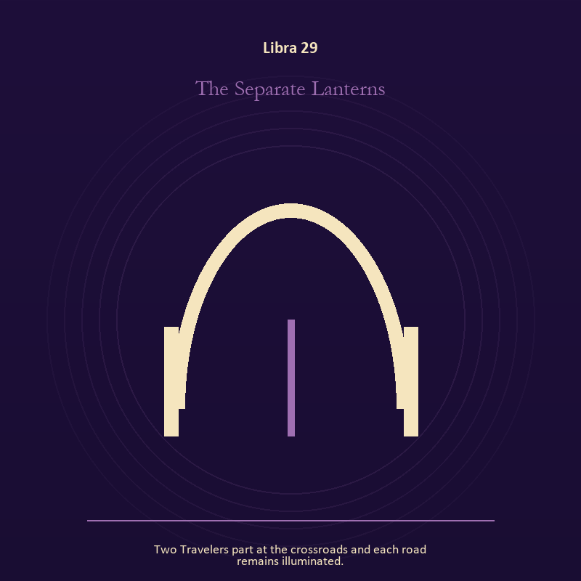

Libra 29 The Separate Lanterns
Two Travelers part at the crossroads and each road remains illuminated.
INTERPRETATION The Separate Lanterns gives the threshold consequences inside the Hall of Mirrors. Within the Separate Lanterns, doors and roads turn inner change into an embodied decision. At Libra 29, the next room matters, but so does the condition under which it is entered. The same image also carries relationship; at Libra 29, more than one will is active in this scene. As a release degree, Libra 29 lets the sign set down the identity built around its ordeal.
SIGNAL The usable force at Libra 29 is a boundary that clarifies freedom joined to contact without capture; Libra gives it form by asking you to make room for the other account without surrendering your own perception.
SHADOW At Libra 29, the Separate Lanterns can turn toward crossing before consent and projection mistaken for intimacy; beware peace purchased with silence, charm used as pressure, or fairness reduced to appearances.
MIRROR The question at Libra 29: what are you protecting by remaining on this side of the door?
PRACTICE Give Libra 29 a physical form; stand at a literal doorway, name what you are leaving and what you refuse to abandon, then cross only if the answer feels clean.
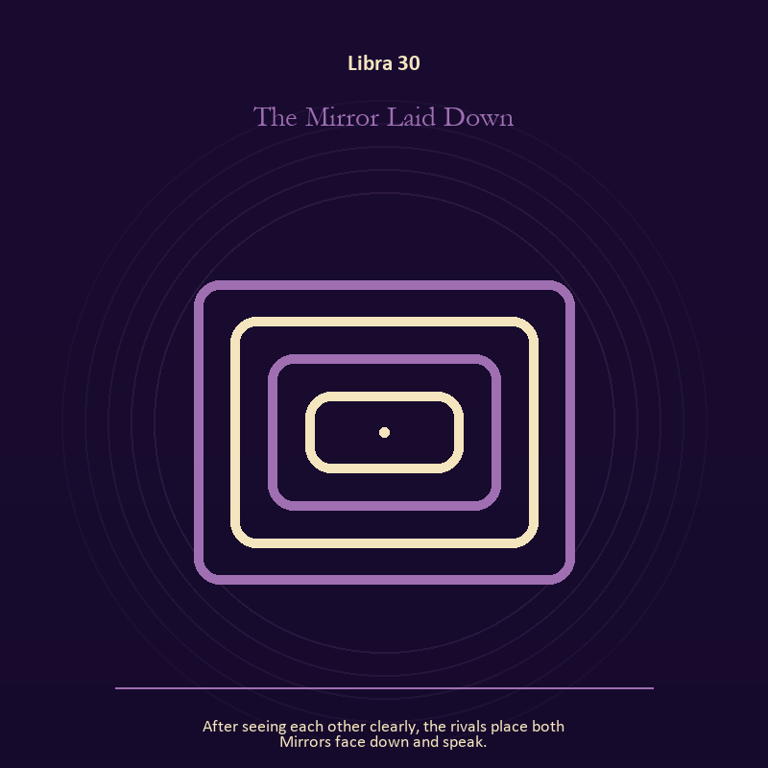

Libra 30 The Mirror Laid Down
After seeing each other clearly, the rivals place both Mirrors face down and speak.
INTERPRETATION The Mirror Laid Down puts the Mirror under pressure from relation, proportion, projection, and the ethics of holding two truths. Within the Mirror Laid Down, a shadow proves that something real stands in the light, while a reflection shows only an angle. At Libra 30, neither is the whole person. The same image also carries identity; at Libra 30, masks and names can conceal, reveal, or give shape to a truth that plain speech cannot yet hold. As a release degree, Libra 30 returns the earned knowledge to ordinary life, where another cycle can use it.
SIGNAL At Libra 30, self-recognition without self-worship joined to a protective form used consciously carries the signal; it stays honest when you make room for the other account without surrendering your own perception.
SHADOW The shadow at Libra 30 begins with assigning your hidden material to someone else and a mask that can no longer be removed safely; also beware peace purchased with silence, charm used as pressure, or fairness reduced to appearances.
MIRROR At Libra 30, which part of the reflection is asking to be reclaimed rather than judged? From a second angle at Libra 30, what does the mask make possible, and what does it cost to keep wearing it?
PRACTICE Bring Libra 30 out of abstraction: write two accounts of the same conflict: one from your position and one from the person you cannot understand.

Scorpio
The Descent Chamber
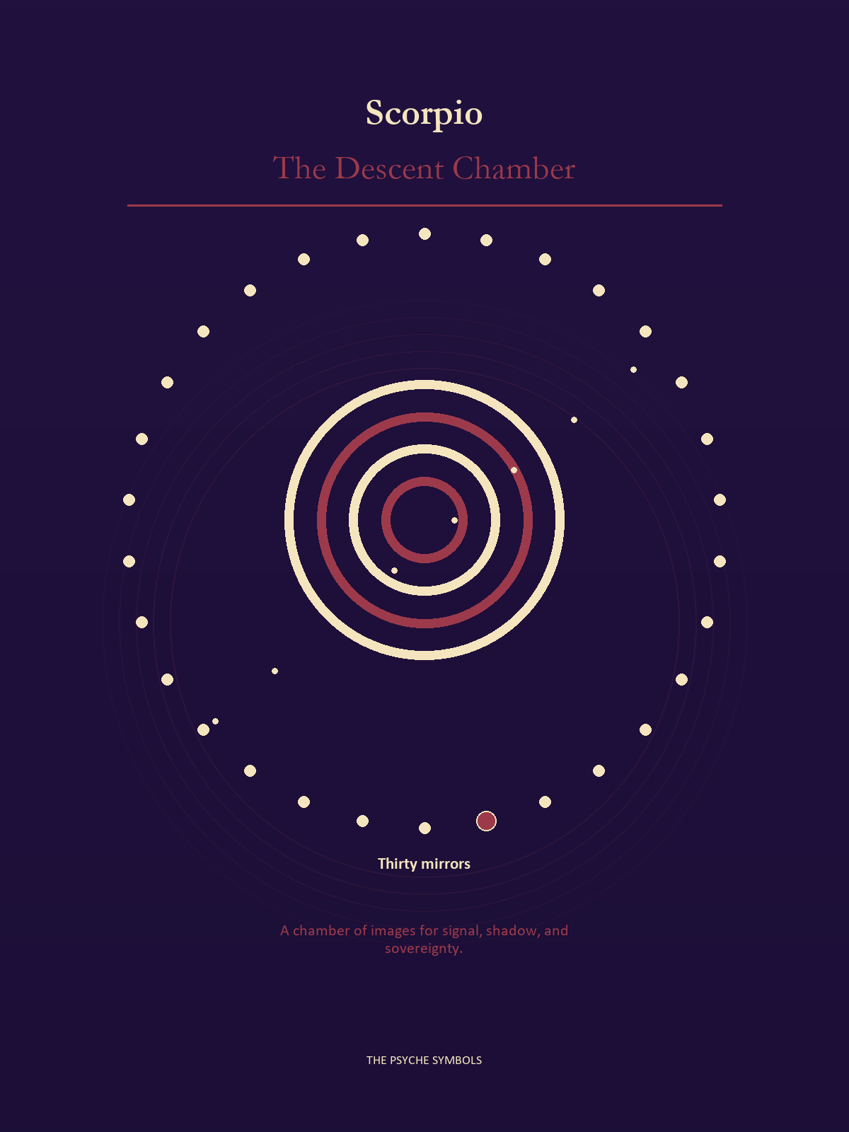
Scorpio follows the signal below the floor where bargains, wounds, loyalties, and buried power remain active. The Descent Chamber does not reward spectacle. It asks what is concealed, who benefits, and what repair will cost. Here the shadow becomes usable when it is named without being worshipped.

Degrees | Gate | Work
1-5 | Arrival | Meet the image before deciding what it means.
6-10 | Friction | Notice what pushes back and what that resistance protects.
11-15 | Revelation | Name the detail that changes the whole scene.
16-20 | Choice | Choose the act that preserves both truth and human dignity.
21-25 | Integration | Use the gift without feeding the shadow that travels beside it.
26-30 | Release | Keep the earned capacity and release the role that delivered it.

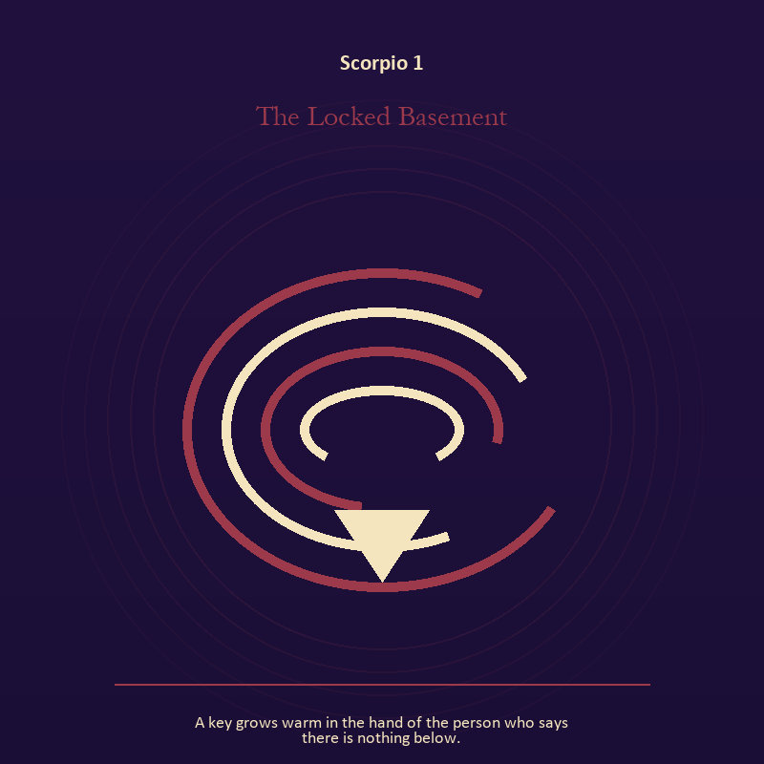

Scorpio 1 The Locked Basement
A key grows warm in the hand of the person who says there is nothing below.
INTERPRETATION In the Locked Basement, the work of the descent must answer to shadow, secrecy, power, loss, and the truth that survives the underworld. Within the Locked Basement, descent imagery carries what ordinary daylight has failed to resolve. At Scorpio 1, it asks for contact with the wound, bargain, fear, or grief beneath the public account. The same image also carries craft and record; at Scorpio 1, workshops honor correction. As an arrival degree, Scorpio 1 arrives before habit can tidy the evidence; notice what is present before deciding what it should become.
SIGNAL What can be carried forward from Scorpio 1 is contact with buried power joined to a useful correction that outlives the moment, tested by the need to stay with the difficult fact long enough to learn what it requires.
SHADOW At Scorpio 1, the image darkens through remaining underground after the danger has passed and measurement mistaken for meaning; watch pain become identity, secrecy become a bargaining weapon, or suspicion invent what evidence cannot support.
MIRROR For Scorpio 1, what difficult fact survives when the dramatic story is removed?
PRACTICE For Scorpio 1, choose a trusted witness and tell the smallest complete truth you can safely tell.
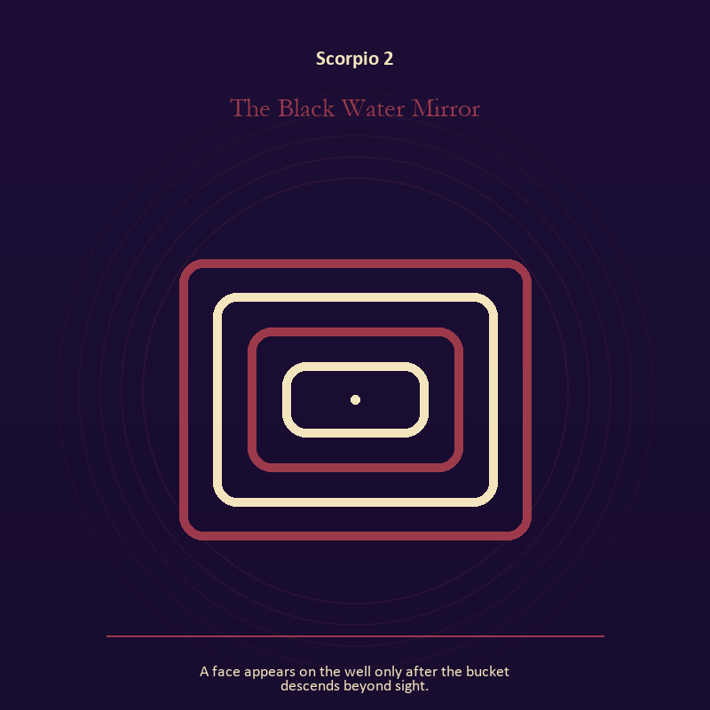

Scorpio 2 The Black Water Mirror
A face appears on the well only after the bucket descends beyond sight.
INTERPRETATION The Black Water Mirror tests the Mirror against shadow, secrecy, power, loss, and the truth that survives the underworld. Within the Black Water Mirror, reflected images divide the observer from the observed self. At Scorpio 2, that gap can hold shame, vanity, curiosity, or the first honest revision of identity. The same image also carries living water; at Scorpio 2, water carries feeling, memory, adaptation, and forces too large for command. As an arrival degree, Scorpio 2 introduces the sign's raw material in an unguarded form; the first response matters less than the honest one.
SIGNAL At Scorpio 2, the courage to revise a familiar self-image joined to feeling with a living boundary becomes the clean signal when Scorpio can stay with the difficult fact long enough to learn what it requires.
SHADOW The distortion at Scorpio 2 is mistaking appearance for character and using mystery to avoid a fact; watch pain become identity, secrecy become a bargaining weapon, or suspicion invent what evidence cannot support.
MIRROR With the Black Water Mirror in mind at Scorpio 2, whose gaze have you installed inside your own Mirror?
PRACTICE Work with The Black Water Mirror directly at Scorpio 2: describe the scene without interpretation, then circle the detail you most want to praise or condemn. For the second pressure at Scorpio 2, write the feeling as weather, then add the exact fact occurring beneath that weather.

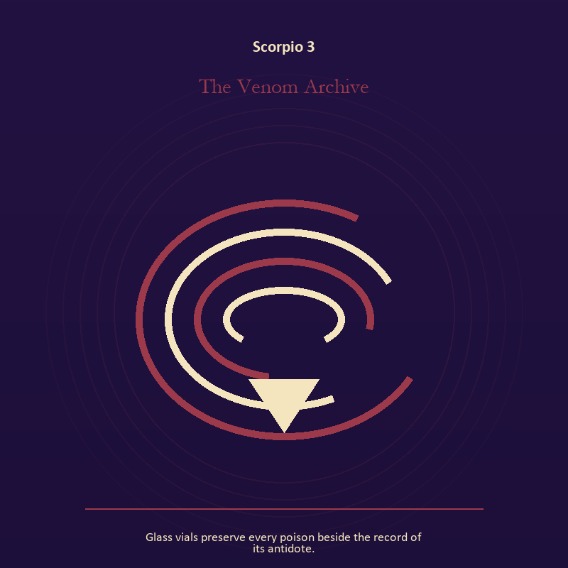

Scorpio 3 The Venom Archive
Glass vials preserve every poison beside the record of its antidote.
INTERPRETATION The Venom Archive holds the descent against shadow, secrecy, power, loss, and the truth that survives the underworld. Within the Venom Archive, ash, bones, scars, and sealed rooms preserve consequences. At Scorpio 3, the symbol asks whether memory will become a witness, a weapon, or material for repair. The same image also carries craft and record; at Scorpio 3, ledgers, maps, machines, and archives make memory operational. As an arrival degree, Scorpio 3 catches the first impulse before it turns into a role; give the image room to remain strange.
SIGNAL The usable force at Scorpio 3 is truth that survives loss joined to evidence preserved without spectacle; Scorpio gives it form by asking you to stay with the difficult fact long enough to learn what it requires.
SHADOW At Scorpio 3, the Venom Archive can turn toward suspicion filling gaps in the record and polish used to hide a structural weakness; watch pain become identity, secrecy become a bargaining weapon, or suspicion invent what evidence cannot support.
MIRROR The question at Scorpio 3: what are you carrying from below that can serve the living? From a second angle at Scorpio 3, what does the tool preserve, and what does it leave out?
PRACTICE Give Scorpio 3 a physical form; name the injury, the present risk, and the next repair as three separate sentences.
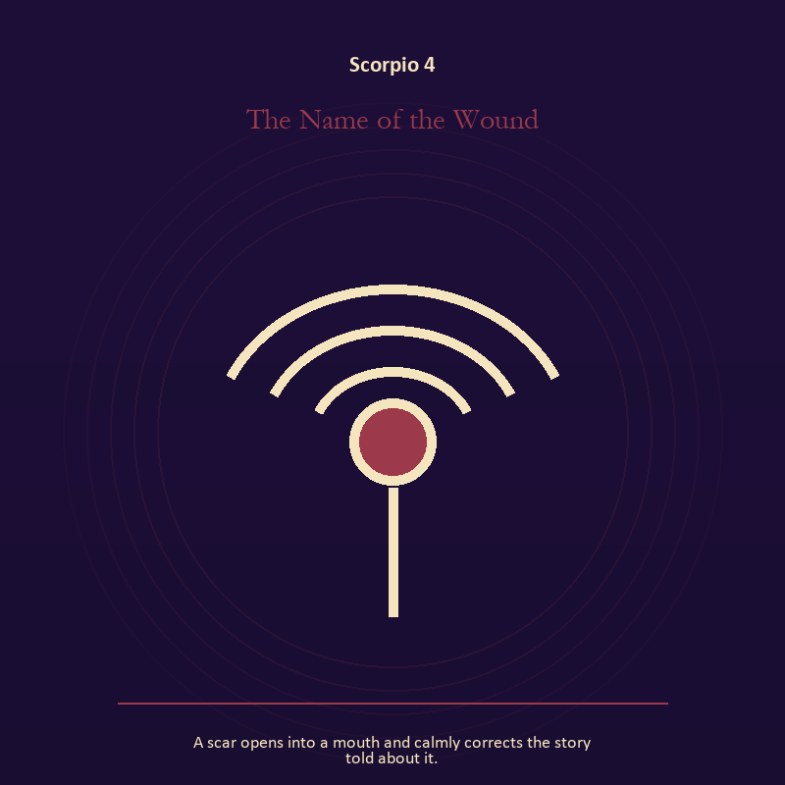

Scorpio 4 The Name of the Wound
A scar opens into a mouth and calmly corrects the story told about it.
INTERPRETATION The Name of the Wound gives voice and naming consequences inside the Descent Chamber. Within the Name of the Wound, voice turns inner pressure into shared consequence. At Scorpio 4, words can witness, summon, distort, repair, or conceal according to their precision and timing. The same image also carries the descent; at Scorpio 4, ash, bones, scars, and sealed rooms preserve consequences. As an arrival degree, Scorpio 4 opens the chamber with no settled method; name the need, risk, or appetite that entered with it.
SIGNAL At Scorpio 4, a name that restores agency joined to a wound converted into discernment carries the signal; it stays honest when you stay with the difficult fact long enough to learn what it requires.
SHADOW The shadow at Scorpio 4 begins with speaking for someone whose voice is present and pain used as permanent jurisdiction; also watch pain become identity, secrecy become a bargaining weapon, or suspicion invent what evidence cannot support.
MIRROR At Scorpio 4, which word in this scene changes the power relationship?
PRACTICE Bring Scorpio 4 out of abstraction: give the current experience a temporary name and date it, leaving room for revision.

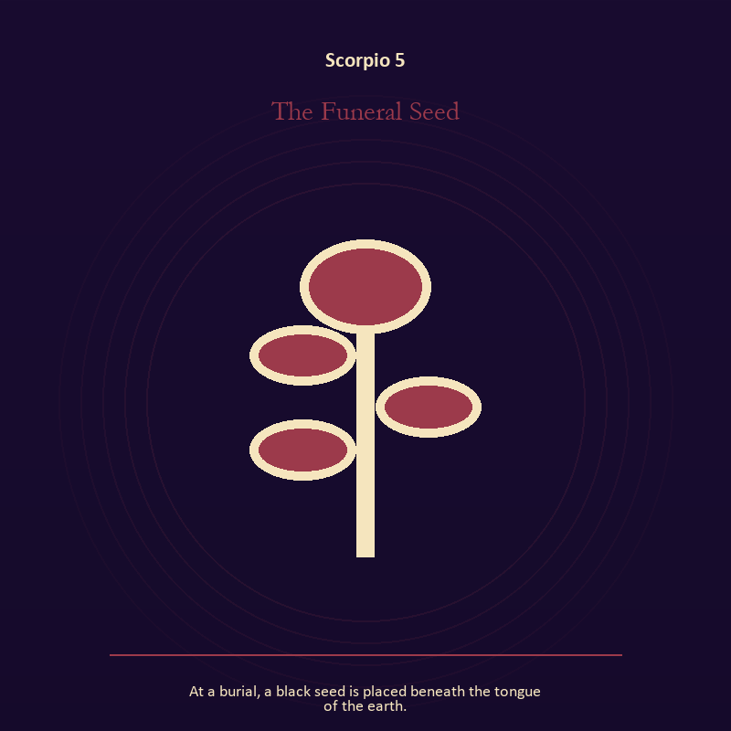

Scorpio 5 The Funeral Seed
At a burial, a black seed is placed beneath the tongue of the earth.
INTERPRETATION The Funeral Seed puts growth under pressure from shadow, secrecy, power, loss, and the truth that survives the underworld. Within the Funeral Seed, seeds, children, roots, and gardens refuse the fantasy of instant transformation. At Scorpio 5, they make becoming physical, seasonal, and dependent on care. The same image also carries the descent; at Scorpio 5, descent imagery carries what ordinary daylight has failed to resolve. As an arrival degree, Scorpio 5 shows the beginning before ownership hardens around it; let attention come before possession.
SIGNAL What can be carried forward from Scorpio 5 is inheritance revised through living action joined to truth that survives loss, tested by the need to stay with the difficult fact long enough to learn what it requires.
SHADOW At Scorpio 5, the image darkens through forcing a season and suspicion filling gaps in the record; watch pain become identity, secrecy become a bargaining weapon, or suspicion invent what evidence cannot support.
MIRROR For Scorpio 5, which condition would help this growth, and which demand would deform it?
PRACTICE For Scorpio 5, tend one living thing and let its pace correct your schedule.
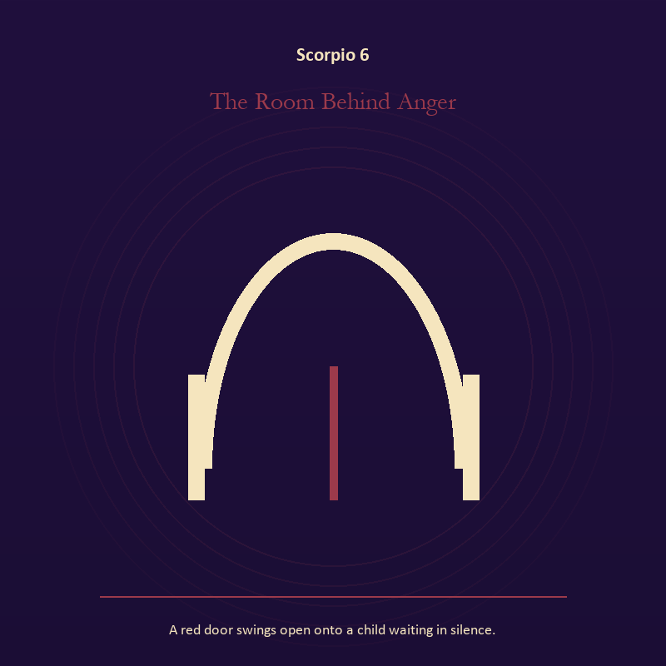

Scorpio 6 The Room Behind Anger
A red door swings open onto a child waiting in silence.
INTERPRETATION In the Room Behind Anger, the work of the threshold must answer to shadow, secrecy, power, loss, and the truth that survives the underworld. Within the Room Behind Anger, a boundary can protect life, restrict it, or clarify the terms of meeting. At Scorpio 6, the surrounding action reveals which function is active here. The same image also carries growth; at Scorpio 6, seeds, children, roots, and gardens refuse the fantasy of instant transformation. As a friction degree, Scorpio 6 meets resistance, and that resistance reveals what the first impulse failed to consider.
SIGNAL At Scorpio 6, honest passage joined to care that honors timing becomes the clean signal when Scorpio can stay with the difficult fact long enough to learn what it requires.
SHADOW The distortion at Scorpio 6 is guarding an obsolete enclosure and protecting potential so tightly that it cannot emerge; watch pain become identity, secrecy become a bargaining weapon, or suspicion invent what evidence cannot support.
MIRROR With the Room Behind Anger in mind at Scorpio 6, what would make the next step chosen rather than compelled? From a second angle at Scorpio 6, which condition would help this growth, and which demand would deform it?
PRACTICE Work with The Room Behind Anger directly at Scorpio 6: draw the boundary as a line on paper; then mark the gate, the guard, and the person who holds the key. For the second pressure at Scorpio 6, release one expectation about what the new form must resemble.

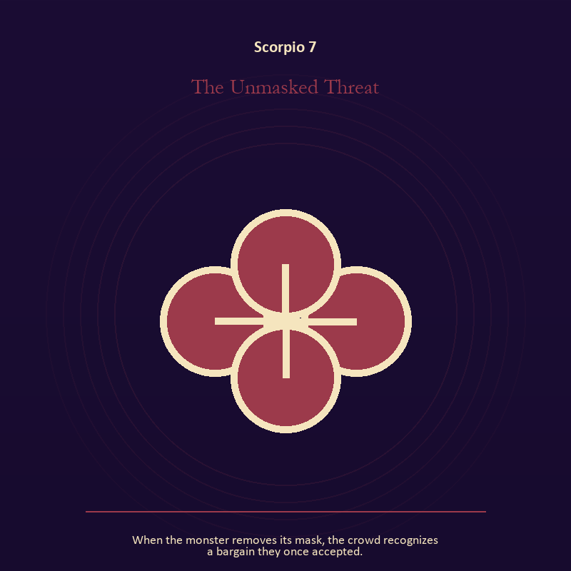

Scorpio 7 The Unmasked Threat
When the monster removes its mask, the crowd recognizes a bargain they once accepted.
INTERPRETATION The Unmasked Threat tests relationship against shadow, secrecy, power, loss, and the truth that survives the underworld. Within the Unmasked Threat, more than one will is active in this scene. At Scorpio 7, meaning emerges through distance, consent, conflict, care, and the terms under which contact continues. The same image also carries identity; at Scorpio 7, a role organizes behavior but cannot contain the whole person. As a friction degree, Scorpio 7 places consequence beside desire; the obstruction may be an enemy, a limit, or a needed correction.
SIGNAL The usable force at Scorpio 7 is mutual responsibility joined to the freedom to revise a name or role; Scorpio gives it form by asking you to stay with the difficult fact long enough to learn what it requires.
SHADOW At Scorpio 7, the Unmasked Threat can turn toward the group protecting itself by sacrificing an outsider and performance mistaken for selfhood; watch pain become identity, secrecy become a bargaining weapon, or suspicion invent what evidence cannot support.
MIRROR The question at Scorpio 7: what agreement is operating here even if nobody has spoken it?
PRACTICE Give Scorpio 7 a physical form; make one repair that does not require the other person to erase their account.
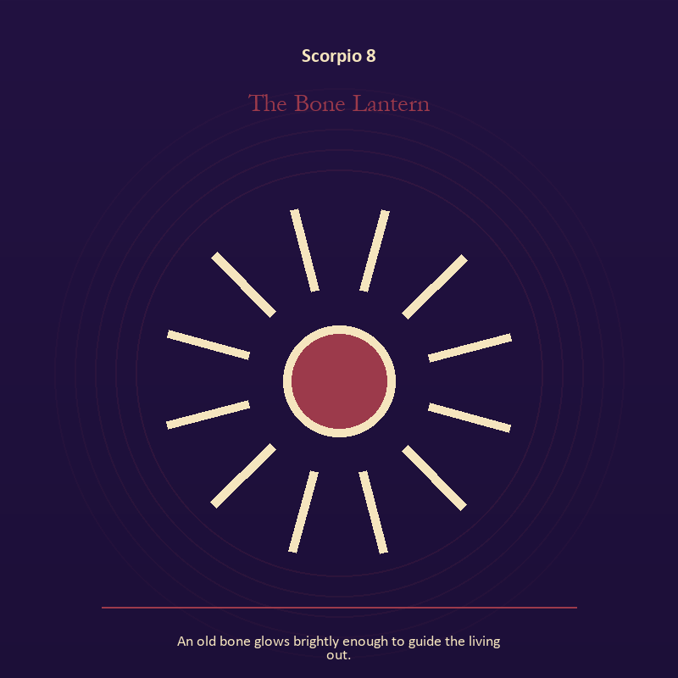

Scorpio 8 The Bone Lantern
An old bone glows brightly enough to guide the living out.
INTERPRETATION The Bone Lantern holds living fire against shadow, secrecy, power, loss, and the truth that survives the underworld. Within the Bone Lantern, fire gives change a visible cost. At Scorpio 8, something is illuminated here because something else is being spent. The same image also carries the descent; at Scorpio 8, descent imagery carries what ordinary daylight has failed to resolve. As a friction degree, Scorpio 8 tests whether the sign can change course without treating correction as defeat.
SIGNAL At Scorpio 8, a truth made visible at the right scale joined to truth that survives loss carries the signal; it stays honest when you stay with the difficult fact long enough to learn what it requires.
SHADOW The shadow at Scorpio 8 begins with burning for recognition and suspicion filling gaps in the record; also watch pain become identity, secrecy become a bargaining weapon, or suspicion invent what evidence cannot support.
MIRROR At Scorpio 8, where has your fire become performance rather than warmth?
PRACTICE Bring Scorpio 8 out of abstraction: light one candle and give its entire burn to a single unfinished question.

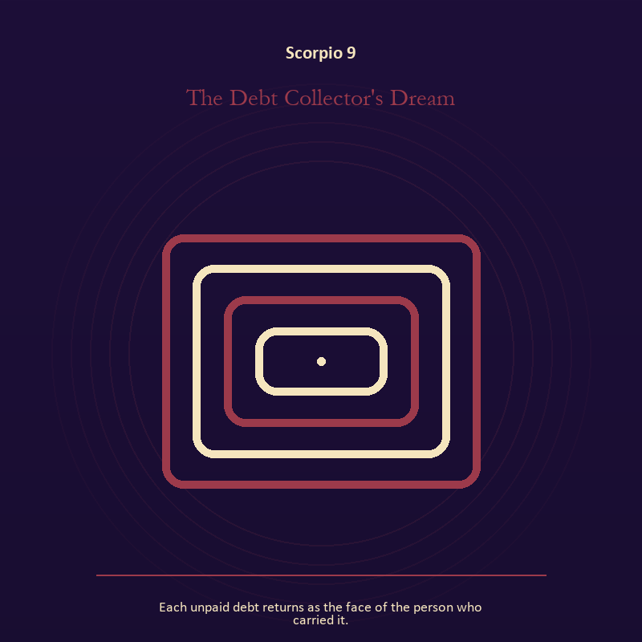

Scorpio 9 The Debt Collector's Dream
Each unpaid debt returns as the face of the person who carried it.
INTERPRETATION The Debt Collector's Dream gives the Mirror consequences inside the Descent Chamber. Within the Debt Collector's Dream, a shadow proves that something real stands in the light, while a reflection shows only an angle. At Scorpio 9, neither is the whole person. The same image also carries relationship; at Scorpio 9, relationship imagery tests the fantasy that harmony requires sameness. As a friction degree, Scorpio 9 brings another will, material limit, or inconvenient fact into the frame.
SIGNAL What can be carried forward from Scorpio 9 is self-recognition without self-worship joined to mutual responsibility, tested by the need to stay with the difficult fact long enough to learn what it requires.
SHADOW At Scorpio 9, the image darkens through assigning your hidden material to someone else and the group protecting itself by sacrificing an outsider; watch pain become identity, secrecy become a bargaining weapon, or suspicion invent what evidence cannot support.
MIRROR For Scorpio 9, which part of the reflection is asking to be reclaimed rather than judged? From a second angle at Scorpio 9, where does responsibility belong, and where has it been displaced?
PRACTICE For Scorpio 9, write two accounts of the same conflict: one from your position and one from the person you cannot understand.
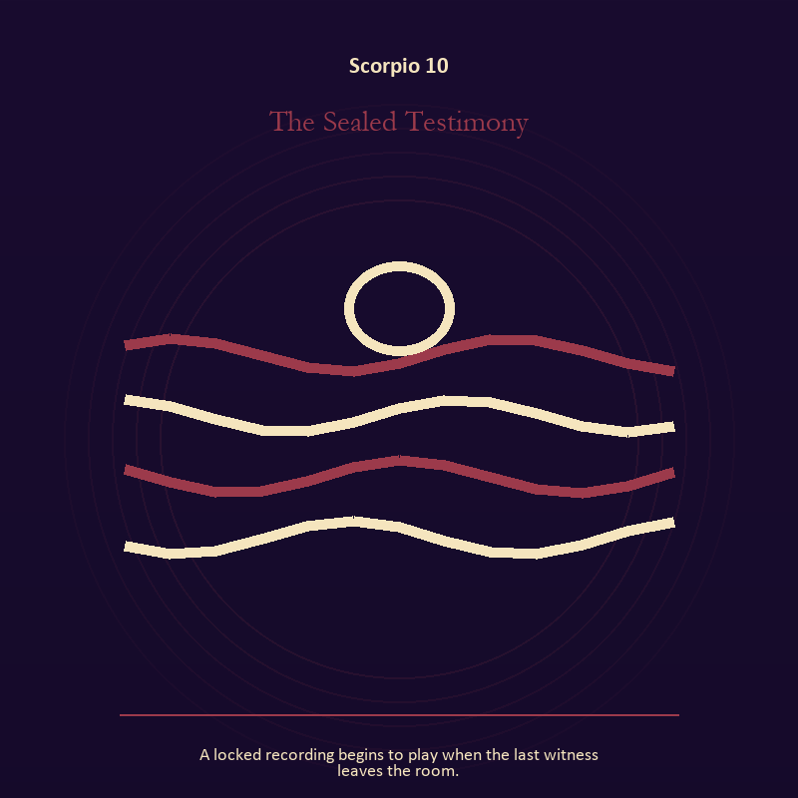

Scorpio 10 The Sealed Testimony
A locked recording begins to play when the last witness leaves the room.
INTERPRETATION The Sealed Testimony puts mystery under pressure from shadow, secrecy, power, loss, and the truth that survives the underworld. Within the Sealed Testimony, the scene behaves like a dream with its own exact logic. At Scorpio 10, meaning lives in the relationship between figure, place, action, and the detail that refuses ordinary explanation. As a friction degree, Scorpio 10 slows the original motion long enough to expose what haste concealed.
SIGNAL At Scorpio 10, imagination disciplined by the scene becomes the clean signal when Scorpio can stay with the difficult fact long enough to learn what it requires.
SHADOW The distortion at Scorpio 10 is mistaking intensity for accuracy; watch pain become identity, secrecy become a bargaining weapon, or suspicion invent what evidence cannot support.
MIRROR With the Sealed Testimony in mind at Scorpio 10, which detail keeps returning after the rest of the scene fades?
PRACTICE Work with The Sealed Testimony directly at Scorpio 10: keep the image nearby for one day and record only the moments when it returns on its own.

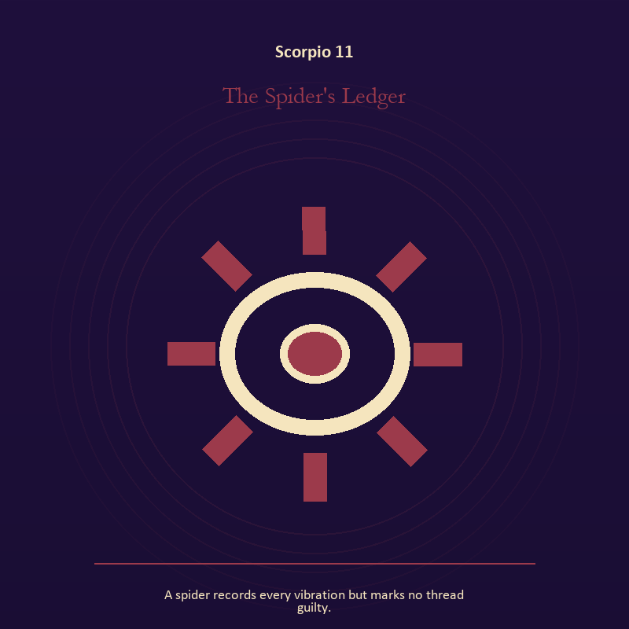

Scorpio 11 The Spider's Ledger
A spider records every vibration but marks no thread guilty.
INTERPRETATION In the Spider's Ledger, the work of craft and record must answer to shadow, secrecy, power, loss, and the truth that survives the underworld. Within the Spider's Ledger, ledgers, maps, machines, and archives make memory operational. At Scorpio 11, they can protect truth or compress living complexity until only the form remains. As a revelation degree, Scorpio 11 reveals the mechanism under the mood; one concrete detail changes the reading.
SIGNAL The usable force at Scorpio 11 is a useful correction that outlives the moment; Scorpio gives it form by asking you to stay with the difficult fact long enough to learn what it requires.
SHADOW At Scorpio 11, the Spider's Ledger can turn toward measurement mistaken for meaning; watch pain become identity, secrecy become a bargaining weapon, or suspicion invent what evidence cannot support.
MIRROR The question at Scorpio 11: what does the tool preserve, and what does it leave out?
PRACTICE Give Scorpio 11 a physical form; inspect one repeated task and add a check that would catch the most expensive error.
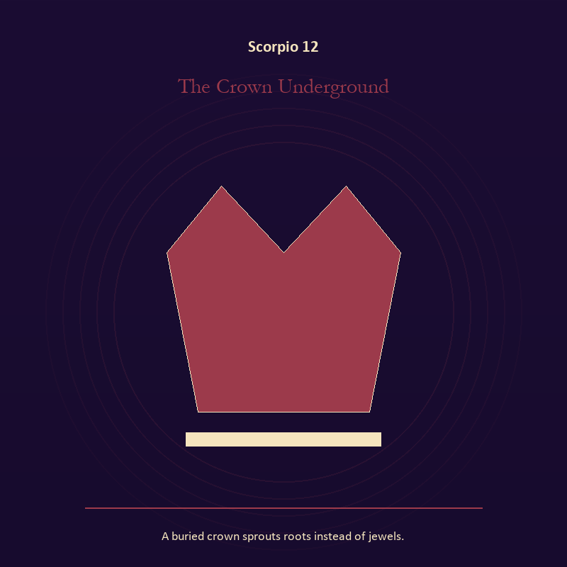

Scorpio 12 The Crown Underground
A buried crown sprouts roots instead of jewels.
INTERPRETATION The Crown Underground tests authority against shadow, secrecy, power, loss, and the truth that survives the underworld. Within the Crown Underground, institutional objects reveal the bargain between role and person. At Scorpio 12, a title may organize service or become a mask that excuses harm. The same image also carries the descent; at Scorpio 12, the underworld strips away rank and performance. As a revelation degree, Scorpio 12 moves the hidden arrangement into view, where it can be named without being exaggerated.
SIGNAL At Scorpio 12, stewardship with an exit plan joined to contact with buried power carries the signal; it stays honest when you stay with the difficult fact long enough to learn what it requires.
SHADOW The shadow at Scorpio 12 begins with procedure used to avoid conscience and remaining underground after the danger has passed; also watch pain become identity, secrecy become a bargaining weapon, or suspicion invent what evidence cannot support.
MIRROR At Scorpio 12, which part of this authority serves life, and which part serves its own continuation? From a second angle at Scorpio 12, which part of the wound needs witness, and which part needs a boundary?
PRACTICE Bring Scorpio 12 out of abstraction: remove your title from a current problem and describe the duty that remains.

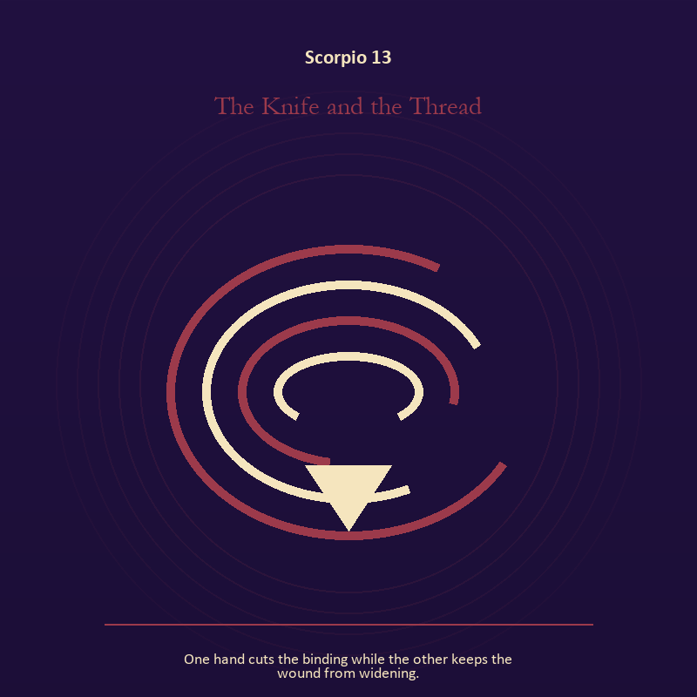

Scorpio 13 The Knife and the Thread
One hand cuts the binding while the other keeps the wound from widening.
INTERPRETATION The Knife and the Thread holds the descent against shadow, secrecy, power, loss, and the truth that survives the underworld. Within the Knife and the Thread, descent imagery carries what ordinary daylight has failed to resolve. At Scorpio 13, it asks for contact with the wound, bargain, fear, or grief beneath the public account. The same image also carries the body; at Scorpio 13, embodiment gives every choice a pace and a cost. As a revelation degree, Scorpio 13 turns atmosphere into evidence; attend to the object or action that cannot be explained away.
SIGNAL What can be carried forward from Scorpio 13 is contact with buried power joined to a decision the nervous system can inhabit, tested by the need to stay with the difficult fact long enough to learn what it requires.
SHADOW At Scorpio 13, the image darkens through remaining underground after the danger has passed and using transcendence to ignore need; watch pain become identity, secrecy become a bargaining weapon, or suspicion invent what evidence cannot support.
MIRROR For Scorpio 13, what difficult fact survives when the dramatic story is removed?
PRACTICE For Scorpio 13, choose a trusted witness and tell the smallest complete truth you can safely tell.
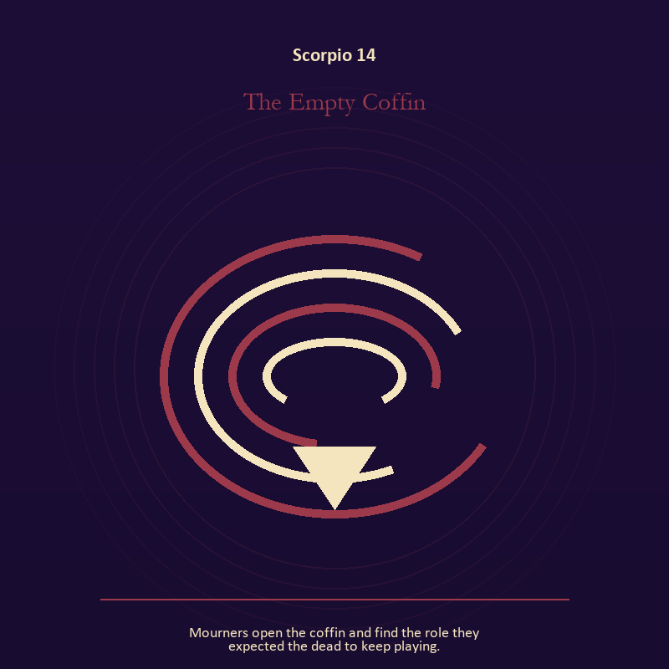

Scorpio 14 The Empty Coffin
Mourners open the coffin and find the role they expected the dead to keep playing.
INTERPRETATION The Empty Coffin gives the descent consequences inside the Descent Chamber. Within the Empty Coffin, the underworld strips away rank and performance. At Scorpio 14, what remains must be handled as evidence of experience, not proof of every story built around it. The same image also carries identity; at Scorpio 14, identity appears as something worn, spoken, assigned, revised, or returned. As a revelation degree, Scorpio 14 shows who carries the cost, who controls the passage, and what the scene refuses to hide.
SIGNAL At Scorpio 14, a wound converted into discernment joined to self-authorship becomes the clean signal when Scorpio can stay with the difficult fact long enough to learn what it requires.
SHADOW The distortion at Scorpio 14 is pain used as permanent jurisdiction and an assigned identity accepted as fate; watch pain become identity, secrecy become a bargaining weapon, or suspicion invent what evidence cannot support.
MIRROR With the Empty Coffin in mind at Scorpio 14, which part of the wound needs witness, and which part needs a boundary?
PRACTICE Work with The Empty Coffin directly at Scorpio 14: write two columns titled KNOWN and INFERRED; then place every part of the story where it belongs. For the second pressure at Scorpio 14, write your name beside one quality no title can grant or remove.

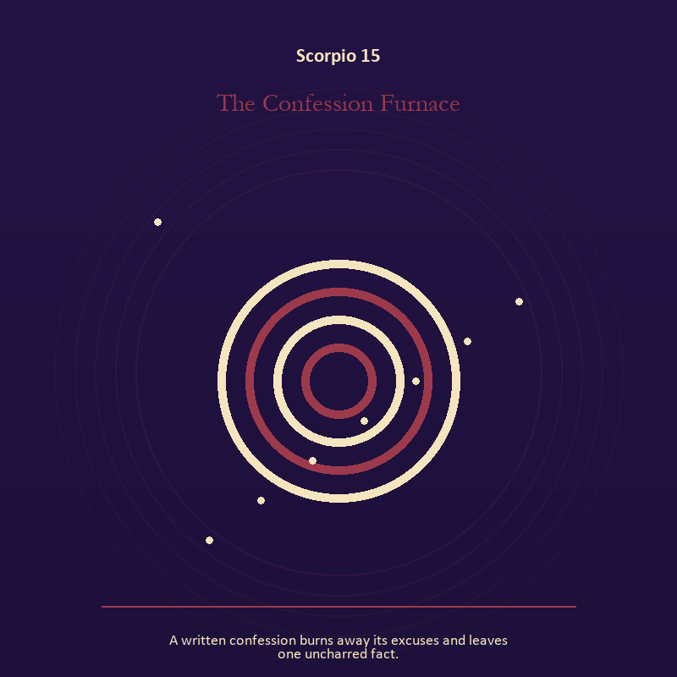

Scorpio 15 The Confession Furnace
A written confession burns away its excuses and leaves one uncharred fact.
INTERPRETATION The Confession Furnace puts mystery under pressure from shadow, secrecy, power, loss, and the truth that survives the underworld. Within the Confession Furnace, the symbol remains useful when no single interpretation closes it. At Scorpio 15, its work is to make one hidden relationship visible enough to examine. As a revelation degree, Scorpio 15 brings the middle truth forward, after the first story has lost its grip.
SIGNAL The usable force at Scorpio 15 is attention without premature certainty; Scorpio gives it form by asking you to stay with the difficult fact long enough to learn what it requires.
SHADOW At Scorpio 15, the Confession Furnace can turn toward using beauty to avoid the ordinary fact; watch pain become identity, secrecy become a bargaining weapon, or suspicion invent what evidence cannot support.
MIRROR The question at Scorpio 15: what changes if the scene is a question rather than an answer?
PRACTICE Give Scorpio 15 a physical form; describe the scene to another person without explaining it, then notice what they ask first.
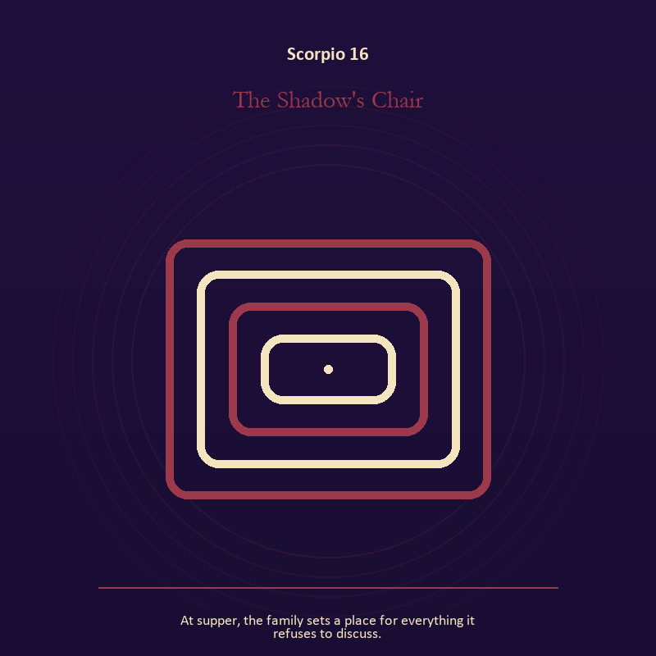

Scorpio 16 The Shadow's Chair
At supper, the family sets a place for everything it refuses to discuss.
INTERPRETATION In the Shadow's Chair, the work of the Mirror must answer to shadow, secrecy, power, loss, and the truth that survives the underworld. Within the Shadow's Chair, the Mirror returns perception without guaranteeing accuracy. At Scorpio 16, it reveals projection, self-image, and the temptation to kneel before a reflection. The same image also carries the body; at Scorpio 16, embodiment gives every choice a pace and a cost. As a choice degree, Scorpio 16 requires a choice with a human cost; insight alone no longer completes the work.
SIGNAL At Scorpio 16, a projection reclaimed joined to a decision the nervous system can inhabit carries the signal; it stays honest when you stay with the difficult fact long enough to learn what it requires.
SHADOW The shadow at Scorpio 16 begins with letting shame dictate what the Mirror may show and using transcendence to ignore need; also watch pain become identity, secrecy become a bargaining weapon, or suspicion invent what evidence cannot support.
MIRROR At Scorpio 16, what are you seeing clearly, and what may be projection?
PRACTICE Bring Scorpio 16 out of abstraction: look into a Mirror for one minute and name facts only; then notice when judgment tries to enter as description.



Scorpio 17 The Scorpion's Gift
A scorpion leaves its stinger on the altar and walks away smaller but alive.
INTERPRETATION The Scorpion's Gift tests mystery against shadow, secrecy, power, loss, and the truth that survives the underworld. Within the Scorpion's Gift, this image invites attention before conclusion. At Scorpio 17, its strange fact creates a pressure point where memory, desire, fear, and choice can speak indirectly. As a choice degree, Scorpio 17 asks what action preserves truth without using another person as material.
SIGNAL What can be carried forward from Scorpio 17 is an unanswered image that keeps thought alive, tested by the need to stay with the difficult fact long enough to learn what it requires.
SHADOW At Scorpio 17, the image darkens through forcing a prophecy from ambiguity; watch pain become identity, secrecy become a bargaining weapon, or suspicion invent what evidence cannot support.
MIRROR For Scorpio 17, what ordinary fact sits beneath the strange image?
PRACTICE For Scorpio 17, copy the image by hand, underline three concrete nouns, and write one association for each.
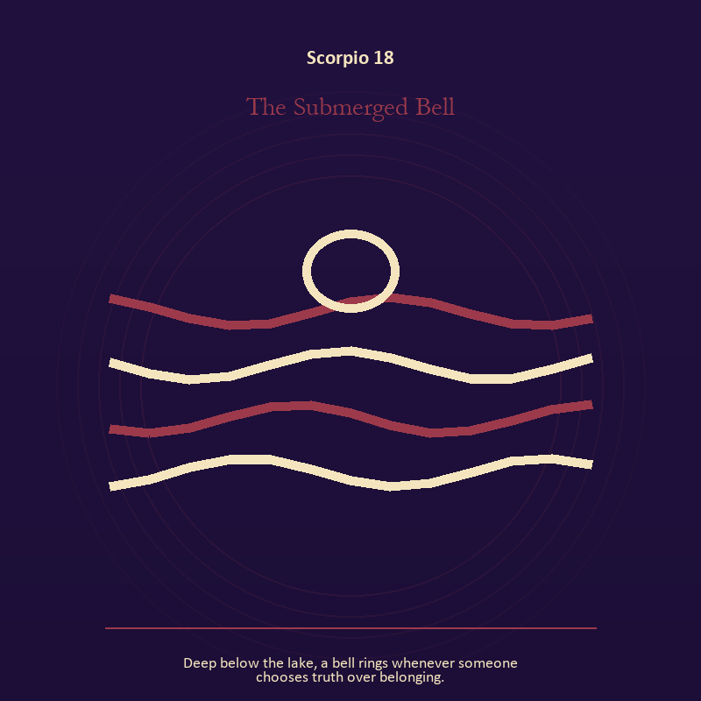

Scorpio 18 The Submerged Bell
Deep below the lake, a bell rings whenever someone chooses truth over belonging.
INTERPRETATION The Submerged Bell holds voice and naming against shadow, secrecy, power, loss, and the truth that survives the underworld. Within the Submerged Bell, naming creates a handle for experience, but the handle must remain smaller than the life it describes. At Scorpio 18, the image tests language against reality. The same image also carries living water; at Scorpio 18, a shore or vessel gives emotion a boundary without denying its depth. As a choice degree, Scorpio 18 moves from recognition to conduct; the clean choice must survive outside the imagination.
SIGNAL At Scorpio 18, speech with consequence joined to adaptation without self-erasure becomes the clean signal when Scorpio can stay with the difficult fact long enough to learn what it requires.
SHADOW The distortion at Scorpio 18 is repeating a message until it sounds like evidence and building a vessel too rigid for living water; watch pain become identity, secrecy become a bargaining weapon, or suspicion invent what evidence cannot support.
MIRROR With the Submerged Bell in mind at Scorpio 18, what are you naming accurately, and what remains larger than the name? From a second angle at Scorpio 18, where are you adapting wisely, and where are you disappearing?
PRACTICE Work with The Submerged Bell directly at Scorpio 18: listen to one person without planning your answer; then repeat their meaning before offering your own. For the second pressure at Scorpio 18, wash your hands with attention and decide what belongs to you after the water stops.

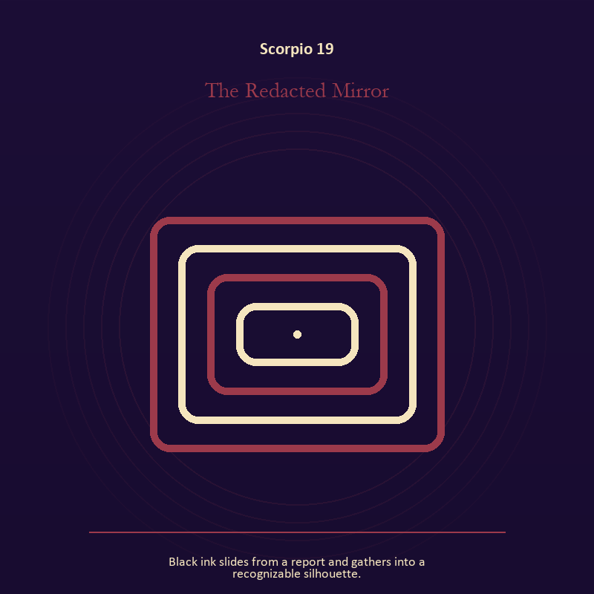

Scorpio 19 The Redacted Mirror
Black ink slides from a report and gathers into a recognizable silhouette.
INTERPRETATION The Redacted Mirror gives the Mirror consequences inside the Descent Chamber. Within the Redacted Mirror, the Mirror returns perception without guaranteeing accuracy. At Scorpio 19, it reveals projection, self-image, and the temptation to kneel before a reflection. As a choice degree, Scorpio 19 tests whether awareness can become restraint, repair, refusal, or consent.
SIGNAL The usable force at Scorpio 19 is a projection reclaimed; Scorpio gives it form by asking you to stay with the difficult fact long enough to learn what it requires.
SHADOW At Scorpio 19, the Redacted Mirror can turn toward letting shame dictate what the Mirror may show; watch pain become identity, secrecy become a bargaining weapon, or suspicion invent what evidence cannot support.
MIRROR The question at Scorpio 19: what are you seeing clearly, and what may be projection?
PRACTICE Give Scorpio 19 a physical form; look into a Mirror for one minute and name facts only; then notice when judgment tries to enter as description.
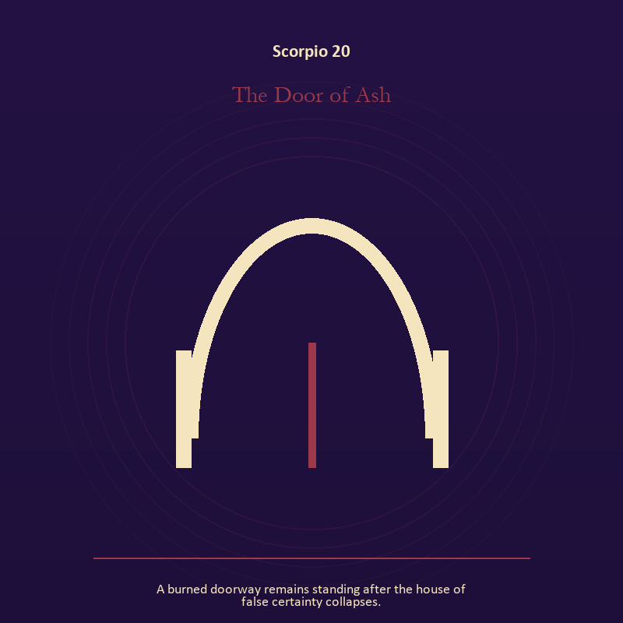

Scorpio 20 The Door of Ash
A burned doorway remains standing after the house of false certainty collapses.
INTERPRETATION The Door of Ash puts the threshold under pressure from shadow, secrecy, power, loss, and the truth that survives the underworld. Within the Door of Ash, doors and roads turn inner change into an embodied decision. At Scorpio 20, the next room matters, but so does the condition under which it is entered. The same image also carries the descent; at Scorpio 20, descent imagery carries what ordinary daylight has failed to resolve. As a choice degree, Scorpio 20 places responsibility in the reader's hands without promising a painless answer.
SIGNAL At Scorpio 20, a boundary that clarifies freedom joined to truth that survives loss carries the signal; it stays honest when you stay with the difficult fact long enough to learn what it requires.
SHADOW The shadow at Scorpio 20 begins with crossing before consent and suspicion filling gaps in the record; also watch pain become identity, secrecy become a bargaining weapon, or suspicion invent what evidence cannot support.
MIRROR At Scorpio 20, what are you protecting by remaining on this side of the door?
PRACTICE Bring Scorpio 20 out of abstraction: stand at a literal doorway, name what you are leaving and what you refuse to abandon, then cross only if the answer feels clean.

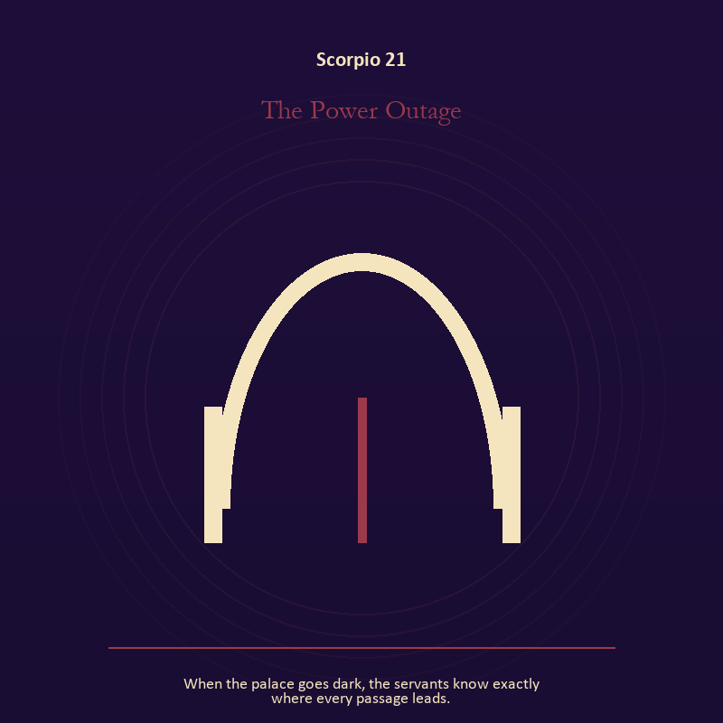

Scorpio 21 The Power Outage
When the palace goes dark, the servants know exactly where every passage leads.
INTERPRETATION In the Power Outage, the work of the threshold must answer to shadow, secrecy, power, loss, and the truth that survives the underworld. Within the Power Outage, a boundary can protect life, restrict it, or clarify the terms of meeting. At Scorpio 21, the surrounding action reveals which function is active here. The same image also carries authority; at Scorpio 21, crowns, laws, offices, and verdicts turn private judgment into public consequence. As a integration degree, Scorpio 21 holds the gift beside its distortion; using one without feeding the other is the work.
SIGNAL What can be carried forward from Scorpio 21 is honest passage joined to power made answerable, tested by the need to stay with the difficult fact long enough to learn what it requires.
SHADOW At Scorpio 21, the image darkens through guarding an obsolete enclosure and authority defending itself against correction; watch pain become identity, secrecy become a bargaining weapon, or suspicion invent what evidence cannot support.
MIRROR For Scorpio 21, what would make the next step chosen rather than compelled? From a second angle at Scorpio 21, what would accountability require from the person holding the key?
PRACTICE For Scorpio 21, draw the boundary as a line on paper; then mark the gate, the guard, and the person who holds the key.
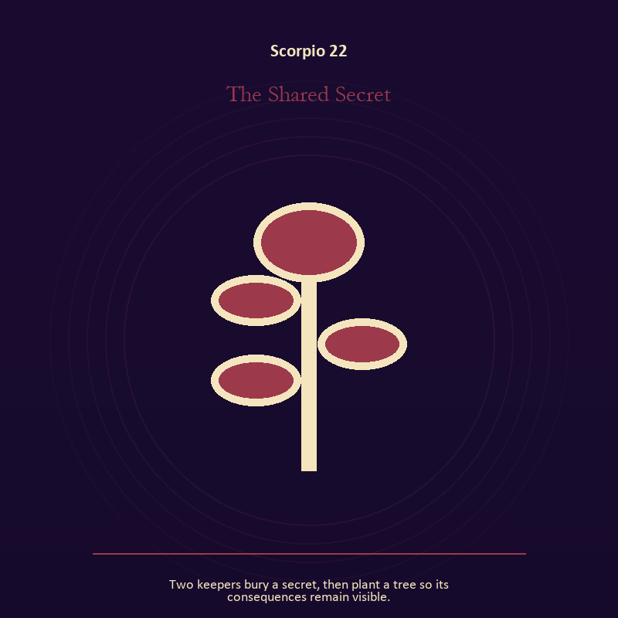

Scorpio 22 The Shared Secret
Two keepers bury a secret, then plant a tree so its consequences remain visible.
INTERPRETATION The Shared Secret tests the descent against shadow, secrecy, power, loss, and the truth that survives the underworld. Within the Shared Secret, descent imagery carries what ordinary daylight has failed to resolve. At Scorpio 22, it asks for contact with the wound, bargain, fear, or grief beneath the public account. The same image also carries relationship; at Scorpio 22, the shared object in the scene carries an agreement. As a integration degree, Scorpio 22 asks the sign to carry its strength without turning that strength into jurisdiction.
SIGNAL At Scorpio 22, contact with buried power joined to difference held without humiliation becomes the clean signal when Scorpio can stay with the difficult fact long enough to learn what it requires.
SHADOW The distortion at Scorpio 22 is remaining underground after the danger has passed and harmony purchased by one person's silence; watch pain become identity, secrecy become a bargaining weapon, or suspicion invent what evidence cannot support.
MIRROR With the Shared Secret in mind at Scorpio 22, what difficult fact survives when the dramatic story is removed?
PRACTICE Work with The Shared Secret directly at Scorpio 22: choose a trusted witness and tell the smallest complete truth you can safely tell. For the second pressure at Scorpio 22, ask the other person what they believe the agreement is, then compare it with your own version.

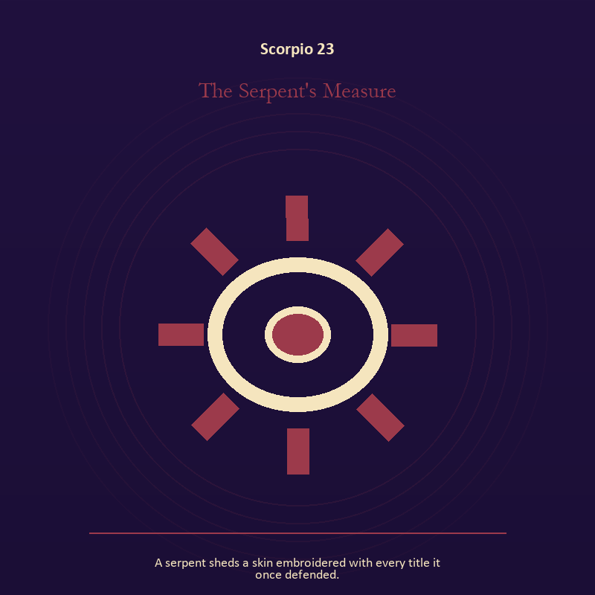

Scorpio 23 The Serpent's Measure
A serpent sheds a skin embroidered with every title it once defended.
INTERPRETATION The Serpent's Measure holds craft and record against shadow, secrecy, power, loss, and the truth that survives the underworld. Within the Serpent's Measure, ledgers, maps, machines, and archives make memory operational. At Scorpio 23, they can protect truth or compress living complexity until only the form remains. The same image also carries identity; at Scorpio 23, identity appears as something worn, spoken, assigned, revised, or returned. As a integration degree, Scorpio 23 joins capacity to consequence; what helps in one setting may harm in another.
SIGNAL The usable force at Scorpio 23 is a useful correction that outlives the moment joined to self-authorship; Scorpio gives it form by asking you to stay with the difficult fact long enough to learn what it requires.
SHADOW At Scorpio 23, the Serpent's Measure can turn toward measurement mistaken for meaning and an assigned identity accepted as fate; watch pain become identity, secrecy become a bargaining weapon, or suspicion invent what evidence cannot support.
MIRROR The question at Scorpio 23: what does the tool preserve, and what does it leave out?
PRACTICE Give Scorpio 23 a physical form; inspect one repeated task and add a check that would catch the most expensive error.
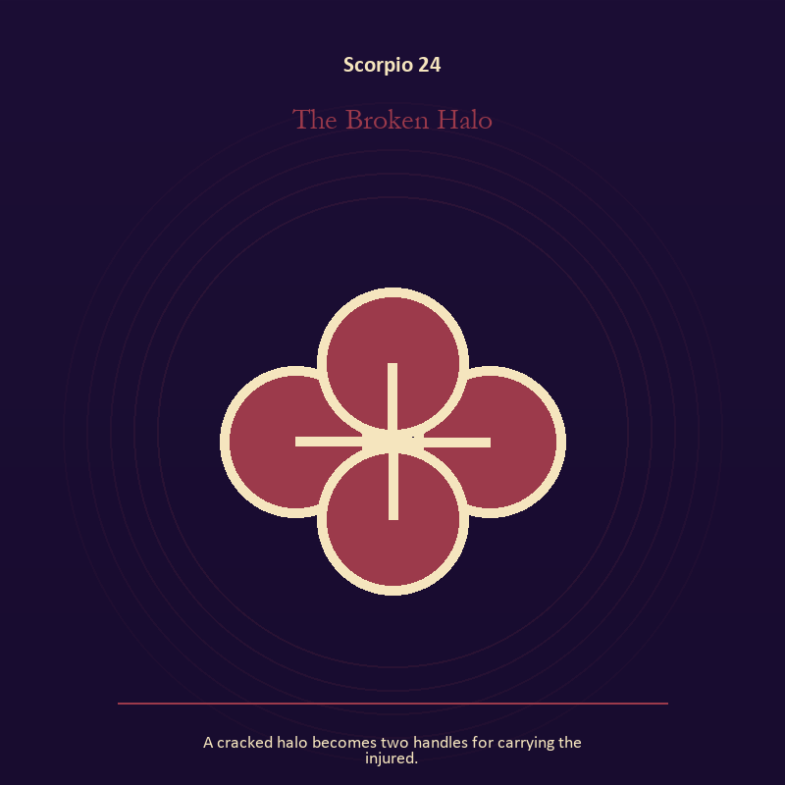

Scorpio 24 The Broken Halo
A cracked halo becomes two handles for carrying the injured.
INTERPRETATION The Broken Halo gives relationship consequences inside the Descent Chamber. Within the Broken Halo, the shared object in the scene carries an agreement. At Scorpio 24, its condition reveals whether responsibility is mutual, hidden, refused, or unevenly assigned. As a integration degree, Scorpio 24 shows the mature tool and the temptation hidden inside its handle.
SIGNAL At Scorpio 24, contact without capture carries the signal; it stays honest when you stay with the difficult fact long enough to learn what it requires.
SHADOW The shadow at Scorpio 24 begins with projection mistaken for intimacy; also watch pain become identity, secrecy become a bargaining weapon, or suspicion invent what evidence cannot support.
MIRROR At Scorpio 24, can this bond survive an honest difference and a visible exit?
PRACTICE Bring Scorpio 24 out of abstraction: name one need, one boundary, and one freedom that belong to each person in the scene.

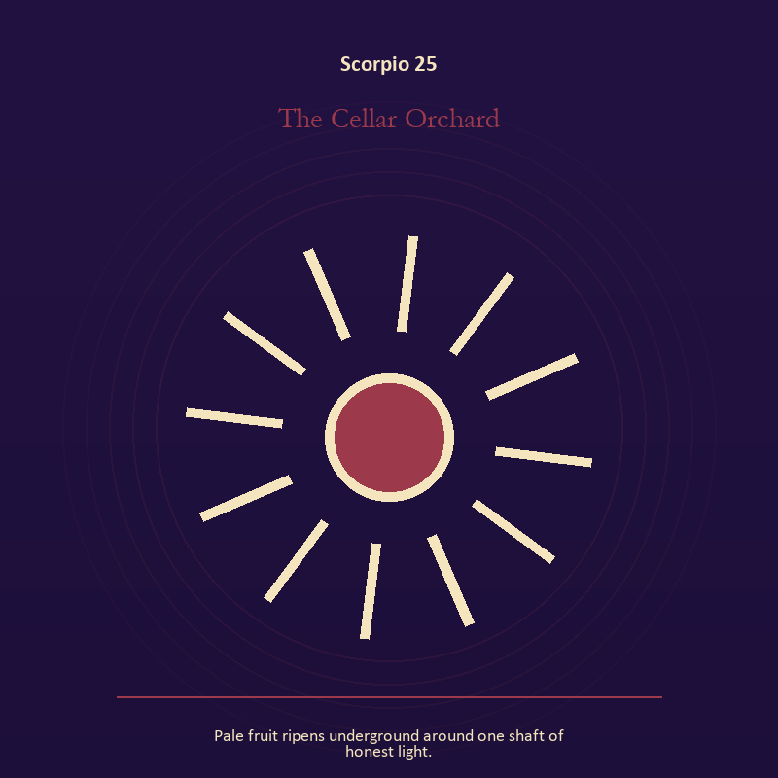

Scorpio 25 The Cellar Orchard
Pale fruit ripens underground around one shaft of honest light.
INTERPRETATION The Cellar Orchard puts growth under pressure from shadow, secrecy, power, loss, and the truth that survives the underworld. Within the Cellar Orchard, growth appears as vulnerable potential under specific conditions. At Scorpio 25, it requires time, nourishment, protection, and eventual release from the form that began it. The same image also carries the descent; at Scorpio 25, ash, bones, scars, and sealed rooms preserve consequences. As a integration degree, Scorpio 25 tests whether the lesson can be lived without becoming a new performance.
SIGNAL What can be carried forward from Scorpio 25 is care that honors timing joined to a wound converted into discernment, tested by the need to stay with the difficult fact long enough to learn what it requires.
SHADOW At Scorpio 25, the image darkens through protecting potential so tightly that it cannot emerge and pain used as permanent jurisdiction; watch pain become identity, secrecy become a bargaining weapon, or suspicion invent what evidence cannot support.
MIRROR For Scorpio 25, what is alive here but not ready to be displayed?
PRACTICE For Scorpio 25, release one expectation about what the new form must resemble.
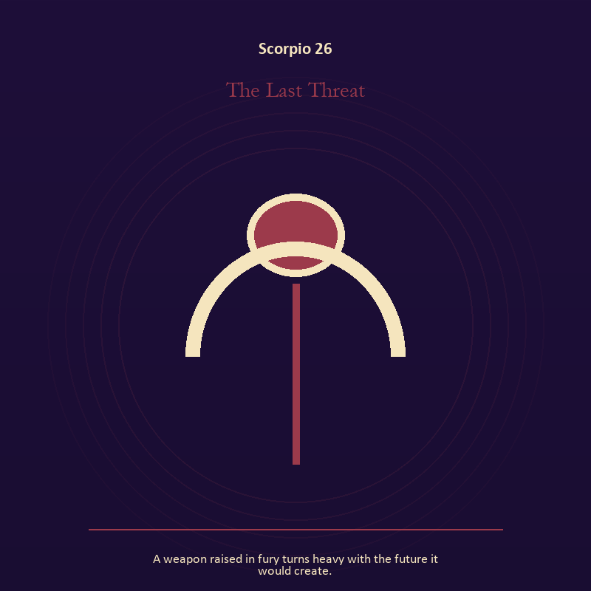

Scorpio 26 The Last Threat
A weapon raised in fury turns heavy with the future it would create.
INTERPRETATION In the Last Threat, the work of mystery must answer to shadow, secrecy, power, loss, and the truth that survives the underworld. Within the Last Threat, this image invites attention before conclusion. At Scorpio 26, its strange fact creates a pressure point where memory, desire, fear, and choice can speak indirectly. As a release degree, Scorpio 26 prepares the lesson to leave its original container; keep the capacity and loosen the role.
SIGNAL At Scorpio 26, an unanswered image that keeps thought alive becomes the clean signal when Scorpio can stay with the difficult fact long enough to learn what it requires.
SHADOW The distortion at Scorpio 26 is forcing a prophecy from ambiguity; watch pain become identity, secrecy become a bargaining weapon, or suspicion invent what evidence cannot support.
MIRROR With the Last Threat in mind at Scorpio 26, what ordinary fact sits beneath the strange image?
PRACTICE Work with The Last Threat directly at Scorpio 26: copy the image by hand, underline three concrete nouns, and write one association for each.

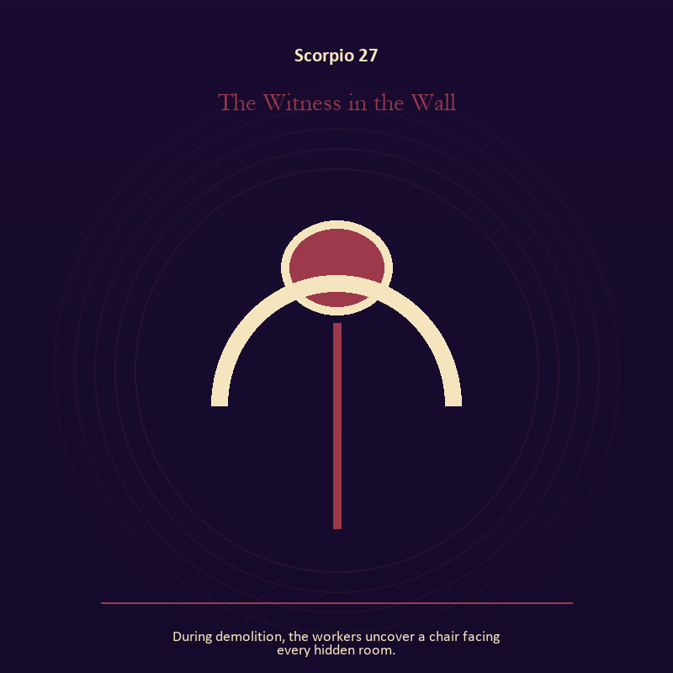

Scorpio 27 The Witness in the Wall
During demolition, the workers uncover a chair facing every hidden room.
INTERPRETATION The Witness in the Wall tests the body against shadow, secrecy, power, loss, and the truth that survives the underworld. Within the Witness in the Wall, embodiment gives every choice a pace and a cost. At Scorpio 27, the scene asks whether the person can remain present inside the experience being interpreted. As a release degree, Scorpio 27 asks what can be handed onward without demanding imitation or loyalty.
SIGNAL The usable force at Scorpio 27 is presence with weight and limits; Scorpio gives it form by asking you to stay with the difficult fact long enough to learn what it requires.
SHADOW At Scorpio 27, the Witness in the Wall can turn toward treating exhaustion as devotion; watch pain become identity, secrecy become a bargaining weapon, or suspicion invent what evidence cannot support.
MIRROR The question at Scorpio 27: can the choice be lived at the pace your body can sustain?
PRACTICE Give Scorpio 27 a physical form; place both feet on the floor and name five physical facts about the present moment.
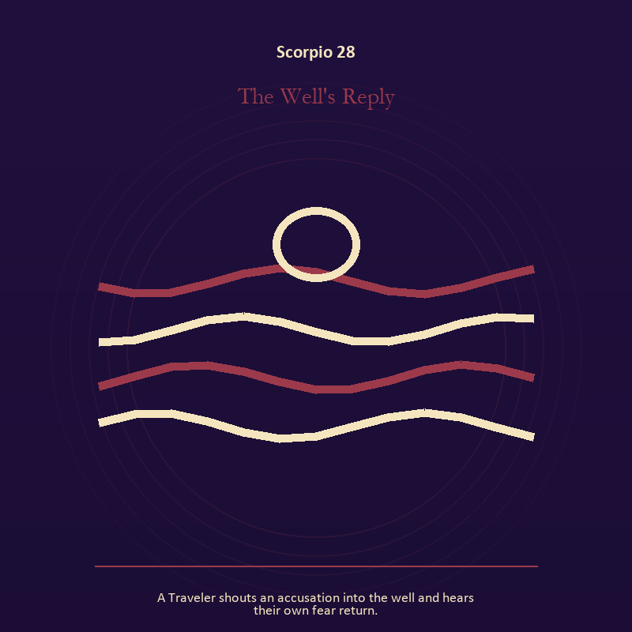

Scorpio 28 The Well's Reply
A Traveler shouts an accusation into the well and hears their own fear return.
INTERPRETATION The Well's Reply holds living water against shadow, secrecy, power, loss, and the truth that survives the underworld. Within the Well's Reply, water carries feeling, memory, adaptation, and forces too large for command. At Scorpio 28, its shape comes from the vessel, but its movement remains its own. As a release degree, Scorpio 28 turns completion into transfer; the work survives by changing hands.
SIGNAL At Scorpio 28, adaptation without self-erasure carries the signal; it stays honest when you stay with the difficult fact long enough to learn what it requires.
SHADOW The shadow at Scorpio 28 begins with building a vessel too rigid for living water; also watch pain become identity, secrecy become a bargaining weapon, or suspicion invent what evidence cannot support.
MIRROR At Scorpio 28, what feeling needs a vessel rather than a solution?
PRACTICE Bring Scorpio 28 out of abstraction: wash your hands with attention and decide what belongs to you after the water stops.

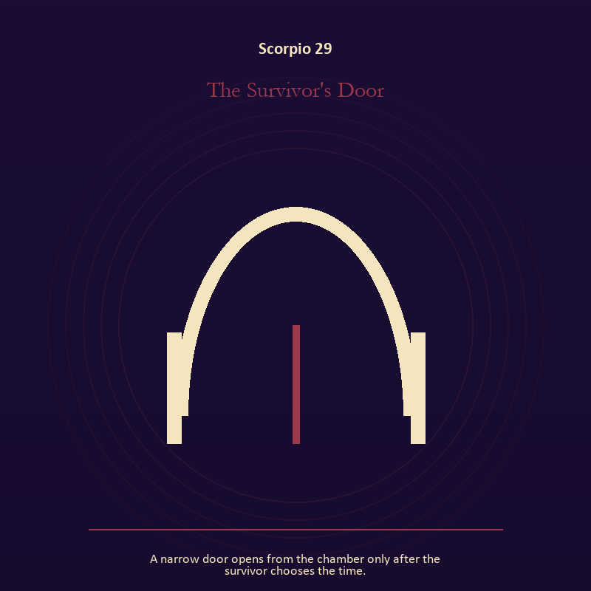

Scorpio 29 The Survivor's Door
A narrow door opens from the chamber only after the survivor chooses the time.
INTERPRETATION The Survivor's Door gives the threshold consequences inside the Descent Chamber. Within the Survivor's Door, doors and roads turn inner change into an embodied decision. At Scorpio 29, the next room matters, but so does the condition under which it is entered. As a release degree, Scorpio 29 lets the sign set down the identity built around its ordeal.
SIGNAL What can be carried forward from Scorpio 29 is a boundary that clarifies freedom, tested by the need to stay with the difficult fact long enough to learn what it requires.
SHADOW At Scorpio 29, the image darkens through crossing before consent; watch pain become identity, secrecy become a bargaining weapon, or suspicion invent what evidence cannot support.
MIRROR For Scorpio 29, what are you protecting by remaining on this side of the door?
PRACTICE For Scorpio 29, stand at a literal doorway, name what you are leaving and what you refuse to abandon, then cross only if the answer feels clean.
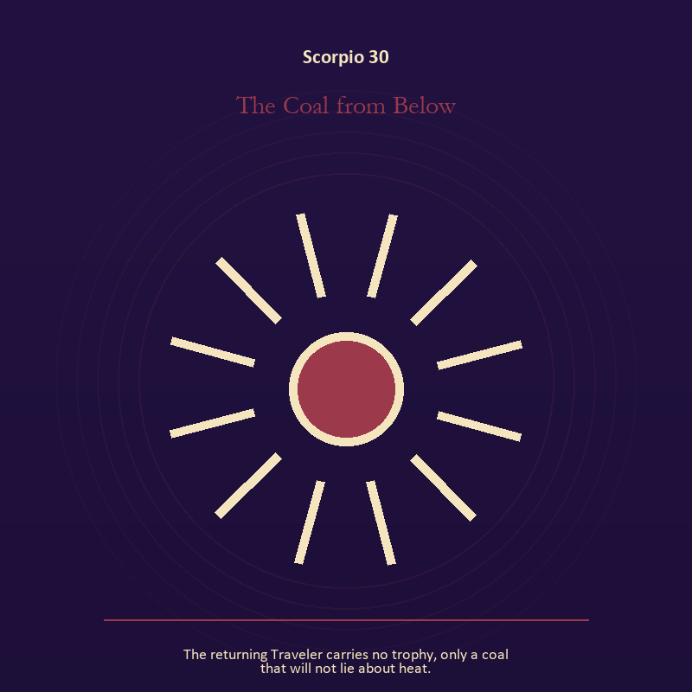

Scorpio 30 The Coal from Below
The returning Traveler carries no trophy, only a coal that will not lie about heat.
INTERPRETATION The Coal from Below puts living fire under pressure from shadow, secrecy, power, loss, and the truth that survives the underworld. Within the Coal from Below, a Lantern offers enough light for the next honest step. At Scorpio 30, it does not remove night, and its usefulness depends on how it is carried. The same image also carries the descent; at Scorpio 30, the underworld strips away rank and performance. As a release degree, Scorpio 30 returns the earned knowledge to ordinary life, where another cycle can use it.
SIGNAL At Scorpio 30, attention with warmth joined to contact with buried power becomes the clean signal when Scorpio can stay with the difficult fact long enough to learn what it requires.
SHADOW The distortion at Scorpio 30 is exposure without care and remaining underground after the danger has passed; watch pain become identity, secrecy become a bargaining weapon, or suspicion invent what evidence cannot support.
MIRROR With the Coal from Below in mind at Scorpio 30, how much light does the next step require, and who might it expose? From a second angle at Scorpio 30, which part of the wound needs witness, and which part needs a boundary?
PRACTICE Work with The Coal from Below directly at Scorpio 30: move one hidden concern into plain view by naming it to a trusted person. For the second pressure at Scorpio 30, choose a trusted witness and tell the smallest complete truth you can safely tell.

Sagittarius
The Library Without Walls
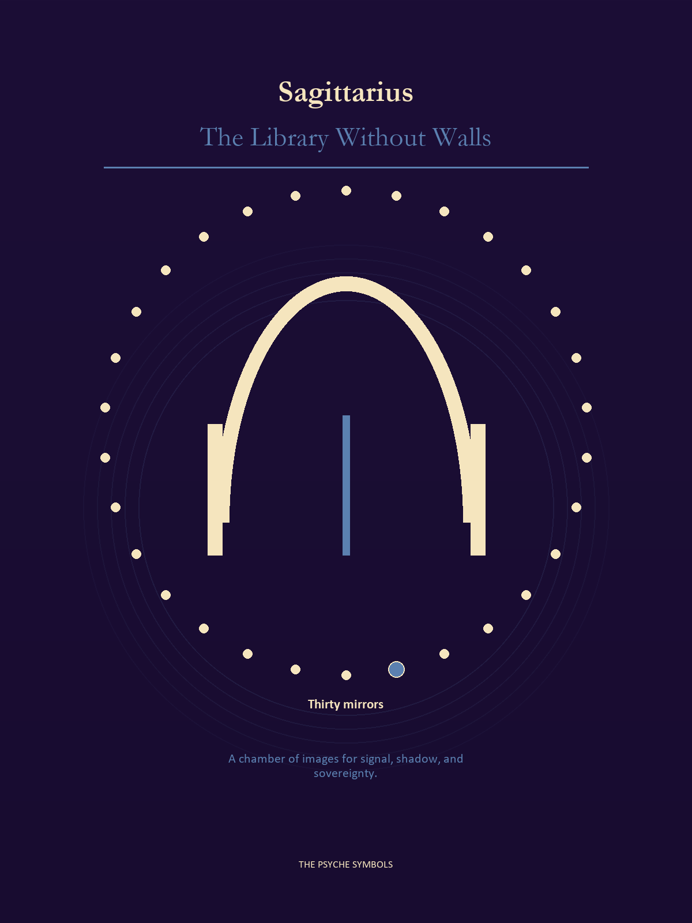
Sagittarius carries the coal from the descent toward a horizon large enough to question it. The Library Without Walls gathers maps, myths, arguments, foreign customs, teachers, and the freedom to outgrow a doctrine. Here belief becomes a road rather than a throne.

Degrees | Gate | Work
1-5 | Arrival | Meet the image before deciding what it means.
6-10 | Friction | Notice what pushes back and what that resistance protects.
11-15 | Revelation | Name the detail that changes the whole scene.
16-20 | Choice | Choose the act that preserves both truth and human dignity.
21-25 | Integration | Use the gift without feeding the shadow that travels beside it.
26-30 | Release | Keep the earned capacity and release the role that delivered it.

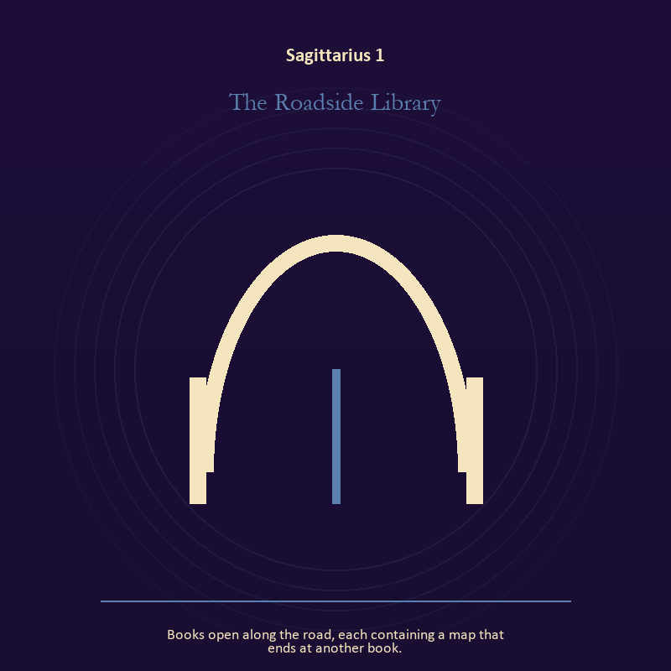

Sagittarius 1 The Roadside Library
Books open along the road, each containing a map that ends at another book.
INTERPRETATION In the Roadside Library, the work of the threshold must answer to meaning, pilgrimage, teaching, and wonder disciplined by evidence. Within the Roadside Library, a threshold measures consent, timing, and consequence. At Sagittarius 1, its presence asks whether passage is chosen, forced, delayed, or already under way. The same image also carries voice and naming; at Sagittarius 1, naming creates a handle for experience, but the handle must remain smaller than the life it describes. As an arrival degree, Sagittarius 1 arrives before habit can tidy the evidence; notice what is present before deciding what it should become.
SIGNAL The usable force at Sagittarius 1 is chosen change joined to listening precise enough to change the reply; Sagittarius gives it form by asking you to follow the question far enough to meet a mind unlike your own.
SHADOW At Sagittarius 1, the Roadside Library can turn toward waiting for permission that will never come and using language to outrun experience; beware conviction that outruns evidence, teaching that cannot listen, or escape disguised as pilgrimage.
MIRROR The question at Sagittarius 1: which threshold in your life requires consent rather than momentum?
PRACTICE Give Sagittarius 1 a physical form; write one sentence beginning, 'I may enter when,' and one beginning, 'I remain free to leave when.'.
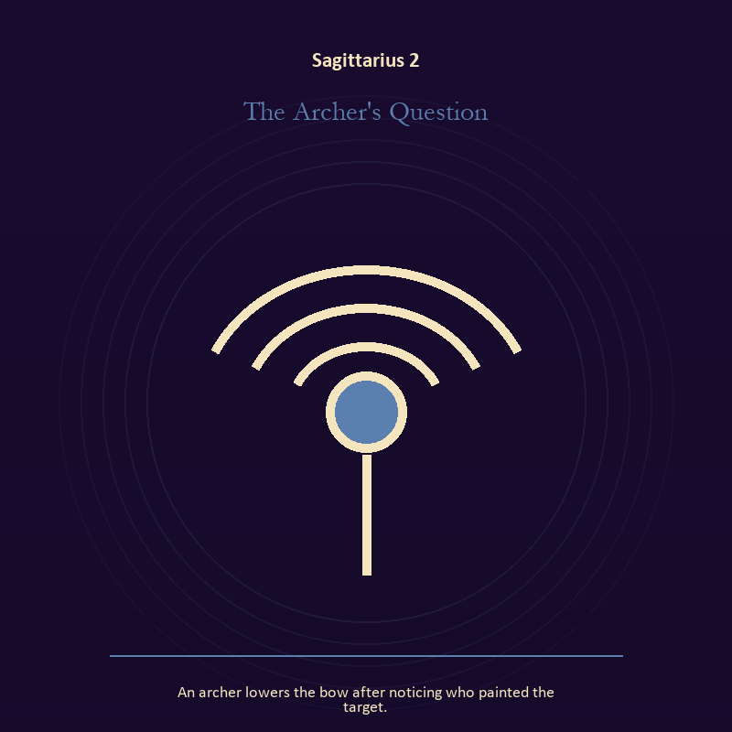

Sagittarius 2 The Archer's Question
An archer lowers the bow after noticing who painted the target.
INTERPRETATION The Archer's Question tests voice and naming against meaning, pilgrimage, teaching, and wonder disciplined by evidence. Within the Archer's Question, books, letters, bells, and songs extend speech beyond the speaker's body. At Sagittarius 2, the message acquires a life that intention can no longer fully govern. As an arrival degree, Sagittarius 2 introduces the sign's raw material in an unguarded form; the first response matters less than the honest one.
SIGNAL At Sagittarius 2, listening precise enough to change the reply carries the signal; it stays honest when you follow the question far enough to meet a mind unlike your own.
SHADOW The shadow at Sagittarius 2 begins with using language to outrun experience; also beware conviction that outruns evidence, teaching that cannot listen, or escape disguised as pilgrimage.
MIRROR At Sagittarius 2, what needs to be said plainly, and who has earned the right to hear it?
PRACTICE Bring Sagittarius 2 out of abstraction: write the sentence you keep rehearsing, remove every accusation you cannot prove, and read what remains aloud.

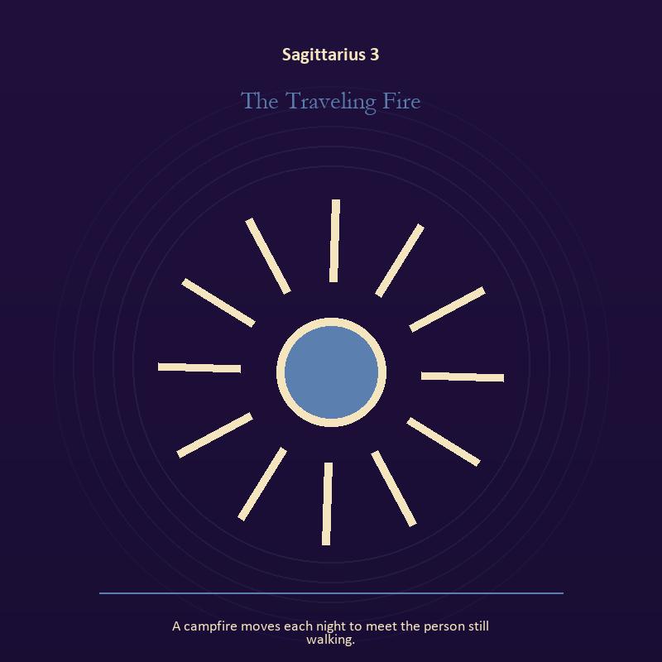

Sagittarius 3 The Traveling Fire
A campfire moves each night to meet the person still walking.
INTERPRETATION The Traveling Fire holds living fire against meaning, pilgrimage, teaching, and wonder disciplined by evidence. Within the Traveling Fire, a Lantern offers enough light for the next honest step. At Sagittarius 3, it does not remove night, and its usefulness depends on how it is carried. The same image also carries the descent; at Sagittarius 3, the underworld strips away rank and performance. As an arrival degree, Sagittarius 3 catches the first impulse before it turns into a role; give the image room to remain strange.
SIGNAL What can be carried forward from Sagittarius 3 is attention with warmth joined to contact with buried power, tested by the need to follow the question far enough to meet a mind unlike your own.
SHADOW At Sagittarius 3, the image darkens through exposure without care and remaining underground after the danger has passed; beware conviction that outruns evidence, teaching that cannot listen, or escape disguised as pilgrimage.
MIRROR For Sagittarius 3, how much light does the next step require, and who might it expose? From a second angle at Sagittarius 3, which part of the wound needs witness, and which part needs a boundary?
PRACTICE For Sagittarius 3, move one hidden concern into plain view by naming it to a trusted person.
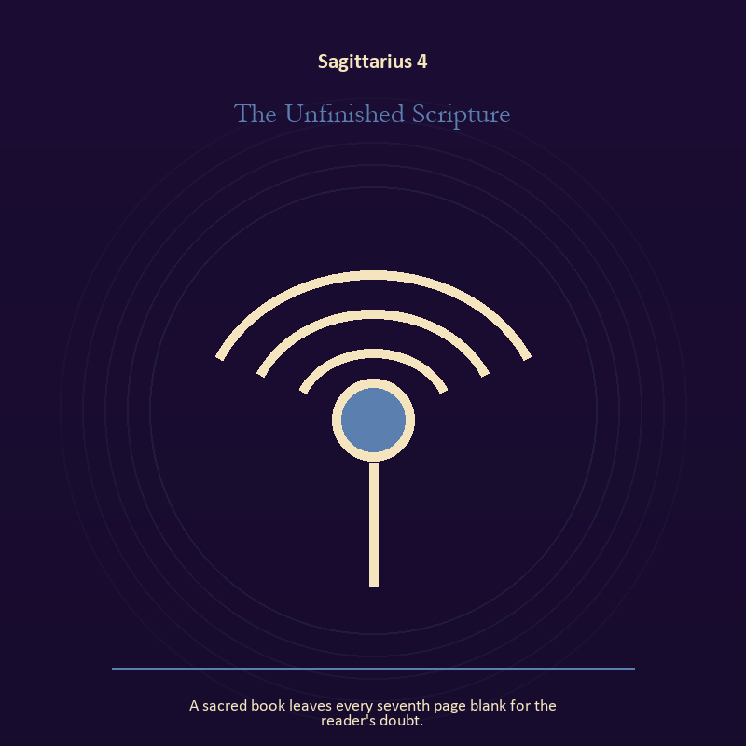

Sagittarius 4 The Unfinished Scripture
A sacred book leaves every seventh page blank for the reader's doubt.
INTERPRETATION The Unfinished Scripture gives voice and naming consequences inside the Library Without Walls. Within the Unfinished Scripture, voice turns inner pressure into shared consequence. At Sagittarius 4, words can witness, summon, distort, repair, or conceal according to their precision and timing. As an arrival degree, Sagittarius 4 opens the chamber with no settled method; name the need, risk, or appetite that entered with it.
SIGNAL At Sagittarius 4, a name that restores agency becomes the clean signal when Sagittarius can follow the question far enough to meet a mind unlike your own.
SHADOW The distortion at Sagittarius 4 is speaking for someone whose voice is present; beware conviction that outruns evidence, teaching that cannot listen, or escape disguised as pilgrimage.
MIRROR With the Unfinished Scripture in mind at Sagittarius 4, which word in this scene changes the power relationship?
PRACTICE Work with The Unfinished Scripture directly at Sagittarius 4: give the current experience a temporary name and date it, leaving room for revision.

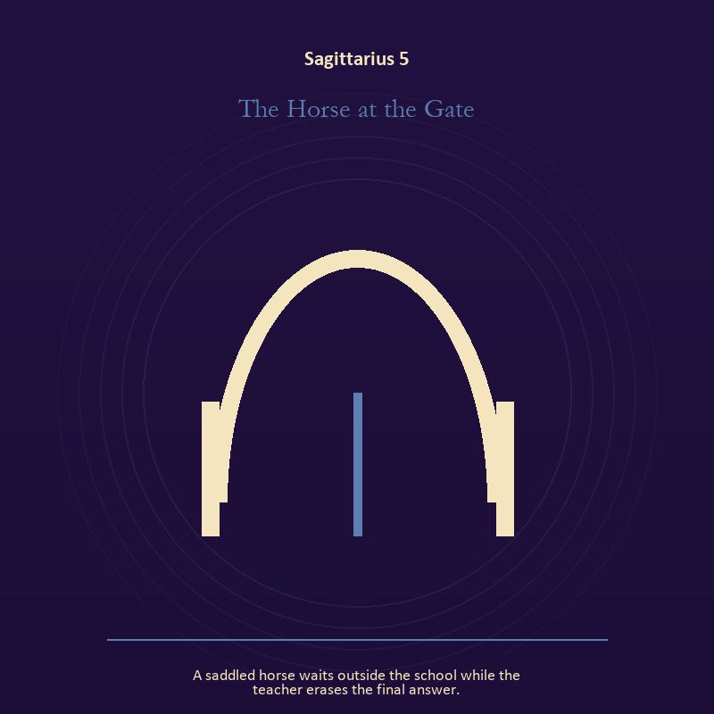

Sagittarius 5 The Horse at the Gate
A saddled horse waits outside the school while the teacher erases the final answer.
INTERPRETATION The Horse at the Gate puts the threshold under pressure from meaning, pilgrimage, teaching, and wonder disciplined by evidence. Within the Horse at the Gate, doors and roads turn inner change into an embodied decision. At Sagittarius 5, the next room matters, but so does the condition under which it is entered. The same image also carries voice and naming; at Sagittarius 5, voice turns inner pressure into shared consequence. As an arrival degree, Sagittarius 5 shows the beginning before ownership hardens around it; let attention come before possession.
SIGNAL The usable force at Sagittarius 5 is a boundary that clarifies freedom joined to speech with consequence; Sagittarius gives it form by asking you to follow the question far enough to meet a mind unlike your own.
SHADOW At Sagittarius 5, the Horse at the Gate can turn toward crossing before consent and repeating a message until it sounds like evidence; beware conviction that outruns evidence, teaching that cannot listen, or escape disguised as pilgrimage.
MIRROR The question at Sagittarius 5: what are you protecting by remaining on this side of the door?
PRACTICE Give Sagittarius 5 a physical form; stand at a literal doorway, name what you are leaving and what you refuse to abandon, then cross only if the answer feels clean.
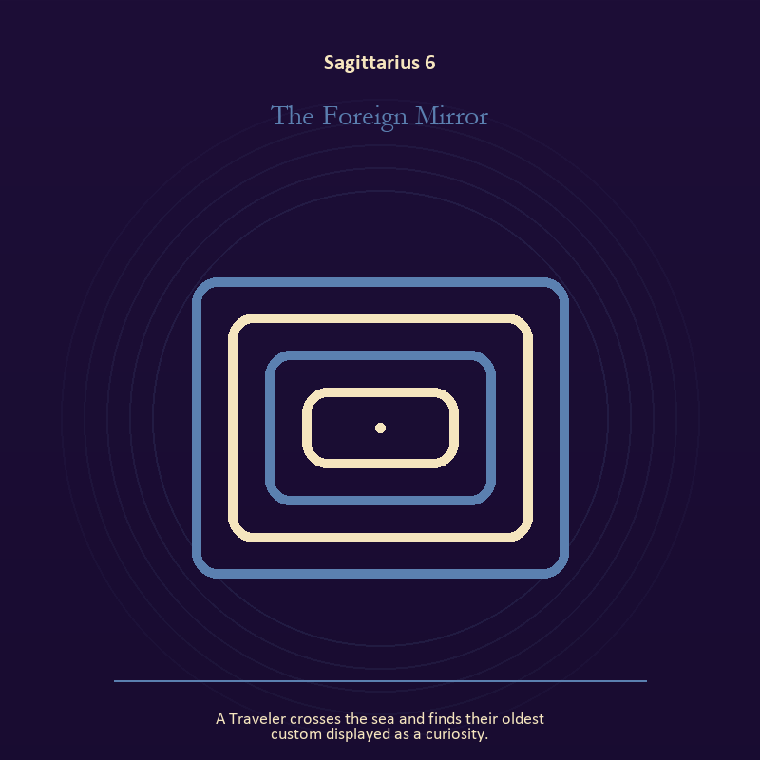

Sagittarius 6 The Foreign Mirror
A Traveler crosses the sea and finds their oldest custom displayed as a curiosity.
INTERPRETATION In the Foreign Mirror, the work of the Mirror must answer to meaning, pilgrimage, teaching, and wonder disciplined by evidence. Within the Foreign Mirror, a shadow proves that something real stands in the light, while a reflection shows only an angle. At Sagittarius 6, neither is the whole person. The same image also carries living water; at Sagittarius 6, a shore or vessel gives emotion a boundary without denying its depth. As a friction degree, Sagittarius 6 meets resistance, and that resistance reveals what the first impulse failed to consider.
SIGNAL At Sagittarius 6, self-recognition without self-worship joined to adaptation without self-erasure carries the signal; it stays honest when you follow the question far enough to meet a mind unlike your own.
SHADOW The shadow at Sagittarius 6 begins with assigning your hidden material to someone else and building a vessel too rigid for living water; also beware conviction that outruns evidence, teaching that cannot listen, or escape disguised as pilgrimage.
MIRROR At Sagittarius 6, which part of the reflection is asking to be reclaimed rather than judged? From a second angle at Sagittarius 6, where are you adapting wisely, and where are you disappearing?
PRACTICE Bring Sagittarius 6 out of abstraction: write two accounts of the same conflict: one from your position and one from the person you cannot understand.

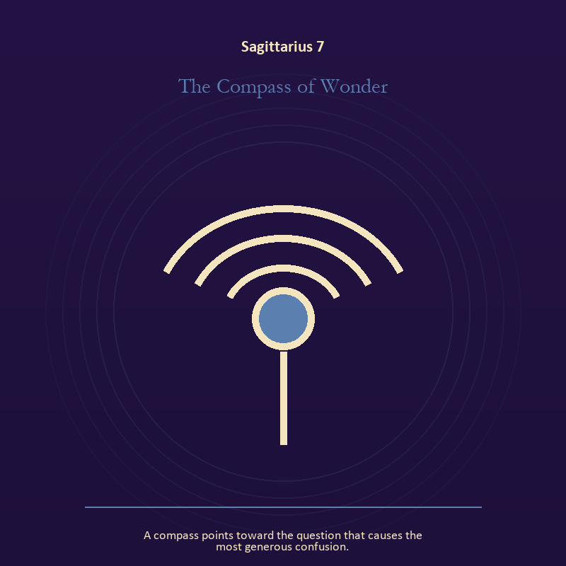

Sagittarius 7 The Compass of Wonder
A compass points toward the question that causes the most generous confusion.
INTERPRETATION The Compass of Wonder tests voice and naming against meaning, pilgrimage, teaching, and wonder disciplined by evidence. Within the Compass of Wonder, voice turns inner pressure into shared consequence. At Sagittarius 7, words can witness, summon, distort, repair, or conceal according to their precision and timing. As a friction degree, Sagittarius 7 places consequence beside desire; the obstruction may be an enemy, a limit, or a needed correction.
SIGNAL What can be carried forward from Sagittarius 7 is a name that restores agency, tested by the need to follow the question far enough to meet a mind unlike your own.
SHADOW At Sagittarius 7, the image darkens through speaking for someone whose voice is present; beware conviction that outruns evidence, teaching that cannot listen, or escape disguised as pilgrimage.
MIRROR For Sagittarius 7, which word in this scene changes the power relationship?
PRACTICE For Sagittarius 7, give the current experience a temporary name and date it, leaving room for revision.
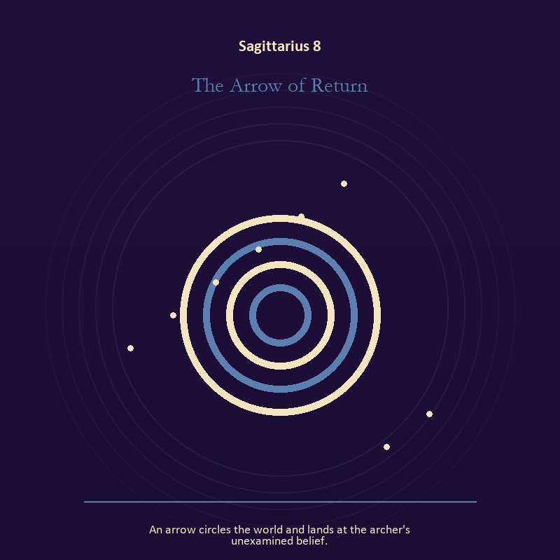

Sagittarius 8 The Arrow of Return
An arrow circles the world and lands at the archer's unexamined belief.
INTERPRETATION The Arrow of Return holds mystery against meaning, pilgrimage, teaching, and wonder disciplined by evidence. Within the Arrow of Return, this image invites attention before conclusion. At Sagittarius 8, its strange fact creates a pressure point where memory, desire, fear, and choice can speak indirectly. As a friction degree, Sagittarius 8 tests whether the sign can change course without treating correction as defeat.
SIGNAL At Sagittarius 8, an unanswered image that keeps thought alive becomes the clean signal when Sagittarius can follow the question far enough to meet a mind unlike your own.
SHADOW The distortion at Sagittarius 8 is forcing a prophecy from ambiguity; beware conviction that outruns evidence, teaching that cannot listen, or escape disguised as pilgrimage.
MIRROR With the Arrow of Return in mind at Sagittarius 8, what ordinary fact sits beneath the strange image?
PRACTICE Work with The Arrow of Return directly at Sagittarius 8: copy the image by hand, underline three concrete nouns, and write one association for each.

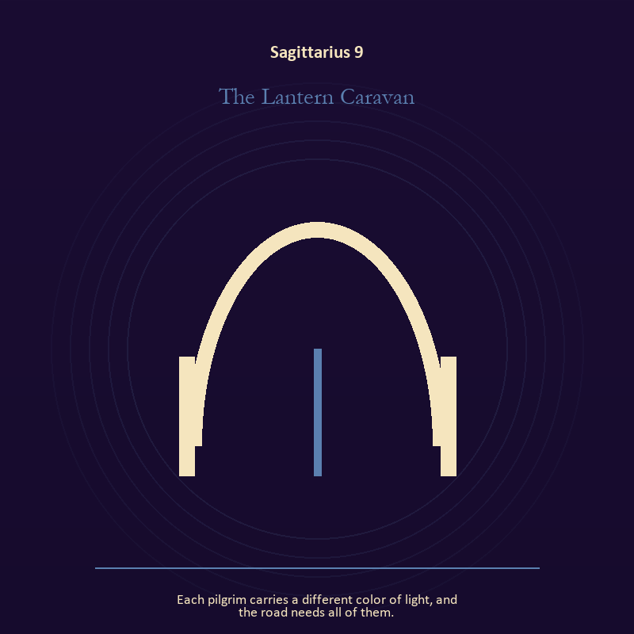

Sagittarius 9 The Lantern Caravan
Each pilgrim carries a different color of light, and the road needs all of them.
INTERPRETATION The Lantern Caravan gives living fire consequences inside the Library Without Walls. Within the Lantern Caravan, a Lantern offers enough light for the next honest step. At Sagittarius 9, it does not remove night, and its usefulness depends on how it is carried. The same image also carries the threshold; at Sagittarius 9, doors and roads turn inner change into an embodied decision. As a friction degree, Sagittarius 9 brings another will, material limit, or inconvenient fact into the frame.
SIGNAL The usable force at Sagittarius 9 is attention with warmth joined to chosen change; Sagittarius gives it form by asking you to follow the question far enough to meet a mind unlike your own.
SHADOW At Sagittarius 9, the Lantern Caravan can turn toward exposure without care and waiting for permission that will never come; beware conviction that outruns evidence, teaching that cannot listen, or escape disguised as pilgrimage.
MIRROR The question at Sagittarius 9: how much light does the next step require, and who might it expose? From a second angle at Sagittarius 9, what are you protecting by remaining on this side of the door?
PRACTICE Give Sagittarius 9 a physical form; move one hidden concern into plain view by naming it to a trusted person.
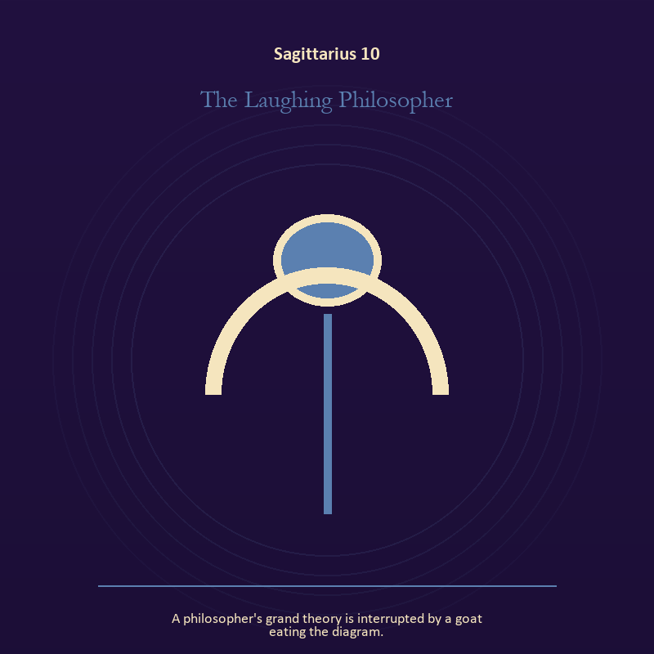

Sagittarius 10 The Laughing Philosopher
A philosopher's grand theory is interrupted by a goat eating the diagram.
INTERPRETATION The Laughing Philosopher puts mystery under pressure from meaning, pilgrimage, teaching, and wonder disciplined by evidence. Within the Laughing Philosopher, the scene behaves like a dream with its own exact logic. At Sagittarius 10, meaning lives in the relationship between figure, place, action, and the detail that refuses ordinary explanation. As a friction degree, Sagittarius 10 slows the original motion long enough to expose what haste concealed.
SIGNAL At Sagittarius 10, imagination disciplined by the scene carries the signal; it stays honest when you follow the question far enough to meet a mind unlike your own.
SHADOW The shadow at Sagittarius 10 begins with mistaking intensity for accuracy; also beware conviction that outruns evidence, teaching that cannot listen, or escape disguised as pilgrimage.
MIRROR At Sagittarius 10, which detail keeps returning after the rest of the scene fades?
PRACTICE Bring Sagittarius 10 out of abstraction: keep the image nearby for one day and record only the moments when it returns on its own.

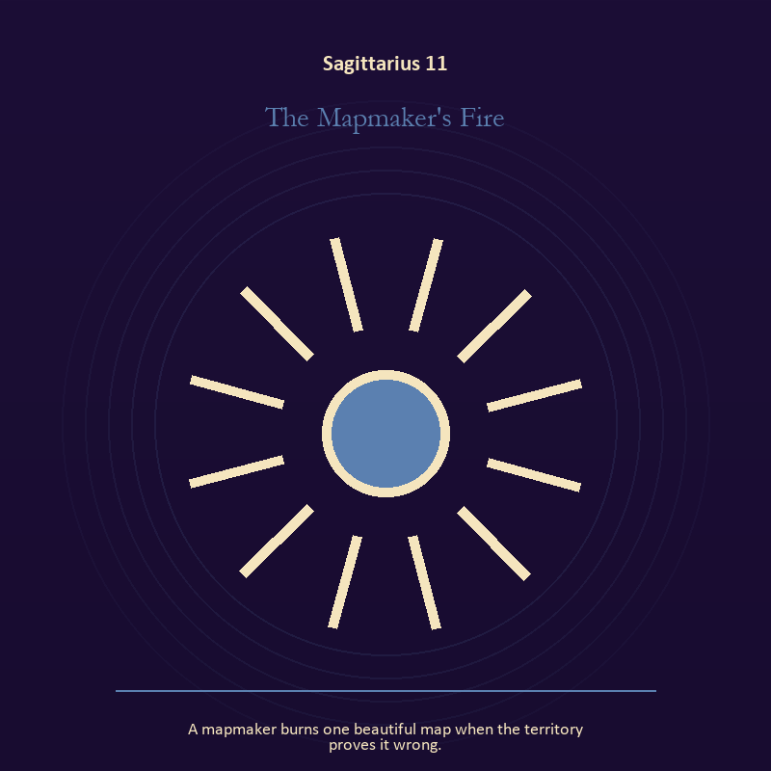

Sagittarius 11 The Mapmaker's Fire
A mapmaker burns one beautiful map when the territory proves it wrong.
INTERPRETATION In the Mapmaker's Fire, the work of living fire must answer to meaning, pilgrimage, teaching, and wonder disciplined by evidence. Within the Mapmaker's Fire, fire gives change a visible cost. At Sagittarius 11, something is illuminated here because something else is being spent. The same image also carries craft and record; at Sagittarius 11, craft turns intention into a repeatable act with materials, limits, and evidence of failure. As a revelation degree, Sagittarius 11 reveals the mechanism under the mood; one concrete detail changes the reading.
SIGNAL What can be carried forward from Sagittarius 11 is a truth made visible at the right scale joined to care made repeatable, tested by the need to follow the question far enough to meet a mind unlike your own.
SHADOW At Sagittarius 11, the image darkens through burning for recognition and the tool becoming the master; beware conviction that outruns evidence, teaching that cannot listen, or escape disguised as pilgrimage.
MIRROR For Sagittarius 11, where has your fire become performance rather than warmth?
PRACTICE For Sagittarius 11, light one candle and give its entire burn to a single unfinished question.
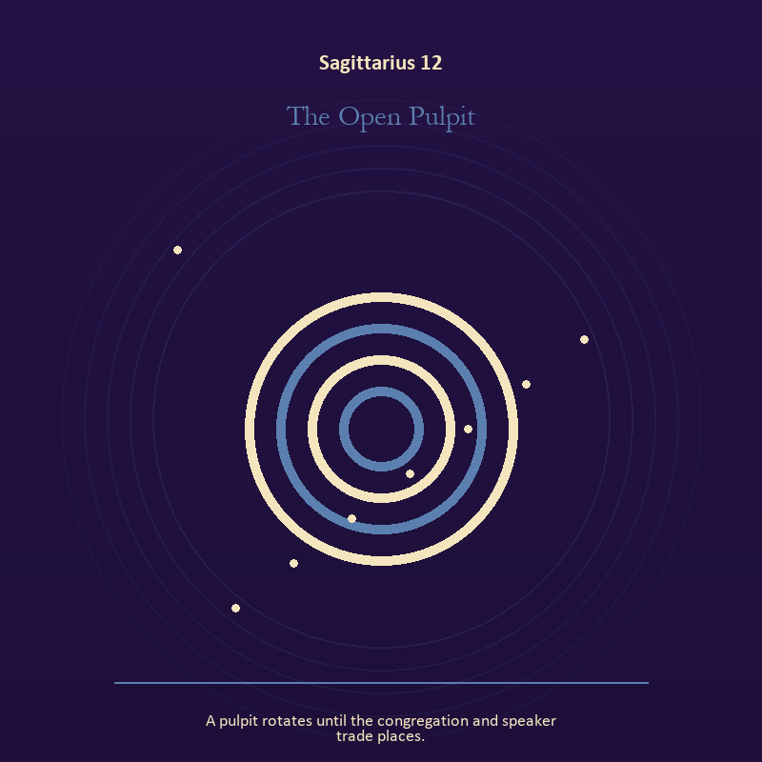

Sagittarius 12 The Open Pulpit
A pulpit rotates until the congregation and speaker trade places.
INTERPRETATION The Open Pulpit tests mystery against meaning, pilgrimage, teaching, and wonder disciplined by evidence. Within the Open Pulpit, the symbol remains useful when no single interpretation closes it. At Sagittarius 12, its work is to make one hidden relationship visible enough to examine. As a revelation degree, Sagittarius 12 moves the hidden arrangement into view, where it can be named without being exaggerated.
SIGNAL At Sagittarius 12, attention without premature certainty becomes the clean signal when Sagittarius can follow the question far enough to meet a mind unlike your own.
SHADOW The distortion at Sagittarius 12 is using beauty to avoid the ordinary fact; beware conviction that outruns evidence, teaching that cannot listen, or escape disguised as pilgrimage.
MIRROR With the Open Pulpit in mind at Sagittarius 12, what changes if the scene is a question rather than an answer?
PRACTICE Work with The Open Pulpit directly at Sagittarius 12: describe the scene to another person without explaining it, then notice what they ask first.

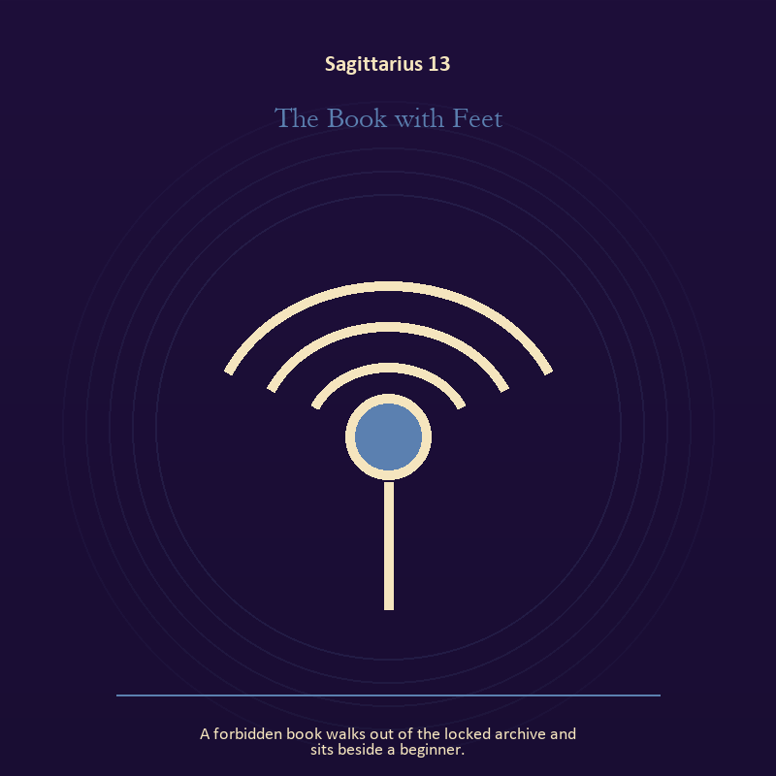

Sagittarius 13 The Book with Feet
A forbidden book walks out of the locked archive and sits beside a beginner.
INTERPRETATION The Book with Feet holds voice and naming against meaning, pilgrimage, teaching, and wonder disciplined by evidence. Within the Book with Feet, voice turns inner pressure into shared consequence. At Sagittarius 13, words can witness, summon, distort, repair, or conceal according to their precision and timing. The same image also carries the body; at Sagittarius 13, embodiment gives every choice a pace and a cost. As a revelation degree, Sagittarius 13 turns atmosphere into evidence; attend to the object or action that cannot be explained away.
SIGNAL The usable force at Sagittarius 13 is a name that restores agency joined to a decision the nervous system can inhabit; Sagittarius gives it form by asking you to follow the question far enough to meet a mind unlike your own.
SHADOW At Sagittarius 13, the Book with Feet can turn toward speaking for someone whose voice is present and using transcendence to ignore need; beware conviction that outruns evidence, teaching that cannot listen, or escape disguised as pilgrimage.
MIRROR The question at Sagittarius 13: which word in this scene changes the power relationship?
PRACTICE Give Sagittarius 13 a physical form; give the current experience a temporary name and date it, leaving room for revision.
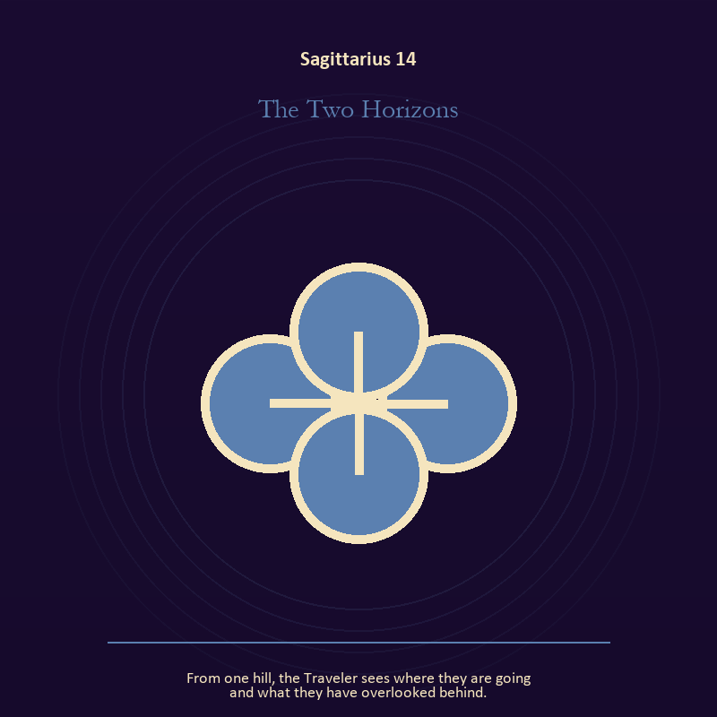

Sagittarius 14 The Two Horizons
From one hill, the Traveler sees where they are going and what they have overlooked behind.
INTERPRETATION The Two Horizons gives relationship consequences inside the Library Without Walls. Within the Two Horizons, relationship imagery tests the fantasy that harmony requires sameness. At Sagittarius 14, a living bond can hold difference, correction, privacy, and departure. As a revelation degree, Sagittarius 14 shows who carries the cost, who controls the passage, and what the scene refuses to hide.
SIGNAL At Sagittarius 14, difference held without humiliation carries the signal; it stays honest when you follow the question far enough to meet a mind unlike your own.
SHADOW The shadow at Sagittarius 14 begins with harmony purchased by one person's silence; also beware conviction that outruns evidence, teaching that cannot listen, or escape disguised as pilgrimage.
MIRROR At Sagittarius 14, where does responsibility belong, and where has it been displaced?
PRACTICE Bring Sagittarius 14 out of abstraction: ask the other person what they believe the agreement is, then compare it with your own version.

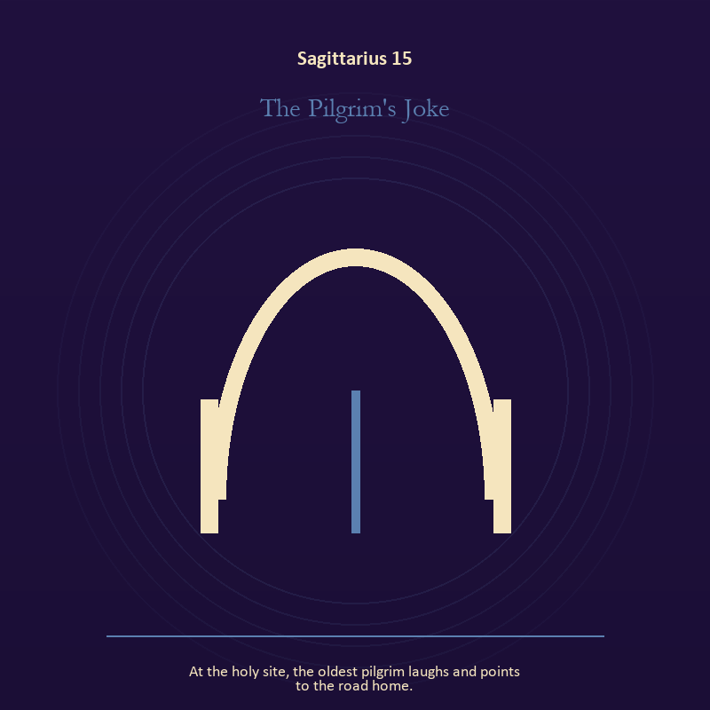

Sagittarius 15 The Pilgrim's Joke
At the holy site, the oldest pilgrim laughs and points to the road home.
INTERPRETATION The Pilgrim's Joke puts the threshold under pressure from meaning, pilgrimage, teaching, and wonder disciplined by evidence. Within the Pilgrim's Joke, a boundary can protect life, restrict it, or clarify the terms of meeting. At Sagittarius 15, the surrounding action reveals which function is active here. As a revelation degree, Sagittarius 15 brings the middle truth forward, after the first story has lost its grip.
SIGNAL What can be carried forward from Sagittarius 15 is honest passage, tested by the need to follow the question far enough to meet a mind unlike your own.
SHADOW At Sagittarius 15, the image darkens through guarding an obsolete enclosure; beware conviction that outruns evidence, teaching that cannot listen, or escape disguised as pilgrimage.
MIRROR For Sagittarius 15, what would make the next step chosen rather than compelled?
PRACTICE For Sagittarius 15, draw the boundary as a line on paper; then mark the gate, the guard, and the person who holds the key.
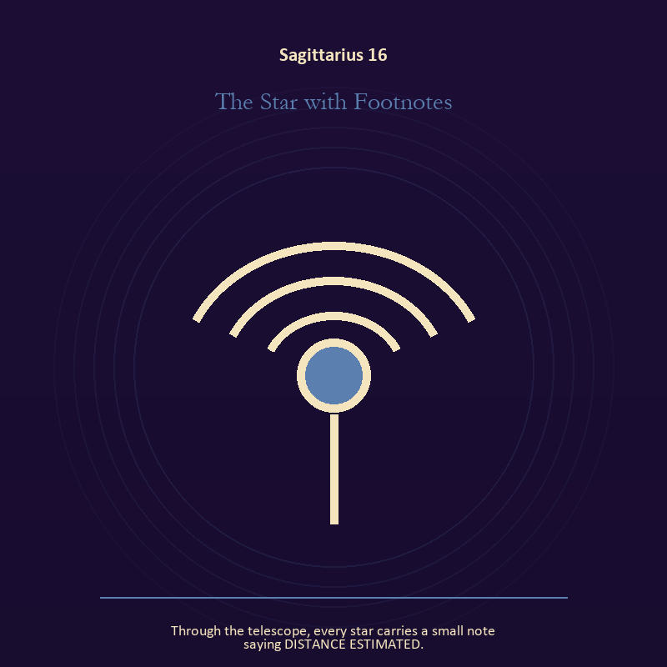

Sagittarius 16 The Star with Footnotes
Through the telescope, every star carries a small note saying DISTANCE ESTIMATED.
INTERPRETATION In the Star with Footnotes, the work of voice and naming must answer to meaning, pilgrimage, teaching, and wonder disciplined by evidence. Within the Star with Footnotes, voice turns inner pressure into shared consequence. At Sagittarius 16, words can witness, summon, distort, repair, or conceal according to their precision and timing. As a choice degree, Sagittarius 16 requires a choice with a human cost; insight alone no longer completes the work.
SIGNAL At Sagittarius 16, a name that restores agency becomes the clean signal when Sagittarius can follow the question far enough to meet a mind unlike your own.
SHADOW The distortion at Sagittarius 16 is speaking for someone whose voice is present; beware conviction that outruns evidence, teaching that cannot listen, or escape disguised as pilgrimage.
MIRROR With the Star with Footnotes in mind at Sagittarius 16, which word in this scene changes the power relationship?
PRACTICE Work with The Star with Footnotes directly at Sagittarius 16: give the current experience a temporary name and date it, leaving room for revision.

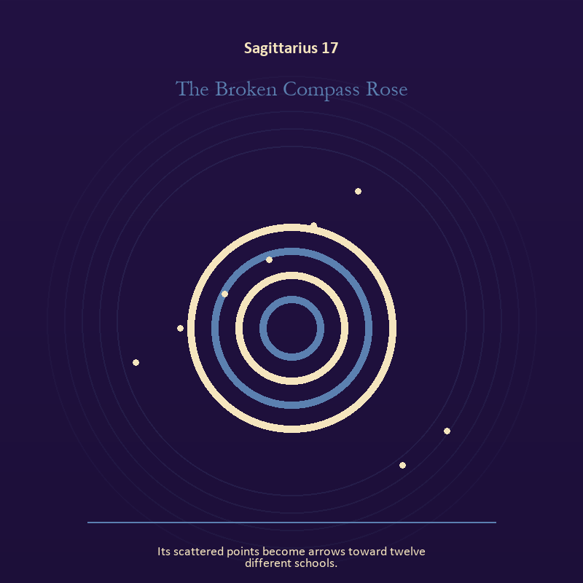

Sagittarius 17 The Broken Compass Rose
Its scattered points become arrows toward twelve different schools.
INTERPRETATION The Broken Compass Rose tests mystery against meaning, pilgrimage, teaching, and wonder disciplined by evidence. Within the Broken Compass Rose, this image invites attention before conclusion. At Sagittarius 17, its strange fact creates a pressure point where memory, desire, fear, and choice can speak indirectly. As a choice degree, Sagittarius 17 asks what action preserves truth without using another person as material.
SIGNAL The usable force at Sagittarius 17 is an unanswered image that keeps thought alive; Sagittarius gives it form by asking you to follow the question far enough to meet a mind unlike your own.
SHADOW At Sagittarius 17, the Broken Compass Rose can turn toward forcing a prophecy from ambiguity; beware conviction that outruns evidence, teaching that cannot listen, or escape disguised as pilgrimage.
MIRROR The question at Sagittarius 17: what ordinary fact sits beneath the strange image?
PRACTICE Give Sagittarius 17 a physical form; copy the image by hand, underline three concrete nouns, and write one association for each.
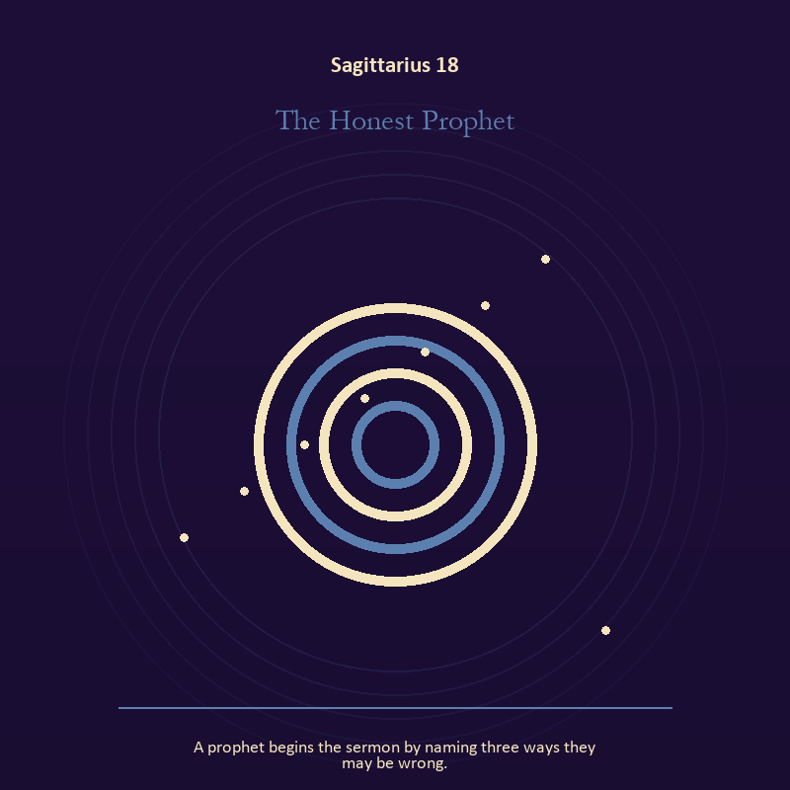

Sagittarius 18 The Honest Prophet
A prophet begins the sermon by naming three ways they may be wrong.
INTERPRETATION The Honest Prophet holds mystery against meaning, pilgrimage, teaching, and wonder disciplined by evidence. Within the Honest Prophet, the symbol remains useful when no single interpretation closes it. At Sagittarius 18, its work is to make one hidden relationship visible enough to examine. As a choice degree, Sagittarius 18 moves from recognition to conduct; the clean choice must survive outside the imagination.
SIGNAL At Sagittarius 18, attention without premature certainty carries the signal; it stays honest when you follow the question far enough to meet a mind unlike your own.
SHADOW The shadow at Sagittarius 18 begins with using beauty to avoid the ordinary fact; also beware conviction that outruns evidence, teaching that cannot listen, or escape disguised as pilgrimage.
MIRROR At Sagittarius 18, what changes if the scene is a question rather than an answer?
PRACTICE Bring Sagittarius 18 out of abstraction: describe the scene to another person without explaining it, then notice what they ask first.

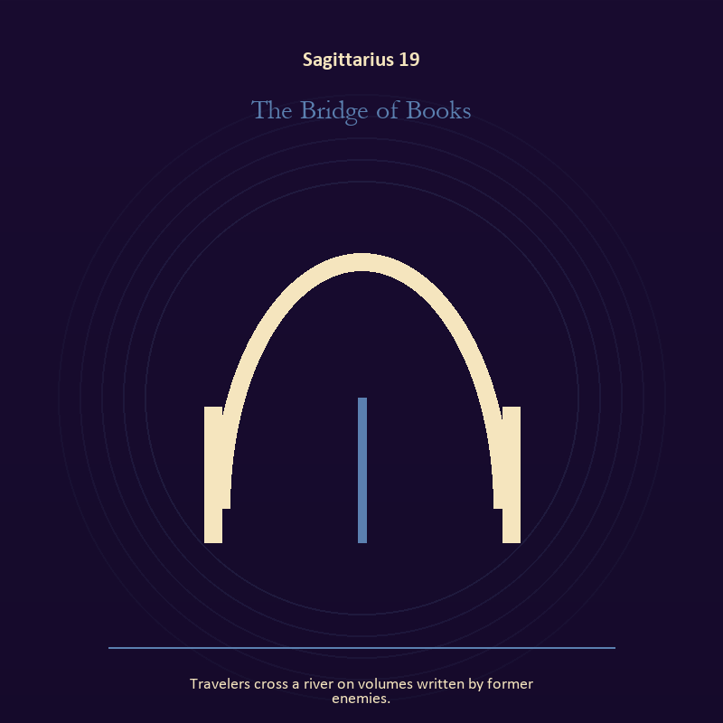

Sagittarius 19 The Bridge of Books
Travelers cross a river on volumes written by former enemies.
INTERPRETATION The Bridge of Books gives the threshold consequences inside the Library Without Walls. Within the Bridge of Books, a threshold measures consent, timing, and consequence. At Sagittarius 19, its presence asks whether passage is chosen, forced, delayed, or already under way. The same image also carries living water; at Sagittarius 19, rain, tides, wells, and floods move private material into a shared landscape. As a choice degree, Sagittarius 19 tests whether awareness can become restraint, repair, refusal, or consent.
SIGNAL What can be carried forward from Sagittarius 19 is chosen change joined to grief allowed to move, tested by the need to follow the question far enough to meet a mind unlike your own.
SHADOW At Sagittarius 19, the image darkens through waiting for permission that will never come and drowning in another person's weather; beware conviction that outruns evidence, teaching that cannot listen, or escape disguised as pilgrimage.
MIRROR For Sagittarius 19, which threshold in your life requires consent rather than momentum?
PRACTICE For Sagittarius 19, write one sentence beginning, 'I may enter when,' and one beginning, 'I remain free to leave when.'.
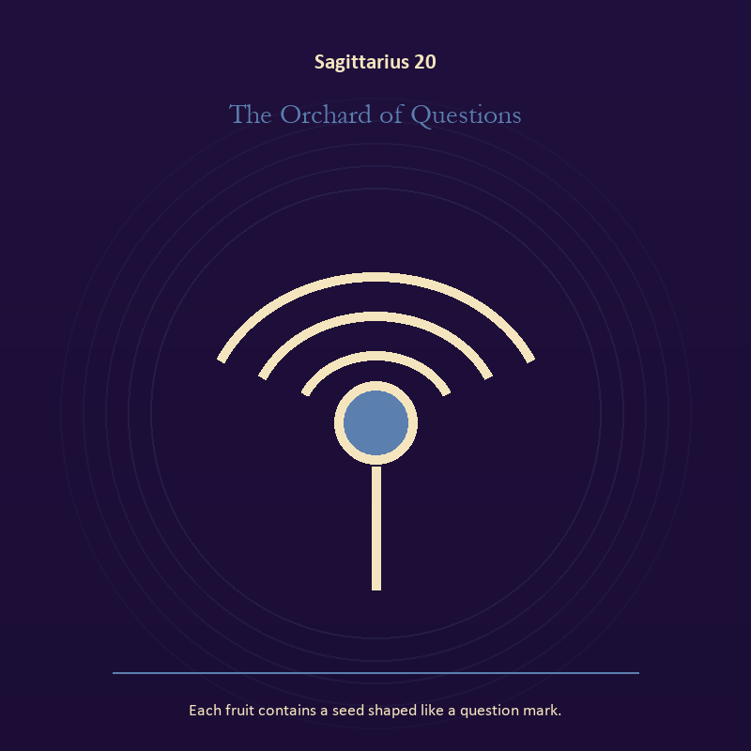

Sagittarius 20 The Orchard of Questions
Each fruit contains a seed shaped like a question mark.
INTERPRETATION The Orchard of Questions puts growth under pressure from meaning, pilgrimage, teaching, and wonder disciplined by evidence. Within the Orchard of Questions, seeds, children, roots, and gardens refuse the fantasy of instant transformation. At Sagittarius 20, they make becoming physical, seasonal, and dependent on care. The same image also carries voice and naming; at Sagittarius 20, voice turns inner pressure into shared consequence. As a choice degree, Sagittarius 20 places responsibility in the reader's hands without promising a painless answer.
SIGNAL At Sagittarius 20, inheritance revised through living action joined to speech with consequence becomes the clean signal when Sagittarius can follow the question far enough to meet a mind unlike your own.
SHADOW The distortion at Sagittarius 20 is forcing a season and repeating a message until it sounds like evidence; beware conviction that outruns evidence, teaching that cannot listen, or escape disguised as pilgrimage.
MIRROR With the Orchard of Questions in mind at Sagittarius 20, which condition would help this growth, and which demand would deform it?
PRACTICE Work with The Orchard of Questions directly at Sagittarius 20: tend one living thing and let its pace correct your schedule. For the second pressure at Sagittarius 20, listen to one person without planning your answer; then repeat their meaning before offering your own.

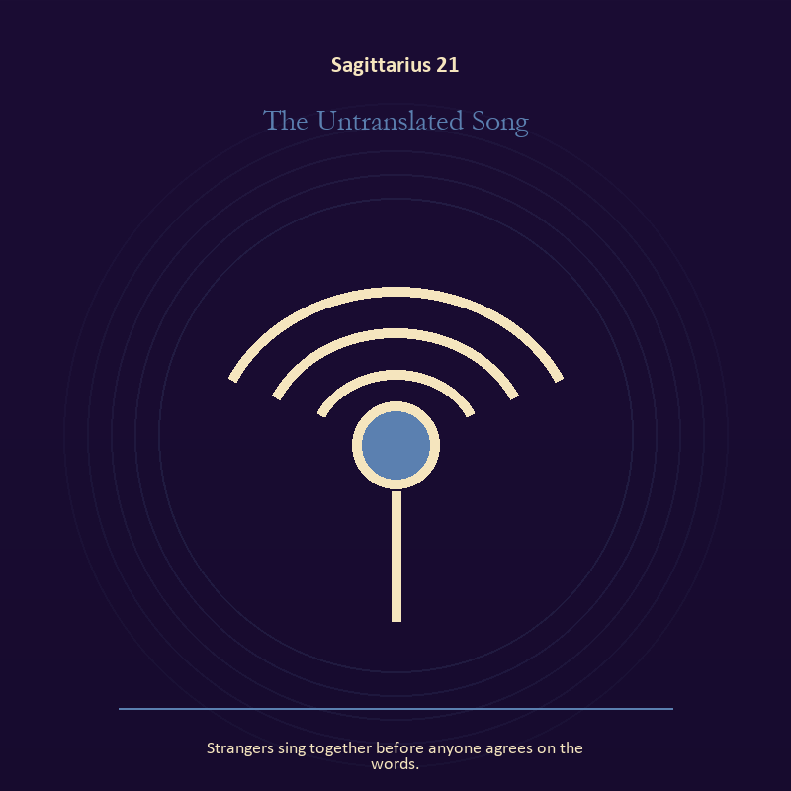

Sagittarius 21 The Untranslated Song
Strangers sing together before anyone agrees on the words.
INTERPRETATION In the Untranslated Song, the work of voice and naming must answer to meaning, pilgrimage, teaching, and wonder disciplined by evidence. Within the Untranslated Song, naming creates a handle for experience, but the handle must remain smaller than the life it describes. At Sagittarius 21, the image tests language against reality. The same image also carries relationship; at Sagittarius 21, relationship imagery tests the fantasy that harmony requires sameness. As a integration degree, Sagittarius 21 holds the gift beside its distortion; using one without feeding the other is the work.
SIGNAL The usable force at Sagittarius 21 is speech with consequence joined to mutual responsibility; Sagittarius gives it form by asking you to follow the question far enough to meet a mind unlike your own.
SHADOW At Sagittarius 21, the Untranslated Song can turn toward repeating a message until it sounds like evidence and the group protecting itself by sacrificing an outsider; beware conviction that outruns evidence, teaching that cannot listen, or escape disguised as pilgrimage.
MIRROR The question at Sagittarius 21: what are you naming accurately, and what remains larger than the name? From a second angle at Sagittarius 21, where does responsibility belong, and where has it been displaced?
PRACTICE Give Sagittarius 21 a physical form; listen to one person without planning your answer; then repeat their meaning before offering your own.
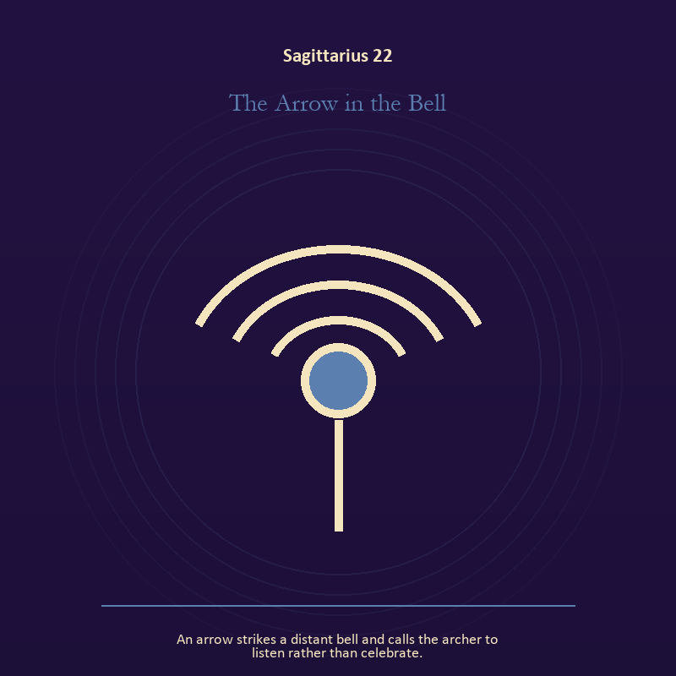

Sagittarius 22 The Arrow in the Bell
An arrow strikes a distant bell and calls the archer to listen rather than celebrate.
INTERPRETATION The Arrow in the Bell tests voice and naming against meaning, pilgrimage, teaching, and wonder disciplined by evidence. Within the Arrow in the Bell, voice turns inner pressure into shared consequence. At Sagittarius 22, words can witness, summon, distort, repair, or conceal according to their precision and timing. As a integration degree, Sagittarius 22 asks the sign to carry its strength without turning that strength into jurisdiction.
SIGNAL At Sagittarius 22, a name that restores agency carries the signal; it stays honest when you follow the question far enough to meet a mind unlike your own.
SHADOW The shadow at Sagittarius 22 begins with speaking for someone whose voice is present; also beware conviction that outruns evidence, teaching that cannot listen, or escape disguised as pilgrimage.
MIRROR At Sagittarius 22, which word in this scene changes the power relationship?
PRACTICE Bring Sagittarius 22 out of abstraction: give the current experience a temporary name and date it, leaving room for revision.

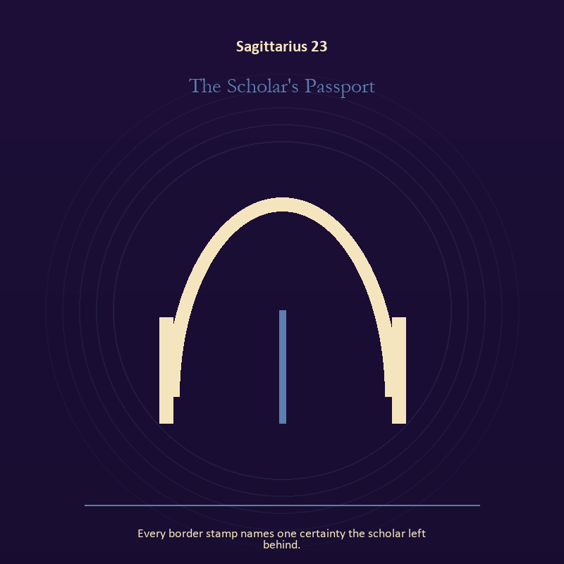

Sagittarius 23 The Scholar's Passport
Every border stamp names one certainty the scholar left behind.
INTERPRETATION The Scholar's Passport holds the threshold against meaning, pilgrimage, teaching, and wonder disciplined by evidence. Within the Scholar's Passport, doors and roads turn inner change into an embodied decision. At Sagittarius 23, the next room matters, but so does the condition under which it is entered. As a integration degree, Sagittarius 23 joins capacity to consequence; what helps in one setting may harm in another.
SIGNAL What can be carried forward from Sagittarius 23 is a boundary that clarifies freedom, tested by the need to follow the question far enough to meet a mind unlike your own.
SHADOW At Sagittarius 23, the image darkens through crossing before consent; beware conviction that outruns evidence, teaching that cannot listen, or escape disguised as pilgrimage.
MIRROR For Sagittarius 23, what are you protecting by remaining on this side of the door?
PRACTICE For Sagittarius 23, stand at a literal doorway, name what you are leaving and what you refuse to abandon, then cross only if the answer feels clean.
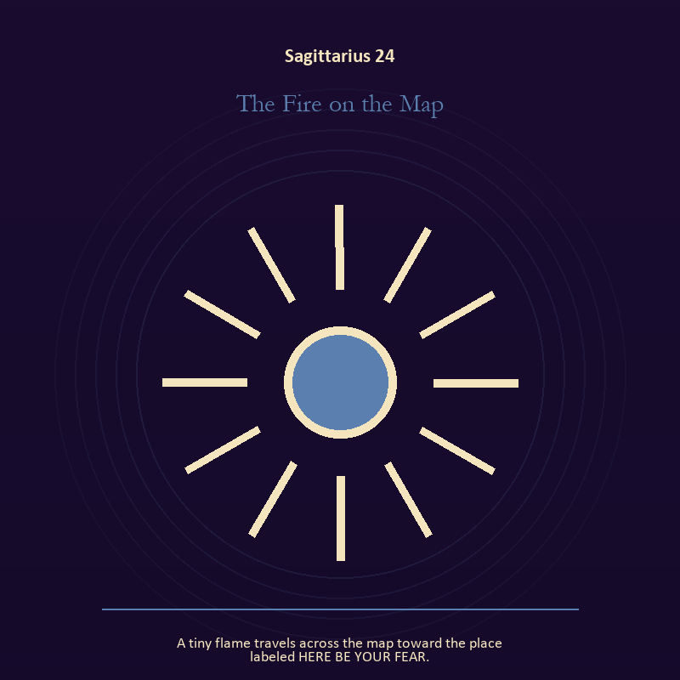

Sagittarius 24 The Fire on the Map
A tiny flame travels across the map toward the place labeled HERE BE YOUR FEAR.
INTERPRETATION The Fire on the Map gives living fire consequences inside the Library Without Walls. Within the Fire on the Map, a Lantern offers enough light for the next honest step. At Sagittarius 24, it does not remove night, and its usefulness depends on how it is carried. The same image also carries craft and record; at Sagittarius 24, ledgers, maps, machines, and archives make memory operational. As a integration degree, Sagittarius 24 shows the mature tool and the temptation hidden inside its handle.
SIGNAL At Sagittarius 24, attention with warmth joined to evidence preserved without spectacle becomes the clean signal when Sagittarius can follow the question far enough to meet a mind unlike your own.
SHADOW The distortion at Sagittarius 24 is exposure without care and polish used to hide a structural weakness; beware conviction that outruns evidence, teaching that cannot listen, or escape disguised as pilgrimage.
MIRROR With the Fire on the Map in mind at Sagittarius 24, how much light does the next step require, and who might it expose? From a second angle at Sagittarius 24, what does the tool preserve, and what does it leave out?
PRACTICE Work with The Fire on the Map directly at Sagittarius 24: move one hidden concern into plain view by naming it to a trusted person. For the second pressure at Sagittarius 24, repair one useful object without disguising the place where it broke.

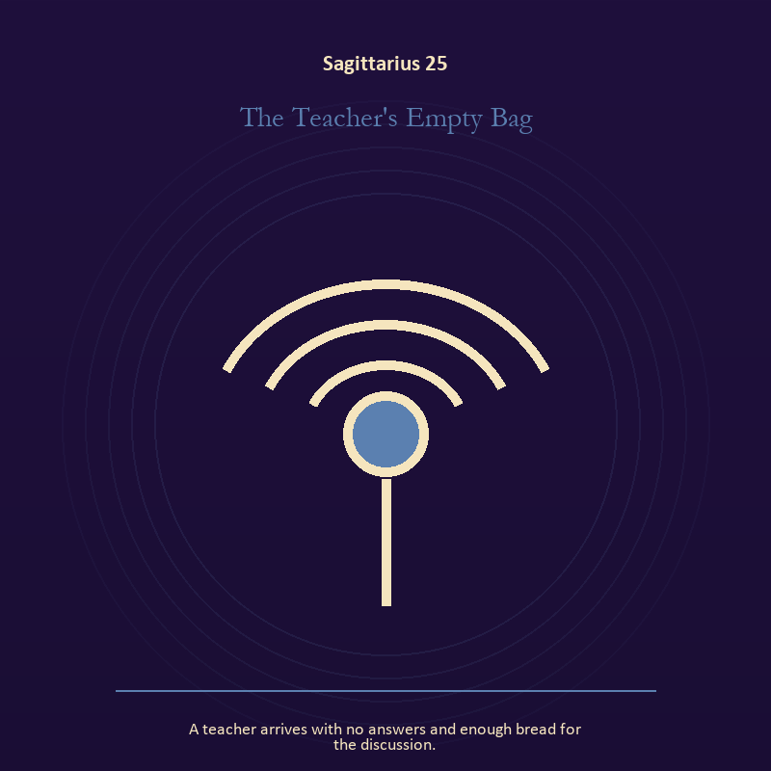

Sagittarius 25 The Teacher's Empty Bag
A teacher arrives with no answers and enough bread for the discussion.
INTERPRETATION The Teacher's Empty Bag puts the body under pressure from meaning, pilgrimage, teaching, and wonder disciplined by evidence. Within the Teacher's Empty Bag, the body enters as witness, limit, appetite, labor, and home. At Sagittarius 25, its response may reveal what the mind has explained away. As a integration degree, Sagittarius 25 tests whether the lesson can be lived without becoming a new performance.
SIGNAL The usable force at Sagittarius 25 is care made material; Sagittarius gives it form by asking you to follow the question far enough to meet a mind unlike your own.
SHADOW At Sagittarius 25, the Teacher's Empty Bag can turn toward letting appetite make the whole decision; beware conviction that outruns evidence, teaching that cannot listen, or escape disguised as pilgrimage.
MIRROR The question at Sagittarius 25: what does your body know before your argument begins?
PRACTICE Give Sagittarius 25 a physical form; choose the next action that your body can repeat without punishment.
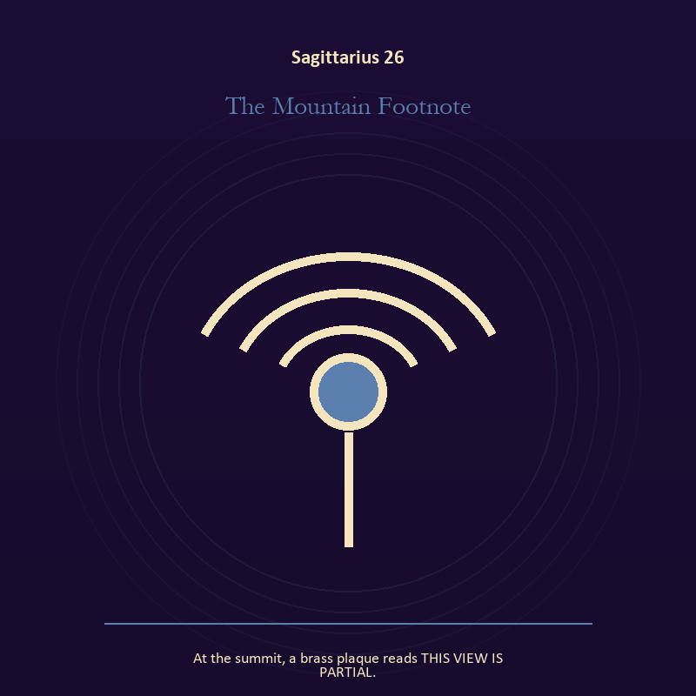

Sagittarius 26 The Mountain Footnote
At the summit, a brass plaque reads THIS VIEW IS PARTIAL.
INTERPRETATION In the Mountain Footnote, the work of mystery must answer to meaning, pilgrimage, teaching, and wonder disciplined by evidence. Within the Mountain Footnote, this image invites attention before conclusion. At Sagittarius 26, its strange fact creates a pressure point where memory, desire, fear, and choice can speak indirectly. As a release degree, Sagittarius 26 prepares the lesson to leave its original container; keep the capacity and loosen the role.
SIGNAL At Sagittarius 26, an unanswered image that keeps thought alive carries the signal; it stays honest when you follow the question far enough to meet a mind unlike your own.
SHADOW The shadow at Sagittarius 26 begins with forcing a prophecy from ambiguity; also beware conviction that outruns evidence, teaching that cannot listen, or escape disguised as pilgrimage.
MIRROR At Sagittarius 26, what ordinary fact sits beneath the strange image?
PRACTICE Bring Sagittarius 26 out of abstraction: copy the image by hand, underline three concrete nouns, and write one association for each.

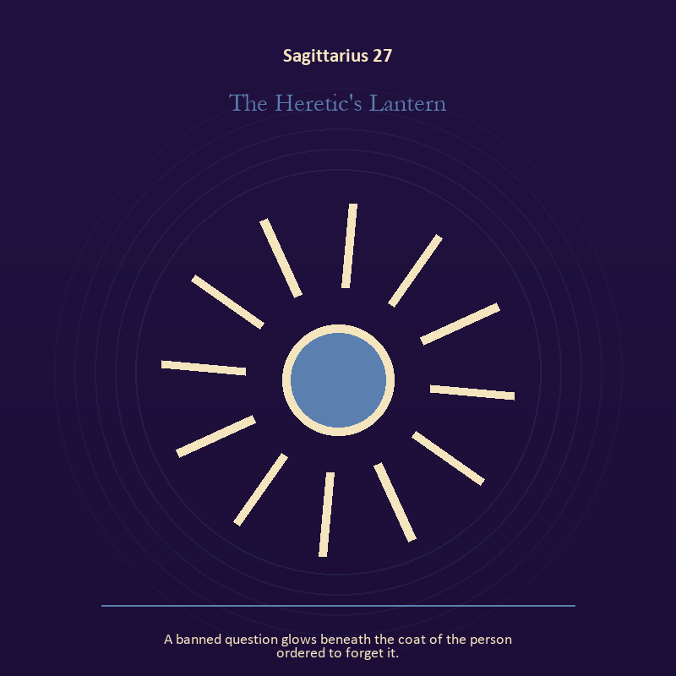

Sagittarius 27 The Heretic's Lantern
A banned question glows beneath the coat of the person ordered to forget it.
INTERPRETATION The Heretic's Lantern tests living fire against meaning, pilgrimage, teaching, and wonder disciplined by evidence. Within the Heretic's Lantern, a Lantern offers enough light for the next honest step. At Sagittarius 27, it does not remove night, and its usefulness depends on how it is carried. The same image also carries voice and naming; at Sagittarius 27, books, letters, bells, and songs extend speech beyond the speaker's body. As a release degree, Sagittarius 27 asks what can be handed onward without demanding imitation or loyalty.
SIGNAL What can be carried forward from Sagittarius 27 is attention with warmth joined to a name that restores agency, tested by the need to follow the question far enough to meet a mind unlike your own.
SHADOW At Sagittarius 27, the image darkens through exposure without care and speaking for someone whose voice is present; beware conviction that outruns evidence, teaching that cannot listen, or escape disguised as pilgrimage.
MIRROR For Sagittarius 27, how much light does the next step require, and who might it expose? From a second angle at Sagittarius 27, what needs to be said plainly, and who has earned the right to hear it?
PRACTICE For Sagittarius 27, move one hidden concern into plain view by naming it to a trusted person.
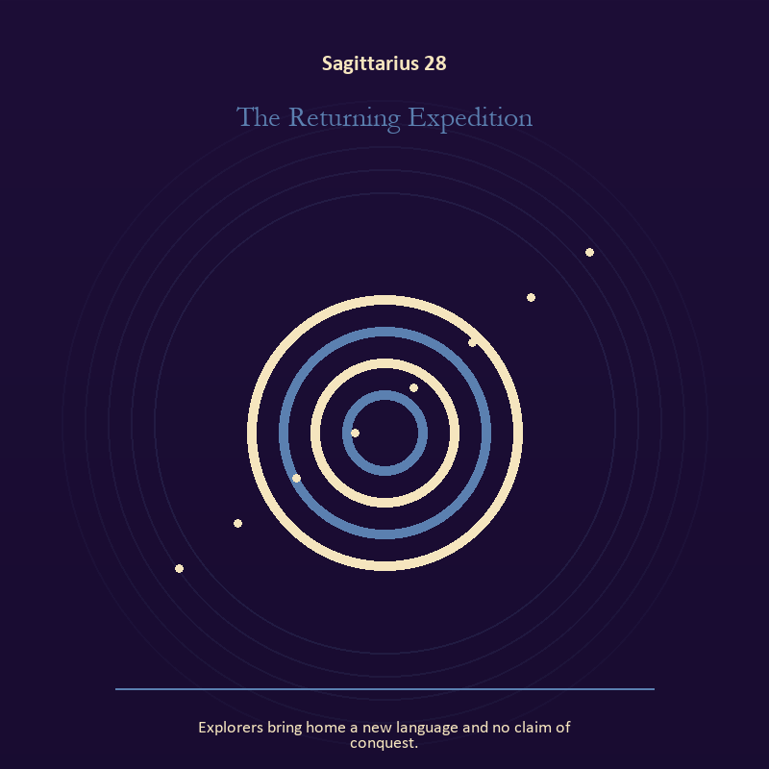

Sagittarius 28 The Returning Expedition
Explorers bring home a new language and no claim of conquest.
INTERPRETATION The Returning Expedition holds mystery against meaning, pilgrimage, teaching, and wonder disciplined by evidence. Within the Returning Expedition, the scene behaves like a dream with its own exact logic. At Sagittarius 28, meaning lives in the relationship between figure, place, action, and the detail that refuses ordinary explanation. As a release degree, Sagittarius 28 turns completion into transfer; the work survives by changing hands.
SIGNAL At Sagittarius 28, imagination disciplined by the scene becomes the clean signal when Sagittarius can follow the question far enough to meet a mind unlike your own.
SHADOW The distortion at Sagittarius 28 is mistaking intensity for accuracy; beware conviction that outruns evidence, teaching that cannot listen, or escape disguised as pilgrimage.
MIRROR With the Returning Expedition in mind at Sagittarius 28, which detail keeps returning after the rest of the scene fades?
PRACTICE Work with The Returning Expedition directly at Sagittarius 28: keep the image nearby for one day and record only the moments when it returns on its own.

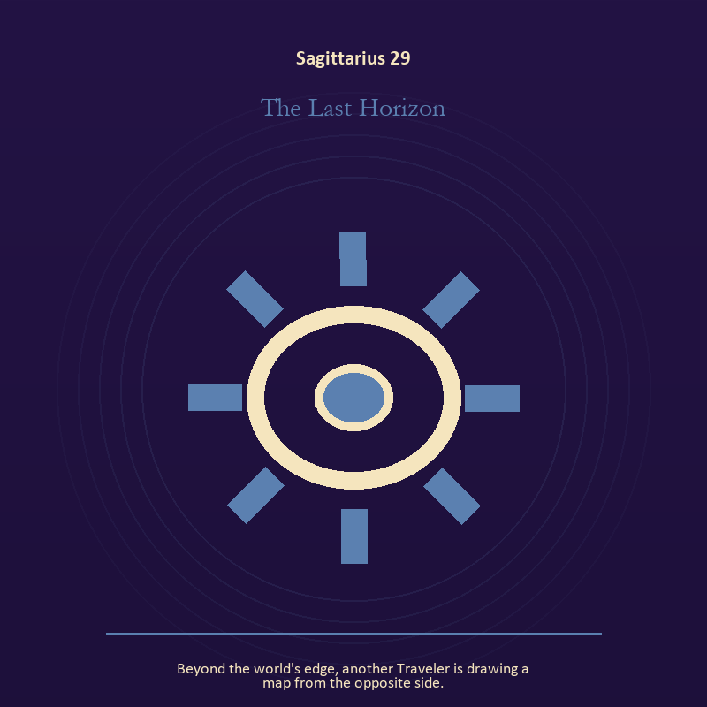

Sagittarius 29 The Last Horizon
Beyond the world's edge, another Traveler is drawing a map from the opposite side.
INTERPRETATION The Last Horizon gives craft and record consequences inside the Library Without Walls. Within the Last Horizon, ledgers, maps, machines, and archives make memory operational. At Sagittarius 29, they can protect truth or compress living complexity until only the form remains. The same image also carries relationship; at Sagittarius 29, more than one will is active in this scene. As a release degree, Sagittarius 29 lets the sign set down the identity built around its ordeal.
SIGNAL The usable force at Sagittarius 29 is a useful correction that outlives the moment joined to contact without capture; Sagittarius gives it form by asking you to follow the question far enough to meet a mind unlike your own.
SHADOW At Sagittarius 29, the Last Horizon can turn toward measurement mistaken for meaning and projection mistaken for intimacy; beware conviction that outruns evidence, teaching that cannot listen, or escape disguised as pilgrimage.
MIRROR The question at Sagittarius 29: what does the tool preserve, and what does it leave out?
PRACTICE Give Sagittarius 29 a physical form; inspect one repeated task and add a check that would catch the most expensive error.
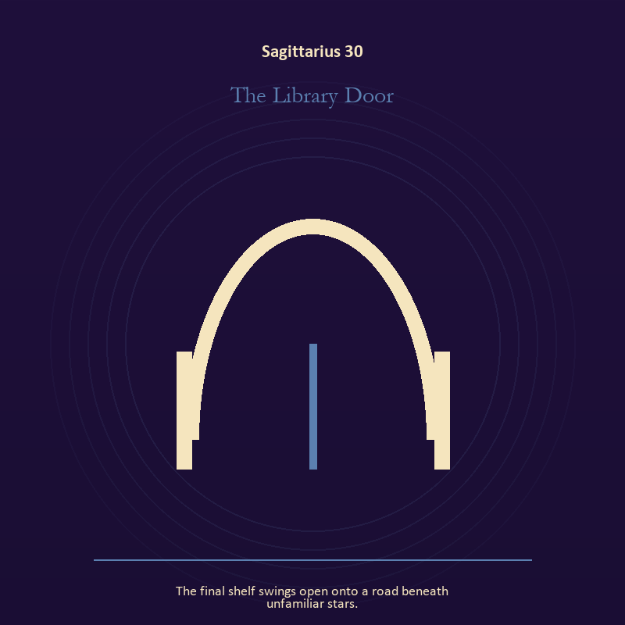

Sagittarius 30 The Library Door
The final shelf swings open onto a road beneath unfamiliar stars.
INTERPRETATION The Library Door puts the threshold under pressure from meaning, pilgrimage, teaching, and wonder disciplined by evidence. Within the Library Door, a boundary can protect life, restrict it, or clarify the terms of meeting. At Sagittarius 30, the surrounding action reveals which function is active here. As a release degree, Sagittarius 30 returns the earned knowledge to ordinary life, where another cycle can use it.
SIGNAL At Sagittarius 30, honest passage carries the signal; it stays honest when you follow the question far enough to meet a mind unlike your own.
SHADOW The shadow at Sagittarius 30 begins with guarding an obsolete enclosure; also beware conviction that outruns evidence, teaching that cannot listen, or escape disguised as pilgrimage.
MIRROR At Sagittarius 30, what would make the next step chosen rather than compelled?
PRACTICE Bring Sagittarius 30 out of abstraction: draw the boundary as a line on paper; then mark the gate, the guard, and the person who holds the key.

Capricorn
The Storm-Born Architect
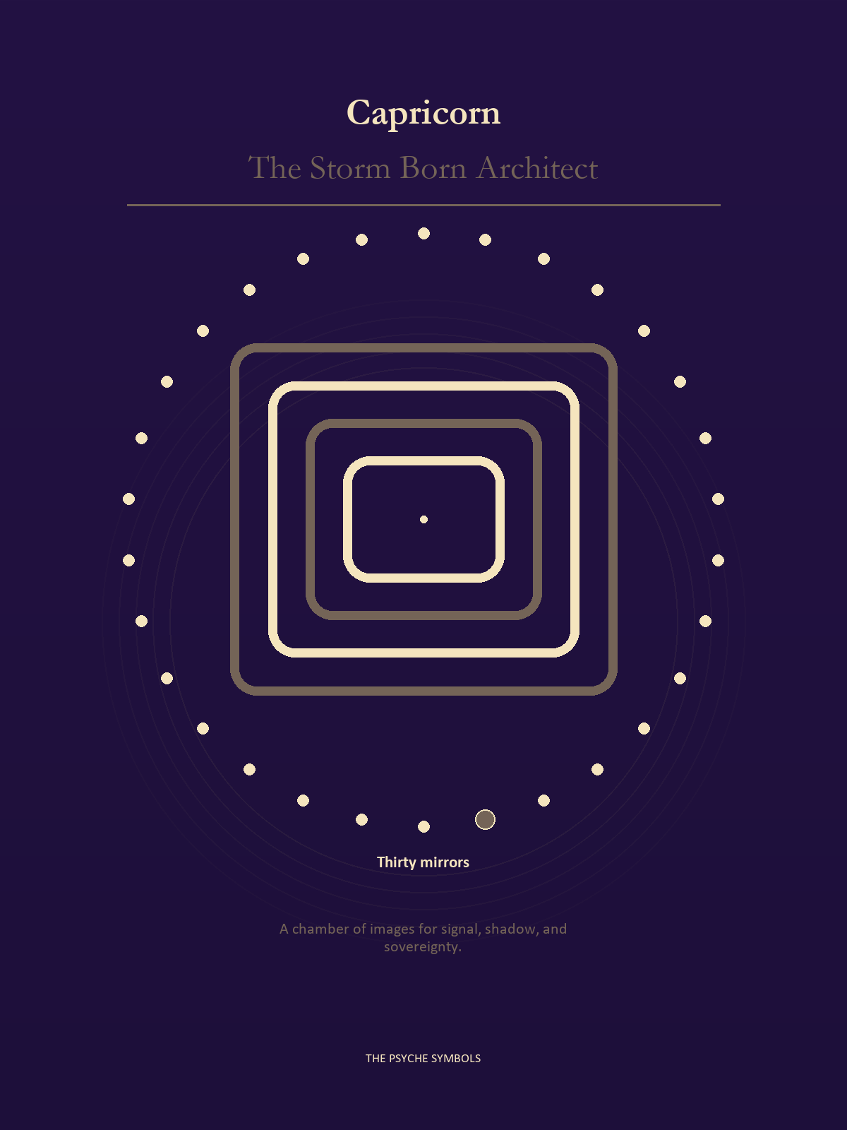
Capricorn gives the vision walls, duties, records, succession, and consequences. The Storm Born Architect asks whether a structure serves living people after its founder leaves the room. Here power earns respect through restraint, repair, clear limits, and an exit that remains available.

Degrees | Gate | Work
1-5 | Arrival | Meet the image before deciding what it means.
6-10 | Friction | Notice what pushes back and what that resistance protects.
11-15 | Revelation | Name the detail that changes the whole scene.
16-20 | Choice | Choose the act that preserves both truth and human dignity.
21-25 | Integration | Use the gift without feeding the shadow that travels beside it.
26-30 | Release | Keep the earned capacity and release the role that delivered it.

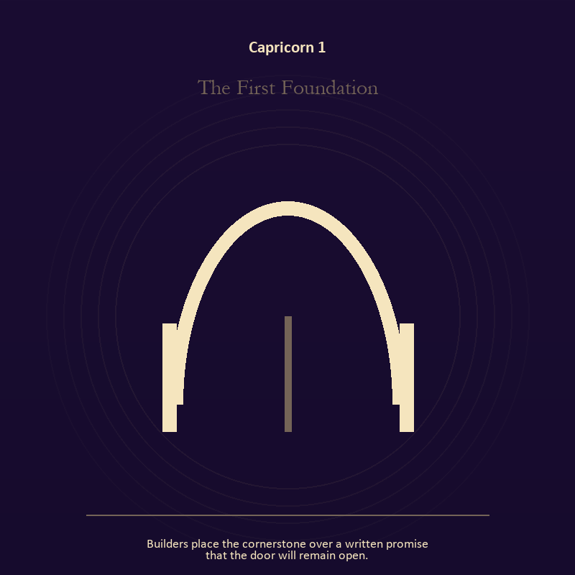

Capricorn 1 The First Foundation
Builders place the cornerstone over a written promise that the door will remain open.
INTERPRETATION In the First Foundation, the work of the threshold must answer to responsibility, endurance, institution, and authority tested by what it protects. Within the First Foundation, a threshold measures consent, timing, and consequence. At Capricorn 1, its presence asks whether passage is chosen, forced, delayed, or already under way. As an arrival degree, Capricorn 1 arrives before habit can tidy the evidence; notice what is present before deciding what it should become.
SIGNAL What can be carried forward from Capricorn 1 is chosen change, tested by the need to build the support that lets other people stand without you.
SHADOW At Capricorn 1, the image darkens through waiting for permission that will never come; watch duty become domination, hardship become vanity, or the institution defend itself against its purpose.
MIRROR For Capricorn 1, which threshold in your life requires consent rather than momentum?
PRACTICE For Capricorn 1, write one sentence beginning, 'I may enter when,' and one beginning, 'I remain free to leave when.'.
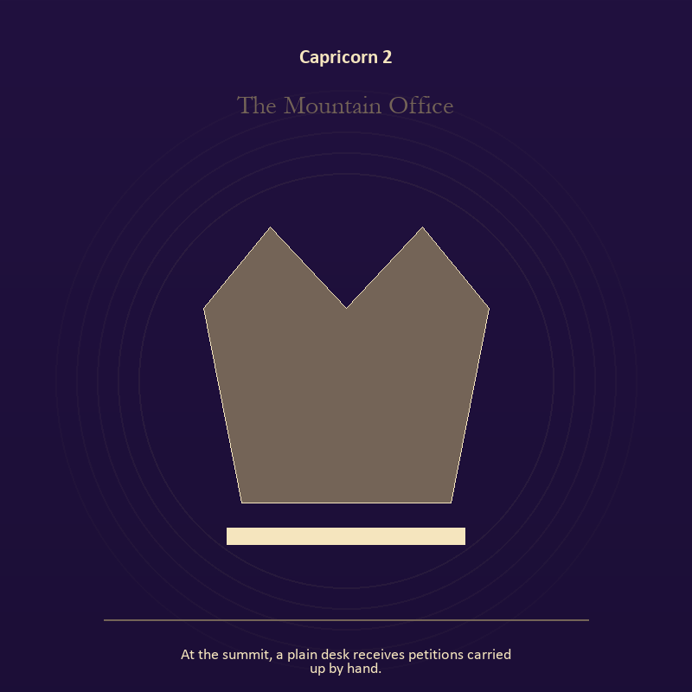

Capricorn 2 The Mountain Office
At the summit, a plain desk receives petitions carried up by hand.
INTERPRETATION The Mountain Office tests authority against responsibility, endurance, institution, and authority tested by what it protects. Within the Mountain Office, crowns, laws, offices, and verdicts turn private judgment into public consequence. At Capricorn 2, their legitimacy depends on restraint and correction. The same image also carries the body; at Capricorn 2, the body enters as witness, limit, appetite, labor, and home. As an arrival degree, Capricorn 2 introduces the sign's raw material in an unguarded form; the first response matters less than the honest one.
SIGNAL At Capricorn 2, a rule that protects the vulnerable person in the room joined to presence with weight and limits becomes the clean signal when Capricorn can build the support that lets other people stand without you.
SHADOW The distortion at Capricorn 2 is role mistaken for worth and treating exhaustion as devotion; watch duty become domination, hardship become vanity, or the institution defend itself against its purpose.
MIRROR With the Mountain Office in mind at Capricorn 2, what would accountability require from the person holding the key?
PRACTICE Work with The Mountain Office directly at Capricorn 2: choose one decision you control and write down who can challenge it, correct it, and leave its consequences. For the second pressure at Capricorn 2, place both feet on the floor and name five physical facts about the present moment.

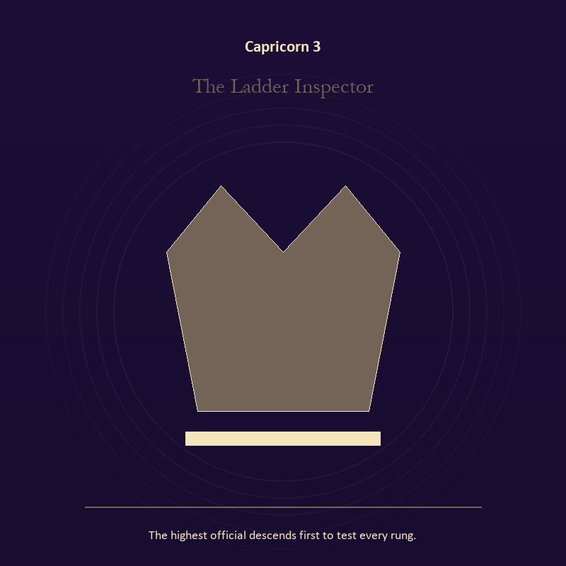

Capricorn 3 The Ladder Inspector
The highest official descends first to test every rung.
INTERPRETATION The Ladder Inspector holds authority against responsibility, endurance, institution, and authority tested by what it protects. Within the Ladder Inspector, institutional objects reveal the bargain between role and person. At Capricorn 3, a title may organize service or become a mask that excuses harm. As an arrival degree, Capricorn 3 catches the first impulse before it turns into a role; give the image room to remain strange.
SIGNAL The usable force at Capricorn 3 is stewardship with an exit plan; Capricorn gives it form by asking you to build the support that lets other people stand without you.
SHADOW At Capricorn 3, the Ladder Inspector can turn toward procedure used to avoid conscience; watch duty become domination, hardship become vanity, or the institution defend itself against its purpose.
MIRROR The question at Capricorn 3: which part of this authority serves life, and which part serves its own continuation?
PRACTICE Give Capricorn 3 a physical form; remove your title from a current problem and describe the duty that remains.
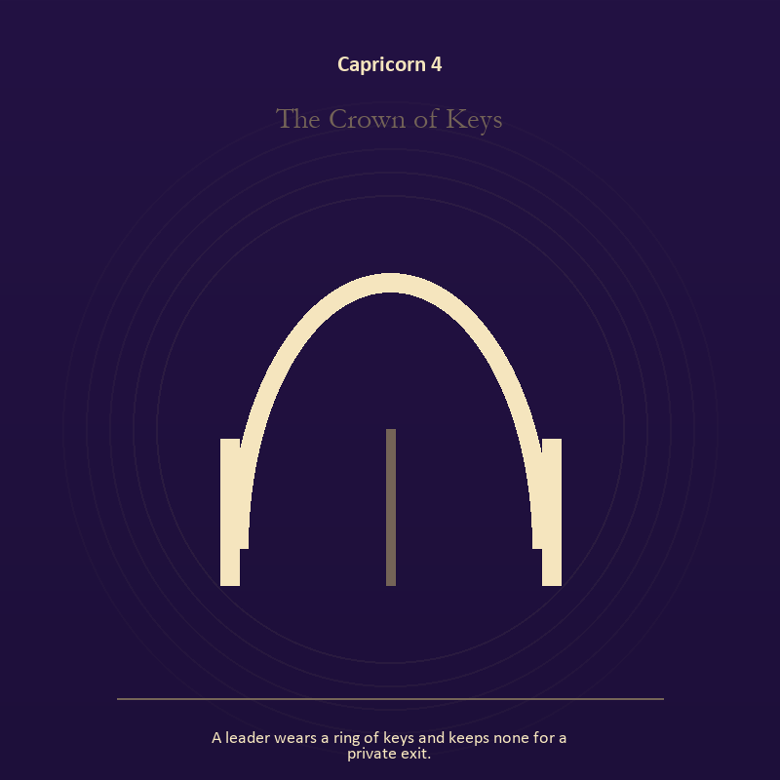

Capricorn 4 The Crown of Keys
A leader wears a ring of keys and keeps none for a private exit.
INTERPRETATION The Crown of Keys gives authority consequences inside the Storm-Born Architect. Within the Crown of Keys, authority is shown as a tool with weight, limits, witnesses, and an eventual transfer. At Capricorn 4, the symbol asks whom power protects when nobody is applauding. The same image also carries identity; at Capricorn 4, a role organizes behavior but cannot contain the whole person. As an arrival degree, Capricorn 4 opens the chamber with no settled method; name the need, risk, or appetite that entered with it.
SIGNAL At Capricorn 4, power made answerable joined to the freedom to revise a name or role carries the signal; it stays honest when you build the support that lets other people stand without you.
SHADOW The shadow at Capricorn 4 begins with authority defending itself against correction and performance mistaken for selfhood; also watch duty become domination, hardship become vanity, or the institution defend itself against its purpose.
MIRROR At Capricorn 4, who carries the cost of the decision made here?
PRACTICE Bring Capricorn 4 out of abstraction: inspect one standing rule by asking how it treats the person with the least power.

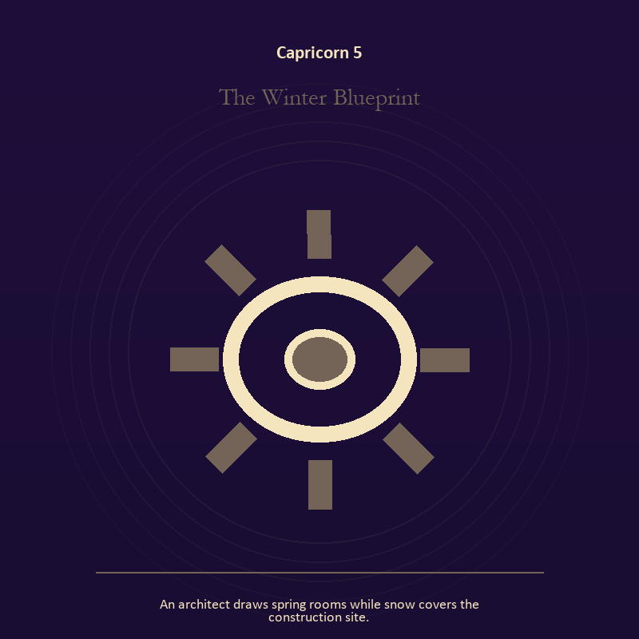

Capricorn 5 The Winter Blueprint
An architect draws spring rooms while snow covers the construction site.
INTERPRETATION The Winter Blueprint puts craft and record under pressure from responsibility, endurance, institution, and authority tested by what it protects. Within the Winter Blueprint, ledgers, maps, machines, and archives make memory operational. At Capricorn 5, they can protect truth or compress living complexity until only the form remains. As an arrival degree, Capricorn 5 shows the beginning before ownership hardens around it; let attention come before possession.
SIGNAL What can be carried forward from Capricorn 5 is a useful correction that outlives the moment, tested by the need to build the support that lets other people stand without you.
SHADOW At Capricorn 5, the image darkens through measurement mistaken for meaning; watch duty become domination, hardship become vanity, or the institution defend itself against its purpose.
MIRROR For Capricorn 5, what does the tool preserve, and what does it leave out?
PRACTICE For Capricorn 5, inspect one repeated task and add a check that would catch the most expensive error.
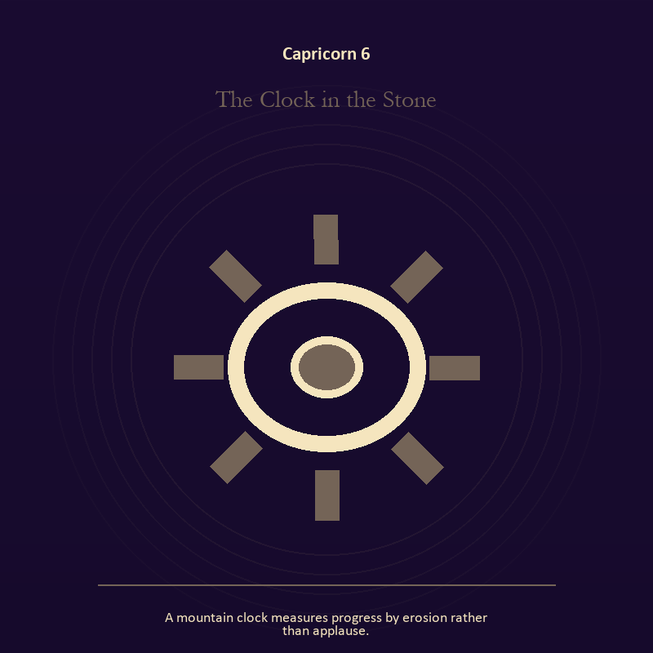

Capricorn 6 The Clock in the Stone
A mountain clock measures progress by erosion rather than applause.
INTERPRETATION In the Clock in the Stone, the work of craft and record must answer to responsibility, endurance, institution, and authority tested by what it protects. Within the Clock in the Stone, workshops honor correction. At Capricorn 6, a flaw becomes useful when it is found early, recorded honestly, and repaired without hiding the seam. As a friction degree, Capricorn 6 meets resistance, and that resistance reveals what the first impulse failed to consider.
SIGNAL At Capricorn 6, care made repeatable becomes the clean signal when Capricorn can build the support that lets other people stand without you.
SHADOW The distortion at Capricorn 6 is the tool becoming the master; watch duty become domination, hardship become vanity, or the institution defend itself against its purpose.
MIRROR With the Clock in the Stone in mind at Capricorn 6, where would an honest repair remain visible?
PRACTICE Work with The Clock in the Stone directly at Capricorn 6: keep a brief record of what happened, what you expected, and what changed your mind.

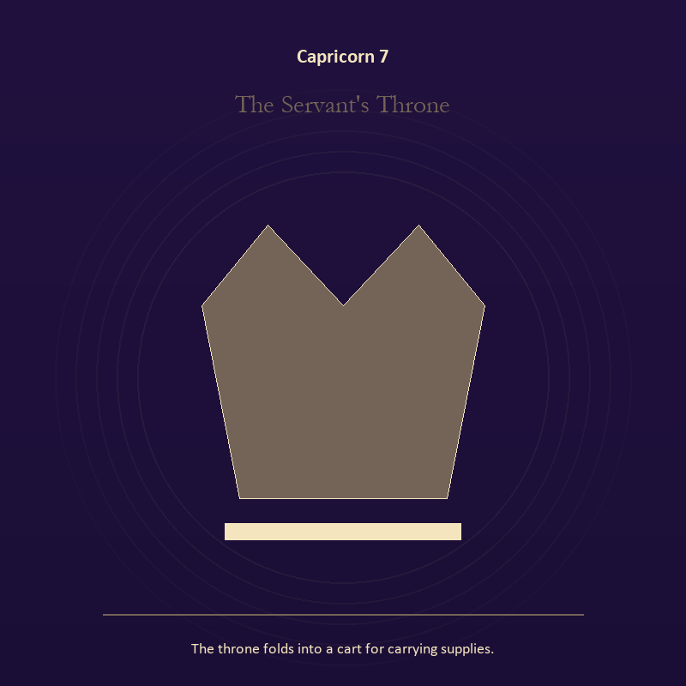

Capricorn 7 The Servant's Throne
The throne folds into a cart for carrying supplies.
INTERPRETATION The Servant's Throne tests authority against responsibility, endurance, institution, and authority tested by what it protects. Within the Servant's Throne, authority is shown as a tool with weight, limits, witnesses, and an eventual transfer. At Capricorn 7, the symbol asks whom power protects when nobody is applauding. As a friction degree, Capricorn 7 places consequence beside desire; the obstruction may be an enemy, a limit, or a needed correction.
SIGNAL The usable force at Capricorn 7 is power made answerable; Capricorn gives it form by asking you to build the support that lets other people stand without you.
SHADOW At Capricorn 7, the Servant's Throne can turn toward authority defending itself against correction; watch duty become domination, hardship become vanity, or the institution defend itself against its purpose.
MIRROR The question at Capricorn 7: who carries the cost of the decision made here?
PRACTICE Give Capricorn 7 a physical form; inspect one standing rule by asking how it treats the person with the least power.
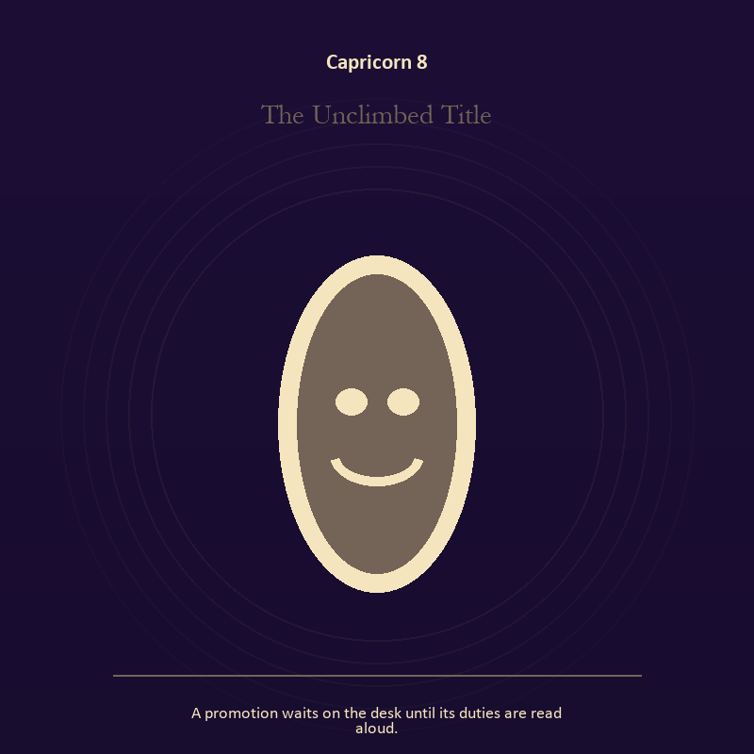

Capricorn 8 The Unclimbed Title
A promotion waits on the desk until its duties are read aloud.
INTERPRETATION The Unclimbed Title holds identity against responsibility, endurance, institution, and authority tested by what it protects. Within the Unclimbed Title, masks and names can conceal, reveal, or give shape to a truth that plain speech cannot yet hold. At Capricorn 8, their value depends on whether removal remains possible. As a friction degree, Capricorn 8 tests whether the sign can change course without treating correction as defeat.
SIGNAL At Capricorn 8, the freedom to revise a name or role carries the signal; it stays honest when you build the support that lets other people stand without you.
SHADOW The shadow at Capricorn 8 begins with performance mistaken for selfhood; also watch duty become domination, hardship become vanity, or the institution defend itself against its purpose.
MIRROR At Capricorn 8, what does the mask make possible, and what does it cost to keep wearing it?
PRACTICE Bring Capricorn 8 out of abstraction: list the roles you carry; then mark each as chosen, inherited, temporary, or ready to release.

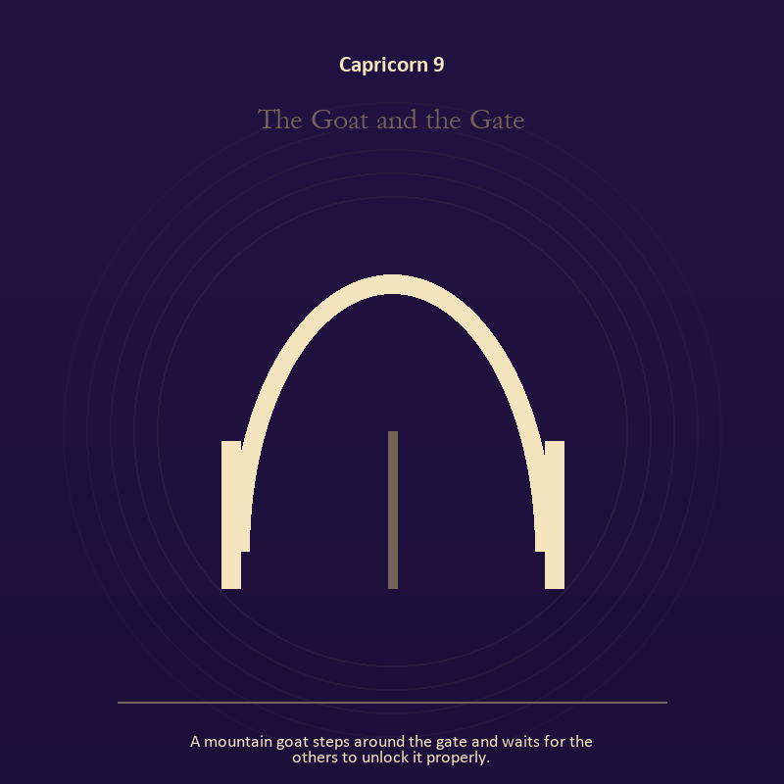

Capricorn 9 The Goat and the Gate
A mountain goat steps around the gate and waits for the others to unlock it properly.
INTERPRETATION The Goat and the Gate gives the threshold consequences inside the Storm-Born Architect. Within the Goat and the Gate, a boundary can protect life, restrict it, or clarify the terms of meeting. At Capricorn 9, the surrounding action reveals which function is active here. As a friction degree, Capricorn 9 brings another will, material limit, or inconvenient fact into the frame.
SIGNAL What can be carried forward from Capricorn 9 is honest passage, tested by the need to build the support that lets other people stand without you.
SHADOW At Capricorn 9, the image darkens through guarding an obsolete enclosure; watch duty become domination, hardship become vanity, or the institution defend itself against its purpose.
MIRROR For Capricorn 9, what would make the next step chosen rather than compelled?
PRACTICE For Capricorn 9, draw the boundary as a line on paper; then mark the gate, the guard, and the person who holds the key.
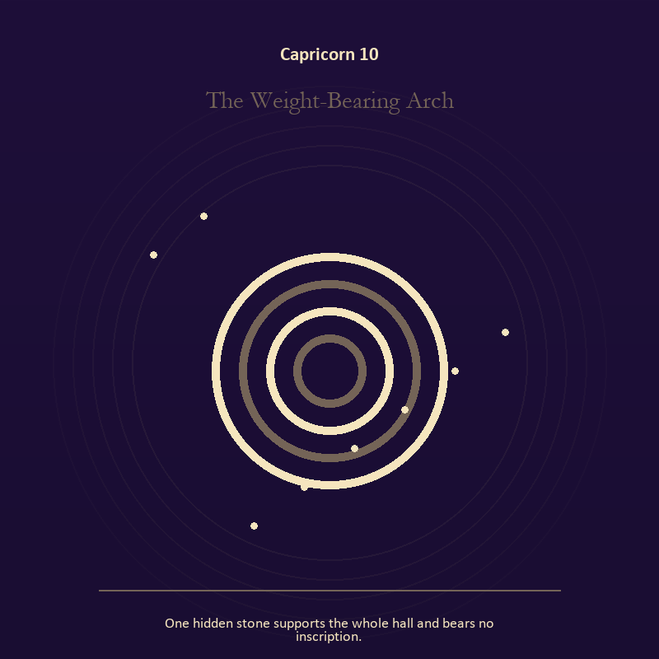

Capricorn 10 The Weight-Bearing Arch
One hidden stone supports the whole hall and bears no inscription.
INTERPRETATION The Weight-Bearing Arch puts mystery under pressure from responsibility, endurance, institution, and authority tested by what it protects. Within the Weight-Bearing Arch, the scene behaves like a dream with its own exact logic. At Capricorn 10, meaning lives in the relationship between figure, place, action, and the detail that refuses ordinary explanation. As a friction degree, Capricorn 10 slows the original motion long enough to expose what haste concealed.
SIGNAL At Capricorn 10, imagination disciplined by the scene becomes the clean signal when Capricorn can build the support that lets other people stand without you.
SHADOW The distortion at Capricorn 10 is mistaking intensity for accuracy; watch duty become domination, hardship become vanity, or the institution defend itself against its purpose.
MIRROR With the Weight-Bearing Arch in mind at Capricorn 10, which detail keeps returning after the rest of the scene fades?
PRACTICE Work with The Weight-Bearing Arch directly at Capricorn 10: keep the image nearby for one day and record only the moments when it returns on its own.

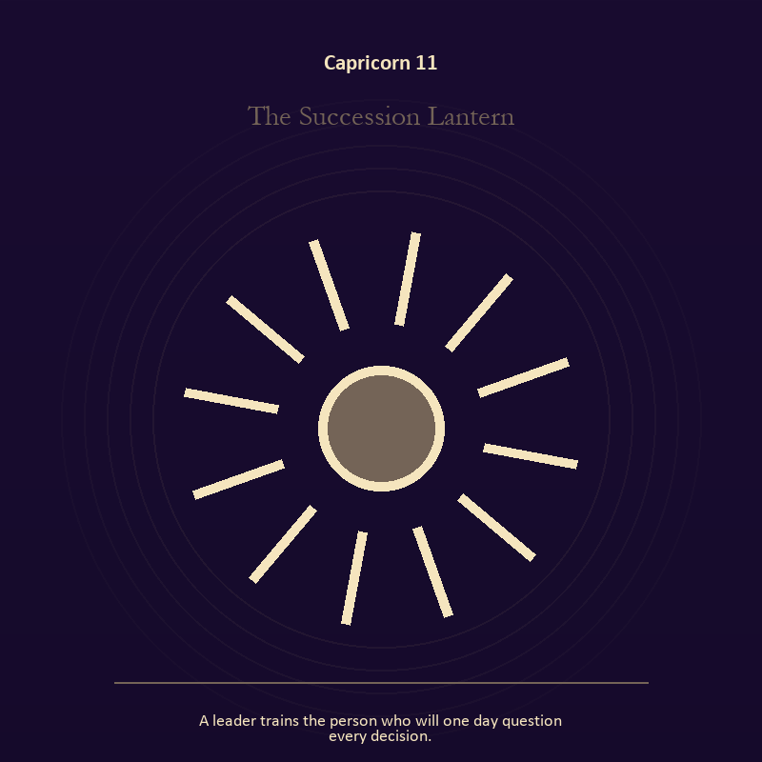

Capricorn 11 The Succession Lantern
A leader trains the person who will one day question every decision.
INTERPRETATION In the Succession Lantern, the work of living fire must answer to responsibility, endurance, institution, and authority tested by what it protects. Within the Succession Lantern, fire gives change a visible cost. At Capricorn 11, something is illuminated here because something else is being spent. The same image also carries voice and naming; at Capricorn 11, voice turns inner pressure into shared consequence. As a revelation degree, Capricorn 11 reveals the mechanism under the mood; one concrete detail changes the reading.
SIGNAL The usable force at Capricorn 11 is a truth made visible at the right scale joined to speech with consequence; Capricorn gives it form by asking you to build the support that lets other people stand without you.
SHADOW At Capricorn 11, the Succession Lantern can turn toward burning for recognition and repeating a message until it sounds like evidence; watch duty become domination, hardship become vanity, or the institution defend itself against its purpose.
MIRROR The question at Capricorn 11: where has your fire become performance rather than warmth?
PRACTICE Give Capricorn 11 a physical form; light one candle and give its entire burn to a single unfinished question.
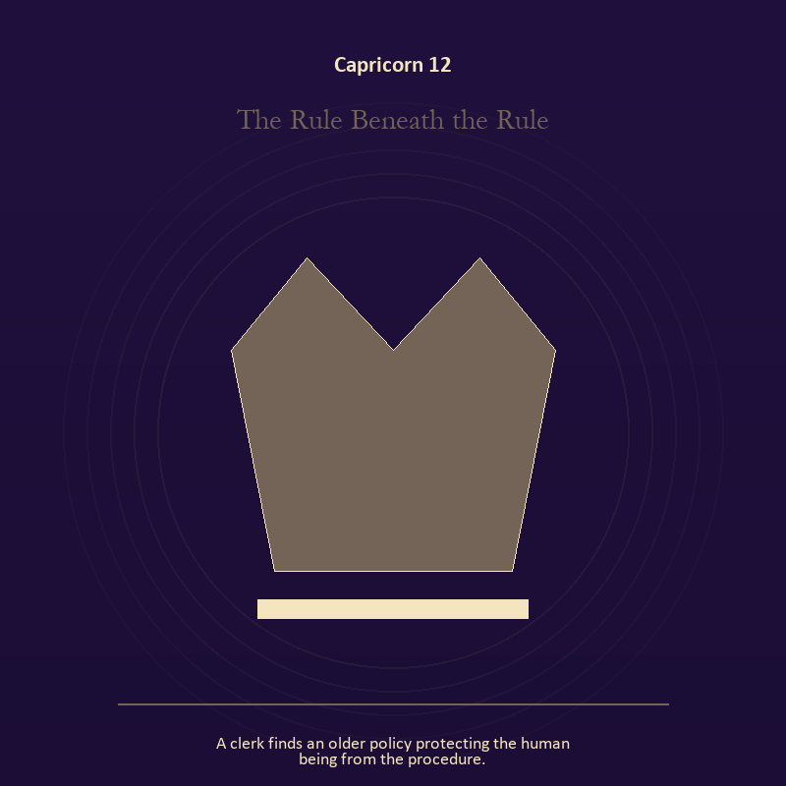

Capricorn 12 The Rule Beneath the Rule
A clerk finds an older policy protecting the human being from the procedure.
INTERPRETATION The Rule Beneath the Rule tests authority against responsibility, endurance, institution, and authority tested by what it protects. Within the Rule Beneath the Rule, institutional objects reveal the bargain between role and person. At Capricorn 12, a title may organize service or become a mask that excuses harm. The same image also carries craft and record; at Capricorn 12, ledgers, maps, machines, and archives make memory operational. As a revelation degree, Capricorn 12 moves the hidden arrangement into view, where it can be named without being exaggerated.
SIGNAL At Capricorn 12, stewardship with an exit plan joined to evidence preserved without spectacle carries the signal; it stays honest when you build the support that lets other people stand without you.
SHADOW The shadow at Capricorn 12 begins with procedure used to avoid conscience and polish used to hide a structural weakness; also watch duty become domination, hardship become vanity, or the institution defend itself against its purpose.
MIRROR At Capricorn 12, which part of this authority serves life, and which part serves its own continuation? From a second angle at Capricorn 12, what does the tool preserve, and what does it leave out?
PRACTICE Bring Capricorn 12 out of abstraction: remove your title from a current problem and describe the duty that remains.

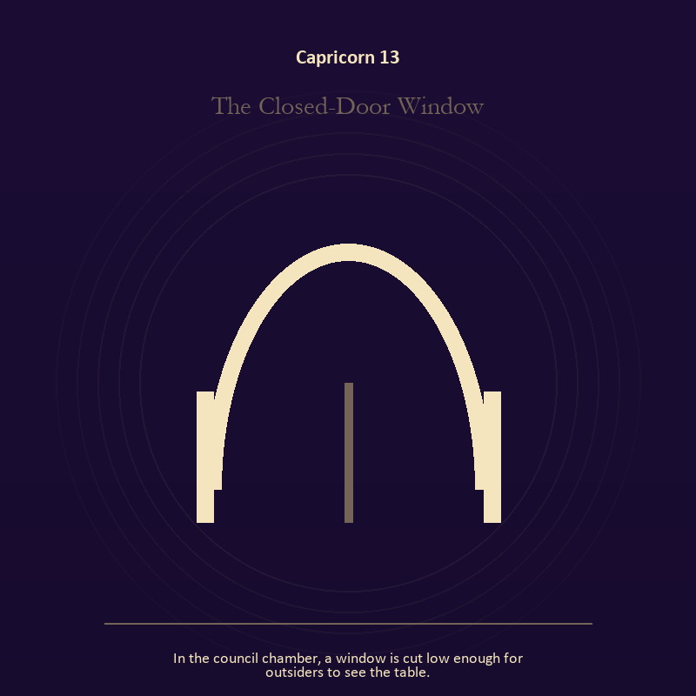

Capricorn 13 The Closed-Door Window
In the council chamber, a window is cut low enough for outsiders to see the table.
INTERPRETATION The Closed-Door Window holds the threshold against responsibility, endurance, institution, and authority tested by what it protects. Within the Closed-Door Window, a threshold measures consent, timing, and consequence. At Capricorn 13, its presence asks whether passage is chosen, forced, delayed, or already under way. The same image also carries authority; at Capricorn 13, institutional objects reveal the bargain between role and person. As a revelation degree, Capricorn 13 turns atmosphere into evidence; attend to the object or action that cannot be explained away.
SIGNAL What can be carried forward from Capricorn 13 is chosen change joined to a rule that protects the vulnerable person in the room, tested by the need to build the support that lets other people stand without you.
SHADOW At Capricorn 13, the image darkens through waiting for permission that will never come and role mistaken for worth; watch duty become domination, hardship become vanity, or the institution defend itself against its purpose.
MIRROR For Capricorn 13, which threshold in your life requires consent rather than momentum?
PRACTICE For Capricorn 13, write one sentence beginning, 'I may enter when,' and one beginning, 'I remain free to leave when.'.
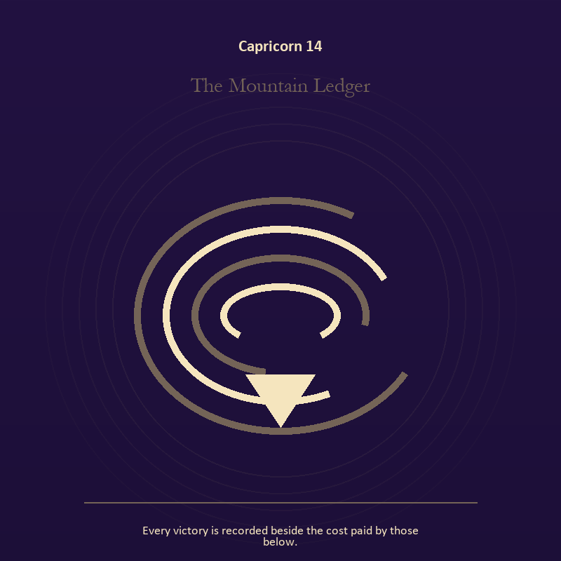

Capricorn 14 The Mountain Ledger
Every victory is recorded beside the cost paid by those below.
INTERPRETATION The Mountain Ledger gives craft and record consequences inside the Storm-Born Architect. Within the Mountain Ledger, ledgers, maps, machines, and archives make memory operational. At Capricorn 14, they can protect truth or compress living complexity until only the form remains. The same image also carries the descent; at Capricorn 14, descent imagery carries what ordinary daylight has failed to resolve. As a revelation degree, Capricorn 14 shows who carries the cost, who controls the passage, and what the scene refuses to hide.
SIGNAL At Capricorn 14, a useful correction that outlives the moment joined to truth that survives loss becomes the clean signal when Capricorn can build the support that lets other people stand without you.
SHADOW The distortion at Capricorn 14 is measurement mistaken for meaning and suspicion filling gaps in the record; watch duty become domination, hardship become vanity, or the institution defend itself against its purpose.
MIRROR With the Mountain Ledger in mind at Capricorn 14, what does the tool preserve, and what does it leave out?
PRACTICE Work with The Mountain Ledger directly at Capricorn 14: inspect one repeated task and add a check that would catch the most expensive error. For the second pressure at Capricorn 14, name the injury, the present risk, and the next repair as three separate sentences.

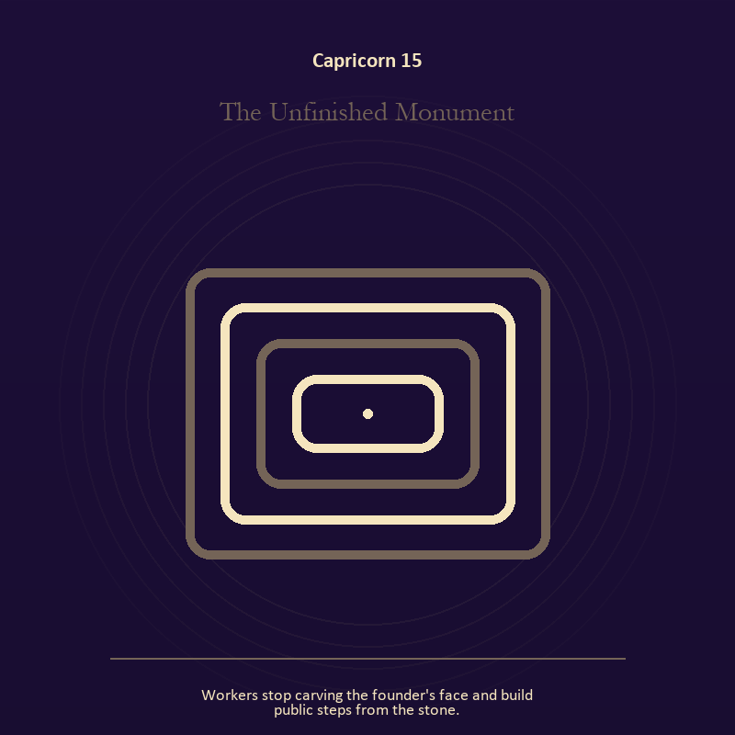

Capricorn 15 The Unfinished Monument
Workers stop carving the founder's face and build public steps from the stone.
INTERPRETATION The Unfinished Monument puts the Mirror under pressure from responsibility, endurance, institution, and authority tested by what it protects. Within the Unfinished Monument, a shadow proves that something real stands in the light, while a reflection shows only an angle. At Capricorn 15, neither is the whole person. The same image also carries craft and record; at Capricorn 15, ledgers, maps, machines, and archives make memory operational. As a revelation degree, Capricorn 15 brings the middle truth forward, after the first story has lost its grip.
SIGNAL The usable force at Capricorn 15 is self-recognition without self-worship joined to evidence preserved without spectacle; Capricorn gives it form by asking you to build the support that lets other people stand without you.
SHADOW At Capricorn 15, the Unfinished Monument can turn toward assigning your hidden material to someone else and polish used to hide a structural weakness; watch duty become domination, hardship become vanity, or the institution defend itself against its purpose.
MIRROR The question at Capricorn 15: which part of the reflection is asking to be reclaimed rather than judged? From a second angle at Capricorn 15, what does the tool preserve, and what does it leave out?
PRACTICE Give Capricorn 15 a physical form; write two accounts of the same conflict: one from your position and one from the person you cannot understand.
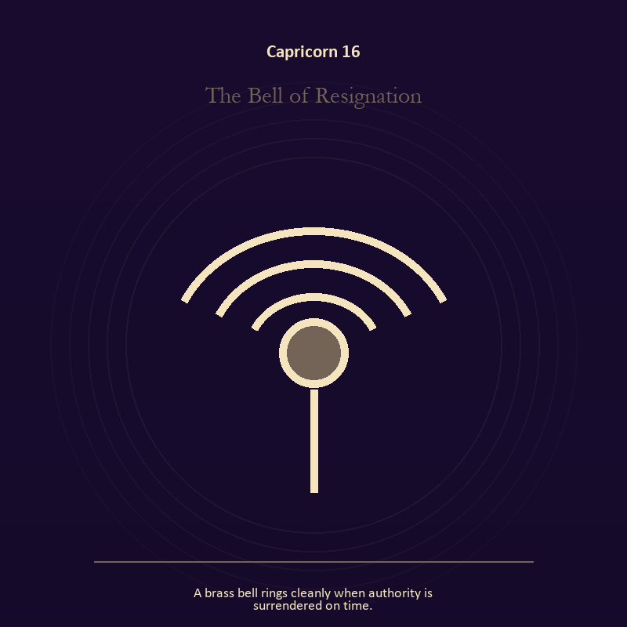

Capricorn 16 The Bell of Resignation
A brass bell rings cleanly when authority is surrendered on time.
INTERPRETATION In the Bell of Resignation, the work of voice and naming must answer to responsibility, endurance, institution, and authority tested by what it protects. Within the Bell of Resignation, voice turns inner pressure into shared consequence. At Capricorn 16, words can witness, summon, distort, repair, or conceal according to their precision and timing. As a choice degree, Capricorn 16 requires a choice with a human cost; insight alone no longer completes the work.
SIGNAL At Capricorn 16, a name that restores agency carries the signal; it stays honest when you build the support that lets other people stand without you.
SHADOW The shadow at Capricorn 16 begins with speaking for someone whose voice is present; also watch duty become domination, hardship become vanity, or the institution defend itself against its purpose.
MIRROR At Capricorn 16, which word in this scene changes the power relationship?
PRACTICE Bring Capricorn 16 out of abstraction: give the current experience a temporary name and date it, leaving room for revision.

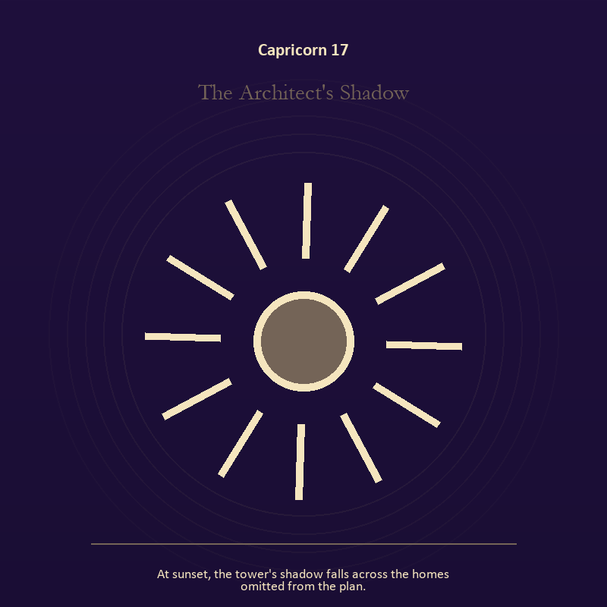

Capricorn 17 The Architect's Shadow
At sunset, the tower's shadow falls across the homes omitted from the plan.
INTERPRETATION The Architect's Shadow tests the Mirror against responsibility, endurance, institution, and authority tested by what it protects. Within the Architect's Shadow, reflected images divide the observer from the observed self. At Capricorn 17, that gap can hold shame, vanity, curiosity, or the first honest revision of identity. The same image also carries craft and record; at Capricorn 17, craft turns intention into a repeatable act with materials, limits, and evidence of failure. As a choice degree, Capricorn 17 asks what action preserves truth without using another person as material.
SIGNAL What can be carried forward from Capricorn 17 is the courage to revise a familiar self-image joined to care made repeatable, tested by the need to build the support that lets other people stand without you.
SHADOW At Capricorn 17, the image darkens through mistaking appearance for character and the tool becoming the master; watch duty become domination, hardship become vanity, or the institution defend itself against its purpose.
MIRROR For Capricorn 17, whose gaze have you installed inside your own Mirror?
PRACTICE For Capricorn 17, describe the scene without interpretation, then circle the detail you most want to praise or condemn.
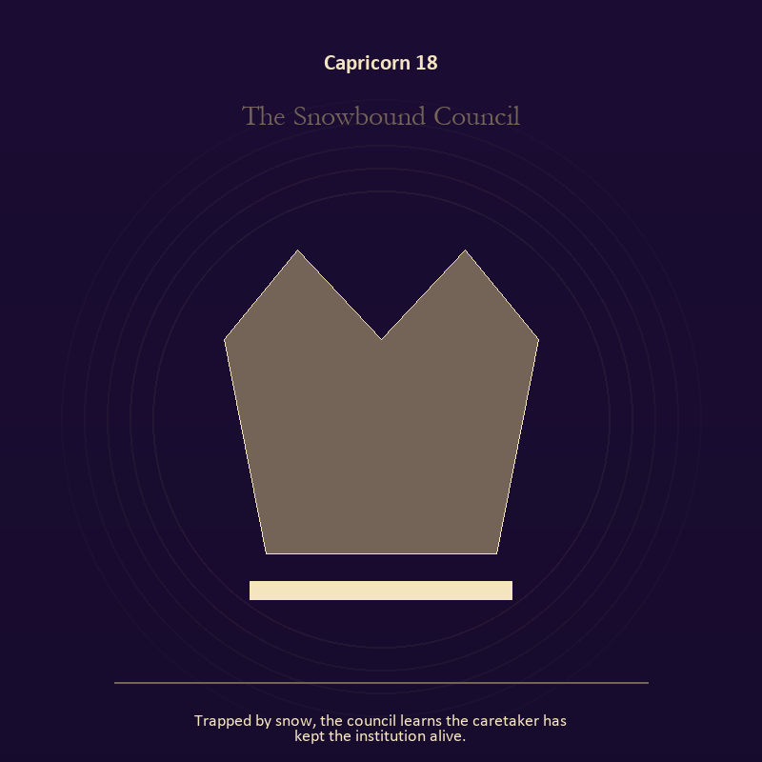

Capricorn 18 The Snowbound Council
Trapped by snow, the council learns the caretaker has kept the institution alive.
INTERPRETATION The Snowbound Council holds authority against responsibility, endurance, institution, and authority tested by what it protects. Within the Snowbound Council, institutional objects reveal the bargain between role and person. At Capricorn 18, a title may organize service or become a mask that excuses harm. The same image also carries relationship; at Capricorn 18, relationship imagery tests the fantasy that harmony requires sameness. As a choice degree, Capricorn 18 moves from recognition to conduct; the clean choice must survive outside the imagination.
SIGNAL At Capricorn 18, stewardship with an exit plan joined to mutual responsibility becomes the clean signal when Capricorn can build the support that lets other people stand without you.
SHADOW The distortion at Capricorn 18 is procedure used to avoid conscience and the group protecting itself by sacrificing an outsider; watch duty become domination, hardship become vanity, or the institution defend itself against its purpose.
MIRROR With the Snowbound Council in mind at Capricorn 18, which part of this authority serves life, and which part serves its own continuation? From a second angle at Capricorn 18, where does responsibility belong, and where has it been displaced?
PRACTICE Work with The Snowbound Council directly at Capricorn 18: remove your title from a current problem and describe the duty that remains. For the second pressure at Capricorn 18, make one repair that does not require the other person to erase their account.

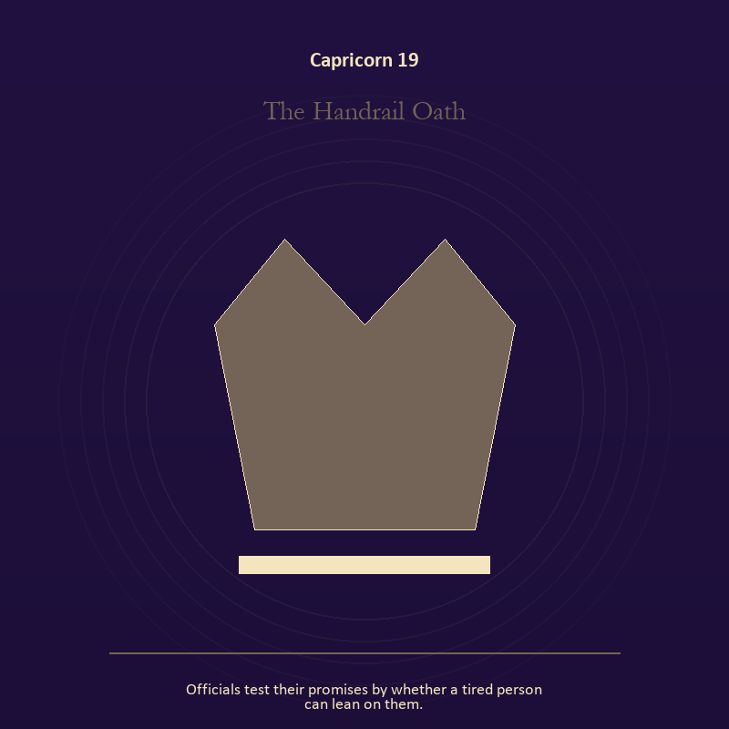

Capricorn 19 The Handrail Oath
Officials test their promises by whether a tired person can lean on them.
INTERPRETATION The Handrail Oath gives authority consequences inside the Storm-Born Architect. Within the Handrail Oath, authority is shown as a tool with weight, limits, witnesses, and an eventual transfer. At Capricorn 19, the symbol asks whom power protects when nobody is applauding. The same image also carries relationship; at Capricorn 19, the shared object in the scene carries an agreement. As a choice degree, Capricorn 19 tests whether awareness can become restraint, repair, refusal, or consent.
SIGNAL The usable force at Capricorn 19 is power made answerable joined to difference held without humiliation; Capricorn gives it form by asking you to build the support that lets other people stand without you.
SHADOW At Capricorn 19, the Handrail Oath can turn toward authority defending itself against correction and harmony purchased by one person's silence; watch duty become domination, hardship become vanity, or the institution defend itself against its purpose.
MIRROR The question at Capricorn 19: who carries the cost of the decision made here?
PRACTICE Give Capricorn 19 a physical form; inspect one standing rule by asking how it treats the person with the least power.
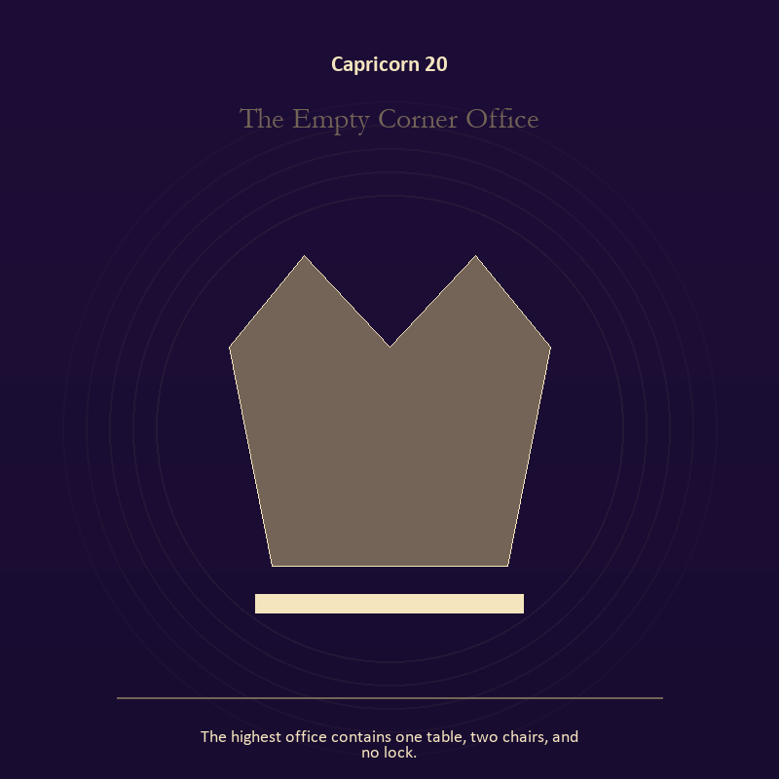

Capricorn 20 The Empty Corner Office
The highest office contains one table, two chairs, and no lock.
INTERPRETATION The Empty Corner Office puts authority under pressure from responsibility, endurance, institution, and authority tested by what it protects. Within the Empty Corner Office, crowns, laws, offices, and verdicts turn private judgment into public consequence. At Capricorn 20, their legitimacy depends on restraint and correction. The same image also carries relationship; at Capricorn 20, more than one will is active in this scene. As a choice degree, Capricorn 20 places responsibility in the reader's hands without promising a painless answer.
SIGNAL At Capricorn 20, a rule that protects the vulnerable person in the room joined to contact without capture carries the signal; it stays honest when you build the support that lets other people stand without you.
SHADOW The shadow at Capricorn 20 begins with role mistaken for worth and projection mistaken for intimacy; also watch duty become domination, hardship become vanity, or the institution defend itself against its purpose.
MIRROR At Capricorn 20, what would accountability require from the person holding the key?
PRACTICE Bring Capricorn 20 out of abstraction: choose one decision you control and write down who can challenge it, correct it, and leave its consequences.

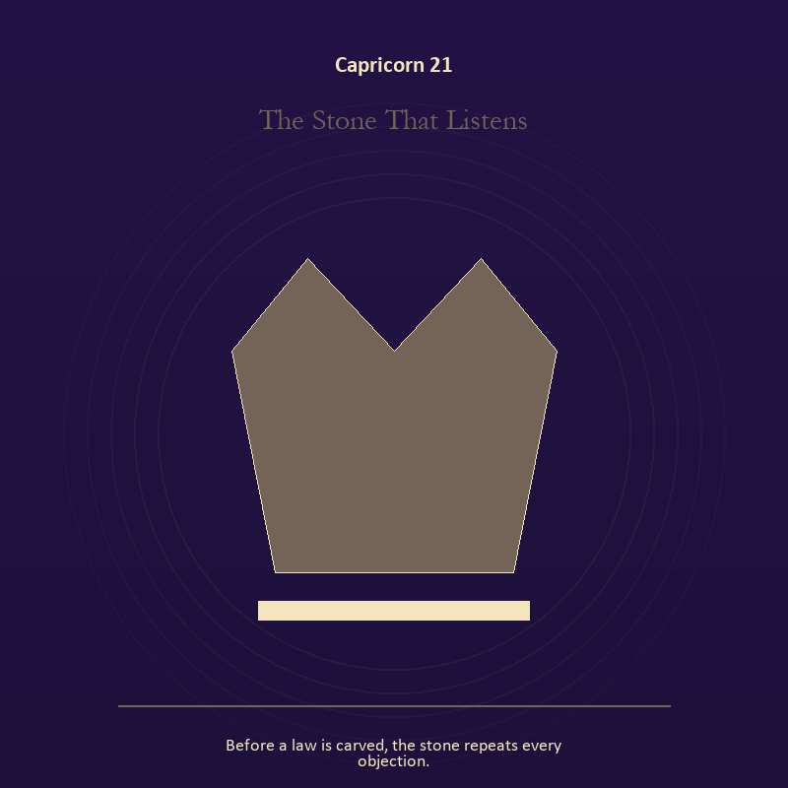

Capricorn 21 The Stone That Listens
Before a law is carved, the stone repeats every objection.
INTERPRETATION In the Stone That Listens, the work of authority must answer to responsibility, endurance, institution, and authority tested by what it protects. Within the Stone That Listens, institutional objects reveal the bargain between role and person. At Capricorn 21, a title may organize service or become a mask that excuses harm. As a integration degree, Capricorn 21 holds the gift beside its distortion; using one without feeding the other is the work.
SIGNAL What can be carried forward from Capricorn 21 is stewardship with an exit plan, tested by the need to build the support that lets other people stand without you.
SHADOW At Capricorn 21, the image darkens through procedure used to avoid conscience; watch duty become domination, hardship become vanity, or the institution defend itself against its purpose.
MIRROR For Capricorn 21, which part of this authority serves life, and which part serves its own continuation?
PRACTICE For Capricorn 21, remove your title from a current problem and describe the duty that remains.
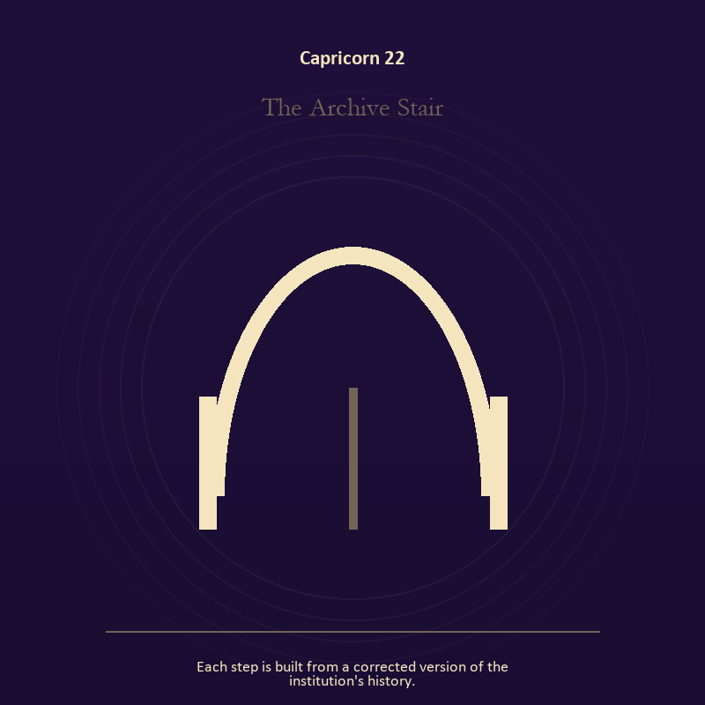

Capricorn 22 The Archive Stair
Each step is built from a corrected version of the institution's history.
INTERPRETATION The Archive Stair tests the threshold against responsibility, endurance, institution, and authority tested by what it protects. Within the Archive Stair, a threshold measures consent, timing, and consequence. At Capricorn 22, its presence asks whether passage is chosen, forced, delayed, or already under way. The same image also carries craft and record; at Capricorn 22, workshops honor correction. As a integration degree, Capricorn 22 asks the sign to carry its strength without turning that strength into jurisdiction.
SIGNAL At Capricorn 22, chosen change joined to a useful correction that outlives the moment becomes the clean signal when Capricorn can build the support that lets other people stand without you.
SHADOW The distortion at Capricorn 22 is waiting for permission that will never come and measurement mistaken for meaning; watch duty become domination, hardship become vanity, or the institution defend itself against its purpose.
MIRROR With the Archive Stair in mind at Capricorn 22, which threshold in your life requires consent rather than momentum?
PRACTICE Work with The Archive Stair directly at Capricorn 22: write one sentence beginning, 'I may enter when,' and one beginning, 'I remain free to leave when.'. For the second pressure at Capricorn 22, inspect one repeated task and add a check that would catch the most expensive error.

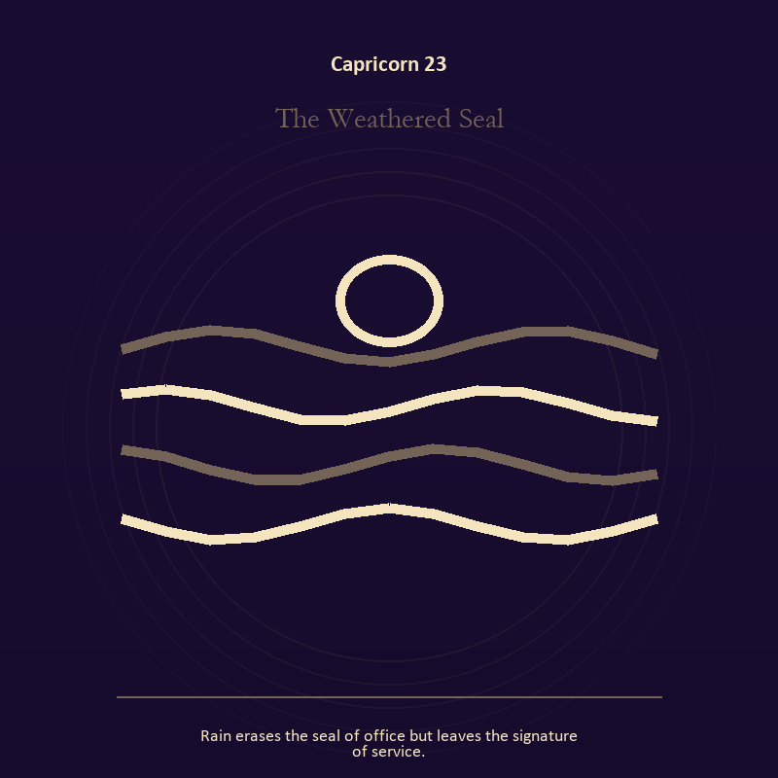

Capricorn 23 The Weathered Seal
Rain erases the seal of office but leaves the signature of service.
INTERPRETATION The Weathered Seal holds living water against responsibility, endurance, institution, and authority tested by what it protects. Within the Weathered Seal, a shore or vessel gives emotion a boundary without denying its depth. At Capricorn 23, the scene asks whether the feeling needs containment, release, or witness. The same image also carries authority; at Capricorn 23, authority is shown as a tool with weight, limits, witnesses, and an eventual transfer. As a integration degree, Capricorn 23 joins capacity to consequence; what helps in one setting may harm in another.
SIGNAL The usable force at Capricorn 23 is grief allowed to move joined to stewardship with an exit plan; Capricorn gives it form by asking you to build the support that lets other people stand without you.
SHADOW At Capricorn 23, the Weathered Seal can turn toward drowning in another person's weather and procedure used to avoid conscience; watch duty become domination, hardship become vanity, or the institution defend itself against its purpose.
MIRROR The question at Capricorn 23: where are you adapting wisely, and where are you disappearing?
PRACTICE Give Capricorn 23 a physical form; pour water slowly between two vessels and name what must change shape without losing its substance.
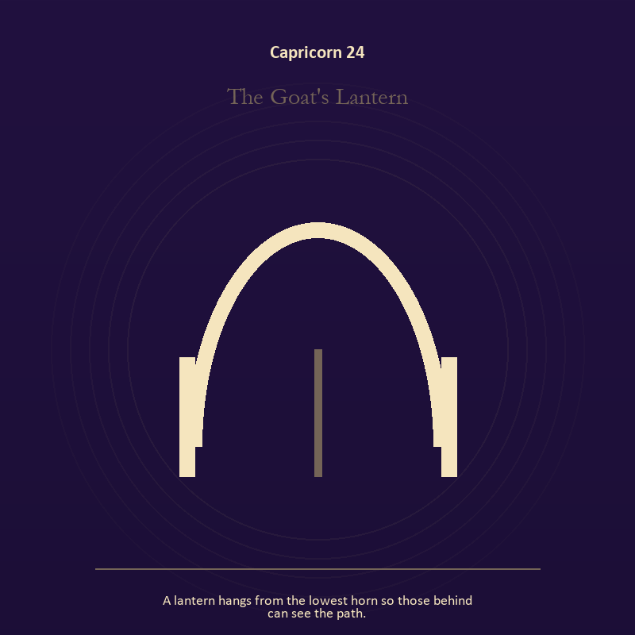

Capricorn 24 The Goat's Lantern
A lantern hangs from the lowest horn so those behind can see the path.
INTERPRETATION The Goat's Lantern gives living fire consequences inside the Storm-Born Architect. Within the Goat's Lantern, a Lantern offers enough light for the next honest step. At Capricorn 24, it does not remove night, and its usefulness depends on how it is carried. The same image also carries the threshold; at Capricorn 24, doors and roads turn inner change into an embodied decision. As a integration degree, Capricorn 24 shows the mature tool and the temptation hidden inside its handle.
SIGNAL At Capricorn 24, attention with warmth joined to chosen change carries the signal; it stays honest when you build the support that lets other people stand without you.
SHADOW The shadow at Capricorn 24 begins with exposure without care and waiting for permission that will never come; also watch duty become domination, hardship become vanity, or the institution defend itself against its purpose.
MIRROR At Capricorn 24, how much light does the next step require, and who might it expose? From a second angle at Capricorn 24, what are you protecting by remaining on this side of the door?
PRACTICE Bring Capricorn 24 out of abstraction: move one hidden concern into plain view by naming it to a trusted person.

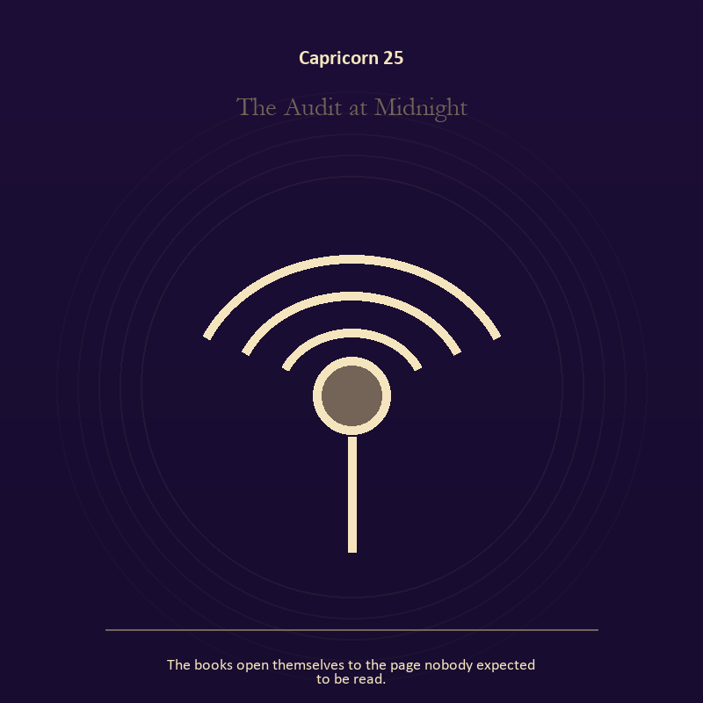

Capricorn 25 The Audit at Midnight
The books open themselves to the page nobody expected to be read.
INTERPRETATION The Audit at Midnight puts the descent under pressure from responsibility, endurance, institution, and authority tested by what it protects. Within the Audit at Midnight, descent imagery carries what ordinary daylight has failed to resolve. At Capricorn 25, it asks for contact with the wound, bargain, fear, or grief beneath the public account. The same image also carries voice and naming; at Capricorn 25, naming creates a handle for experience, but the handle must remain smaller than the life it describes. As a integration degree, Capricorn 25 tests whether the lesson can be lived without becoming a new performance.
SIGNAL What can be carried forward from Capricorn 25 is contact with buried power joined to listening precise enough to change the reply, tested by the need to build the support that lets other people stand without you.
SHADOW At Capricorn 25, the image darkens through remaining underground after the danger has passed and using language to outrun experience; watch duty become domination, hardship become vanity, or the institution defend itself against its purpose.
MIRROR For Capricorn 25, what difficult fact survives when the dramatic story is removed?
PRACTICE For Capricorn 25, choose a trusted witness and tell the smallest complete truth you can safely tell.
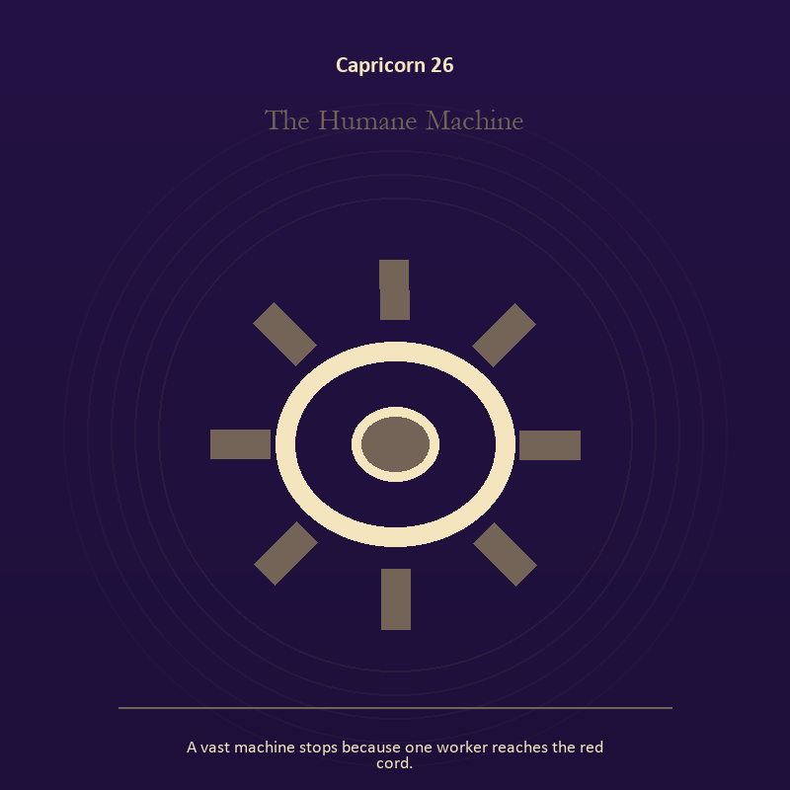

Capricorn 26 The Humane Machine
A vast machine stops because one worker reaches the red cord.
INTERPRETATION In the Humane Machine, the work of craft and record must answer to responsibility, endurance, institution, and authority tested by what it protects. Within the Humane Machine, ledgers, maps, machines, and archives make memory operational. At Capricorn 26, they can protect truth or compress living complexity until only the form remains. As a release degree, Capricorn 26 prepares the lesson to leave its original container; keep the capacity and loosen the role.
SIGNAL At Capricorn 26, a useful correction that outlives the moment becomes the clean signal when Capricorn can build the support that lets other people stand without you.
SHADOW The distortion at Capricorn 26 is measurement mistaken for meaning; watch duty become domination, hardship become vanity, or the institution defend itself against its purpose.
MIRROR With the Humane Machine in mind at Capricorn 26, what does the tool preserve, and what does it leave out?
PRACTICE Work with The Humane Machine directly at Capricorn 26: inspect one repeated task and add a check that would catch the most expensive error.

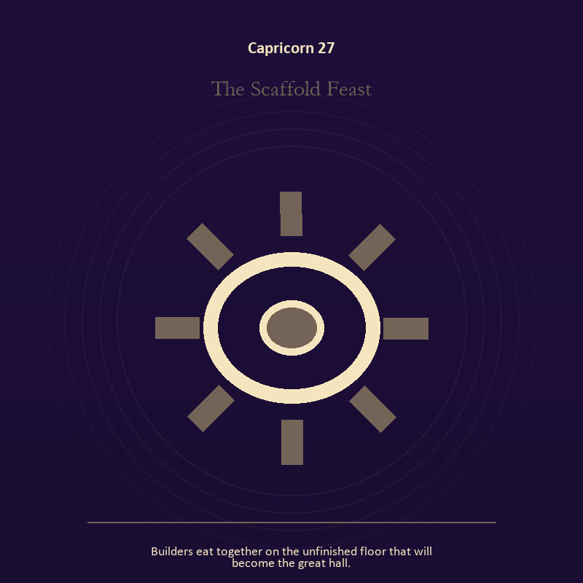

Capricorn 27 The Scaffold Feast
Builders eat together on the unfinished floor that will become the great hall.
INTERPRETATION The Scaffold Feast tests relationship against responsibility, endurance, institution, and authority tested by what it protects. Within the Scaffold Feast, the shared object in the scene carries an agreement. At Capricorn 27, its condition reveals whether responsibility is mutual, hidden, refused, or unevenly assigned. The same image also carries the body; at Capricorn 27, bread, rest, touch, clothing, and shelter make spiritual language answer to material need. As a release degree, Capricorn 27 asks what can be handed onward without demanding imitation or loyalty.
SIGNAL The usable force at Capricorn 27 is contact without capture joined to care made material; Capricorn gives it form by asking you to build the support that lets other people stand without you.
SHADOW At Capricorn 27, the Scaffold Feast can turn toward projection mistaken for intimacy and letting appetite make the whole decision; watch duty become domination, hardship become vanity, or the institution defend itself against its purpose.
MIRROR The question at Capricorn 27: can this bond survive an honest difference and a visible exit? From a second angle at Capricorn 27, which need in this scene has been made too ordinary to mention?
PRACTICE Give Capricorn 27 a physical form; name one need, one boundary, and one freedom that belong to each person in the scene.
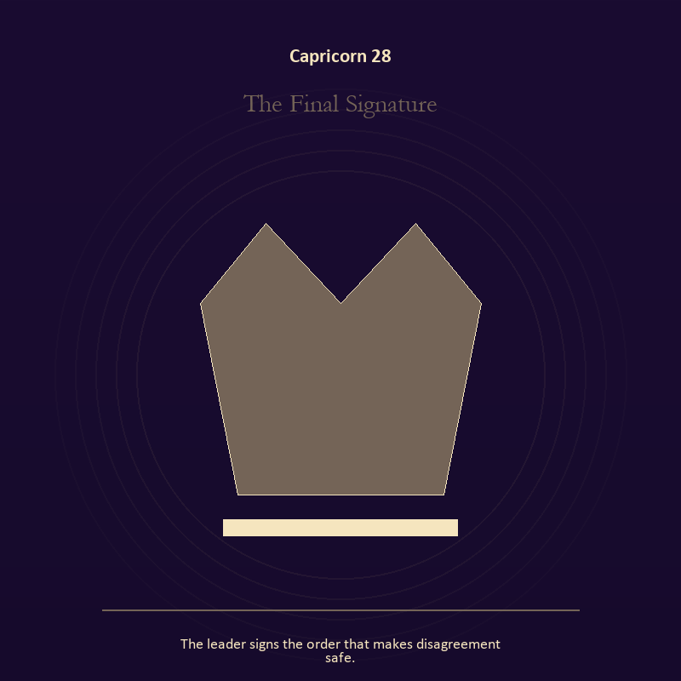

Capricorn 28 The Final Signature
The leader signs the order that makes disagreement safe.
INTERPRETATION The Final Signature holds authority against responsibility, endurance, institution, and authority tested by what it protects. Within the Final Signature, authority is shown as a tool with weight, limits, witnesses, and an eventual transfer. At Capricorn 28, the symbol asks whom power protects when nobody is applauding. As a release degree, Capricorn 28 turns completion into transfer; the work survives by changing hands.
SIGNAL At Capricorn 28, power made answerable carries the signal; it stays honest when you build the support that lets other people stand without you.
SHADOW The shadow at Capricorn 28 begins with authority defending itself against correction; also watch duty become domination, hardship become vanity, or the institution defend itself against its purpose.
MIRROR At Capricorn 28, who carries the cost of the decision made here?
PRACTICE Bring Capricorn 28 out of abstraction: inspect one standing rule by asking how it treats the person with the least power.

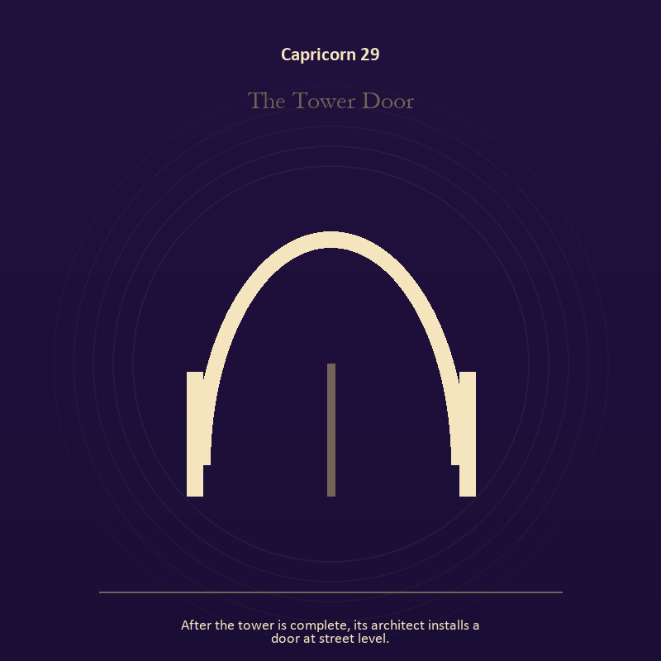

Capricorn 29 The Tower Door
After the tower is complete, its architect installs a door at street level.
INTERPRETATION The Tower Door gives the threshold consequences inside the Storm-Born Architect. Within the Tower Door, doors and roads turn inner change into an embodied decision. At Capricorn 29, the next room matters, but so does the condition under which it is entered. The same image also carries craft and record; at Capricorn 29, craft turns intention into a repeatable act with materials, limits, and evidence of failure. As a release degree, Capricorn 29 lets the sign set down the identity built around its ordeal.
SIGNAL What can be carried forward from Capricorn 29 is a boundary that clarifies freedom joined to care made repeatable, tested by the need to build the support that lets other people stand without you.
SHADOW At Capricorn 29, the image darkens through crossing before consent and the tool becoming the master; watch duty become domination, hardship become vanity, or the institution defend itself against its purpose.
MIRROR For Capricorn 29, what are you protecting by remaining on this side of the door?
PRACTICE For Capricorn 29, stand at a literal doorway, name what you are leaving and what you refuse to abandon, then cross only if the answer feels clean.
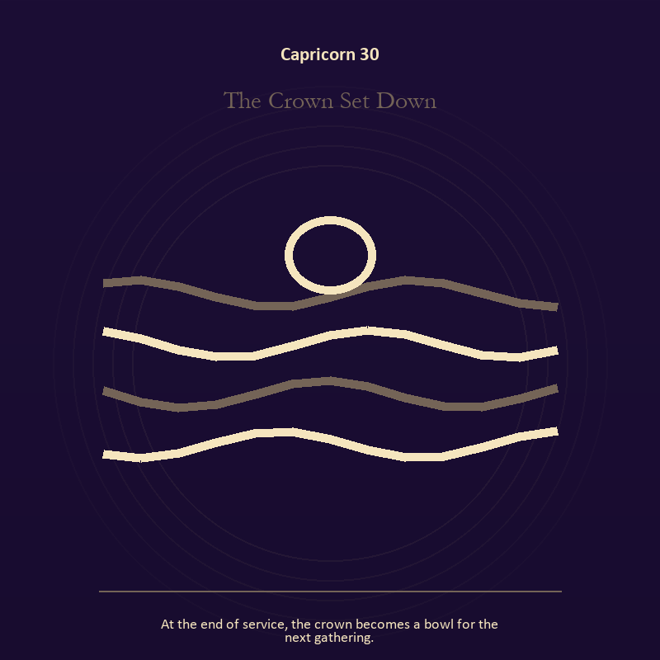

Capricorn 30 The Crown Set Down
At the end of service, the crown becomes a bowl for the next gathering.
INTERPRETATION The Crown Set Down puts authority under pressure from responsibility, endurance, institution, and authority tested by what it protects. Within the Crown Set Down, institutional objects reveal the bargain between role and person. At Capricorn 30, a title may organize service or become a mask that excuses harm. The same image also carries identity; at Capricorn 30, masks and names can conceal, reveal, or give shape to a truth that plain speech cannot yet hold. As a release degree, Capricorn 30 returns the earned knowledge to ordinary life, where another cycle can use it.
SIGNAL At Capricorn 30, stewardship with an exit plan joined to a protective form used consciously becomes the clean signal when Capricorn can build the support that lets other people stand without you.
SHADOW The distortion at Capricorn 30 is procedure used to avoid conscience and a mask that can no longer be removed safely; watch duty become domination, hardship become vanity, or the institution defend itself against its purpose.
MIRROR With the Crown Set Down in mind at Capricorn 30, which part of this authority serves life, and which part serves its own continuation? From a second angle at Capricorn 30, what does the mask make possible, and what does it cost to keep wearing it?
PRACTICE Work with The Crown Set Down directly at Capricorn 30: remove your title from a current problem and describe the duty that remains. For the second pressure at Capricorn 30, set aside one performance for a day and notice which relationships still feel safe.

Aquarius
The Living Network
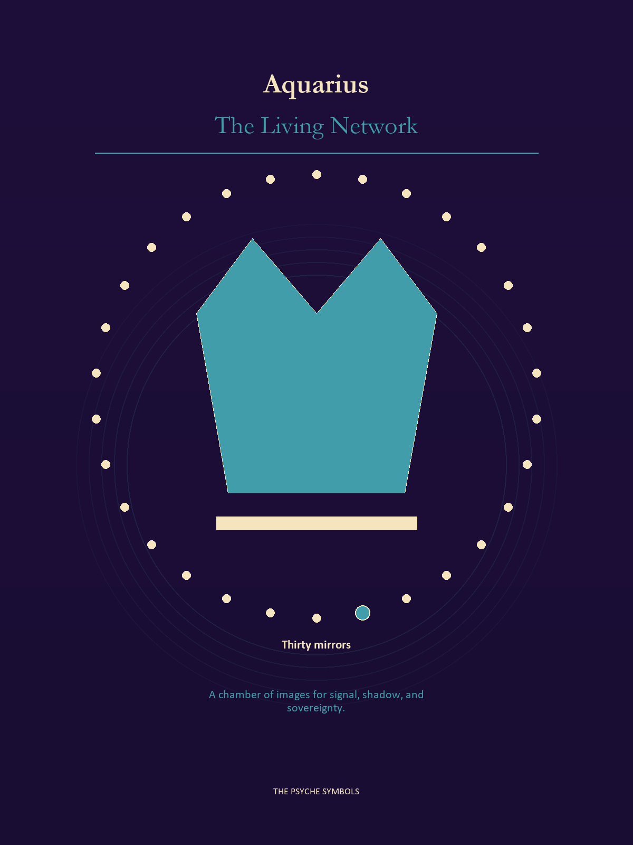
Aquarius opens the structure to the many and listens for the pattern no single voice can own. The Living Network concerns technology, dissent, access, strange alliances, collective memory, and the design of shared power. Here community becomes intelligent when difference can move through it without being flattened.

Degrees | Gate | Work
1-5 | Arrival | Meet the image before deciding what it means.
6-10 | Friction | Notice what pushes back and what that resistance protects.
11-15 | Revelation | Name the detail that changes the whole scene.
16-20 | Choice | Choose the act that preserves both truth and human dignity.
21-25 | Integration | Use the gift without feeding the shadow that travels beside it.
26-30 | Release | Keep the earned capacity and release the role that delivered it.

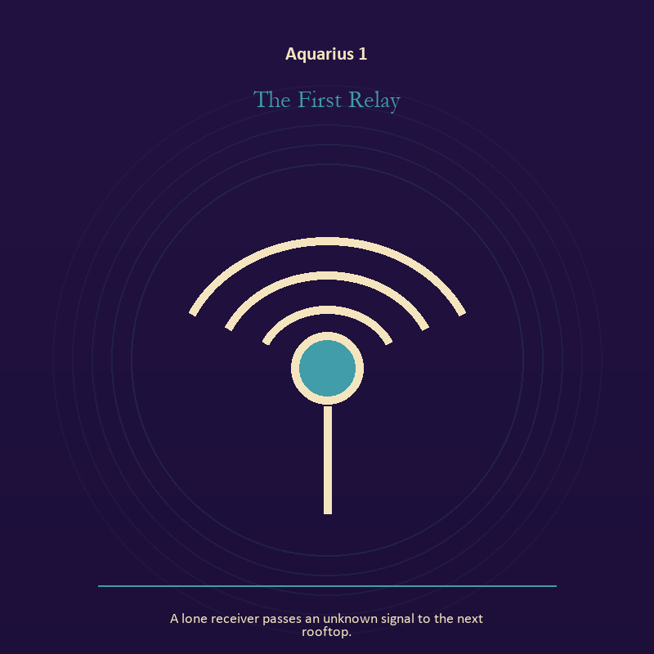

Aquarius 1 The First Relay
A lone receiver passes an unknown signal to the next rooftop.
INTERPRETATION In the First Relay, the work of the Signal must answer to invention, fellowship, dissent, and intelligence between independent minds. Within the First Relay, signal imagery asks what is being transmitted beneath performance. At Aquarius 1, interference may come from fear, vanity, noise, or a container too narrow for the message. As an arrival degree, Aquarius 1 arrives before habit can tidy the evidence; notice what is present before deciding what it should become.
SIGNAL The usable force at Aquarius 1 is contact across distance; Aquarius gives it form by asking you to share the mechanism, distribute the power, and keep dissent inside the design.
SHADOW At Aquarius 1, the First Relay can turn toward letting noise impersonate urgency; beware abstraction that forgets bodies, belonging based on sameness, or systems that hide their gatekeepers.
MIRROR The question at Aquarius 1: what remains of your message when performance is removed?
PRACTICE Give Aquarius 1 a physical form; write the same message for a friend, an opponent, and your future self; then keep the sentence that stays true in all three versions.
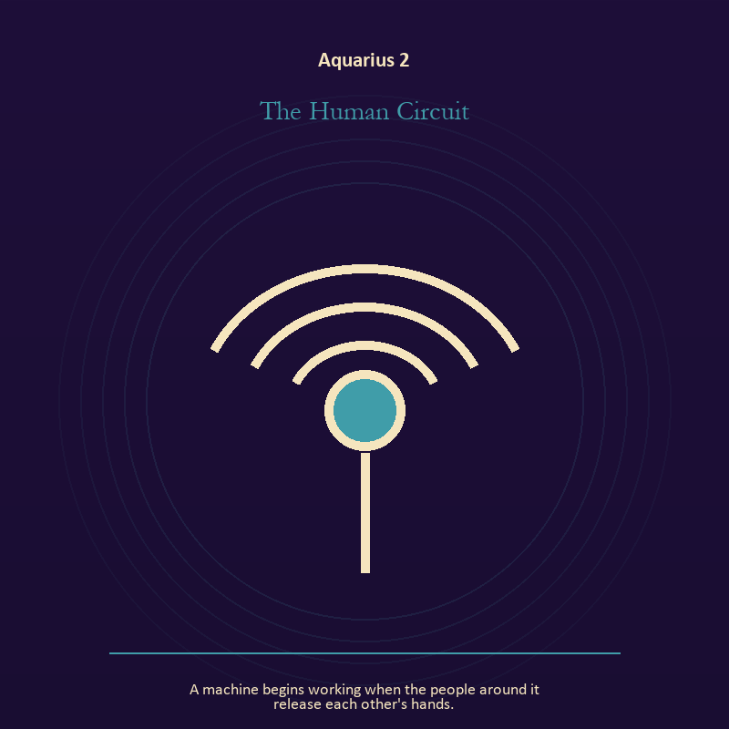

Aquarius 2 The Human Circuit
A machine begins working when the people around it release each other's hands.
INTERPRETATION The Human Circuit tests the Signal against invention, fellowship, dissent, and intelligence between independent minds. Within the Human Circuit, a broadcast joins private interior life to a field of witnesses. At Aquarius 2, the ethical question is whether the transmission informs, manipulates, performs, or genuinely makes contact. The same image also carries craft and record; at Aquarius 2, craft turns intention into a repeatable act with materials, limits, and evidence of failure. As an arrival degree, Aquarius 2 introduces the sign's raw material in an unguarded form; the first response matters less than the honest one.
SIGNAL At Aquarius 2, a message that survives its container joined to care made repeatable carries the signal; it stays honest when you share the mechanism, distribute the power, and keep dissent inside the design.
SHADOW The shadow at Aquarius 2 begins with performing instead of speaking and the tool becoming the master; also beware abstraction that forgets bodies, belonging based on sameness, or systems that hide their gatekeepers.
MIRROR At Aquarius 2, which noise have you mistaken for proof that you are being heard?
PRACTICE Bring Aquarius 2 out of abstraction: say the message aloud in one plain sentence without branding, apology, or decoration.

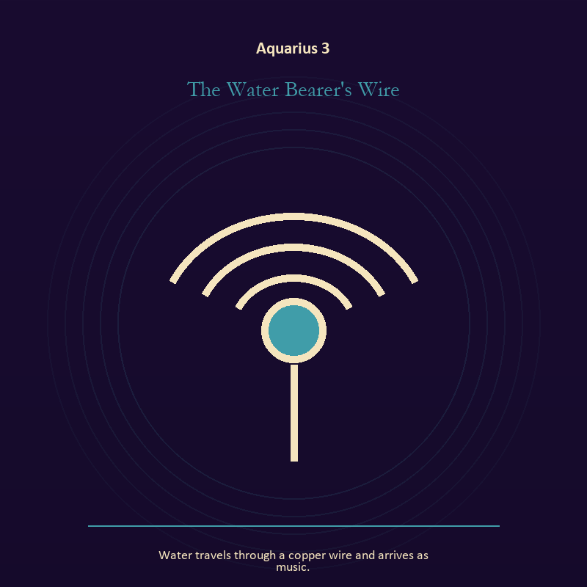

Aquarius 3 The Water Bearer's Wire
Water travels through a copper wire and arrives as music.
INTERPRETATION The Water Bearer's Wire holds the Signal against invention, fellowship, dissent, and intelligence between independent minds. Within the Water Bearer's Wire, machines in these symbols expose the difference between a living message and the equipment carrying it. At Aquarius 3, when the device fails, the signal may become easier to hear. The same image also carries living water; at Aquarius 3, a shore or vessel gives emotion a boundary without denying its depth. As an arrival degree, Aquarius 3 catches the first impulse before it turns into a role; give the image room to remain strange.
SIGNAL What can be carried forward from Aquarius 3 is clear transmission joined to adaptation without self-erasure, tested by the need to share the mechanism, distribute the power, and keep dissent inside the design.
SHADOW At Aquarius 3, the image darkens through confusing reach with truth and building a vessel too rigid for living water; beware abstraction that forgets bodies, belonging based on sameness, or systems that hide their gatekeepers.
MIRROR For Aquarius 3, who is the real receiver of the signal you are sending? From a second angle at Aquarius 3, where are you adapting wisely, and where are you disappearing?
PRACTICE For Aquarius 3, turn off one source of noise for an hour and notice what thought keeps returning.
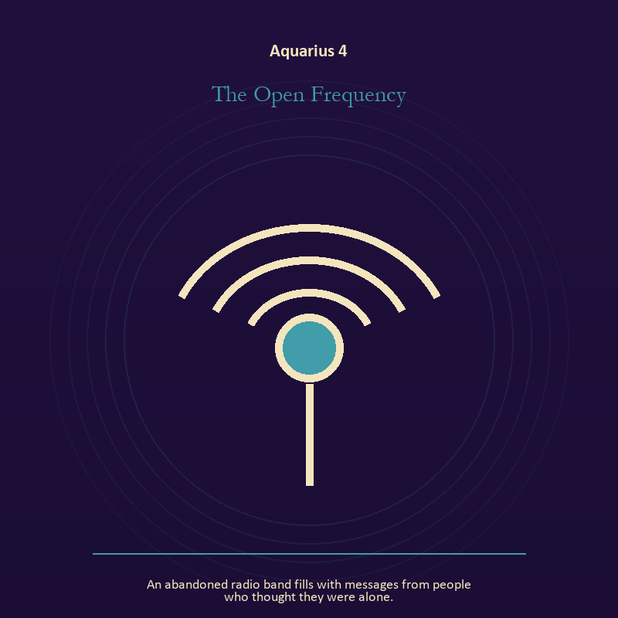

Aquarius 4 The Open Frequency
An abandoned radio band fills with messages from people who thought they were alone.
INTERPRETATION The Open Frequency gives the Signal consequences inside the Living Network. Within the Open Frequency, signal imagery asks what is being transmitted beneath performance. At Aquarius 4, interference may come from fear, vanity, noise, or a container too narrow for the message. The same image also carries relationship; at Aquarius 4, the shared object in the scene carries an agreement. As an arrival degree, Aquarius 4 opens the chamber with no settled method; name the need, risk, or appetite that entered with it.
SIGNAL At Aquarius 4, contact across distance joined to difference held without humiliation becomes the clean signal when Aquarius can share the mechanism, distribute the power, and keep dissent inside the design.
SHADOW The distortion at Aquarius 4 is letting noise impersonate urgency and harmony purchased by one person's silence; beware abstraction that forgets bodies, belonging based on sameness, or systems that hide their gatekeepers.
MIRROR With the Open Frequency in mind at Aquarius 4, what remains of your message when performance is removed?
PRACTICE Work with The Open Frequency directly at Aquarius 4: write the same message for a friend, an opponent, and your future self; then keep the sentence that stays true in all three versions. For the second pressure at Aquarius 4, ask the other person what they believe the agreement is, then compare it with your own version.

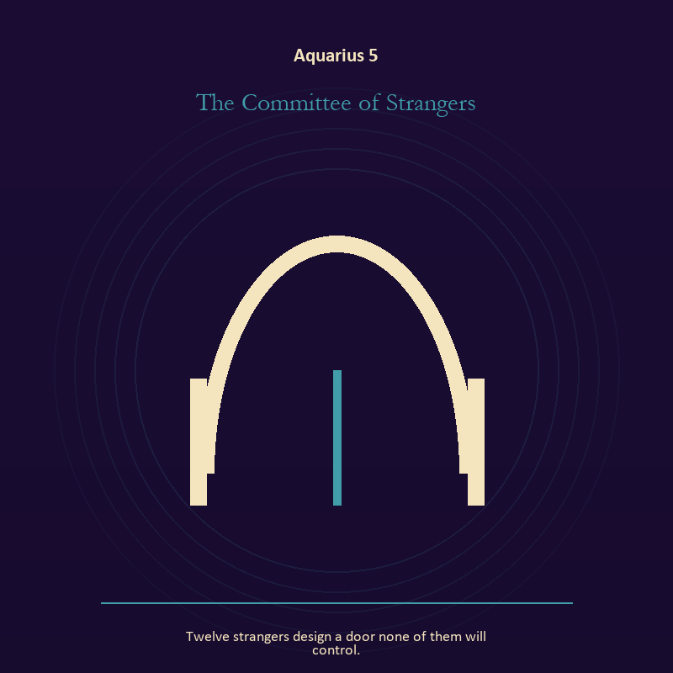

Aquarius 5 The Committee of Strangers
Twelve strangers design a door none of them will control.
INTERPRETATION The Committee of Strangers puts relationship under pressure from invention, fellowship, dissent, and intelligence between independent minds. Within the Committee of Strangers, relationship imagery tests the fantasy that harmony requires sameness. At Aquarius 5, a living bond can hold difference, correction, privacy, and departure. The same image also carries the threshold; at Aquarius 5, a threshold measures consent, timing, and consequence. As an arrival degree, Aquarius 5 shows the beginning before ownership hardens around it; let attention come before possession.
SIGNAL The usable force at Aquarius 5 is difference held without humiliation joined to honest passage; Aquarius gives it form by asking you to share the mechanism, distribute the power, and keep dissent inside the design.
SHADOW At Aquarius 5, the Committee of Strangers can turn toward harmony purchased by one person's silence and guarding an obsolete enclosure; beware abstraction that forgets bodies, belonging based on sameness, or systems that hide their gatekeepers.
MIRROR The question at Aquarius 5: where does responsibility belong, and where has it been displaced?
PRACTICE Give Aquarius 5 a physical form; ask the other person what they believe the agreement is, then compare it with your own version.
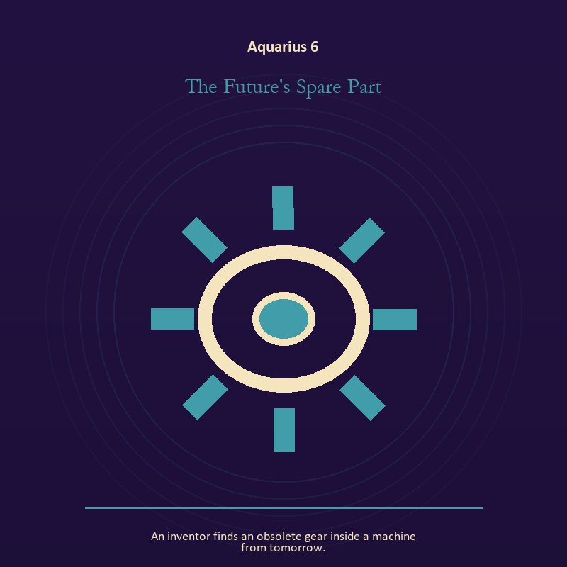

Aquarius 6 The Future's Spare Part
An inventor finds an obsolete gear inside a machine from tomorrow.
INTERPRETATION In the Future's Spare Part, the work of craft and record must answer to invention, fellowship, dissent, and intelligence between independent minds. Within the Future's Spare Part, workshops honor correction. At Aquarius 6, a flaw becomes useful when it is found early, recorded honestly, and repaired without hiding the seam. As a friction degree, Aquarius 6 meets resistance, and that resistance reveals what the first impulse failed to consider.
SIGNAL At Aquarius 6, care made repeatable carries the signal; it stays honest when you share the mechanism, distribute the power, and keep dissent inside the design.
SHADOW The shadow at Aquarius 6 begins with the tool becoming the master; also beware abstraction that forgets bodies, belonging based on sameness, or systems that hide their gatekeepers.
MIRROR At Aquarius 6, where would an honest repair remain visible?
PRACTICE Bring Aquarius 6 out of abstraction: keep a brief record of what happened, what you expected, and what changed your mind.

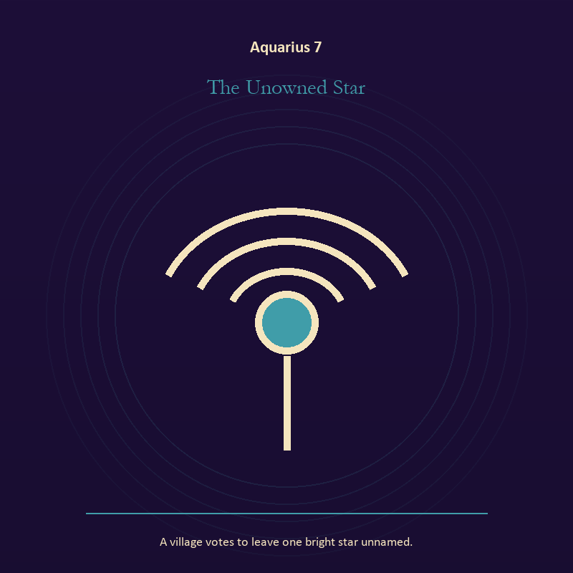

Aquarius 7 The Unowned Star
A village votes to leave one bright star unnamed.
INTERPRETATION The Unowned Star tests mystery against invention, fellowship, dissent, and intelligence between independent minds. Within the Unowned Star, the scene behaves like a dream with its own exact logic. At Aquarius 7, meaning lives in the relationship between figure, place, action, and the detail that refuses ordinary explanation. As a friction degree, Aquarius 7 places consequence beside desire; the obstruction may be an enemy, a limit, or a needed correction.
SIGNAL What can be carried forward from Aquarius 7 is imagination disciplined by the scene, tested by the need to share the mechanism, distribute the power, and keep dissent inside the design.
SHADOW At Aquarius 7, the image darkens through mistaking intensity for accuracy; beware abstraction that forgets bodies, belonging based on sameness, or systems that hide their gatekeepers.
MIRROR For Aquarius 7, which detail keeps returning after the rest of the scene fades?
PRACTICE For Aquarius 7, keep the image nearby for one day and record only the moments when it returns on its own.
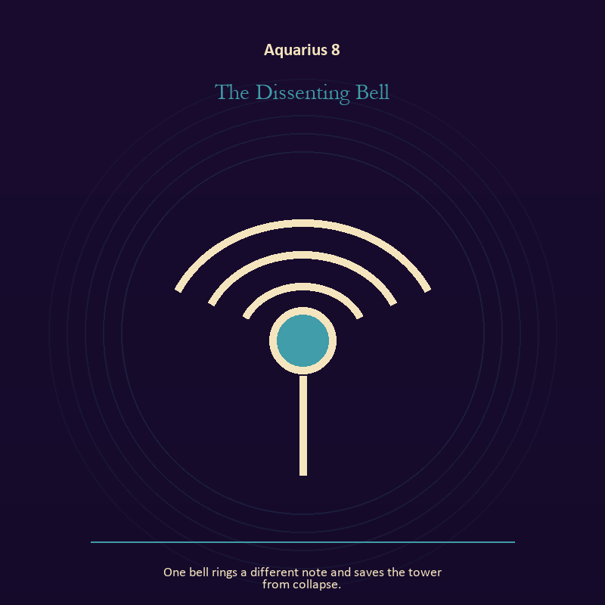

Aquarius 8 The Dissenting Bell
One bell rings a different note and saves the tower from collapse.
INTERPRETATION The Dissenting Bell holds voice and naming against invention, fellowship, dissent, and intelligence between independent minds. Within the Dissenting Bell, books, letters, bells, and songs extend speech beyond the speaker's body. At Aquarius 8, the message acquires a life that intention can no longer fully govern. As a friction degree, Aquarius 8 tests whether the sign can change course without treating correction as defeat.
SIGNAL At Aquarius 8, listening precise enough to change the reply becomes the clean signal when Aquarius can share the mechanism, distribute the power, and keep dissent inside the design.
SHADOW The distortion at Aquarius 8 is using language to outrun experience; beware abstraction that forgets bodies, belonging based on sameness, or systems that hide their gatekeepers.
MIRROR With the Dissenting Bell in mind at Aquarius 8, what needs to be said plainly, and who has earned the right to hear it?
PRACTICE Work with The Dissenting Bell directly at Aquarius 8: write the sentence you keep rehearsing, remove every accusation you cannot prove, and read what remains aloud.

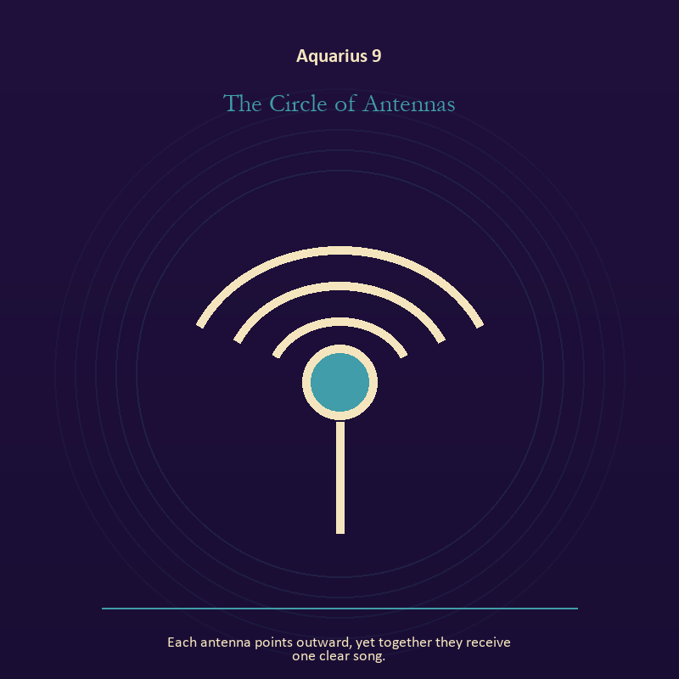

Aquarius 9 The Circle of Antennas
Each antenna points outward, yet together they receive one clear song.
INTERPRETATION The Circle of Antennas gives the Signal consequences inside the Living Network. Within the Circle of Antennas, machines in these symbols expose the difference between a living message and the equipment carrying it. At Aquarius 9, when the device fails, the signal may become easier to hear. The same image also carries voice and naming; at Aquarius 9, books, letters, bells, and songs extend speech beyond the speaker's body. As a friction degree, Aquarius 9 brings another will, material limit, or inconvenient fact into the frame.
SIGNAL The usable force at Aquarius 9 is clear transmission joined to a name that restores agency; Aquarius gives it form by asking you to share the mechanism, distribute the power, and keep dissent inside the design.
SHADOW At Aquarius 9, the Circle of Antennas can turn toward confusing reach with truth and speaking for someone whose voice is present; beware abstraction that forgets bodies, belonging based on sameness, or systems that hide their gatekeepers.
MIRROR The question at Aquarius 9: who is the real receiver of the signal you are sending? From a second angle at Aquarius 9, what needs to be said plainly, and who has earned the right to hear it?
PRACTICE Give Aquarius 9 a physical form; turn off one source of noise for an hour and notice what thought keeps returning.


Aquarius 10 The Anonymous Gift
A package circulates through the city, repaired and improved by every recipient.
INTERPRETATION The Anonymous Gift puts mystery under pressure from invention, fellowship, dissent, and intelligence between independent minds. Within the Anonymous Gift, the scene behaves like a dream with its own exact logic. At Aquarius 10, meaning lives in the relationship between figure, place, action, and the detail that refuses ordinary explanation. As a friction degree, Aquarius 10 slows the original motion long enough to expose what haste concealed.
SIGNAL At Aquarius 10, imagination disciplined by the scene carries the signal; it stays honest when you share the mechanism, distribute the power, and keep dissent inside the design.
SHADOW The shadow at Aquarius 10 begins with mistaking intensity for accuracy; also beware abstraction that forgets bodies, belonging based on sameness, or systems that hide their gatekeepers.
MIRROR At Aquarius 10, which detail keeps returning after the rest of the scene fades?
PRACTICE Bring Aquarius 10 out of abstraction: keep the image nearby for one day and record only the moments when it returns on its own.

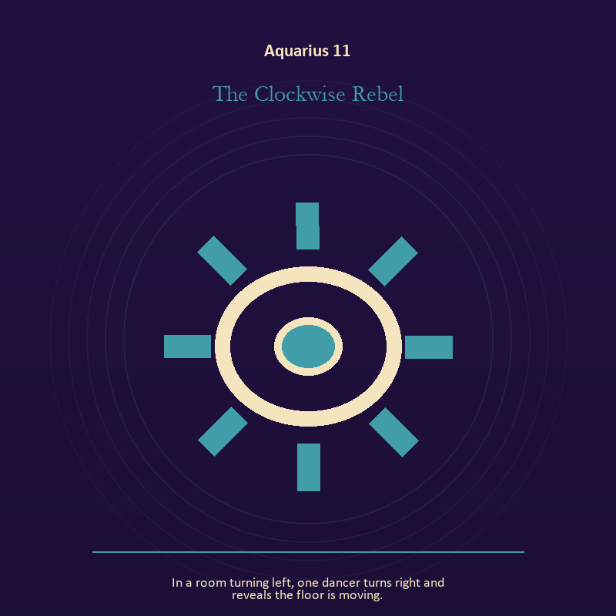

Aquarius 11 The Clockwise Rebel
In a room turning left, one dancer turns right and reveals the floor is moving.
INTERPRETATION In the Clockwise Rebel, the work of mystery must answer to invention, fellowship, dissent, and intelligence between independent minds. Within the Clockwise Rebel, this image invites attention before conclusion. At Aquarius 11, its strange fact creates a pressure point where memory, desire, fear, and choice can speak indirectly. As a revelation degree, Aquarius 11 reveals the mechanism under the mood; one concrete detail changes the reading.
SIGNAL What can be carried forward from Aquarius 11 is an unanswered image that keeps thought alive, tested by the need to share the mechanism, distribute the power, and keep dissent inside the design.
SHADOW At Aquarius 11, the image darkens through forcing a prophecy from ambiguity; beware abstraction that forgets bodies, belonging based on sameness, or systems that hide their gatekeepers.
MIRROR For Aquarius 11, what ordinary fact sits beneath the strange image?
PRACTICE For Aquarius 11, copy the image by hand, underline three concrete nouns, and write one association for each.
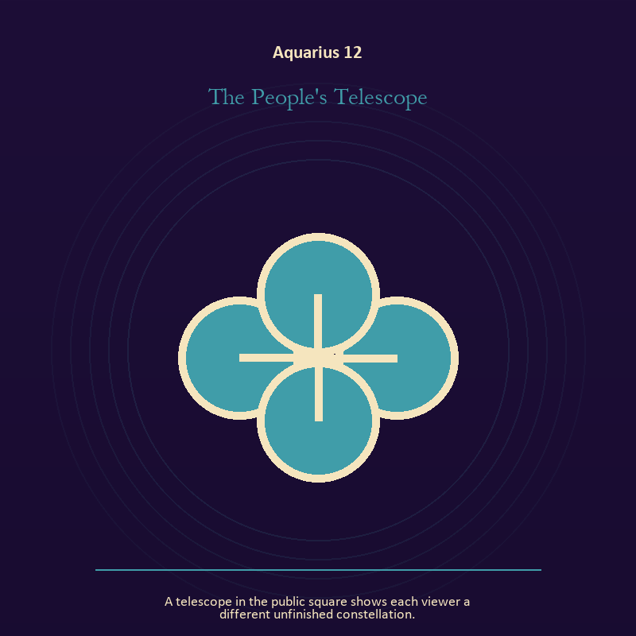

Aquarius 12 The People's Telescope
A telescope in the public square shows each viewer a different unfinished constellation.
INTERPRETATION The People's Telescope tests relationship against invention, fellowship, dissent, and intelligence between independent minds. Within the People's Telescope, the shared object in the scene carries an agreement. At Aquarius 12, its condition reveals whether responsibility is mutual, hidden, refused, or unevenly assigned. As a revelation degree, Aquarius 12 moves the hidden arrangement into view, where it can be named without being exaggerated.
SIGNAL At Aquarius 12, contact without capture becomes the clean signal when Aquarius can share the mechanism, distribute the power, and keep dissent inside the design.
SHADOW The distortion at Aquarius 12 is projection mistaken for intimacy; beware abstraction that forgets bodies, belonging based on sameness, or systems that hide their gatekeepers.
MIRROR With the People's Telescope in mind at Aquarius 12, can this bond survive an honest difference and a visible exit?
PRACTICE Work with The People's Telescope directly at Aquarius 12: name one need, one boundary, and one freedom that belong to each person in the scene.

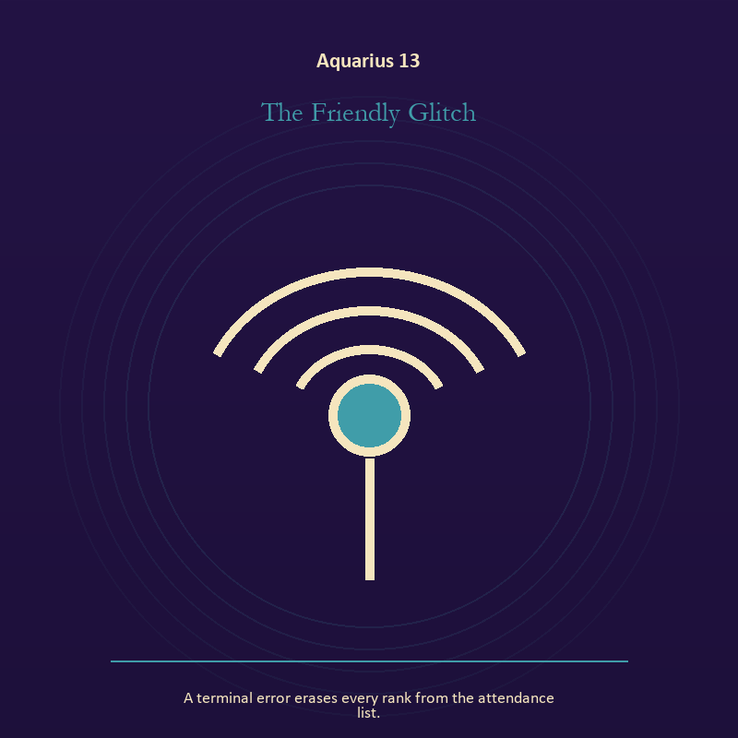

Aquarius 13 The Friendly Glitch
A terminal error erases every rank from the attendance list.
INTERPRETATION The Friendly Glitch holds the Signal against invention, fellowship, dissent, and intelligence between independent minds. Within the Friendly Glitch, signal imagery asks what is being transmitted beneath performance. At Aquarius 13, interference may come from fear, vanity, noise, or a container too narrow for the message. The same image also carries authority; at Aquarius 13, institutional objects reveal the bargain between role and person. As a revelation degree, Aquarius 13 turns atmosphere into evidence; attend to the object or action that cannot be explained away.
SIGNAL The usable force at Aquarius 13 is contact across distance joined to a rule that protects the vulnerable person in the room; Aquarius gives it form by asking you to share the mechanism, distribute the power, and keep dissent inside the design.
SHADOW At Aquarius 13, the Friendly Glitch can turn toward letting noise impersonate urgency and role mistaken for worth; beware abstraction that forgets bodies, belonging based on sameness, or systems that hide their gatekeepers.
MIRROR The question at Aquarius 13: what remains of your message when performance is removed?
PRACTICE Give Aquarius 13 a physical form; write the same message for a friend, an opponent, and your future self; then keep the sentence that stays true in all three versions.
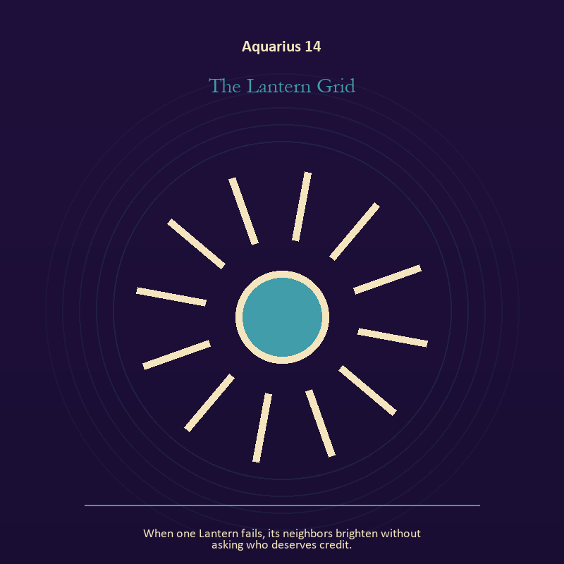

Aquarius 14 The Lantern Grid
When one Lantern fails, its neighbors brighten without asking who deserves credit.
INTERPRETATION The Lantern Grid gives living fire consequences inside the Living Network. Within the Lantern Grid, fire gives change a visible cost. At Aquarius 14, something is illuminated here because something else is being spent. As a revelation degree, Aquarius 14 shows who carries the cost, who controls the passage, and what the scene refuses to hide.
SIGNAL At Aquarius 14, a truth made visible at the right scale carries the signal; it stays honest when you share the mechanism, distribute the power, and keep dissent inside the design.
SHADOW The shadow at Aquarius 14 begins with burning for recognition; also beware abstraction that forgets bodies, belonging based on sameness, or systems that hide their gatekeepers.
MIRROR At Aquarius 14, where has your fire become performance rather than warmth?
PRACTICE Bring Aquarius 14 out of abstraction: light one candle and give its entire burn to a single unfinished question.

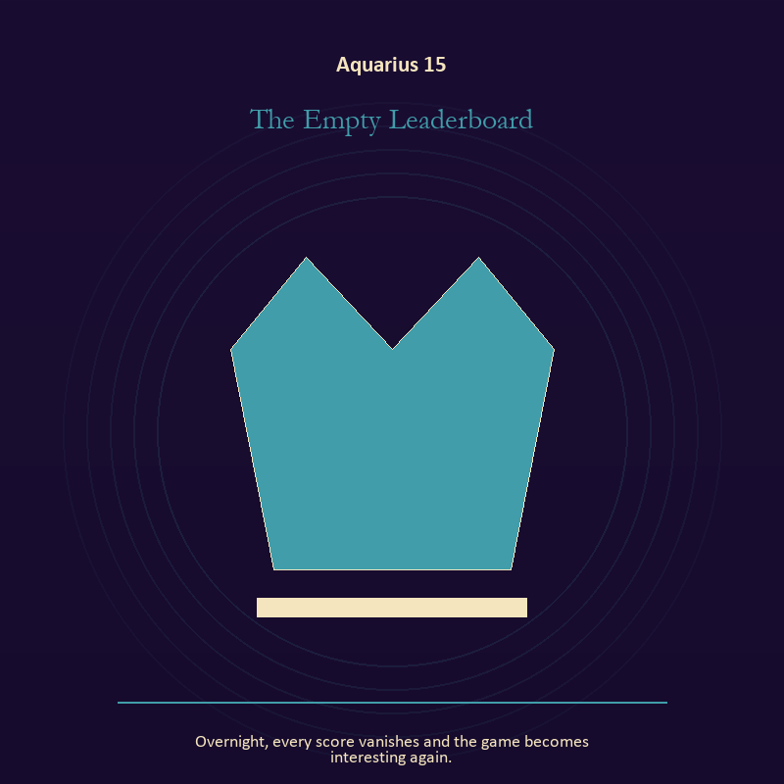

Aquarius 15 The Empty Leaderboard
Overnight, every score vanishes and the game becomes interesting again.
INTERPRETATION The Empty Leaderboard puts mystery under pressure from invention, fellowship, dissent, and intelligence between independent minds. Within the Empty Leaderboard, the symbol remains useful when no single interpretation closes it. At Aquarius 15, its work is to make one hidden relationship visible enough to examine. As a revelation degree, Aquarius 15 brings the middle truth forward, after the first story has lost its grip.
SIGNAL What can be carried forward from Aquarius 15 is attention without premature certainty, tested by the need to share the mechanism, distribute the power, and keep dissent inside the design.
SHADOW At Aquarius 15, the image darkens through using beauty to avoid the ordinary fact; beware abstraction that forgets bodies, belonging based on sameness, or systems that hide their gatekeepers.
MIRROR For Aquarius 15, what changes if the scene is a question rather than an answer?
PRACTICE For Aquarius 15, describe the scene to another person without explaining it, then notice what they ask first.
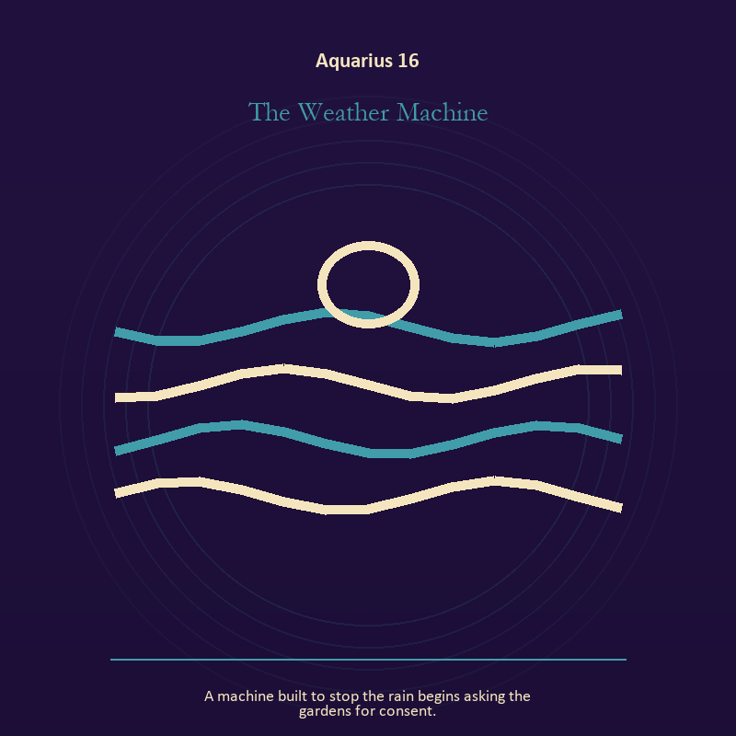

Aquarius 16 The Weather Machine
A machine built to stop the rain begins asking the gardens for consent.
INTERPRETATION In the Weather Machine, the work of craft and record must answer to invention, fellowship, dissent, and intelligence between independent minds. Within the Weather Machine, craft turns intention into a repeatable act with materials, limits, and evidence of failure. At Aquarius 16, the tool reveals the quality of attention brought to it. The same image also carries living water; at Aquarius 16, rain, tides, wells, and floods move private material into a shared landscape. As a choice degree, Aquarius 16 requires a choice with a human cost; insight alone no longer completes the work.
SIGNAL At Aquarius 16, evidence preserved without spectacle joined to grief allowed to move becomes the clean signal when Aquarius can share the mechanism, distribute the power, and keep dissent inside the design.
SHADOW The distortion at Aquarius 16 is polish used to hide a structural weakness and drowning in another person's weather; beware abstraction that forgets bodies, belonging based on sameness, or systems that hide their gatekeepers.
MIRROR With the Weather Machine in mind at Aquarius 16, which part of this process can be checked rather than assumed?
PRACTICE Work with The Weather Machine directly at Aquarius 16: repair one useful object without disguising the place where it broke. For the second pressure at Aquarius 16, pour water slowly between two vessels and name what must change shape without losing its substance.

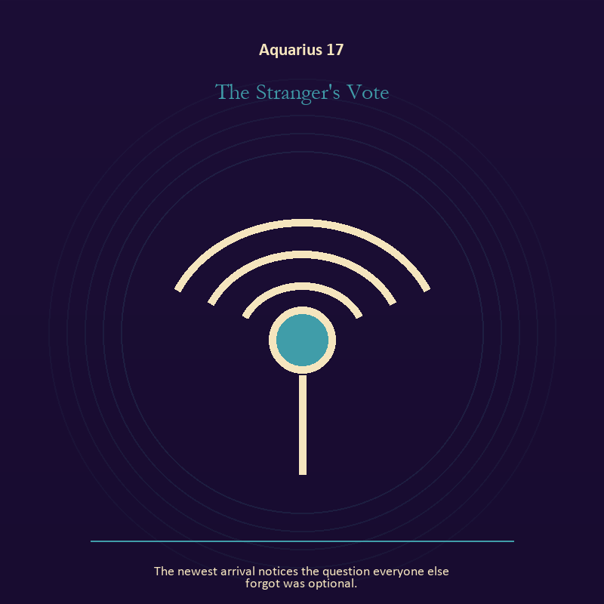

Aquarius 17 The Stranger's Vote
The newest arrival notices the question everyone else forgot was optional.
INTERPRETATION The Stranger's Vote tests relationship against invention, fellowship, dissent, and intelligence between independent minds. Within the Stranger's Vote, relationship imagery tests the fantasy that harmony requires sameness. At Aquarius 17, a living bond can hold difference, correction, privacy, and departure. The same image also carries voice and naming; at Aquarius 17, voice turns inner pressure into shared consequence. As a choice degree, Aquarius 17 asks what action preserves truth without using another person as material.
SIGNAL The usable force at Aquarius 17 is difference held without humiliation joined to speech with consequence; Aquarius gives it form by asking you to share the mechanism, distribute the power, and keep dissent inside the design.
SHADOW At Aquarius 17, the Stranger's Vote can turn toward harmony purchased by one person's silence and repeating a message until it sounds like evidence; beware abstraction that forgets bodies, belonging based on sameness, or systems that hide their gatekeepers.
MIRROR The question at Aquarius 17: where does responsibility belong, and where has it been displaced?
PRACTICE Give Aquarius 17 a physical form; ask the other person what they believe the agreement is, then compare it with your own version.
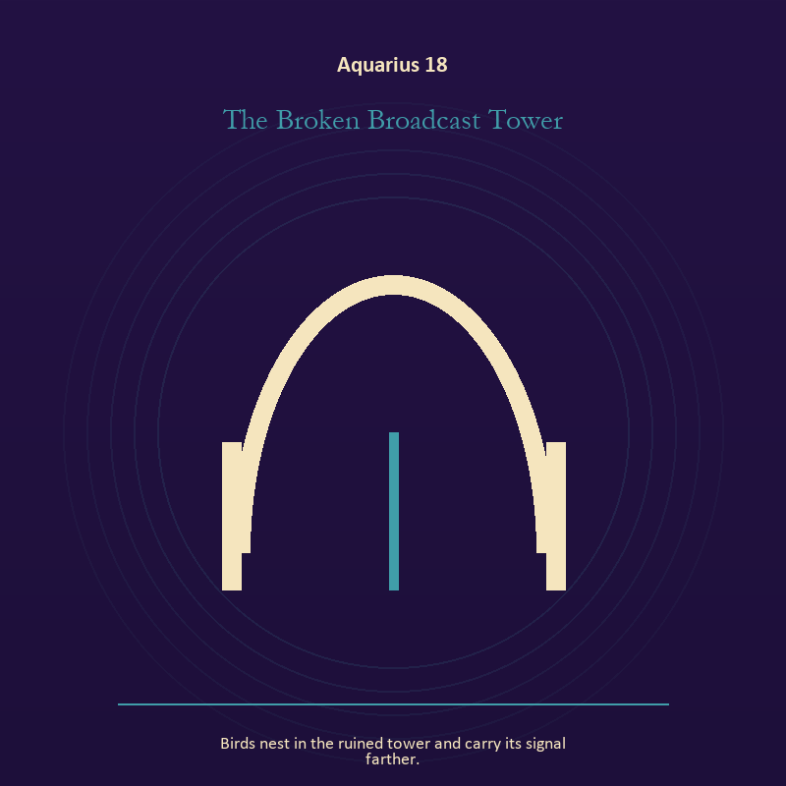

Aquarius 18 The Broken Broadcast Tower
Birds nest in the ruined tower and carry its signal farther.
INTERPRETATION The Broken Broadcast Tower holds the Signal against invention, fellowship, dissent, and intelligence between independent minds. Within the Broken Broadcast Tower, machines in these symbols expose the difference between a living message and the equipment carrying it. At Aquarius 18, when the device fails, the signal may become easier to hear. The same image also carries the descent; at Aquarius 18, the underworld strips away rank and performance. As a choice degree, Aquarius 18 moves from recognition to conduct; the clean choice must survive outside the imagination.
SIGNAL At Aquarius 18, clear transmission joined to contact with buried power carries the signal; it stays honest when you share the mechanism, distribute the power, and keep dissent inside the design.
SHADOW The shadow at Aquarius 18 begins with confusing reach with truth and remaining underground after the danger has passed; also beware abstraction that forgets bodies, belonging based on sameness, or systems that hide their gatekeepers.
MIRROR At Aquarius 18, who is the real receiver of the signal you are sending? From a second angle at Aquarius 18, which part of the wound needs witness, and which part needs a boundary?
PRACTICE Bring Aquarius 18 out of abstraction: turn off one source of noise for an hour and notice what thought keeps returning.

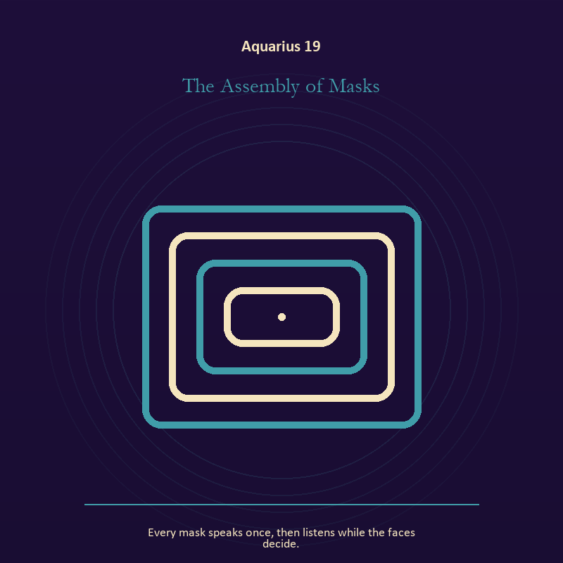

Aquarius 19 The Assembly of Masks
Every mask speaks once, then listens while the faces decide.
INTERPRETATION The Assembly of Masks gives voice and naming consequences inside the Living Network. Within the Assembly of Masks, voice turns inner pressure into shared consequence. At Aquarius 19, words can witness, summon, distort, repair, or conceal according to their precision and timing. The same image also carries identity; at Aquarius 19, a role organizes behavior but cannot contain the whole person. As a choice degree, Aquarius 19 tests whether awareness can become restraint, repair, refusal, or consent.
SIGNAL What can be carried forward from Aquarius 19 is a name that restores agency joined to the freedom to revise a name or role, tested by the need to share the mechanism, distribute the power, and keep dissent inside the design.
SHADOW At Aquarius 19, the image darkens through speaking for someone whose voice is present and performance mistaken for selfhood; beware abstraction that forgets bodies, belonging based on sameness, or systems that hide their gatekeepers.
MIRROR For Aquarius 19, which word in this scene changes the power relationship?
PRACTICE For Aquarius 19, give the current experience a temporary name and date it, leaving room for revision.
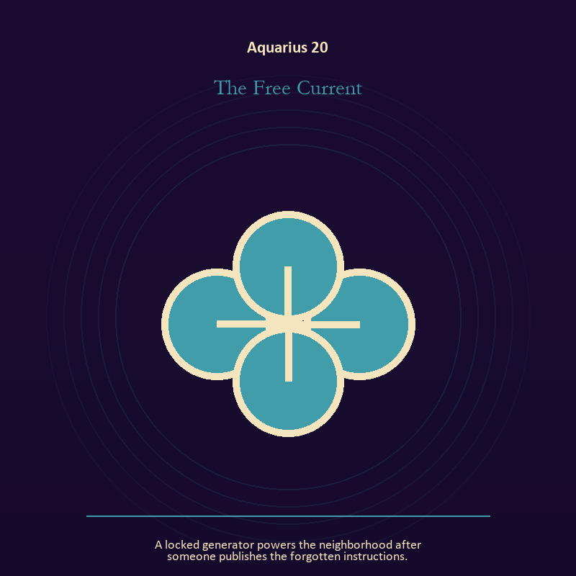

Aquarius 20 The Free Current
A locked generator powers the neighborhood after someone publishes the forgotten instructions.
INTERPRETATION The Free Current puts mystery under pressure from invention, fellowship, dissent, and intelligence between independent minds. Within the Free Current, this image invites attention before conclusion. At Aquarius 20, its strange fact creates a pressure point where memory, desire, fear, and choice can speak indirectly. As a choice degree, Aquarius 20 places responsibility in the reader's hands without promising a painless answer.
SIGNAL At Aquarius 20, an unanswered image that keeps thought alive becomes the clean signal when Aquarius can share the mechanism, distribute the power, and keep dissent inside the design.
SHADOW The distortion at Aquarius 20 is forcing a prophecy from ambiguity; beware abstraction that forgets bodies, belonging based on sameness, or systems that hide their gatekeepers.
MIRROR With the Free Current in mind at Aquarius 20, what ordinary fact sits beneath the strange image?
PRACTICE Work with The Free Current directly at Aquarius 20: copy the image by hand, underline three concrete nouns, and write one association for each.

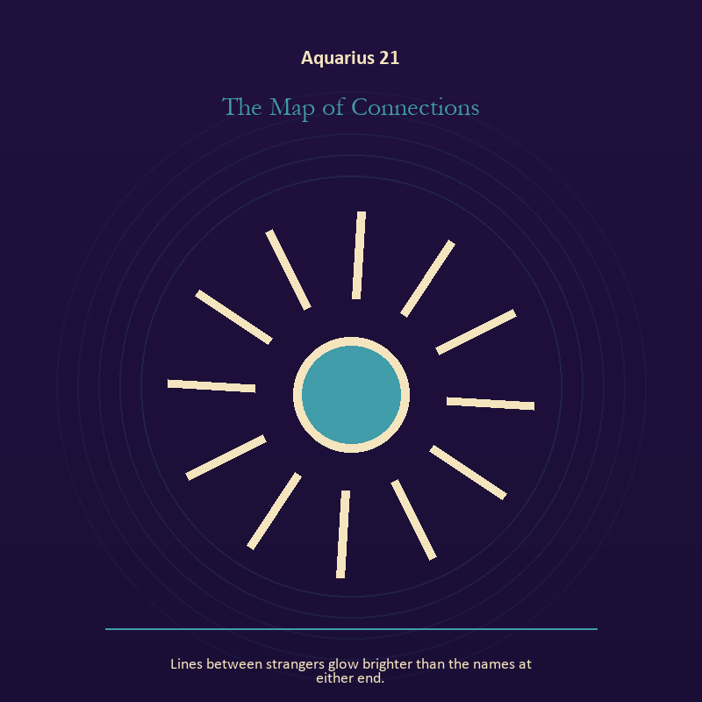

Aquarius 21 The Map of Connections
Lines between strangers glow brighter than the names at either end.
INTERPRETATION In the Map of Connections, the work of craft and record must answer to invention, fellowship, dissent, and intelligence between independent minds. Within the Map of Connections, workshops honor correction. At Aquarius 21, a flaw becomes useful when it is found early, recorded honestly, and repaired without hiding the seam. The same image also carries living fire; at Aquarius 21, fire gives change a visible cost. As a integration degree, Aquarius 21 holds the gift beside its distortion; using one without feeding the other is the work.
SIGNAL The usable force at Aquarius 21 is care made repeatable joined to courage that helps another see; Aquarius gives it form by asking you to share the mechanism, distribute the power, and keep dissent inside the design.
SHADOW At Aquarius 21, the Map of Connections can turn toward the tool becoming the master and mistaking brightness for moral authority; beware abstraction that forgets bodies, belonging based on sameness, or systems that hide their gatekeepers.
MIRROR The question at Aquarius 21: where would an honest repair remain visible? From a second angle at Aquarius 21, where has your fire become performance rather than warmth?
PRACTICE Give Aquarius 21 a physical form; keep a brief record of what happened, what you expected, and what changed your mind.
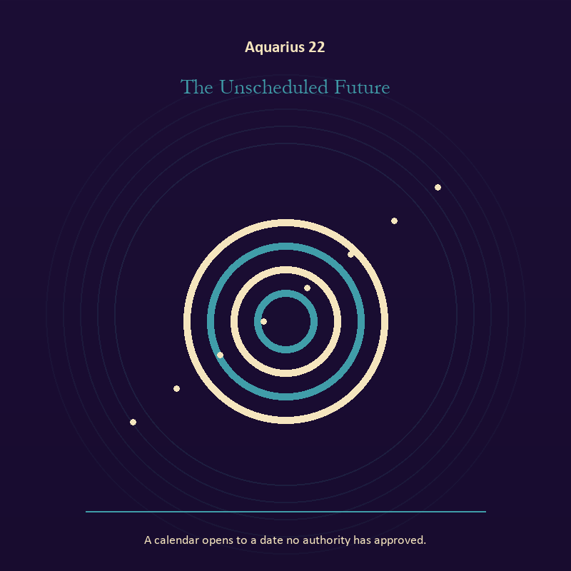

Aquarius 22 The Unscheduled Future
A calendar opens to a date no authority has approved.
INTERPRETATION The Unscheduled Future tests mystery against invention, fellowship, dissent, and intelligence between independent minds. Within the Unscheduled Future, the scene behaves like a dream with its own exact logic. At Aquarius 22, meaning lives in the relationship between figure, place, action, and the detail that refuses ordinary explanation. As a integration degree, Aquarius 22 asks the sign to carry its strength without turning that strength into jurisdiction.
SIGNAL At Aquarius 22, imagination disciplined by the scene carries the signal; it stays honest when you share the mechanism, distribute the power, and keep dissent inside the design.
SHADOW The shadow at Aquarius 22 begins with mistaking intensity for accuracy; also beware abstraction that forgets bodies, belonging based on sameness, or systems that hide their gatekeepers.
MIRROR At Aquarius 22, which detail keeps returning after the rest of the scene fades?
PRACTICE Bring Aquarius 22 out of abstraction: keep the image nearby for one day and record only the moments when it returns on its own.

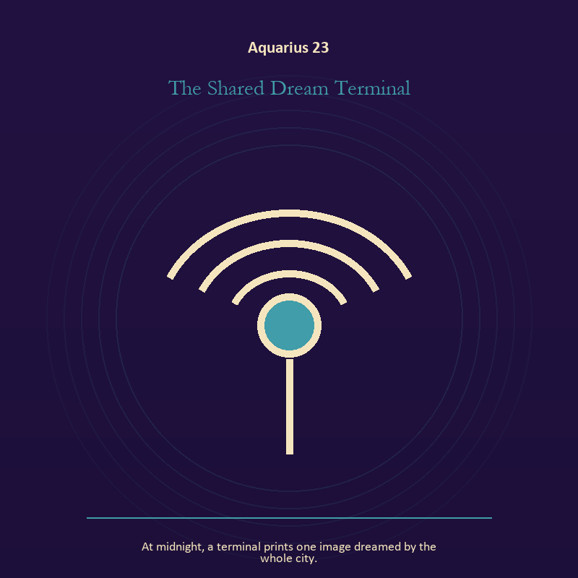

Aquarius 23 The Shared Dream Terminal
At midnight, a terminal prints one image dreamed by the whole city.
INTERPRETATION The Shared Dream Terminal holds the Signal against invention, fellowship, dissent, and intelligence between independent minds. Within the Shared Dream Terminal, a broadcast joins private interior life to a field of witnesses. At Aquarius 23, the ethical question is whether the transmission informs, manipulates, performs, or genuinely makes contact. The same image also carries relationship; at Aquarius 23, more than one will is active in this scene. As a integration degree, Aquarius 23 joins capacity to consequence; what helps in one setting may harm in another.
SIGNAL What can be carried forward from Aquarius 23 is a message that survives its container joined to contact without capture, tested by the need to share the mechanism, distribute the power, and keep dissent inside the design.
SHADOW At Aquarius 23, the image darkens through performing instead of speaking and projection mistaken for intimacy; beware abstraction that forgets bodies, belonging based on sameness, or systems that hide their gatekeepers.
MIRROR For Aquarius 23, which noise have you mistaken for proof that you are being heard?
PRACTICE For Aquarius 23, say the message aloud in one plain sentence without branding, apology, or decoration.
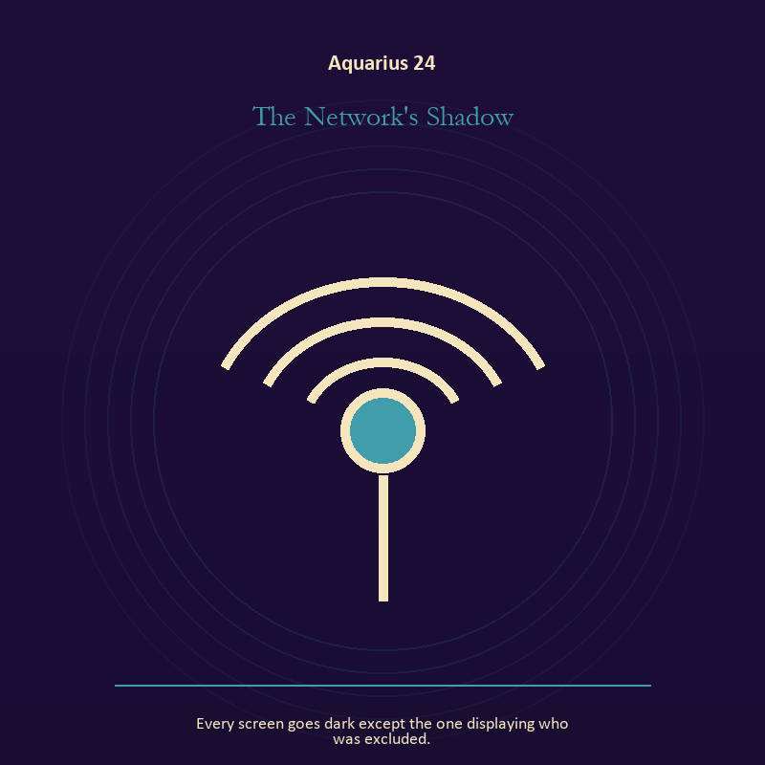

Aquarius 24 The Network's Shadow
Every screen goes dark except the one displaying who was excluded.
INTERPRETATION The Network's Shadow gives the Mirror consequences inside the Living Network. Within the Network's Shadow, a shadow proves that something real stands in the light, while a reflection shows only an angle. At Aquarius 24, neither is the whole person. The same image also carries the Signal; at Aquarius 24, a broadcast joins private interior life to a field of witnesses. As a integration degree, Aquarius 24 shows the mature tool and the temptation hidden inside its handle.
SIGNAL At Aquarius 24, self-recognition without self-worship joined to contact across distance becomes the clean signal when Aquarius can share the mechanism, distribute the power, and keep dissent inside the design.
SHADOW The distortion at Aquarius 24 is assigning your hidden material to someone else and letting noise impersonate urgency; beware abstraction that forgets bodies, belonging based on sameness, or systems that hide their gatekeepers.
MIRROR With the Network's Shadow in mind at Aquarius 24, which part of the reflection is asking to be reclaimed rather than judged? From a second angle at Aquarius 24, which noise have you mistaken for proof that you are being heard?
PRACTICE Work with The Network's Shadow directly at Aquarius 24: write two accounts of the same conflict: one from your position and one from the person you cannot understand. For the second pressure at Aquarius 24, write the same message for a friend, an opponent, and your future self; then keep the sentence that stays true in all three versions.

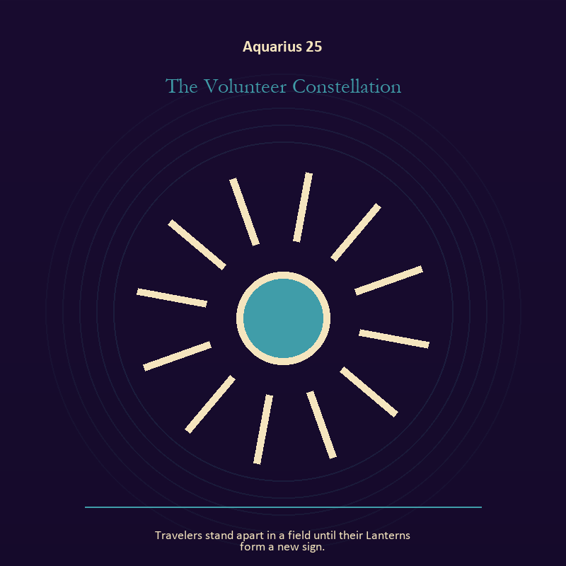

Aquarius 25 The Volunteer Constellation
Travelers stand apart in a field until their Lanterns form a new sign.
INTERPRETATION The Volunteer Constellation puts mystery under pressure from invention, fellowship, dissent, and intelligence between independent minds. Within the Volunteer Constellation, the scene behaves like a dream with its own exact logic. At Aquarius 25, meaning lives in the relationship between figure, place, action, and the detail that refuses ordinary explanation. As a integration degree, Aquarius 25 tests whether the lesson can be lived without becoming a new performance.
SIGNAL The usable force at Aquarius 25 is imagination disciplined by the scene; Aquarius gives it form by asking you to share the mechanism, distribute the power, and keep dissent inside the design.
SHADOW At Aquarius 25, the Volunteer Constellation can turn toward mistaking intensity for accuracy; beware abstraction that forgets bodies, belonging based on sameness, or systems that hide their gatekeepers.
MIRROR The question at Aquarius 25: which detail keeps returning after the rest of the scene fades?
PRACTICE Give Aquarius 25 a physical form; keep the image nearby for one day and record only the moments when it returns on its own.
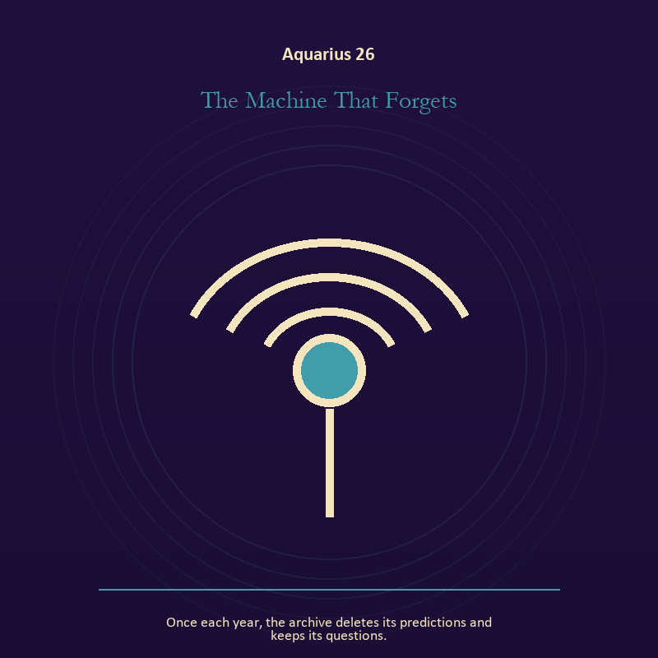

Aquarius 26 The Machine That Forgets
Once each year, the archive deletes its predictions and keeps its questions.
INTERPRETATION In the Machine That Forgets, the work of craft and record must answer to invention, fellowship, dissent, and intelligence between independent minds. Within the Machine That Forgets, ledgers, maps, machines, and archives make memory operational. At Aquarius 26, they can protect truth or compress living complexity until only the form remains. As a release degree, Aquarius 26 prepares the lesson to leave its original container; keep the capacity and loosen the role.
SIGNAL At Aquarius 26, a useful correction that outlives the moment carries the signal; it stays honest when you share the mechanism, distribute the power, and keep dissent inside the design.
SHADOW The shadow at Aquarius 26 begins with measurement mistaken for meaning; also beware abstraction that forgets bodies, belonging based on sameness, or systems that hide their gatekeepers.
MIRROR At Aquarius 26, what does the tool preserve, and what does it leave out?
PRACTICE Bring Aquarius 26 out of abstraction: inspect one repeated task and add a check that would catch the most expensive error.



Aquarius 27 The Open-Source Oracle
The oracle reveals its mechanism and becomes more mysterious.
INTERPRETATION The Open-Source Oracle tests mystery against invention, fellowship, dissent, and intelligence between independent minds. Within the Open-Source Oracle, the symbol remains useful when no single interpretation closes it. At Aquarius 27, its work is to make one hidden relationship visible enough to examine. As a release degree, Aquarius 27 asks what can be handed onward without demanding imitation or loyalty.
SIGNAL What can be carried forward from Aquarius 27 is attention without premature certainty, tested by the need to share the mechanism, distribute the power, and keep dissent inside the design.
SHADOW At Aquarius 27, the image darkens through using beauty to avoid the ordinary fact; beware abstraction that forgets bodies, belonging based on sameness, or systems that hide their gatekeepers.
MIRROR For Aquarius 27, what changes if the scene is a question rather than an answer?
PRACTICE For Aquarius 27, describe the scene to another person without explaining it, then notice what they ask first.
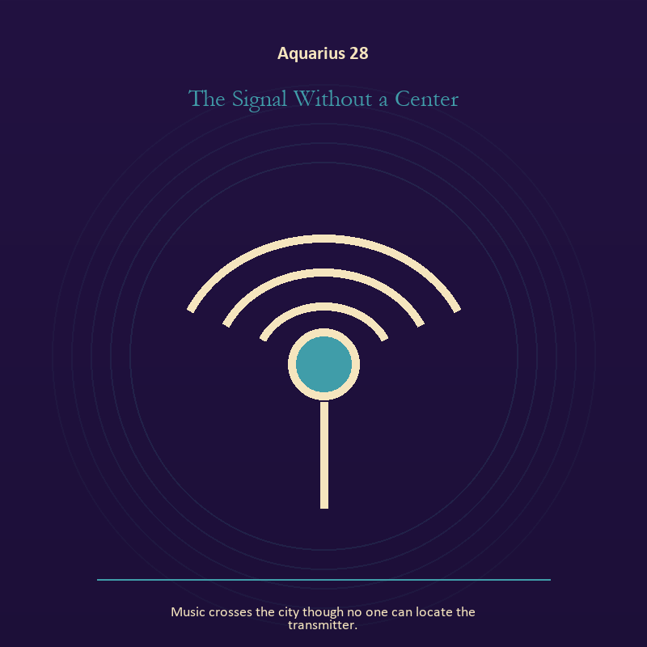

Aquarius 28 The Signal Without a Center
Music crosses the city though no one can locate the transmitter.
INTERPRETATION The Signal Without a Center holds the Signal against invention, fellowship, dissent, and intelligence between independent minds. Within the Signal Without a Center, signal imagery asks what is being transmitted beneath performance. At Aquarius 28, interference may come from fear, vanity, noise, or a container too narrow for the message. The same image also carries voice and naming; at Aquarius 28, naming creates a handle for experience, but the handle must remain smaller than the life it describes. As a release degree, Aquarius 28 turns completion into transfer; the work survives by changing hands.
SIGNAL At Aquarius 28, contact across distance joined to listening precise enough to change the reply becomes the clean signal when Aquarius can share the mechanism, distribute the power, and keep dissent inside the design.
SHADOW The distortion at Aquarius 28 is letting noise impersonate urgency and using language to outrun experience; beware abstraction that forgets bodies, belonging based on sameness, or systems that hide their gatekeepers.
MIRROR With the Signal Without a Center in mind at Aquarius 28, what remains of your message when performance is removed?
PRACTICE Work with The Signal Without a Center directly at Aquarius 28: write the same message for a friend, an opponent, and your future self; then keep the sentence that stays true in all three versions. For the second pressure at Aquarius 28, write the sentence you keep rehearsing, remove every accusation you cannot prove, and read what remains aloud.

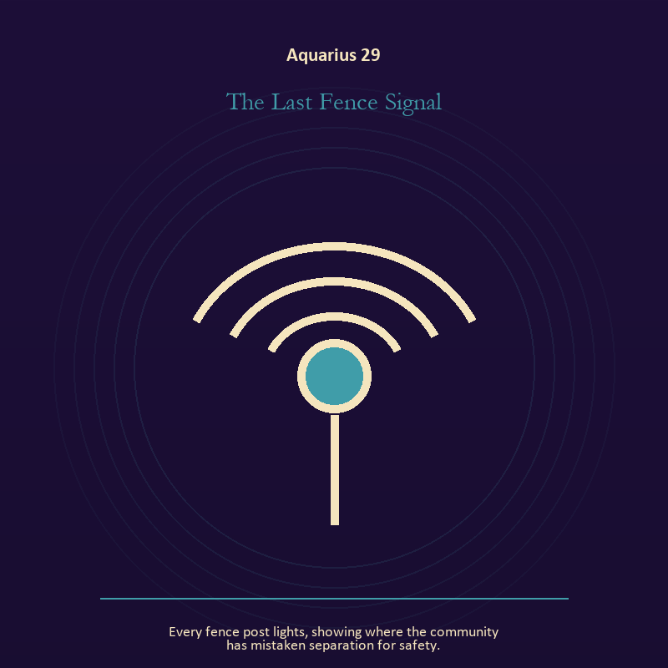

Aquarius 29 The Last Fence Signal
Every fence post lights, showing where the community has mistaken separation for safety.
INTERPRETATION The Last Fence Signal gives the Signal consequences inside the Living Network. Within the Last Fence Signal, a broadcast joins private interior life to a field of witnesses. At Aquarius 29, the ethical question is whether the transmission informs, manipulates, performs, or genuinely makes contact. The same image also carries relationship; at Aquarius 29, more than one will is active in this scene. As a release degree, Aquarius 29 lets the sign set down the identity built around its ordeal.
SIGNAL The usable force at Aquarius 29 is a message that survives its container joined to contact without capture; Aquarius gives it form by asking you to share the mechanism, distribute the power, and keep dissent inside the design.
SHADOW At Aquarius 29, the Last Fence Signal can turn toward performing instead of speaking and projection mistaken for intimacy; beware abstraction that forgets bodies, belonging based on sameness, or systems that hide their gatekeepers.
MIRROR The question at Aquarius 29: which noise have you mistaken for proof that you are being heard?
PRACTICE Give Aquarius 29 a physical form; say the message aloud in one plain sentence without branding, apology, or decoration.
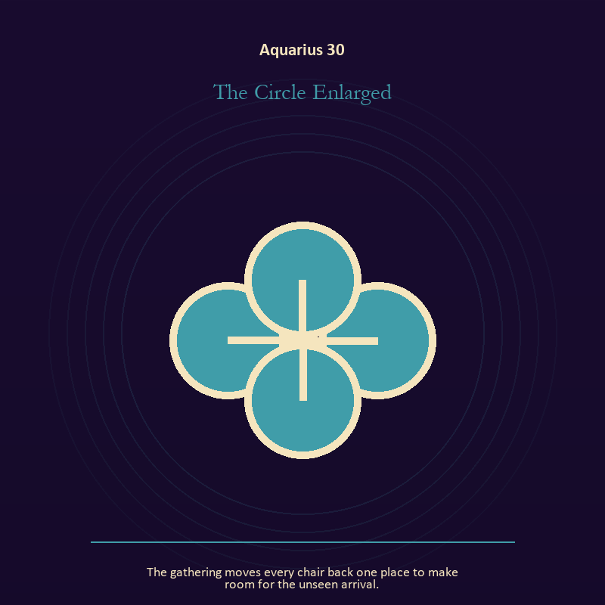

Aquarius 30 The Circle Enlarged
The gathering moves every chair back one place to make room for the unseen arrival.
INTERPRETATION The Circle Enlarged puts the body under pressure from invention, fellowship, dissent, and intelligence between independent minds. Within the Circle Enlarged, embodiment gives every choice a pace and a cost. At Aquarius 30, the scene asks whether the person can remain present inside the experience being interpreted. As a release degree, Aquarius 30 returns the earned knowledge to ordinary life, where another cycle can use it.
SIGNAL At Aquarius 30, presence with weight and limits carries the signal; it stays honest when you share the mechanism, distribute the power, and keep dissent inside the design.
SHADOW The shadow at Aquarius 30 begins with treating exhaustion as devotion; also beware abstraction that forgets bodies, belonging based on sameness, or systems that hide their gatekeepers.
MIRROR At Aquarius 30, can the choice be lived at the pace your body can sustain?
PRACTICE Bring Aquarius 30 out of abstraction: place both feet on the floor and name five physical facts about the present moment.

Pisces
The Return to Mystery
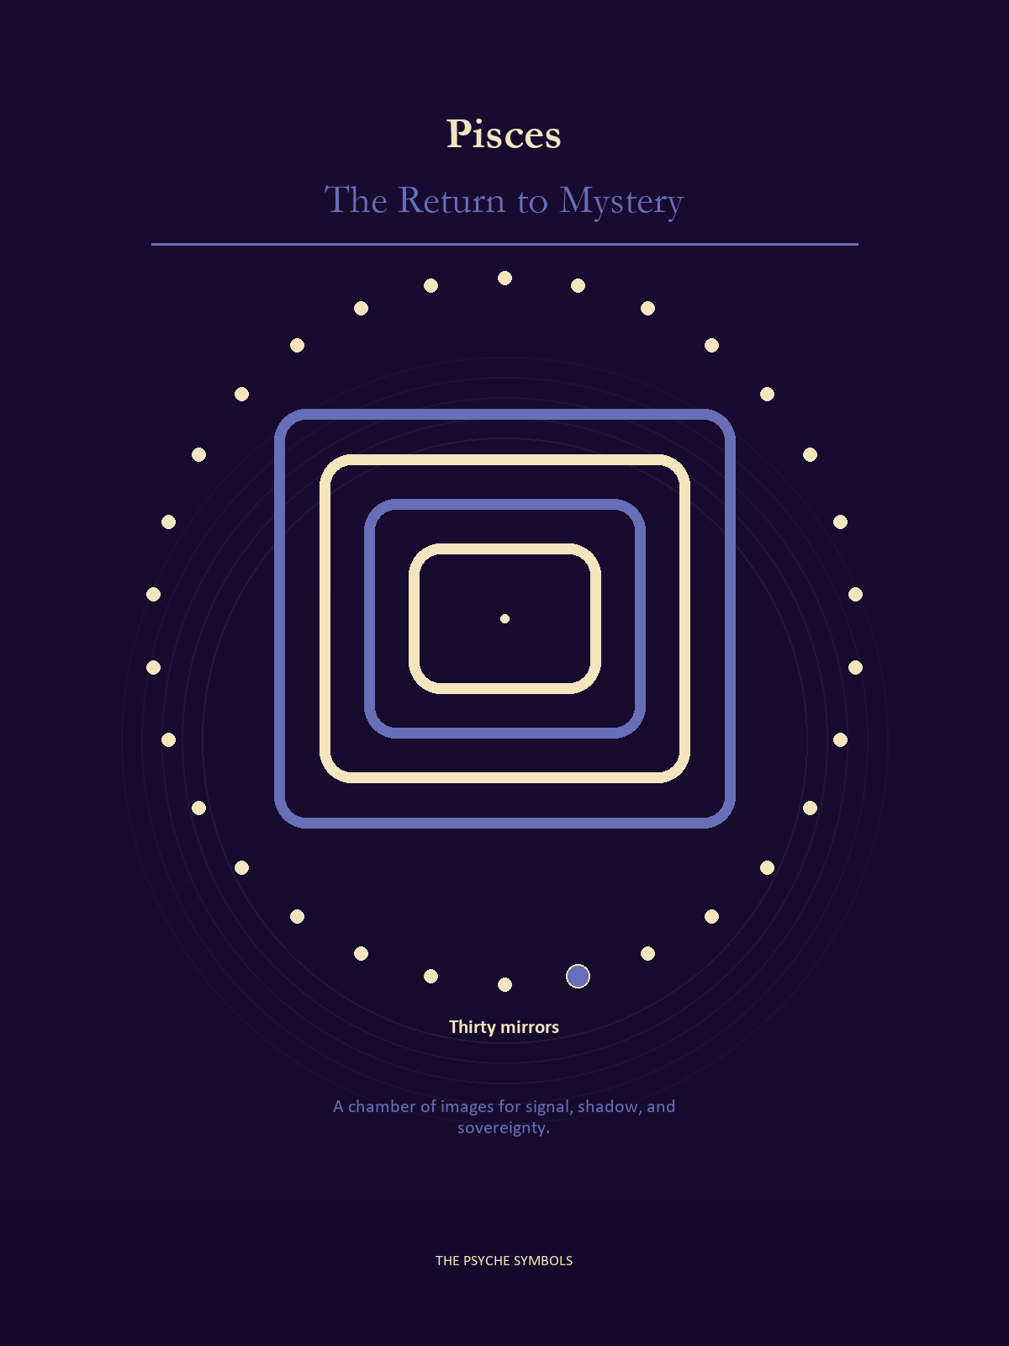
Pisces returns every separate signal to the sea of dream, grief, love, memory, and imagination. The Return to Mystery loosens borders while asking the Traveler to keep one living thread back to the shore. Here compassion stays honest by refusing to confuse fusion, rescue, fantasy, and care.

Degrees | Gate | Work
1-5 | Arrival | Meet the image before deciding what it means.
6-10 | Friction | Notice what pushes back and what that resistance protects.
11-15 | Revelation | Name the detail that changes the whole scene.
16-20 | Choice | Choose the act that preserves both truth and human dignity.
21-25 | Integration | Use the gift without feeding the shadow that travels beside it.
26-30 | Release | Keep the earned capacity and release the role that delivered it.

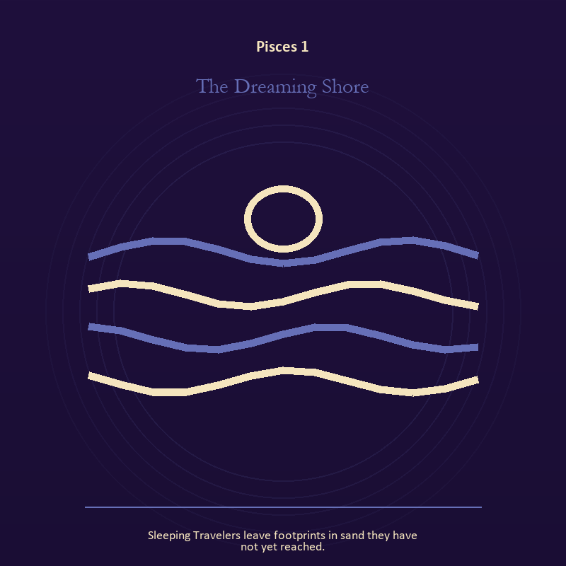

Pisces 1 The Dreaming Shore
Sleeping Travelers leave footprints in sand they have not yet reached.
INTERPRETATION In the Dreaming Shore, the work of living water must answer to dream, compassion, surrender, and a return that preserves a thread of self. Within the Dreaming Shore, water carries feeling, memory, adaptation, and forces too large for command. At Pisces 1, its shape comes from the vessel, but its movement remains its own. As an arrival degree, Pisces 1 arrives before habit can tidy the evidence; notice what is present before deciding what it should become.
SIGNAL What can be carried forward from Pisces 1 is adaptation without self-erasure, tested by the need to let the image soften what control cannot solve, while keeping one hand on the shore.
SHADOW At Pisces 1, the image darkens through building a vessel too rigid for living water; watch surrender become disappearance, intuition become certainty, or compassion erase a necessary boundary.
MIRROR For Pisces 1, what feeling needs a vessel rather than a solution?
PRACTICE For Pisces 1, wash your hands with attention and decide what belongs to you after the water stops.
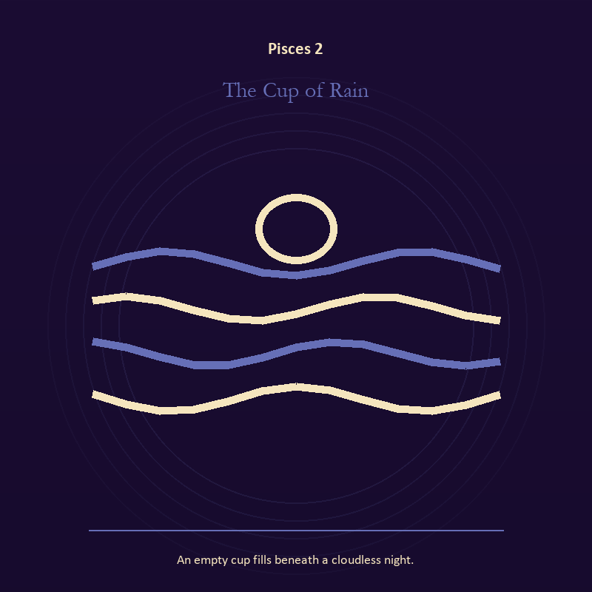

Pisces 2 The Cup of Rain
An empty cup fills beneath a cloudless night.
INTERPRETATION The Cup of Rain tests living water against dream, compassion, surrender, and a return that preserves a thread of self. Within the Cup of Rain, a shore or vessel gives emotion a boundary without denying its depth. At Pisces 2, the scene asks whether the feeling needs containment, release, or witness. The same image also carries the descent; at Pisces 2, descent imagery carries what ordinary daylight has failed to resolve. As an arrival degree, Pisces 2 introduces the sign's raw material in an unguarded form; the first response matters less than the honest one.
SIGNAL At Pisces 2, grief allowed to move joined to truth that survives loss becomes the clean signal when Pisces can let the image soften what control cannot solve, while keeping one hand on the shore.
SHADOW The distortion at Pisces 2 is drowning in another person's weather and suspicion filling gaps in the record; watch surrender become disappearance, intuition become certainty, or compassion erase a necessary boundary.
MIRROR With the Cup of Rain in mind at Pisces 2, where are you adapting wisely, and where are you disappearing?
PRACTICE Work with The Cup of Rain directly at Pisces 2: pour water slowly between two vessels and name what must change shape without losing its substance. For the second pressure at Pisces 2, name the injury, the present risk, and the next repair as three separate sentences.

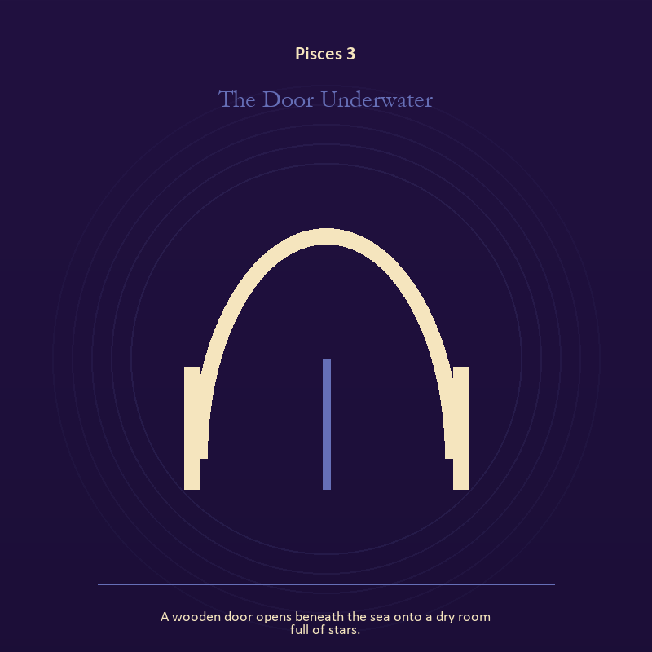

Pisces 3 The Door Underwater
A wooden door opens beneath the sea onto a dry room full of stars.
INTERPRETATION The Door Underwater holds the threshold against dream, compassion, surrender, and a return that preserves a thread of self. Within the Door Underwater, a boundary can protect life, restrict it, or clarify the terms of meeting. At Pisces 3, the surrounding action reveals which function is active here. The same image also carries living water; at Pisces 3, a shore or vessel gives emotion a boundary without denying its depth. As an arrival degree, Pisces 3 catches the first impulse before it turns into a role; give the image room to remain strange.
SIGNAL The usable force at Pisces 3 is honest passage joined to adaptation without self-erasure; Pisces gives it form by asking you to let the image soften what control cannot solve, while keeping one hand on the shore.
SHADOW At Pisces 3, the Door Underwater can turn toward guarding an obsolete enclosure and building a vessel too rigid for living water; watch surrender become disappearance, intuition become certainty, or compassion erase a necessary boundary.
MIRROR The question at Pisces 3: what would make the next step chosen rather than compelled? From a second angle at Pisces 3, where are you adapting wisely, and where are you disappearing?
PRACTICE Give Pisces 3 a physical form; draw the boundary as a line on paper; then mark the gate, the guard, and the person who holds the key.
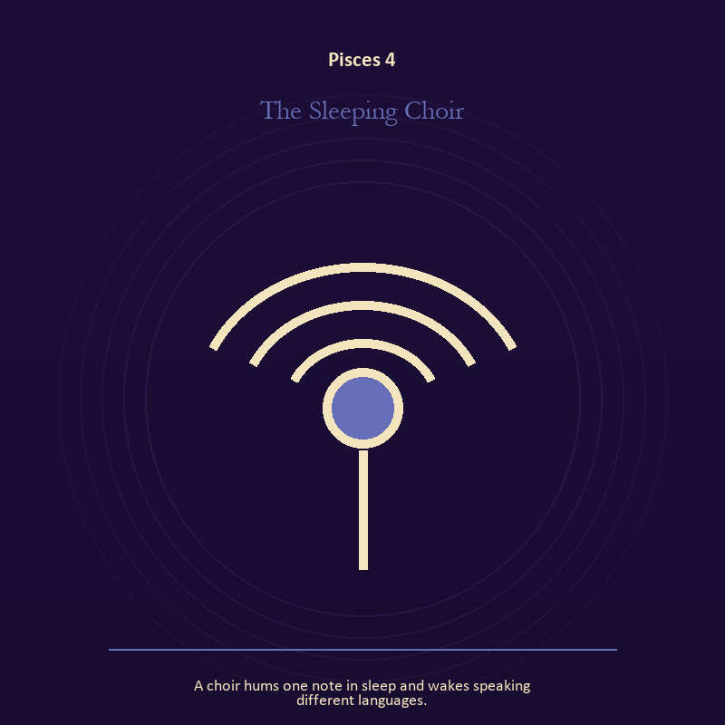

Pisces 4 The Sleeping Choir
A choir hums one note in sleep and wakes speaking different languages.
INTERPRETATION The Sleeping Choir gives voice and naming consequences inside the Return to Mystery. Within the Sleeping Choir, voice turns inner pressure into shared consequence. At Pisces 4, words can witness, summon, distort, repair, or conceal according to their precision and timing. The same image also carries relationship; at Pisces 4, the shared object in the scene carries an agreement. As an arrival degree, Pisces 4 opens the chamber with no settled method; name the need, risk, or appetite that entered with it.
SIGNAL At Pisces 4, a name that restores agency joined to difference held without humiliation carries the signal; it stays honest when you let the image soften what control cannot solve, while keeping one hand on the shore.
SHADOW The shadow at Pisces 4 begins with speaking for someone whose voice is present and harmony purchased by one person's silence; also watch surrender become disappearance, intuition become certainty, or compassion erase a necessary boundary.
MIRROR At Pisces 4, which word in this scene changes the power relationship?
PRACTICE Bring Pisces 4 out of abstraction: give the current experience a temporary name and date it, leaving room for revision.

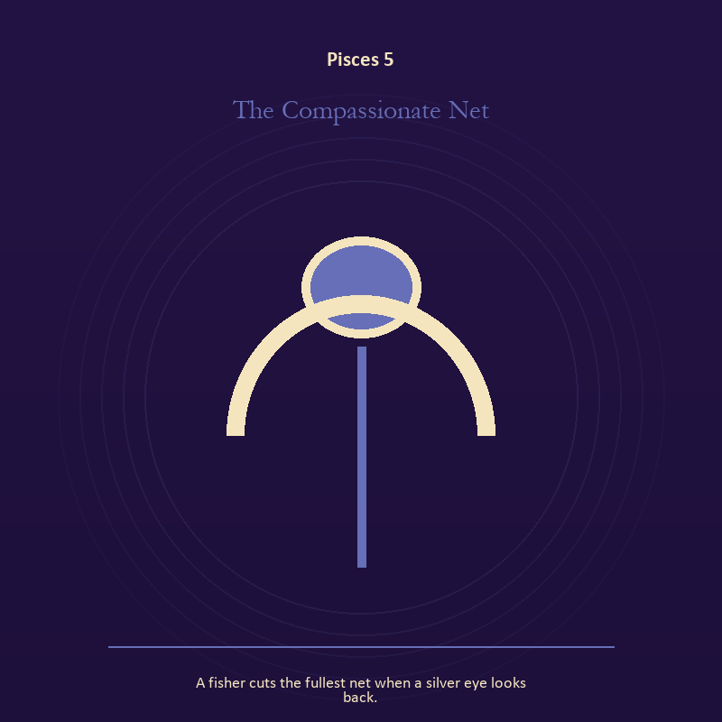

Pisces 5 The Compassionate Net
A fisher cuts the fullest net when a silver eye looks back.
INTERPRETATION The Compassionate Net puts the body under pressure from dream, compassion, surrender, and a return that preserves a thread of self. Within the Compassionate Net, bread, rest, touch, clothing, and shelter make spiritual language answer to material need. At Pisces 5, an insight that harms the body requires correction. As an arrival degree, Pisces 5 shows the beginning before ownership hardens around it; let attention come before possession.
SIGNAL What can be carried forward from Pisces 5 is a decision the nervous system can inhabit, tested by the need to let the image soften what control cannot solve, while keeping one hand on the shore.
SHADOW At Pisces 5, the image darkens through using transcendence to ignore need; watch surrender become disappearance, intuition become certainty, or compassion erase a necessary boundary.
MIRROR For Pisces 5, which need in this scene has been made too ordinary to mention?
PRACTICE For Pisces 5, eat, drink, rest, or move before making the interpretation more dramatic.
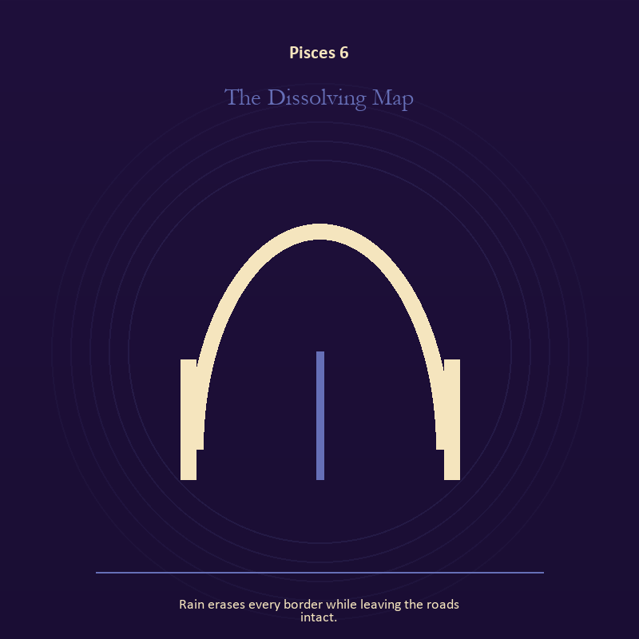

Pisces 6 The Dissolving Map
Rain erases every border while leaving the roads intact.
INTERPRETATION In the Dissolving Map, the work of craft and record must answer to dream, compassion, surrender, and a return that preserves a thread of self. Within the Dissolving Map, workshops honor correction. At Pisces 6, a flaw becomes useful when it is found early, recorded honestly, and repaired without hiding the seam. The same image also carries the threshold; at Pisces 6, doors and roads turn inner change into an embodied decision. As a friction degree, Pisces 6 meets resistance, and that resistance reveals what the first impulse failed to consider.
SIGNAL At Pisces 6, care made repeatable joined to chosen change becomes the clean signal when Pisces can let the image soften what control cannot solve, while keeping one hand on the shore.
SHADOW The distortion at Pisces 6 is the tool becoming the master and waiting for permission that will never come; watch surrender become disappearance, intuition become certainty, or compassion erase a necessary boundary.
MIRROR With the Dissolving Map in mind at Pisces 6, where would an honest repair remain visible? From a second angle at Pisces 6, what are you protecting by remaining on this side of the door?
PRACTICE Work with The Dissolving Map directly at Pisces 6: keep a brief record of what happened, what you expected, and what changed your mind. For the second pressure at Pisces 6, write one sentence beginning, 'I may enter when,' and one beginning, 'I remain free to leave when.'.

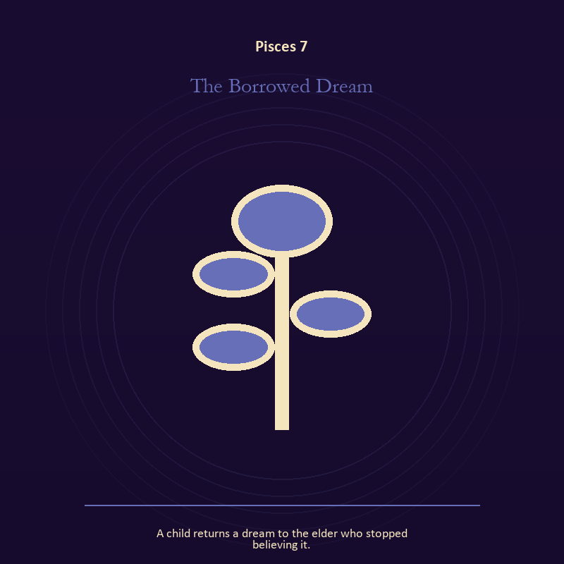

Pisces 7 The Borrowed Dream
A child returns a dream to the elder who stopped believing it.
INTERPRETATION The Borrowed Dream tests growth against dream, compassion, surrender, and a return that preserves a thread of self. Within the Borrowed Dream, growth appears as vulnerable potential under specific conditions. At Pisces 7, it requires time, nourishment, protection, and eventual release from the form that began it. As a friction degree, Pisces 7 places consequence beside desire; the obstruction may be an enemy, a limit, or a needed correction.
SIGNAL The usable force at Pisces 7 is care that honors timing; Pisces gives it form by asking you to let the image soften what control cannot solve, while keeping one hand on the shore.
SHADOW At Pisces 7, the Borrowed Dream can turn toward protecting potential so tightly that it cannot emerge; watch surrender become disappearance, intuition become certainty, or compassion erase a necessary boundary.
MIRROR The question at Pisces 7: what is alive here but not ready to be displayed?
PRACTICE Give Pisces 7 a physical form; release one expectation about what the new form must resemble.
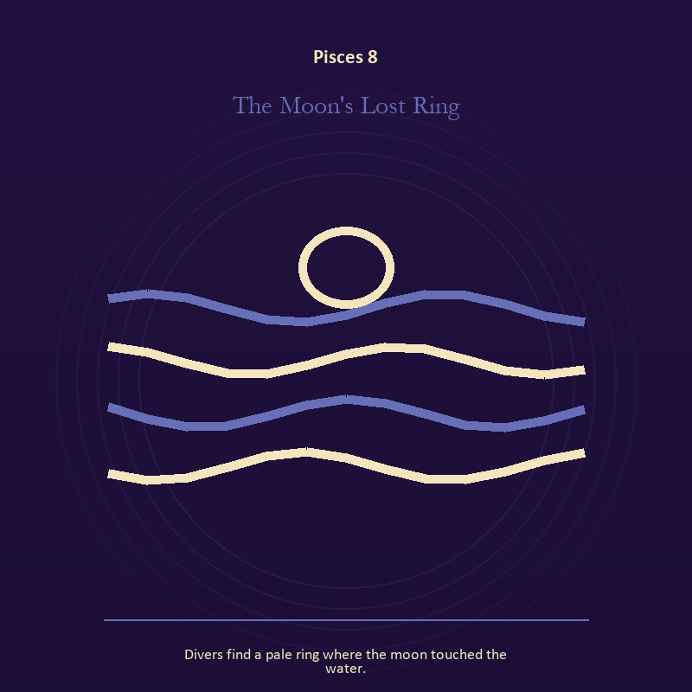

Pisces 8 The Moon's Lost Ring
Divers find a pale ring where the moon touched the water.
INTERPRETATION The Moon's Lost Ring holds living water against dream, compassion, surrender, and a return that preserves a thread of self. Within the Moon's Lost Ring, a shore or vessel gives emotion a boundary without denying its depth. At Pisces 8, the scene asks whether the feeling needs containment, release, or witness. As a friction degree, Pisces 8 tests whether the sign can change course without treating correction as defeat.
SIGNAL At Pisces 8, grief allowed to move carries the signal; it stays honest when you let the image soften what control cannot solve, while keeping one hand on the shore.
SHADOW The shadow at Pisces 8 begins with drowning in another person's weather; also watch surrender become disappearance, intuition become certainty, or compassion erase a necessary boundary.
MIRROR At Pisces 8, where are you adapting wisely, and where are you disappearing?
PRACTICE Bring Pisces 8 out of abstraction: pour water slowly between two vessels and name what must change shape without losing its substance.

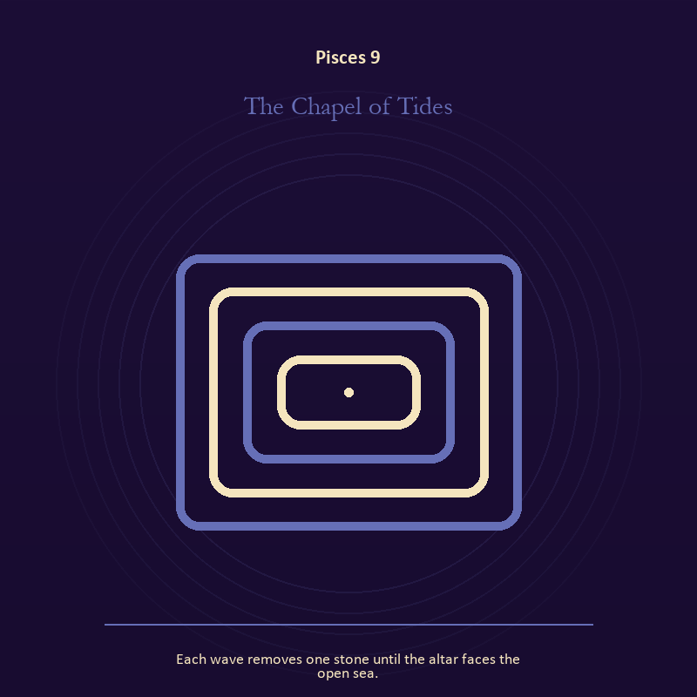

Pisces 9 The Chapel of Tides
Each wave removes one stone until the altar faces the open sea.
INTERPRETATION The Chapel of Tides gives living water consequences inside the Return to Mystery. Within the Chapel of Tides, rain, tides, wells, and floods move private material into a shared landscape. At Pisces 9, what was hidden becomes environmental and must be answered together. As a friction degree, Pisces 9 brings another will, material limit, or inconvenient fact into the frame.
SIGNAL What can be carried forward from Pisces 9 is feeling with a living boundary, tested by the need to let the image soften what control cannot solve, while keeping one hand on the shore.
SHADOW At Pisces 9, the image darkens through using mystery to avoid a fact; watch surrender become disappearance, intuition become certainty, or compassion erase a necessary boundary.
MIRROR For Pisces 9, what has the tide exposed that cannot be covered again?
PRACTICE For Pisces 9, write the feeling as weather, then add the exact fact occurring beneath that weather.
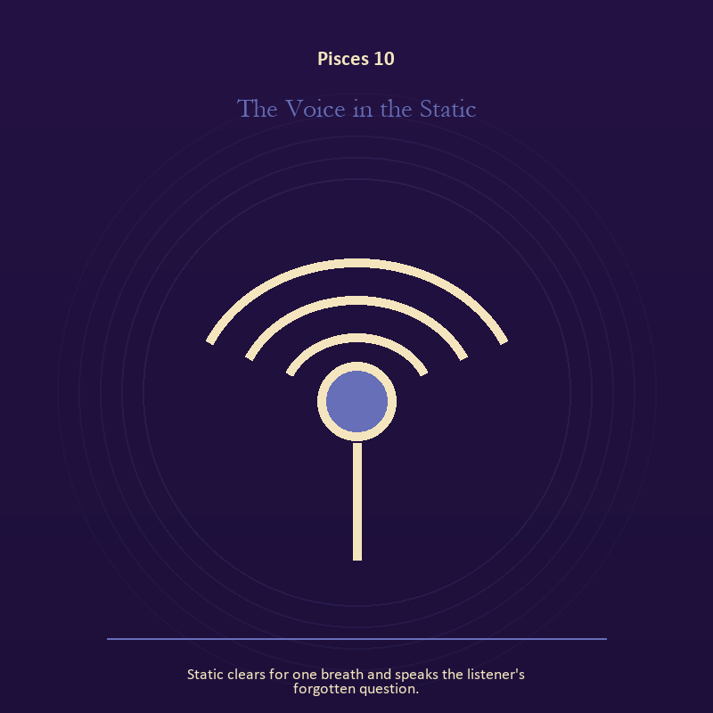

Pisces 10 The Voice in the Static
Static clears for one breath and speaks the listener's forgotten question.
INTERPRETATION The Voice in the Static puts the Signal under pressure from dream, compassion, surrender, and a return that preserves a thread of self. Within the Voice in the Static, signal imagery asks what is being transmitted beneath performance. At Pisces 10, interference may come from fear, vanity, noise, or a container too narrow for the message. The same image also carries voice and naming; at Pisces 10, naming creates a handle for experience, but the handle must remain smaller than the life it describes. As a friction degree, Pisces 10 slows the original motion long enough to expose what haste concealed.
SIGNAL At Pisces 10, contact across distance joined to listening precise enough to change the reply becomes the clean signal when Pisces can let the image soften what control cannot solve, while keeping one hand on the shore.
SHADOW The distortion at Pisces 10 is letting noise impersonate urgency and using language to outrun experience; watch surrender become disappearance, intuition become certainty, or compassion erase a necessary boundary.
MIRROR With the Voice in the Static in mind at Pisces 10, what remains of your message when performance is removed?
PRACTICE Work with The Voice in the Static directly at Pisces 10: write the same message for a friend, an opponent, and your future self; then keep the sentence that stays true in all three versions. For the second pressure at Pisces 10, write the sentence you keep rehearsing, remove every accusation you cannot prove, and read what remains aloud.

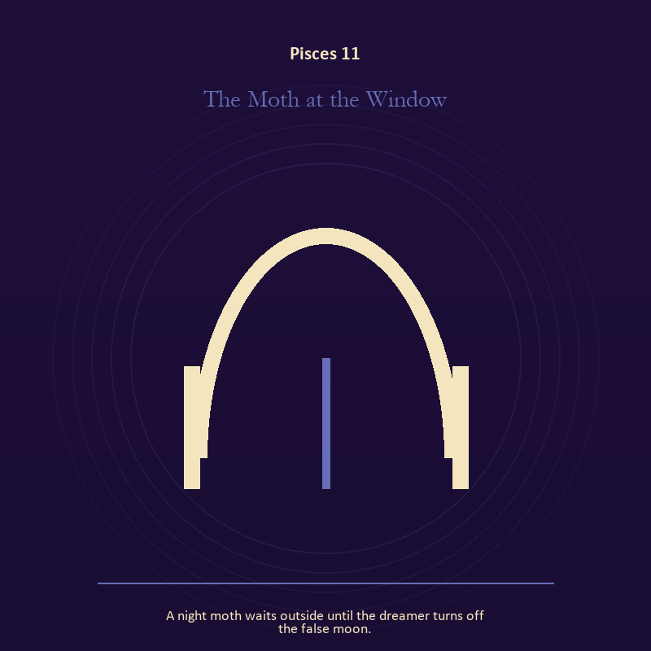

Pisces 11 The Moth at the Window
A night moth waits outside until the dreamer turns off the false moon.
INTERPRETATION In the Moth at the Window, the work of the threshold must answer to dream, compassion, surrender, and a return that preserves a thread of self. Within the Moth at the Window, doors and roads turn inner change into an embodied decision. At Pisces 11, the next room matters, but so does the condition under which it is entered. The same image also carries the descent; at Pisces 11, descent imagery carries what ordinary daylight has failed to resolve. As a revelation degree, Pisces 11 reveals the mechanism under the mood; one concrete detail changes the reading.
SIGNAL The usable force at Pisces 11 is a boundary that clarifies freedom joined to truth that survives loss; Pisces gives it form by asking you to let the image soften what control cannot solve, while keeping one hand on the shore.
SHADOW At Pisces 11, the Moth at the Window can turn toward crossing before consent and suspicion filling gaps in the record; watch surrender become disappearance, intuition become certainty, or compassion erase a necessary boundary.
MIRROR The question at Pisces 11: what are you protecting by remaining on this side of the door?
PRACTICE Give Pisces 11 a physical form; stand at a literal doorway, name what you are leaving and what you refuse to abandon, then cross only if the answer feels clean.
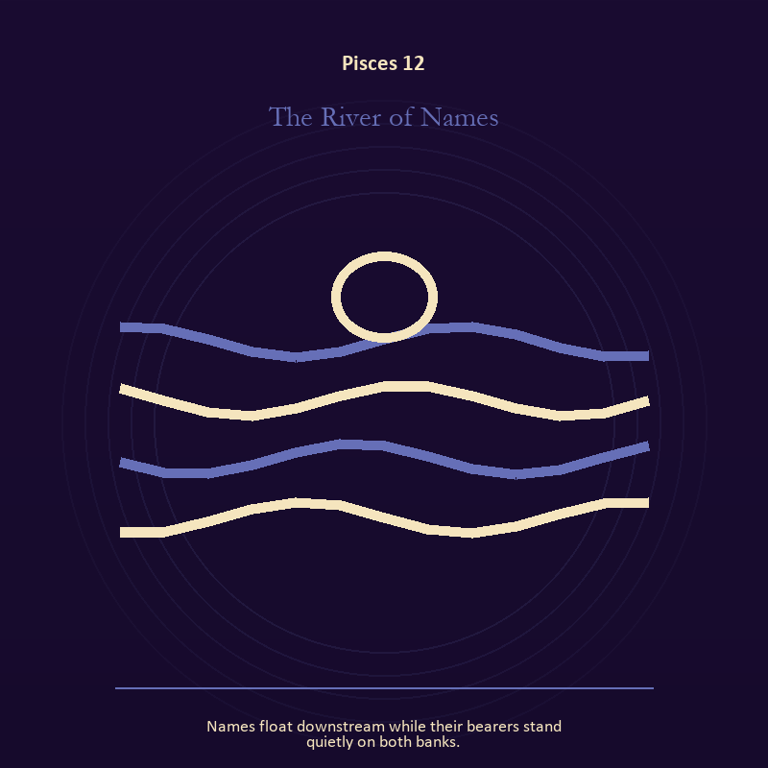

Pisces 12 The River of Names
Names float downstream while their bearers stand quietly on both banks.
INTERPRETATION The River of Names tests living water against dream, compassion, surrender, and a return that preserves a thread of self. Within the River of Names, rain, tides, wells, and floods move private material into a shared landscape. At Pisces 12, what was hidden becomes environmental and must be answered together. As a revelation degree, Pisces 12 moves the hidden arrangement into view, where it can be named without being exaggerated.
SIGNAL At Pisces 12, feeling with a living boundary carries the signal; it stays honest when you let the image soften what control cannot solve, while keeping one hand on the shore.
SHADOW The shadow at Pisces 12 begins with using mystery to avoid a fact; also watch surrender become disappearance, intuition become certainty, or compassion erase a necessary boundary.
MIRROR At Pisces 12, what has the tide exposed that cannot be covered again?
PRACTICE Bring Pisces 12 out of abstraction: write the feeling as weather, then add the exact fact occurring beneath that weather.

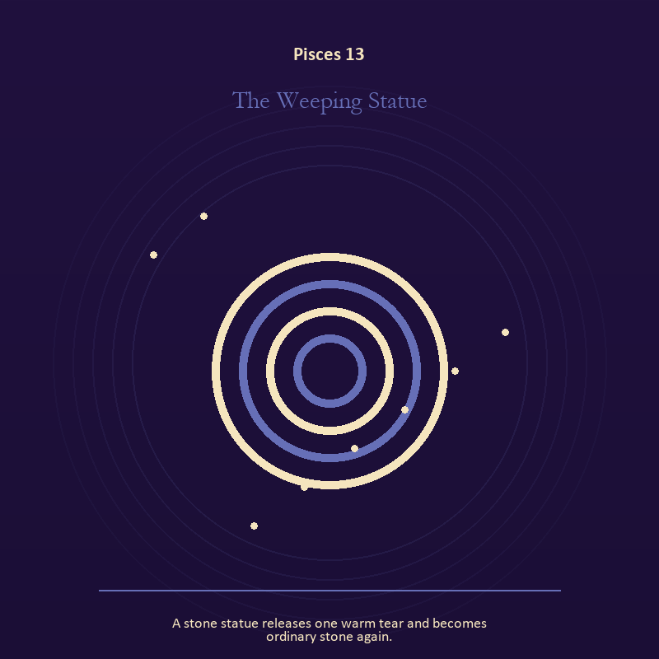

Pisces 13 The Weeping Statue
A stone statue releases one warm tear and becomes ordinary stone again.
INTERPRETATION The Weeping Statue holds mystery against dream, compassion, surrender, and a return that preserves a thread of self. Within the Weeping Statue, the scene behaves like a dream with its own exact logic. At Pisces 13, meaning lives in the relationship between figure, place, action, and the detail that refuses ordinary explanation. As a revelation degree, Pisces 13 turns atmosphere into evidence; attend to the object or action that cannot be explained away.
SIGNAL What can be carried forward from Pisces 13 is imagination disciplined by the scene, tested by the need to let the image soften what control cannot solve, while keeping one hand on the shore.
SHADOW At Pisces 13, the image darkens through mistaking intensity for accuracy; watch surrender become disappearance, intuition become certainty, or compassion erase a necessary boundary.
MIRROR For Pisces 13, which detail keeps returning after the rest of the scene fades?
PRACTICE For Pisces 13, keep the image nearby for one day and record only the moments when it returns on its own.
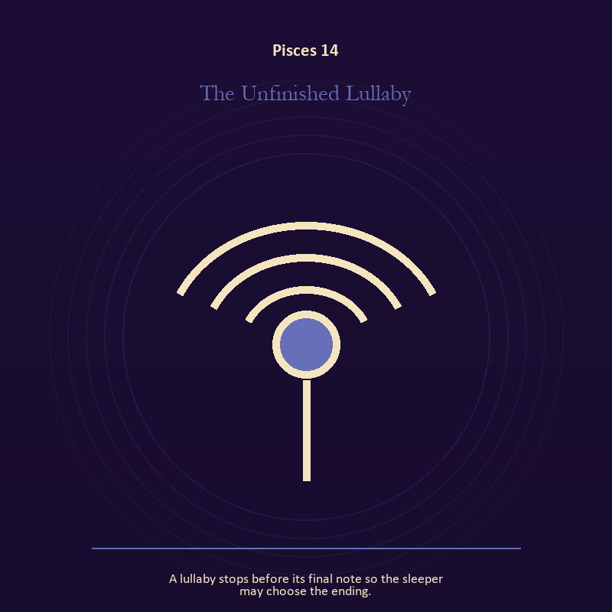

Pisces 14 The Unfinished Lullaby
A lullaby stops before its final note so the sleeper may choose the ending.
INTERPRETATION The Unfinished Lullaby gives voice and naming consequences inside the Return to Mystery. Within the Unfinished Lullaby, books, letters, bells, and songs extend speech beyond the speaker's body. At Pisces 14, the message acquires a life that intention can no longer fully govern. As a revelation degree, Pisces 14 shows who carries the cost, who controls the passage, and what the scene refuses to hide.
SIGNAL At Pisces 14, listening precise enough to change the reply becomes the clean signal when Pisces can let the image soften what control cannot solve, while keeping one hand on the shore.
SHADOW The distortion at Pisces 14 is using language to outrun experience; watch surrender become disappearance, intuition become certainty, or compassion erase a necessary boundary.
MIRROR With the Unfinished Lullaby in mind at Pisces 14, what needs to be said plainly, and who has earned the right to hear it?
PRACTICE Work with The Unfinished Lullaby directly at Pisces 14: write the sentence you keep rehearsing, remove every accusation you cannot prove, and read what remains aloud.



Pisces 15 The Mirror Lake
The lake reflects every star except the one directly overhead.
INTERPRETATION The Mirror Lake puts the Mirror under pressure from dream, compassion, surrender, and a return that preserves a thread of self. Within the Mirror Lake, a shadow proves that something real stands in the light, while a reflection shows only an angle. At Pisces 15, neither is the whole person. The same image also carries living water; at Pisces 15, a shore or vessel gives emotion a boundary without denying its depth. As a revelation degree, Pisces 15 brings the middle truth forward, after the first story has lost its grip.
SIGNAL The usable force at Pisces 15 is self-recognition without self-worship joined to adaptation without self-erasure; Pisces gives it form by asking you to let the image soften what control cannot solve, while keeping one hand on the shore.
SHADOW At Pisces 15, the Mirror Lake can turn toward assigning your hidden material to someone else and building a vessel too rigid for living water; watch surrender become disappearance, intuition become certainty, or compassion erase a necessary boundary.
MIRROR The question at Pisces 15: which part of the reflection is asking to be reclaimed rather than judged? From a second angle at Pisces 15, where are you adapting wisely, and where are you disappearing?
PRACTICE Give Pisces 15 a physical form; write two accounts of the same conflict: one from your position and one from the person you cannot understand.
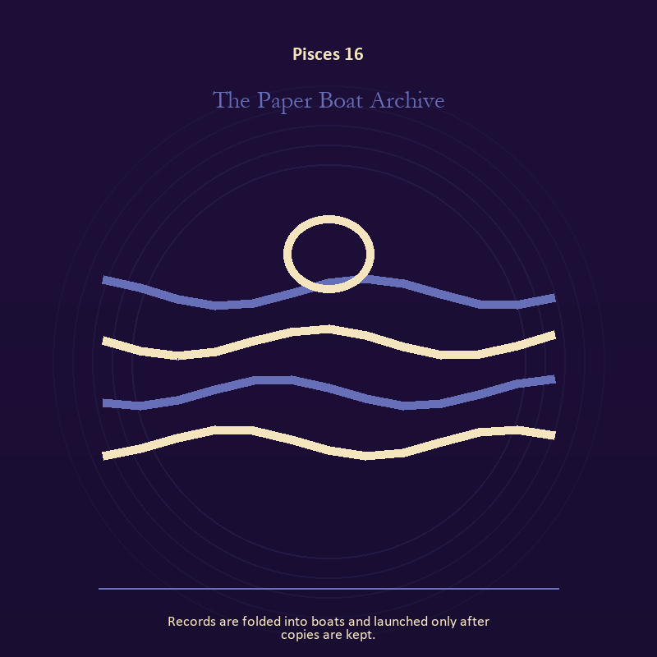

Pisces 16 The Paper Boat Archive
Records are folded into boats and launched only after copies are kept.
INTERPRETATION In the Paper Boat Archive, the work of living water must answer to dream, compassion, surrender, and a return that preserves a thread of self. Within the Paper Boat Archive, water carries feeling, memory, adaptation, and forces too large for command. At Pisces 16, its shape comes from the vessel, but its movement remains its own. The same image also carries craft and record; at Pisces 16, workshops honor correction. As a choice degree, Pisces 16 requires a choice with a human cost; insight alone no longer completes the work.
SIGNAL At Pisces 16, adaptation without self-erasure joined to a useful correction that outlives the moment carries the signal; it stays honest when you let the image soften what control cannot solve, while keeping one hand on the shore.
SHADOW The shadow at Pisces 16 begins with building a vessel too rigid for living water and measurement mistaken for meaning; also watch surrender become disappearance, intuition become certainty, or compassion erase a necessary boundary.
MIRROR At Pisces 16, what feeling needs a vessel rather than a solution?
PRACTICE Bring Pisces 16 out of abstraction: wash your hands with attention and decide what belongs to you after the water stops.

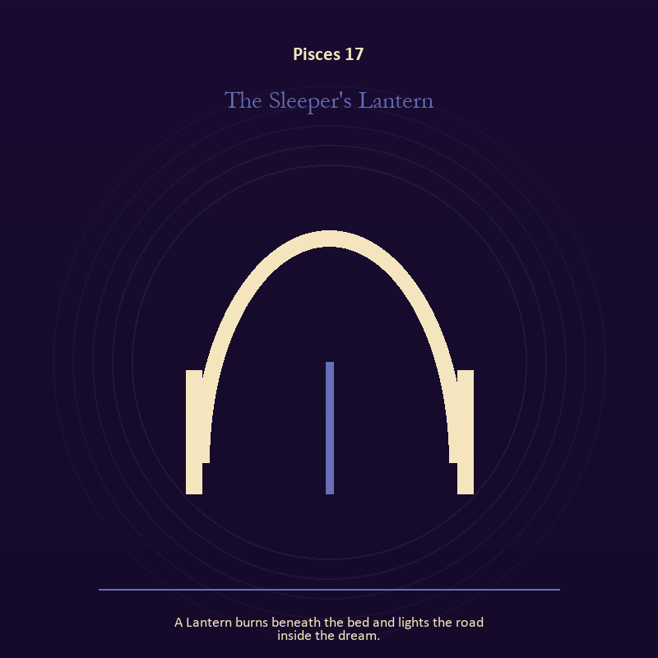

Pisces 17 The Sleeper's Lantern
A Lantern burns beneath the bed and lights the road inside the dream.
INTERPRETATION The Sleeper's Lantern tests living fire against dream, compassion, surrender, and a return that preserves a thread of self. Within the Sleeper's Lantern, fire gives change a visible cost. At Pisces 17, something is illuminated here because something else is being spent. The same image also carries the threshold; at Pisces 17, a threshold measures consent, timing, and consequence. As a choice degree, Pisces 17 asks what action preserves truth without using another person as material.
SIGNAL What can be carried forward from Pisces 17 is a truth made visible at the right scale joined to honest passage, tested by the need to let the image soften what control cannot solve, while keeping one hand on the shore.
SHADOW At Pisces 17, the image darkens through burning for recognition and guarding an obsolete enclosure; watch surrender become disappearance, intuition become certainty, or compassion erase a necessary boundary.
MIRROR For Pisces 17, where has your fire become performance rather than warmth?
PRACTICE For Pisces 17, light one candle and give its entire burn to a single unfinished question.
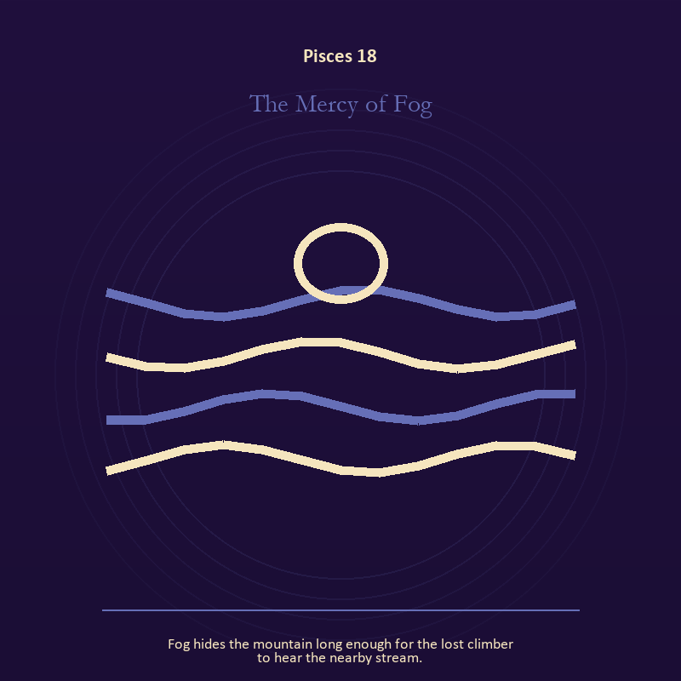

Pisces 18 The Mercy of Fog
Fog hides the mountain long enough for the lost climber to hear the nearby stream.
INTERPRETATION The Mercy of Fog holds living water against dream, compassion, surrender, and a return that preserves a thread of self. Within the Mercy of Fog, rain, tides, wells, and floods move private material into a shared landscape. At Pisces 18, what was hidden becomes environmental and must be answered together. As a choice degree, Pisces 18 moves from recognition to conduct; the clean choice must survive outside the imagination.
SIGNAL At Pisces 18, feeling with a living boundary becomes the clean signal when Pisces can let the image soften what control cannot solve, while keeping one hand on the shore.
SHADOW The distortion at Pisces 18 is using mystery to avoid a fact; watch surrender become disappearance, intuition become certainty, or compassion erase a necessary boundary.
MIRROR With the Mercy of Fog in mind at Pisces 18, what has the tide exposed that cannot be covered again?
PRACTICE Work with The Mercy of Fog directly at Pisces 18: write the feeling as weather, then add the exact fact occurring beneath that weather.

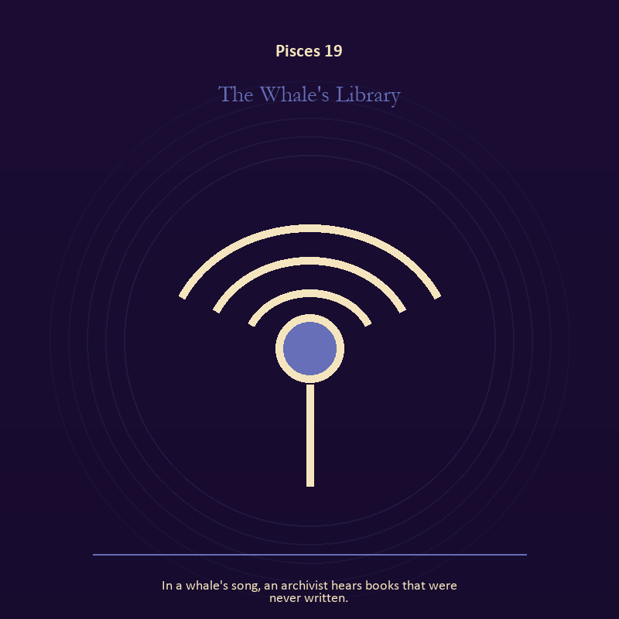

Pisces 19 The Whale's Library
In a whale's song, an archivist hears books that were never written.
INTERPRETATION The Whale's Library gives voice and naming consequences inside the Return to Mystery. Within the Whale's Library, voice turns inner pressure into shared consequence. At Pisces 19, words can witness, summon, distort, repair, or conceal according to their precision and timing. As a choice degree, Pisces 19 tests whether awareness can become restraint, repair, refusal, or consent.
SIGNAL The usable force at Pisces 19 is a name that restores agency; Pisces gives it form by asking you to let the image soften what control cannot solve, while keeping one hand on the shore.
SHADOW At Pisces 19, the Whale's Library can turn toward speaking for someone whose voice is present; watch surrender become disappearance, intuition become certainty, or compassion erase a necessary boundary.
MIRROR The question at Pisces 19: which word in this scene changes the power relationship?
PRACTICE Give Pisces 19 a physical form; give the current experience a temporary name and date it, leaving room for revision.
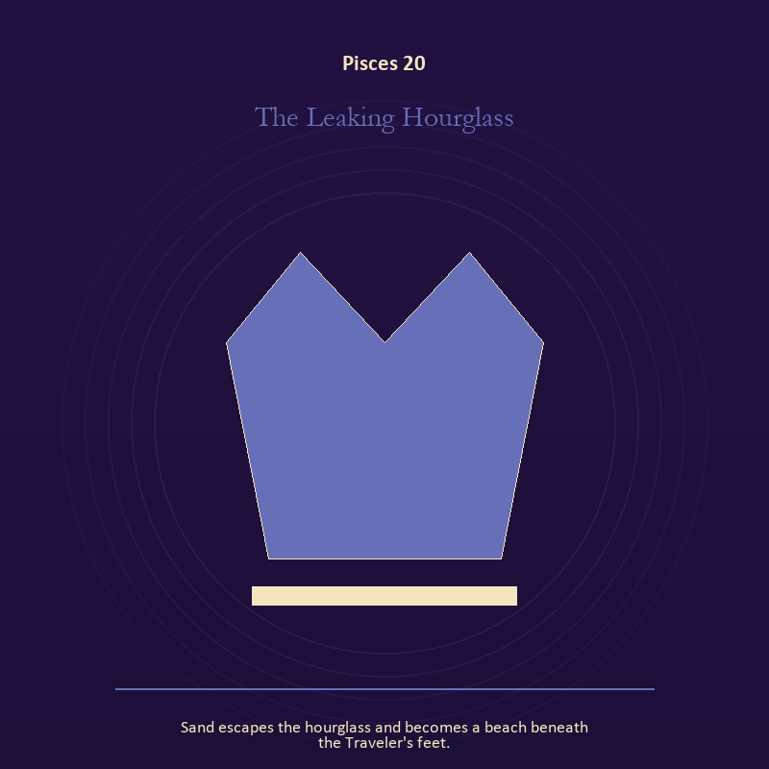

Pisces 20 The Leaking Hourglass
Sand escapes the hourglass and becomes a beach beneath the Traveler's feet.
INTERPRETATION The Leaking Hourglass puts the body under pressure from dream, compassion, surrender, and a return that preserves a thread of self. Within the Leaking Hourglass, bread, rest, touch, clothing, and shelter make spiritual language answer to material need. At Pisces 20, an insight that harms the body requires correction. As a choice degree, Pisces 20 places responsibility in the reader's hands without promising a painless answer.
SIGNAL At Pisces 20, a decision the nervous system can inhabit carries the signal; it stays honest when you let the image soften what control cannot solve, while keeping one hand on the shore.
SHADOW The shadow at Pisces 20 begins with using transcendence to ignore need; also watch surrender become disappearance, intuition become certainty, or compassion erase a necessary boundary.
MIRROR At Pisces 20, which need in this scene has been made too ordinary to mention?
PRACTICE Bring Pisces 20 out of abstraction: eat, drink, rest, or move before making the interpretation more dramatic.

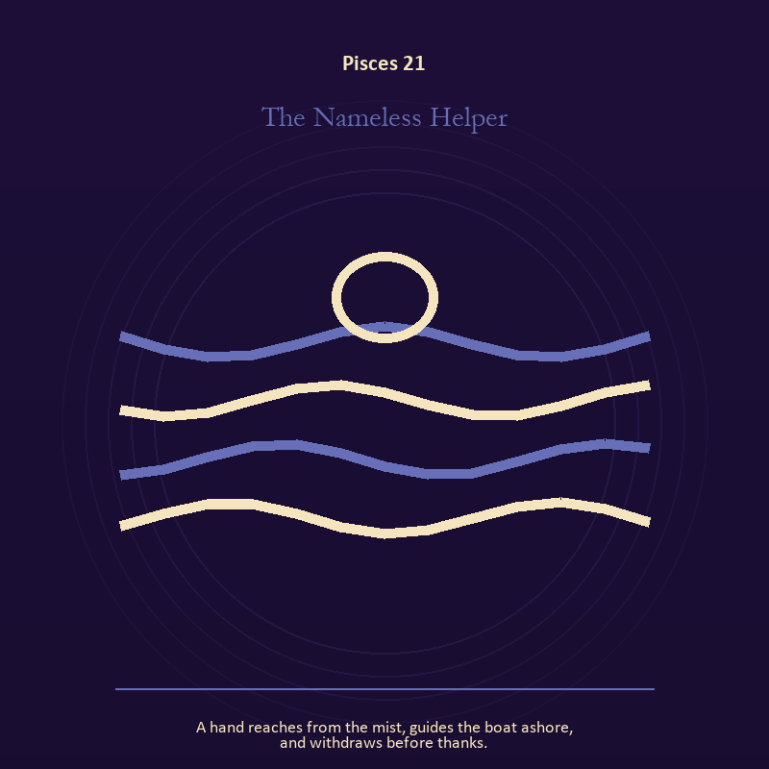

Pisces 21 The Nameless Helper
A hand reaches from the mist, guides the boat ashore, and withdraws before thanks.
INTERPRETATION In the Nameless Helper, the work of living water must answer to dream, compassion, surrender, and a return that preserves a thread of self. Within the Nameless Helper, rain, tides, wells, and floods move private material into a shared landscape. At Pisces 21, what was hidden becomes environmental and must be answered together. The same image also carries the body; at Pisces 21, bread, rest, touch, clothing, and shelter make spiritual language answer to material need. As a integration degree, Pisces 21 holds the gift beside its distortion; using one without feeding the other is the work.
SIGNAL What can be carried forward from Pisces 21 is feeling with a living boundary joined to care made material, tested by the need to let the image soften what control cannot solve, while keeping one hand on the shore.
SHADOW At Pisces 21, the image darkens through using mystery to avoid a fact and letting appetite make the whole decision; watch surrender become disappearance, intuition become certainty, or compassion erase a necessary boundary.
MIRROR For Pisces 21, what has the tide exposed that cannot be covered again? From a second angle at Pisces 21, which need in this scene has been made too ordinary to mention?
PRACTICE For Pisces 21, write the feeling as weather, then add the exact fact occurring beneath that weather.
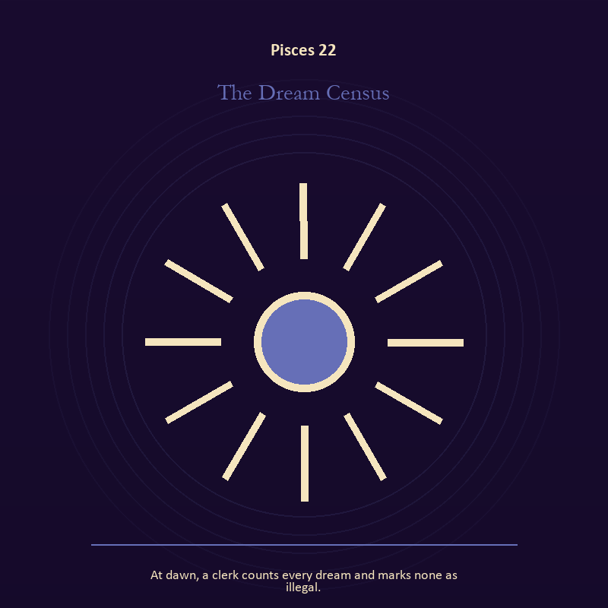

Pisces 22 The Dream Census
At dawn, a clerk counts every dream and marks none as illegal.
INTERPRETATION The Dream Census tests living fire against dream, compassion, surrender, and a return that preserves a thread of self. Within the Dream Census, light represents directed attention. At Pisces 22, it can warm, expose, guide, consume, or turn a person into a spectacle depending on who controls it. The same image also carries craft and record; at Pisces 22, workshops honor correction. As a integration degree, Pisces 22 asks the sign to carry its strength without turning that strength into jurisdiction.
SIGNAL At Pisces 22, courage that helps another see joined to a useful correction that outlives the moment becomes the clean signal when Pisces can let the image soften what control cannot solve, while keeping one hand on the shore.
SHADOW The distortion at Pisces 22 is mistaking brightness for moral authority and measurement mistaken for meaning; watch surrender become disappearance, intuition become certainty, or compassion erase a necessary boundary.
MIRROR With the Dream Census in mind at Pisces 22, what deserves the full light of your attention now?
PRACTICE Work with The Dream Census directly at Pisces 22: choose one person or project that needs warmth rather than intensity and act accordingly. For the second pressure at Pisces 22, inspect one repeated task and add a check that would catch the most expensive error.

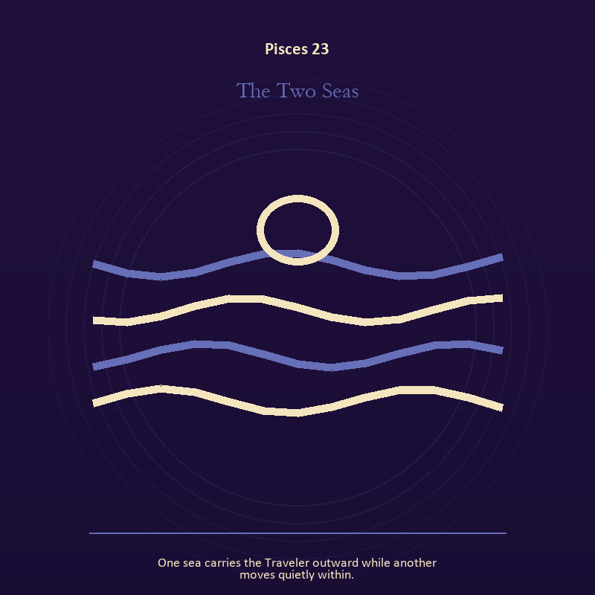

Pisces 23 The Two Seas
One sea carries the Traveler outward while another moves quietly within.
INTERPRETATION The Two Seas holds relationship against dream, compassion, surrender, and a return that preserves a thread of self. Within the Two Seas, relationship imagery tests the fantasy that harmony requires sameness. At Pisces 23, a living bond can hold difference, correction, privacy, and departure. The same image also carries living water; at Pisces 23, water carries feeling, memory, adaptation, and forces too large for command. As a integration degree, Pisces 23 joins capacity to consequence; what helps in one setting may harm in another.
SIGNAL The usable force at Pisces 23 is difference held without humiliation joined to feeling with a living boundary; Pisces gives it form by asking you to let the image soften what control cannot solve, while keeping one hand on the shore.
SHADOW At Pisces 23, the Two Seas can turn toward harmony purchased by one person's silence and using mystery to avoid a fact; watch surrender become disappearance, intuition become certainty, or compassion erase a necessary boundary.
MIRROR The question at Pisces 23: where does responsibility belong, and where has it been displaced?
PRACTICE Give Pisces 23 a physical form; ask the other person what they believe the agreement is, then compare it with your own version.
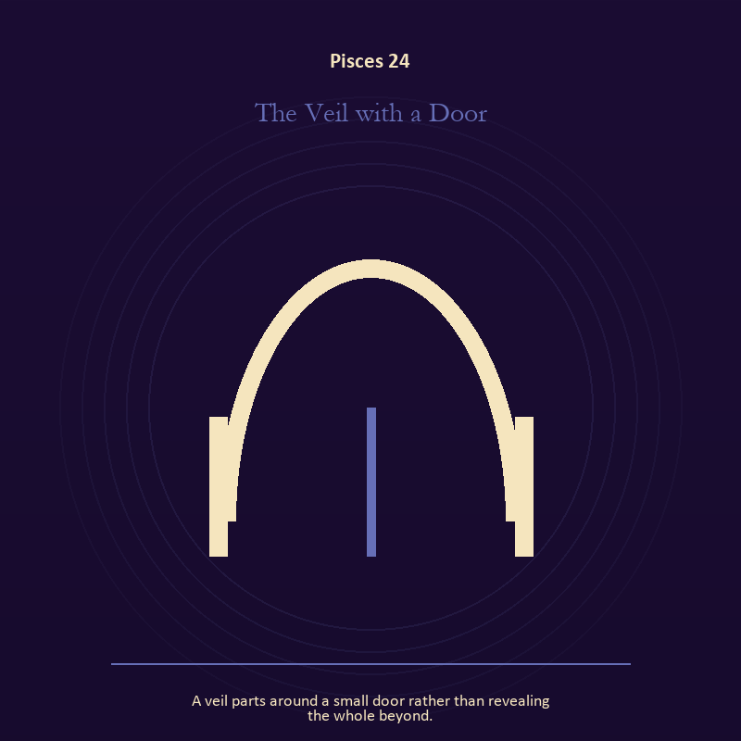

Pisces 24 The Veil with a Door
A veil parts around a small door rather than revealing the whole beyond.
INTERPRETATION The Veil with a Door gives the threshold consequences inside the Return to Mystery. Within the Veil with a Door, a boundary can protect life, restrict it, or clarify the terms of meeting. At Pisces 24, the surrounding action reveals which function is active here. As a integration degree, Pisces 24 shows the mature tool and the temptation hidden inside its handle.
SIGNAL At Pisces 24, honest passage carries the signal; it stays honest when you let the image soften what control cannot solve, while keeping one hand on the shore.
SHADOW The shadow at Pisces 24 begins with guarding an obsolete enclosure; also watch surrender become disappearance, intuition become certainty, or compassion erase a necessary boundary.
MIRROR At Pisces 24, what would make the next step chosen rather than compelled?
PRACTICE Bring Pisces 24 out of abstraction: draw the boundary as a line on paper; then mark the gate, the guard, and the person who holds the key.

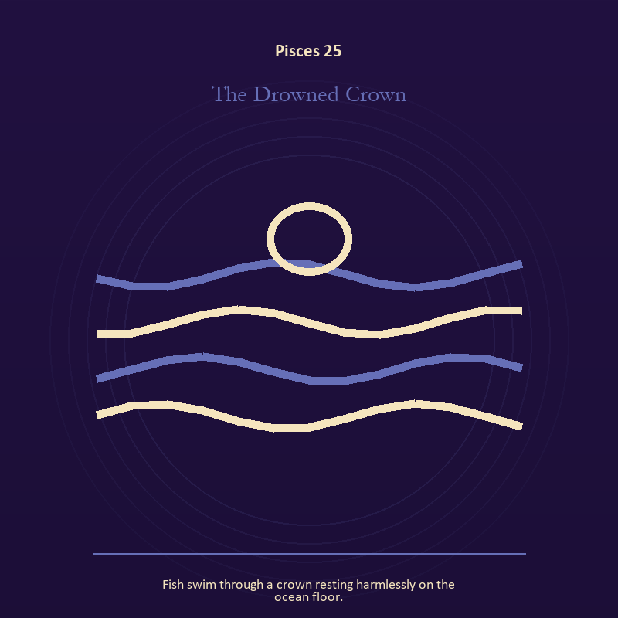

Pisces 25 The Drowned Crown
Fish swim through a crown resting harmlessly on the ocean floor.
INTERPRETATION The Drowned Crown puts authority under pressure from dream, compassion, surrender, and a return that preserves a thread of self. Within the Drowned Crown, authority is shown as a tool with weight, limits, witnesses, and an eventual transfer. At Pisces 25, the symbol asks whom power protects when nobody is applauding. The same image also carries the descent; at Pisces 25, ash, bones, scars, and sealed rooms preserve consequences. As a integration degree, Pisces 25 tests whether the lesson can be lived without becoming a new performance.
SIGNAL What can be carried forward from Pisces 25 is power made answerable joined to a wound converted into discernment, tested by the need to let the image soften what control cannot solve, while keeping one hand on the shore.
SHADOW At Pisces 25, the image darkens through authority defending itself against correction and pain used as permanent jurisdiction; watch surrender become disappearance, intuition become certainty, or compassion erase a necessary boundary.
MIRROR For Pisces 25, who carries the cost of the decision made here?
PRACTICE For Pisces 25, inspect one standing rule by asking how it treats the person with the least power.
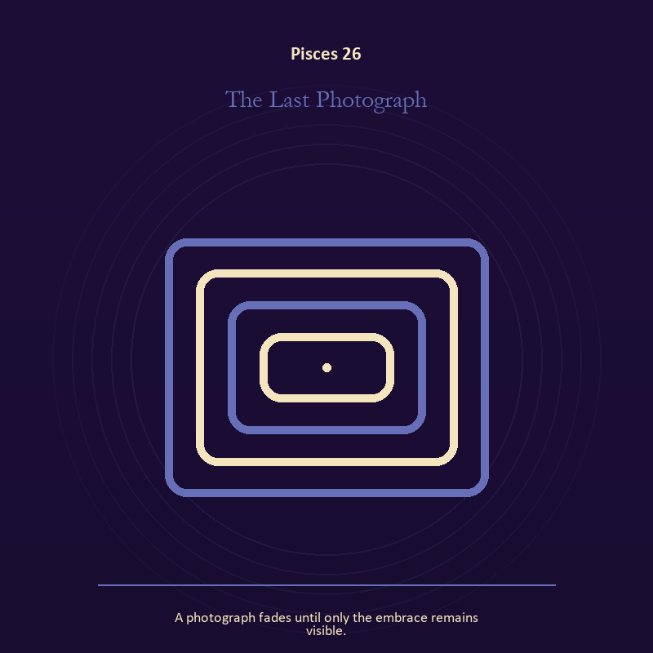

Pisces 26 The Last Photograph
A photograph fades until only the embrace remains visible.
INTERPRETATION In the Last Photograph, the work of the Mirror must answer to dream, compassion, surrender, and a return that preserves a thread of self. Within the Last Photograph, reflected images divide the observer from the observed self. At Pisces 26, that gap can hold shame, vanity, curiosity, or the first honest revision of identity. As a release degree, Pisces 26 prepares the lesson to leave its original container; keep the capacity and loosen the role.
SIGNAL At Pisces 26, the courage to revise a familiar self-image becomes the clean signal when Pisces can let the image soften what control cannot solve, while keeping one hand on the shore.
SHADOW The distortion at Pisces 26 is mistaking appearance for character; watch surrender become disappearance, intuition become certainty, or compassion erase a necessary boundary.
MIRROR With the Last Photograph in mind at Pisces 26, whose gaze have you installed inside your own Mirror?
PRACTICE Work with The Last Photograph directly at Pisces 26: describe the scene without interpretation, then circle the detail you most want to praise or condemn.

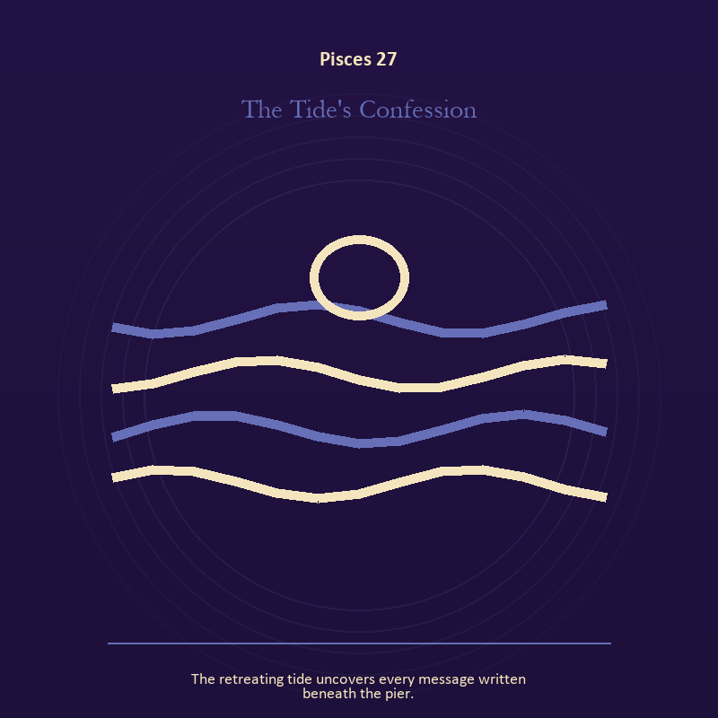

Pisces 27 The Tide's Confession
The retreating tide uncovers every message written beneath the pier.
INTERPRETATION The Tide's Confession tests living water against dream, compassion, surrender, and a return that preserves a thread of self. Within the Tide's Confession, rain, tides, wells, and floods move private material into a shared landscape. At Pisces 27, what was hidden becomes environmental and must be answered together. The same image also carries voice and naming; at Pisces 27, books, letters, bells, and songs extend speech beyond the speaker's body. As a release degree, Pisces 27 asks what can be handed onward without demanding imitation or loyalty.
SIGNAL The usable force at Pisces 27 is feeling with a living boundary joined to a name that restores agency; Pisces gives it form by asking you to let the image soften what control cannot solve, while keeping one hand on the shore.
SHADOW At Pisces 27, the Tide's Confession can turn toward using mystery to avoid a fact and speaking for someone whose voice is present; watch surrender become disappearance, intuition become certainty, or compassion erase a necessary boundary.
MIRROR The question at Pisces 27: what has the tide exposed that cannot be covered again? From a second angle at Pisces 27, what needs to be said plainly, and who has earned the right to hear it?
PRACTICE Give Pisces 27 a physical form; write the feeling as weather, then add the exact fact occurring beneath that weather.
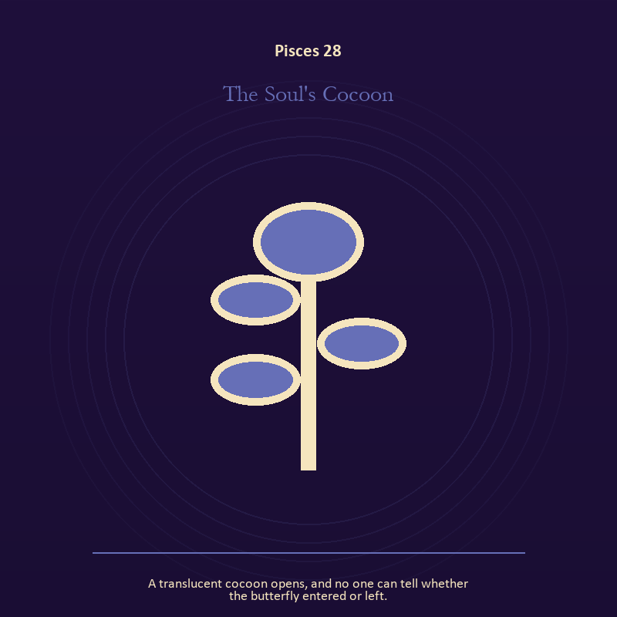

Pisces 28 The Soul's Cocoon
A translucent cocoon opens, and no one can tell whether the butterfly entered or left.
INTERPRETATION The Soul's Cocoon holds growth against dream, compassion, surrender, and a return that preserves a thread of self. Within the Soul's Cocoon, growth appears as vulnerable potential under specific conditions. At Pisces 28, it requires time, nourishment, protection, and eventual release from the form that began it. As a release degree, Pisces 28 turns completion into transfer; the work survives by changing hands.
SIGNAL At Pisces 28, care that honors timing carries the signal; it stays honest when you let the image soften what control cannot solve, while keeping one hand on the shore.
SHADOW The shadow at Pisces 28 begins with protecting potential so tightly that it cannot emerge; also watch surrender become disappearance, intuition become certainty, or compassion erase a necessary boundary.
MIRROR At Pisces 28, what is alive here but not ready to be displayed?
PRACTICE Bring Pisces 28 out of abstraction: release one expectation about what the new form must resemble.

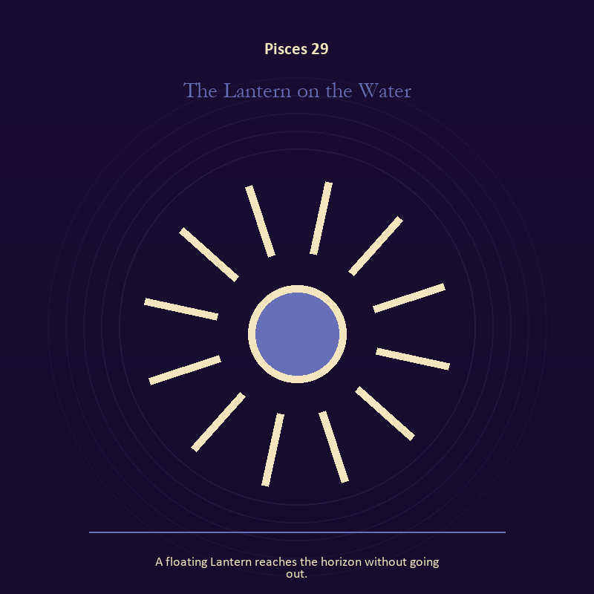

Pisces 29 The Lantern on the Water
A floating Lantern reaches the horizon without going out.
INTERPRETATION The Lantern on the Water gives living fire consequences inside the Return to Mystery. Within the Lantern on the Water, fire gives change a visible cost. At Pisces 29, something is illuminated here because something else is being spent. The same image also carries living water; at Pisces 29, water carries feeling, memory, adaptation, and forces too large for command. As a release degree, Pisces 29 lets the sign set down the identity built around its ordeal.
SIGNAL What can be carried forward from Pisces 29 is a truth made visible at the right scale joined to feeling with a living boundary, tested by the need to let the image soften what control cannot solve, while keeping one hand on the shore.
SHADOW At Pisces 29, the image darkens through burning for recognition and using mystery to avoid a fact; watch surrender become disappearance, intuition become certainty, or compassion erase a necessary boundary.
MIRROR For Pisces 29, where has your fire become performance rather than warmth?
PRACTICE For Pisces 29, light one candle and give its entire burn to a single unfinished question.
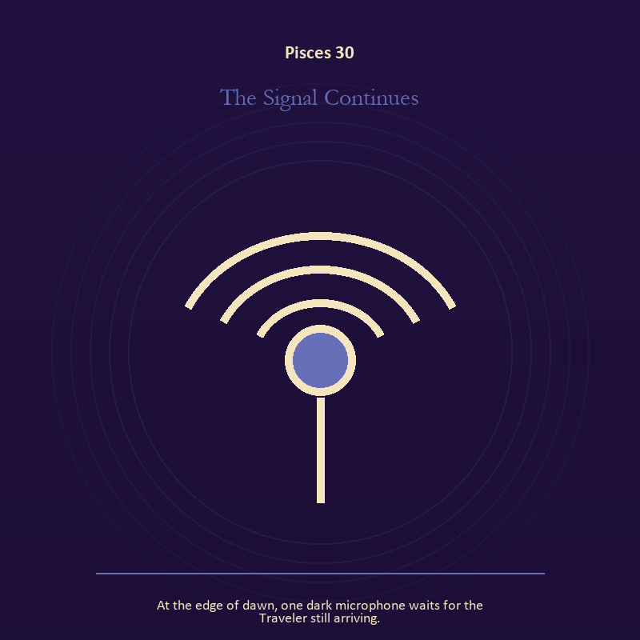

Pisces 30 The Signal Continues
At the edge of dawn, one dark microphone waits for the Traveler still arriving.
INTERPRETATION The Signal Continues puts the Signal under pressure from dream, compassion, surrender, and a return that preserves a thread of self. Within the Signal Continues, machines in these symbols expose the difference between a living message and the equipment carrying it. At Pisces 30, when the device fails, the signal may become easier to hear. The same image also carries living fire; at Pisces 30, fire gives change a visible cost. As a release degree, Pisces 30 returns the earned knowledge to ordinary life, where another cycle can use it.
SIGNAL At Pisces 30, clear transmission joined to courage that helps another see becomes the clean signal when Pisces can let the image soften what control cannot solve, while keeping one hand on the shore.
SHADOW The distortion at Pisces 30 is confusing reach with truth and mistaking brightness for moral authority; watch surrender become disappearance, intuition become certainty, or compassion erase a necessary boundary.
MIRROR With the Signal Continues in mind at Pisces 30, who is the real receiver of the signal you are sending? From a second angle at Pisces 30, where has your fire become performance rather than warmth?
PRACTICE Work with The Signal Continues directly at Pisces 30: turn off one source of noise for an hour and notice what thought keeps returning. For the second pressure at Pisces 30, choose one person or project that needs warmth rather than intensity and act accordingly.

The Signal Continues
The final degree leaves a microphone waiting at the edge of dawn. The book closes there because a living symbol completes its work in another mind.
Return to any image when its detail begins moving again. Read slowly. Keep what clarifies. Question what flatters. Put down whatever tries to take your judgment from you.
These pages belong to fellow Travelers, each carrying a Lantern far enough to see the next honest step.
The dark microphone waits for the one still arriving.

THE PSYCHE SYMBOLS

