

CATHOLIC UNIVERSITY OF RWANDA
GROUP 14 AUTOMATED MILK PUMP SYSTEM

GROUP MEMBER REG NUMBER

MUTABARUKA Placide 1CUR23AK07200
NKUNDIMANA Fraterne 1CUR23AK07127
MUKASHEMA Esther 1CUR23AK07122
IRADUKUNDA Cynthia 1CUR23AK07276
TUYISHIMIRE Valentine 1CUR23AK07383

AUTOMATED MILK PUMP SYSTEM

INTRODUCTION
This project automates a milk pump using an Arduino Uno, relay, sensor (simulated by a potentiometer), LCD, buzzer and push buttons. The controller monitors the sensor and starts or stops the pump automatically while displaying the system status. This project also has a pressure sensor which is also a major device because it checks if the pressure doesn’t extend the normal level of cow milking which is 250kpa and also an Arduino has the ability to stop all action very short of time

COMPONENT
Component | Function
Arduino Uno | Main controller
16x2 LCD | Displays status and sensor value
PCF8574 | I2C LCD interface
Relay Module | Switches pump
Electromagnetic Relay | Controls motor power
DC Motor | Milk pump
Potentiometer | Simulated milk level sensor
Buzzer | Audible alert
Push Buttons | Start/Stop
BDX53C Transistor | Relay driver
Diode | Flyback protection
Figure 1: Initial state
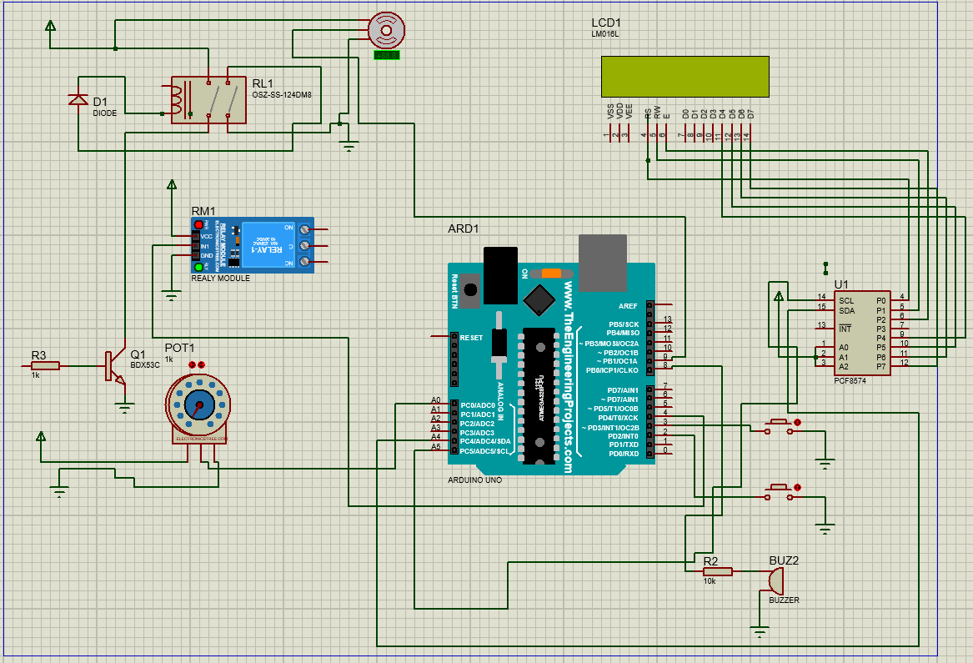

Figure 1: Initial state. LCD shows STOPPED, relay OFF, motor OFF, waiting for threshold. Here is the initial phase where system is off
Figure 2: System initialization
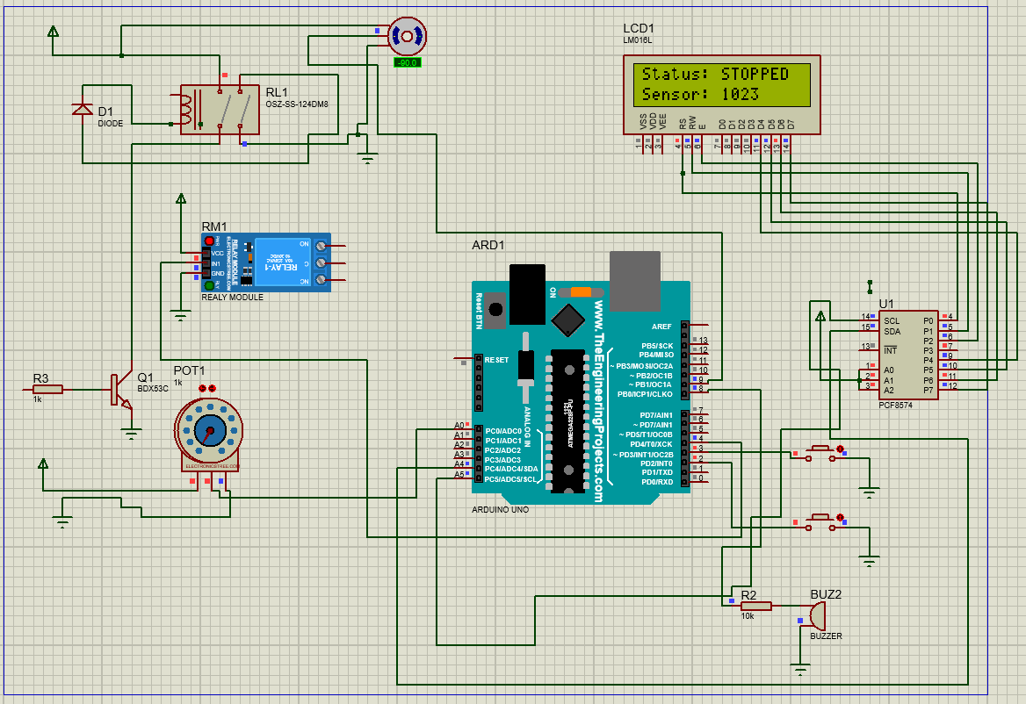

Figure 2: System initialization. LCD is initializing, Arduino configures peripherals before operation. when the system initialized Arduino configure all peripherals before starting button and moto servo is ready to pump and pressure sensor is ready to check if pressure of servo motor not extend 250pka

Figure 3: Milking state
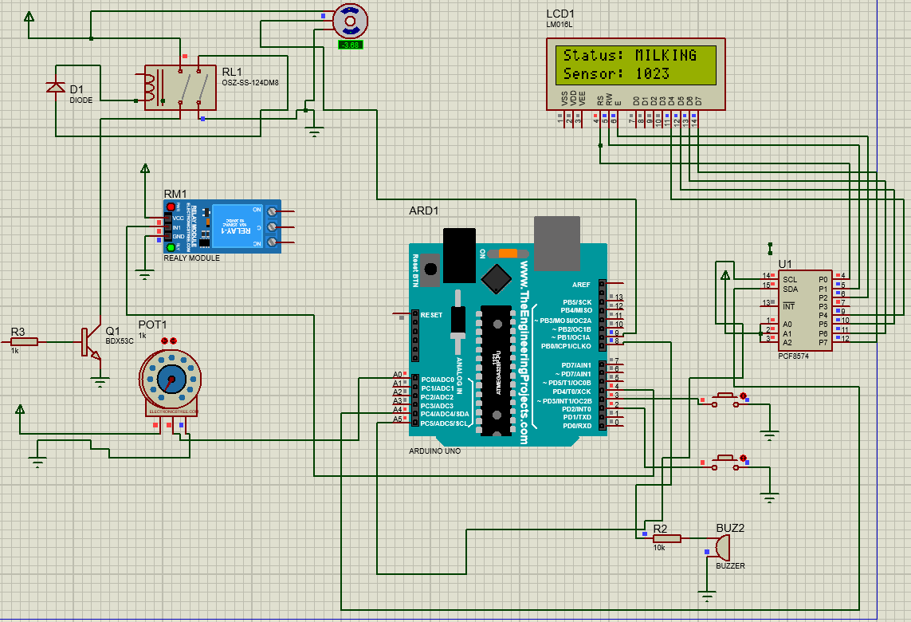

Figure 3: Milking state. LCD shows MILKING, relay energized, pump motor running. As we see motor pump is running and LCD is showing us that milking is going well

Working Principle
- Arduino initializes.
2. Reads analog sensor.
3. Compares value with threshold.
4. If threshold is met, relay activates the pump and LCD displays MILKING; otherwise STOPPED.
5. Buzzer provides audible indication.

Advantages
Automatic operation, reduced manual work, improved reliability, real-time monitoring, low cost, easy expansion.
Also automated milk pump reduced the effect caused by low level hygiene
We can not forget to say about time spending because automated milk pump reduce the time time taken by farmers

Conclusion
The prototype demonstrates an effective automated milk pumping system suitable for educational purposes and adaptable to dairy automation.

