# 搭建邮件服务器

首先安装HMailServer，并打开软件

## 添加域名

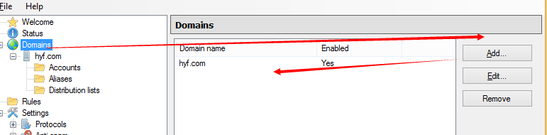

## 添加账号

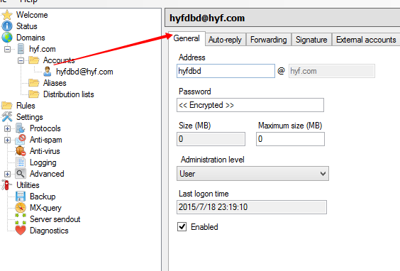

## 远程管理

### 配置QuickPHP

绑定地址为：本地地址

根目录为：HMailServer安装目录下的PHPWebAdmin文件夹

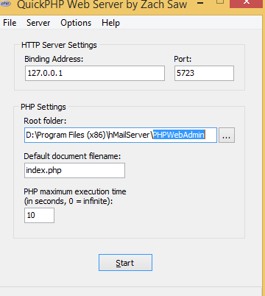

### 修改config.php

修改PHPWebAdmin文件夹下的config-dist.php文件名为config.php

打开config.php文件。做如下修改：

|  |
| --- |
| $hmail_config['rooturl'] = "http://127.0.0.1:5723/"; |

### 在邮件服务器设置管理密码

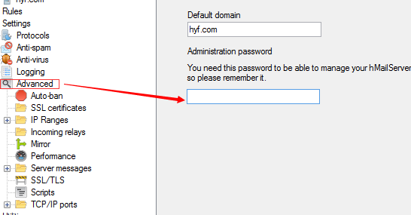

### 在浏览器中用管理账号登陆

在浏览器中打开：<http://127.0.0.1:5723/>

输入账号与密码：账号为：administrator，密码为1.3.3节中设置的密码

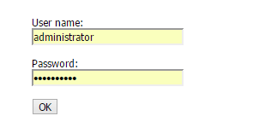

### 进行账号的管理

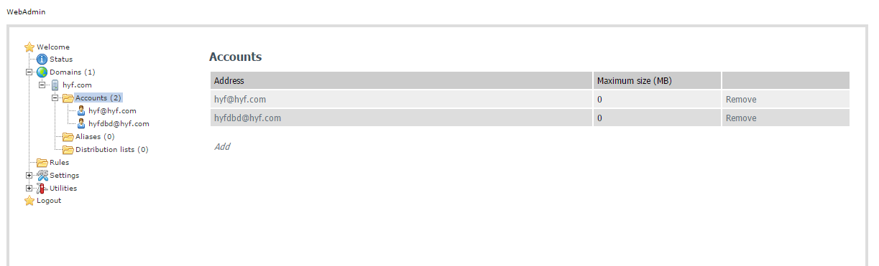

# 用FoxMail收发邮件

## 添加账号

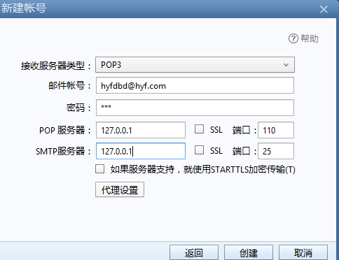

## 写邮件

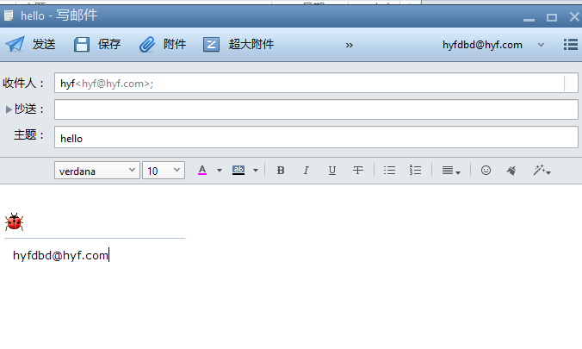

## 收邮件

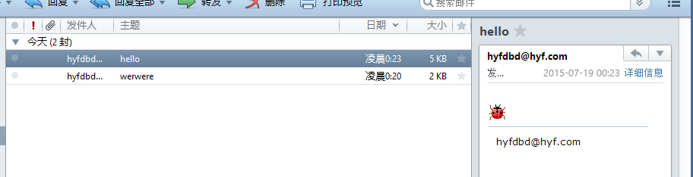

# C#中发邮件

## 界面

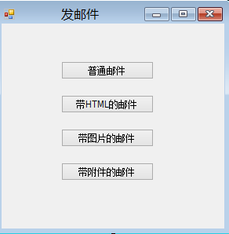

## 发普通邮件

|  |
| --- |
| private void button1_Click(object sender, EventArgs e)  {  //1.创建邮件信息对象  MailMessage mail = new MailMessage();  //主题  mail.Subject = "这是邮件的标题";  mail.SubjectEncoding = Encoding.UTF8;  //正文  mail.Body = "这是普通的正文";  mail.BodyEncoding = Encoding.UTF8;  //发件人  mail.From = new MailAddress("hyf@hyf.com","西瓜皮");  //收件人  mail.To.Add(new MailAddress("hyfdbd@hyf.com"));  //抄送  //mail.CC.Add();  //2. 发送邮件  //设置发件服务器的地址和端口  SmtpClient client = new SmtpClient("127.0.0.1", 25);  //验证发件人的账号密码信息  client.Credentials = new NetworkCredential("hyf@hyf.com", "123");  //发送邮件  client.Send(mail);  MessageBox.Show("发送成功");  } |

在foxmail中收取邮件

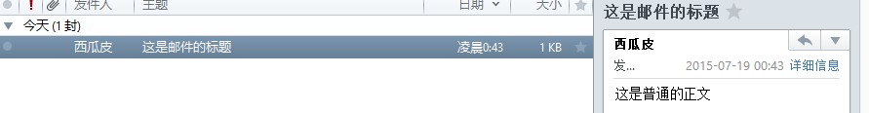

## 发送Html邮件

|  |
| --- |
| private void button2_Click(object sender, EventArgs e)  {    MailMessage mail = new MailMessage();  mail.Subject = "这是邮件的标题";  mail.SubjectEncoding = Encoding.UTF8;  mail.Body = "这是普通的正文";  mail.BodyEncoding = Encoding.UTF8;  mail.From = new MailAddress("hyf@hyf.com", "西瓜皮");  mail.To.Add(new MailAddress("hyfdbd@hyf.com"));  //发送html邮件  AlternateView htmlBody = AlternateView.CreateAlternateViewFromString("<font color='red' size='12'>hello</font>", null, "text/html");  mail.AlternateViews.Add(htmlBody);  SmtpClient client = new SmtpClient("127.0.0.1", 25);  client.Credentials = new NetworkCredential("hyf@hyf.com", "123");  client.Send(mail);  MessageBox.Show("发送成功");  } |

## 发送带图片的邮件

|  |
| --- |
| private void button3_Click(object sender, EventArgs e)  {  MailMessage mail = new MailMessage();  mail.Subject = "这是带图片的邮件";  mail.SubjectEncoding = Encoding.UTF8;  mail.Body = "这是普通的正文";  mail.BodyEncoding = Encoding.UTF8;  mail.From = new MailAddress("hyf@hyf.com", "西瓜皮");  mail.To.Add(new MailAddress("hyfdbd@hyf.com"));  //发送image  AlternateView htmlBody = AlternateView.CreateAlternateViewFromString("<img src='cid:zp'/>", null, "text/html");    LinkedResource lr = new LinkedResource(@"D:\1.jpg","image/gif");  lr.ContentId = "zp";  htmlBody.LinkedResources.Add(lr);    mail.AlternateViews.Add(htmlBody);  SmtpClient client = new SmtpClient("127.0.0.1", 25);  client.Credentials = new NetworkCredential("hyf@hyf.com", "123");  client.Send(mail);  MessageBox.Show("发送成功");  } |

收取邮件

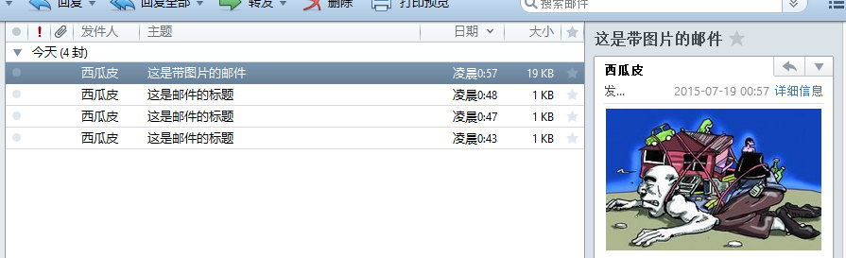

## 发送带附件的邮件

|  |
| --- |
| private void button4_Click(object sender, EventArgs e)  {  MailMessage mail = new MailMessage();  mail.Subject = "这是带附件的邮件";  mail.SubjectEncoding = Encoding.UTF8;  mail.Body = "这是普通的正文";  mail.BodyEncoding = Encoding.UTF8;  mail.From = new MailAddress("hyf@hyf.com", "西瓜皮");  mail.To.Add(new MailAddress("hyfdbd@hyf.com"));  //添加附件-----------------------------  Attachment a1 = new Attachment(@"C:\wzlog.txt");  Attachment a2 = new Attachment(@"D:\1.jpg");  mail.Attachments.Add(a1);  mail.Attachments.Add(a2);  //-------------------------------------  SmtpClient client = new SmtpClient("127.0.0.1", 25);  client.Credentials = new NetworkCredential("hyf@hyf.com", "123");  client.Send(mail);  MessageBox.Show("发送成功");  } |

收取邮件

