# Asp.net原理

首先创建一个空的asp.net应用程序

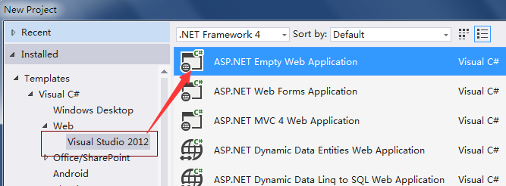

之后创建一个名为hello1.html的页面

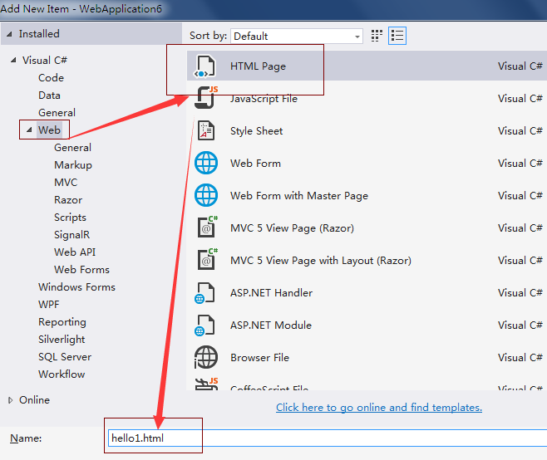

内容如下：

|  |
| --- |
| <!DOCTYPE html>  <html xmlns="http://www.w3.org/1999/xhtml">  <head>  <title></title>  </head>  <body>  <form action="hello1.ashx">  姓名：<input type="text" name="userName"/><input type="submit" value="提交" />  </form>  </body>  </html> |

在上面的代码中，点击提交按钮会把信息提交到hello1.ashx。接下来创建一个名为hello1.ashx的一般处理程序

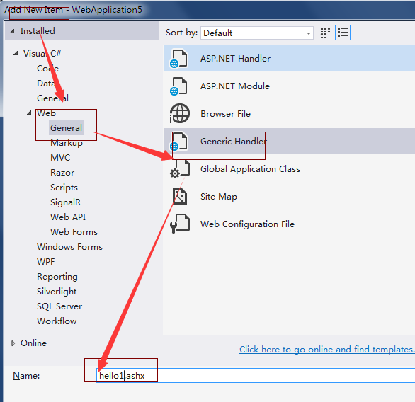

在其中添加内容处理内容：

|  |
| --- |
| using System;  using System.Collections.Generic;  using System.Linq;  using System.Web;  namespace WebApplication5  {  /// <summary>  /// Summary description for hello1  /// </summary>  public class hello1 : IHttpHandler  {  /// <summary>  /// 处理请求的程序。  /// </summary>  /// <param name="context"></param>  public void ProcessRequest(HttpContext context)  {  context.Response.ContentType = "text/html";//表示响应的数据是html数据  context.Response.Write(@" <form action='hello1.ashx'>  姓名：<input type='text' name='userName'/><input type='submit' value='提交' />  </form>");//动态生成控件  context.Response.Write("Hello World");  var userName = context.Request["userName"];//取得用户提交过来的name为userName的控件的值  context.Response.Write(userName);//将字符串写回到浏览器端。  }  public bool IsReusable  {  get  {  return false;  }  }  }  } |

还能取得原来网页中的内容，并写回

|  |
| --- |
| using System;  using System.Collections.Generic;  using System.Linq;  using System.Web;  namespace WebApplication5  {  /// <summary>  /// Summary description for hello1  /// </summary>  public class hello1 : IHttpHandler  {  /// <summary>  /// 处理请求的程序。  /// </summary>  /// <param name="context"></param>  public void ProcessRequest(HttpContext context)  {  context.Response.ContentType = "text/html";//表示响应的数据是html数据  string fullpath = context.Server.MapPath("hello1.html");//得到文件的全路径  string content = System.IO.File.ReadAllText(fullpath);//读取文件  context.Response.Write(content);  string username = context.Request["userName"];  if(string.IsNullOrEmpty(username))//用户名为空，拒绝进入  {  context.Response.Write("拒绝进入");    }  else  {  context.Response.Write("提交进入");  }  }    public bool IsReusable  {  get  {  return false;  }  }  }  } |

# 自增

首先创建一个模板

|  |
| --- |
| <!DOCTYPE html>  <html xmlns="http://www.w3.org/1999/xhtml">  <head>  <title></title>  </head>  <body>  <form action="IncValue.ashx">  <input type="hidden" value="true" name="ispostback" />  <input type="text" name="number" value="@value" /><input type="submit" value="自增" />  </form>  </body>  </html> |

创建处理程序

|  |
| --- |
| using System;  using System.Collections.Generic;  using System.Linq;  using System.Web;  namespace WebApplication5  {  /// <summary>  /// Summary description for IncValue  /// </summary>  public class IncValue : IHttpHandler  {  public void ProcessRequest(HttpContext context)  {  context.Response.ContentType = "text/html";  string ispostback = context.Request["ispostback"];  string number = context.Request["number"];//通过表单得到的数据都是String类型  if(ispostback=="true")//点击自增按钮进来的，把当前数据自增  {  int i = Convert.ToInt32(number);  i++;  number = i.ToString();  }  else//第一次进入，值为0.  {  number = "0";  }  string fullpath = context.Server.MapPath("IncValue.html");//获取模板IncValue.html的全地址  string content = System.IO.File.ReadAllText(fullpath);//加载模板  content = content.Replace("@value", number);//将模板中的占位符替换为值  context.Response.Write(content);//写回  }  public bool IsReusable  {  get  {  return false;  }  }  }  } |

# 加法计算器

创建模板

|  |
| --- |
| <!DOCTYPE html>  <html xmlns="http://www.w3.org/1999/xhtml">  <head>  <title></title>  </head>  <body>  <form action="AddCalc.ashx">  <input type="hidden" value="true" name="ispostback" />  <input type="text" value="@num1" name="num1"/>+<input type="text" value="@num2" name="num2" /><input type="submit" value="=" />  <input type="text" readonly="readonly" value="@result" name="result" />  </form>  </body>  </html> |

创建处理程序

|  |
| --- |
| using System;  using System.Collections.Generic;  using System.Linq;  using System.Web;  namespace WebApplication5  {  /// <summary>  /// Summary description for AddCalc  /// </summary>  public class AddCalc : IHttpHandler  {  public void ProcessRequest(HttpContext context)  {  context.Response.ContentType = "text/html";  string ispostback = context.Request["ispostback"];  string num1 = "";  string num2 = "";  string reslut = "";  if(ispostback=="true")  {  num1 = context.Request["num1"];  num2 = context.Request["num2"];  reslut = (Convert.ToInt32(num1) + Convert.ToInt32(num2)).ToString();  }  string fullpath = context.Server.MapPath("AddCalc.html");  string content = System.IO.File.ReadAllText(fullpath);  content = content.Replace("@num1", num1);  content = content.Replace("@num2", num2);  content = content.Replace("@result", reslut);  context.Response.Write(content);  }  public bool IsReusable  {  get  {  return false;  }  }  }  } |